Supplementary Information for

Longitudinal monitoring of sewershed resistomes in socioeconomically diverse urban neighbourhoods

Jangwoo Lee^{1, 2}, Kevin Xiang², Emily Au¹, Shahrzad Sarabi³, Nicole Acosta¹, Srijak Bhatnagar^{2, 4}, Jennifer Van Doorn², Stefania Bertazzon³, John Conly^{1,5-8}, Elissa Rennert-May^{1, 5-6}, Johann Pitout^{1, 8}, Bonita E. Lee⁹⁻¹⁰, Xiaoli Pang¹¹⁻¹³, Christine O’Grady¹⁴, Kevin Frankowski¹⁴, Casey R.J. Hubert², and Michael D. Parkins^{1, 5-7*}

¹ Department of Microbiology, Immunology and Infectious Diseases, University of Calgary, Calgary, Canada
² Department of Biological Sciences, University of Calgary, Calgary, Canada
³ Department of Geography, University of Calgary, Calgary, Canada
⁴ Faculty of Science and Technology, Athabasca University, Athabasca, Alberta, Canada
⁵ Department of Medicine, University of Calgary and Alberta Health Services, Calgary, Canada
⁶ O'Brien Institute for Public Health, University of Calgary, Calgary, Canada
⁷ Snyder Institute for Chronic Diseases, University of Calgary and Alberta Health Services, Calgary, Canada
⁸ Department of Pathology and Laboratory Medicine, University of Calgary and Alberta Health Services, Calgary, Canada
⁹ Department of Pediatrics, University of Alberta, Edmonton, Alberta, Canada
¹⁰ Women & Children's Health Research Institute; Li Ka Shing Institute of Virology, Edmonton, Alberta, Canada
¹¹ Department of Laboratory Medicine and Pathology, University of Alberta, Edmonton, Alberta, Canada
¹² Alberta Precision Laboratories, Public Health Laboratory, Alberta Health Services, Edmonton, Alberta, Canada
¹³ Li Ka Shing Institute of Virology, University of Alberta, Edmonton, Alberta, Canada
¹⁴ Advancing Canadian Water Assets, University of Calgary, Calgary, Canada

*Corresponding Author:
Michael D. Parkins, Professor, Departments of Medicine and Microbiology, Immunology & Infectious Diseases, Cumming School of Medicine, University of Calgary.
Section Chief, Infectious Diseases, Calgary Zone, Alberta Health Services
Postal address: 3330 Hospital Drive, NW, Calgary, Alberta, T2N 2V5. CANADA.
e-mail: mdparkin@ucalgary.ca
Phone: 403-220-5951, Fax: 403-270-2772.

Supplementary Methods

1. Examining uncertainties potentially linked to the comparison of multiple studies
Three types of uncertainties (technical error, sampling bias, and temporal variation), delineated in section 4.6, may be involved in our meta-analysis. This required an analysis including complementary controls (i.e., 8 sewage metagenomes, obtained from a WWTP, serving >80% population in Calgary).
Firstly, to analyse technical errors, we included additional Calgary area controls. We compared four previously reported Calgary municipal wastewater samples collected at the level of a municipal wastewater treatment plant from published global metagenome libraries (Calgary2017–2018, hereafter, collected on June-13, June-26, November-21, and December-10 in 2017 or 2018, respectively), with four additional control points (termed as Group1-Controls, hereafter) collected from the same site in 2022 matched for months of collection (May-26, July-06, November-23, and December 2022-07, respectively). Considering that Calgary2017–2018 and Group1-Controls were analysed during a comparable seasonal period –– it was anticipated that the two groups would demonstrate similar resistomes, in case technical errors were not significantly present. Based on the ordination visualizing the dissimilarity distance across samples, Group-1 Controls exhibited relatively low dissimilarity compared to other four published Calgary metagenomes, confirming that technical errors were not profound (Fig. S1a).
Secondly, to assess whether a single aggregate data point for 2021 neighbourhoods (distilled using the median of the longitudinal datasets, a total of 52 samples; termed as Calgary2021, hereafter) is representative of Calgary, we compared an additional four control samples (termed as Group2-Controls, hereafter), collected during a comparable period under the influence of COVID-19 travel restriction (Jan-26, Feb-09, and Feb-16 2022), lifted on March-01 2022 (Fig. S1a). Given that Calgary-2021 did not show high dissimilarity relative to Group2-Controls, we concluded that Calgary-2021 well represented the entire Calgary resistome.
Finally, we compared the Calgary2017-2018 to Calgary2021, in order to assess potential existence of temporal variations, particularly relevant given the confounding COVID-19 pandemic and its associated restrictions. The resistomes of Period-A (i.e., Calgary2017-2018 and Group2-Controls) were significantly
different from those of Period-B (i.e., Calgary2021 and Group1-Controls) (Fig. S1a). Although this might suggest the existence of temporal variation between Period-A and B, the magnitude of variation is relative – the dissimilarity between Calgary versus other cities, especially with lower-middle or low-HDI, was significantly greater than that observed among Calgary samples (regardless of year or library), confirming existence of a greater influence of the overarching factor, namely HDI. (Fig. S1b).

Supplementary Figures and Tables
Figure S1. The comparisons of dissimilarity distance across samples, including this, other published samples, and controls, using (a) ordination analysis based on Non-metric Multidimensional Scaling, and (b) boxplots visualizing dissimilarity distance between Calgary samples (irrespective of year or study), in comparison to that between Calgary and other cities, with varied HDI categories (high, upper middle (UM), lower middle (LM), or low HDI)
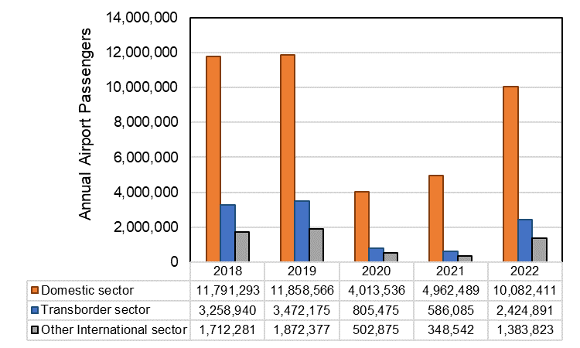
Figure S2. Annual passengers arriving at the Calgary international airport by sector (domestic, transborder, and international sectors) from 2018 to 2022. Data obtained from Statistics-Canada, 2023c.
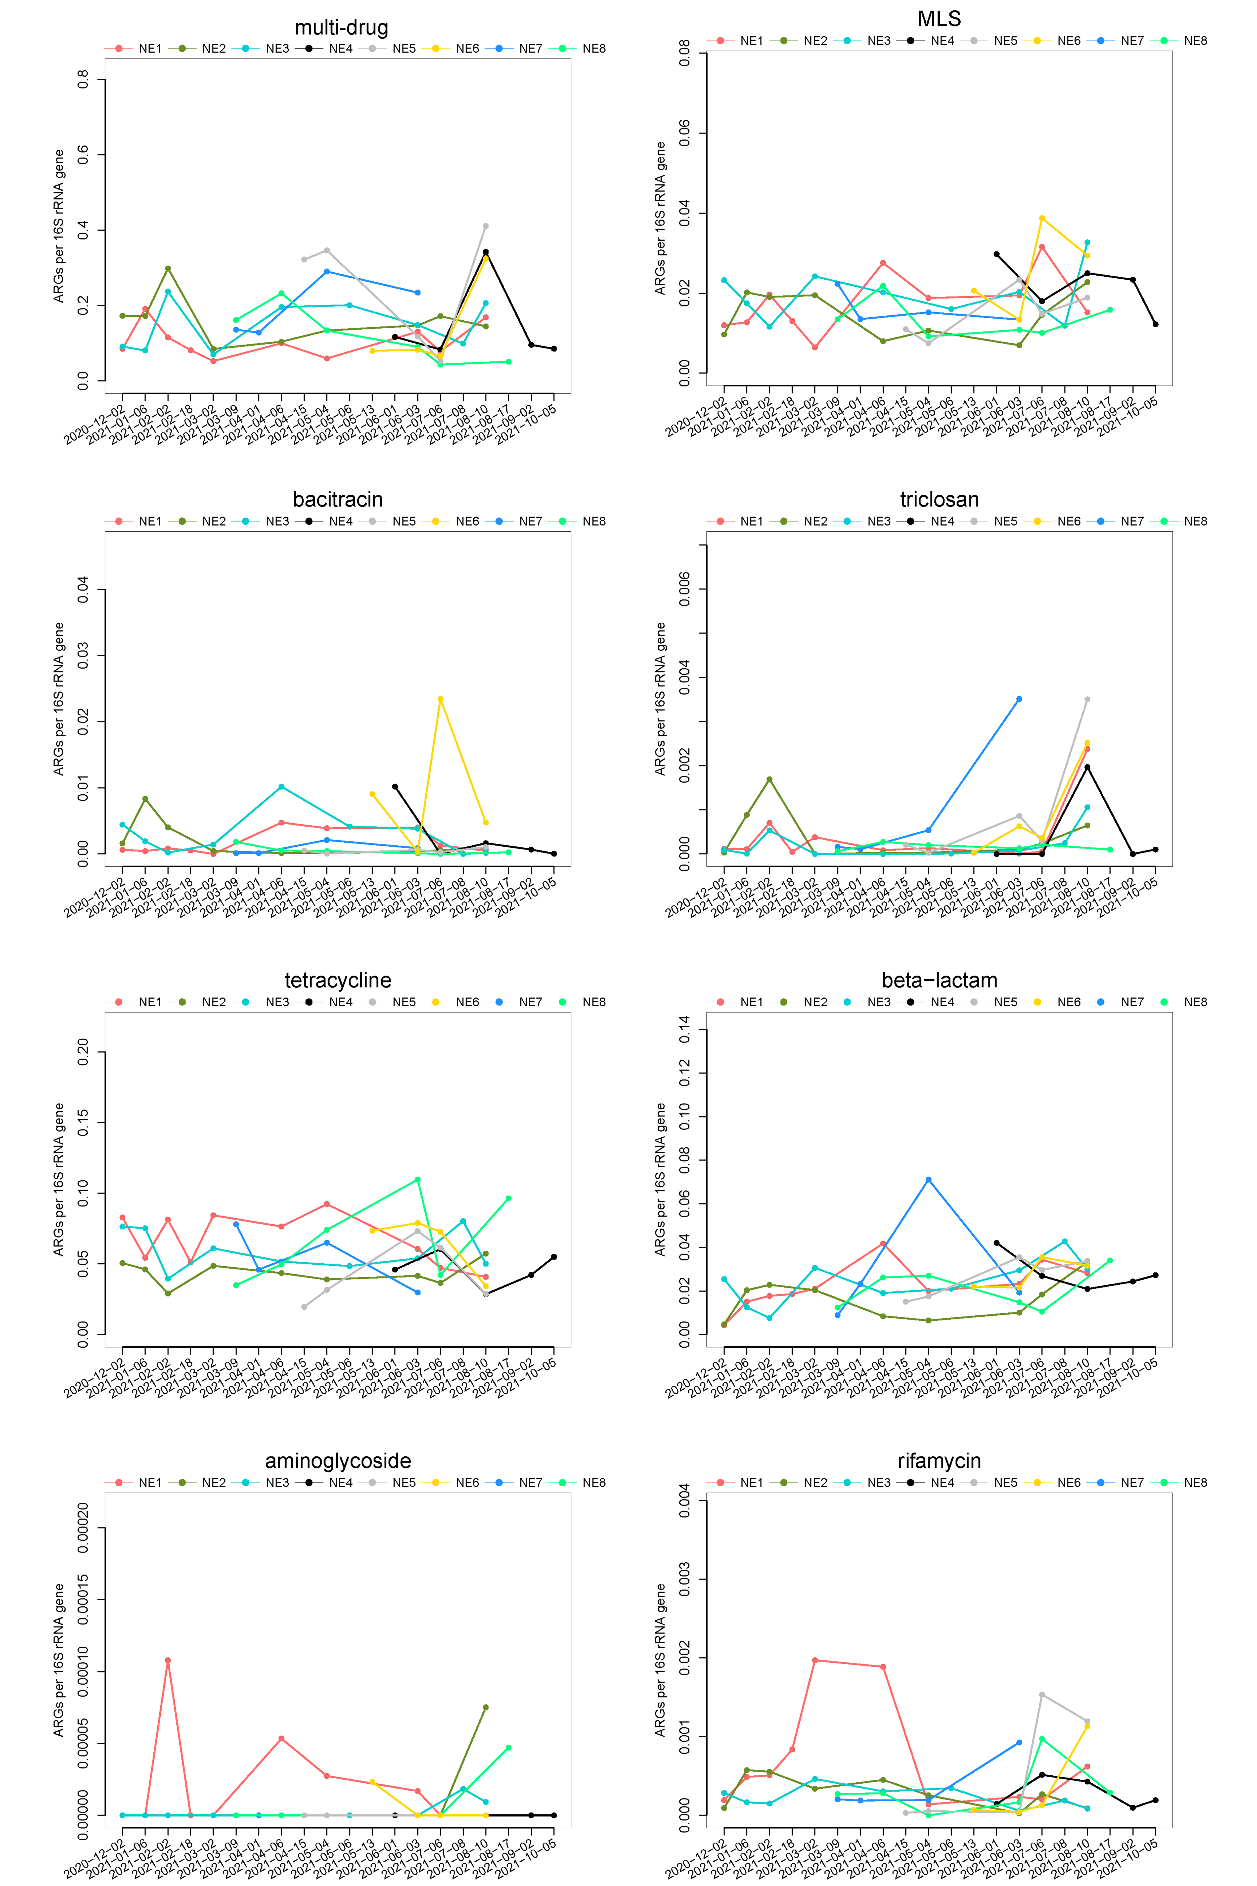
Figure S3. Relative abundances of wastewater ARGs (by type) during this study (2020-12-02 – 2021-10-05) in different neighborhoods in Calgary, Canada; only eight most abundant ARGs are shown.

Figure S4. Comparisons in log-transformed relative abundance of ARG among eight different neighborhoods in Calgary, Canada for the rest ‘less-abundant’ types (see Fig. 2 for the more abundant types).
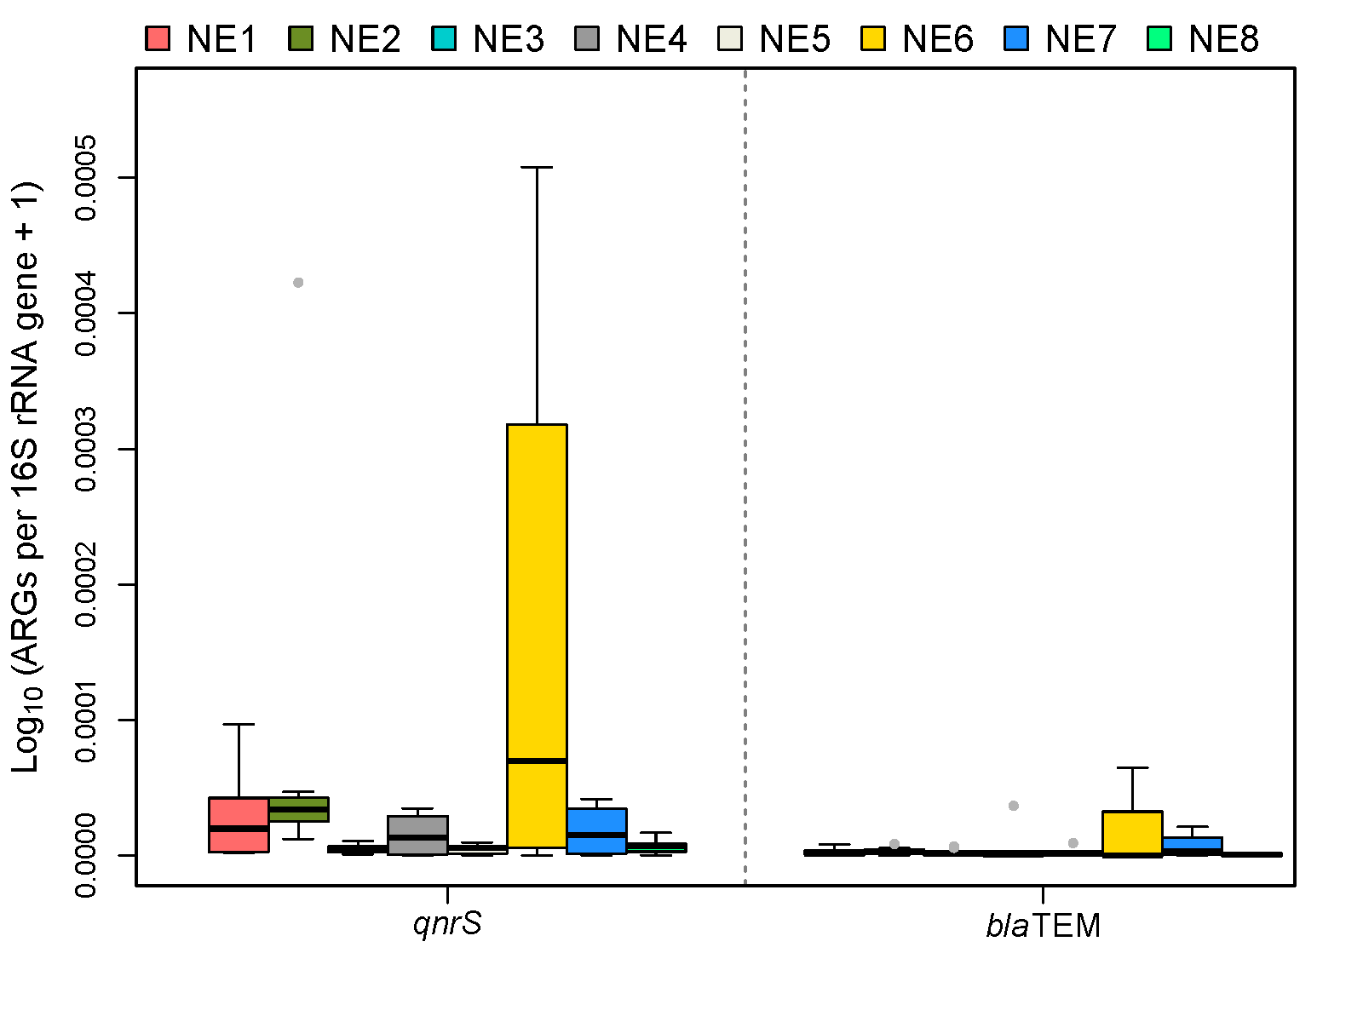
Figure S5. Comparison in log-transformed relative abundance of qnrS and blaTEM quantified using qPCR among eight different neighborhoods in Calgary, Canada.
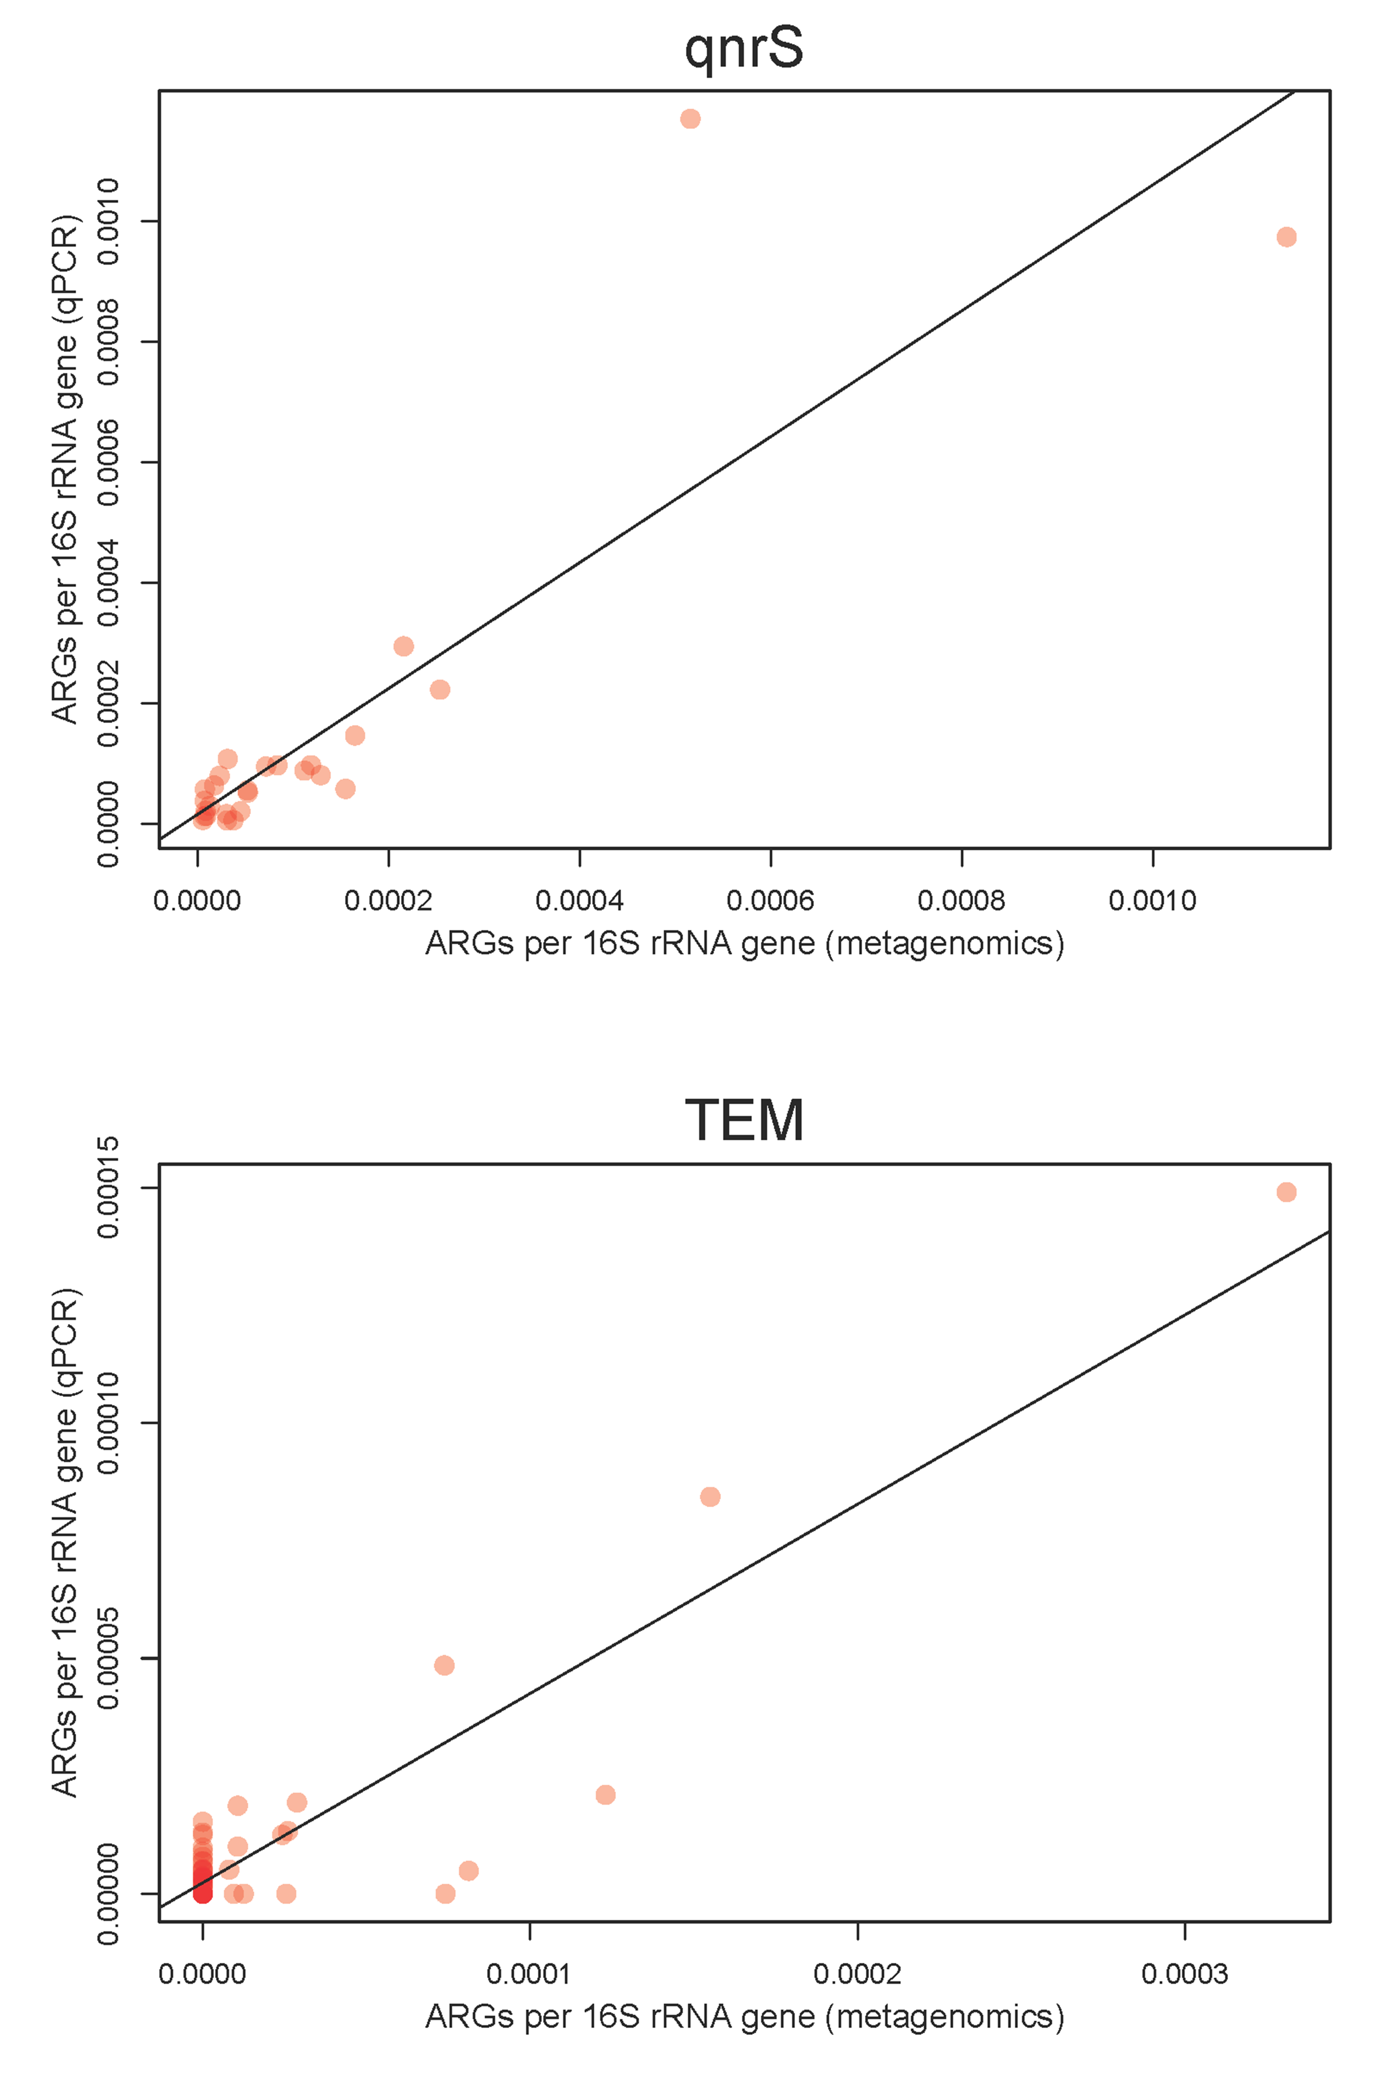
Figure S6. The association between metagenome and qPCR data for two selected ARGs (qnrS and TEM), exhibiting significant positive correlation (r=0.87 with p<0.0001 and 0.91 with p<0.0001, respectively). Trendlines (in black) were generated using linear model.
Figure S7. Global meta-analysis of the resistome relative to Calgary neighborhoods. (a) A map visualizing the distribution of cities from which wastewater was collected, with the corresponding country colored differently based on its Unemployment Rate, (b) Beta diversity calculations visualised by NMDS with colours and ellipses (standard deviation of ordination scores; 0.95 confidence limit) denoting upper, upper-middle, lower-middle and low quartile distributions for unemployment rate.
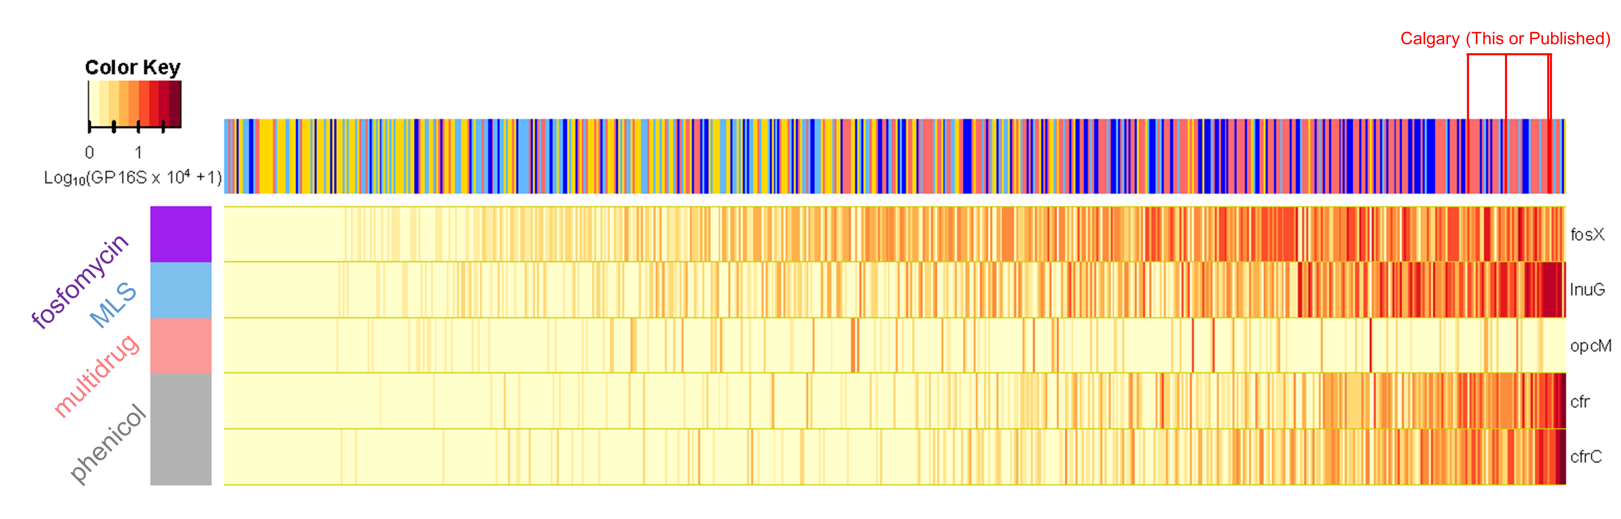
Figure S8. A heatmap for visualizing log-transformed relative abundance of ARGs that were positively associated with Calgary samples (disproportionally enriched within Calgary) in Fig. 6c. Unit : Log₁₀(Genes per 16S rRNA gene (GP16S) × 10⁴ + 1).

Figure S9. A heatmap for visualizing log-transformed relative abundance of ARGs that were negatively associated with Calgary samples (disproportionally diminished) in Fig. 6c. Unit : Log₁₀(Genes per 16S rRNA gene (GP16S) × 10⁴ + 1).

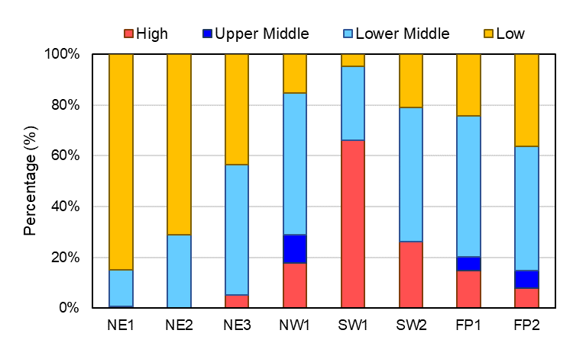
Figure S10. Income of country of birth (by Human Development Index) among the recent immigrant population in private households across neighborhoods in Calgary (data obtained from Statistics-Canada, 2023; https://www12.statcan.gc.ca/census-recensement/index-eng.cfm). Each country was categorized into four groups (See Fig. S12 for classification criteria) based on the Human Development Index.
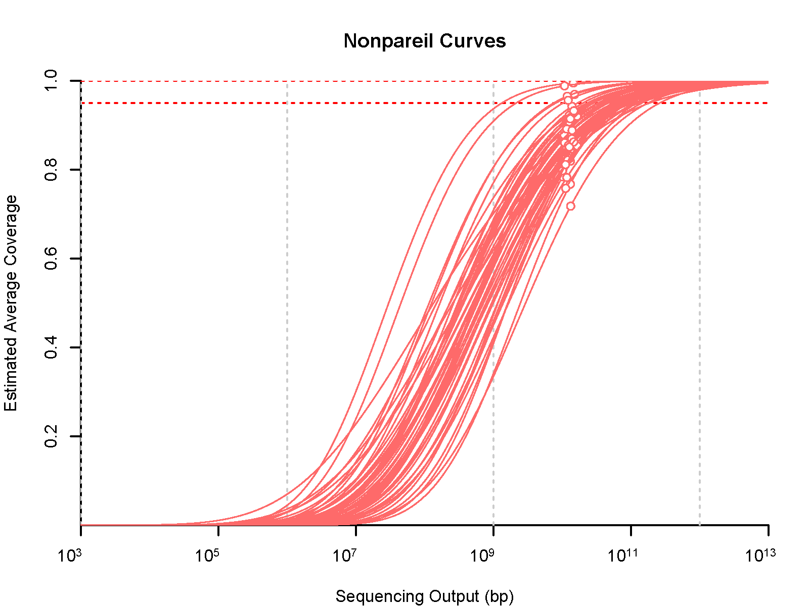
Figure S11. Estimated average coverage values for 53 sewage metagenomes, generated in this study. The symbol ‘ᴼ’ highlights the actual value for the estimated average coverage of each sample – any curve extending from this point was extrapolated using regression analysis, calculated using Nonpareil v3.303.
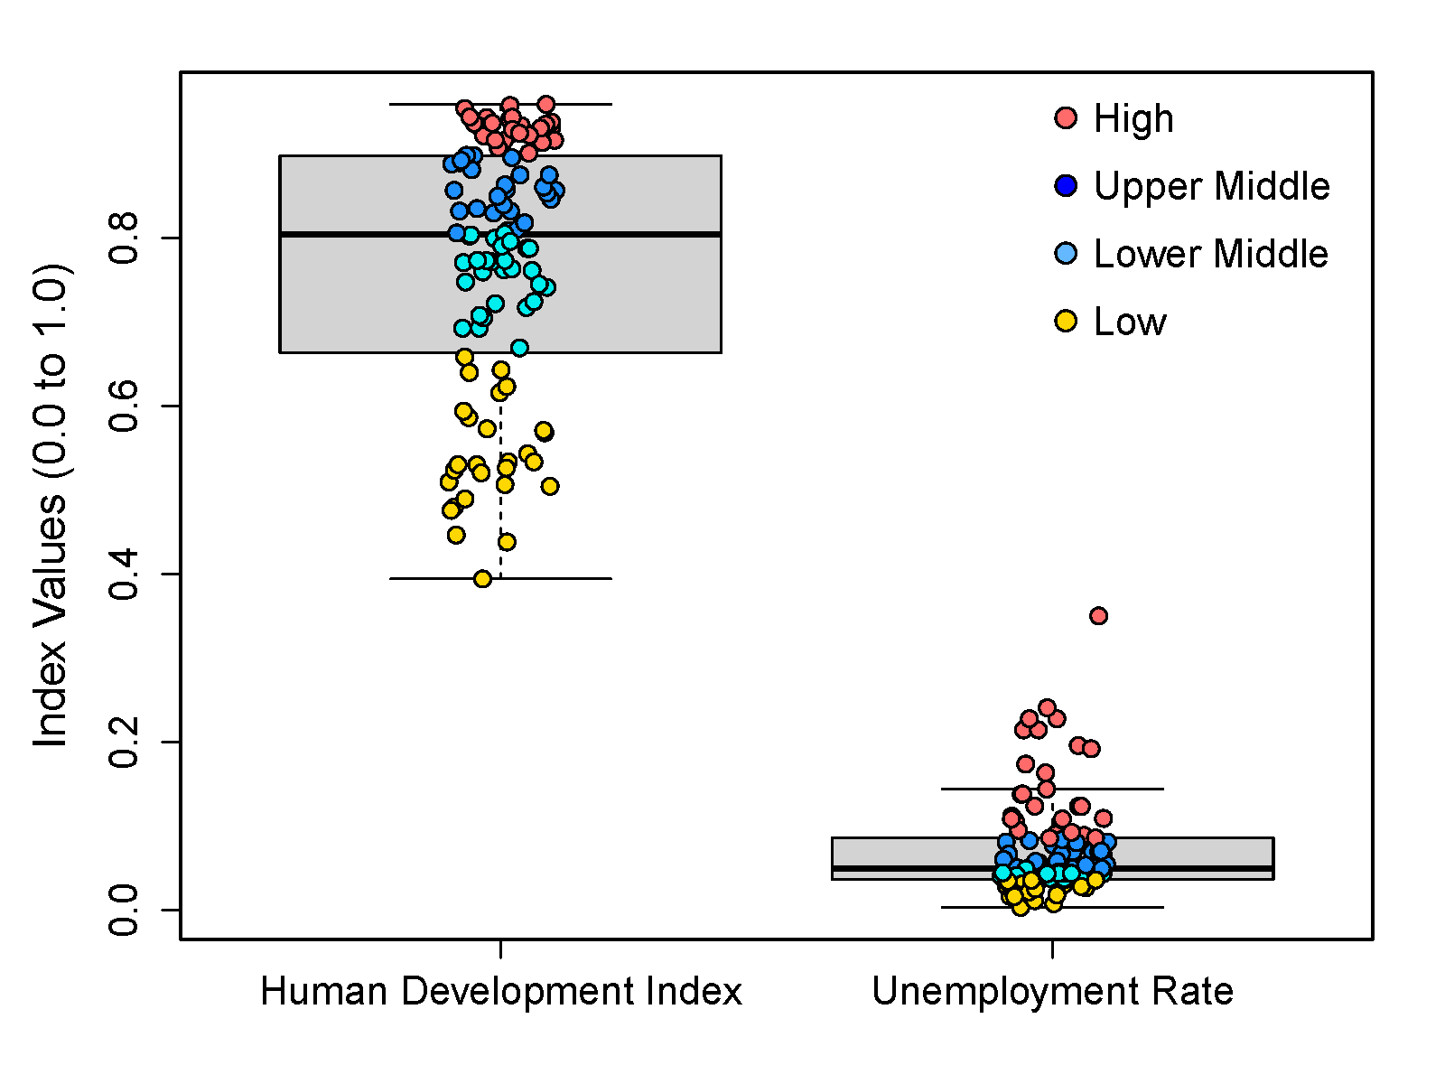
Figure S12. Human development index and unemployment rate values for the countries that were included in the global meta-analysis. The countries were categorized into four group within our sample list (n = 101 countries) – high, upper middle, lower middle, and low groups (25-26 countries per group).
Table S1. Pairwise Wilcoxon rank-sum test between neighborhoods in terms of arnA, bcrA, catQ, lnuD, blaOXA-11, taeA, tet32, and tetM that were analyzed by metagenomics. The pairs with p<0.05 were highlighted in red.
ARG-Subtype | Location | FP1 | FP2 | NE1 | NE2 | NE3 | NW1 | SW1
arnA | FP2 | 0.21 | - | - | - | - | - | -
arnA | NE1 | 0.04 | 0.25 | - | - | - | - | -
arnA | NE2 | 0.42 | 0.10 | 0.03 | - | - | - | -
arnA | NE3 | 0.04 | 0.07 | 0.83 | 0.02 | - | - | -
arnA | NW1 | 0.32 | 0.42 | 0.07 | 0.40 | 0.02 | - | -
arnA | SW1 | 0.83 | 0.04 | 0.02 | 0.40 | 0.02 | 0.12 | -
arnA | SW2 | 0.03 | 0.04 | 0.53 | 0.02 | 0.40 | 0.04 | 0.02
bcrA | FP2 | 0.21 | - | - | - | - | - | -
bcrA | NE1 | 0.21 | 0.96 | - | - | - | - | -
bcrA | NE2 | 0.33 | 0.74 | 0.77 | - | - | - | -
bcrA | NE3 | 0.10 | 0.21 | 0.26 | 0.02 | - | - | -
bcrA | NW1 | 0.74 | 0.85 | 0.85 | 0.97 | 0.29 | - | -
bcrA | SW1 | 0.74 | 0.85 | 0.85 | 0.97 | 0.21 | 1.00 | -
bcrA | SW2 | 0.74 | 0.85 | 1.00 | 0.74 | 0.74 | 0.97 | 0.85
catQ | FP2 | 0.21 | - | - | - | - | - | -
catQ | NE1 | 0.34 | 0.36 | - | - | - | - | -
catQ | NE2 | 0.18 | 0.04 | 0.04 | - | - | - | -
catQ | NE3 | 1.00 | 0.10 | 0.23 | 0.04 | - | - | -
catQ | NW1 | 0.95 | 0.14 | 0.18 | 0.17 | 0.56 | - | -
catQ | SW1 | 0.29 | 0.90 | 0.64 | 0.04 | 0.18 | 0.17 | -
catQ | SW2 | 0.30 | 0.95 | 0.76 | 0.06 | 0.17 | 0.21 | 0.90
lnuD | FP2 | 0.59 | - | - | - | - | - | -
lnuD | NE1 | 0.42 | 0.96 | - | - | - | - | -
lnuD | NE2 | 0.59 | 0.03 | 0.01 | - | - | - | -
lnuD | NE3 | 0.93 | 0.42 | 0.38 | 0.38 | - | - | -
lnuD | NW1 | 0.94 | 0.47 | 0.42 | 0.38 | 0.93 | - | -
lnuD | SW1 | 0.94 | 0.47 | 0.42 | 0.38 | 0.93 | 0.93 | -
lnuD | SW2 | 0.93 | 0.38 | 0.38 | 0.65 | 0.93 | 0.80 | 0.80
mdtB | FP2 | 0.42 | - | - | - | - | - | -
mdtB | NE1 | 0.19 | 0.62 | - | - | - | - | -
mdtB | NE2 | 1.00 | 0.19 | 0.04 | - | - | - | -
mdtB | NE3 | 0.42 | 0.87 | 0.62 | 0.19 | - | - | -
mdtB | NW1 | 0.94 | 0.47 | 0.12 | 0.79 | 0.33 | - | -
mdtB | SW1 | 0.87 | 0.68 | 0.42 | 0.79 | 0.42 | 0.90 | -
mdtB | SW2 | 0.42 | 0.87 | 0.68 | 0.19 | 0.90 | 0.42 | 0.79
blaOXA-11 | FP2 | 0.11 | - | - | - | - | - | -
blaOXA-11 | NE1 | 0.92 | 0.32 | - | - | - | - | -
blaOXA-11 | NE2 | 0.71 | 0.04 | 1.00 | - | - | - | -
blaOXA-11 | NE3 | 0.85 | 0.11 | 0.99 | 0.98 | - | - | -
blaOXA-11 | NW1 | 0.78 | 0.21 | 1.00 | 1.00 | 0.92 | - | -
blaOXA-11 | SW1 | 0.11 | 0.78 | 0.32 | 0.11 | 0.12 | 0.28 | -
blaOXA-11 | SW2 | 0.32 | 0.67 | 0.78 | 0.26 | 0.45 | 0.77 | 0.78
taeA | FP2 | 0.59 | - | - | - | - | - | -
taeA | NE1 | 0.43 | 0.59 | - | - | - | - | -
taeA | NE2 | 0.59 | 0.59 | 0.05 | - | - | - | -
taeA | NE3 | 1.00 | 0.83 | 0.32 | 0.88 | - | - | -
taeA | NW1 | 0.59 | 0.59 | 0.08 | 0.83 | 0.59 | - | -
taeA | SW1 | 0.91 | 0.59 | 0.22 | 0.59 | 1.00 | 0.59 | -
taeA | SW2 | 1.00 | 1.00 | 0.59 | 0.76 | 1.00 | 0.64 | -
tet32 | FP2 | 0.62 | - | - | - | - | - | -
tet32 | NE1 | 0.18 | 0.62 | - | - | - | - | -
tet32 | NE2 | 0.85 | 0.39 | 0.05 | - | - | - | -
tet32 | NE3 | 0.62 | 0.62 | 0.26 | 0.62 | - | - | -
tet32 | NW1 | 0.90 | 0.39 | 0.17 | 0.76 | 0.80 | - | -
tet32 | SW1 | 0.62 | 0.70 | 0.39 | 0.59 | 0.70 | 0.80 | -
tet32 | SW2 | 0.62 | 0.81 | 0.39 | 0.39 | 0.70 | 0.50 | 0.80
tetM | FP2 | 0.67 | - | - | - | - | - | -
tetM | NE1 | 0.35 | 0.91 | - | - | - | - | -
tetM | NE2 | 0.35 | 0.11 | 0.01 | - | - | - | -
tetM | NE3 | 0.97 | 0.36 | 0.21 | 0.35 | - | - | -
tetM | NW1 | 0.97 | 0.68 | 0.35 | 0.15 | 0.91 | - | -
tetM | SW1 | 0.91 | 0.55 | 0.35 | 0.97 | 0.91 | 0.68 | -
tetM | SW2 | 1.00 | 0.67 | 0.67 | 0.35 | 0.97 | 0.97 | 0.91

Table S2. Pairwise-ANOSIM and -PERMANOVA results for the entire resistome (see Fig. 4b).
Location1 | Location2 | ANOSIM |  | PERMANOVA
Location1 | Location2 | r | p-value | R2 | p-value
FP1 | FP2 | 0.16 | 0.32 | 0.17 | 0.24
FP1 | NE1 | 0.27 | 0.24 | 0.18 | 0.18
FP1 | NE2 | 0.02 | 0.52 | 0.04 | 0.80
FP1 | NE3 | 0.36 | 0.22 | 0.23 | 0.13
FP1 | NW1 | 0.03 | 0.47 | 0.13 | 0.52
FP1 | SW1 | -0.08 | 0.66 | 0.07 | 0.78
FP1 | SW2 | 0.17 | 0.32 | 0.25 | 0.24
FP2 | NE1 | -0.03 | 0.60 | 0.07 | 0.52
FP2 | NE2 | 0.05 | 0.35 | 0.12 | 0.24
FP2 | NE3 | 0.07 | 0.35 | 0.11 | 0.26
FP2 | NW1 | -0.07 | 0.74 | 0.10 | 0.53
FP2 | SW1 | 0.20 | 0.29 | 0.18 | 0.24
FP2 | SW2 | 0.21 | 0.30 | 0.16 | 0.32
NE1 | NE2 | 0.17 | 0.22 | 0.19 | 0.13
NE1 | NE3 | -0.03 | 0.60 | 0.04 | 0.61
NE1 | NW1 | 0.11 | 0.32 | 0.15 | 0.23
NE1 | SW1 | 0.31 | 0.22 | 0.22 | 0.13
NE1 | SW2 | -0.03 | 0.60 | 0.05 | 0.69
NE2 | NE3 | 0.21 | 0.22 | 0.22 | 0.13
NE2 | NW1 | -0.02 | 0.60 | 0.08 | 0.52
NE2 | SW1 | 0.09 | 0.32 | 0.06 | 0.61
NE2 | SW2 | 0.26 | 0.22 | 0.21 | 0.18
NE3 | NW1 | 0.22 | 0.24 | 0.20 | 0.13
NE3 | SW1 | 0.46 | 0.22 | 0.27 | 0.13
NE3 | SW2 | 0.10 | 0.35 | 0.08 | 0.52
NW1 | SW1 | 0.09 | 0.35 | 0.14 | 0.45
NW1 | SW2 | 0.28 | 0.29 | 0.24 | 0.24
SW1 | SW2 | 0.28 | 0.29 | 0.26 | 0.24

Table S3. Pairwise-ANOSIM and -PERMANOVA results for beta-lactam antibiotics genes (see Fig. 4c).
Location1 | Location2 | ANOSIM |  | PERMANOVA
Location1 | Location2 | r | p-value | R2 | p-value
FP1 | FP2 | 0.22 | 0.48 | 0.14 | 0.42
FP1 | NE1 | 0.21 | 0.48 | 0.09 | 0.42
FP1 | NE2 | 0.10 | 0.48 | 0.07 | 0.69
FP1 | NE3 | 0.36 | 0.48 | 0.13 | 0.42
FP1 | NW1 | 0.12 | 0.48 | 0.15 | 0.44
FP1 | SW1 | 0.14 | 0.48 | 0.16 | 0.42
FP1 | SW2 | 0.05 | 0.53 | 0.16 | 0.46
FP2 | NE1 | -0.02 | 0.64 | 0.07 | 0.48
FP2 | NE2 | 0.02 | 0.53 | 0.09 | 0.42
FP2 | NE3 | 0.07 | 0.48 | 0.10 | 0.42
FP2 | NW1 | -0.08 | 0.79 | 0.08 | 0.69
FP2 | SW1 | -0.12 | 0.91 | 0.07 | 0.84
FP2 | SW2 | 0.22 | 0.48 | 0.18 | 0.42
NE1 | NE2 | 0.06 | 0.48 | 0.08 | 0.42
NE1 | NE3 | -0.04 | 0.79 | 0.04 | 0.75
NE1 | NW1 | -0.07 | 0.79 | 0.06 | 0.69
NE1 | SW1 | -0.10 | 0.79 | 0.06 | 0.69
NE1 | SW2 | 0.02 | 0.53 | 0.09 | 0.44
NE2 | NE3 | 0.06 | 0.48 | 0.08 | 0.42
NE2 | NW1 | 0.05 | 0.48 | 0.11 | 0.42
NE2 | SW1 | 0.08 | 0.48 | 0.11 | 0.42
NE2 | SW2 | 0.11 | 0.48 | 0.12 | 0.42
NE3 | NW1 | -0.05 | 0.79 | 0.06 | 0.69
NE3 | SW1 | 0.06 | 0.48 | 0.09 | 0.44
NE3 | SW2 | 0.09 | 0.48 | 0.11 | 0.42
NW1 | SW1 | -0.10 | 0.79 | 0.08 | 0.69
NW1 | SW2 | 0.14 | 0.48 | 0.18 | 0.42
SW1 | SW2 | 0.17 | 0.48 | 0.17 | 0.42

Table S4. Pairwise-ANOSIM and -PERMANOVA results for beta-lactamases ARGs (see Fig. 4d).
Location1 | Location2 | ANOSIM |  | PERMANOVA
Location1 | Location2 | r | p-value | R2 | p-value
FP1 | FP2 | 0.09 | 0.64 | 0.12 | 0.62
FP1 | NE1 | -0.07 | 0.78 | 0.06 | 0.74
FP1 | NE2 | 0.10 | 0.64 | 0.09 | 0.62
FP1 | NE3 | 0.11 | 0.64 | 0.09 | 0.59
FP1 | NW1 | -0.11 | 0.88 | 0.08 | 0.91
FP1 | SW1 | 0.01 | 0.71 | 0.11 | 0.73
FP1 | SW2 | 0.09 | 0.64 | 0.17 | 0.59
FP2 | NE1 | -0.11 | 0.89 | 0.07 | 0.62
FP2 | NE2 | 0.09 | 0.64 | 0.11 | 0.53
FP2 | NE3 | -0.01 | 0.71 | 0.08 | 0.59
FP2 | NW1 | 0.01 | 0.71 | 0.10 | 0.65
FP2 | SW1 | -0.03 | 0.75 | 0.09 | 0.73
FP2 | SW2 | 0.31 | 0.64 | 0.17 | 0.53
NE1 | NE2 | 0.04 | 0.64 | 0.08 | 0.59
NE1 | NE3 | 0.00 | 0.71 | 0.07 | 0.59
NE1 | NW1 | -0.14 | 0.89 | 0.06 | 0.73
NE1 | SW1 | -0.15 | 0.89 | 0.08 | 0.59
NE1 | SW2 | -0.12 | 0.88 | 0.07 | 0.73
NE2 | NE3 | 0.04 | 0.64 | 0.07 | 0.59
NE2 | NW1 | -0.04 | 0.75 | 0.07 | 0.73
NE2 | SW1 | 0.00 | 0.71 | 0.10 | 0.59
NE2 | SW2 | 0.05 | 0.71 | 0.09 | 0.62
NE3 | NW1 | -0.01 | 0.71 | 0.06 | 0.73
NE3 | SW1 | 0.00 | 0.71 | 0.10 | 0.59
NE3 | SW2 | 0.12 | 0.64 | 0.11 | 0.59
NW1 | SW1 | -0.05 | 0.78 | 0.08 | 0.81
NW1 | SW2 | 0.18 | 0.64 | 0.16 | 0.59
SW1 | SW2 | 0.46 | 0.49 | 0.21 | 0.53

Table S5. Key quality parameters for qPCR standards in this study. LOQ denoted limit of quantification; NTC indicates non-template control.
Primer | Efficiency (%)  (min - max) | R²  (min - max) | Linear dynamic range (genes or copies per mL) | Ct of LOQ  (min - max) | Standard Deviation of Ct at LOQ  (min - max) | Ct of NTC | Number of runs
16S rRNA gene | 85.5 - 92.2 | 0.997 - 0.999 | 2.3 × 10⁴ - 1.4 × 10⁷ | 22.1 - 23.0 | 0.06 - 0.16 | 31.3 - 31.6 | 4
qnrS | 91.5 - 91.7 | 0.999 - 0.999 | 1.0 × 10¹ - 1.0 × 10⁸ | 33.7 - 35.1 | 0.22 - 0.45 | 39.7 - 40.7 | 2
blaTEM | 86.8 - 85.7 | 1.0 - 1.0 | 1.0 × 10¹ - 1.0 × 10⁸ | 34.5 - 35.0 | 0.05 - 0.33 | Not Detected | 2

