Supplementary File S1

An integrated recording device for the analysis of daily de external activity in colonies of highly eusocial bees
Arthur Roque Justino¹, Klaus Hartfelder^{1,2}
¹Departamento de Biologia Celular, Molecular e Bioagentes Patogênicos, Faculdade de Medicina de Ribeirão Preto, Universidade de São Paulo, Ribeirão Preto, SP, Brazil.
²Departamento de Genética, Faculdade de Medicina de Ribeirão Preto, Universidade de São Paulo, Ribeirão Preto, SP, Brazil.

E-mail adresses: a.roque0@usp.br, klaus@fmrp.usp.br
ORCID: Arthur Roque Justino, https://orcid.org/0000-0002-6820-0151; Klaus Hartfelder, https://orcid.org/0000-0001-7981-8427

Corresponding Author: Klaus Hartfelder, Departamento de Biologia Celular, Molecular e Bioagentes Patogênicos, Faculdade de Medicina de Ribeirão Preto - USP, Av. Bandeirantes 3900, 14049-900 Ribeirão Preto, SP, Brazil.
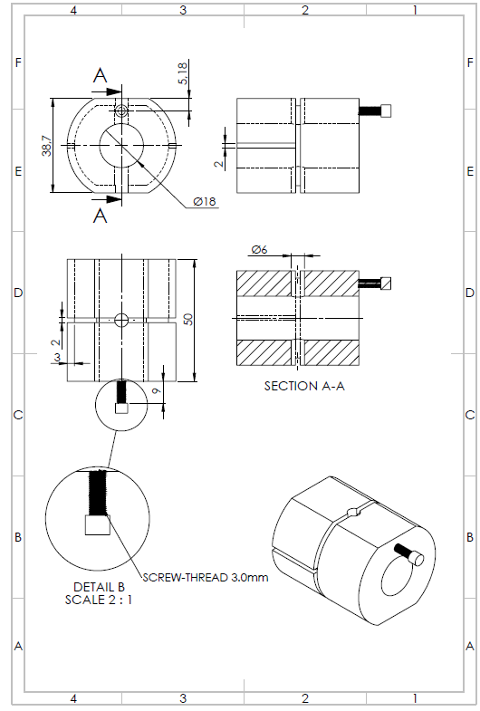
Technical representation of the detection block. The values indicate the actual measurements in mm of the device.

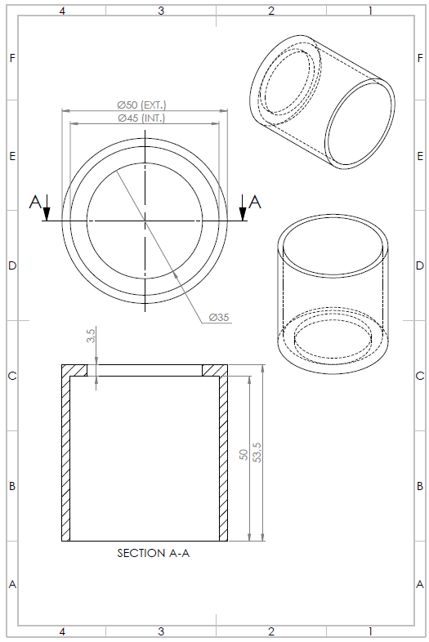
Technical design of the case used to protect the detection block. The values indicate the actual measurements in mm.
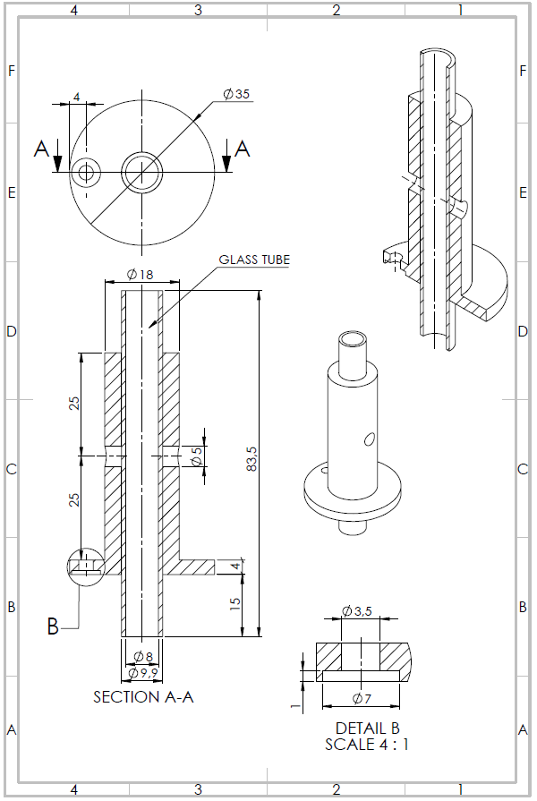
Technical design of the internal and external structure of an adapter tube for the passage of bees. The values indicate the actual measurements in mm. The internal measurement of the glass tube varies according to the species analyzed. The example shows the adapter tube used for recordings of Melipona quadrifasciata colonies.

