Supplementary File S2
An integrated recording device for comparative analysis of daily foraging activity in colonies of social bees
Arthur Roque Justino¹ , Klaus Hartfelder^{1,2}

¹ Departamento de Biologia Celular, Molecular e Bioagentes Patogênicos, Faculdade de Medicina de Ribeirão Preto, Universidade de São Paulo, Ribeirão Preto, SP, Brazil.
² Departamento de Genética, Faculdade de Medicina de Ribeirão Preto, Universidade de São Paulo, Universidade de São Paulo, Ribeirão Preto, SP, Brazil.

E-mail adresses: a.roque0@usp.br, klaus@fmrp.usp.br

Description
This project was developed in Arduino environment, to help scientists and interested parts to easily access the foraging and locomotor activity rhythms of bee colonies or similar, as well as the environmental conditions that might impact on these activities. The system is based on an IR emitter and IR receiver, and a HDC1080 module to record the environmental Temperature and Relative Humidity, both connected to an Arduino board. It is also a cheap alternative, with an average cost of US$ 60.00 per unity or less.

What is Arduino?
Arduino is an open-source electronics platform based on easy-to-use hardware and software. It can be used for different porpoises, by reading inputs and emitting output responses, e.g., reading voltage values, and summing the number of interruption events (in our case, the number of bees crossing the tube). Arduino programs is based on c/c++ languages, and have an Integrated Development Environment (IDE) for writing sketches, open files, download and manage libraries, etc.
For more information: https://www.arduino.cc/en/Guide/Introduction
Download the Arduino IDE: https://www.arduino.cc/en/software
Necessary material:
- Arduino board. For this project we used an Arduino UNO R3 board.
- USB cable for Arduino
- Electronic wires
- HDC1080 High Accuracy Digital Humidity Sensor
- Pushbutton
- TIL32 (Emitter)
- TIL78 (Phototransistor)
- 2.7 kΩ Resistor
- 220 Ω Resistor
- 10 kΩ Resistor
- Transparent glass tubes

Building the sensor
The structure of the sensor was machined using a black polyethylene block adapted to hold the glass tube and the IR emitter and IR receiver, as seen in the photograph below. We also designed a case to involve the sensor containing the IRs, and the wires so it could be protected from any damages. Also, we projected the adaptable tubes that can be changed according to the size of the insect of interest. In our analysis, we used tubes with internal diameters of 5 mm for Friesomelitta varia, 8 mm for Melipona quadrifasciata, and 10 mm for Apis mellifera. The tube allows the passage of just one bee at a time, thus preventing multiple bees from crossing the IR emitter-receiver simultaneously and being counted as just one event.
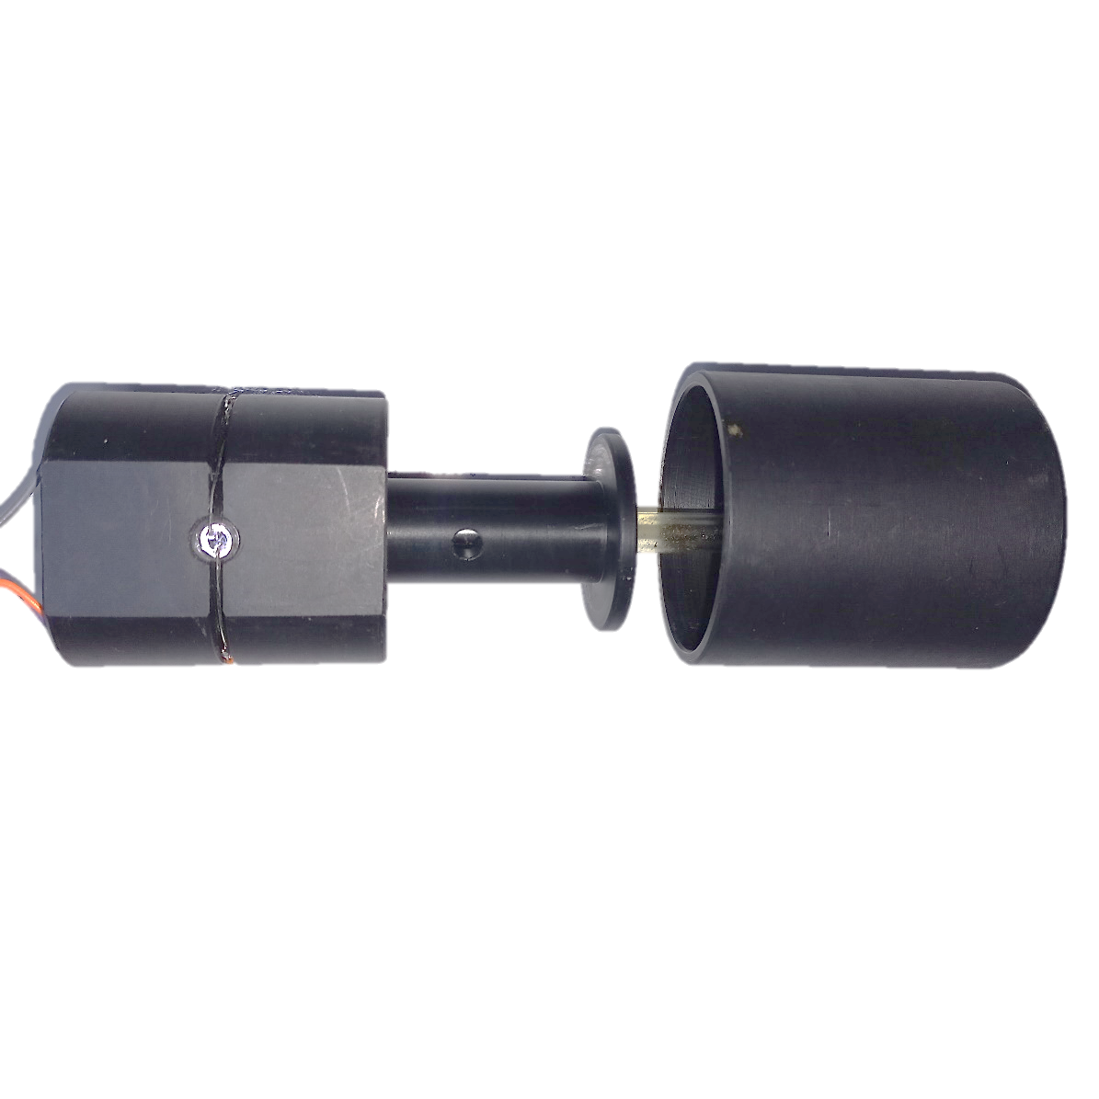
The electronic circuitry of the sensor is shown in the image below.
In case the Arduino board acquired has the SCL and SDA Pins, the respective wires from the module HDC1080 can be connected directly to it. If not, the Analog Pins A4 and A5 can be used as the SCL and SDA pins, respectively.

The Sketch
The sketch written for this program is available below. It is based on an analog input that reads values of voltages constantly and takes the average. If the difference between the average value and the immediately previous measure >= delta (z_ant - mz >= delta), 1 event is counted and added to the “es” variable. “delta” is used to establish the threshold for the count. Values <= 30 are considered false positives, and values > 300 are considered false negatives. The measurements are taken during a constant interval, established by the variable “tz”, which is defined by a millis() function.
At the end of the function “flow()”, which is the subroutine that registers the counting of the bees’ passage, a new subroutine “t_u” is started, which registers the correspondent values for the environmental Temperature (°C) and Relative Humidity (%). Once both subroutines are finished, “tz” is equaled to the time elapsed since the beginning of the program “millis()” (tz = millis ()), and the function “loop()” is restarted. Alternatively, it can also be equaled to 0.

/* Sketch for the integrated system of bee counting and recording of Temperature and Relative Humidity using an Arduino board.
* The program counts the total of bees that enter or leaves the colony at a specified interval. It also records the environmental temperature and Relative Humidity simultaneously.
* The program counts the events of bee's entries or exits through transitions of high voltage to low voltage. Also, it has a lock to avoid multiple counts.
* The interval is stablished through the millis() function. So once the interval determined is reached, a new measure starts.
* Before starting the score, the program checks the transparency of the tube, and shows in the screen: Good, Average, and Low.
* The transparency is measured in 10 steps; in case any bees are transiting through the tube.
* At the end of the setup(), it is possible to write down the day and the hour the experiment started, before upload the sketch.
* The exit of the flow recording device must be connected to the analog pin A0 from the Arduino UNO board.
* The program for the HDC1080 must be obtained from the Arduino Library: <ClosedCube_HDC1080.h>
*
*//

#define ea A0 // define the Input pin A0 as the analog input, according to the Circuit diagram.
#include <Wire.h>
#include <ClosedCube_HDC1080.h>
ClosedCube_HDC1080 hdc1080;

// Defining variables and pins. Established names are not fixed and may be changed according to personal preferences.
int es = 0; // variable that update the number of interruptions by bee crossing events during an established interval.
long sv = 0; //Records the number of valueless events which, when analyzed, do not register any event.
int z = 0; // variable that registers the momentary voltage of the sensor. Values range from 0 to 1023 after A/D conversion.
long zz = 0; // Records the total of "z" to obtain the average voltage. The average represents the most stable value of the momentary voltage.
int z_ant = 0; // Variable that registers the average value of the immediate-ly preceding "moment".
int i = 0; // index for the "for" loop which limits the sum of "z". The maxi-mum value of "i" must me assigned in the "for" loops in the setup() and in the loop().
unsigned long tz = millis (); // the tz variable establishes the duration of the interval in milliseconds. 1 second = 1000 ms. 60 s = 60000 ms, etc.
int np = 0; // Variable that records the sequency of periods with flows shown.
const int stop = 8; // Pushbutton to interrupt the counts if HIGH. Its presence is optional.
const int delta = 30; // This variable is used to establish the threshold for the count. Values <= 30 are considered false positives, and values > 300 are considered false negatives.

void setup ()
{
Serial.begin(9600); // Open the serial port at 9600 bps.
hdc1080.begin(0x40); // Initialize the HDC1080 module in the address 0x40.

for (int t=0; t<10;t++) // Tests the transparency of the tube 10 times before start the count.
{
z=0;
zz=0;
for (i=0; i<=99; i=i+1)
{
z = analogRead(ea);
zz=zz+z;
}
mz=mz/100; // Average the readings and record in "mz". Denominator depends on the value established in the "for" loop.

if (mz<100) { // If the value read is less than 100.
Serial.println ("High transparency"); // Prints on screen.
Serial.print ("Digital voltage 0-1023= ");Serial.println (mz); // Prints on screen.
Serial.println (" ");
delay (1000);
}
if (mz > 300) { // If the value read is less than 300.
Serial.println ("Low transparency"); // Prints on screen.
Serial.print ("Digital voltage 0-1023 = "); Serial.println (mz); // Prints on screen.
Serial.println (" ");
delay (1000);
}
if (mz < 300 && mz > 100) { // If the value read is greater than 1000 and less than 300.
Serial.println ("Average transparency"); // Prints on screen.
Serial.print ("Digital voltage 0-1023 = "); Serial.println (mz); // Prints on screen.
Serial.println (" ");
delay (1000);
}
}

Serial.println ("Date: DD-MM-YYYY. Time: HH:MM - Information about the colony analyzed");
Serial.println (" "); Serial.println (" "); Serial.println (" ");
Serial.print("NP,"); Serial.print ("Flow,"); Serial.print("Temperature (ºC),"); Serial.println ("Humidity (%),"); // Heading. "," signals are inserted so the data can be read as a CSV table.

// Wait to start the counting.
}
void loop()
{
z=0;
zz=0;
for(i=0;i<=99;i=i+1)
{
z=analogRead(ea);
zz=zz+z;
}
mz=zz/100; // Average the readings and record in "mz". Denominator depends on the value established in the "for" loop.
if(z_ant - mz >= delta) // "delta" value must be defined considering the aver-age time spent by the bees to cross the tube.
{
es=es+1; // Sums an "es" event if the voltage in the sensor is decreasing, i.e., the bee finished crossing the tube.
while (mz > delta) // lock the count until mz is sufficiently low.
{
zz=0;
for(i=0;i<=9;i=i+1)
{
z=analogRead(ea);
zz=zz+z;
}
mz=zz/10; //Average the readings.
}
}

else
{
sv=sv+1; // Sums an "sv" value just to equal time spent in incrementing "es".
}
z_ant=mz; //Keeps memory of the voltage value of the last reading.

if (millis() - tz >= 60000*10) // calculates the difference between the time elapsed since the beginning of the loop and the time of the previous period.
{
flow();
}
}
// Subroutines
void flow() // prints on the screen and return to loop().

{
Serial.print(","); Serial.print(np); Serial.print (","); // Use this line if convenient.
Serial.print (es);Serial.print (","); // Prints on screen the total of bee crossing events recorded in the last period.
es=0; // reset the values of "es" recorded to start a new count.
np=np+1; // It increments the annotated period indicator.
t_u(); // Measure the Temperature and Humidity.
}

void t_u()
{
float t = hdc1080.readTemperature(); // Read the values of Temperature.
float h = hdc1080.readHumidity(); // Read the values of Relative Humidity.
Serial.print(t);
Serial.print (",");
Serial.println(h);
tz = millis (); // update the elapsed "tz" to start the next count --- tz = millis().
loop (); // Return to loop() do start counting the events in the next period.

void end() // Interrupt the program.
{
for (int f=0; f <30000; f++) // Keeps the program locked in this loop.
{
}
}

Data analysis
Once the Sketch is uploaded from the IDE to the Board, the measurements can be seen through the Serial Monitor. In order to avoid loss of the data, and to adapt it to an adequate file for the subsequent analysis, we suggest here the use of the software PuTTy (https://putty.org/). PuTTy is an open-source software that can be used to replace the Arduino IDE, and save data printed in specific formats, e.g., CSV tables, txt files, etc. Its application is intuitive, i.e., the communication port (COM) used for PuTTy must be the same used by the Arduino Board, and the output to be printed must be selected, as well as the file name and format.
Once the data is ready, the software for the analysis can be of your preference. For the current manuscript we used the ActogramJ (https://bene51.github.io/ActogramJ/index.html) plugin at Image J, and the R package lomb (https://www.rdocumentation.org/packages/lomb/versions/2.1.0) to create the actograms and perform statistical analysis.

Final remarks
To avoid loss of data, be careful with the wiring setup, and be sure that all wires are correctly connected to their respective Arduino pin. In the absence of a computer or in case of usage for field colonies monitoring, the Arduino board can also be connected directly to a power cable for electrical supply, and an SD module can be used for data storing, conditioned to necessary adaptations in the sketch. Make sure to not expose the system to moisture.
For further information or questions, please contact the authors.

