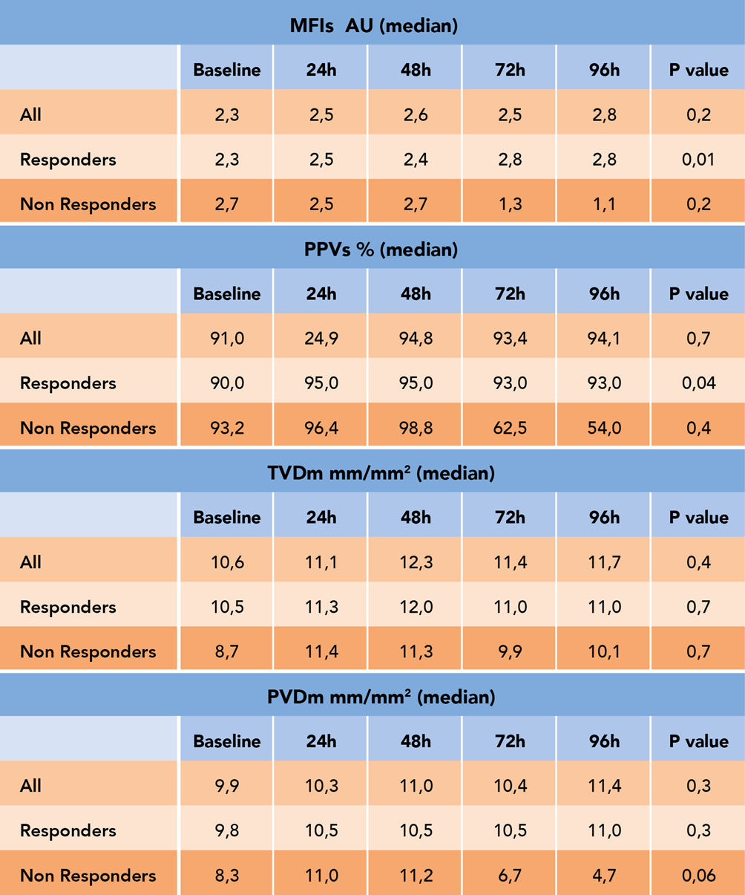
Table 2. Median data of microcirculatory parameters for small vessels (< 20 µm) of mean flow index (MFI) and proportion of perfused vessels (PPV) and for medium average vessels (large and small vessels) for total small vessel density (TVD) and perfused microvascular density (PVD) in all, in responders and non responders patients at different time points. Baseline: before the onset of blood purification (BP); 24 hours from the onset of BP (24 h); 48 hours from the onset of BP (48 h); 72 hours from the onset of BP (72 h); 96 hours from the onset of BP (96 h).

