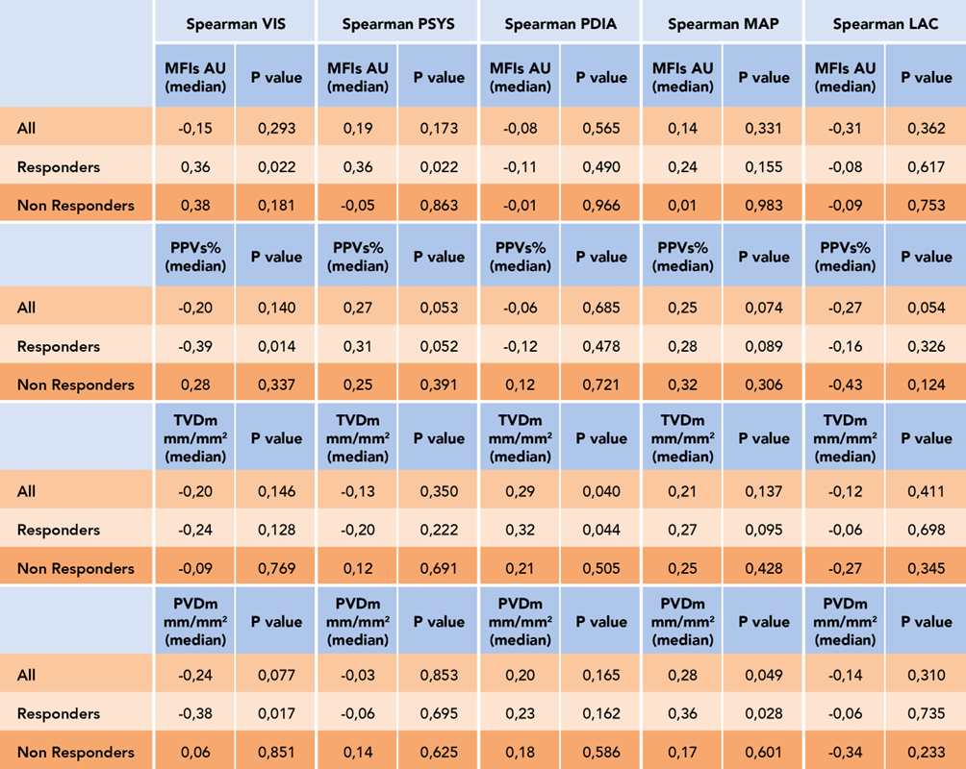
Table 4. Spearman correlation in our cohort between Systolic Blood Pressure (SBP), Diastolic Blood Pressure (DBP), Mean Arterial Pressure (MAP), Vaso-inotropic Score (VIS), Lactate (LAC) with mean flow index (MFI) and proportion of perfused vessels (PPV) and for medium average vessels (large and small vessels) for total small vessel density (TVD) and perfused microvascular density (PVD) in all, in responders and no responders patients.

