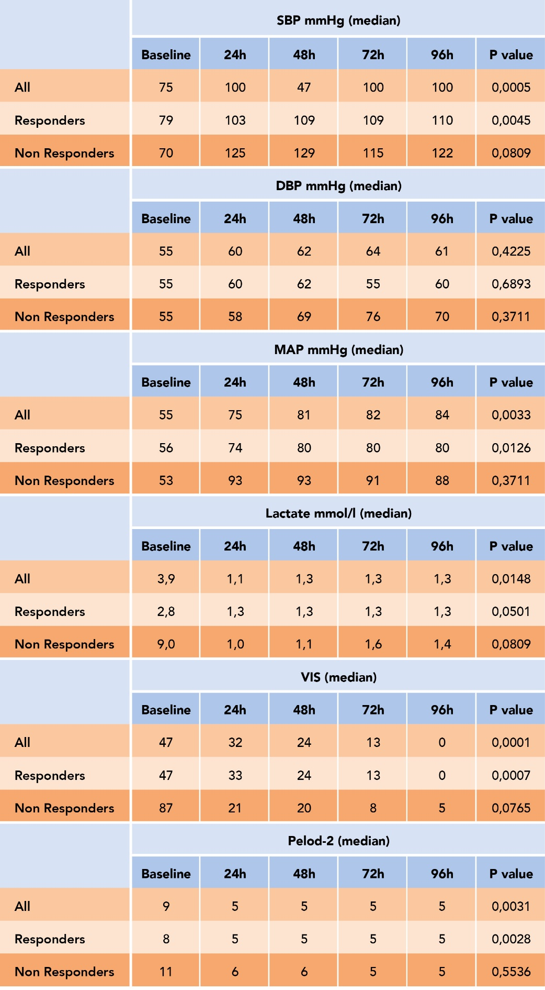
Table 3. Median data (interquartile ranges) of hemodynamic variables: Systolic Blood Pressure (SBP), Diastolic Blood Pressure (DPB), Mean Blood Pressure (MAP); Lactate, Vasoactive Inotropic Score (VIS) and Pediatric Logistic Organ Dysfunction 2 (PELOD-2) in all, in responders and no responders patients at different time points. Baseline: before the onset of blood purification (BP); 24 hours from the onset of BP (24 h); 48 hours from the onset of BP (48 h); 72 hours from the onset of BP (72 h); 96 hours from the onset of BP (96 h).

