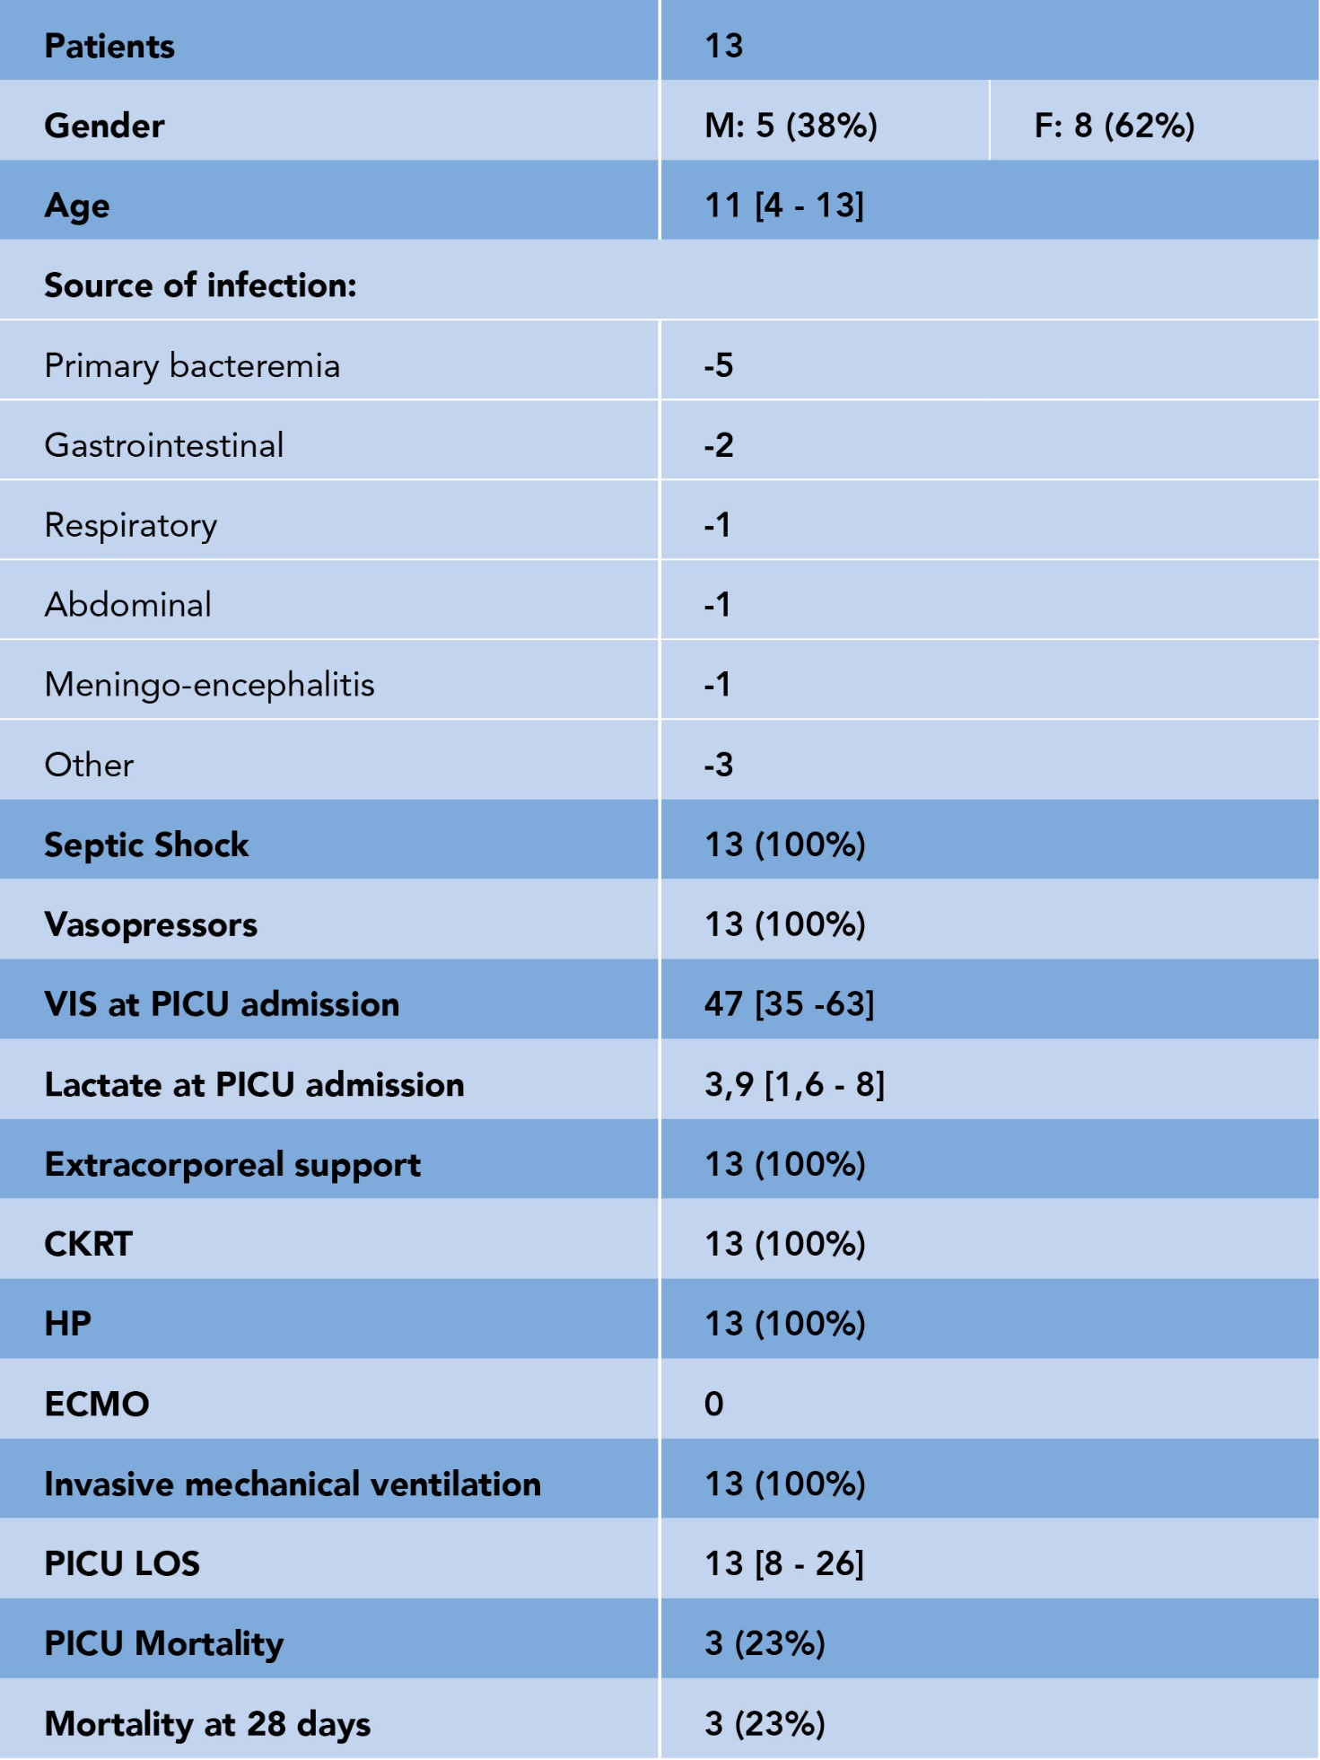
Table 1. Demographic and clinical characteristics at PICU admission and outcome of the study population.

T

