Biological characterization and clinical value of PLOD gene family in clear cell renal cell carcinoma

Xuan Shang^{1,†}, Liu Liu^{1,†}, Min Yan¹, Rui-Min Ren², Ke-Xin Guo¹, Jia-Song Chang¹, Jia-Lei Li¹, Jie Wang¹, Li-Juan Gao^{1,*}, Ji-Min Cao^{1,*}

¹ Key Laboratory of Cellular Physiology at Shanxi Medical University, Ministry of Education, and the Department of Physiology, Shanxi Medical University, Taiyuan 030001, China
²Department of Urology, Shanxi Bethune Hospital (Third Hospital of Shanxi Medical University), Taiyuan 030001, China

† These authors contributed equally to this work.
* Correspondence:
Ji-Min Cao, MD, PhD. Department of Physiology, Shanxi Medical University, Taiyuan, Shanxi 030001, P. R. China. Email: caojimin@sxmu.edu.cn. ORCID: 0000-0002-6546-555X
Li-Juan Gao. MS. Department of Physiology, Shanxi Medical University, Taiyuan, Shanxi 030001, P. R. China. Email: gaolijuan@sxmu.edu.cn. ORCID: 0000-0002-2274-8445

Supplementary Table 1. The top 50 genes most relevant to the PLOD gene family
Predicted Functional Partners | Score | Predicted Functional Partners | Score | Predicted Functional Partners | Score | Predicted Functional Partners | Score | Predicted Functional Partners | Score
COL5A2 | 0.982 | P4HA2 | 0.92 | COLGALT2 | 0.671 | COL13A1 | 0.539 | COL4A1 | 0.487
COL1A2 | 0.977 | P4HA1 | 0.909 | COL4A2 | 0.665 | COLQ | 0.536 | COL6A3 | 0.478
COL5A1 | 0.972 | EHMT2 | 0.867 | COLGALT1 | 0.627 | COL25A1 | 0.53 | COL15A1 | 0.473
COL1A1 | 0.97 | CAMKMT | 0.867 | IFITM5 | 0.607 | COL4A6 | 0.53 | COL12A1 | 0.472
COL3A1 | 0.967 | SETD7 | 0.854 | COL7A1 | 0.606 | COL22A1 | 0.525 | COL6A6 | 0.453
COL27A1 | 0.949 | SETD8 | 0.818 | COL26A1 | 0.597 | TMEM38B | 0.522 | COL18A1 | 0.438
COL11A1 | 0.946 | FKBP10 | 0.773 | COL9A3 | 0.56 | COL6A2 | 0.5 | COL20A1 | 0.427
ADAMTS2 | 0.946 | NSD1 | 0.76 | COL9A2 | 0.554 | COL14A1 | 0.496 | COL17A1 | 0.413
COL2A1 | 0.945 | CRTAP | 0.744 | KDM1A | 0.546 | COL8A2 | 0.491 | COL8A1 | 0.411
COL5A3 | 0.934 | LEPRE1 | 0.701 | COL4A5 | 0.543 | COL6A1 | 0.488 | COL16A1 | 0.402

Supplementary Table 2. GO analysis of the top 50 genes closely related to PLOD gene family
Category | Term | Description | LogP | Symbols
MF | GO:0030020 | extracellular matrix structural constituent conferring tensile strength | -75.2448 | COL1A1, COL2A1, COL3A1, COL4A1, COL4A2, COL4A5, COL4A6, COL5A1, COL5A2, COL6A1, COL6A2, COL6A3, COL7A1, COL8A1, COL8A2, COL9A2, COL9A3, COL11A1, COL12A1, COL13A1, COL15A1, COL16A1, COL17A1, COL14A1, COL5A3, COL18A1, COL25A1, COL27A1, COL6A6, COLQ, COL20A1, COL26A1, COL22A1, P4HA1, P4HA2, PLOD3, CRTAP, COLGALT2, FKBP10, P3H1, COLGALT1, TMEM38B
CC | GO:0098644 | complex of collagen trimers | -37.5008 | COL1A1, COL2A1, COL3A1, COL4A1, COL4A2, COL4A5, COL4A6, COL5A1, COL5A2, COL7A1, COL8A1, COL11A1, COL16A1, COL5A3, COL27A1, COL8A2
BP | GO:0030199 | collagen fibril organization | -32.0638 | COL1A1, COL2A1, COL3A1, COL5A1, COL5A2, COL11A1, COL12A1, COL13A1, P4HA1, COL14A1, PLOD3, CRTAP, COLGALT2, COL5A3, FKBP10, COLGALT1
CC | GO:0005604 | basement membrane | -23.3994 | COL2A1, COL4A1, COL4A2, COL4A5, COL4A6, COL5A1, COL7A1, COL8A1, COL8A2, COL9A3, COL15A1, COL17A1, COLQ, COL18A1, COL1A1, COL3A1, FKBP10, COL22A1, PLOD3, TMEM38B
BP | GO:0018126 | protein hydroxylation | -16.1679 | P4HA1, PLOD1, PLOD2, P4HA2, PLOD3, CRTAP, FKBP10, P3H1, KDM1A
CC | GO:0098651 | basement membrane collagen trimer | -14.8985 | COL4A1, COL4A2, COL4A5, COL4A6, COL8A1, COL15A1, COL1A1, COLQ, COL3A1, COL17A1
MF | GO:0048407 | platelet-derived growth factor binding | -14.1593 | COL1A1, COL2A1, COL3A1, COL4A1, COL5A1, COL6A1, COL4A6, COL5A2, COL16A1, EHMT2, KDM1A, TMEM38B, COL4A2, FKBP10
CC | GO:0005593 | FACIT collagen trimer | -13.2169 | COL9A2, COL9A3, COL12A1, COL16A1, COL14A1, COL7A1
BP | GO:0035987 | endodermal cell differentiation | -10.1873 | COL4A2, COL6A1, COL7A1, COL8A1, COL11A1, COL12A1, COL2A1
BP | GO:0001501 | skeletal system development | -9.2737 | COL1A1, COL2A1, COL3A1, COL5A2, COL9A2, COL11A1, COL13A1, TMEM38B, P3H1, COL27A1, IFITM5, COL6A1, COL5A1, COL18A1
MF | GO:0005518 | collagen binding | -8.8156 | COL6A1, COL6A2, COL14A1, CRTAP, COL5A3, P3H1, COL6A3
MF | GO:0050211 | procollagen galactosyltransferase activity | -8.3695 | PLOD3, COLGALT2, COLGALT1
BP | GO:0018205 | peptidyl-lysine modification | -7.4243 | PLOD1, PLOD2, PLOD3, EHMT2, FKBP10, NSD1, SETD7, KMT5A, KDM1A
MF | GO:0008201 | heparin binding | -6.4236 | COL5A1, COL11A1, COL13A1, COLQ, COL5A3, COL25A1, COL3A1, COL17A1
BP | GO:0032963 | collagen metabolic process | -5.5783 | COL1A1, COL5A1, PLOD3, P3H1
BP | GO:0085029 | extracellular matrix assembly | -4.6478 | COL3A1, PLOD3, FKBP10, COL1A1, COL2A1, COL11A1, IFITM5, COL4A1, COL5A1, TMEM38B
BP | GO:0035265 | organ growth | -3.4315 | EHMT2, TMEM38B, COL27A1, COL1A1, IFITM5, KDM1A, COL3A1
BP | GO:0010810 | regulation of cell-substrate adhesion | -3.3288 | COL1A1, COL8A1, COL16A1, COL26A1
BP | GO:0008544 | epidermis development | -2.7982 | COL7A1, COL17A1, PLOD1, PLOD3
BP | GO:0061061 | muscle structure development | -2.0762 | COL3A1, COL6A3, COL11A1, KDM1A

Supplementary Table 3. KEGG pathway analysis of the top 50 genes closely related to PLOD gene family
Term | Description | LogP | Symbols
hsa04974 | Protein digestion and absorption | -68.04737 | COL1A1, COL2A1, COL3A1, COL4A1, COL4A2, COL4A5, COL4A6, COL5A1, COL5A2, COL6A1, COL6A2, COL6A3, COL7A1, COL8A1, COL8A2, COL9A2, COL9A3, COL11A1, COL12A1, COL13A1, COL15A1, COL16A1, COL17A1, COL14A1, COL5A3, COL20A1, COL18A1, COL25A1, COL27A1, COL6A6, COL26A1, COL22A1
hsa04512 | ECM-receptor interaction | -19.72010 | COL1A1, COL2A1, COL4A1, COL4A2, COL4A5, COL4A6, COL6A1, COL6A2, COL6A3, COL9A2, COL9A3, COL6A6, COL3A1
hsa00310 | Lysine degradation | -15.01518 | PLOD1, PLOD2, PLOD3, EHMT2, COLGALT2, NSD1, COLGALT1, SETD7, KMT5A

Supplementary Figures
Supplementary Figure 1. The co-expressed TFs that regulate the expressions of PLOD1, PLOD2, PLOD3. Data were mined from GeneCards and hTFtarget databases.
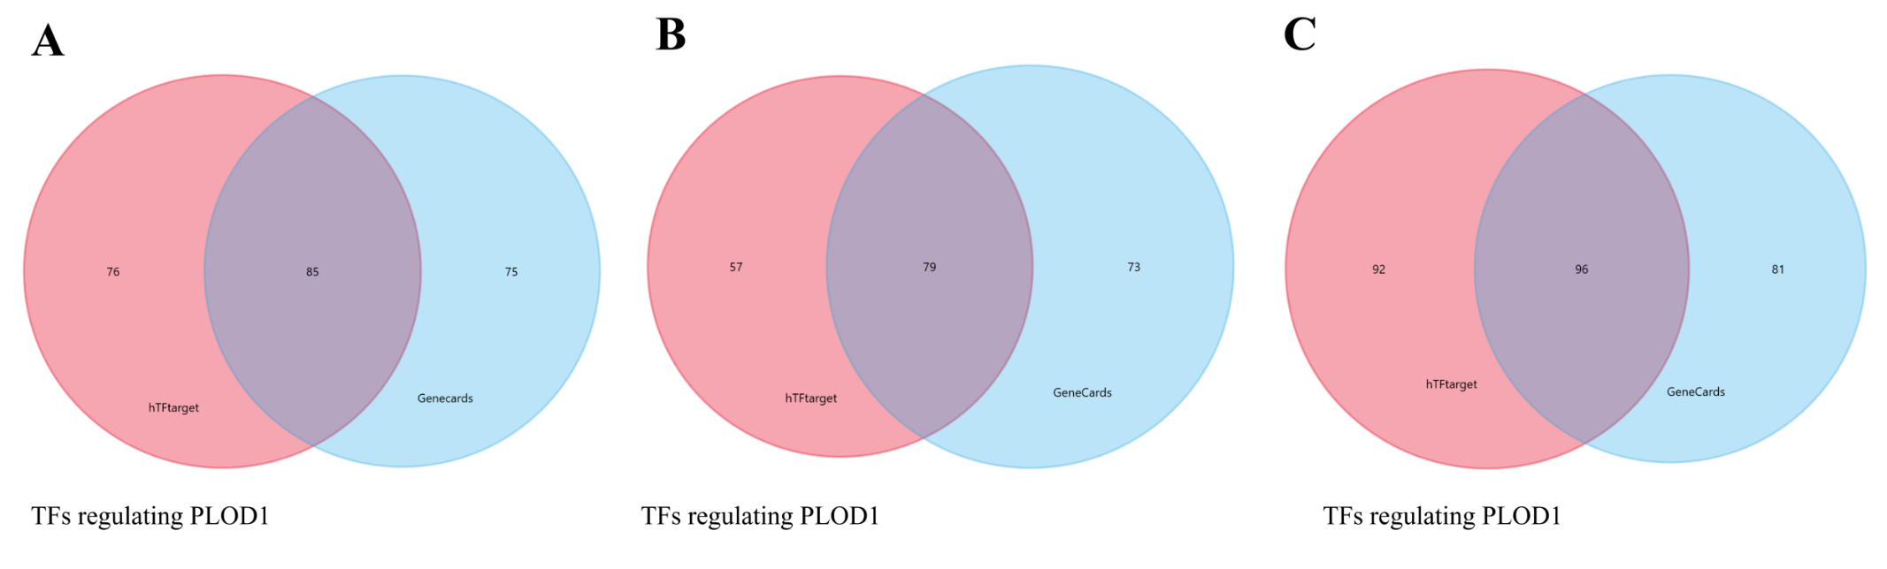

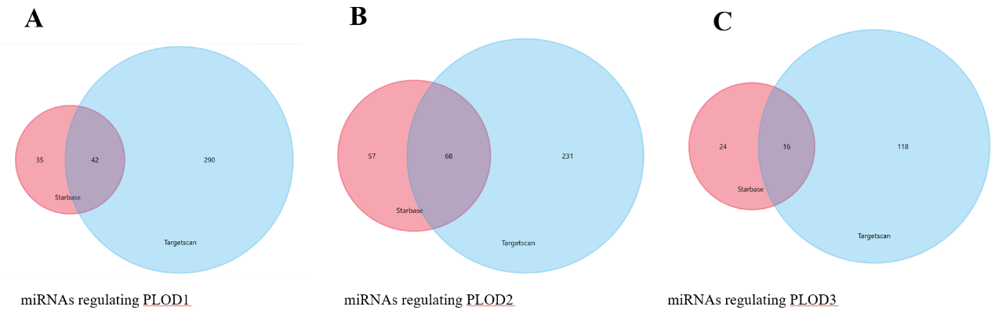
Supplementary Figure 2. The co-expressed miRNAs that regulate the expressions of PLOD1, PLOD2, PLOD3. Data were mined from Starbase and Targetscan databases.

