Supplementary material
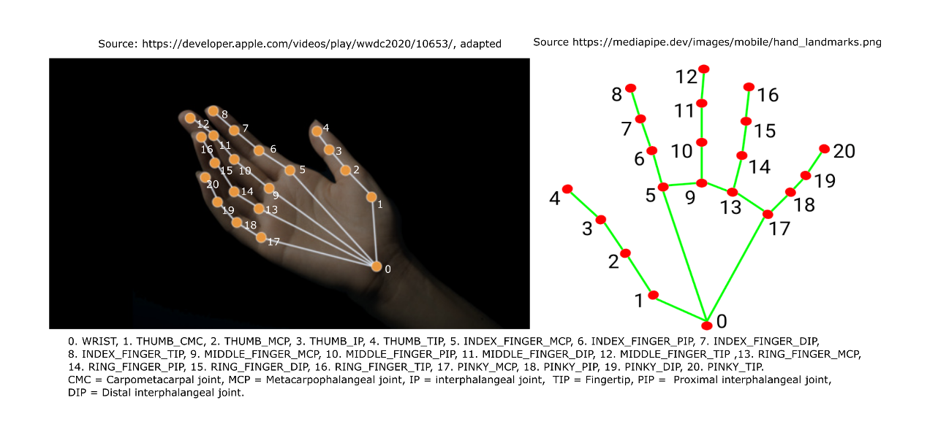
Supplementary Figure 1. This figure shows the 21 tracked points by VI (left) and MP (right). For both frameworks the tracked landmarks where the same. VI returned x/y positions relative to the frames’ width and height, MP x/y/z positions normalized to the frames’ and height as well as x/y/z positions in estimated world coordinates.

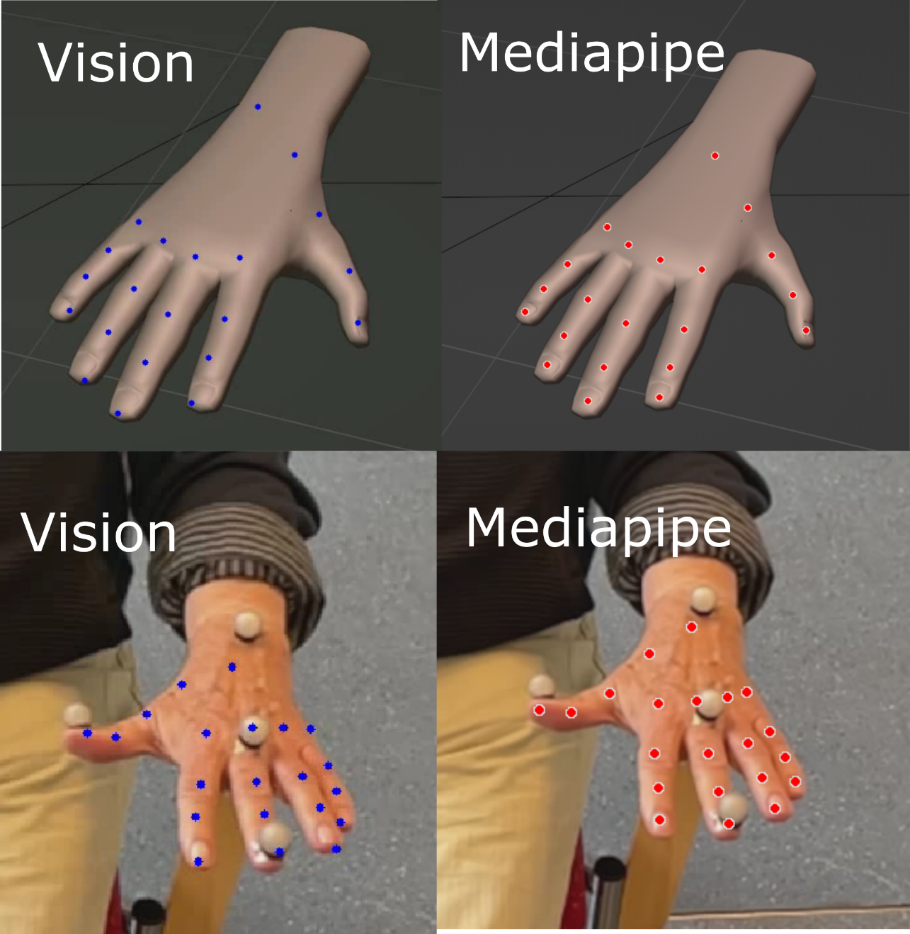
Supplementary Figure 2. Example of qualitative tracking results of VI and MP for simulated and real data. The OMC markers did not interfere severely with the tracking.

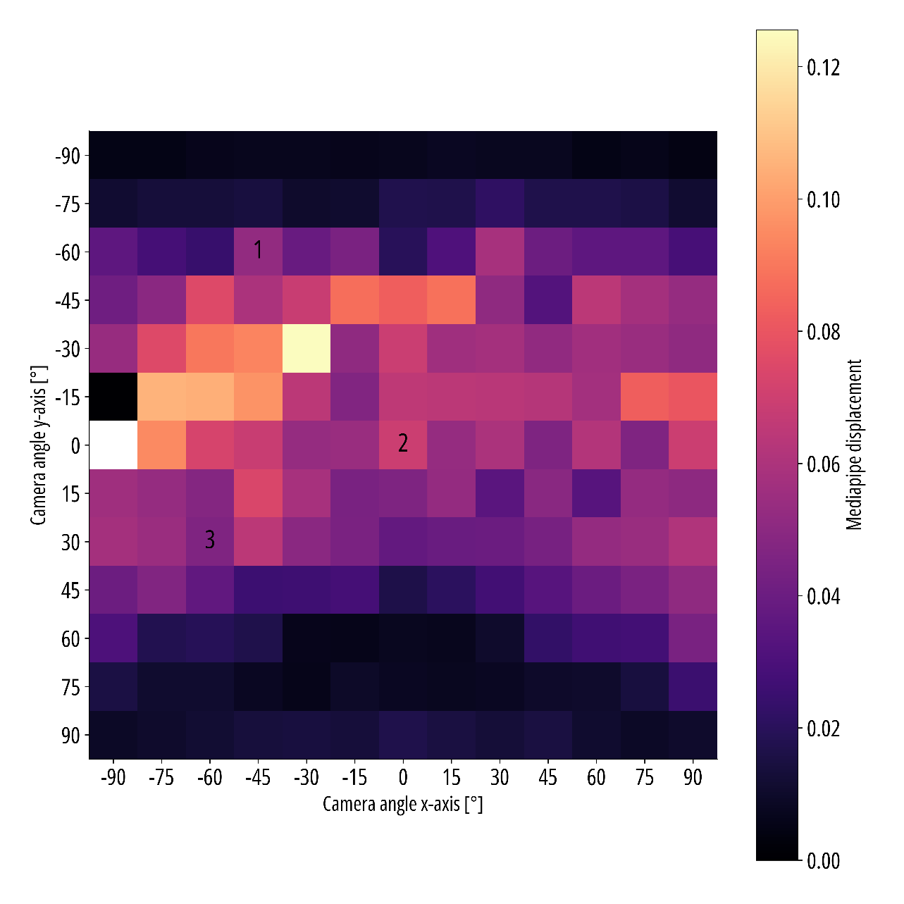
Supplementary Figure 3. Estimated amplitude using the x/y/z axis of MP norm depending on camera viewpoint.

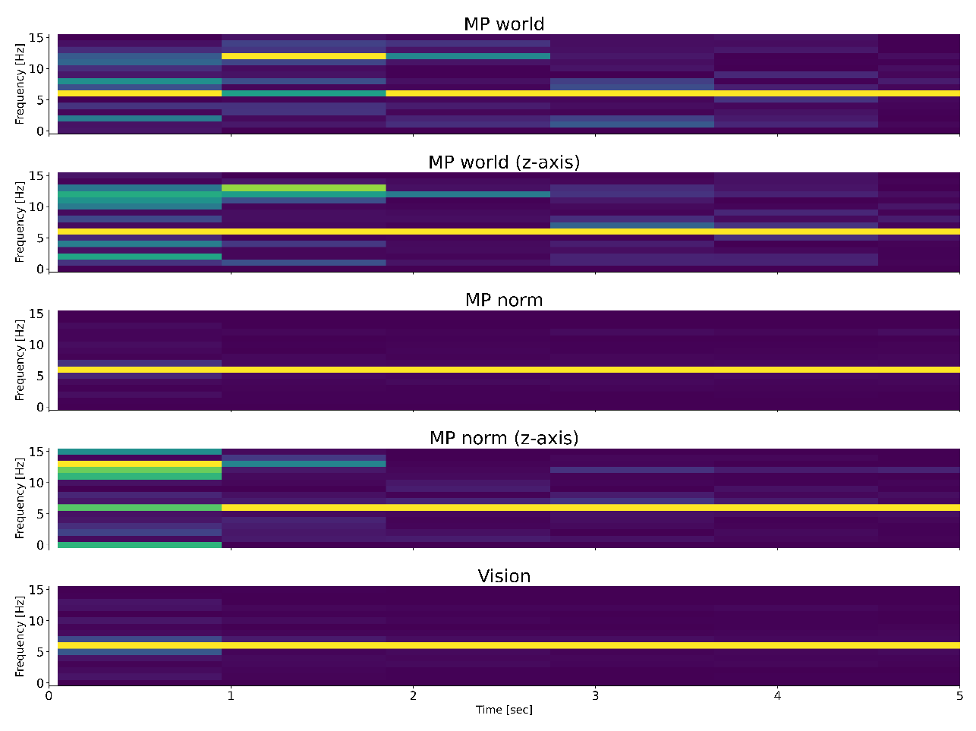
Supplementary Figure 4. First five seconds of the frequency spectra derived from the simulated hand with linearly increasing amplitude. The power of the frequency bins was normalized to the maximum power of each second separately. MP world, MP world with z axis and MP norm with z-axis show noisier frequency spectra when the tremor amplitudes are small.

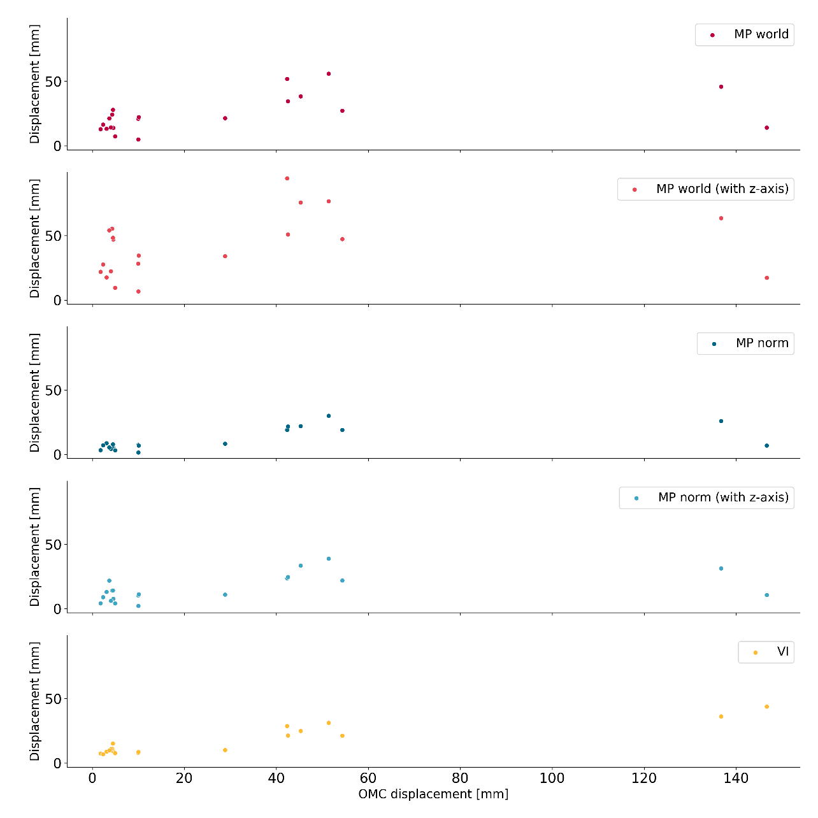
Supplementary Figure 5. These scatterplots show the estimated amplitude of the CV frameworks against the OMC amplitude.

Supplementary Table 1: Absolute differences to OMC in mm of the estimated median amplitude
 | Median | Minimum | IQR 25 | IQR 75 | Maximum
MP world | 11 | 2 | 8 | 18 | 133
MP world (z-axis) | 25 | 0 | 13 | 45 | 129
MP norm | 5 | 0 | 2 | 22 | 140
MP norm (z-axis) | 10 | 0 | 3 | 18 | 136
VI | 7 | 1 | 5 | 20 | 103

Supplementary Table 2: Relative differences to OMC in % OMC of the estimated median amplitude
 | Median | Minimum | IQR 25 | IQR 75 | Maximum
MP world | 100 | 9 | 29 | 359 | 632
MP world (z-axis) | 153 | 3 | 52 | 938 | 1375
MP norm | 53 | 7 | 34 | 77 | 206
MP norm (z-axis) | 64 | 4 | 38 | 160 | 493
VI | 68 | 12 | 43 | 169 | 321

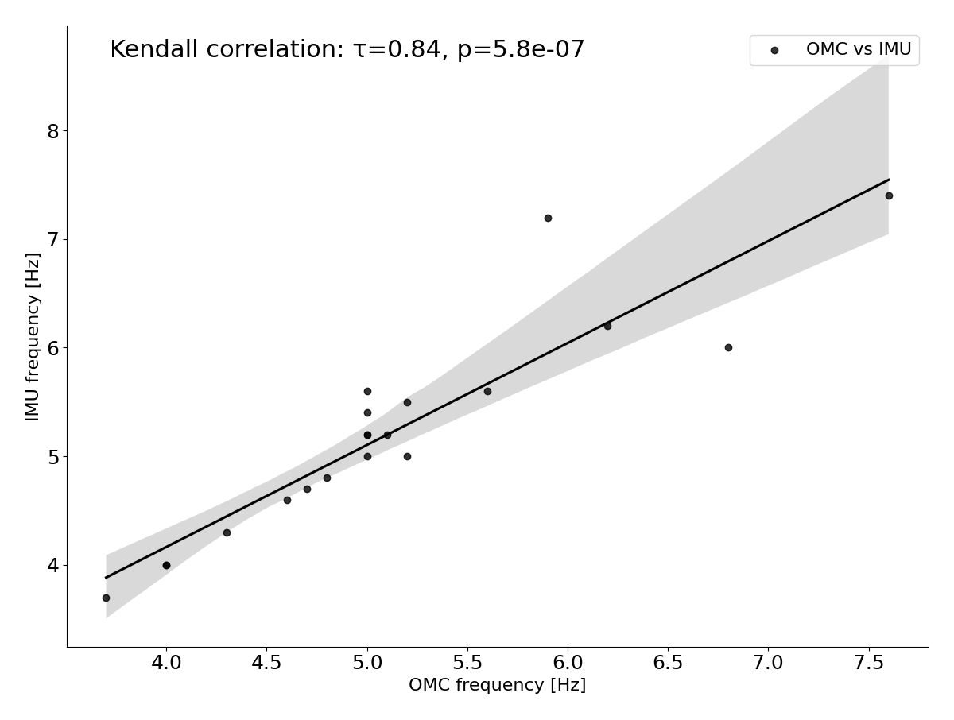
Supplementary Figure 6. The frequency estimation by OMC and IMU using the RAW pipeline showed only slight deviation between the identified peak frequency.

Supplementary Table 3: Absolute differences in Hz of detected peak frequencies.
 | Median | Minimum | IQR 25 | IQR 75 | Maximum
MP vs OMC | 0.1 | 0 | 0 | 0.375 | 2.9
MP vs IMU | 0.15 | 0 | 0 | 0.55 | 3.3
VI vs OMC | 0.05 | 0 | 0 | 0.2 | 3.7
VI vs IMU | 0.1 | 0 | 0 | 0.325 | 4.1

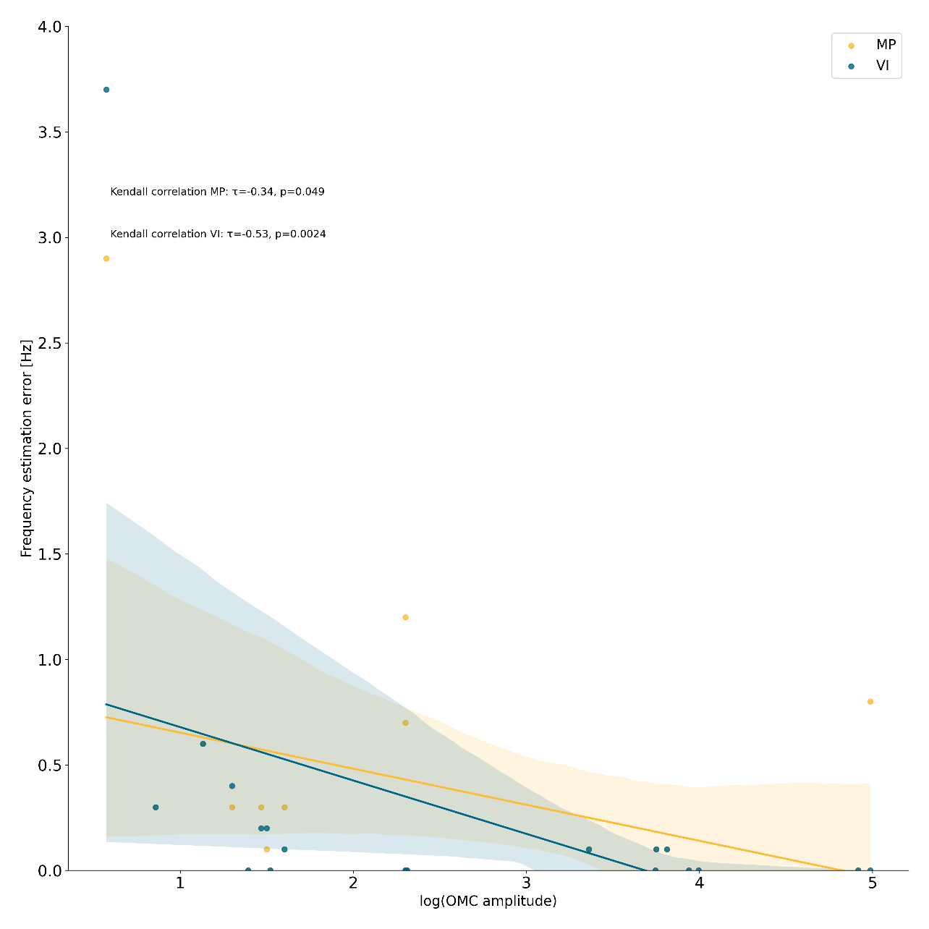
Supplementary Figure 7. These scatterplots show the logarithm of the OMC Amplitude in vs the frequency estimation error in Hz of MP and VI compared to the frequency detected by OMC.

