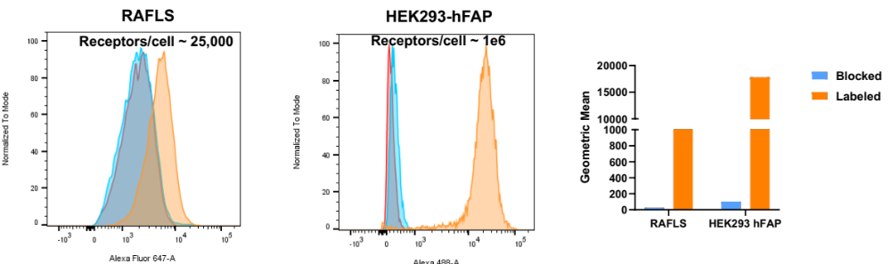

Figure S1. Specific binding of FAPI to both overexpressing and endogenous cells.

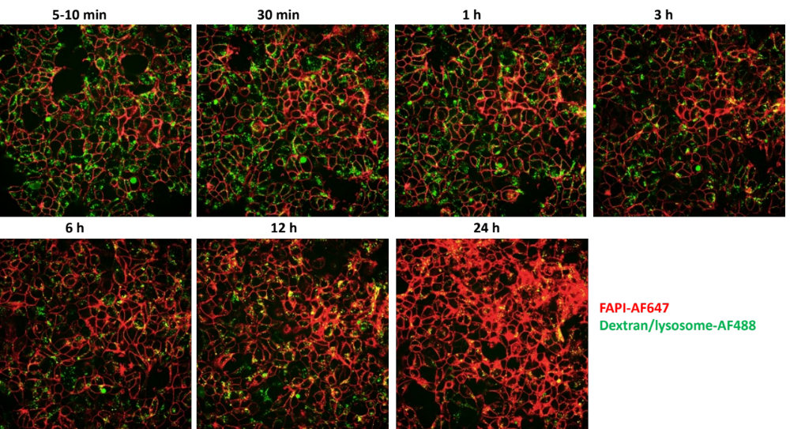

Figure S2. Time-lapse cell imaging of HEK293-hFAP cells labeled with FAPI-AF647 (red) which co-localizes with lysosomes (green) visualized by yellow punctures.

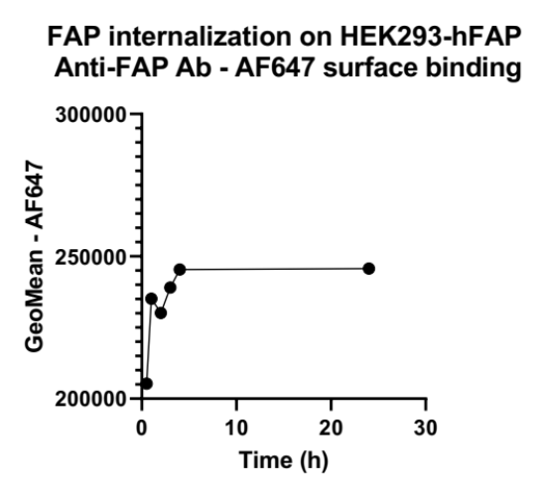
Figure S3. Constant surface expression of FAP on HEK293 overexpressing cells over time.

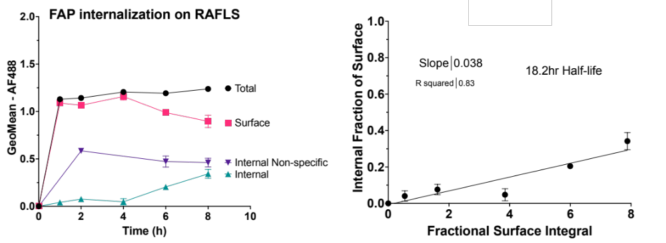

Figure S4. RAFLS internalization kinetics from a donor with higher non-specific uptake relative to that observed for a different donor shown in Figure 3.

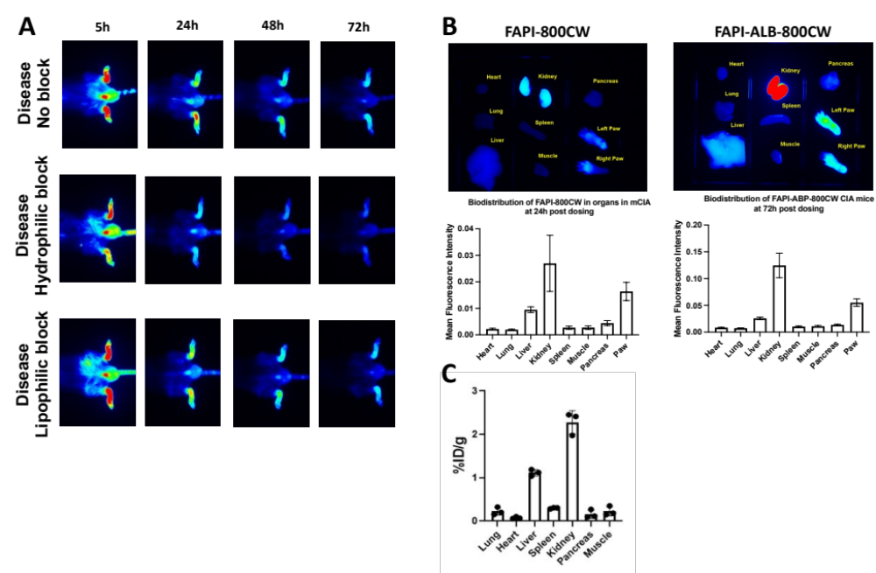

Figure S5. (A) Representative images illustrating longitudinal imaging of the slower clearing FAPI-ALB-800CW disposition in inflamed paws of the same CIA mouse up to 72 h post-dosing. The middle and bottom image panels demonstrate the temporal impact on the uptake with blocking with 50 nmol excess of FAPI-ALB-AF647 (hydrophilic) and FAPI-ABP (lipophilic), respectively. (B) Ex vivo biodistribution in mice dosed with FAPI-800CW (left) and FAPI-ALB-800CW (right). The organ image panels, and the corresponding graphs below demonstrate limited uptake in all non-target organs, except kidney. The kidney uptake is related to the excretion of the labeled peptide. The uptake levels in the diseased paws are higher for both FAP reagents, consistent with images shown in (A) and in Figure 5. (C) Whole organ homogenate data are shown for FAPI-800CW at 24 h post-IV dose. The organs from this group were weighed, homogenized, and scanned with digest standards to quantify normalized uptake as described previously¹. Aside from the high uptake in kidneys, consistent with the organ panel data in (B), the increased uptake observed in the liver may be due to a combination of increased negative charge density due to fluorophore conjugation and the residualizing nature of the fluorophore.

- Zhang, L.; Wang, Y.; Homan, K. T.; Gaudette, S. M.; McCluskey, A. J.; Chan, Y.; Murphy, J.; Abdalla, M.; Nelson, C. M.; Sun, V. Z.; Erickson, J. E.; Knight, H. L.; Clabbers, A.; Sterman, A. J. S.; Mitra, S. Imaging the Alternatively Spliced D Domain of Tenascin C in a Preclinical Model of Inflammatory Bowel Disease. Mol Imaging Biol 2022. https://doi.org/10.1007/s11307-022-01758-6.

