Table 1. Physicochemical parameters for FAPI conjugates, including MW, cLogP and plasma protein binding. Addition of sulfonated dyes alone increases hydrophilicity. Addition of the albumin-binding small molecule significantly increases plasma protein binding.
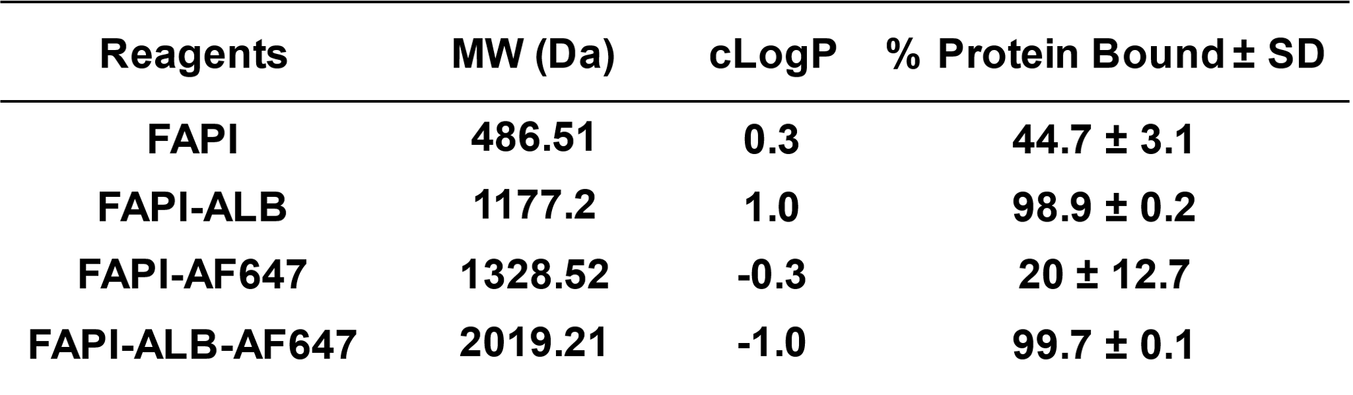

Table 2. (A) Cell surface determined binding affinities (K_{D}) for directly measured and indirectly* calculated FAP conjugates. (B) Flow cytometry using saturating concentrations of FAPI-AF488 and MESF beads to quantify surface expression in overexpressing and endogenous cells.
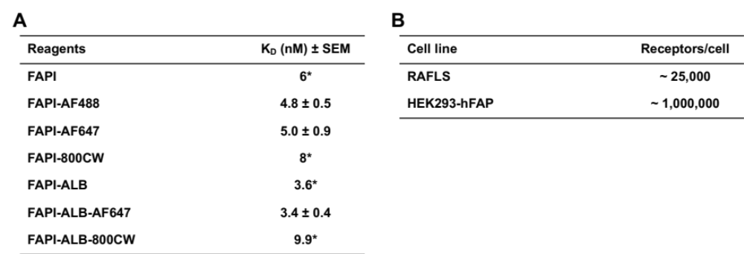

Table 3. Summary of PK parameters derived from non-compartmental analysis (Mean ± SEM). †FAPI was delivered at a higher dose than other conjugates to maintain concentration above LLOQ during sampling. Concentration data for this probe has been linearly dose normalized to 2 nmol for consistency to other probes.
