SUPPLEMENTAL DATA

PROBE DESIGN
FAPI is a known high-affinity ligand for the tumor associated membrane serine protease fibroblast-activating protein (FAP) to which various imaging reagents have been conjugated¹. The red dye (AF647) and near-IR dye (800CW) conjugates of both native FAPI and FAPI conjugated with a serum albumin binding small-molecule² were prepared as shown in figure 1. The original biphenyl acylsulfonamide albumin binding probe binds with relatively high affinity to domain III of human serum albumin and was utilized to keep the FAPI-fluorophore conjugate in serum to increase circulating half-life.
METHODS
Reagents: Unless otherwise specified all the reagents and solvents used were purchased from Millipore-Sigma, St. Louis MO. Trifluoroacetic acid (TFA) was obtained from Chem-Impex, Wood Dale, IL. 2-((1E,3E)-5-((E)-3,3-dimethyl-5-sulfonato-1-(3-sulfopropyl)indolin-2-ylidene)penta-1,3-dien-1-yl)-3-(6-((2,5-dioxocyclopentyl)oxy)-6-oxohexyl)-3-methyl-1-(3-sulfonatopropyl)-3H-indol-1-ium-5-sulfonate bis triethylammonium salt (AF647-NHS) was synthesized as described³. sodium 2-((E)-2-((E)-3-(2-((E)-3,3-dimethyl-5-sulfonato-1-(4-sulfonatobutyl)indolin-2-ylidene)ethylidene)-2-(4-sulfonatophenoxy)cyclohex-1-en-1-yl)vinyl)-1-(6-((2,5-dioxopyrrolidin-1-yl)oxy)-6-oxohexyl)-3,3-dimethyl-3H-indol-1-ium-5-sulfonate (IR800CW-NHS) was obtained from Licor Biosciences, Lincoln, NE. 4'-(trifluoromethyl)-[1,1'-biphenyl]-4-carboxylic acid, 4-cyanobenzenesulfonamide, (S)-4-((((9H-fluoren-9-yl)methoxy)carbonyl)amino)-5-(tert-butoxy)-5-oxopentanoic acid (Fmoc-Glu-OtBu) and 2,2-dimethyl-4-oxo-3,8,11-trioxa-5-azatridecan-13-oic acid were obtained from Combi-Blocks, San Diego, CA. ((3H-[1,2,3]triazolo[4,5-b]pyridin-3-yl)oxy)tri(pyrrolidin-1-yl)phosphonium hexafluorophosphate(V) (PyAOP) was obtained from Oakwood Chemicals, Estill, SC.

ABBREVIATIONS:
AA ammonium acetate
AF647-NHS 2-((1E,3E)-5-((E)-3,3-dimethyl-5-sulfonato-1-(3-sulfopropyl)indolin-2-ylidene)penta-1,3-dien-1-yl)-3-(6-((2,5-dioxocyclopentyl)oxy)-6-oxohexyl)-3-methyl-1-(3-sulfonatopropyl)-3H-indol-1-ium-5-sulfonate bis triethylammonium salt. AlexaFluor™647-N-hydroxysuccinimide
APCI-MS atmospheric pressure chemical ionization mass spectrometry
DMF N,N-dimethylformamide
DMSO dimethylsulfoxide
ESI-MS electrospray ionization mass spectrometry
Fmoc-Glu-OtBu (S)-4-((((9H-fluoren-9-yl)methoxy)carbonyl)amino)-5-(tert-butoxy)-5-oxopentanoic acid
HPLC high-performance liquid chromatography
IR800CW-NHS IR800CW™-N-hydroxysuccinimide
LCMS liquid chromatography mass-spectrometry
MeCN acetonitrile
PyAOP ((3H-[1,2,3]triazolo[4,5-b]pyridin-3-yl)oxy)tri(pyrrolidin-1-yl)phosphonium hexafluorophosphate(V)
RP-HPLC reverse-phase high-performance liquid chromatography
R_{t} Retention time
TFA trifluoroacetic acid

SYNTHETIC METHODS
Analytical LCMS with TFA method 1, TFA method 2, AA method 1 and AA method 2: Analytical LCMS was performed on a Thermo MSQ-Plus mass spectrometer and Agilent 1100/1200 HPLC system running Xcalibur 2.0.7, Open-Access 1.4, and custom login software. The mass spectrometer was operated under positive APCI or ESI ionization conditions dependent on the system used, as noted in the text. The HPLC system comprised an Agilent Binary pump, degasser, column compartment, autosampler and diode-array detector, with a Polymer Labs ELS-2100 evaporative light-scattering detector. The column used was a Phenomenex Kinetex C8, 2.6 μm 100 Å (2.1mm × 30mm), at a temperature of 65°C. Elution times are reported as R_{t}.
“TFA method 1”: A gradient of 5-100% acetonitrile (A) and 0.1% trifluoroacetic acid in water (B) was used, at a flow rate of 1.5 mL/min (0-0.05 min 5% A, 0.05-1.2 min 5-100% A, 1.2-1.4 min 100% A, 1.4-1.5 min 100-5% A. 0.25 min post-run delay). Elution times are reported as R_{t}.
“TFA method 2”: A gradient of 5-100% acetonitrile (A) and 0.1% trifluoroacetic acid in water (B) was used, at a flow rate of 1.5 mL/min (0-0.1 min 5% A, 0.1-5.2 min 5-100% A, 5.2-5.7 min 100% A, 5.7-6.0 min 100-5% A. 0.25 min post-run delay). Elution times are reported as R_{t}.
“AA method 1”: A gradient of 5-100% acetonitrile (A) and 10 mM ammonium acetate in water (B) was used, at a flow rate of 1.5 mL/min (0-0.05 min 5% A, 0.05-1.2 min 5-100% A, 1.2-1.4 min 100% A, 1.4-1.5 min 100-5% A. 0.25 min post-run delay). Elution times are reported as R_{t}.
“AA method 2”: A gradient of 5-100% acetonitrile (A) and 10 mM ammonium acetate in water (B) was used, at a flow rate of 1.5 mL/min (0-0.1 min 5% A, 0.1-5.2 min 5-100% A, 5.2-5.7 min 100% A, 5.7-6.0 min 100-5% A. 0.25 min post-run delay). Elution times are reported as R_{t}.
Analytical LCMS with AA method 3 and FA method 1: Analytical LCMS was performed on a Thermo MSQ-Plus mass spectrometer and Agilent 1100/1200 HPLC system running Xcalibur 2.0.7, Open-Access 1.4, and custom login software. The HPLC system comprised an Agilent Binary pump, degasser, column compartment, autosampler and diode-array detector, with a Polymer Labs ELS-2100 evaporative light-scattering detector. The column used was a Waters Cortecs C18+, 2.7 μm 100Å (2.1mm × 30mm), at a temperature of 40°C. Elution times are reported as R_{t}.
“AA method 3”: A gradient of 5-100% acetonitrile (A) and 10 mM ammonium acetate water:acetonitrile (98:2) (B) was used, at a flow rate of 1.5 mL/min (0-0.05 min 0% A, 0.05-2.8 min 0-100% A, 2.8-3.0 min 100-0% A, 160-1500 amu positive/negative ESI-MS ionization. Elution times are reported as R_{t}.
“FA method 1”: A gradient of 5-100% acetonitrile (A) and 0.1% formic acid water:acetonitrile (98:2) (B) was used, at a flow rate of 1.5 mL/min (0-0.05 min 0% A, 0.05-2.8 min 0-100% A, 2.8-3.0 min 100-0% A, 160-1500 amu positive/negative ESI-MS ionization. Elution times are reported as R_{t}.
Preparative HPLC TFA method 1. RP-HPLC was performed on a Gilson HPLC system equipped with liquid handler (Gilson-215) and UV/Vis detector using a Waters Deltapak C18 column (5 µm, 100 Å, 200 x 21.2 mm) eluted with A (0.1% TFA-water):B (acetonitrile) [0-5 min: 5% A; 5-35 min linear gradient to 100% B, 3.16%/min linear gradient] with a 20 mL/min flowrate.
Preparative HPLC TFA method 2. RP-HPLC was performed on a Gilson HPLC system equipped with liquid handler (Gilson-215) and UV/Vis detector using a Phenomenex Gemini NX-C18 column (5 µm, 110 Å, 250 x 25 mm) eluted with A (0.1% TFA-water):B (acetonitrile) [0-5 min: 2% A; 5-35 min linear gradient to 100% B, 3.16%/min linear gradient] with a 20 mL/min flowrate.
NMR Spectra were collected in DMSO-d₆ at room temperature (27 °C) on a Bruker Avance III HD spectrometer equipped with a TCI cryoprobe. ¹H spectra were acquired with SW= 16 ppm, 3.65 s acquisition time & 8-24 scans. ¹³C spectra were acquired with SW 200 ppm, 0.205 s acquisition time & 2 scans.
(S)-N-(2-(2-cyano-4,4-difluoropyrrolidin-1-yl)-2-oxoethyl)-6-(3-(piperazin-1-yl)propoxy)quinoline-4-carboxamide bis-2,2,2-trifluoroacetate (FAPI):
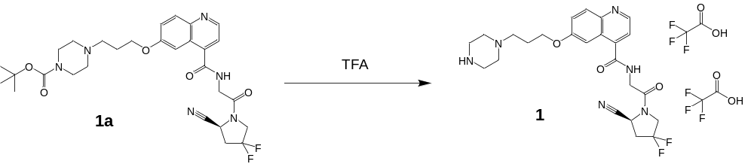
tert-butyl (S)-4-(3-((4-((2-(2-cyano-4,4-difluoropyrrolidin-1-yl)-2-oxoethyl)carbamoyl)quinolin-6-yl)oxy)propyl)piperazine-1-carboxylate (FAPI-BOC, 1a) synthesized by Enamine (Kyiv, Ukraine) via the route described¹ (50 mg, 0.085 mmol) was treated with neat TFA (1 mL) and immediately evaporated to dryness under a stream of dry nitrogen gas to give 1 (51.4 mg, 84.4%) as a colorless glass LCMS TFA method 1: R_{t} = 0.45 min, ESI-MS m/z 487.1(M+H)⁺; LCMS AA method 3: R_{t} = 0.925 min, ESI-MS m/z 487.2 (M+H)⁺, 485.2 (M-H)⁻; ¹H NMR (499 MHz, DMSO) δ _{H} 9.12 (t, J = 6.0 Hz, 1H), 9.06 (s, 2H), 8.86 (d, J = 4.3 Hz, 1H), 8.03 (d, J = 9.2 Hz, 1H), 7.91 (d, J = 2.8 Hz, 1H), 7.57 (d, J = 4.4 Hz, 1H), 7.49 (dd, J = 9.2, 2.8 Hz, 1H), 5.16 (dd, J = 9.4, 2.9 Hz, 1H), 4.35 (m, J = 11.7, 4.7 Hz, 1H), 4.22 – 4.11 (m, 2H), 3.44 – 3.09 (m, 6H), 3.03 – 2.79 (m, 2H), 2.18 (p, J = 6.3 Hz, 2H); ¹³C NMR (125 MHz, DMSO-d₆) δ _{C} 168.03, 167.34, 156.66, 147.53, 143.9, 140.77, 130.62, 126.73, 125.37, 122.47, 119.33, 117.75, 104.64, 65.27, 53.51 (2 C), 51.24, 44.06, 41.49, 41.36, 50.82 (2 C), 36.22, 23.92.
3-(6-(4-(3-((4-((2-((S)-2-cyano-4,4-difluoropyrrolidin-1-yl)-2-oxoethyl)carbamoyl)quinolin-6-yl)oxy)propyl)piperazin-1-yl)-6-oxohexyl)-2-((1E,3E)-5-((E)-3,3-dimethyl-5-sulfo-1-(3-sulfopropyl)indolin-2-ylidene)penta-1,3-dien-1-yl)-3-methyl-1-(3-sulfopropyl)-3H-indol-1-ium-5-sulfonate 2,2,2-trifluoroacetate (FAPI-AF647):
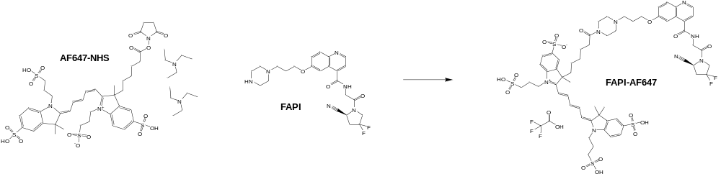
2-((1E,3E)-5-((E)-3,3-dimethyl-5-sulfonato-1-(3-sulfopropyl)indolin-2-ylidene)penta-1,3-dien-1-yl)-3-(6-((2,5-dioxocyclopentyl)oxy)-6-oxohexyl)-3-methyl-1-(3-sulfonatopropyl)-3H-indol-1-ium-5-sulfonate bis triethylammonium salt (AF647-NHS, 24.32 mg, 0.021 mmol) was combined with (S)-N-(2-(2-cyano-4,4-difluoropyrrolidin-1-yl)-2-oxoethyl)-6-(3-(piperazin-1-yl)propoxy)quinoline-4-carboxamide bis-2,2,2-trifluoroacetate (FAPI, 10 mg, 0.014 mmol) in 1 mL anhydrous DMSO containing 2% DIEA (v/v) and shaken at ambient overnight. The crude reaction mixture was diluted to 3 mL with 90% DMSO/water (v/v) and purified by preparative HPLC Preparative HPLC TFA method 1. Fractions containing the desired product were combined and lyophilized to give FAPI-AF647 as a dark blue solid (7.6 mg, 37.7%): LCMS TFA method 2: R_{t} = 1.60 min, ESI-MS m/z 664.1 (M+2H)²⁺; LCMS AA method 2: R_{t} = 1.55 min, ESI-MS m/z 664.1 (M+2H)²⁺, 1327.6 (M+H)⁺; LCMS FA method 1: R_{t} = 0.97 min, ESI-MS m/z 664.2 (M+2H)²⁺, 662.2 (M-H)⁻; LCMS AA method 3: R_{t} = 0.851 min, ESI-MS m/z 664.2 (M+2H)²⁺, 662.0 (M-H)⁻, 1325.4 (M-2H)²⁻.
4-((E)-2-((E)-2-(3-((E)-2-(1-(6-(4-(3-((4-((2-((S)-2-cyano-4,4-difluoropyrrolidin-1-yl)-2-oxoethyl)carbamoyl)quinolin-6-yl)oxy)propyl)piperazin-1-yl)-6-oxohexyl)-3,3-dimethyl-5-sulfo-3H-indol-1-ium-2-yl)vinyl)-2-(4-sulfophenoxy)cyclohex-2-en-1-ylidene)ethylidene)-3,3-dimethyl-5-sulfoindolin-1-yl)butane-1-sulfonate 2,2,2-trifluoroacetate (FAPI-800CW):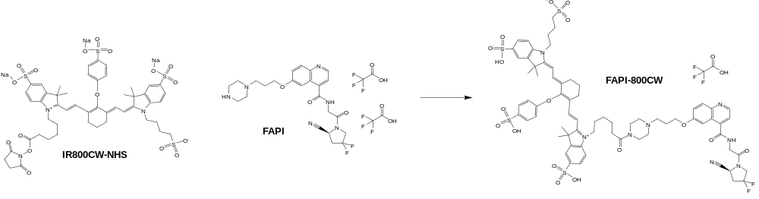
sodium 2-((E)-2-((E)-3-(2-((E)-3,3-dimethyl-5-sulfonato-1-(4-sulfonatobutyl)indolin-2-ylidene)ethylidene)-2-(4-sulfonatophenoxy)cyclohex-1-en-1-yl)vinyl)-1-(6-((2,5-dioxopyrrolidin-1-yl)oxy)-6-oxohexyl)-3,3-dimethyl-3H-indol-1-ium-5-sulfonate (IR800CW-NHS, 15 mg, 0.013 mmol) was combined with (S)-N-(2-(2-cyano-4,4-difluoropyrrolidin-1-yl)-2-oxoethyl)-6-(3-(piperazin-1-yl)propoxy)quinoline-4-carboxamide bis-2,2,2-trifluoroacetate (FAPI, 10 mg, 0.014 mmol) in 1 mL anhydrous DMSO containing 2% DIEA (v/v) and shaken at ambient overnight. The crude reaction mixture was diluted to 3 mL with 90% DMSO/water (v/v) and purified by preparative HPLC Preparative HPLC TFA method 2. Fractions containing the desired product were combined and lyophilized to give FAPI-AF647 as a green solid (8.5 mg, 41.7%): LCMS TFA method 2: R_{t} = 2.01 min, ESI-MS m/z 744.4 (M+H+Na)²⁺; LCMS AA method 1: R_{t} = 0.55 min, ESI-MS m/z 1472.31 (M+H)⁺, 1327.6 (M+H)⁺; LCMS FA method 1: R_{t} = 0.915 min, ESI-MS m/z 734.2 (M-2H)²⁻, 732.8 (M-H)⁻; LCMS AA method 3: R_{t} = 1.016 min, ESI-MS m/z 736.2 (M+2H)²⁺, 734.2 (M-2H)²⁻, 1325.4 (M-2H)²⁻.
N-((4-cyanophenyl)sulfonyl)-4'-(trifluoromethyl)-[1,1'-biphenyl]-4-carboxamide (1):
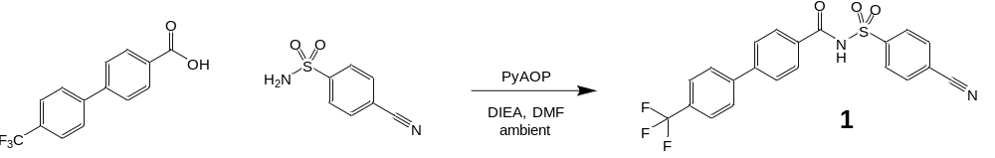
4'-(trifluoromethyl)-[1,1'-biphenyl]-4-carboxylic acid (1.46 g, 5.49 mmol) and 4-cyanobenzenesulfonamide (1.00 g, 5.49 mmol) were combined in 15 mL anhydrous DMF. When fully dissolved, PyAOP (3.57 g, 6.86 mmol) was added and when fully dissolved, DIEA (2.13 g, 16.5 mmol) was added and the reaction shaken at ambient for overnight. The reaction was diluted with 90% DMSO/water and purified by Preparative HPLC TFA method 1 go give the desired product 1 (1.22 g, 51.7 %): LCMS FA method 1: R_{t} = 1.82 min, ESI-MS m/z 431.0 (M+H)⁺, 428.8 (M-H)⁻; LCMS AA method 3: R_{t} = 1.32 min, ESI-MS m/z 431.0 (M+H)⁺; 429.0 (M-H)⁻; ¹H NMR (499 MHz, DMSO-d₆) δ _{H} 8.22 – 8.17 (m, 2H), 8.17 – 8.12 (m, 2H), 8.04 – 8.00 (m, 2H), 8.00 – 7.95 (m, 2H), 7.92 – 7.83 (m, 4H); ¹³C NMR (125 MHz, DMSO-d₆) δ _{C} 165.5, 143.77, 142.91 (2 C), 133.21 (2 C), 131.26, 129.29 (2 C), 128.59, 128.32 (2 C), 127.8 (2 C), 127.12 (2 C), 125.82 (2 C), 124.16, 117.54, 115.72.
N-((4-(aminomethyl)phenyl)sulfonyl)-4'-(trifluoromethyl)-[1,1'-biphenyl]-4-carboxamide (2):
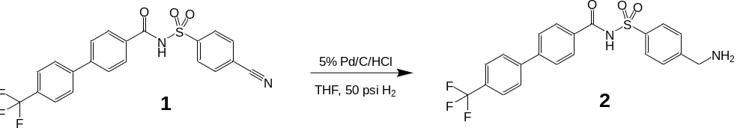
N-((4-cyanophenyl)sulfonyl)-4'-(trifluoromethyl)-[1,1'-biphenyl]-4-carboxamide (1, 1.047 g, 2.43 mmol) in THF (20 mL) and 4 M HCl in dioxane (1.216 mL, 4.87 mmol) in a Barnstead Hast C reactor was reduced with 5% Pd/C (wet JM#9) (0.67 g, 2.8 mmol) was reduced with 50 psi hydrogen at 25 C. The mixture was filtered through a polypropylene membrane and the solids washed with THF to give the desired product 2 (1.30 g, 92.3%) which was used without further purification. A sample (20 mg) was dissolved in 90% DMSO/water (v/v, 1.5 mL) and purified by Preparative HPLC TFA method 1 to give the desired product 2 as the 2,2,2-trifluoroacetic acid salt: LCMS FA method 1: R_{t} = 1.22 min, ESI-MS m/z 435.0 (M+H)⁺, 869.2 (2M+H)⁺, 432.8 (M-H)⁻; LCMS AA method 3: R_{t} = 1.21 min, ESI-MS m/z 435.2 (M+H)⁺, 892.0 (2M+Na)⁺, 433.0 (M-H)⁻, 889.0 (2M-2H+Na)⁺.
tert-butyl (2-(2-(2-oxo-2-((4-(N-(4'-(trifluoromethyl)-[1,1'-biphenyl]-4-carbonyl)sulfamoyl)benzyl)-amino)ethoxy)ethoxy)ethyl)carbamate (3):

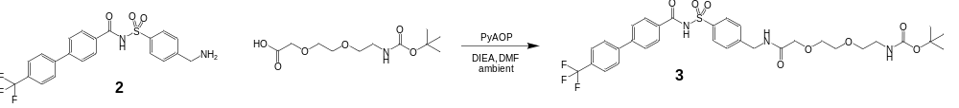
To N-((4-(aminomethyl)phenyl)sulfonyl)-4'-(trifluoromethyl)-[1,1'-biphenyl]-4-carboxamide (2, 106.4 mg, 0.245 mmol) and 2,2-dimethyl-4-oxo-3,8,11-trioxa-5-azatridecan-13-oic acid (77 mg, 0.294 mmol) were dissolved in 1 mL anhydrous DMF was added PyAOP (153 mg, 0.294 mmol), then DIEA (95 mg, 0.735 mmol). The reaction was shaken at ambient for 1h. The reaction was diluted to 3 mL with 90% DMSO/water (v/v) and purified by Preparative HPLC TFA method 2 to give the desired product 3: LCMS FA method 1: R_{t} = 1.98 min, ESI-MS m/z 580.0 (M+H-Boc)⁺; 678.0 (M-H)⁻.
N-((4-((2-(2-(2-aminoethoxy)ethoxy)acetamido)methyl)phenyl)sulfonyl)-4'-(trifluoromethyl)-[1,1'-biphenyl]-4-carboxamide 2,2,2-trifluoroacetate (4):
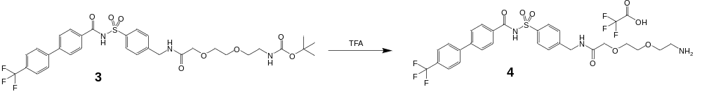
tert-butyl (2-(2-(2-oxo-2-((4-(N-(4'-(trifluoromethyl)-[1,1'-biphenyl]-4-carbonyl)sulfamoyl)benzyl)-amino)ethoxy)ethoxy)ethyl)carbamate (3, 139.5 mg, 0.205 mmol) was dissolved in 1 mL TFA and immediately evaporated to dryness under a stream of dry nitrogen gas to give the desired product 4 (142 mg, 100%) which was used without further purification: LCMS FA method 1: R_{t} = 1.37 min, ESI-MS m/z 579.8 (M+H)⁺; 578.0 (M-H)⁻.
tert-butyl (S)-15-((((9H-fluoren-9-yl)methoxy)carbonyl)amino)-3,12-dioxo-1-(4-(N-(4'-(trifluoro-methyl)-[1,1'-biphenyl]-4-carbonyl)sulfamoyl)phenyl)-5,8-dioxa-2,11-diazahexadecan-16-oate (5):
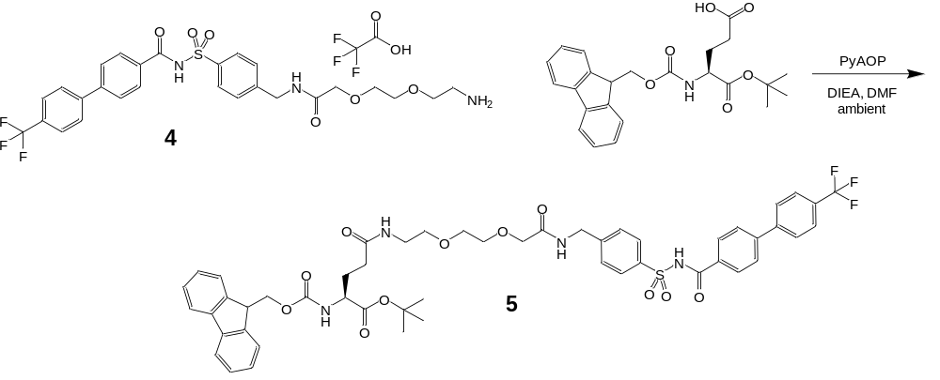
To N-((4-((2-(2-(2-aminoethoxy)ethoxy)acetamido)methyl)phenyl)sulfonyl)-4'-(trifluoromethyl)-[1,1'-biphenyl]-4-carboxamide 2,2,2-trifluoroacetate (4, 142 mg, 0.205 mmol) and Fmoc-Glu-OtBu (105 mg, 0.246 mmol) dissolved in 2 mL anhydrous DMF was added PyAOP (128 mg, 0.246 mmol) and DIEA (148 mg, 1.145 mmol). The reaction was shaken at ambient for 1 h. The reaction was diluted to 4 mL with 90% DMSO/water (v/v) and purified by Preparative HPLC TFA method 2 to give the desired product 5 (182.7 mg, 90.4%): LCMS FA method 1: R_{t} = 2.39 min, failed to show ions in ESI-MS.
(S)-15-((((9H-fluoren-9-yl)methoxy)carbonyl)amino)-3,12-dioxo-1-(4-(N-(4'-(trifluoromethyl)-[1,1'-biphenyl]-4-carbonyl)sulfamoyl)phenyl)-5,8-dioxa-2,11-diazahexadecan-16-oic acid (6):
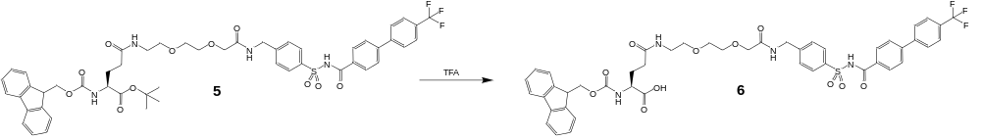
tert-butyl (S)-15-((((9H-fluoren-9-yl)methoxy)carbonyl)amino)-3,12-dioxo-1-(4-(N-(4'-(trifluoro-methyl)-[1,1'-biphenyl]-4-carbonyl)sulfamoyl)phenyl)-5,8-dioxa-2,11-diazahexadecan-16-oate (5, 182.7 mg, 0.185 mmol) was dissolved in 1 mL TFA and immediately evaporated to dryness under a stream of dry nitrogen gas. The TFA treatment was repeated to give the desired product 6 (172 mg, 100%) which was used without further purification: LCMS FA method 1: R_{t} = 1.89 min, ESI-MS m/z 931.2 (M+H)⁺; 929.0 (M-H)⁻; LCMS AA method 3: R_{t} = 1.31 min, ESI-MS m/z 931.4 (M+H)⁺; 929.0 (M-H)⁻.
(9H-fluoren-9-yl)methyl ((S)-16-(4-(3-((4-((2-((S)-2-cyano-4,4-difluoropyrrolidin-1-yl)-2-oxoethyl)carbamoyl)quinolin-6-yl)oxy)propyl)piperazin-1-yl)-3,12,16-trioxo-1-(4-(N-(4'-(trifluoromethyl)-[1,1'-biphenyl]-4-carbonyl)sulfamoyl)phenyl)-5,8-dioxa-2,11-diazahexadecan-15-yl)carbamate 2,2,2-trifluoroacetate (7):
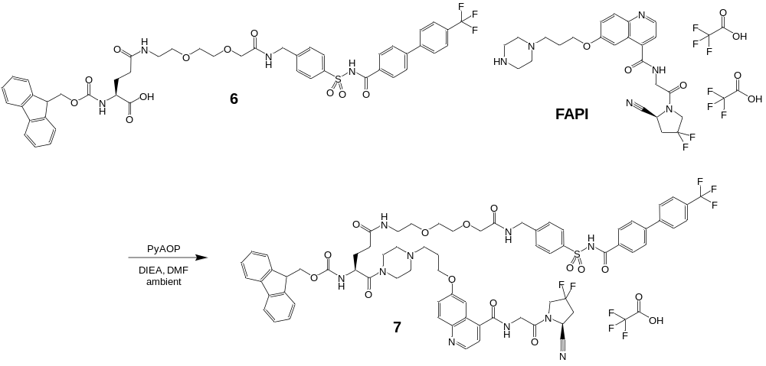
To (S)-15-((((9H-fluoren-9-yl)methoxy)carbonyl)amino)-3,12-dioxo-1-(4-(N-(4'-(trifluoromethyl)-[1,1'-biphenyl]-4-carbonyl)sulfamoyl)phenyl)-5,8-dioxa-2,11-diazahexadecan-16-oic acid (6, 43.8 mg, 0.047 mmol) and FAPI (33.6 mg, 0.047 mmol) in 1 mL anhydrous DMF was added PyAOP (29.4 mg, 0.056 mmol) and DIEA (30.4 mg, 0.235 mmol). The reaction was shaken at ambient for 1 h. The reaction was diluted to 3 mL with 90% DMSO/water (v/v) and purified by Preparative HPLC TFA method 2 to give the desired product 7 (46.2 mg, 64.9%): LCMS FA method 1: R_{t} = 1.76 min, ESI-MS m/z 700.2 (M+2H)²⁺.
6-(3-(4-((S)-15-amino-3,12-dioxo-1-(4-(N-(4'-(trifluoromethyl)-[1,1'-biphenyl]-4-carbonyl)sulfamoyl)phenyl)-5,8-dioxa-2,11-diazahexadecan-16-oyl)piperazin-1-yl)propoxy)-N-(2-((S)-2-cyano-4,4-difluoropyrrolidin-1-yl)-2-oxoethyl)quinoline-4-carboxamide bis-2,2,2-trifluoroacetate (FAPI-albumin):
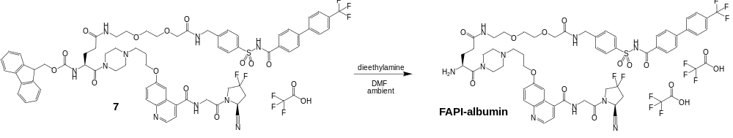
(9H-fluoren-9-yl)methyl ((S)-16-(4-(3-((4-((2-((S)-2-cyano-4,4-difluoropyrrolidin-1-yl)-2-oxoethyl)carbamoyl)quinolin-6-yl)oxy)propyl)piperazin-1-yl)-3,12,16-trioxo-1-(4-(N-(4'-(trifluoromethyl)-[1,1'-biphenyl]-4-carbonyl)sulfamoyl)phenyl)-5,8-dioxa-2,11-diazahexadecan-15-yl)carbamate 2,2,2-trifluoroacetate (7, 46.2 mg, 0.031 mmol) was dissolved in 1 mL 1:4 diethylamine:anhydrous DMF and shaken at ambient for 15 min. The solvent was partially removed under a stream of dry nitrogen gas. The residue was diluted to 3 mL with 90% DMSO/water (v/v) and purified by Preparative HPLC TFA method 2 to give the desired product FAPI-albumin (also referred to as FAPI-ALB in this manuscript) (41.2 mg, 96.0%): LCMS FA method 1: R_{t} = 1.13 min, ESI-MS m/z 393.2 (M+3H)³⁺, 589.4 (M+2H)²⁺, 1177.6 (M+H)⁺, 1175.0 (M-H)⁻; LCMS AA method 3: R_{t} = 1.38 min, ESI-MS m/z 589.2 (M+2H)²⁺, 1177.6 (M+H)⁺, 587.2 (M-2H)²⁻, 1175.4 (M-H)⁻.
3-((S)-15-(4-(3-((4-((2-((S)-2-cyano-4,4-difluoropyrrolidin-1-yl)-2-oxoethyl)carbamoyl)quinolin-6-yl)oxy)propyl)piperazine-1-carbonyl)-3,12,17-trioxo-1-(4-(N-(4'-(trifluoromethyl)-[1,1'-biphenyl]-4-carbonyl)sulfamoyl)phenyl)-5,8-dioxa-2,11,16-triazadocosan-22-yl)-2-((1E,3E)-5-((E)-3,3-dimethyl-5-sulfo-1-(3-sulfopropyl)indolin-2-ylidene)penta-1,3-dien-1-yl)-3-methyl-1-(3-sulfopropyl)-3H-indol-1-ium-5-sulfonate 2,2,2-trifluoroacetate (FAPI-albumin-AF647): 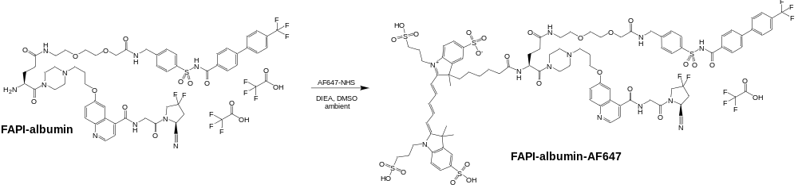
FAPI-albumin (13.5 mg, 0.0096 mmol) and AF647-NHS (16 mg, 0.014 mmol) were combined in 1 mL anhydrous DMSO containing 2% DIEA (v/v) and shaken at ambient overnight. The reaction was diluted to 3 mL with 90% DMSO/water (v/v) and purified by Preparative HPLC TFA method 2 to give the desired product FAPI-albumin-AF647 (12.2 mg, 59.6%): LCMS FA method 1: R_{t} = 1.55 min, ESI-MS m/z 673.4 (M+3H)³⁺, 1009.2 (M+2H)²⁺, 671.8 (M-3H)³⁻, 1008.4 (M-2H)²⁻; LCMS AA method 3: R_{t} = 1.07 min, ESI-MS m/z 1009.6 (M+2H)²⁺, 671.2 (M-3H)³⁻, 1007.6 (M-2H)²⁻.
4-((E)-2-((E)-2-(3-((E)-2-(1-((S)-15-(4-(3-((4-((2-((S)-2-cyano-4,4-difluoropyrrolidin-1-yl)-2-oxoethyl)carbamoyl)quinolin-6-yl)oxy)propyl)piperazine-1-carbonyl)-3,12,17-trioxo-1-(4-(N-(4'-(trifluoromethyl)-[1,1'-biphenyl]-4-carbonyl)sulfamoyl)phenyl)-5,8-dioxa-2,11,16-triazadocosan-22-yl)-3,3-dimethyl-5-sulfo-3H-indol-1-ium-2-yl)vinyl)-2-(4-sulfophenoxy)cyclohex-2-en-1-ylidene)ethylidene)-3,3-dimethyl-5-sulfoindolin-1-yl)butane-1-sulfonate 2,2,2-trifluoroacetate (FAPI-albumin-800CW):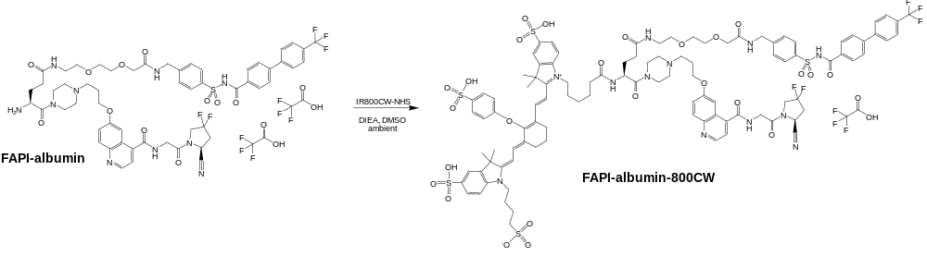
FAPI-albumin (15 mg, 0.0107 mmol) and IR800CW-NHS (13.7 mg, 0.012 mmol) were combined in 1 mL anhydrous DMSO containing 2% DIEA (v/v) and shaken at ambient overnight. The reaction was diluted to 3 mL with 90% DMSO/water (v/v) and purified by Preparative HPLC TFA method 2 to give the desired product FAPI-albumin-AF647 (12.2 mg, 59.6%): LCMS FA method 1: R_{t} = 1.58 min, ESI-MS m/z 721.0 (M+3H)³⁺, 1081.2 (M+2H)²⁺, 718.9 (M-3H)³⁻, 1079.6 (M-2H)²⁻; LCMS AA method 3: R_{t} = 1.14 min, ESI-MS m/z (M+3H)³⁺, 1083.0 (M+2H)²⁺, 539.0 (M-4H)⁴⁻, 719.4 (M-3H)³⁻, 1078.6 (M-2H)²⁻.

REFERENCES
(1) Lindner, T.; Altmann, A.; Krämer, S.; Kleist, C.; Loktev, A.; Kratochwil, C.; Giesel, F.; Mier, W.; Marme, F.; Debus, J.; Haberkorn, U. Design and Development of 99mTc-Labeled FAPI Tracers for SPECT Imaging and 188Re Therapy. J. Nucl. Med. Off. Publ. Soc. Nucl. Med. 2020, 61 (10), 1507–1513. https://doi.org/10.2967/jnumed.119.239731.
(2) Bruncko, M.; Wang, L.; Sheppard, G. S.; Phillips, D. C.; Tahir, S. K.; Xue, J.; Erickson, S.; Fidanze, S.; Fry, E.; Hasvold, L.; Jenkins, G. J.; Jin, S.; Judge, R. A.; Kovar, P. J.; Madar, D.; Nimmer, P.; Park, C.; Petros, A. M.; Rosenberg, S. H.; Smith, M. L.; Song, X.; Sun, C.; Tao, Z.-F.; Wang, X.; Xiao, Y.; Zhang, H.; Tse, C.; Leverson, J. D.; Elmore, S. W.; Souers, A. J. Structure-Guided Design of a Series of MCL‑1 Inhibitors with High Affinity and Selectivity. J. Med. Chem. 2015, 58 (5), 2180–2194. https://doi.org/10.1021/jm501258m.
(3) Wai-Yee Leung, Shing-Ying Cheung, Stephen, Yue, PCT Int. Appl., 2002, WO 2002026891 A1.

