Supplementary Material 1: Summary of bat-box actions made in Spain.

Experience | Site | Habitat type | Number total of bat-boxes | Bat species present | Number maximum of bats recorded | Annual increased rate | % bat-boxes occupied | Reference
Embalse de la Breña, Sierra Morena | Córdoba, Spain | Natural | 280 | P. pipistrellus; P. pygmaus;  P. kuhlii | 5792 | 50-800% | 5.0-70.0% | Nogueras and Ibañez, 2020.
Colonia Nyctalus lasiopterus en el Parque Nacional de Doñana | Huelva, Spain | Natural | 90 | N. lasiopterus; Pipistrellus spp. | 30-1000 | 117-249% | 41.3-61.4% | Nogueras and Ibáñez, 2020
Parque Regional de Sierra Espuña | Murcia, Spain | Natural | 69 | P. kuhlii | 55 | - | 30.0-50.0% | Yelo et al. 2020.
Cajas refugio en Castilla-La Mancha | Castilla-La Mancha, Spain | Natural | 150 | M. bechteinii; M. myotis;  N. leisleri;  P. pipistrellus; P. pygmaeus; P. kuhlii. | 1861 | - | 55.0% | de Paz, 2020.
Cajas refugio zonas forestales Comunidad Valenciana | Comunidad Valenciana, Spain | Natural | 168 | P. pipistrellus | 168 | - | 15.0-27.0% | Crespo et al. 2020.
Cajas refugios en torres eléctricas | Comunidad Valenciana, Spain | Artificial | 61 | P. pygmaeus | 8 | 9.0-30.0% | 1.7-28.8% | Monsalve and Montesinos, 2020
Parque Natural La Albufera | Comunidad Valenciana, | Crops | 204 | P. pygmaeus | 600 | 125.0-160.0% | 14.0-39.0% | Monsalve et al. 2020.
Cajas en pinares | Illes Balears, Spain | Natural | 419 | Pipistrellus spp. | 4 | - | 1.0-4.3% | García, D. 2020.
Cajas refugio en arrozales y humedales de Delta del Ebro | Cataluña, Spain | Crops | 69 | P. pygmaeus; P. pipistrellus; P. nathusii | ~3000 | 15.0-53.0% | 71.0% | Puig-Montserrat et al. 2020.
Variabilidad de temperaturas en verano según modelo y orientación | Cataluña, Spain | Natural/Crops | 90 | - | - | - | - | Martín Bideguren et al. 2020.
Parques naturales en pinares urbanos | Cataluña, Spain | Natural/Urban | 200 | Pipistrellus spp.;  N. leisleri | 50 | - | 5.0-30.0% | Puig-Montserrat et al. 2020
Cajas refugio en el humedal de Ivars y Vila-sana | Cataluña, Spain | Natural | 25 | P. pygmaeus | - | 3.0-15.0% | 35.0% | Guixé and Sort, 2020
Cajas murciélagos forestales proyecto Biosilva | Cataluña, Spain | Natural | 466 | N. leisleri;  P. pygmaeus; N. lasiopterus; P. pipistrellus; P. kuhlii;  P. nathusii | 1048 | - | 5.0-45.0% | Camprodon and Guixé, 2020.
Cajas refugio en arrozales de Arguedas | Navarra, Spain | Crops | 18 | P. pygmaeus | ~350 | 150.0-625.0% | 10.0-98.0% | Alcalde et al. 2020
Cajas refugio nóctulos en parques urbanos | Navarra, Spain | Urban | 75 | N. noctula;  N. leisleri;  P. pygmaeus; P. pipistrellus | - | - | 36.0-55.0% | Alcalde and Martínez, 2020.
Eficacia de cajas refugio en puentes restaurados de los ríos Arga y Erro | Navarra, Spain | Natural/Urban | 12 | M. daubentonii; M. myotis;  P. pipistrellus | 15 | - | - | Alcalde and Belaskoain, 2020
Cajas refugio ríos Arga y Aragón | Navarra, Spain | Natural | 292 | N. noctula;  P. kuhlii;  P. nathusii;  P. pygmaeus | 831 | - | 89.0% | Alcalde and Artázcoz, 2020
Red de cajas refugio en las Insuas do Miño | Galicia, Spain | Natural | 111 | M. escalerai;  P. Pipistrellus; P. pygmaeus; P. auritus | 105 | - | 40.8% | Hermida et al. 2020
Red de refugios de la Reserva de la Biosfera Gêres-Xurés | Galicia, Spain | Natural | 222 | N. leisleri;  P. auritus | - | - | 40.8% | Pardavila et al. 2020.
Cajas en Murcia | Murcia, Spain | Natural/Crops | 600 | P. pipistrellus; P. kuhlii | - | - | 36.0% | Guardiola et al. 2021.
Cajas Castilla-La Mancha | Castilla-La Mancha, Spain | Natural | 2314 | P. auritus;  P. pipistrellus | 178 | - | 7.7% | de Paz et al. 2000

Supplementary Material 2: Environmental variables used as covariates in species distribution models and its statistical summary. SD is standard deviation and CV is coefficient of variation, respectively.
Category | Acronyms | Description | Mean ± SD  (Min-Max) | Variance | CV(%)
Weather | prec | Mean annual precipitation (mm) | 727.0 ± 375.3  (154.6-2621.2) | 140823.6 | 51.6
Weather | anmt | Average annual temperature (°C) | 13.6 ± 2.6  (3.9 – 19.4) | 7.0 | 19.4
Weather | anhr | Annual relative air humidity range (%) | 18.8 ± 9.4  (0.1 – 41.6) | 88.3 | 50.0
Weather | antr | Annual temperature range (°C) = (TJul-TJan) | 16.2 ± 2.8  (6.9 – 21.5) | 7.8 | 17.2
Soil characteristic | perm | Soil Permeability (m/s) | 1.9 ± 0.8  (0 – 3) | 0.6 | 42.8
Topographic | slope | Average slope (%) | 3.2 ± 2.8  (0 – 19.6) | 7.7 | 85.3
Human activity | u100 | Distance to the nearest town  with more than 100,000 inhabitants (km) | 60.7 ± 32.3  (0.1 – 166.4) | 1041.8 | 53.2
Land cover | urban | Urban areas (%) | 2.4 ± 7.3  (0 – 99.7) | 54.1 | 309.9
Land cover | rainfallcrops | Rainfall crops (%) | 22.7 ± 26.7  (0 – 100) | 711.2 | 117.5
Land cover | irrigatedcrops | Irrigate crops (%) | 6.2 ± 13.7  (0-100) | 189.1 | 222.1
Land cover | pasture | Pasture (%) | 6.1 ± 11.2  (0 – 96.8) | 125.4 | 183.4
Land cover | mixedcrops | Mixed crops (%) | 8.3 ± 12.4  (0 – 83.6) | 154.7 | 149.2
Land cover | agroforestry | Agroforestry areas (%) | 5.3 ± 13.2  (0 – 98.5) | 173.9 | 249.7
Land cover | forest | Forest (%) | 18.7 ± 19.6  (0 – 93.7) | 382.7 | 104.6
Land cover | shrubland | Shrubland (%) | 21.6 ± 19.5  (0 – 97.8) | 378.9 | 90.1
Land cover | wetland | Wetland (%) | 0.9 ± 4.1  (0 – 99.7) | 17.2 | 478.8
Land cover | river | Rivers (%) | 0.1 ± 0.6  (0 – 27.4) | 0.4 | 543.9

Supplementary Material 3: Total records of each species and their prevalence in the Iberian Peninsula. Prevalence is the proportion of locations (10x10 km² UTM girds) that are occupied by the species in Iberian Peninsula. Models’ predictive performance of the best combination hyperparameters per species evaluated in a 10-fold cross-validation framework. RM and F correspond to the "regularization multiplier" and “features” hyperparameters, respectively. AUC is the area under the average curve of the 10 iterations, showing that AUC.SD is the standard deviation. L, Q, P, T and H are linear, quadratic, product, threshold, and hinge, respectively.
Type | Species | Total records | Prevalence (%) | RM | F | AUC (Mean ± SD)
Bat-boxes users (BBU) | P. pipistrellus | 2297 | 37.2 | 0.5 | HP | 0.79 ± 0.02
Bat-boxes users (BBU) | P. pygmaeus | 1938 | 31.4 | 0.5 | QHP | 0.79 ± 0.02
Bat-boxes users (BBU) | P. kuhlii | 1095 | 17.8 | 0.5 | LQHP | 0.74 ± 0.03
Bat-boxes users (BBU) | N. leisleri | 620 | 10.1 | 1 | QHP | 0.83 ± 0.02
Bat-boxes users (BBU) | N. lasiopterus | 208 | 3.4 | 1.5 | LQP | 0.85 ± 0.04
Bat-boxes users (BBU) | E. serotinus | 776 | 12.6 | 0.5 | LHP | 0.80 ± 0.03
Bat-boxes users (BBU) | E. isabellinus | 139 | 2.3 | 1 | LQT | 0.89 ± 0.03
Bat-boxes users (BBU) | P. auritus | 294 | 4.8 | 5 | QHP | 0.88 ± 0.03
Bat-boxes users (BBU) | B. barbastellus | 349 | 5.7 | 1 | QPT | 0.84 ± 0.03
Bat boxes not-users (BNU) | M. blythii | 278 | 4.5 | 2 | LQHP | 0.74 ± 0.04
Bat boxes not-users (BNU) | M. capaccinii | 94 | 1.5 | 1 | LQT | 0.92 ± 0.04
Bat boxes not-users (BNU) | M. daubentonii | 859 | 13.9 | 1.5 | HPT | 0.77 ± 0.02
Bat boxes not-users (BNU) | M. myotis | 811 | 13.1 | 1 | LHP | 0.70 ± 0.03
Bat boxes not-users (BNU) | M. schreibersii | 810 | 13.1 | 1 | QHP | 0.74 ± 0.03
Bat boxes not-users (BNU) | P. austriacus | 741 | 12 | 1 | HP | 0.76 ± 0.03
Bat boxes not-users (BNU) | R. euryale | 522 | 8.5 | 1.5 | LHP | 0.76 ± 0.03
Bat boxes not-users (BNU) | R. ferrumequinum | 1531 | 24.8 | 0.5 | LQHP | 0.75 ± 0.02
Bat boxes not-users (BNU) | R. hipposideros | 1298 | 21 | 0.5 | LQHP | 0.75 ± 0.01
Bat boxes not-users (BNU) | R. mehelyi | 214 | 3.5 | 1.5 | LH | 0.81 ± 0.03

Supplementary Material 4: Covariates contribution in MaxEnt models. The models for M. cappaccinii and E. isabellinus were calibrated with 9 and 14 covariates, respectively, in order to avoid overfitting.
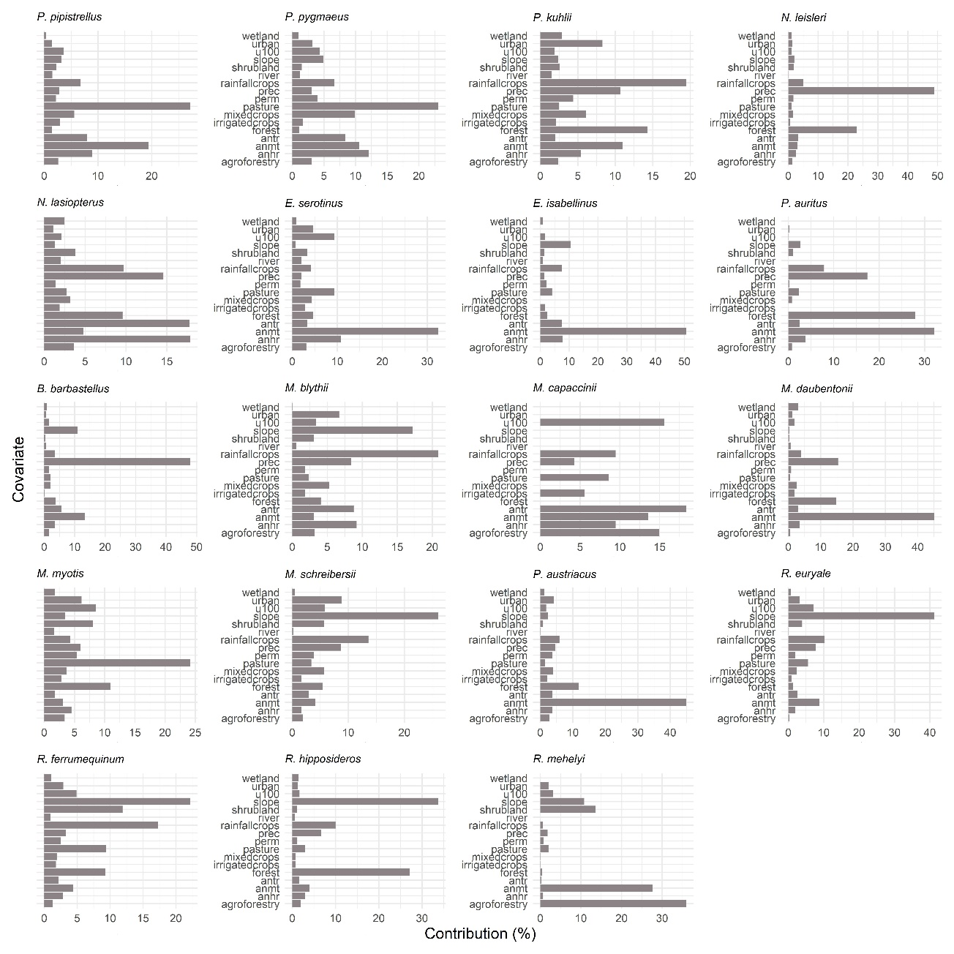
Supplementary Material 5: Descriptive statistics of the probability of interaction between bat boxes users (BBU) species with bat boxes not-users (BNU) species.
 |  | Bat boxes users (BBU)
 |  | B. barbastellus | E. isabellinus | E. serotinus | N. lasiopterus | N. leisleri | P. auritus | P. kuhlii | P. pipisprellus | P. pygmaeus | Mean of means
Bat boxes not user (BNU) | M. daubentonii | 57.2 ± 29.4  (0 – 100) | 41.3 ± 26.9  (0 – 97.3) | 55.2 ± 28.9  (0 – 99.8) | 55.9 ± 28.6  (0 – 99.9) | 55.8 ± 29.3  (0 – 99.6) | 46.4 ± 34.9  (0 – 99.1) | 59.9 ± 24.5  (0 – 99.3) | 48.1 ± 26.3  (0 – 99.3) | 43.6 ± 26.7  (0 – 99.5) | 51.5
Bat boxes not user (BNU) | R. mehelyi | 59.9 ± 27.8  (0 – 98.9) | 54.2 ± 33.3  (0 – 99.6) | 55.8 ± 26.9  (0 – 99.7) | 63.8 ± 27.9  (0 – 99.7) | 59.0 ± 28.0  (0 – 98.6) | 45.2 ± 33.0  (0 – 100) | 66.3 ± 22.3  (0 – 100) | 49.1 ± 24.3  (0 – 100) | 45.4 ± 26.0  (0 – 99.7) | 55.4
Bat boxes not user (BNU) | R. hipposideros | 56.9 ± 28.9  (0 – 99.0) | 43.4 ± 27.8  (0 – 97.9) | 52.2 ± 27.5  (0 – 97.9) | 57.2 ± 27.6  (0 – 98.9) | 55.5 ± 28.7  (0 – 98.3) | 45.3 ± 34.3  (0 – 99.0) | 59.0 ± 23.4  (0.4 – 98.6) | 45.6 ± 24.0  (0.3 – 99.2) | 41.3 ± 24.3  (0.3 – 98.9) | 50.7
Bat boxes not user (BNU) | R. ferrumequinum | 54.2 ± 28.1  (0 – 97.2) | 43.6 ± 28.8  (0 – 99.8) | 51.1 ± 27.4  (0 – 100) | 55.2 ± 27.2  (0 – 99.8) | 53.1 ± 28.1  (0 – 97.9) | 43.4 ± 32.9  (0 – 100) | 57.3 ± 23.8  (0 – 100) | 44.7 ± 24.3  (0 – 100) | 40.9 ± 24.7  (0 – 100) | 49.3
Bat boxes not user (BNU) | R. euryale | 60.7 ± 28.8  (0 – 98.4) | 51.2 ± 31.7  (0 – 99.6) | 57.3 ± 28.0  (0 – 99.2) | 62.4 ± 27.7  (0 – 99.6) | 59.6 ± 28.6  (0 – 98.8) | 47.1 ± 34.9  (0 – 100) | 65.6 ± 22.4  (0.6 – 100) | 49.7 ± 24.6  (0.3 – 100) | 45.4 ± 26.0  (0.4 – 99.6) | 55.4
Bat boxes not user (BNU) | P. austriacus | 59.6 ± 28.8  (0 – 98.7) | 46.2 ± 29.0  (0 – 99.0) | 58.7 ± 28.3  (0 – 99.2) | 59.6 ± 27.6  (0 – 99.3) | 57.0 ± 28.6  (0 – 98.6) | 47.6 ± 35.0  (0 – 99.1) | 63.7 ± 23.1  (0.8 – 99.2) | 50.3 ± 25.8  (0.3 – 99.3) | 46.0 ± 26.8  (0.4 – 99.2) | 54.3
Bat boxes not user (BNU) | M. schreibersii | 60.1 ± 27.6  (0 – 97.8) | 51.4 ± 31.1  (0 – 99.4) | 56.8 ± 27.2  (0 – 99.4) | 62.4 ± 26.6  (0 – 99.5) | 59.0 ± 27.7  (0 – 97.8) | 46.3 ± 33.8  (0 – 99.8) | 65.5 ± 21.3  (0.8 – 99.8) | 49.8 ± 24.4  (0.3 – 99.8) | 46.0 ± 25.9  (0.4 – 99.5) | 55.3
Bat boxes not user (BNU) | M. myotis | 61.8 ± 27.0  (0 – 97.9) | 52.9 ± 30.5  (0 – 99.5) | 59.9 ± 27.0  (0 – 98.4) | 63.9 ± 26.0  (0 – 99.6) | 60.4 ± 27.2  (0 – 97.6) | 47.6 ± 34.1  (0 – 100) | 68.3 ± 19.5  (0.7 – 100) | 52.8 ± 24.9  (0.3 – 100) | 48.7 ± 26.9  (0.4 – 99.9) | 57.4
Bat boxes not user (BNU) | M. cappaccinii | 29.5 ± 28.8  (0 – 98.6) | 31.3 ± 33.3  (0 – 99.9) | 29.9 ± 29.8  (0 – 99.6) | 30.7 ± 29.0  (0 – 98.6) | 28.2 ± 28.3  (0 – 99.4) | 21.8 ± 26.5  (0 – 98.7) | 34.5 ± 31.2  (0 – 99.0) | 24.8 ± 24.0  (0 – 99.2) | 22.9 ± 23.5  (0 – 97.7) | 28.2
Bat boxes not user (BNU) | M. blythii | 65.2 ± 28.4  (0 – 99.1) | 57.3 ± 33.2  (0 – 99.5) | 62.3 ± 27.7  (0 – 99.3) | 68.0 ± 27.3  (0 – 99.4) | 63.6 ± 28.5  (0 – 99.3) | 49.8 ± 35.8  (0 – 99.5) | 72.2 ± 20.1  (0.9 – 99.5) | 54.4 ± 25.3  (0.3 – 99.5) | 50.0 ± 27.2  (0.4 – 99.4) | 60.3

Supplementary Material 6: Probability distribution maps estimated with MaxEnt of bat boxes users (BBU) species.
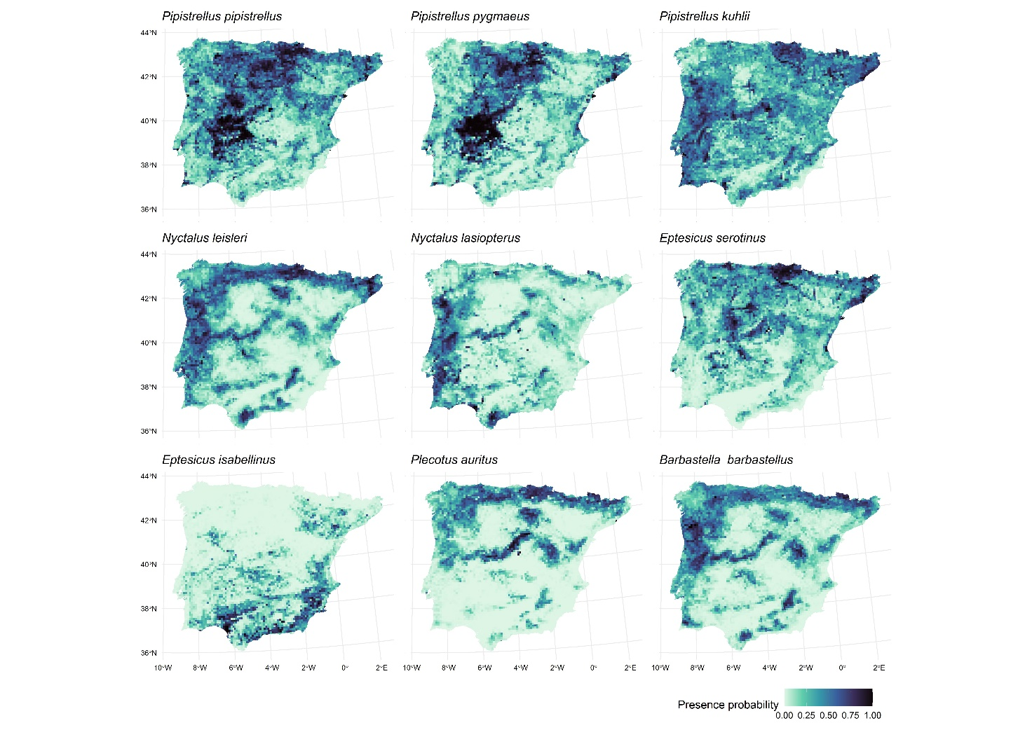

Supplementary Material 7: Environmental favourability distribution maps estimated with MaxEnt of bat boxes users (BBU) species.
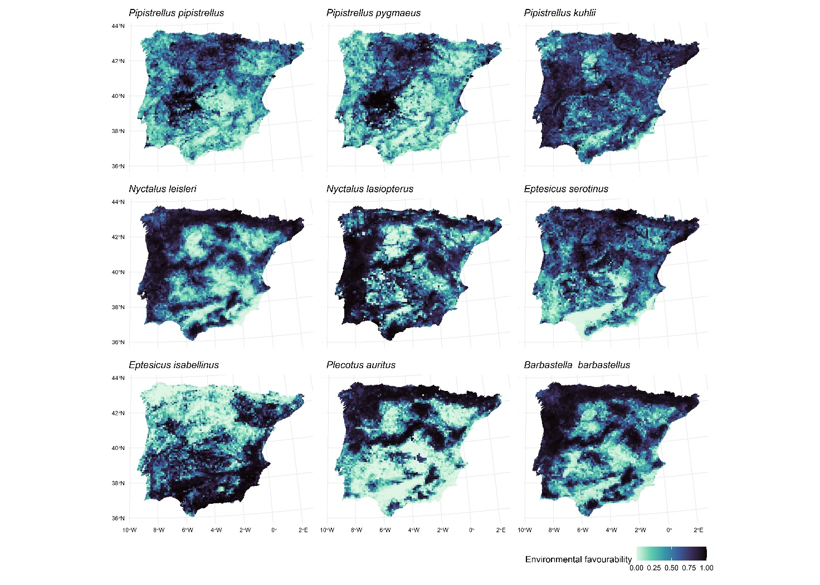

Supplementary Material 8: Probability distribution maps estimated with MaxEnt of bat boxes not users (BNU) species.
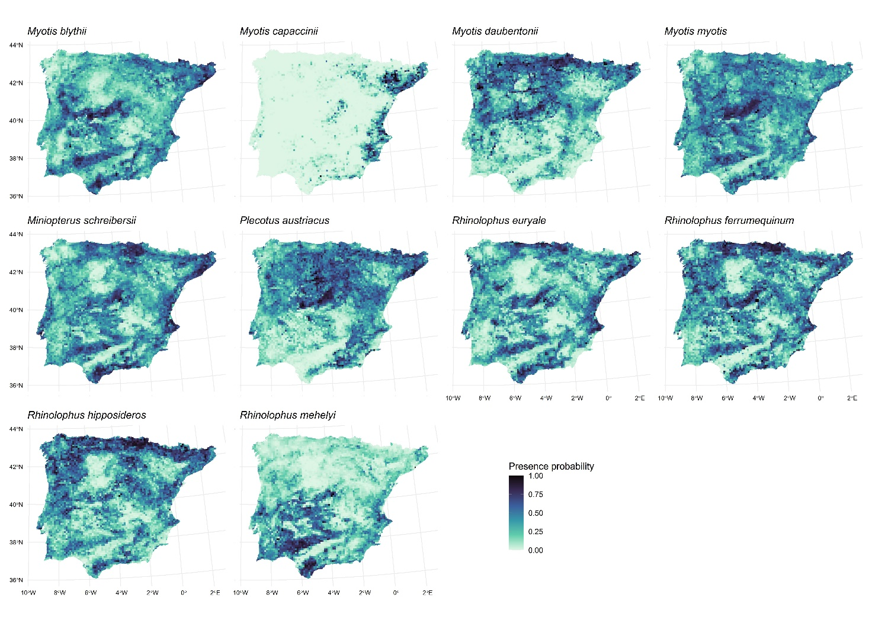

Supplementary Material 9: Environmental favourability distribution maps estimated with MaxEnt of bat boxes not users (BNU) species.
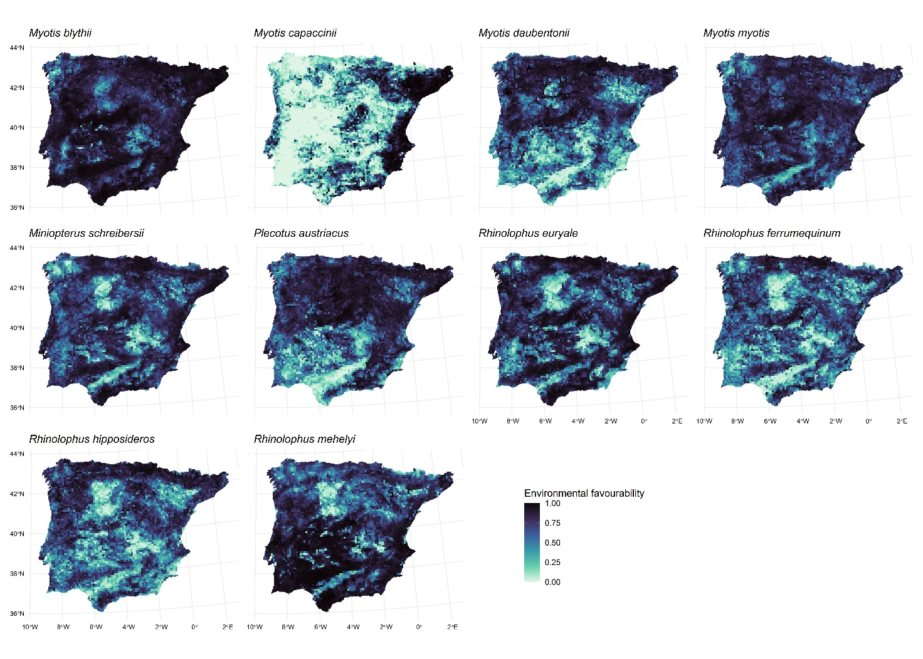

Supplementary Material 10: Geographic distribution of the probability of interaction between Myotis daubentonii and bat-box users.
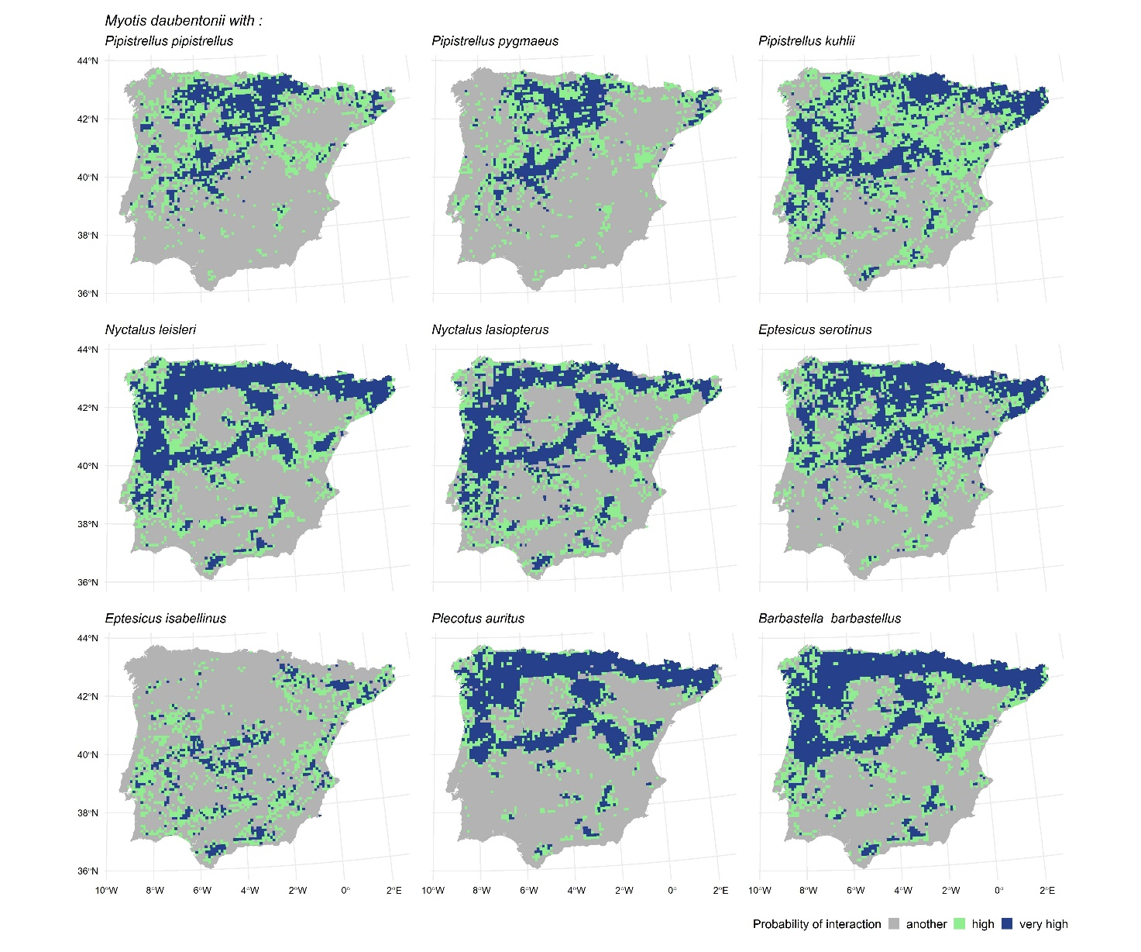

Supplementary Material 11: Geographic distribution of the probability of interaction between Rhinolophus ferrumequinum and bat-box users.
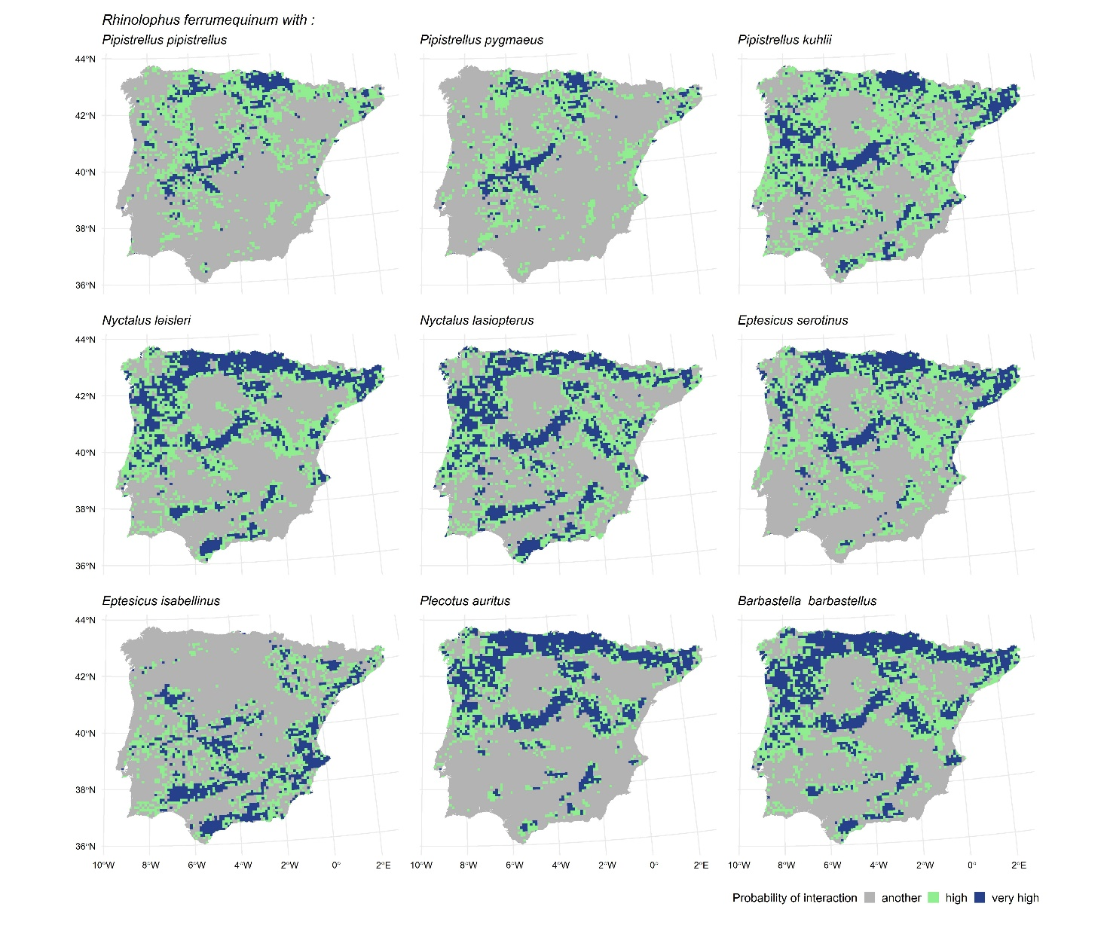

Supplementary Material 12: Geographic distribution of the probability of interaction between Rhinolophus hipposideros and bat-box users.
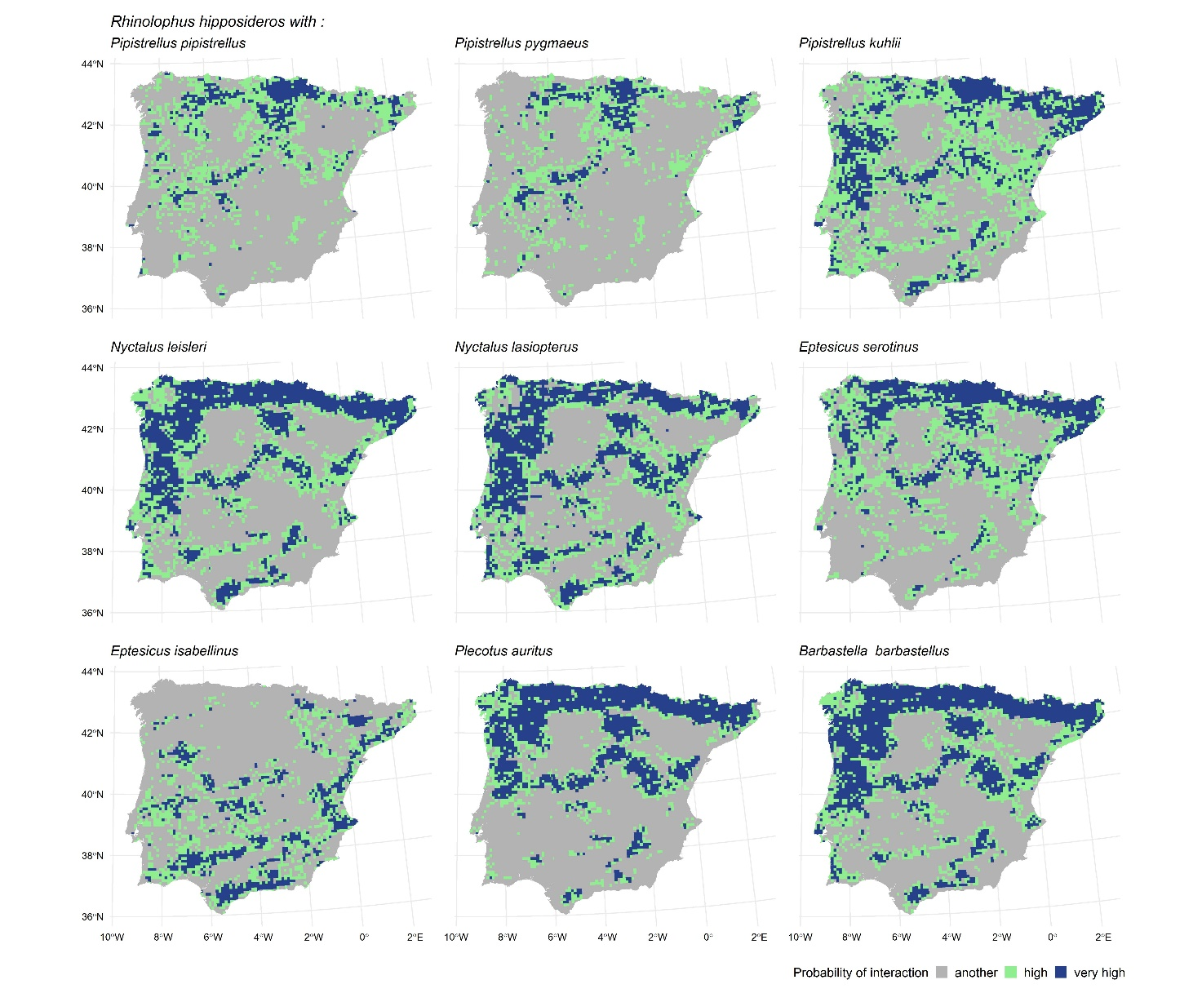

Supplementary Material 13: Geographic distribution of the probability of interaction between Rhinolophus mehelyi and bat-box users.
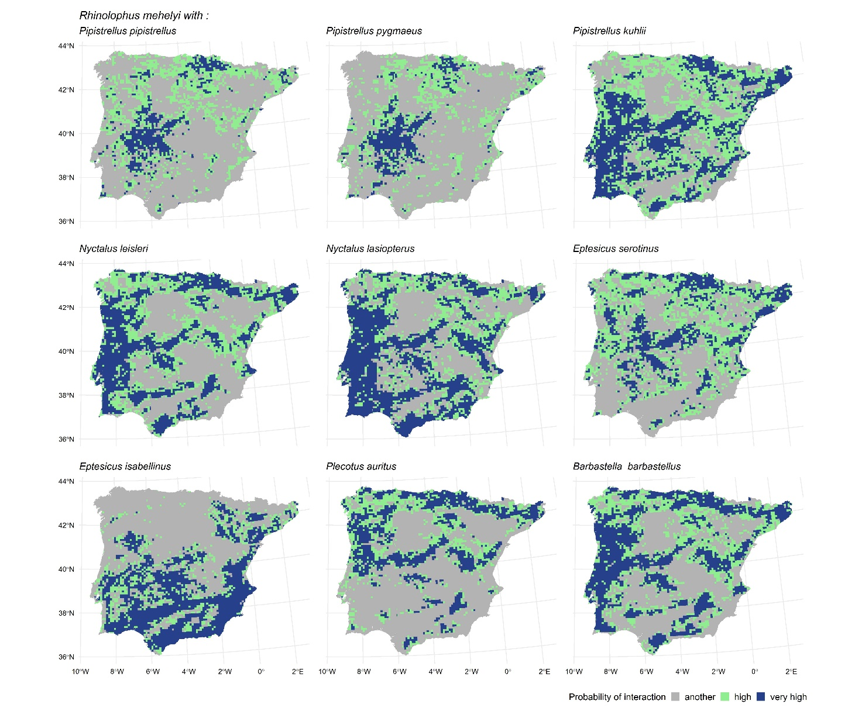

Supplementary Material 14: Geographic distribution of the probability of interaction between Miniopterus schreibersii and bat-box users.
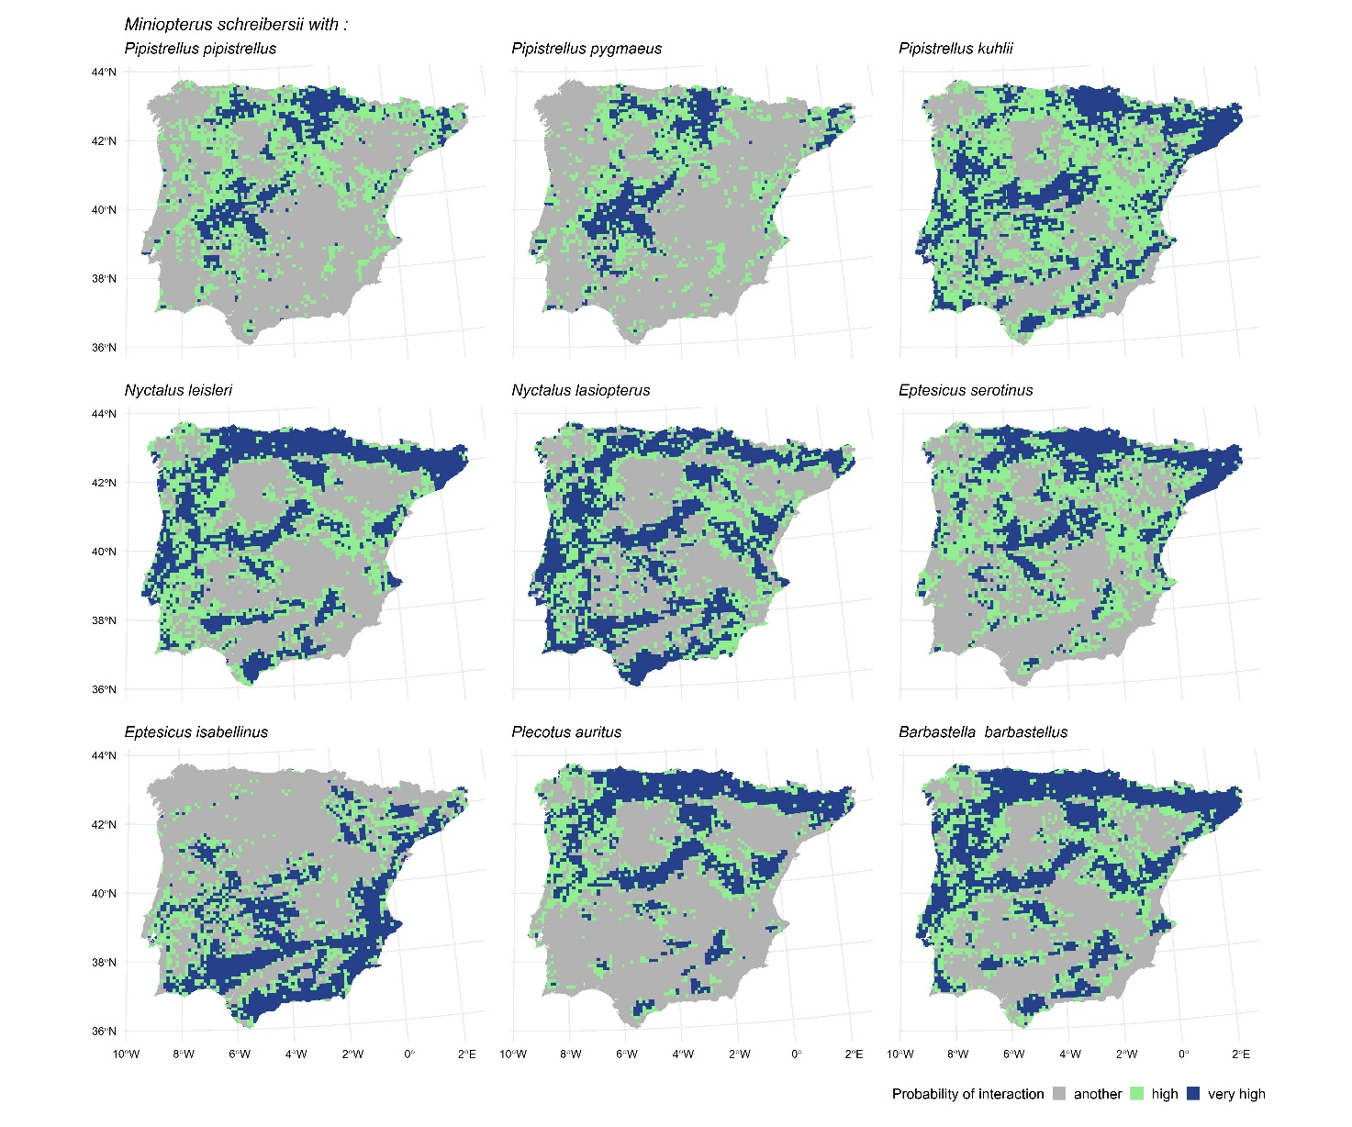

Supplementary Material 15: Geographic distribution of the probability of interaction between Plecotus austriacus and bat-box users.
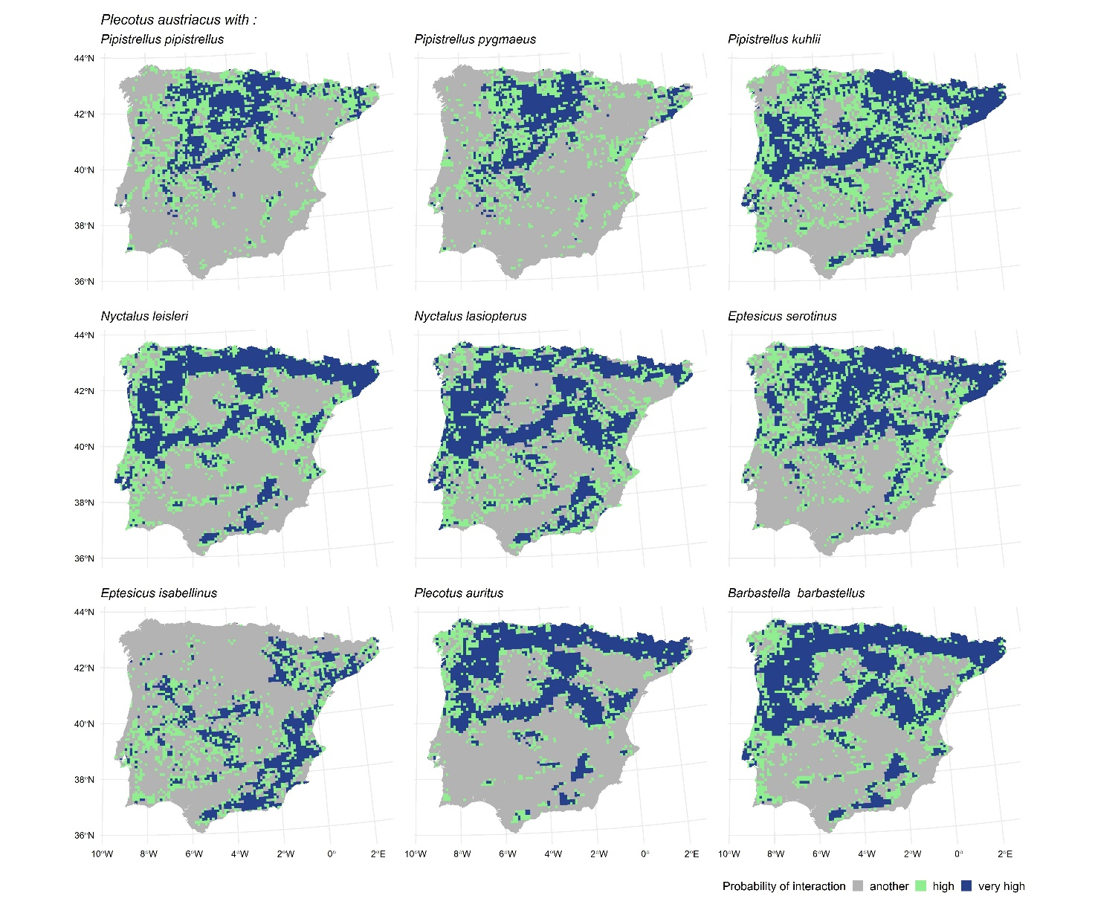

Supplementary Material 16: Geographic distribution of the probability of interaction between Rhinolophus euryale and bat-box users.
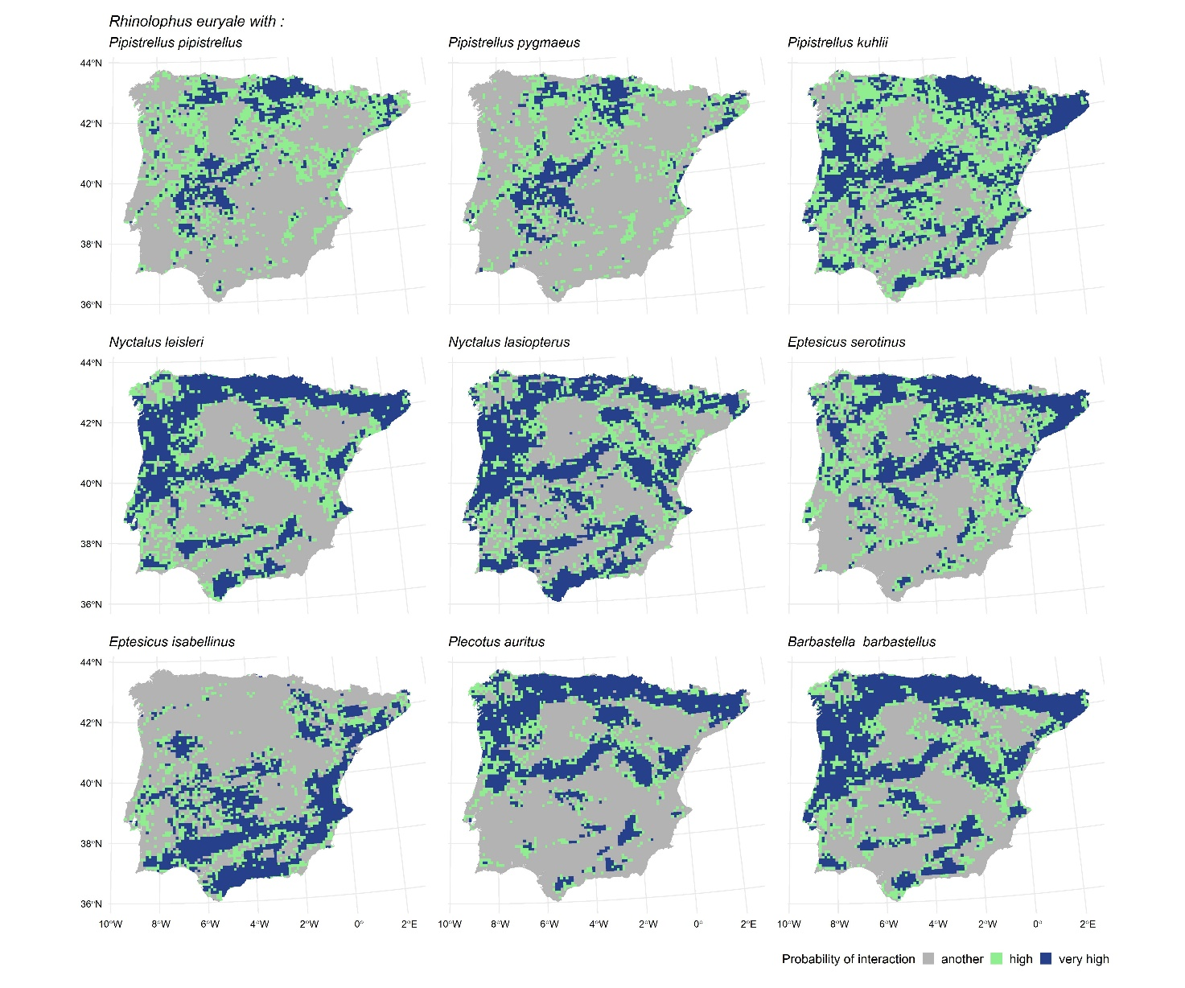

Supplementary Material 17: Geographic distribution of the probability of interaction between Myotis blythii and bat-box users.
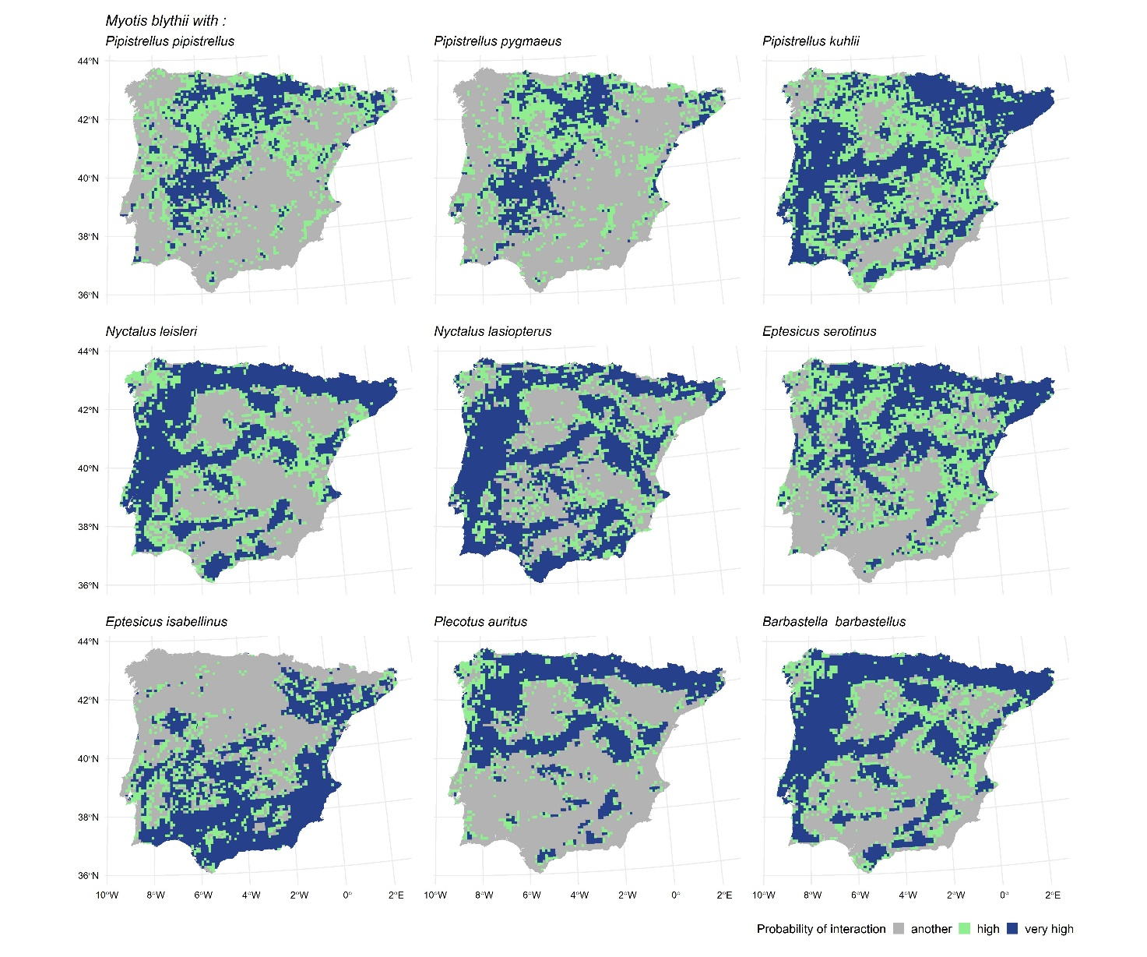

Supplementary Material 18: Geographic distribution of the probability of interaction between Myotis capaccinii and bat-box users.
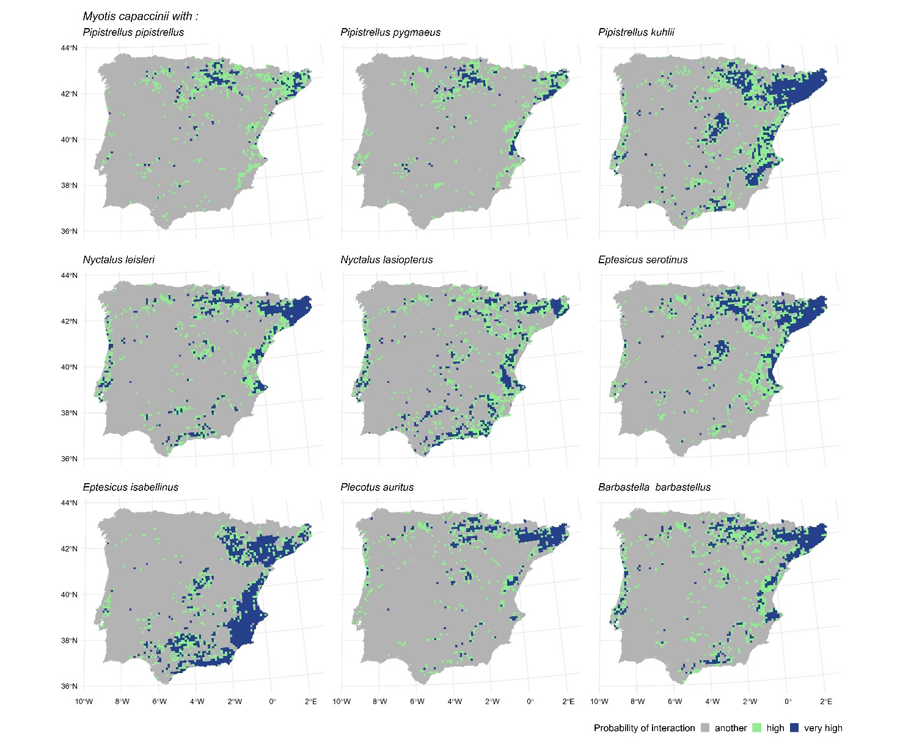

Supplementary Material 19: Geographic distribution of the probability of interaction between Myotis myotis and bat-box users.
