Appendices
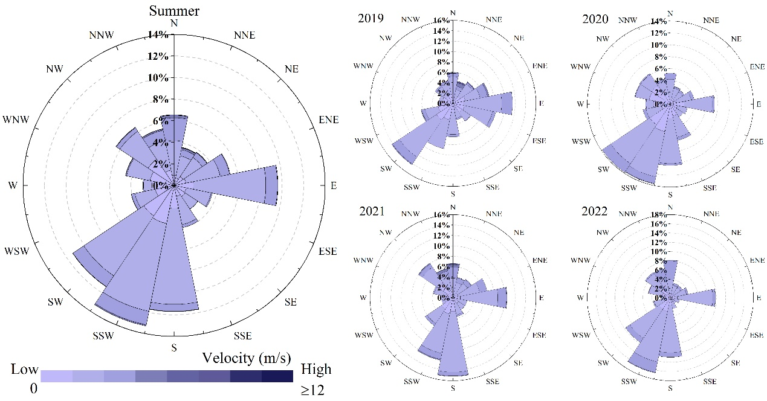
Supplementary Figure 1. Hangzhou summer wind rose diagram. Summer wind direction and wind speed frequency in Hangzhou during 2019-2022.

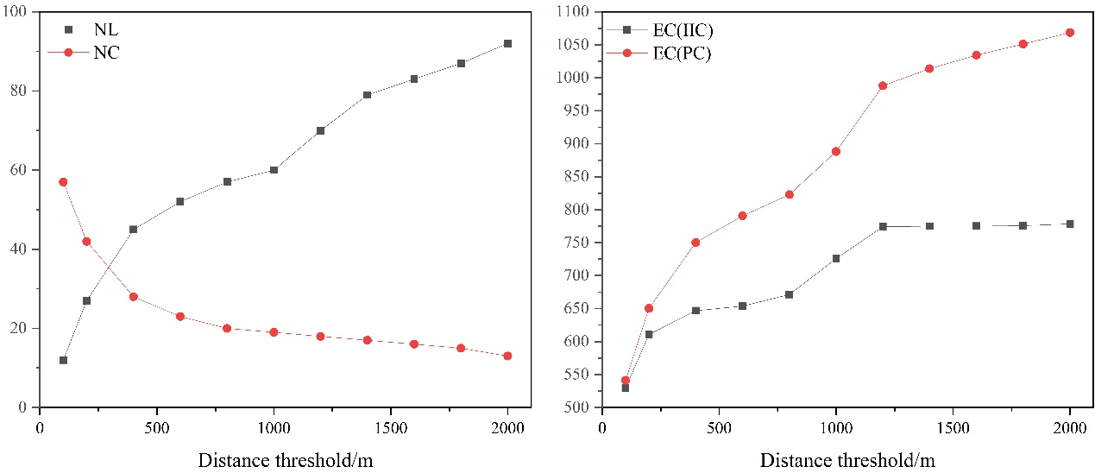
Supplementary Figure 2. The distance gradient map of connectivity indicators. NL, NC, EC(IIC) and EC(PC) are number of links, number of components, equivalent connectivity corresponding to the integral index of connectivity, and equivalent connectivity corresponding to the probability of connectivity.

Supplementary Table 1. Information of cold island source connectivity. IIC and PC are the integral index of connectivity and probability of connectivity.
ID | Area/ha | IIC | PC | Level | ID | Area/ha | IIC | PC | Level
1 | 1.2182 | 0.0002 | 0.0002 | 3 | 36 | 1.0294 | 0.0002 | 0.0001 | 3
2 | 2.1882 | 0.0695 | 0.0862 | 3 | 37 | 1.9401 | 0.1981 | 0.1893 | 3
3 | 1.8712 | 0.0006 | 0.0004 | 3 | 38 | 1.4414 | 0.0772 | 0.0756 | 3
4 | 16.4561 | 0.5358 | 0.4897 | 2 | 39 | 1.2277 | 0.1570 | 0.1968 | 3
5 | 5.2538 | 0.1678 | 0.1897 | 3 | 40 | 3.8101 | 0.2885 | 0.4021 | 2
6 | 1.2597 | 0.0003 | 0.0002 | 3 | 41 | 1.1244 | 0.0002 | 0.0001 | 3
7 | 55.5459 | 5.8894 | 9.6137 | 1 | 42 | 7.5109 | 0.7632 | 0.6850 | 2
8 | 3.6735 | 0.2962 | 0.5104 | 2 | 43 | 52.7985 | 19.0623 | 22.8279 | 1
9 | 2.8246 | 0.2278 | 0.6287 | 2 | 44 | 36.2260 | 0.2315 | 0.1496 | 2
10 | 1.8665 | 0.0006 | 0.0004 | 3 | 45 | 59.2919 | 20.3848 | 33.8174 | 1
11 | 173.7200 | 5.7435 | 3.8066 | 1 | 46 | 1.1742 | 0.0002 | 0.0001 | 3
12 | 1.3749 | 0.0003 | 0.0002 | 3 | 47 | 1.6504 | 0.1233 | 0.1901 | 3
13 | 2.2203 | 0.0043 | 0.0045 | 3 | 48 | 37.8289 | 3.6274 | 4.4473 | 1
14 | 35.2726 | 9.2765 | 14.6372 | 1 | 49 | 1.1707 | 0.1237 | 0.1981 | 3
15 | 1.2954 | 0.0003 | 0.0002 | 3 | 50 | 1.8534 | 0.1692 | 0.1898 | 3
16 | 9.3465 | 0.0180 | 0.0129 | 3 | 51 | 2.7178 | 0.3258 | 0.4498 | 2
17 | 3.1250 | 0.0016 | 0.0010 | 3 | 52 | 9.9354 | 1.2742 | 0.9765 | 2
18 | 2.4554 | 0.0010 | 0.0006 | 3 | 53 | 1.7667 | 0.2258 | 0.2699 | 2
19 | 3.9609 | 0.3370 | 0.4376 | 2 | 54 | 106.6786 | 15.5399 | 18.2788 | 1
20 | 29.1021 | 4.1661 | 5.1478 | 1 | 55 | 1.4996 | 0.1585 | 0.2398 | 3
21 | 1.1600 | 0.0985 | 0.1495 | 3 | 56 | 4.7754 | 0.6455 | 0.8581 | 2
22 | 26.5934 | 2.9708 | 4.1407 | 1 | 57 | 8.3468 | 0.6430 | 0.7221 | 2
23 | 2.7712 | 0.3115 | 1.0276 | 2 | 58 | 1.1849 | 0.1514 | 0.1683 | 3
24 | 14.5232 | 1.6550 | 3.4371 | 1 | 59 | 1.0092 | 0.0787 | 0.1481 | 3
25 | 1.1564 | 0.0002 | 0.0001 | 3 | 60 | 4.2696 | 0.4605 | 0.4172 | 2
26 | 2.0742 | 0.0133 | 0.0155 | 3 | 61 | 81.3972 | 16.4095 | 16.6344 | 1
27 | 3.1939 | 0.0017 | 0.0010 | 3 | 62 | 1.2479 | 0.1414 | 0.1191 | 3
28 | 31.4518 | 2.9796 | 3.0574 | 1 | 63 | 1.1386 | 0.1054 | 0.1146 | 3
29 | 7.0918 | 0.0084 | 0.0052 | 3 | 64 | 2.7391 | 0.3511 | 0.5751 | 2
30 | 3.8801 | 1.1850 | 0.7631 | 2 | 65 | 13.7764 | 2.4163 | 10.1021 | 1
31 | 6.7451 | 0.6433 | 0.9538 | 2 | 66 | 16.9370 | 2.2064 | 2.3642 | 1
32 | 65.9859 | 7.5057 | 10.9433 | 1 | 67 | 3.0466 | 0.5360 | 0.7607 | 2
33 | 3.7092 | 0.2765 | 0.3152 | 2 | 68 | 410.3710 | 64.8295 | 65.2070 | 1
34 | 1.7442 | 0.1699 | 0.2384 | 3 | 69 | 70.0715 | 9.5494 | 12.5338 | 1
35 | 2.7605 | 0.3893 | 0.4678 | 2
Supplementary Table 2. Information of Landsat 8/9 C2L2 data.
Satellite | Data | Cloud cover
Landsat 8 | 2019-08-21 | 4.58
Landsat 8 | 2020-09-08 | 2.21
Landsat 8 | 2021-06-23 | 7.47
Landsat 8 | 2021-09-27 | 0.64
Landsat 8 | 2022-07-28 | 0.98
Landsat 9 | 2022-08-05 | 4.39
Landsat 9 | 2022-09-06 | 0.94

Supplementary Table 3 Calculation of urban form parameters
Index | Formulation | Explanation
Building density (BD) | $$BD= \frac{S_{Build}}{S_{Area}}$$ | $S_{Build}$ is the building base area in the unit grid, $S_{Area}$ is the area of grid
Building height (BH) | $$BH= \frac{\sum_{i=1 }^{N}{H_{I}}}{N}$$ | $H_{I}$ is the height of i buildings in the grid, N is the number of all buildings in the grid

The fraction of vegetation cover (FVC) was derived from the following equation:
$$\begin{aligned}NDVI= \frac{NIR - RED}{NIR + RED}\#\left(A1\right)\end{aligned}$$
$$\begin{aligned}FVC= \frac{NDVI - {NDVI}_{soil}}{{NDVI}_{veg}+ {NDVI}_{soil}}\#(A2)\end{aligned}$$
Where the NIR is the reflectance of the near-infrared band, RED is the reflectivity of the red-light band, the ${NDVI}_{soil}$ is the $NDVI$ value of pure bare ground pixel, the ${NDVI}_{veg}$ is the $NDVI$ value of pure vegetation pixel. In theory, the ${NDVI}_{soil}$ and ${NDVI}_{veg}$ should be close to 0 and 1, respectively. In this study, the upper and lower thresholds of $NDVI$ are intercepted with a 5% confidence level, and the regions with the highest and lowest $NDVI$ values are averaged to obtain ${NDVI}_{soil}$ and ${NDVI}_{veg}$.

