Supplementary Material: Multiple time scale complex dynamics in nonlinear time-delayed optoelectronic oscillator
Dengfei Tang,^{1,2} QiuYi Lu,³ En Liang,^{1,2} HaiBin Zhao,^{1,2} and Ziwei Li³
¹Department of Physics, State Key Laboratory of Surface Physics, Fudan University, Shanghai 200433, China.
²Key Laboratory of Micro and Nano Photonic Structures (Ministry of Education), and Shanghai Ultra-precision Optical Manufacturing Engineering Research Center, Department of Optical Science and Engineering, Fudan University, Shanghai 200433, China.
³Key Laboratory for Information Science of Electromagnetic Waves (MoE), Fudan University, Shanghai 200433, China.
(*Electronic mail: hbzhao@fudan.edu.cn and lizw@fudan.edu.cn)

S1. Intermittent switch from sinusoidal to square-wave
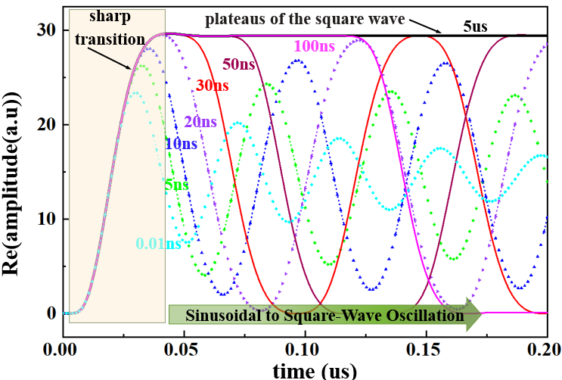
Fig. 1. time traces of the progressive transformation from sinusoidal to square-wave oscillation as different $τ_{D}$
In the study of the underlying mechanism of the transformation process of dynamic, we numerically analysis the time traces of the possible time delays and show that the both sinusoidal and square-wave oscillations emerge from a sharp transition essentially. As illustrated in Fig.1, taking $2τ_{D}$period dynamic regime C as the object of discussion, as the $τ_{D}$ increases from 0.01ns to 5us the oscillations progressively change from sinusoidal oscillation to square wave oscillation. When the delay time is small enough, time traces concentrate on the fast transition layers. Therefore, the sinusoidal oscillations originate from the rising edge of the sharp transition at 0.01 to 20 ns. As the delay time gradually increases, the plateaus of the square wave are connected by fast transition layers on time intervals which is proportional to $ε$ and fast transition layers contribute to the total period at each time delay. As a consequence, the square-wave oscillations then consist of sharp transition layers of a size proportional to $ε$, obviously, the effect of this item is ignored when the time delay is long enough, it’s clear the output waveform is getting closer to a perfect square wave when the time delay exceeds 30ns.
Fig. 2. effects of system response time

Moreover, we extended the integral response time of the feedback electronic circuit by cascading the RF amplifier 16 times. The inset in Fig. 2 serves as an enlargement of the system’s output, which is not merely a simple translation at different response times. This implies that the occurrence of the bifurcation phenomenon is not only related to the normalized parameter but also to the ratio between the different time scales of the system and the integro-differential dynamical property of the feedback loop. Effectively, this phenomenon indicates that both the sinusoidal oscillations and the quasi-square-wave were essentially born in different positions of the same steady state, and periodic solutions are generated by repeated iterations of the system.

S2 Periodic Modulation of bifurcation diagram
We use a standard Euler integration method to simulate delayed equation of the system’s response at different biases$V_{B}$for various dynamic regimes A-F. Based on our observations, the common feature between these orbits is that they admit a similar envelope of the nonlinear transmission function of the MZM, bifurcation diagram of all dynamic regimes A-F periodic modulation by bias voltage $V_{B}$ for both large and small delays. As illustrated in Fig.3. (a) and (b), when the incident power is low (dynamic regime A), the fundamental bifurcation diagram with large and small are exactly the same, in the course of the transition from regime A to B, there appears an upper branch and a low branch with traces of periodic structure successively which started from the portion of the fixed point at $V_{B}$=6 and there has a clear-cut boundary. For higher powers, the noticeable difference in behavior between large and small delays within chaotic regime E is the periodicity windows of the bifurcation diagram, one can distinguish many different period windows at large delay regimes D and E: period-two, period-three and period-four regimes have been observed which is much more than the small case. These periodicity windows are more abundant in contrast to a discrete-time nonlinear delay oscillator which was discussed in Ref¹. Moreover, the periodicity windows of the harmonic solutions realized by changing have their limit, when power is further increased to F and G the periodicity windows dribble away.
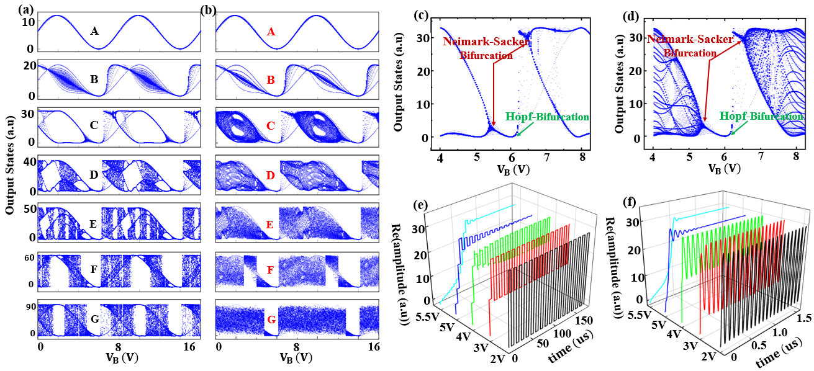
Fig. 3. (a) (b) periodic modulation of bifurcation diagram of large and small delays of different biases for various dynamic regimes A-F (c) (d) bifurcation diagram at dynamic regimes C of large and small delays. (e)(f) time traces for large time-delay scales 5us and small time-delay 5ns
Finally, we further discuss the bifurcation diagram and time traces under different bias voltage. On the one hand, it’s noteworthy that both Hopf bifurcations and Neimark-Sacker bifurcations sequentially appear from regime A to C for both large and small times delay as the bias voltage progressively increased from 4 to 8 V. In the course of the transition, an upper branch and a low branch with traces of periodic structure successively appear, starting from the portion of the fixed point a = 6V as Hopf bifurcations point and there has a clear-cut boundary which are illustrated respectively in Fig.3(c) and (d). Subsequently, dynamic regimes A-C show periodic modulation by bias voltage for both large and small delay. On the other hand, those time traces of large delay (5us) reproduced the behaviors observed at Ref ² fairly well as shown in Fig. 3(e), where is fixed at the half-transmission point while it is tunable by varying the bias voltage in our case. In comparison, various time traces of small-time delays (5ns) display that the system has yet undergone the similar dynamic behavior and bifurcation process as shown in Fig. 3(f) indicating that the nonlinear behavior of different time scales is ubiquitous in nature. To our knowledge the reported periodically modulated bifurcation phenomena have not been reported in the already published literature on the OEO.

References
1. Larger, L., Lacourt, P. A., Poinsot, S. & Hanna, M. From flow to map in an experimental high-dimensional electro-optic nonlinear delay oscillator. Phys Rev Lett 95, 4 (2005).
2. Chembo, Y. K., et al. Dynamic instabilities of microwaves generated with optoelectronic oscillators. Opt Lett 32, 2571-2573 (2007).

