Annex

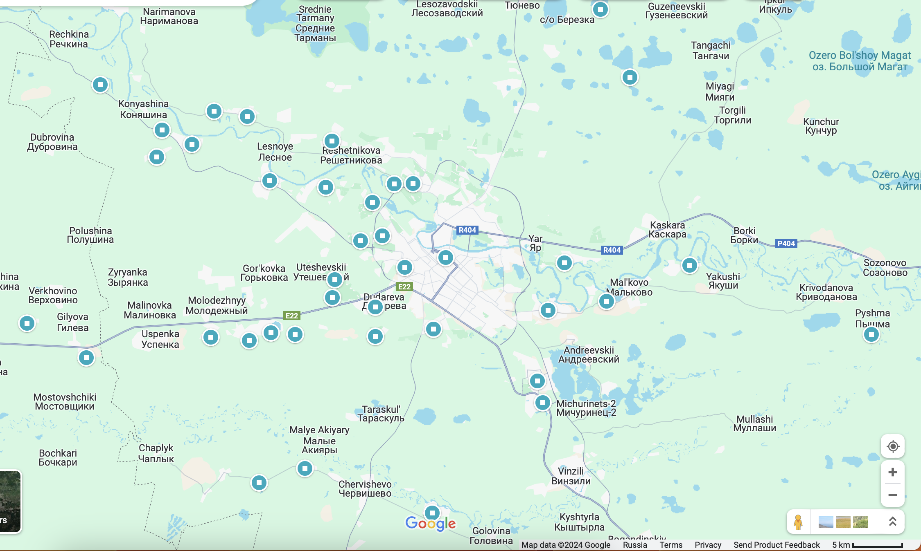
Figure 1. Sampling map (schematic map), Tyumen urban agglomeration, N=139 samples, 1 : 500000

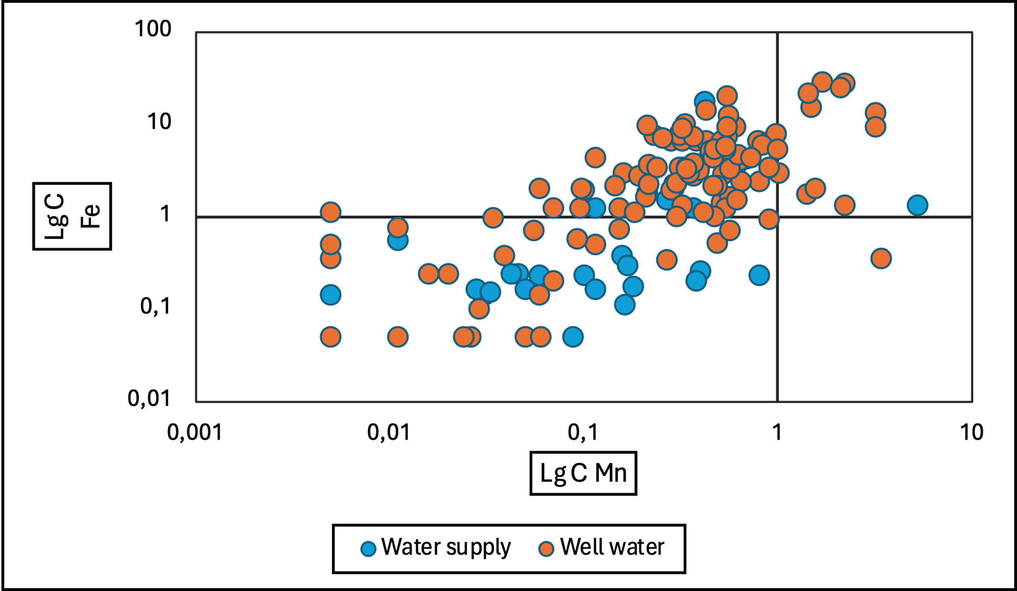
Figure 2. Fe-Mn correlation in water supply and well water, Tyumen oblast’, Lg C, ppm

Figure 3. Spearman rank correlation results
Note: PI - permanganate index, oxidation of organic molecules by KMnO₄, HW – hardness of water

Figure 4. Principle components factor loadings analysis, unrotated
Note: PI - permanganate index, oxidation of organic molecules by KMnO₄, HW – hardness of water

Table 2. Concentration of Fe, Mn in surface water according to the literature review
Fe, ppm | Mn, ppm | Region | Reference
1.4 | 0.2 | Tyumen, well | Current study
0.3 | 0.1 | Tyumen, water supply | Current study
5.6 | 0.4 | Sakha Republic | [8]
0.6 | 0.04 | Njagan', Neftejugansk | [4]
0.1 | 0.01 | Tomsk Oblast' | [6, 12]
- | 2 | Tymen oblast', Ertys | [3]
0.3 | 0.02 | Yuznouralskoe reservoir | [14]
0.5 | 0.1 | Pavlovsk water reservoir | [9]
1.4 | 0.1 | Novodvinsk | [7]
8.7 | 22 | Perm' | [19]
126 | 23 | Bratsk reservoir | [17]
19 | 2.9 | Source of the Angara River | [18]
1.7 | 0.8 | Sak-Elga river | [5]
332 | 15 | Pechora River | [20]
54 | 5.8 | Kola river | [15]
0.1 | 0.01 | Murmansk Oblast | [13]
0.4 | 0.02 | Novosibirsk water reservoir | [10]
1.1 | 0.4 | Angara river | [16]
0.5 | 0.1 | Lake Baikal | [18]
0.7 | 0.1 | Saint Petersburg rivers | [11]
0.0004 | 0.0001 | Baikal water quality standard | [1]
0.06 | 5.1 | Kareliya | [2]

Table 3. Freshwater ecotoxicity characterization factor derived from the USEtox model. [PAF*m³/day/kg_{emitted}]
N | Chemical | CF eco | N | Chemical | CF eco
1 | Mn | 1.6E+04 | 2 | Fe | 3.5E+05

REFERENCES
1. Aleksandrovich K. A. [i dr.]. Osobennosti povedeniya himicheskih elementov v sisteme voda-poroda rajona razrabatyvaemogo kar'era butovogo kamnya v pitkyarantskom rudnom rajone (Kareliya).
2. Vetrov V. A., Kuznecova A. I., Sklyarova O. A. Bazovye urovni himicheskih elementov v vode ozera Bajkal // Geografiya i prirodnye resursy. 2013. (3). C. 41–51.
3. Kornienkova A. A., Akat'eva T. G. Kachestvo vody rek irtyshskogo bassejna v predelah Tyumenskoj oblasti Tyumen': Gosudarstvennyj agrarnyj universitet Severnogo Zaural'ya, 2023.C. 123–128.
4. Minyajlo L.A., Korchina T.YA., Korchin V.I. Korrelyacionnye svyazi mezhdu soderzhaniem himicheskih elementov v volosah u zhitelej Nyagani i Nefteyuganska i ih koncentraciej v pit'evoj vode // Medicinskaya nauka i obrazovanie Urala. 2019. (3). C. 19–24.
5. Nohrin D. YU., Davydova N. A. Himicheskij sostav i kachestvo vody reki Sak-Elga (CHelyabinskaya oblast') v 2016 g // Ekologiya, prirodopol'zovanie i resursy Urala. 2019. № 2 (2). C. 14–20.
6. Pasechnik E. YU. [i dr.]. Himicheskij sostav rodnikov kak indikator prirodno-tekhnogennoj evolyucii gorodskoj ekosistemy (na primere goroda Tomska, yugo-vostok zapadnoj Sibiri) // Bulletin of the Tomsk Polytechnic University Geo Assets Engineering. 2022. № 7 (333). C. 195–206.
7. Unguryanu T. N. Risk dlya zdorov'ya naseleniya pri kompleksnom dejstvii veshchestv, zagryaznyayushchih pit'evuyu vodu // Ekologiya cheloveka. 2011. (03). C. 14–20.
8. YAzikov E.G. [i dr.]. Izvestiya Tomskogo politekhnicheskogo universiteta. Inzhiniring georesursov. 2021. T. 332. № 2.
9. Abdrakhmanov R. F., Shkundina F. B., Poleva A. O. Hydrochemical and hydrobioloigical regime of the Pavlovskoe Reservoir // Water Resources. 2014. № 1 (41). C. 87–96.
10. Bobrov V. A., Leonova G. A., Malikov Y. I. Geochemical features of the silt sediment of the Novosibirsk Reservoir // Water Resources. 2009. № 5 (36). C. 525–537.
11. Chukaeva M., Petrov D. Assessment and analysis of metal bioaccumulation in freshwater gastropods of urban river habitats, Saint Petersburg (Russia) // Environmental Science and Pollution Research. 2023. № 3 (30). C. 7162–7172.
12. Kolubaeva Y. V., Ivanova I. S., Shirokova L. S. Assessment of risk for the development of non-cancirogenic effects in using water from non-centralized water suppliers in the Tomsk region // Hygiene and sanitation. 2022. № 9 (101). C. 1111–1118.
13. Matveeva V. A. [i dr.]. Manganese Pollution in Mining-Influenced Rivers and Lakes: Current State and Forecast under Climate Change in the Russian Arctic // Water (Switzerland). 2022. № 7 (14).
14. Nokhrin D. Y. [i dr.]. The structure of the variability of the hydrochemical composition of water in lake-type reservoir // Scientific Notes of V.I. Vernadsky Crimean Federal University. Biology. Chemistry. 2021. № 2 (7 (73)). C. 117–133.
15. Pekka L. [i dr.]. Assessing pollution in the Kola river, northwestern russia, using metal concentrations in water and bryophytes. 2008.
16. Poletaeva V. I., Pastukhov M. V., Dolgikh P. G. Trace Element Compositions and Water Quality Assessment in the Angara River Source (Baikal Region, Russia) // Water. 2022. № 21 (14). C. 3564.
17. Poletaeva V. I., Pastukhov M. V., Tirskikh E. N. Dynamics of Trace Element Composition of Bratsk Reservoir Water in Different Periods of Anthropogenic Impact (Baikal Region, Russia) // Archives of Environmental Contamination and Toxicology. 2021. № 3 (80). C. 531–545.
18. Sklyarova O. A. Distribution of trace elements in the water column of middle Baikal // Geography and Natural Resources. 2011. № 1 (32). C. 34–39.
19. Ushakova E. [i dr.]. Impact of Wastewater on Water Quality and Fish Community in the Tolych River, Perm Krai, Russia // Pollution. 2023. № 2 (9). C. 459–476.
20. Yakovlev E. [i dr.]. Trace metals in surface water of the Pechora River and its tributaries: Content, water quality and risks assessment (Arctic Ocean basin) // Marine Pollution Bulletin. 2023. (194). C. 115317.

