Supplement Table 3. Self-Efficacy for Managing Chronic Disease 6-Item Scale

Please select a number below that reflects your self-confidence in completing these tasks. “1” stands for “no confidence” and “10” stands for “full confidence”.

1 How confident are you that you can keep the fatigue caused by your disease from interfering with the things you want to do?

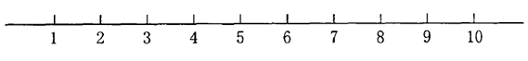

2 How confident are you that you can keep the physical discomfort or pain of your disease from interfering with the things you want to do?
3 How confident are you that you can keep the emotional distress caused by your disease from interfering with the things you want to do?
4 How confident are you that you can keep any other symptoms or health problems you have from interfering with the things you want to do?
5 How confident are you that you can do the different tasks and activities needed to manage your health condition so as to reduce you need to see a doctor?
6 How confident are you that you can do things others than just taking medication to reduce how much your illness affects your everyday life?

