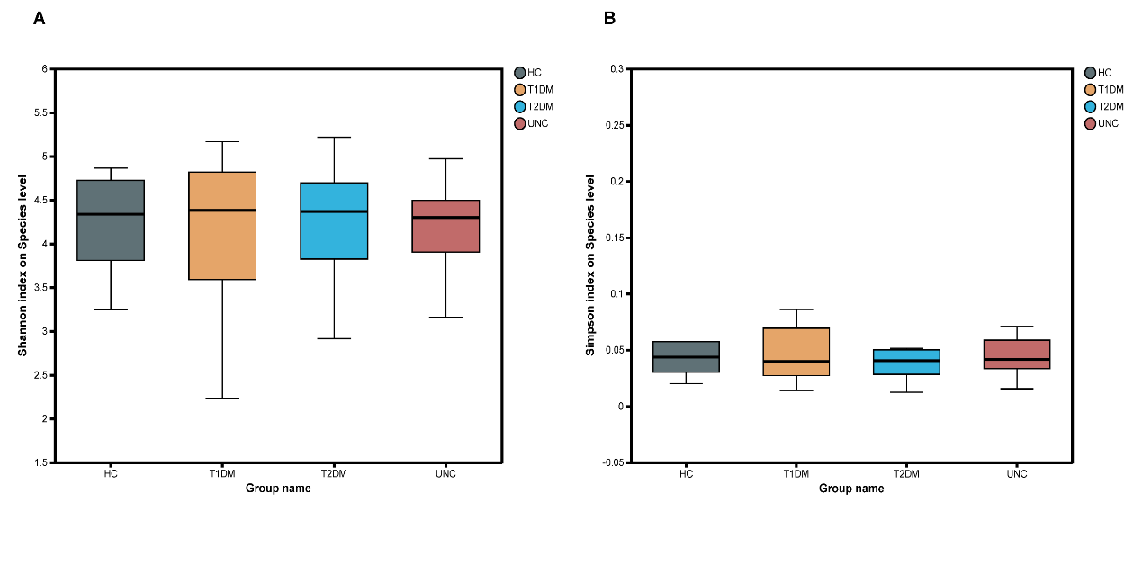
Supplementary Figure 1. The microbial community richness and diversity between groups (Shannon index and Simpson index).

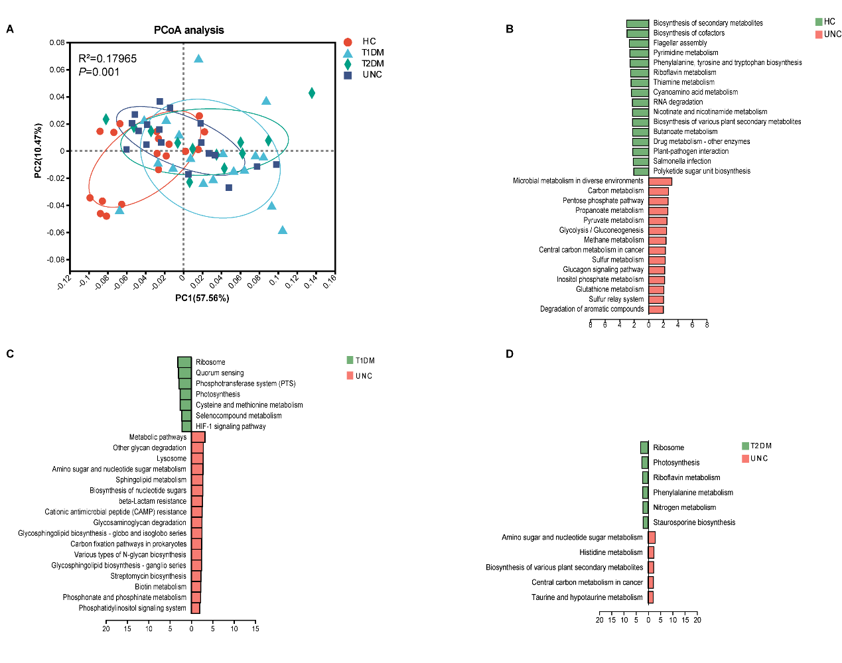
Supplementary Figure 2. Alterations in gut microbiota functionality.
A. Principal coordinate analysis (PCoA) analysis based on PERMANOVA (p = 0.001). B-D. KEGG pathway analysis of differentially abundant gut microbiota between patients with adult-onset UNC and HC (B), between patients with adult-onset T1DM and UNC (C), and between patients with adult-onset T2DM and UNC (D). Pathways with LDA value > 2 and P < 0.05 were considered differentially abundant. KEGG, Kyoto Encyclopedia of Genes and Genomes; HC, healthy control; T1DM, type 1 diabetes mellitus; T2DM, type 2 diabetes mellitus; UNC, unclassified diabetes; LDA, linear discriminant analysis.
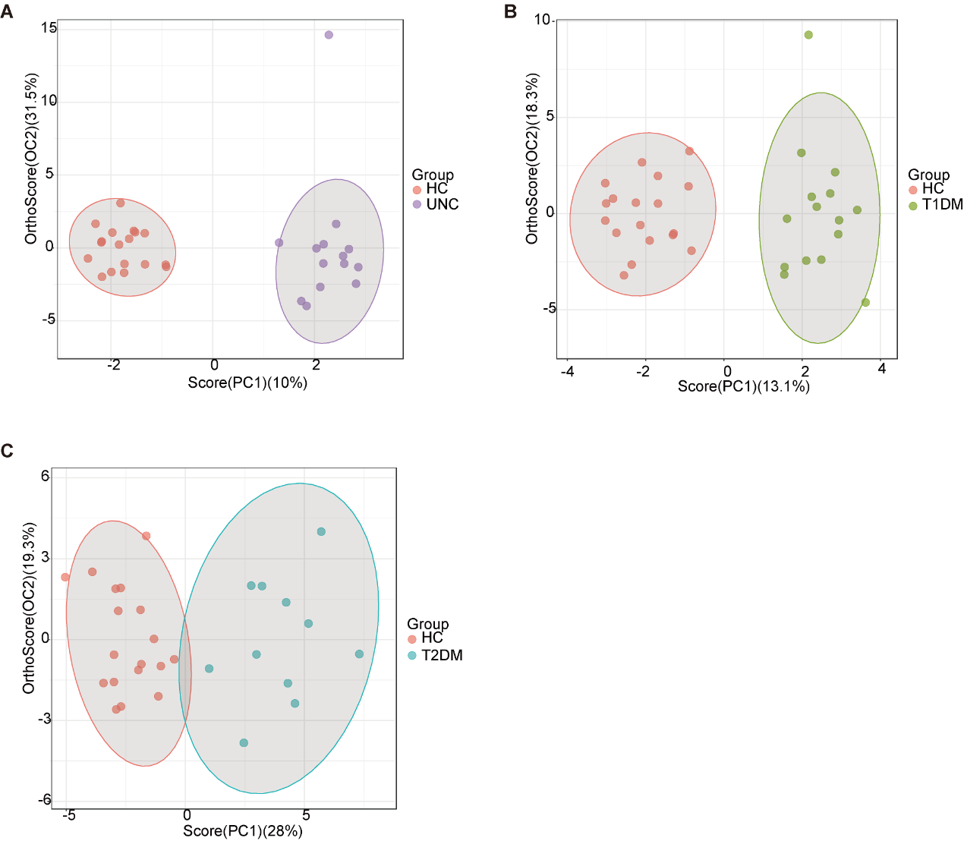
Supplementary Figure 3. Profiles of serum metabolites.
Profiles of serum metabolites between HC and UNC(A) or T1DM(B) or T2DM group(C).
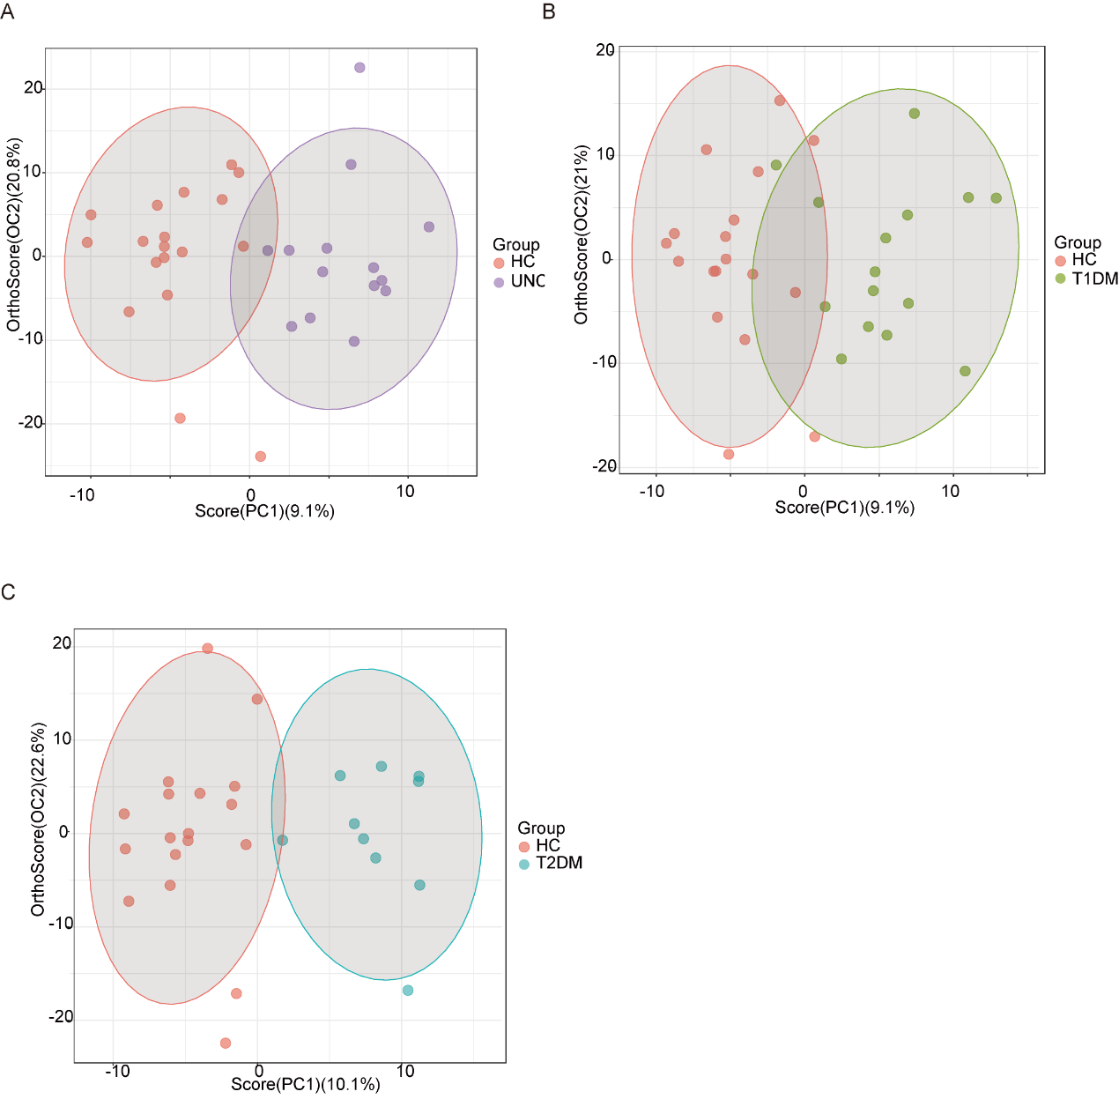
Supplementary Figure 4. Profiles of lipids.
Profiles of lipids between HC and UNC(A) or T1DM(B) or T2DM(C) group.

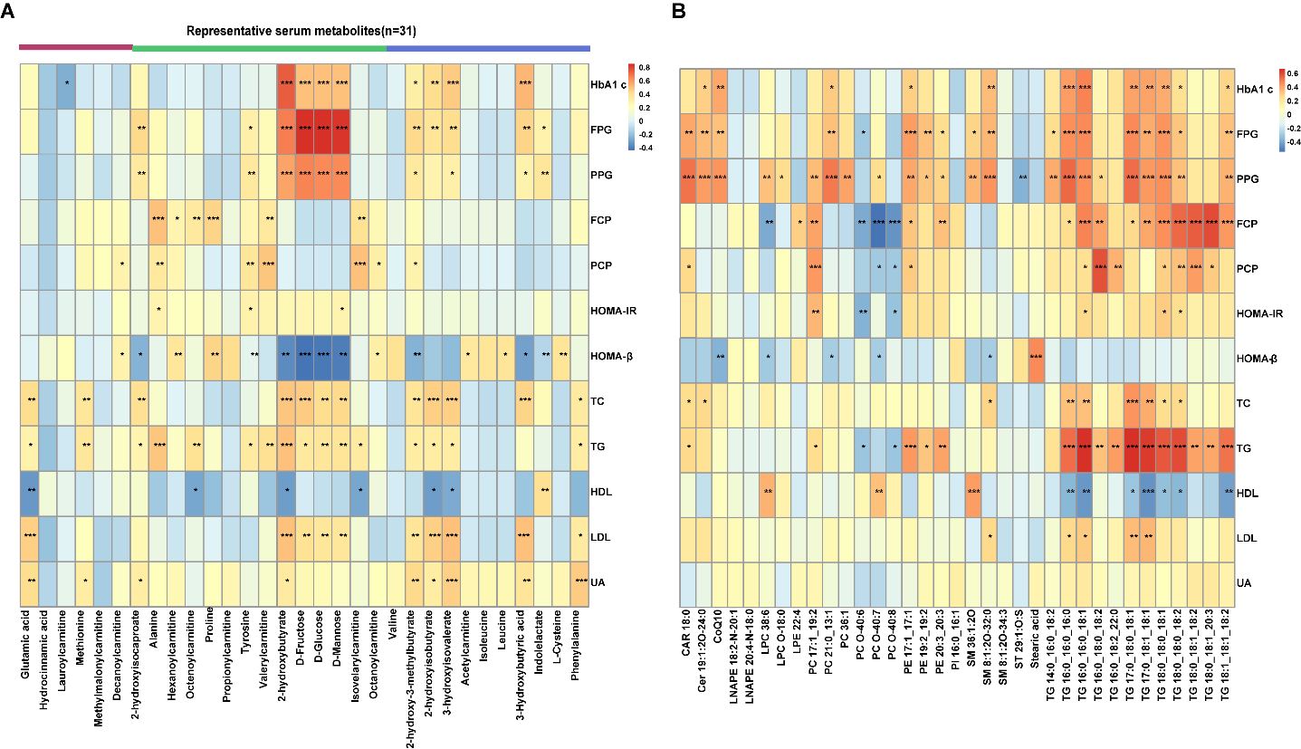
Supplementary Figure 5. Association analysis of serum metabolites, lipids, and clinical parameters.
Associations of serum metabolites (A) and serum lipids(B) and clinical parameters in patients. Correlations were calculated with Spearman’s correlation analysis. FBG, fasting blood glucose; PBG, postprandial blood glucose; HbA1c, hemoglobin A1c; FCP, fasting C-peptide; PCP, postprandial C-peptide; HOMA2-B, homoeostasis model assessment 2 estimates of β-cell function; HOMA2-IR, homoeostasis model assessment 2 estimates of insulin resistance.
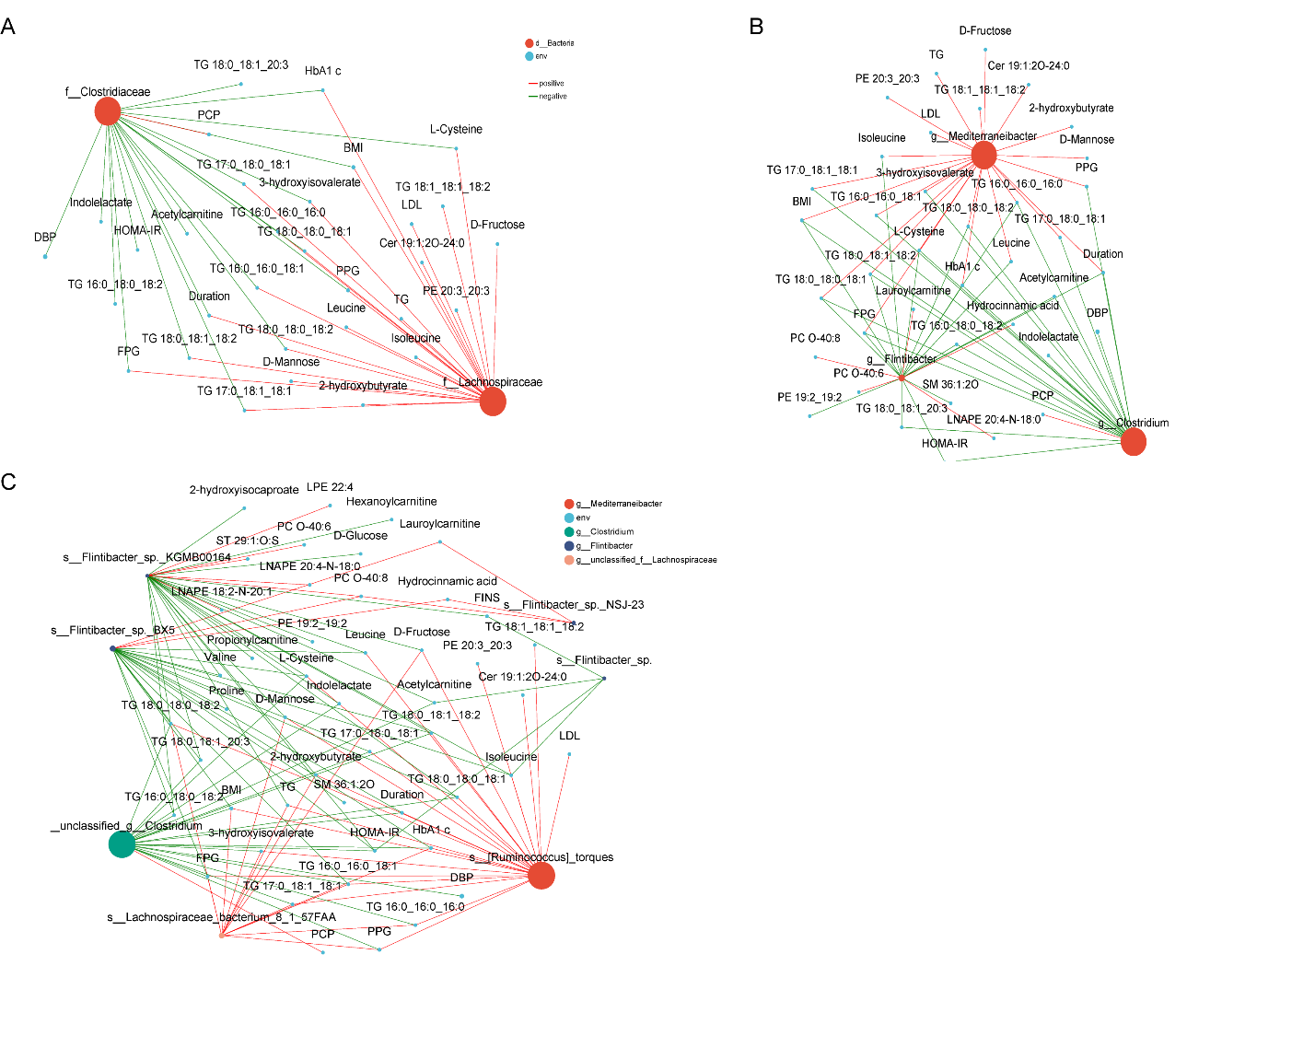
Supplementary Figure 6. Correlations among gut microbiota, host serum metabolites, and host clinical phenotypes in the context of UNC.
A. Gut microbiota in family level. B. Gut microbiota in genus level. C. Gut microbiota in species level. Red lines indicate positive correlations (P Value <0.05), and blue lines indicate negative correlations (P Value<0.05). PCP, 2-h postprandial C-peptide; PPG, 2-h postprandial glucose; FCP, fasting C-peptide.

Supplementary Table 1. The bacteria differentially abundance between patients with adult-onset HC and UNC.
Species | Mean relative abundance |  | Lefse Analysis
Species | HC-Mean(%) | UNC-Mean(%) | LDA score | Pvalue
f__Actinomycetaceae | 0.01098 | 0.07199 | 2.495975492 | 0.026780526
f__Akkermansiaceae | 0.8751 | 0.05825 | 3.620595632 | 0.014843617
f__Akkermansiaceae.g__Akkermansia | 0.8748 | 0.05824 | 3.620405303 | 0.014843617
f__Akkermansiaceae.g__Akkermansia.s__Akkermansia_muciniphila | 0.7825 | 0.02638 | 3.586935029 | 0.014843617
f__Akkermansiaceae.g__Akkermansia.s__Akkermansia_sp_ | 0.02583 | 0.001436 | 2.092848493 | 0.000350011
f__Akkermansiaceae.g__Akkermansia.s__unclassified_g__Akkermansia | 0.02076 | 0.0006865 | 2.034087078 | 0.003924049
f__Atopobiaceae.g__Olsenella.s__Olsenella_sp__AF21_51 | 0.0003568 | 0.02232 | 2.140508927 | 0.04897207
f__Bacteroidaceae.g__Bacteroides.s__Bacteroides_faecis | 0.0915 | 0.04348 | 2.478548204 | 0.039733481
f__Bacteroidaceae.g__Bacteroides.s__Bacteroides_plebeius_CAG_211 | 0.08962 | 0.0128 | 2.578343454 | 0.036784523
f__Bacteroidaceae.g__Bacteroides.s__Bacteroides_sp__CAG_530 | 0.02684 | 0.00128 | 2.199597643 | 0.008639386
f__Bacteroidaceae.g__Bacteroides.s__uncultured_Bacteroides_sp_ | 0.04653 | 0.02673 | 2.066249756 | 0.036784523
f__Bacteroidaceae.g__Phocaeicola.s__Phocaeicola_plebeius | 3.15 | 0.4657 | 4.119282321 | 0.005913164
f__Bacteroidaceae.g__unclassified_f__Bacteroidaceae.s__Bacteroidaceae_bacterium | 0.08106 | 0.04349 | 2.332170766 | 0.014843617
f__Barnesiellaceae.g__Coprobacter.s__Coprobacter_fastidiosus | 0.1215 | 0.01372 | 2.711596215 | 0.017649281
f__Bifidobacteriaceae | 0.4151 | 2.299 | 3.97645362 | 0.042880675
f__Bifidobacteriaceae.g__Bifidobacterium | 0.4037 | 2.226 | 3.960402873 | 0.036784523
f__Bifidobacteriaceae.g__Bifidobacterium.s__Bifidobacterium_longum | 0.0871 | 0.5327 | 3.346513077 | 0.016193118
f__Bifidobacteriaceae.g__Gardnerella | 0.000539 | 0.02721 | 2.228763508 | 0.042827149
f__Bifidobacteriaceae.g__Gardnerella.s__Gardnerella_vaginalis | 0.0004673 | 0.02 | 2.098776585 | 0.046179924
f__Christensenellaceae | 0.06072 | 0.04937 | 2.184887276 | 0.026780526
f__Christensenellaceae.g__unclassified_f__Christensenellaceae | 0.05685 | 0.04337 | 2.200325 | 0.013594216
f__Christensenellaceae.g__unclassified_f__Christensenellaceae.s__Christensenellaceae_bacterium | 0.05685 | 0.04337 | 2.200325 | 0.013594216
f__Clostridiaceae | 3.571 | 2.889 | 3.521361958 | 0.029031142
f__Clostridiaceae.g__Clostridium | 2.969 | 2.041 | 3.636840366 | 0.001556917
f__Clostridiaceae.g__Clostridium.s__Clostridium_sp__26_22 | 0.002667 | 0.03089 | 2.244130016 | 0.027295593
f__Clostridiaceae.g__Clostridium.s__Clostridium_sp__28_17 | 0.002981 | 0.2245 | 3.124549689 | 0.022544917
f__Clostridiaceae.g__Clostridium.s__Clostridium_sp__AF27_2AA | 0.02436 | 0.005831 | 2.004652571 | 6.71E-05
f__Clostridiaceae.g__Clostridium.s__Clostridium_sp__AF37_5 | 0.02827 | 0.0004615 | 2.117743199 | 0.003596971
f__Clostridiaceae.g__Clostridium.s__Clostridium_sp__AM22_11AC | 0.03001 | 0.009314 | 2.060548895 | 0.000797412
f__Clostridiaceae.g__Clostridium.s__Clostridium_sp__AM33_3 | 0.04801 | 0.009943 | 2.308795694 | 2.96E-05
f__Clostridiaceae.g__Clostridium.s__Clostridium_sp__CAG_417 | 0.02499 | 8.70E-05 | 2.067790891 | 0.017982083
f__Clostridiaceae.g__Clostridium.s__Clostridium_sp__CAG_440 | 0.01596 | 0.05369 | 2.394481593 | 0.012408467
f__Clostridiaceae.g__Clostridium.s__Clostridium_sp__CAG_470 | 0.000686 | 0.0447 | 2.408862498 | 0.047740312
f__Clostridiaceae.g__Clostridium.s__Clostridium_sp__CAG_768 | 0.2065 | 0 | 3.02673001 | 0.036876781
f__Clostridiaceae.g__Clostridium.s__Clostridium_sp__TM06_18 | 0.03107 | 0.009544 | 2.08359016191 | 0.000563485
f__Clostridiaceae.g__Clostridium.s__unclassified_g__Clostridium | 0.8119 | 0.2483 | 3.450768859 | 1.46E-05
f__Clostridiaceae.g__Clostridium.s__uncultured_Clostridium_sp_ | 0.197 | 0.1309 | 2.481098162 | 0.017649281
f__Clostridiaceae.g__unclassified_f__Clostridiaceae | 0.3152 | 0.2016 | 2.751545 | 0.031442686
f__Clostridiaceae.g__unclassified_f__Clostridiaceae.s__Clostridiaceae_bacterium_CLA_AA_H274 | 0.03669 | 0.003248 | 2.265618251 | 0.049809866
f__Coriobacteriaceae | 0.04685 | 0.3407 | 3.164649304 | 0.016193118
f__Coriobacteriaceae.g__Collinsella | 0.04462 | 0.3338 | 3.156910241 | 0.016193118
f__Coriobacteriaceae.g__Collinsella.s__Collinsella_sp_ | 0.005041 | 0.0303 | 2.096059838 | 0.004865059
f__Coriobacteriaceae.g__Collinsella.s__unclassified_g__Collinsella | 0.01096 | 0.1224 | 2.743179362 | 0.036784523
f__Eggerthellaceae | 0.03754 | 0.3807 | 3.254035124 | 0.042880675
f__Eggerthellaceae.g__Eggerthella | 0.01731 | 0.2246 | 3.050083926 | 0.001395895
f__Eggerthellaceae.g__Eggerthella.s__Eggerthella_lenta | 0.006205 | 0.08913 | 2.650306905 | 0.001118941
f__Eggerthellaceae.g__Eggerthella.s__unclassified_g__Eggerthella | 0.006279 | 0.1191 | 2.788297934 | 0.00264999
f__Enterobacteriaceae | 1.46 | 4.6 | 4.175647155 | 0.000633225
f__Enterobacteriaceae.g__Citrobacter | 0.2266 | 0.03153 | 3.025233076 | 0.022727818
f__Enterobacteriaceae.g__Citrobacter.s__Citrobacter_freundii | 0.07079 | 0.006586 | 2.538472155 | 0.031442686
f__Enterobacteriaceae.g__Citrobacter.s__Citrobacter_portucalensis | 0.036 | 0.003137 | 2.248238303 | 0.016186263
f__Enterobacteriaceae.g__Enterobacter | 0.02529 | 0.05198 | 2.150041454 | 0.001250355
f__Enterobacteriaceae.g__Escherichia | 0.5409 | 2.176 | 3.895984259 | 0.00360561
f__Enterobacteriaceae.g__Escherichia.s__Escherichia_coli | 0.5294 | 2.111 | 3.882134576 | 0.00360561
f__Enterobacteriaceae.g__Escherichia.s__unclassified_g__Escherichia | 0.008106 | 0.04805 | 2.264880399 | 0.005913164
f__Enterobacteriaceae.g__Klebsiella | 0.2467 | 0.4372 | 3.064347563 | 0.003987959
f__Enterobacteriaceae.g__Klebsiella.s__Klebsiella_pneumoniae | 0.1186 | 0.2353 | 2.778592809 | 0.002148167
f__Enterobacteriaceae.g__Klebsiella.s__unclassified_g__Klebsiella | 0.1023 | 0.1738 | 2.719579893 | 0.042880675
f__Enterobacteriaceae.g__Salmonella | 0.04683 | 0.09477 | 2.351121851 | 0.020909324
f__Enterobacteriaceae.g__Salmonella.s__Salmonella_enterica | 0.04569 | 0.09202 | 2.33548304 | 0.024682201
f__Enterobacteriaceae.g__Shigella | 0.0232 | 0.1237 | 2.691592124 | 0.005913164
f__Enterobacteriaceae.g__Shigella.s__Shigella_flexneri | 0.008501 | 0.0414 | 2.206903147 | 0.005366047
f__Enterobacteriaceae.g__Shigella.s__Shigella_sonnei | 0.008465 | 0.04957 | 2.299169752 | 0.005913164
f__Enterobacteriaceae.g__unclassified_f__Enterobacteriaceae | 0.301 | 1.666 | 3.818646527 | 0.001931402
f__Enterobacteriaceae.g__unclassified_f__Enterobacteriaceae.s__unclassified_f__Enterobacteriaceae | 0.3005 | 1.664 | 3.818194129 | 0.001931402
f__Enterococcaceae.g__Enterococcus.s__Enterococcus_faecalis | 0.002971 | 0.2003 | 2.914900807 | 0.017649281
f__Enterococcaceae.g__Enterococcus.s__Enterococcus_lactis | 0 | 0.03314 | 2.148325393 | 0.000310976
f__Erysipelotrichaceae | 0.3472 | 0.8092 | 3.39139811 | 0.042880675
f__Erysipelotrichaceae.g__Erysipelatoclostridium | 0.0972 | 0.477 | 3.282750744 | 0.016193118
f__Erysipelotrichaceae.g__Erysipelatoclostridium.s___Clostridium__innocuum | 0.04916 | 0.1153 | 2.532860108 | 0.026780526
f__Erysipelotrichaceae.g__Erysipelatoclostridium.s__unclassified_g__Erysipelatoclostridium | 0.02184 | 0.2218 | 3.002902013 | 0.00264999
f__Eubacteriaceae.g__Eubacterium | 1.039 | 0.8321 | 3.132034888 | 0.049809866
f__Eubacteriaceae.g__Eubacterium.s__Eubacterium_sp_ | 0.408 | 0.1922 | 3.037576042 | 0.016193118
f__Eubacteriaceae.g__Eubacterium.s__Eubacterium_sp__CAG_38 | 0.03383 | 0.01201 | 2.019396772 | 0.00173489
f__Eubacteriaceae.g__Eubacterium.s__Eubacterium_ventriosum | 0.1222 | 0.05598 | 2.543169562 | 0.026780526
f__Lachnospiraceae.g__Acetatifactor | 0.06017 | 0.01594 | 2.372288605 | 0.01038538
f__Lachnospiraceae.g__Acetatifactor.s__Acetatifactor_sp_ | 0.05494 | 0.01164 | 2.36630733 | 0.014843617
f__Lachnospiraceae.g__Anaerotignum | 0.09239 | 0.04879 | 2.254322038 | 0.020909324
f__Lachnospiraceae.g__Blautia.s__Blautia_sp__KLE_1732 | 0.008743 | 0.1415 | 2.784023906 | 0.016193118
f__Lachnospiraceae.g__Blautia.s__Blautia_sp__SC05B48 | 0.00178 | 0.04759 | 2.34289018 | 0.016193118
f__Lachnospiraceae.g__Blautia.s__uncultured_Blautia_sp_ | 0.01774 | 0.06719 | 2.399574126 | 0.022727818
f__Lachnospiraceae.g__Butyrivibrio | 0.1075 | 0.009625 | 2.617455984 | 0.031442686
f__Lachnospiraceae.g__Butyrivibrio.s__Butyrivibrio_crossotus | 0.0657 | 0.002058 | 2.431633373 | 0.005913164
f__Lachnospiraceae.g__Enterocloster | 0.3622 | 0.6525 | 3.167729129 | 0.049809866
f__Lachnospiraceae.g__Enterocloster.s__Enterocloster_bolteae | 0.09873 | 0.2364 | 2.779252108 | 0.039733481
f__Lachnospiraceae.g__Enterocloster.s__unclassified_g__Enterocloster | 0.05643 | 0.1643 | 2.676367212 | 0.042880675
f__Lachnospiraceae.g__Lachnospira | 1.406 | 0.2897 | 3.751683771 | 0.000500954
f__Lachnospiraceae.g__Lachnospira.s__Lachnospira_eligens | 0.7 | 0.07043 | 3.516565059 | 0.005366047
f__Lachnospiraceae.g__Lachnospira.s__Lachnospira_pectinoschiza | 0.3862 | 0.1513 | 3.083345639 | 0.01038538
f__Lachnospiraceae.g__Lachnospira.s__Lachnospira_sp_ | 0.2481 | 0.05796 | 2.960416543 | 0.000633225
f__Lachnospiraceae.g__Lachnospira.s__Lachnospira_sp__NSJ_43 | 0.06336 | 0.004502 | 2.433469971 | 0.001556917
f__Lachnospiraceae.g__Mediterraneibacter | 0.4479 | 1.798 | 3.843837754 | 0.000710927
f__Lachnospiraceae.g__Mediterraneibacter.s___Ruminococcus__gnavus | 0.1472 | 0.4683 | 3.167258692 | 0.007868934
f__Lachnospiraceae.g__Mediterraneibacter.s___Ruminococcus__torques | 0.1489 | 0.9173 | 3.621634624 | 5.13E-05
f__Lachnospiraceae.g__Mediterraneibacter.s__Mediterraneibacter_glycyrrhizinilyticus | 0.004641 | 0.05812 | 2.390350088 | 0.00651006
f__Lachnospiraceae.g__Mediterraneibacter.s__unclassified_g__Mediterraneibacter | 0.009897 | 0.06448 | 2.448582998 | 0.013594216
f__Lachnospiraceae.g__Simiaoa | 0.09959 | 0.01787 | 2.669646206 | 0.014843617
f__Lachnospiraceae.g__Simiaoa.s__Simiaoa_sunii | 0.09959 | 0.01787 | 2.669646206 | 0.014843617
f__Lachnospiraceae.g__unclassified_f__Lachnospiraceae.s__Lachnospiraceae_bacterium_8_1_57FAA | 0.00308 | 0.0245 | 2.068886179 | 5.13E-05
f__Lachnospiraceae.g__Waltera | 0.03733 | 0.007823 | 2.191240143 | 0.00360561
f__Lachnospiraceae.g__Waltera.s__Waltera_intestinalis | 0.02129 | 0.0032 | 2.015688691 | 0.010380448
f__Lactobacillaceae.g__Limosilactobacillus | 0.004193 | 0.09651 | 2.7056031 | 0.046236071
f__Morganellaceae | 0.01776 | 0.5308 | 3.270967017 | 0.026780526
f__Morganellaceae.g__Morganella | 0.00177 | 0.4986 | 3.250661926 | 0.002023574
f__Morganellaceae.g__Morganella.s__Morganella_morganii | 0.0005713 | 0.206 | 2.867308988 | 0.005320122
f__Morganellaceae.g__Morganella.s__unclassified_g__Morganella | 0.001189 | 0.2906 | 3.016149898 | 0.0018183
f__Muribaculaceae | 0.2085 | 0.032 | 2.954023796 | 0.00360561
f__Muribaculaceae.g__unclassified_f__Muribaculaceae | 0.1513 | 0.01098 | 2.858089195 | 0.000797412
f__Muribaculaceae.g__unclassified_f__Muribaculaceae.s__Muribaculaceae_bacterium | 0.1188 | 0.008415 | 2.756182399 | 0.00440677
f__Oscillospiraceae.g__Dysosmobacter.s__Dysosmobacter_sp_ | 0.04131 | 0.01078 | 2.191464123 | 0.00173489
f__Oscillospiraceae.g__Dysosmobacter.s__Dysosmobacter_sp__BX15 | 0.08414 | 0.02718 | 2.47178266 | 0.007868934
f__Oscillospiraceae.g__Faecalibacterium | 5.087 | 1.848 | 4.199361124 | 0.00264999
f__Oscillospiraceae.g__Faecalibacterium.s__Faecalibacterium_duncaniae | 0.05609 | 0.02159 | 2.208495695 | 0.001931402
f__Oscillospiraceae.g__Faecalibacterium.s__Faecalibacterium_prausnitzii | 2.404 | 0.9144 | 3.857412882 | 0.005366047
f__Oscillospiraceae.g__Faecalibacterium.s__Faecalibacterium_sp_ | 0.7329 | 0.2549 | 3.386821187 | 0.002148167
f__Oscillospiraceae.g__Faecalibacterium.s__Faecalibacterium_sp__CAG_74 | 0.02374 | 0.0001461 | 2.10042769 | 0.001845454
f__Oscillospiraceae.g__Faecalibacterium.s__Faecalibacterium_sp__CLA_AA_H233 | 0.00716 | 0.002093 | 2.194119116 | 0.001931402
f__Oscillospiraceae.g__Faecalibacterium.s__Faecalibacterium_sp__I3389 | 0.02724 | 0.004555 | 2.033321232 | 0.00360561
f__Oscillospiraceae.g__Faecalibacterium.s__Faecalibacterium_sp__Marseille_Q3530 | 0.02579 | 0.004451 | 2.016316908 | 0.003256897
f__Oscillospiraceae.g__Faecalibacterium.s__Faecalibacterium_sp__OF04_11AC | 0.04379 | 0.007598 | 2.272524316 | 0.001250355
f__Oscillospiraceae.g__Faecalibacterium.s__unclassified_g__Faecalibacterium | 1.188 | 0.4223 | 3.571077903 | 0.001395895
f__Oscillospiraceae.g__Faecalibacterium.s__uncultured_Faecalibacterium_sp_ | 0.04116 | 0.01577 | 2.08377137 | 0.000797412
f__Oscillospiraceae.g__Lawsonibacter | 0.05827 | 0.02261 | 2.234752136 | 0.00440677
f__Oscillospiraceae.g__Oscillibacter | 0.7147 | 0.389 | 3.172544098 | 0.017649281
f__Oscillospiraceae.g__Oscillibacter.s__Oscillibacter_sp_ | 0.3361 | 0.2124 | 2.768263358 | 0.022727818
f__Oscillospiraceae.g__Oscillibacter.s__Oscillibacter_sp__ER4 | 0.0649 | 0.02807 | 2.280051967 | 0.013594216
f__Oscillospiraceae.g__Oscillibacter.s__Oscillibacter_sp__MCC667 | 0.08817 | 0.02414 | 2.511843072 | 0.019218964
f__Oscillospiraceae.g__Oscillibacter.s__Oscillibacter_sp__MSJ_31 | 0.02977 | 0.004835 | 2.093419236 | 0.01038538
f__Oscillospiraceae.g__Oscillibacter.s__Oscillibacter_valericigenes | 0.07328 | 0.02555 | 2.378466655 | 0.001118941
f__Oscillospiraceae.g__Pseudoflavonifractor | 0.07873 | 0.04069 | 2.238827421 | 0.008639386
f__Oscillospiraceae.g__Ruminococcus.s__Ruminococcus_sp__210702_SL_1_03 | 0.02682 | 0.001236 | 2.062465023 | 0.041281657
f__Oscillospiraceae.g__Ruminococcus.s__Ruminococcus_sp__OF02_6 | 0.002592 | 0.04219 | 2.275854776 | 0.046236071
f__Oscillospiraceae.g__Ruminococcus.s__Ruminococcus_sp__SR1_5 | 0.001946 | 0.03394 | 2.166314014 | 0.046236071
f__Oscillospiraceae.g__Subdoligranulum.s__Subdoligranulum_sp__APC924_74 | 0.1705 | 0.03881 | 2.804548274 | 0.029031142
f__Oscillospiraceae.g__unclassified_f__Oscillospiraceae | 1.612 | 1.296 | 3.357694099 | 0.031442686
f__Oscillospiraceae.g__unclassified_f__Oscillospiraceae.s__Ruminococcaceae_bacterium_TF06_43 | 0.03638 | 0.01596 | 2.01737828 | 0.031442686
f__Pasteurellaceae.g__Haemophilus.s__Haemophilus_parainfluenzae | 0.03962 | 0.02065 | 2.0989356 | 0.019218964
f__Porphyromonadaceae | 0.09789 | 0.08625 | 2.257751302 | 0.031442686
f__Porphyromonadaceae.g__unclassified_f__Porphyromonadaceae | 0.04536 | 0.007624 | 2.369196859 | 0.013594216
f__Porphyromonadaceae.g__unclassified_f__Porphyromonadaceae.s__Porphyromonadaceae_bacterium | 0.04514 | 0.007545 | 2.367686211 | 0.01038538
f__Prevotellaceae | 16.26 | 1.128 | 4.914789501 | 0.022727818
f__Prevotellaceae.g__Prevotella | 15.6 | 0.9772 | 4.896709214 | 0.014843617
f__Prevotellaceae.g__Prevotella.s__Prevotella_hominis | 0.172 | 0.00625 | 3.023763397 | 0.005845878
f__Prevotellaceae.g__Prevotella.s__Prevotella_marseillensis | 0.09667 | 0.001064 | 2.659674795 | 0.042880675
f__Prevotellaceae.g__Prevotella.s__Prevotella_pectinovora | 0.1349 | 0.0004447 | 2.879300239 | 0.000633225
f__Prevotellaceae.g__Prevotella.s__Prevotella_rara | 0.1052 | 0.0005072 | 2.698602792 | 0.016193118
f__Prevotellaceae.g__Prevotella.s__Prevotella_sp_ | 1.338 | 0.0687 | 3.85818128 | 0.00173489
f__Prevotellaceae.g__Prevotella.s__Prevotella_sp__CAG_255 | 0.08787 | 0.0009204 | 2.618787178 | 0.016193118
f__Prevotellaceae.g__Prevotella.s__Prevotella_sp__CAG_520 | 0.04301 | 0.0006875 | 2.390455365 | 0.019626802
f__Prevotellaceae.g__Prevotella.s__Prevotella_sp__CAG_891 | 0.03224 | 0.002287 | 2.245060028 | 0.046236071
f__Prevotellaceae.g__Prevotella.s__Prevotella_stercorea | 0.4417 | 0.00789 | 3.361641562 | 0.022727818
f__Prevotellaceae.g__Prevotella.s__Prevotella_stercorea_CAG_629 | 0.0256 | 0.0002676 | 2.076540046 | 0.0174792
f__Prevotellaceae.g__Prevotella.s__unclassified_g__Prevotella | 1.614 | 0.1375 | 3.910154967 | 0.03402408
f__Prevotellaceae.g__Prevotellamassilia | 0.4159 | 0.0006089 | 3.429872742 | 0.000309996
f__Prevotellaceae.g__Prevotellamassilia.s__Prevotellamassilia_timonensis | 0.3529 | 0.0005259 | 3.358356834 | 0.000444941
f__Pseudomonadaceae | 0.01946 | 0.06399 | 2.283631955 | 0.014843617
f__Pseudomonadaceae.g__Pseudomonas | 0.01938 | 0.06367 | 2.280627634 | 0.020909324
f__Pseudomonadaceae.g__Pseudomonas.s__Pseudomonas_aeruginosa | 0.008252 | 0.04941 | 2.25541113 | 0.019218964
f__Streptococcaceae.g__Streptococcus.s__unclassified_g__Streptococcus | 0.01917 | 0.1798 | 2.878196796 | 0.00651006
f__Streptomycetaceae | 0.008716 | 0.04098 | 2.152456416 | 0.042880675
f__Streptomycetaceae.g__Streptomyces | 0.008716 | 0.04095 | 2.152031917 | 0.042880675
f__Tannerellaceae.g__Tannerella | 0.08932 | 0.0202 | 2.52402757 | 0.005913164
f__Tannerellaceae.g__Tannerella.s__Tannerella_sp__AF04_6 | 0.0305 | 0.002885 | 2.126312819 | 0.012946781
f__Turicibacteraceae | 0.006284 | 0.03617 | 2.106257717 | 0.042880675
f__Turicibacteraceae.g__Turicibacter | 0.006284 | 0.03617 | 2.106257717 | 0.042880675
f__unclassified_c__Bacilli.g__unclassified_c__Bacilli.s__Bacilli_bacterium | 0.048 | 0.02397 | 2.068095675 | 0.008639386
f__unclassified_c__Gammaproteobacteria | 0.0198 | 0.06853 | 2.363412767 | 0.002387033
f__unclassified_c__Gammaproteobacteria.g__unclassified_c__Gammaproteobacteria | 0.01954 | 0.06849 | 2.365226912 | 0.001931402
f__unclassified_c__Gammaproteobacteria.g__unclassified_c__Gammaproteobacteria.s__unclassified_c__Gammaproteobacteria | 0.09169 | 0.0496 | 2.414475694 | 0.001250355
f__unclassified_d__Bacteria.g__unclassified_d__Bacteria.s__bacterium | 0.1503 | 0.03035 | 2.358284458 | 0.01038538
f__unclassified_o__Bacteroidales.g__unclassified_o__Bacteroidales.s__Bacteroidales_bacterium | 0.1503 | 0.03035 | 2.830364317 | 0.00264999
f__unclassified_o__Enterobacterales | 0.01902 | 0.1025 | 2.559077816 | 0.001931402
f__unclassified_o__Enterobacterales.g__unclassified_o__Enterobacterales | 0.01902 | 0.1025 | 2.559077816 | 0.001931402
f__unclassified_o__Enterobacterales.g__unclassified_o__Enterobacterales.s__unclassified_o__Enterobacterales | 0.01902 | 0.1025 | 2.559050035 | 0.001931402
f__unclassified_o__Eubacteriales.g__Flintibacter | 0.04673 | 0.006605 | 2.310458764 | 2.24E-05
f__unclassified_o__Eubacteriales.g__Flintibacter.s__Flintibacter_sp__BX5 | 0.03632 | 0.004024 | 2.220311446 | 0.000214146
f__unclassified_o__Eubacteriales.g__unclassified_o__Eubacteriales.s__Clostridiales_bacterium | 1.287 | 0.8363 | 3.266115287 | 0.036784523
f__unclassified_p__Firmicutes.g__unclassified_p__Firmicutes.s__Firmicutes_bacterium_AF22_6AC | 0.03575 | 0.006368 | 2.220822542 | 0.00264999
f__unclassified_p__Firmicutes.g__unclassified_p__Firmicutes.s__Firmicutes_bacterium_AM59_13 | 0.05519 | 0.009438 | 2.419776402 | 0.00440677
f__unclassified_p__Firmicutes.g__unclassified_p__Firmicutes.s__Firmicutes_bacterium_CAG_341 | 0.07083 | 0.06775 | 2.34388526 | 0.02082703
f__unclassified_p__Firmicutes.g__unclassified_p__Firmicutes.s__Firmicutes_bacterium_CAG_65 | 0.02296 | 0.003764 | 2.038880603 | 0.00651006
f__unclassified_p__Firmicutes.g__unclassified_p__Firmicutes.s__Firmicutes_bacterium_OM08_11AC | 0.04662 | 0.008519 | 2.335694146 | 0.00264999
f__Veillonellaceae.g__Dialister | 1.113 | 0.0708 | 3.761358376 | 0.005366047
f__Veillonellaceae.g__Dialister.s__Dialister_invisus | 0.5904 | 0.01999 | 3.499135129 | 0.039733481
f__Veillonellaceae.g__Dialister.s__Dialister_sp_ | 0.2395 | 0.01777 | 3.094387504 | 0.00651006
f__Veillonellaceae.g__Dialister.s__Dialister_succinatiphilus | 0.09686 | 0.001546 | 2.630571128 | 0.038110608
f__Veillonellaceae.g__Dialister.s__unclassified_g__Dialister | 0.07268 | 0.01207 | 2.577969108 | 0.043169769
f__Vibrionaceae | 0.07912 | 0.01913 | 2.505939402 | 0.003987959
f__Vibrionaceae.g__Vibrio | 0.07891 | 0.01874 | 2.507198177 | 0.002387033
f__Vibrionaceae.g__Vibrio.s__Vibrio_parahaemolyticus | 0.07217 | 0.01527 | 2.480153961 | 0.000710927

Supplementary Table 2. The bacteria differentially abundance between patients with adult-onset T1DM and UNC.
Species | Mean relative abundance |  | Lefse Analysis
Species | T1DM-Mean(%) | UNC-Mean(%) | LDA score | Pvalue
f__Bacteroidaceae | 16.7 | 35.59 | 4.896489111 | 0.00651006
f__Bacteroidaceae.g__Bacteroides | 8.995 | 21.53 | 4.736162751 | 0.004865059
f__Bacteroidaceae.g__Bacteroides.s__Bacteroides_cellulosilyticus | 0.07096 | 0.1976 | 2.830180801 | 0.007868934
f__Bacteroidaceae.g__Bacteroides.s__Bacteroides_clarus | 0.0422 | 0.1501 | 2.749166797 | 0.029031142
f__Bacteroidaceae.g__Bacteroides.s__Bacteroides_clarus_CAG_160 | 0.009455 | 0.03142 | 2.053689013 | 0.03402408
f__Bacteroidaceae.g__Bacteroides.s__Bacteroides_fluxus | 0.007162 | 0.04759 | 2.196569095 | 0.008639386
f__Bacteroidaceae.g__Bacteroides.s__Bacteroides_fragilis | 0.7681 | 3.478 | 3.928889091 | 0.022727818
f__Bacteroidaceae.g__Bacteroides.s__Bacteroides_salyersiae | 0.02402 | 0.05934 | 2.173724088 | 0.008639386
f__Bacteroidaceae.g__Bacteroides.s__Bacteroides_sp__3_1_33FAA | 0.02707 | 0.063 | 2.204240776 | 0.019218964
f__Bacteroidaceae.g__Bacteroides.s__Bacteroides_sp__4_1_36 | 0.01412 | 0.03179 | 2.001848569 | 0.03402408
f__Bacteroidaceae.g__Bacteroides.s__Bacteroides_sp__4_3_47FAA | 0.06101 | 0.1395 | 2.489058652 | 0.039733481
f__Bacteroidaceae.g__Bacteroides.s__Bacteroides_sp__9_1_42FAA | 0.03153 | 0.06555 | 2.180514043 | 0.016193118
f__Bacteroidaceae.g__Bacteroides.s__Bacteroides_sp__NSJ_48 | 0.03342 | 0.07306 | 2.328760156 | 0.049809866
f__Bacteroidaceae.g__Bacteroides.s__Bacteroides_stercoris | 1.294 | 4.895 | 4.268740827 | 0.012438646
f__Bacteroidaceae.g__Bacteroides.s__Bacteroides_stercoris_CAG_120 | 0.0252 | 0.1023 | 2.602587165 | 0.009476577
f__Bacteroidaceae.g__Bacteroides.s__Bacteroides_xylanisolvens | 0.2216 | 0.6224 | 3.285103047 | 0.049809866
f__Bacteroidaceae.g__Bacteroides.s__unclassified_g__Bacteroides | 2.366 | 5.756 | 4.1647213 | 0.008639386
f__Bacteroidaceae.g__Phocaeicola.s__Phocaeicola_dorei | 1.241 | 2.998 | 3.873662621 | 0.031442686
f__Bacteroidaceae.g__Phocaeicola.s__Phocaeicola_vulgatus | 1.991 | 4.317 | 3.952115951 | 0.042880675
f__Bacteroidaceae.g__Phocaeicola.s__unclassified_g__Phocaeicola | 1.123 | 2.499 | 3.722763302 | 0.039733481
f__Bacteroidaceae.g__unclassified_f__Bacteroidaceae | 1.108 | 2.263 | 3.670684381 | 0.019218964
f__Bacteroidaceae.g__unclassified_f__Bacteroidaceae.s__unclassified_f__Bacteroidaceae | 1.082 | 2.22 | 3.663455142 | 0.020909324
f__Chromatiaceae.g__Candidatus_Nitrosoglobus | 0 | 0.000009325 | 2.036634643 | 0.036876781
f__Chromatiaceae.g__Candidatus_Nitrosoglobus.s__Candidatus_Nitrosoglobus_terrae | 0 | 0.000009325 | 2.076441322 | 0.036876781
f__Clostridiaceae.g__Clostridium.s__Clostridium_celatum | 0.05011 | 0.009554 | 2.159402761 | 0.02082703
f__Comamonadaceae.g__Delftia.s__Delftia_sp__K82 | 0 | 0.0000151 | 2.107539276 | 0.036876781
f__Comamonadaceae.g__Delftia.s__Delftia_tsuruhatensis | 0 | 0.00001726 | 2.021985445 | 3.69E-02
f__Coprobacillaceae.g__Catenibacterium | 0.01695 | 0.05615 | 2.260509332 | 0.001395895
f__Coprobacillaceae.g__Catenibacterium.s__Catenibacterium_mitsuokai | 0.01586 | 0.04551 | 2.147646389 | 0.001395895
f__Erysipelotrichaceae.g__Erysipelatoclostridium.s__unclassified_g__Erysipelatoclostridium | 0.03314 | 0.2218 | 2.831636286 | 4.29E-02
f__Eubacteriaceae.g__Eubacterium.s__Eubacterium_eligens_CAG_72 | 0.01884 | 4.34E-04 | 2.033734329 | 0.011225368
f__Fusobacteriaceae.g__Fusobacterium.s__Fusobacterium_ulcerans | 0.07863 | 0.05367 | 2.356853338 | 0.017620106
f__Lachnospiraceae.g__Enterocloster.s__Enterocloster_sp_ | 0.01667 | 0.08248 | 2.433693447 | 0.026780526
f__Lachnospiraceae.g__Enterocloster.s__unclassified_g__Enterocloster | 0.05948 | 0.1643 | 2.538443244 | 0.042880675
f__Lachnospiraceae.g__Mediterraneibacter | 1.042 | 1.798 | 3.570177338 | 0.042880675
f__Lachnospiraceae.g__Mediterraneibacter.s___Ruminococcus__torques | 0.5077 | 0.9173 | 3.364221527 | 1.14E-02
f__Lactobacillaceae.g__Lacticaseibacillus | 0.6207 | 0.009772 | 3.517664745 | 0.003987959
f__Lactobacillaceae.g__Lacticaseibacillus.s__Lacticaseibacillus_paracasei | 0.1966 | 0.002957 | 3.025794947 | 0.016193118
f__Lactobacillaceae.g__Lacticaseibacillus.s__Lacticaseibacillus_rhamnosus | 0.03225 | 0.00633 | 2.015240548 | 0.009476577
f__Microbacteriaceae.g__Microbacterium.s__Microbacterium_sp__AISO3 | 0.000004721 | 0 | 2.205081527 | 0.036876781
f__Odoribacteraceae | 0.3261 | 0.6554 | 3.236982264 | 0.042880675
f__Odoribacteraceae.g__Butyricimonas | 0.1004 | 0.2031 | 2.760801433 | 0.046236071
f__Odoribacteraceae.g__Butyricimonas.s__Butyricimonas_virosa | 0.04034 | 0.07294 | 2.27434633 | 0.039733481
f__Oscillospiraceae.g__Faecalibacterium | 4.968 | 1.848 | 4.21346266 | 0.020909324
f__Oscillospiraceae.g__Faecalibacterium.s__Faecalibacterium_duncaniae | 0.06322 | 0.02159 | 2.351571006 | 0.014843617
f__Oscillospiraceae.g__Faecalibacterium.s__Faecalibacterium_prausnitzii | 2.369 | 0.9144 | 3.895091619 | 0.046236071
f__Oscillospiraceae.g__Faecalibacterium.s__Faecalibacterium_sp_ | 0.618 | 0.2549 | 3.266139517 | 0.042880675
f__Oscillospiraceae.g__Faecalibacterium.s__Faecalibacterium_sp__AM43_5AT | 0.03948 | 0.009687 | 2.128759118 | 0.013594216
f__Oscillospiraceae.g__Faecalibacterium.s__unclassified_g__Faecalibacterium | 1.257 | 0.4223 | 3.630756414 | 0.016193118
f__Oscillospiraceae.g__Faecalibacterium.s__uncultured_Faecalibacterium_sp_ | 0.0563 | 0.01577 | 2.263336904 | 0.012438646
f__Oscillospiraceae.g__Jilunia | 0.002053 | 0.03433 | 2.209084432 | 0.001930101
f__Oscillospiraceae.g__Jilunia.s__Jilunia_laotingensis | 0.002053 | 0.03433 | 2.209084432 | 0.001930101
f__Oscillospiraceae.g__Subdoligranulum.s__Subdoligranulum_sp_ | 0.2691 | 0.07701 | 2.943943051 | 0.031442686
f__Oscillospiraceae.g__Subdoligranulum.s__Subdoligranulum_sp__APC924_74 | 0.1347 | 0.03881 | 2.664677973 | 0.049809866
f__Paenibacillaceae.g__Paenibacillus.s__Paenibacillus_sp__BC26 | 0.000005484 | 0 | 2.116986603 | 0.036876781
f__Peptostreptococcaceae | 0.4334 | 0.2243 | 3.014076284 | 0.036784523
f__Peptostreptococcaceae.g__Peptostreptococcus.s__Peptostreptococcus_anaerobius_CAG_621 | 0 | 0.0002734 | 2.578426618 | 0.036876781
f__Peptostreptococcaceae.g__Romboutsia | 0.1222 | 0.03405 | 2.648009657 | 0.019218964
f__Peptostreptococcaceae.g__Romboutsia.s__Romboutsia_timonensis | 0.09331 | 0.02607 | 2.530131575 | 0.022727818
f__Peptostreptococcaceae.g__unclassified_f__Peptostreptococcaceae.s__Peptostreptococcaceae_bacterium | 0.0619 | 0.01862 | 2.341219144 | 0.024682201
f__Porphyromonadaceae | 0.03956 | 0.08625 | 2.380028058 | 0.029031142
f__Porphyromonadaceae.g__Porphyromonas | 0.02188 | 0.06875 | 2.359882414 | 0.03402408
f__Prevotellaceae.g__Prevotella.s__Prevotella_bivia | 0.02247 | 0.05686 | 2.267829117 | 0.049809866
f__Prevotellaceae.g__Prevotella.s__Prevotella_saccharolytica | 0 | 0.0006809 | 2.443508371 | 0.036876781
f__Streptococcaceae.g__Lactococcus.s__Lactococcus_lactis | 0.03659 | 0.00229 | 2.267738347 | 0.042880675
f__Streptococcaceae.g__Streptococcus.s__Streptococcus_sp__959 | 0.000004091 | 0 | 2.024019197 | 0.036876781
f__Sutterellaceae.g__Mesosutterella | 0.0002311 | 0.02839 | 2.138727376 | 0.004107782
f__Sutterellaceae.g__Mesosutterella.s__Mesosutterella_multiformis | 0.00007622 | 0.02577 | 2.106103546 | 0.018297227
f__Sutterellaceae.g__Parasutterella.s__Parasutterella_secunda | 0.000214 | 0.01856 | 2.003795381 | 0.042132714
f__Tannerellaceae.g__Parabacteroides.s__Parabacteroides_goldsteinii | 0.0246 | 0.5119 | 3.392902229 | 0.031442686
f__unclassified_c__Bacilli.g__unclassified_c__Bacilli.s__Bacilli_bacterium | 0.02791 | 0.02397 | 2.036161188 | 0.008639386
f__unclassified_c__Betaproteobacteria.g__Candidatus_Accumulibacter.s__Candidatus_Accumulibacter_phosphatis | 0 | 0.0002168 | 2.112652925 | 0.036876781
f__unclassified_o__Bacteroidales | 1.848 | 2.946 | 3.67084059 | 0.042880675
f__unclassified_o__Bacteroidales.g__unclassified_o__Bacteroidales | 1.848 | 2.945 | 3.670671554 | 0.042880675
f__unclassified_o__Bacteroidales.g__unclassified_o__Bacteroidales.s__unclassified_o__Bacteroidales | 1.805 | 2.897 | 3.667098942 | 0.049809866
f__unclassified_o__Burkholderiales.g__Paucibacter | 0 | 0.00001912 | 2.232526692 | 0.036876781
f__unclassified_o__Eubacteriales.g__Gemmiger | 1.29 | 0.2061 | 3.690473227 | 0.031442686
f__unclassified_o__Eubacteriales.g__Gemmiger.s__Gemmiger_sp_ | 0.2844 | 0.05085 | 3.032247824 | 0.008639386
f__unclassified_p__Bacteroidota | 1.848 | 2.946 | 2.276564442 | 0.042880675
f__unclassified_p__Bacteroidota.g__unclassified_p__Bacteroidota | 0.04836 | 0.08602 | 2.276564442 | 0.042880675
f__unclassified_p__Bacteroidota.g__unclassified_p__Bacteroidota.s__unclassified_p__Bacteroidota | 0.035 | 0.06126 | 2.072686297 | 0.022727818

Supplementary Table 3. The bacteria differentially abundance between patients with adult-onset T2DM and UNC.
Species | Mean relative abundance |  | Lefse Analysis
Species | T2DM-Mean(%) | UNC-Mean(%) | LDA score | Pvalue
f__Actinomycetaceae.g__Actinomyces.s__Actinomyces_bouchesdurhonensis | 0.03105 | 0.001459 | 2.210732724 | 0.027694959
f__Actinomycetaceae.g__Actinomyces.s__Actinomyces_sp_ | 0.05707 | 0.003852 | 2.460691 | 0.04215345
f__Actinomycetaceae.g__Actinomyces.s__Actinomyces_sp__ICM47 | 0.04084 | 0.002726 | 2.318349956 | 0.038048172
f__Bacteroidaceae.g__Bacteroides | 10.95 | 21.53 | 4.753582434 | 0.027712279
f__Bacteroidaceae.g__Bacteroides.s__Bacteroides_coprocola_CAG_162 | 0.03836 | 0.006063 | 2.228719886 | 0.015821715
f__Bacteroidaceae.g__Bacteroides.s__Bacteroides_eggerthii | 0.0537 | 0.1693 | 2.783160364 | 0.027712279
f__Bacteroidaceae.g__Bacteroides.s__Bacteroides_fluxus | 0.00688 | 0.04759 | 2.228621044 | 0.01250128
f__Bacteroidaceae.g__Bacteroides.s__Bacteroides_sp__3_1_33FAA | 0.03418 | 0.063 | 2.229117355 | 0.030849999
f__Bacteroidaceae.g__Bacteroides.s__Bacteroides_sp__NSJ_48 | 0.01699 | 0.07306 | 2.524608772 | 0.034287968
f__Bacteroidaceae.g__Bacteroides.s__Bacteroides_stercoris | 1.091 | 4.895 | 4.353880761 | 0.019894287
f__Bacteroidaceae.g__Bacteroides.s__Bacteroides_stercoris_CAG_120 | 0.02285 | 0.1023 | 2.672909999 | 0.022254125
f__Bacteroidaceae.g__Bacteroides.s__unclassified_g__Bacteroides | 2.869 | 5.756 | 4.175882528 | 0.046627448
f__Barnesiellaceae.g__Coprobacter.s__Coprobacter_secundus | 0.01209 | 0.02904 | 2.026891775 | 0.019894287
f__Burkholderiaceae.g__Caballeronia.s__Caballeronia_hypogeia | 0.000003435 | 0 | 2.099133489 | 0.028172613
f__Candidatus_Nanosynbacteraceae | 0.02747 | 0.003087 | 2.133077514 | 0.017705285
f__Candidatus_Nanosynbacteraceae.g__Candidatus_Nanosynbacter | 0.02747 | 0.003087 | 2.133077514 | 0.017705285
f__Carnobacteriaceae | 0.02403 | 0.002771 | 2.067861755 | 0.038048172
f__Clostridiaceae.g__Clostridium.s__Clostridium_tyrobutyricum | 0.02018 | 0.0001805 | 2.038454729 | 0.028618172
f__Coprobacillaceae.g__Catenibacterium | 0.02237 | 0.05615 | 2.319983616 | 0.04215345
f__Coprobacillaceae.g__Catenibacterium.s__Catenibacterium_mitsuokai | 0.02134 | 0.04551 | 2.177472405 | 0.034287968
f__Erysipelotrichaceae.g__Solobacterium.s__Solobacterium_sp_ | 0.04468 | 0.003981 | 2.336242097 | 0.04215345
f__Eubacteriaceae.g__Eubacterium.s__Eubacterium_ramulus | 0.05053 | 0.03061 | 2.026099006 | 0.046627448
f__Lachnospiraceae.g__Enterocloster.s__Enterocloster_hominis | 0.1339 | 0.01078 | 2.807055108 | 0.007653106
f__Lachnospiraceae.g__Roseburia.s__Roseburia_sp__CAG_471 | 0.02182 | 0.001776 | 2.045085008 | 0.037962539
f__Lactobacillaceae.g__Weissella.s__Weissella_viridescens | 0.02418 | 0.001341 | 2.131992588 | 0.046502665
f__Micrococcaceae.g__Rothia.s__Rothia_mucilaginosa | 0.04198 | 0.003153 | 2.33003175 | 0.046627448
f__Odoribacteraceae.g__Butyricimonas | 0.07973 | 0.2031 | 2.869099781 | 4.66E-02
f__Prevotellaceae.g__Prevotella.s__Prevotella_sp__CAG_520 | 0.02816 | 0.0006875 | 2.161824281 | 0.012828236
f__Prevotellaceae.g__Prevotella.s__Prevotella_sp__Marseille_P4119 | 0.5028 | 0.0004153 | 3.39577332 | 0.048164057
f__Prevotellaceae.g__Prevotella.s__Prevotella_stercorea_CAG_629 | 0.0571 | 0.0002676 | 2.471466508 | 1.48E-02
f__Selenomonadaceae.g__Megamonas.s__Megamonas_funiformis | 0.8693 | 9.48E-02 | 3.63326914 | 0.027712279
f__Selenomonadaceae.g__Megamonas.s__Megamonas_rupellensis | 0.2878 | 0.02229 | 3.165041681 | 0.046627448
f__Streptococcaceae.g__Lactococcus.s__Lactococcus_sp__LG606 | 0.000006659 | 8.853E-07 | 2.19031769 | 0.043261211
f__Streptococcaceae.g__Streptococcus.s__Streptococcus_gallolyticus | 0.02982 | 0.009019 | 2.132245121 | 0.01250128
Supplementary Table 4. The performances of all prediction models.
Random Forest Analysis
Patients with UNC vs HC
Model 1: microbiome (5 species)
Model 2: microbiome (5 species) + serum metabolome (7 serum metabolites)
Model 3: microbiome (5 species) + serum metabolome (7 serum metabolites) +clinical parameters (3)
Features
Model 1 | Model 2 |  | Model 3
s__Clostridium_sp._AF24-2LB | s__Clostridium_sp._AF24-2LB | 2-hydroxyisocaproate | s__Clostridium_sp._AF24-2LB | 2-hydroxyisocaproate
s__Clostridium_saudiense | s__Clostridium_saudiense | 3-hydroxyisovalerate | s__Clostridium_saudiense | 3-hydroxyisovalerate
s__Lachnospira_eligens | s__Lachnospira_eligens | D-Mannose | s__Lachnospira_eligens | D-Mannose
s__Clostridium_sp._AM32-2 | s__Clostridium_sp._AM32-2 | TG 18:0_18:0_18:1 | s__Clostridium_sp._AM32-2 | TG 18:0_18:0_18:1
s__Granulicatella_sp. | s__Granulicatella_sp. | TG 17:0_18:1_18:1 | s__Granulicatella_sp. | TG 17:0_18:1_18:1
 |  | TG 16:0_17:0_18:1 | HBA1C | TG 16:0_17:0_18:1
 |  | TG 18:0_18:2_19:1 | FCP | TG 18:0_18:2_19:1
 |  |  | UA
HC vs UNC: AUC = 0.66 | HC vs UNC: AUC = 0.73 |  | HC vs UNC: AUC = 0.94
HC, healthy control; UNC, unclassified diabetes; AUC: area under curve.

