SUPPORTING INFORMATION

Enhanced capacity of thiol-functionalized sugarcane bagasse and rice husk biochars for arsenite sorption in aqueous solutions
Israr Masood ul Hasan^{1,2,3}, Nabeel Khan Niazi^{1,}*, Irshad Bibi^{4,}*, Fazila Younas⁵, Fahad Al–Misned⁶, Muhammad Bilal Shakoor⁷, Fawad Ali^{8,9}, Shazia Ilyas¹⁰, Muhammad Mahroz Hussain^{1,11}, Jinli Qiao^{2,12}, Andreas Lüttge⁴
¹ Institute of Soil and Environmental Sciences, University of Agriculture Faisalabad, Faisalabad, 38040, Pakistan (E–mail: israrmasood53@yahoo.com; nabeelkniazi@gmail.com)
² State Key Laboratory for Modification of Chemical Fibers and Polymer Materials, College of Environmental Science and Engineering, Donghua University, 2999 Ren’min North Road, Shanghai 201620, China (E–mail: qiaojl@dhu.edu.cn)
³Key Laboratory of Comprehensive and Highly Utilization of Salt and Lake Resources, Qinghai Institute of Salt and Lakes, Chinese Academy of Sciences, Xining, 810008, China
⁴ Department of Geosciences and MARUM—Center for Marine Environmental Sciences, University of Bremen, Bremen 28359, Germany (irshad.niazi81@gmail.com; aluttge@marum.de)
⁵ School of Environmental Science and Engineering, Shandong University, Qingdao, 266237, China (fazila.younas@gmail.com)
⁶ Department of Zoology, College of Science, King Saud University, Riyadh 11451, Saudi Arabia (almisned@ksu.edu.sa)
⁷ College of Earth and Environmental Sciences, University of the Punjab, Lahore 54000, Pakistan (E–mail: bilalshakoor88@gmail.com(BS))
⁸Centre for Planetary Health and Food Security, Griffith University, Nathan campus (4111), Brisbane, Queensland–Australia (E–mail: fawadniazi_a@yahoo.com(FA))
⁹Queensland Department of Agriculture and Fisheries (QDAF), Mareeba (4880), Queensland–Australia
¹⁰ Department of Environmental Sciences, Forman Christian College (A Chartered University), 54600 Lahore, Pakistan (shaziailyas@fccollege.edu.pk)
¹¹ School of Environment and Safety Engineering, Jiangsu University, Zhenjiang 212013, China (hmahroz@gmail.com)
¹² Shanghai Institute of Pollution Control and Ecological Security, Shanghai 200092, China

Corresponding authors’ footnote:
*Irshad Bibi, Department of Geosciences and MARUM—Center for Marine Environmental Sciences, University of Bremen, Bremen 28359, Germany; Email: irshad.niazi81@gmail.com
* Nabeel Khan Niazi, nabeelkniazi@gmail.com
Table S1: Comparison of maximum sorption of As(III) and As(V) onto the different sorbents in batch sorption experiment at initial As(III) concentrations of 6 mg L⁻¹, sorbent dose of 1 g L^{-1,} pH 7 , time 2 h and temperature 20 ºC.
Sorbents | Maximum sorption (mg g⁻¹) | References
Perilla leaf biochar | 3.20 (As(III) | (Niazi et al., 2018a)
Japanese oak wood biochar | 1.81 (As(III)) | (Niazi et al., 2018b)
Water melon rind | 3.40 (As(III)) | (Shakoor et al., 2018)
Almond shell | 4.6 (As(III)) | (Ali et al., 2020)
Xanthated water melon rind | 3.96 (As(III)) | (Shakoor et al., 2018)
Almond shell biochar | 4.86 (As(III)) | (Ali et al., 2020)
Thioglycolated sugarcane carbon | 0.085 (As(III)) | (Roy et al., 2014)
Clay pellets | 0.4 (As(V)) | (Thanh et al., 2019)
Cawfish shell biochar | 17.2 (As(V)) | (Yan et al., 2018)
Chitosan | 19.6 (As(V)) | (Mora et al., 2019)
Charred orange peel | 60.9 (As(V)) | (Abid et al., 2016)
Orange peel | 60.9 (As(V)) | (Abid et al., 2016)
Thioglycolated sugarcane carbon | 0.084 (As(V)) | (Roy et al., 2014)
Almond shell | 3.45 (As(V)) | (Ali et al., 2020)
Almond shell biochar | 3.6 (As(V)) | (Ali et al., 2020)
Thiolated Sugarcane bagasse | 2.75 (As(III)) | This study
Thiolated Rice husk biochar | 2.43 (As(III)) | This study
Sugarcane bagasse biochar | 1.94 (As(III)) | This study
Rice husk biochar | 1.65 (As(III)) | This study

Fig. S1 The linearized plots of pseudo-first order model for As(III) (a) and pseudo-second order model for As(III) sorption (b) of SCB-BC and pseudo-second order model for As(III) (c) and pseudo-second order model for As(III) sorption (d) of RH-BC.

Fig. S2 The linearized plots of pseudo-first order model for As(III) (a) and pseudo-second order model for As(III) sorption (b) of Th/SCB-BC and pseudo-first order model for As(III) (c) and pseudo-second order model for As(III) sorption (d) of Th/RH-BC.

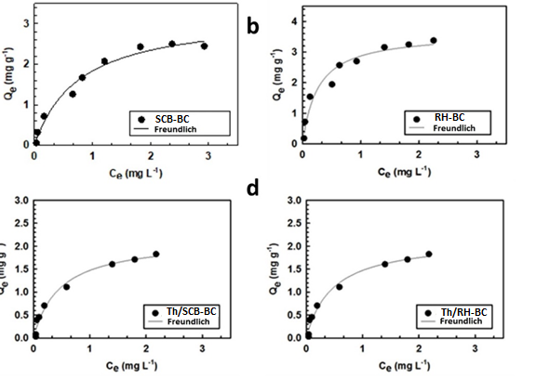
Fig. S3 Freundlich sorption isotherms of thiolated sugarcane bagasse (Th/SCB-BC), thiolated rice husk (Th/RH-BC), sugarcane bagasse biochar (SCB-BC) and rice husk biochar (RH-BC) As(III) at pH 4-7, sorbent dose = 1 g/L, and T = 20 ºC. The solid (−) line represents the model fits of the experimental data and black circles (●) indicate experimental data.

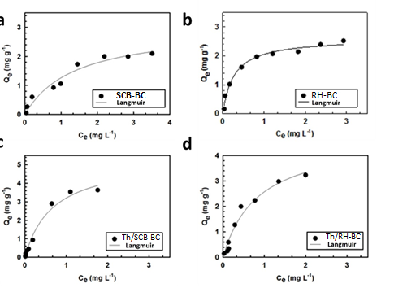
Fig. S4 Langmuir sorption isotherms of thiolated sugarcane bagasse (Th/SCB-BC), thiolated rice husk (Th/RH-BC), sugarcane bagasse biochar (SCB-BC) and rice husk biochar (RH-BC)As(III) at pH 4-7, sorbent dose = 1 g/L, and T = 20 ºC. The solid (−) line represents the model fits of the experimental data and black circles (●) indicate experimental data.
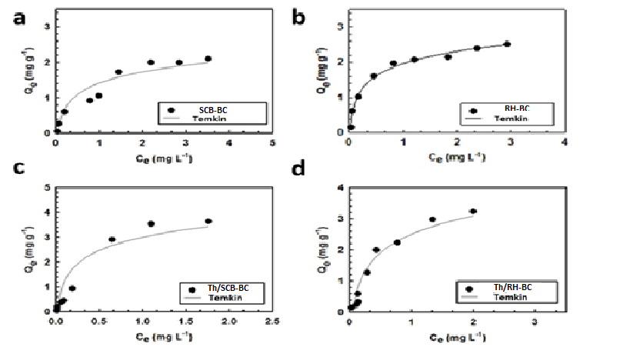
Fig. S5 Temkin sorption isotherms of thiolated sugarcane bagasse (Th/SCB-BC), thiolated rice husk (Th/RH-BC), sugarcane bagasse biochar (SCB-BC) and rice husk biochar (RH-BC)As(III) at pH 4-7, sorbent dose = 1 g/L, and T = 20 ºC. The solid (−) line represents the model fits of the experimental data and black circles (●) indicate experimental data
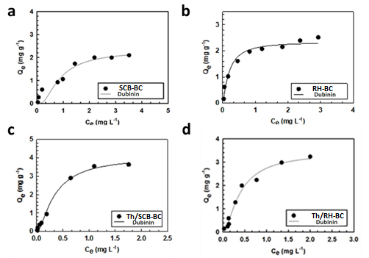
Fig. S6 Dubinin-Radushkevich isotherms of thiolated sugarcane bagasse (Th/SCB-BC), thiolated rice husk (Th/RH-BC), sugarcane bagasse biochar (SCB-BC) and rice husk biochar (RH-BC) As(III) at pH 4-7, sorbent dose = 1 g/L, and T = 20 ºC. The solid (−) line represents the model fits of the experimental data and black circles (●) indicate experimental data
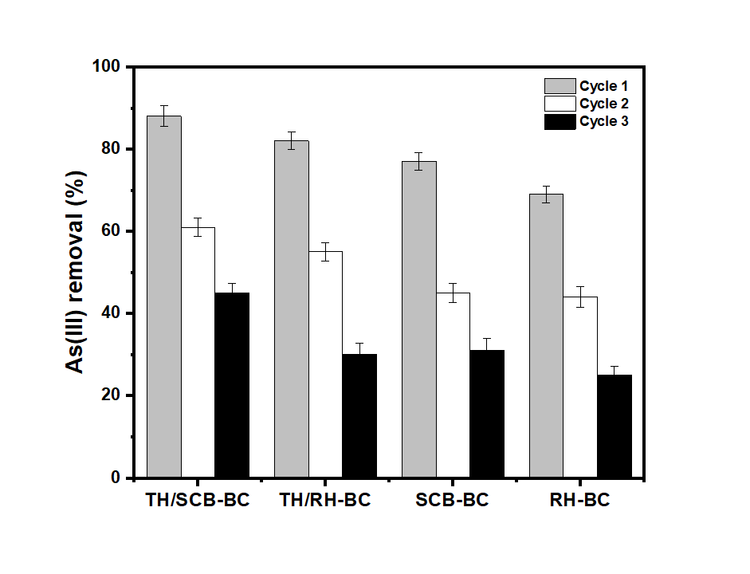
Fig. S7 Desorption of As(III) from thiolated sugarcane bagasse (Th/SCB-BC), thiolated rice husk (Th/RH-BC), sugarcane bagasse biochar (SCB-BC) and rice husk biochar (RH-BC) composite. Mean values are shown as mean ± standard error (n = 3).

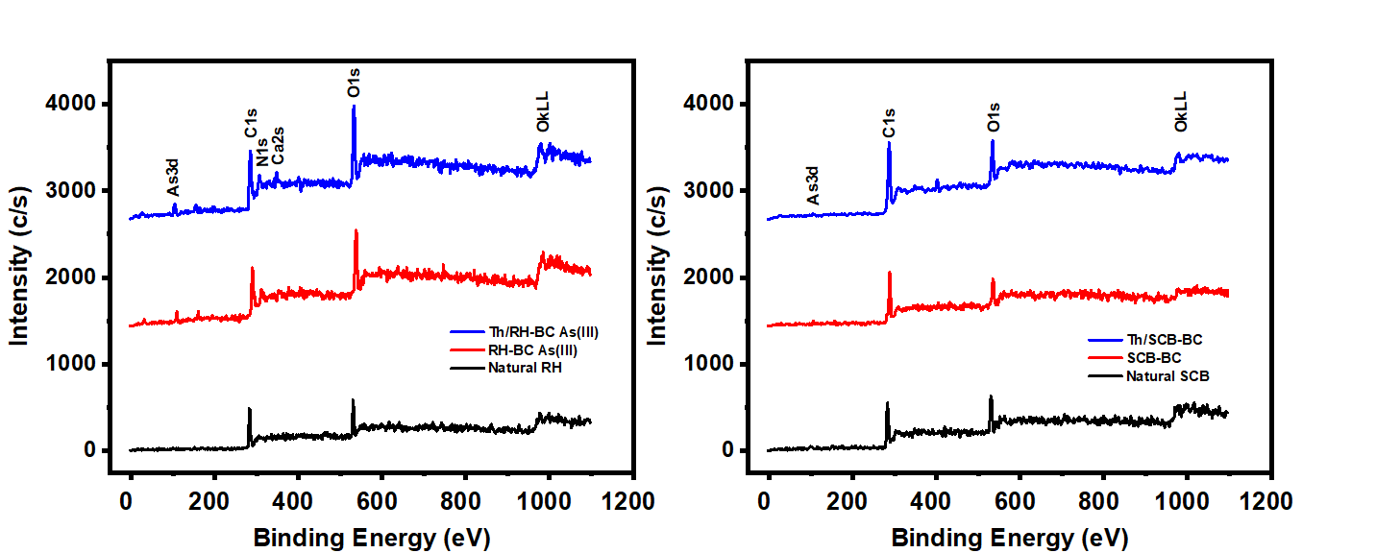
Fig. S8 X-ray photoelectron spectroscopy (XPS) a) Th/RH-BC, RH-BC As(III), natural RH b) Th/SCB-BC, SCB-BC As(III) and natural RH, at pH 7.

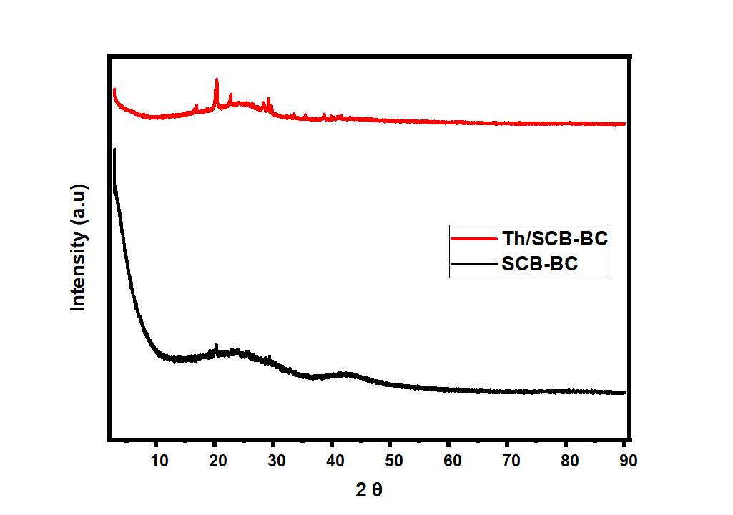
Fig. S9 X-ray Diffraction (XRD) of natural and Th/SCB-BC at pH 7.
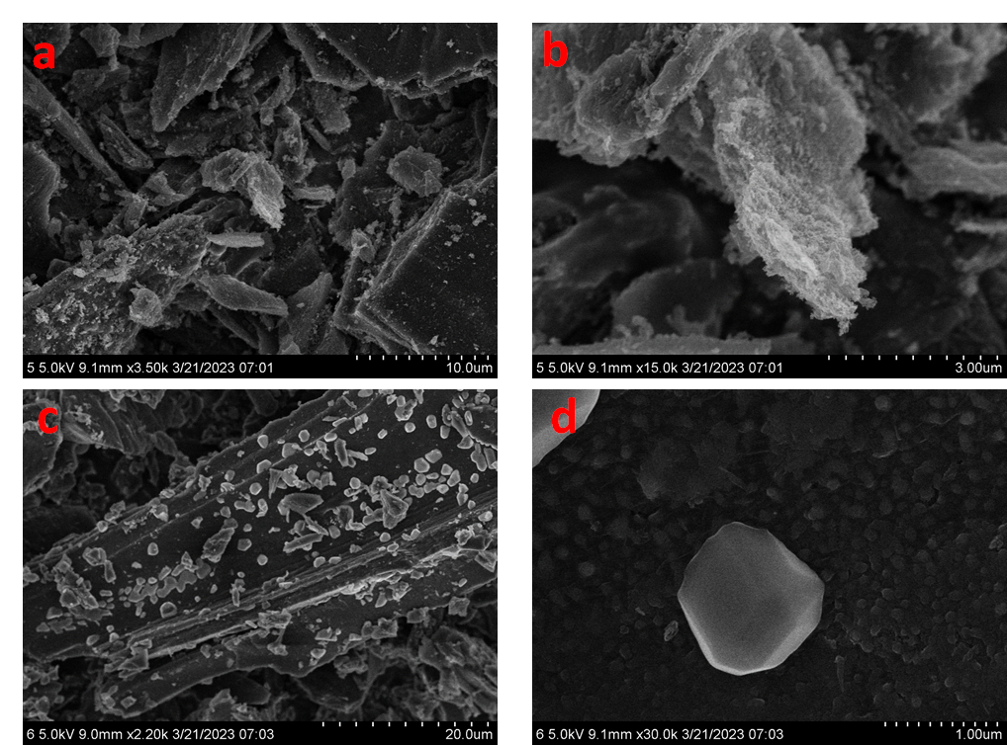
Fig. S10 Scanning electron microscopy (SEM) images of natural SCB (a,b), Th/SCB-BC (c,d) at pH 7.

References
Niazi, N.K., I. Bibi, M. Shahid, Y.S. Ok, E.D. Burton, H. Wang, S.M. Shaheen, J. Rinklebe and A. Lüttge. 2018a. Arsenic removal by perilla leaf biochar in aqueous solutions and groundwater: An integrated spectroscopic and microscopic examination. Environ. Pollut. 232:31-41.
Niazi, N.K., I. Bibi, M. Shahid, Y.S. Ok, S.M. Shaheen, J. Rinklebe, H. Wang, B. Murtaza, E. Islam and M.F. Nawaz. 2018b. Arsenic removal by Japanese oak wood biochar in aqueous solutions and well water: Investigating arsenic fate using integrated spectroscopic and microscopic techniques. Sci. Total Environ. 621:1642-1651.
Shakoor, M.B., N.K. Niazi, I. Bibi, M. Shahid, F. Sharif, S. Bashir, S.M. Shaheen, H. Wang, D.C. Tsang and Y.S. Ok. 2018. Arsenic removal by natural and chemically modified water melon rind in aqueous solutions and groundwater. Sci. Total Environ. 645:1444-1455
Ali, S., M. Rizwan, M.B. Shakoor, A. Jilani and R. Anjum. 2020. High sorption efficiency for as (iii) and as (v) from aqueous solutions using novel almond shell biochar. Chemosphere. 243:125330.
Roy, P., N. Mondal and K. Das. 2014. Modeling of the adsorptive removal of arsenic: A statistical approach. J. Environ. Chem. Eng. 2:585-597.
Thanh, N.C., B. Wichitsathian, C. Yossapol, W. Wonglertarak and B. Te. 2019. Improvement of aqueous solution coexisting with arsenite and arsenate using iron mixed porous clay pellets in batch and fixed-bed column studies. Water Supply. 19:1929-1937.
Yan, J., Y. Xue, L. Long, Y. Zeng and X. Hu. 2018. Adsorptive removal of as (v) by crawfish shell biochar: Batch and column tests. Environ. Sci. Pollut. Res. 25:34674-34683.
Mora, B.P., S. Bellú, M.F. Mangiameli, M.I. Frascaroli and J.C. González. 2019. Response surface methodology and optimization of arsenic continuous sorption process from contaminated water using chitosan. J. Water Process Eng. 32:100913.
Abid, M., N.K. Niazi, I. Bibi, A. Farooqi, Y.S. Ok, A. Kunhikrishnan, F. Ali, S. Ali, A.D. Igalavithana and M. Arshad. 2016. Arsenic (v) biosorption by charred orange peel in aqueous environments. Int. J. Phytorem. 18:442-449.

