SUPPLEMENTARY TABLES, FIGURES AND TEXT
Appendix S1. Observed species of Sebastidae and their corresponding characteristics and weighting factors (W_{t} values). Maximum known ages and trophic levels are as reported by Love et al². and FishBase³, respectively. For the rougheye-blackspotted rockfish complex, trophic levels are the average of the two species, and B_{y}/B₀ is for the southern stock (which has the highest overlap with the study area). For B_{y}/B₀, parenthesis indicate year of last assessment. W_{t} is the sum of scores for vulnerability, conservation status, and ecological role (see Table 1).
Common Name | Scientific Name | Max. age (yrs) | B_{y}/B₀ | Trophic level | Vulnerability score | Depletion score | Ecological score | W_{t}
Yelloweye Rockfish | Sebastes ruberrimus | 119 | 0.33⁴ (2020) | 4.4 | 4 | 2 | 2.0 | 8.0
Shortraker Rockfish | Sebastes borealis | 157 | unassessed | 4.3 | 4 | 1 | 2.0 | 7.0
Rougheye/Blackspotted rockfish | Sebastes aleutianus/ melanostictus | 205 | 0.29⁵ (2020) | 4.0 | 4 | 2 | 0.5 | 6.5
Bocaccio | Sebastes paucispinis | 50 | 0.028⁶ (2020) | 3.5 | 1 | 4 | 0.5 | 5.5
Tiger Rockfish | Sebastes nigrocinctus | 116 | unassessed | 3.5 | 4 | 1 | 0.5 | 5.5
Canary Rockfish | Sebastes pinniger | 84 | 0.25⁷ (2009) | 3.8 | 2 | 2 | 1.0 | 5.0
Quillback Rockfish | Sebastes maliger | 95 | 0.37⁸ (2012) | 3.8 | 3 | 1 | 1.0 | 5.0
Redbanded rockfish | Sebastes babcocki | 106 | 0.27⁹ (2017) | 3.8 | 2 | 2 | 1.0 | 5.0
Shortspine Thornyhead | Sebastolobus alascanus | 100 | unassessed | 3.6 | 3 | 1 | 0.5 | 4.5
Black Rockfish | Sebastes melanops | 50 | unassessed | 4.4 | 1 | 1 | 2.0 | 4.0
China Rockfish | Sebastes nebulosus | 79 | unassessed | 3.9 | 2 | 1 | 1.0 | 4.0
Copper Rockfish | Sebastes caurinus | 50 | unassessed | 4.1 | 1 | 1 | 1.5 | 3.5
Rosethorn Rockfish | Sebastes helvomaculatus | 87 | unassessed | 3.7 | 2 | 1 | 0.5 | 3.5
Redstripe Rockfish | Sebastes proriger | 55 | unassessed | 3.8 | 1 | 1 | 1.0 | 3.0
Silvergray rockfish | Sebastes brevispinis | 82 | 0.56¹⁰ (2016) | 3.8 | 2 | 0 | 1.0 | 3.0
Vermillion Rockfish | Sebastes miniatus | 60 | unassessed | 3.9 | 1 | 1 | 1.0 | 3.0
Brown Rockfish | Sebastes auriculatus | 34 | unassessed | 4.0 | 0 | 1 | 1.5 | 2.5
Dusky-Dark complex | Sebastes variabilis and S. ciliatus | 67 | unassessed | 3.4 | 1 | 1 | 0.5 | 2.5
Greenstriped rockfish | Sebastes elongatus | 54 | unassessed | 3.7 | 1 | 1 | 0.5 | 2.5
Sharpchin Rockfish | Sebastes zacentrus | 58 | unassessed | 3.7 | 1 | 1 | 0.5 | 2.5
Widow Rockfish | Sebastes entomelas | 60 | 0.37 | 3.7 | 1 | 1 | 0.5 | 2.5
Yellowtail Rockfish | Sebastes flavidus | 64 | 0.5 | 4.2 | 1 | 0 | 1.5 | 2.5
Deacon Rockfish | Sebastes diaconus | 44 | unassessed | 3.7 | 0 | 1 | 0.5 | 1.5
Pygmy Rockfish | Sebastes wilsoni | 26 | unassessed | 3.6 | 0 | 1 | 0.5 | 1.5
Puget Sound Rockfish | Sebastes emphaeus | 22 | unassessed | 3.3 | 0 | 1 | 0.0 | 1.0
Shortbelly Rockfish | Sebastes jordani | 32 | unassessed | 3.2 | 0 | 1 | 0.0 | 1.0

Appendix S2. Structural corals analyzed and their corresponding heights (cm) and weighting factors (W_{t}). Height measurements are estimated from images made during deep towed video transects (see Table 1); relative height differences between taxa align with published data sets¹¹.
Order | Species | Mean ±SE height, cm (range) | W_{t}
Alcyonacea | Primnoa pacifica | 42±6 (7-106) | 10
Antipatharia | Chrysopathes formosa and C. speciosa | 21±3 (7-50) | 5
Alcyonacea | *Paragorgia pacifica | 9±2 (1-44) | 3
Alcyonacea | Swiftia cf spauldingi | 4±0 (2-6) | 1
Anthoathecata | Stylaster spp. | 3±0 (2-5) | 1
*At 7 of 33 1-km² planning units with coral presence, some colonies might have been mis-identified as Paragorgia pacifica when they might have been Calcigorgia spiculifera (also an Alcyonacea). The heights of these colonies, however, align with those we recorded for confirmed observations of Paragorgia pacifica. Hotspot index values, therefore, should be unaffected by the potential mis-identifications.

Appendix S3. Expected depths (i.e., typical ranges described in Love et al.² or Butler et al.¹²) and survey method validity for rockfishes and thornyhead. Depth ranges for each method are the 10th and 90th percentiles of sampled depths. See Appendix S1 for scientific names.
Species | *Expected depth (m)  _________________ |  | Survey method valid for species  ________________________________________________
 | Min. | Max | Hook & line (18-78 m) | Shallow diver transect  (15-30 m) | Mid-depth video transect  (25-119 m) | Deep video transect  (126-435 m)
Bocaccio | 95 | 225 | no | yes | yes | yes
Canary | 80 | 200 | yes | yes | yes | yes
China | 10 | 128 | yes | yes | yes | yes
DuskyDark | 100 | 300 | no | yes | yes | yes
Greenstriped | 100 | 300 | yes | yes | yes | yes
PugetSound | 10 | 470 | no | yes | yes | yes
Pygmy | 60 | 150 | yes | yes | yes | yes
Quillback | 10 | 130 | yes | yes | yes | yes
Redbanded | 150 | 350 | no | no | no | yes
Redstripe | 55 | 300 | yes | yes | yes | yes
Rosethorn | 80 | 350 | no | no | yes | yes
REBS | 150 | 450 | no | no | yes | yes
Sharpchin | 200 | 300 | no | no | yes | yes
Shortbelly | 150 | 270 | no | yes | yes | yes
Shortraker | 300 | 600 | no | no | yes | yes
Silvergrey | 100 | 300 | yes | yes | yes | yes
Tiger | 30 | 298 | yes | yes | yes | yes
Vermillion | 50 | 150 | yes | yes | yes | yes
Widow | 0 | 200 | yes | yes | yes | yes
Yelloweye | 91 | 180 | yes | yes | yes | yes
Shortspine Thornyhead | 200 | 800 | no | no | no | yes
Yellowtail | 90 | 180 | yes | yes | yes | yes
*Juveniles of some species may have much shallower distributions than the expected depth of adults and may be detectable by dive surveys.

Appendix S4.
a) Range of hotspot index values within each rank, by species group (left to right: Sebastidae, large-bodied sponges, structural corals). Data are for 1-km² grid cells.
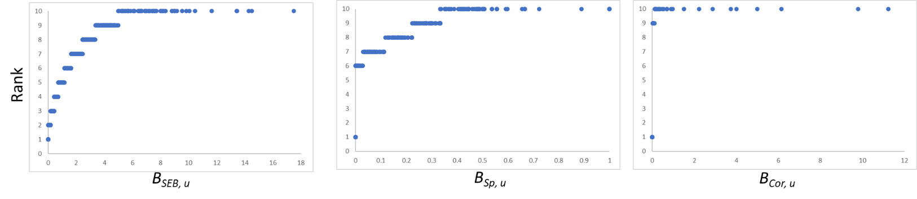
b) Proportion of observations allocated to each hotspot index rank. Sample sizes indicate number of 1-km² grid cells sampled.
Species group | Hotspot Index Rank
 | 1 | 2 | 3 | 4 | 5 | 6 | 7 | 8 | 9 | 10
Sebastidae  (N = 619) | 0.11 | 0.09 | 0.10 | 0.10 | 0.10 | 0.10 | 0.10 | 0.10 | 0.10 | 0.10
Large-bodied sponges  (N = 534) | 0.54 | 0.00 | 0.00 | 0.00 | 0.00 | 0.06 | 0.10 | 0.11 | 0.09 | 0.10
Structural corals (N = 224). | 0.85 | 0.00 | 0.00 | 0.00 | 0.00 | 0.00 | 0.00 | 0.00 | 0.045 | 0.10

Appendix S5.
a) Maximum depths sampled within 16-km² planning units (squares, except where faded over land), overlayed with Upper Ocean Subregions¹ (ABU = Aristazabal Upwelling, CSTM=Cape Scott Tidal Mixing, EQCS = Eastern Queen Charlotte Sound, MF = Mainland Fjords). Panels are constrained to the survey methods (Table 1) applicable to each species group (left to right: Sebastidae, large-bodied sponges, structural corals).
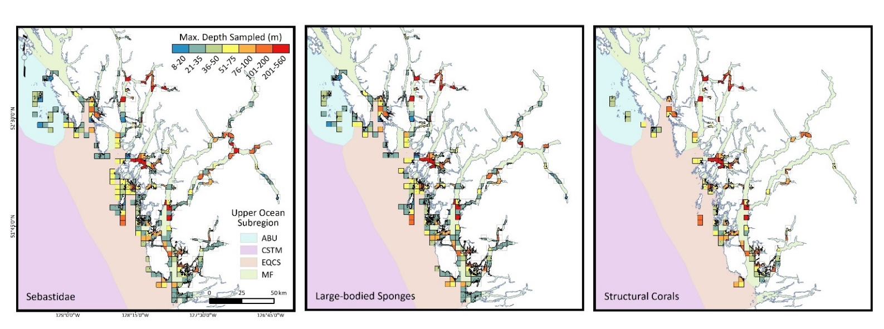

b) Maximum depth sampled within 1-km² planning units, by Upper Ocean Subregion and species group.
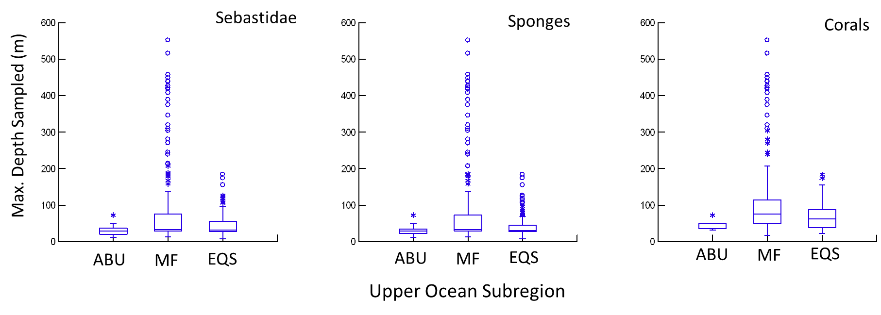

Appendix S6. Proportions of hotspot index ranks by Upper Ocean Subregions (ABU = Aristazabal Upwelling, EQCS = Eastern Queen Charlotte Sound, MF = Mainland Fjords) and species group. Sample sizes indicate the number of 1-km² planning units sampled.
Species group | UOS | Hotspot Index Rank  ___________________________________________________________________
 |  | 1 | 2 | 3 | 4 | 5 | 6 | 7 | 8 | 9 | 10
Sebastidae | ABU  (N = 26) | 0.08 | 0.00 | 0.15 | 0.15 | 0.23 | 0.00 | 0.12 | 0.08 | 0.08 | 0.12
 | MF  (N = 407) | 0.12 | 0.11 | 0.11 | 0.13 | 0.09 | 0.11 | 0.09 | 0.08 | 0.08 | 0.08
 | EQCS  (N = 186) | 0.09 | 0.05 | 0.06 | 0.04 | 0.10 | 0.09 | 0.12 | 0.15 | 0.15 | 0.15
Large-bodied sponges | ABU  (N = 20) | 1.00 | 0.00 | 0.00 | 0.00 | 0.00 | 0.00 | 0.00 | 0.00 | 0.00 | 0.00
 | MF  (N = 373) | 0.42 | 0.00 | 0.00 | 0.00 | 0.00 | 0.06 | 0.12 | 0.15 | 0.12 | 0.13
 | EQCS  (N = 141) | 0.79 | 0.00 | 0.00 | 0.00 | 0.00 | 0.04 | 0.07 | 0.01 | 0.03 | 0.06
Structural corals | ABU  (N = 5) | 1.00 | 0.00 | 0.00 | 0.00 | 0.00 | 0.00 | 0.00 | 0.00 | 0.00 | 0.00
 | MF  (N = 172) | 0.83 | 0.00 | 0.00 | 0.00 | 0.00 | 0.00 | 0.00 | 0.00 | 0.06 | 0.12
 | EQCS  (N = 47) | 0.94 | 0.00 | 0.00 | 0.00 | 0.00 | 0.00 | 0.00 | 0.00 | 0.00 | 0.06

Appendix S7: References for supplementary material
1. Robinson, C. & McBlane, L. A summary of major upper ocean sub regions found within Parks Canada’s five Natural Marine Regions on the Pacific coast of Canada. BCMCA (2013).
2. Love, M., Yoklavich, M. & Thorsteinson, L. The Rockfishes of the Northeast Pacific. (University of California Press, 2002).
3. Froese, R. & Pauly, D. FishBase. World Wide Web electronic publication. www.fishbase.org (2020).
4. DFO. Evaluation of Potential Rebuilding Strategies for Outside Yelloweye Rockfish in British Columbia. DFO Can. Sci. Advis. Sec. Sci. Advis. Rep. 2020/024., (2020).
5. DFO. Rougheye/Blackspotted Rockfish (Sebastes aleutianus/melanostictus) Stock Assessment for British Columbia in 2020. DFO Can. Sci. Advis. Sec. Sci. Advis. Rep. 2020/047, (2020).
6. DFO. Bocaccio (Sebastes paucispinis) stock assessment for British Columbia in 2019, including guidance for rebuilding plans. Can. Sci. Advis. Sec. Sci. Advis. Rep 2020/025, (2020).
7. Stanley, R. D., Starr, P. & Olsen, N. Stock assessment for Canary rockfish (Sebastes pinniger) in British Columbia waters. Can. Sci. Advis. Sec. Res. Doc. 2009/013, (2009).
8. DFO. Stock Assessment And Recovery Potential Assessment For Quillback Rockfish (Sebastes Maliger) Along The Pacific Coast Of Canada. DFO Can. Sci. Advis. Sec. Sci. Advis. Rep. 2011/072, (2012).
9. Edwards, A. M., Haigh, R. & Starr, P. J. Redbanded Rockfish (Sebastes babcocki) stock assessment for the Pacific coast of Canada in 2014. . . DFO Can. Sci. Advis. Sec. Res. Doc. 2017/058, v + 182 p (2017).
10. Starr, P., Haigh, R. & Grandin, C. Stock assessment for Silvergray Rockfish (Sebastes brevispinis) along the Pacific coast of Canada. Can. Sci. Advis. Secr. Res. Doc. 2016/042, (2016).
11. NOAA. National Database for Deep-Sea Corals and Sponges (version 20201021-0). NOAA Deep Sea Coral Res. Technol. Progr. https//deepseacoraldata.noaa.gov/ (2020).
12. Butler, J. L., Love, M. S. & Laidig, T. E. A Guide to the Rockfishes, Thornyheads, and Scorpionfishes of the Northeast Pacific. (University of California Press, 2012).

