Supplementary materials:

Generation of Arbitrarily Patterned Polarizers Using 2-Photon Polymerization
Byron Ganazhapa*^{1,2}(1), Javier Pereiro-García¹, Xabier Quintana Arregui¹, Morten Andreas Geday¹, Gonzalo Guadaño², Manuel Caño-García^{1,3}
1CEMDATIC, ETSI Telecomunicación, Universidad Politécnica de Madrid, Av. Complutense 30, 28040, Madrid, Spain.
²LASING S.A., c/Julián Camarillo, 26, 28037, Madrid, Spain.
³Department of Electronics and Computer Technology, Research Centre for Information and Communication Technologies (CITIC-UGR), University of Granada, Granada, Spain.
*Corresponding author.
(1) Email: b.ganazhapa@upm.es
- Principle of two-photon polymerization (2PP)
Two-photon polymerization (2PP) is a method that enables the fabrication of high-resolution structures in volumes that can reach even millimetric structures with sub-micrometric features. The 2PP is based on two-photon absorption (2PA) and take advantage of the simultaneous absorption of multiple-photons (likely 2 photons) to drive an electronic transition in an atom or molecule (ground state |g⟩ $\underset{→}{∆hv}$ excited state |f⟩)¹, see Figure S1a. During the transition, the matter is transparent to photons wavelength (the optical frequency ν of the photons is out of resonance of electrons in matter), but a non-stationary virtual state is created after the absorption of the first-photon and 2PA occurs only if a second-photon with energy $hν_{ph}=hν_{fg}/2$ arrives within the intermediate state |i⟩ lifetime, and can be absorbed inducing to the final excited state |f⟩, namely, for time intervals between two photons is extremely shorter than the lifetime of the intermediate state, on the order of femtoseconds^{2,3}.
Although photo-sensitive materials, commonly known as photoresists, are composed of a multitude of chemical compounds, the crucial components in photoresists for 2PP are monomers mixed with photo-initiators². Monomers are molecules that can form polymer chains by cross-linking², making the cross-linked regions of the negative-tone photoresist less soluble to a developer⁴, or breaking the cross-linked regions of positive-tone photoresists, making them more soluble and obtaining the inverse results⁵. To initiate the normal 2PP process shown in Figure S1b, the photo-initiators (PI) absorb two photons creating photo-produced radicals (RI), neutral molecules with an unpaired valence electron highly chemically reactive. The photo-produced radicals bond to a monomer (M), which in turn becomes monomer-radical (RM), initiating a chain reaction that propagates through the photoresist, cross-linking the monomers to form a long polymer chain (RMn,m), halting its propagation until when two photo-produced radicals bond to each other or due to monomer depletion caused by the action of inhibitors^{2,4}, see Figure S1c. In the case of the depletion mechanism exposed in the Figure S1c, 2PP occurs when the valence electrons of a photo-initiator are excited from (|g*⟩) to the first singlet excited state (|f*⟩) by simultaneously absorbing two photons followed by intersystem crossing relaxing the excited electrons by a triplet excited state (|T*⟩) where the photo-initiator is susceptible to bond cleavages to form photo-produced radicals for polymerization. However, excited states can relax (deactivate) through radiative processes: emission from singlet states ($hν_{F}$) and emission from triplet states ($hν_{P}$), as well as non-radiative processes: photo-initiator quenching and radical quenching. The quenching of photo-initiator in the triplet states and subsequent photo-produced radicals can prevent the uncontrolled propagation of polymerization in the photoresist⁶. This is typically achieved by adding radical quenchers. These quenched radicals can then be deactivated by irradiation or the release of heat, preventing polymerization reactions in the surroundings far from the center of the focal spot. This inhibition of polymer chain growth occurs due to the quenching effect in regions of low radical density⁷. However, radiative processes contribute to increase resolution and contrast by reducing fluorescence and phosphorescence generated outside the focal point^{2,5}. This control facilitates polymerization in small volumes (voxels), enabling high resolution in optimization processes.
The 2PP method is used for optical devices like as patterned polarizers in liquid crystals (LC) alignment with microscale nano-resolution features which require non-lineal high intensities of focused near infrared (NIR) light through direct laser writing (DLW) techniques available after the invention of the first laser in 1960, experimentally observed in 1961⁸, and subsequently implemented in 1965⁹, thanks to the 2PA initiative presented by Maria Göppert-Mayer in 1930¹.
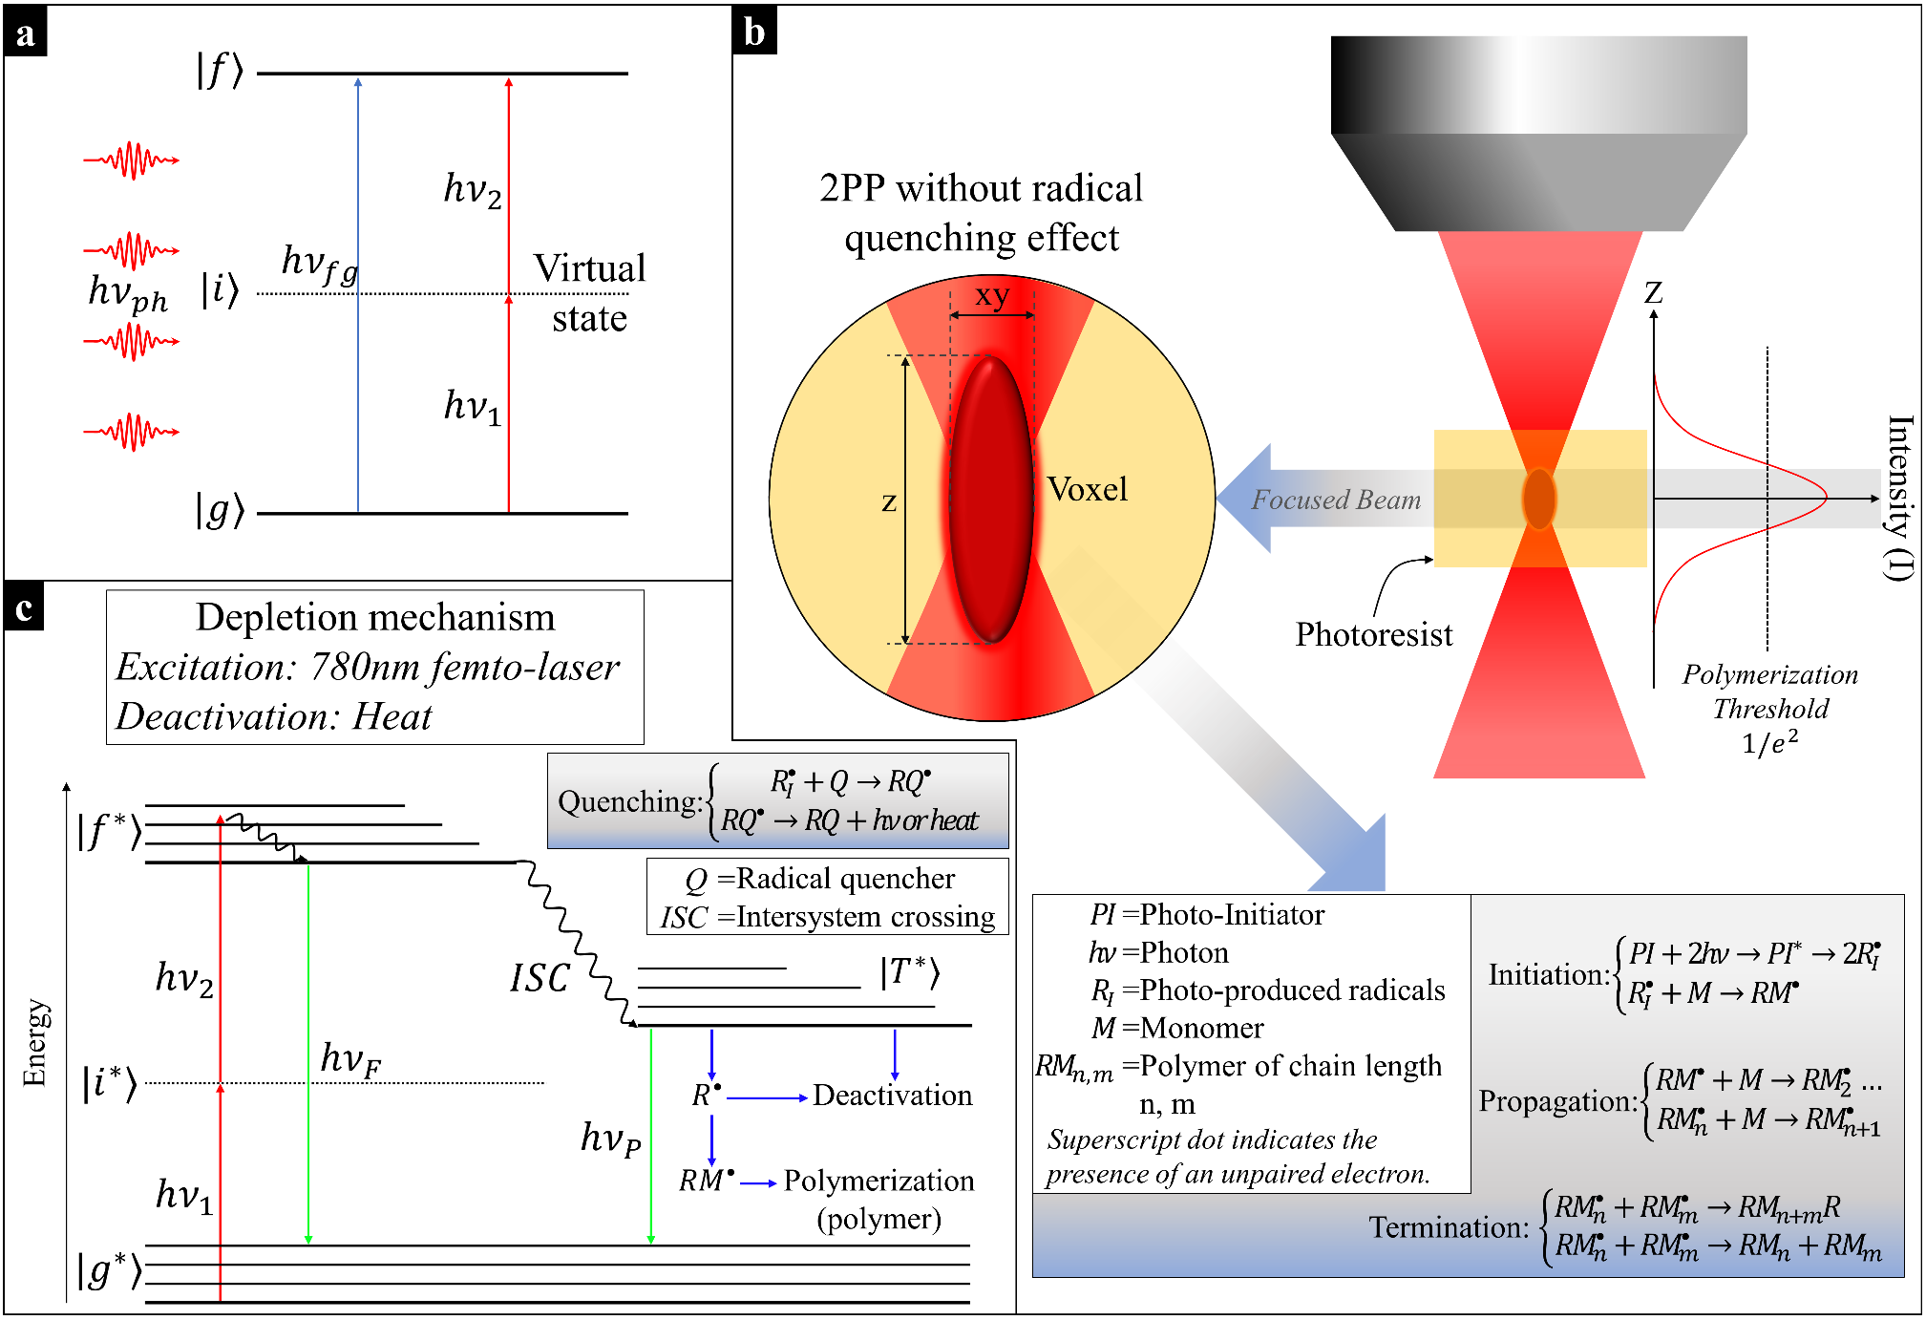
Figure S1. a) 2PA leading to excited state of a molecule through a simultaneous absorption within intermediate state lifetime. b) 2PP steps when a laser beam is focused on a photoresist (energy intensity confined at the spot laser): initiation, propagation, and termination steps. c) 2PP process optimization. In this energy diagram shows the competing process to generate the photoproduced radicals (R•) through emissive (solid green line) fluorescence ($hν_{F}$) and phosphorescence ($hν_{P}$), and non-emissive (solid blue line) routes⁶. Efficient polymerization requires minimizing competing processes such as $hν_{F}$, $hν_{P}$, and deactivation to reduce voxel sizes.
- 2PP customized equipment
The scheme of the 2PP setup for nanofabrication is illustrated in Figure S2a. The femtosecond laser source (Femto-Laser) is used to generate a pulsed beam of 90 fs, with a high repetition rate of 80 MHz, a central wavelength of 780 nm an average power of 250 mW and a pulse energy of 3.125 nJ. The Femto-Laser is a fiber coupled laser appropriated for inducing the 2PP process. The laser beam power can be controlled by a variable attenuator comprised of an acousto-optic modulator (AOM), a half-wave plate (HWP) and a polarization beam-splitter (PBS). The AOM is used to diffract the laser beam into the first diffraction order through planar sound waves controlled by a module provided by the equipment. The HWP is used to control the polarization of input laser beam. The PBS is used to divide the output beam into p- and s-polarizations. The iris (I1) is used to obstruct non-first-order components originating from the AOM. Then, two plano-convex lenses (L1 and L2) are used to collimate and expand the laser beam diameter 4-times, with 25 mm and 100 mm focal lengths respectively. The laser beam is manipulated by a galvanometer scanner (XY-Galvo) to realize dimensional scanning in the XY plane and a piezoelectric stage (Z-Piezo) with 100 µm of travel range is used to move vertically the focused laser beam in the Z-axis. The XYZ nano-positioning is compose by the XY-Galvo and Z-Piezo to realize nanostructures with high nanometric precision and resolution, whereas the XY-Large-Stage with 200 mm of travel range is used to realize long-range XY positioning with high micrometric precision and repeatability¹⁰. XY-Large-Stage allows working on micrometer-sized structures larger than the FOVG of the XY-Galvo in the XY plane. Next, the system also consisted of a pair of high-reflectance mirrors (M1 and M2) to route the laser beam toward the XY-Galvo input. A dichroic mirror (DM) is used as short-pass filter to reflect the beam laser and transmit light on the other bands, i.e., reflective for NIR light and transparent in the visible light band-wide. An objective lens (OL) infinite conjugate is used with magnification of 50×, a numerical aperture of 0.8, a working distance of 0.47 mm and effective focal length of 3.6 mm.
The scheme described in Figure S2a also shows the real-time monitoring part to visualize the DLW process of photoresists which is composed of two lighting sources (LED spotlight and LED Backlight), a CMOS camera, a beam-splitter (BS), and some additional optics (F1, L3, M3) are used to focus the field of view on the camera sensor (FOVC). The lighting sources guarantee excellent uniformity, high intensity, and variability of red light free of spectral components that can cause unwanted polymerization on photoresists. An optical short-pass filter (F1) prevents diffuse NIR reflections from reaching the camera sensor and saturating the pixels, or in the worst cases, burning out some of the pixels in the active region of the sensor. The DM and the OL share the nanofabrication and the monitoring part of the system, whereas the Motion Controller executes the interaction for mechanical movement of the stages in the X, Y and Z axes according to the geometric parameters of a CAD design. The technical details of all components implemented in the 2PP system are listed in Table S1.
The implemented printing mode in the customized equipment described in Figure S2b is air-configuration. In this mode, the immersion medium is air. The laser can be focused directly onto the photoresists on any opaque or transparent substrate. In the air-configuration, the focus quality depends on the vertical position of the focus in the photoresists. For this purpose, an additional Z-Stage with 25 mm of travel range is used to execute laser focusing commands and XY-surface tracking on the substrates.
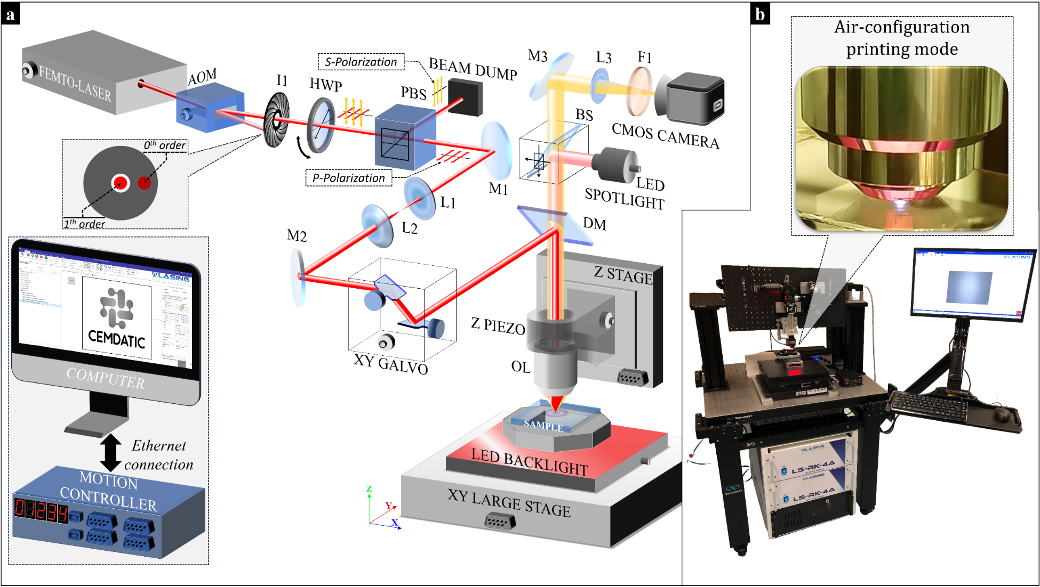
Figure S2. a) 2PP setup. A femtosecond laser source (Femto-Laser), an acousto-optic modulator (AOM), an iris (I1), a half-wave plate (HWP), a polarizing beamsplitter (PBS), two plano-convex lenses (L1, L2), two mirrors (M1, M2), a XY galvanometer scanner (XY-Galvo), a dichroic mirror (DM), a piezoelectric stage (Z-Piezo), a Z-Stage, an objective lens (OL) and a XY-Large-Stage compose the nano-fabrication part of the system. Two lighting sources (LED spotlight and Backlight), the OL, the DM, a Beam-Splitter (BS), a mirror (M3), a plano-convex lens (L3), a filter (F1) and a CMOS camera compose the real-time monitoring part of the system. The Motion Controller manages XYZ nano-positioning, and AOM, HWP and PBS increases or attenuates the laser beam power. The Motion Controller manages XYZ nano-positioning, while the AOM, HWP, and PBS control the increase or attenuation of the laser beam power. The CMOS camera is managed by software on the computer. b) Custom-built 2PP system¹⁰.

Table S1. Technical details of the components implemented in the 2PP system.
Part | Manufacturer | System specifications required
Femto-Laser | Calmar Laser | Repetition rate of 80 MHz, pulse width of 90 fs, average power of 250 mW, pulse energy of 3 nJ, central wavelength of 780 nm and, beam diameter of 1.3 mm
AOM | TaorLab | Operating wavelength range 730–830 nm, frequency of 80 MHz and diffraction efficiency of 85 %
HWP | Thorlabs | Operating wavelength of 780 nm, retardance of λ/2, reflectance <0.25 %, beam deviation of <10 arcsec
PBS | Thorlabs | Wavelength range 620–1000 nm, transmission Efficiency of 90 % and reflection of 95 %
Beam dump | Thorlabs | Wavelength range 400 nm – 2 µm, pulser laser type and max average power of 10 W
L1, L2, L3 | Thorlabs | Focal length of 25.0 mm, 100.0 mm and 150 mm respectively, wavelength ranges 400–1100 nm (L1, L2) and wavelength range 400–700 nm (L3)
I1 | Thorlabs | Aperture range 1–12 mm
M1, M2, M3 | Thorlabs | Diameter of 1" and average reflectance greater than 90 % from 450–2000 nm
XY-Galvo | Newson | Entrance beam diameter of 10 mm, rotor inertia of 2.6 g.cm², repeatability less than 3 µrad and optical angular range of 180 mrad (10.3°)
Z-Piezo | Newport | Close loop travel range of 100 µm, close loop resolution of 3 nm and typical repeatability of 3 nm
XY-Large-Stage | Lasing S.A. | High speed analog encoders, XY range travel of 200 mm and resolution of 10 nm
DM | Semrock | Average transmission greater than 90 % at 360–650 nm band, average reflection greater than 95 % at 685–1600 nm band and edge wavelength of 670 nm.
OL | Olympus | Numerical aperture of 0.8, magnification of 50X, infinite conjugate, lens tube focal length of 180 mm, working distance of 0.47 mm and effective focal length of 3.6mm
Lighting sources | Mvotem Optics | Red light at wavelength range 620–625 nm
Camera | IDS | CMOS Color sensor, pixel class of 5 MP, resolution of 2560x1920, pixel size of 2,2 μm and frame rate of 6,4 fps
BS | Thorlabs | Non-polarizing BS, wavelength range 400–700 nm and absolute transmission and reflection of 47 ± 10 %
F1 | Thorlabs | Curt-off wavelength of 750 nm, transmission region (>90 %) 400–740 nm and rejection region 761–1200 nm
Z-Stage | Newport | Travel range of 25 mm, bi-directional repeatability of ±1.0 µm and minimum incremental motion of 0.05 µm

References for Supporting Information:
1. Göppert-Mayer, M. Über Elementarakte mit zwei Quantensprüngen. Annalen der Physik 401, 273–294 (1931).
2. Balena, A., Bianco, M., Pisanello, F. & De Vittorio, M. Recent Advances on High-Speed and Holographic Two-Photon Direct Laser Writing. Advanced Functional Materials 33, 2211773 (2023).
3. Pawlicki, M., Collins, H. A., Denning, R. G. & Anderson, H. L. Two-Photon Absorption and the Design of Two-Photon Dyes. Angewandte Chemie International Edition 48, 3244–3266 (2009).
4. Maruo, S., Nakamura, O. & Kawata, S. Three-dimensional microfabrication with two-photon-absorbed photopolymerization. Opt. Lett., OL 22, 132–134 (1997).
5. Harinarayana, V. & Shin, Y. C. Two-photon lithography for three-dimensional fabrication in micro/nanoscale regime: A comprehensive review. Optics & Laser Technology 142, 107180 (2021).
6. Sun, H.-B. & Kawata, S. Two-Photon Photopolymerization and 3D Lithographic Microfabrication. in NMR • 3D Analysis • Photopolymerization (eds. Fatkullin, N. et al.) 169–273 (Springer, Berlin, Heidelberg, 2004). doi:10.1007/b94405.
7. Park, S. H., Lim, T. W., Yang, D.-Y., Kim, R. H. & Lee, K.-S. Improvement of spatial resolution in nano-stereolithography using radical quencher. Macromol. Res. 14, 559–564 (2006).
8. Kaiser, W. & Garrett, C. G. B. Two-Photon Excitation in CaF2: Eu2+. Phys. Rev. Lett. 7, 229–231 (1961).
9. Pao, Y. & Rentzepis, P. M. LASER‐INDUCED PRODUCTION OF FREE RADICALS IN ORGANIC COMPOUNDS. Applied Physics Letters 6, 93–95 (1965).
10. Lasing, S.A. https://www.lasing.com/.

