SUPPLEMENTARY DATA
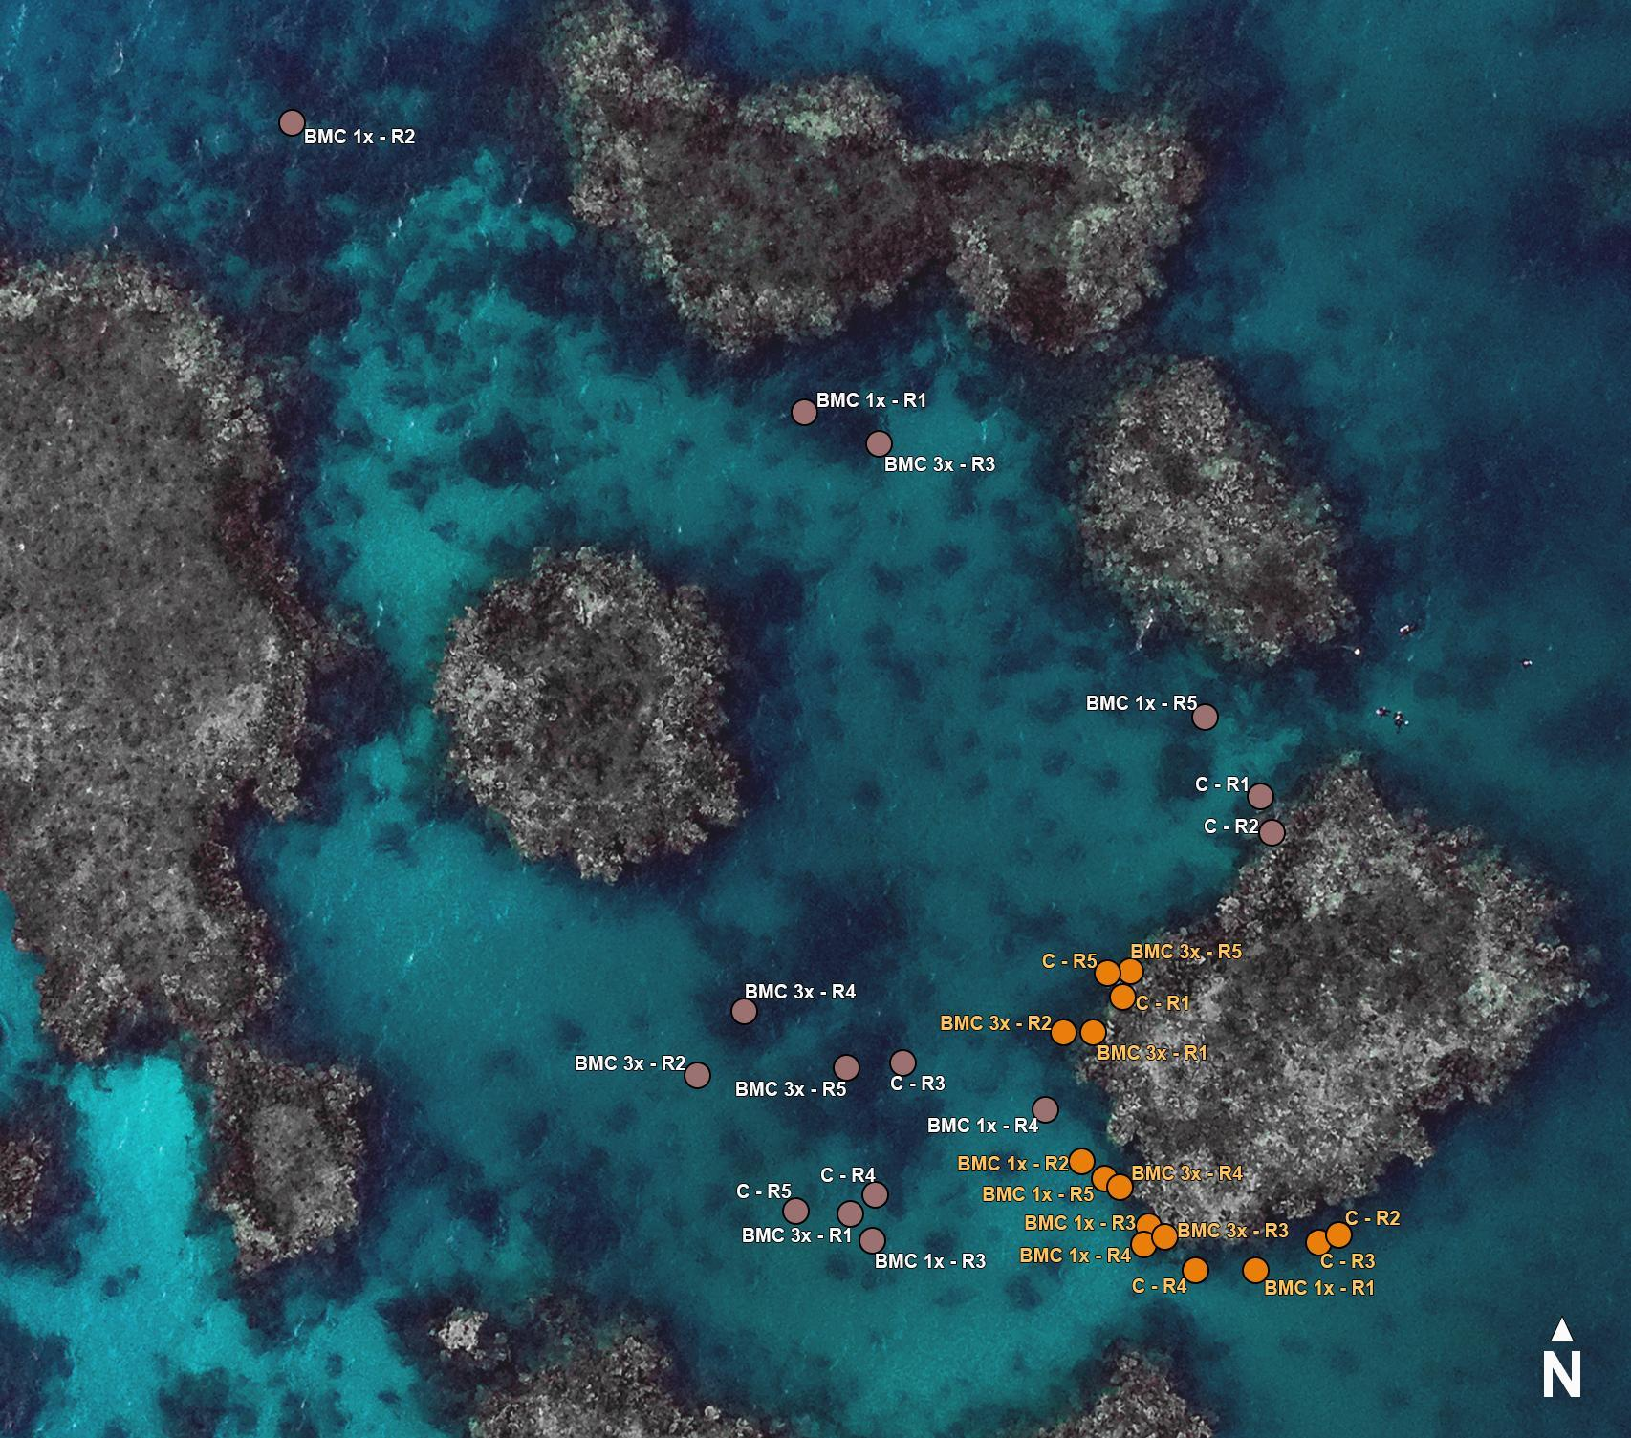
Fig. S1 Sponges tagged in the experiment site Al Fahal reef - Coral Probiotics Village, Saudi Arabia, Red Sea; C = control, beneficial microorganisms for corals (BMC) 1× = inoculation once a week; BMC 3× = inoculation thrice a week; R = replica, orange circle = Stylissa carteri, and brown circle = Callyspongia crassa; background photo: Morgan Bennett-Smith

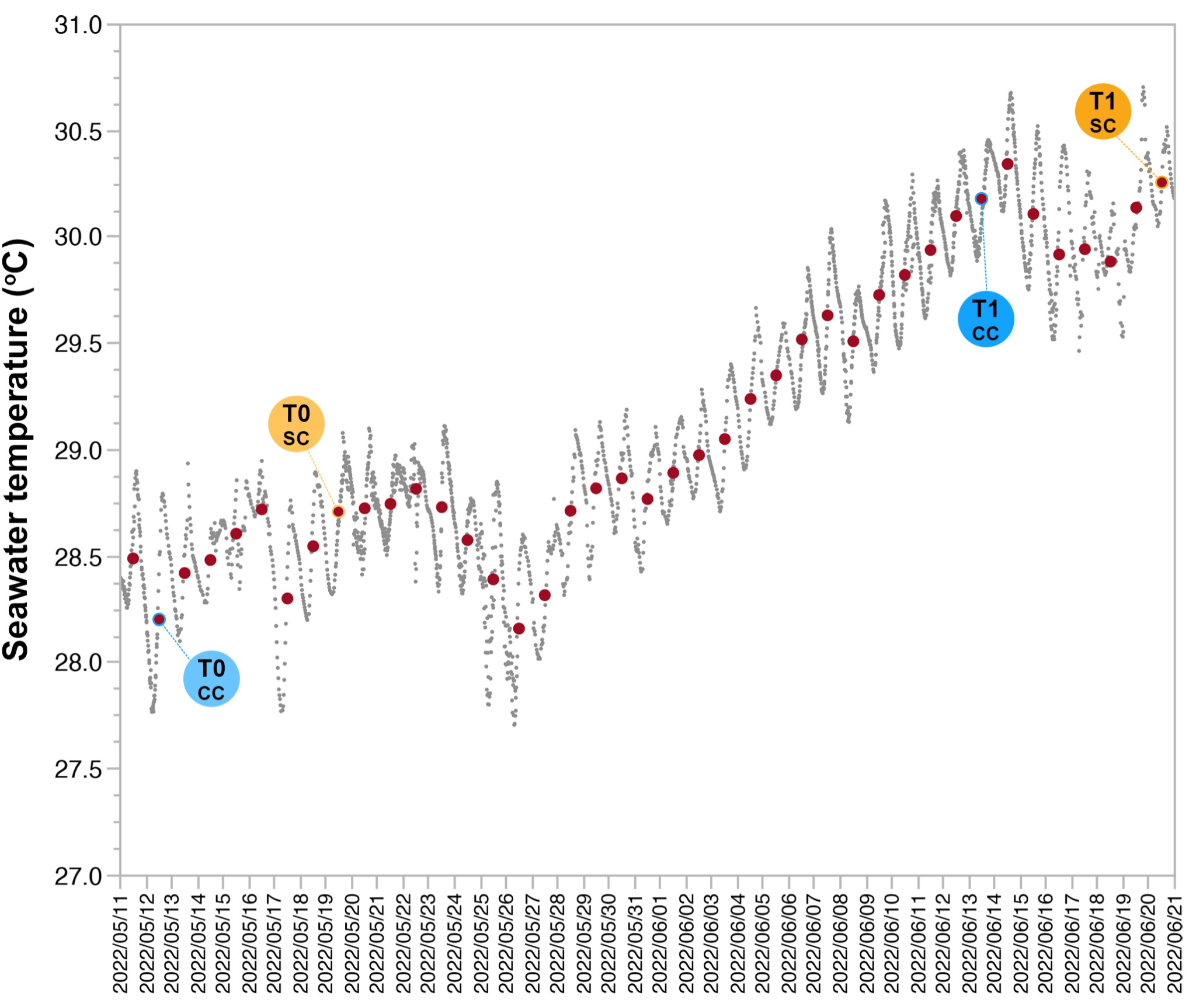
Fig. S2 Seawater temperature during in situ coral probiotics inoculation at Al Fahal reef, Saudi Arabia, Red Sea; CC = Callyspongia crassa; and SC = Stylissa carteri

(NEXT PAGE) Fig. S3 Sponges during the experiment; first plate: Stylissa carteri 13 days after T0; second plate: Callyspongia crassa 26 days after T0; C = control; 1× = inoculation of coral probiotics on sponges once a week; 3× = inoculation thrice a week; R = replica; photos: Bárbara Ribeiro

