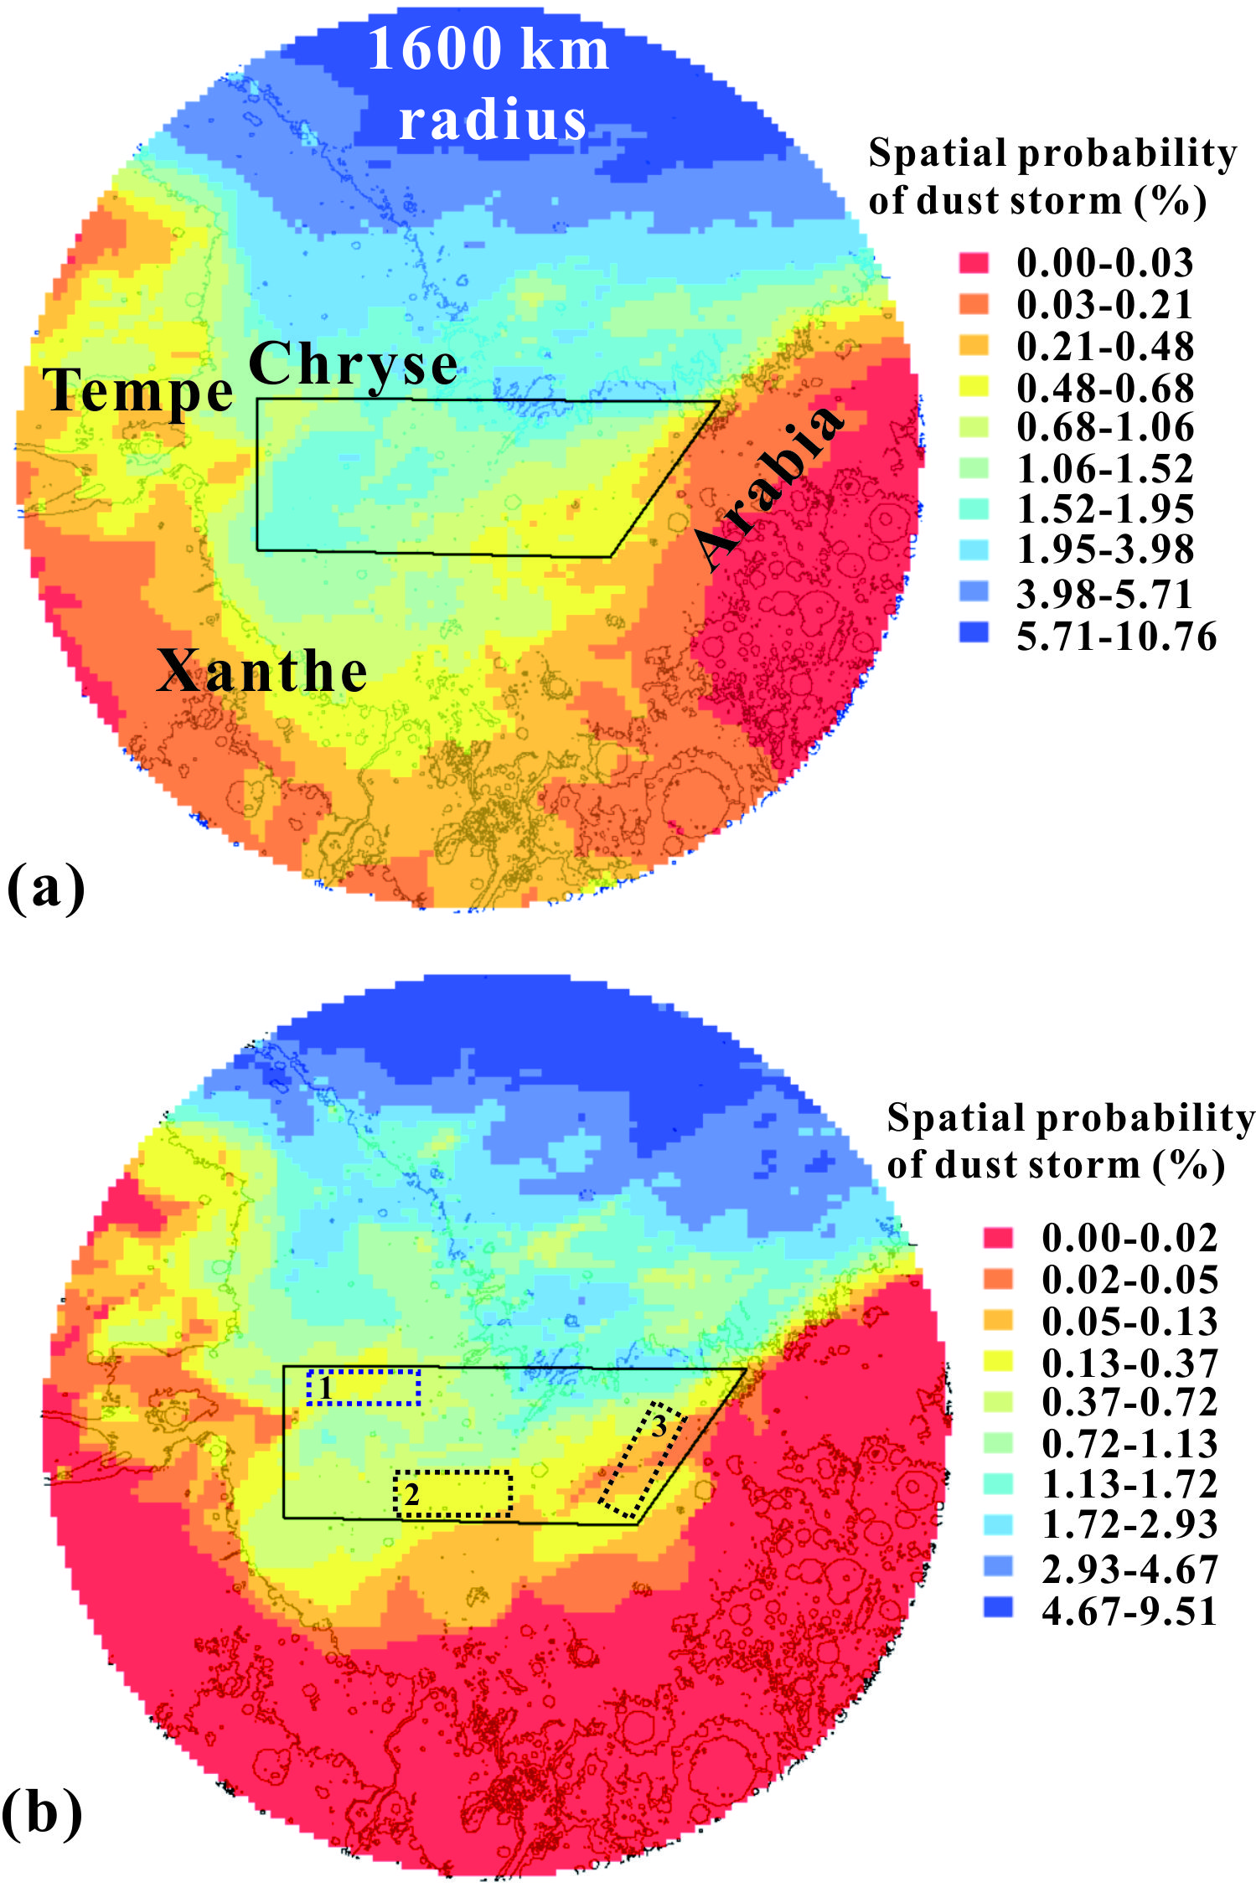
The spatial probability of dust storm activity within 1600 km radius ring of Chryse area in MY (a) and EDL season (b) in 0.5° grids. The black polygon shows the Chryse area. Topography is shown with black contours (2 km interval) for reference. The dotted rectangles marked with number 1-3 are the PLAs.

