Supplement Materials
Supplement 1. Calibration curve for AD and dry biomass weight
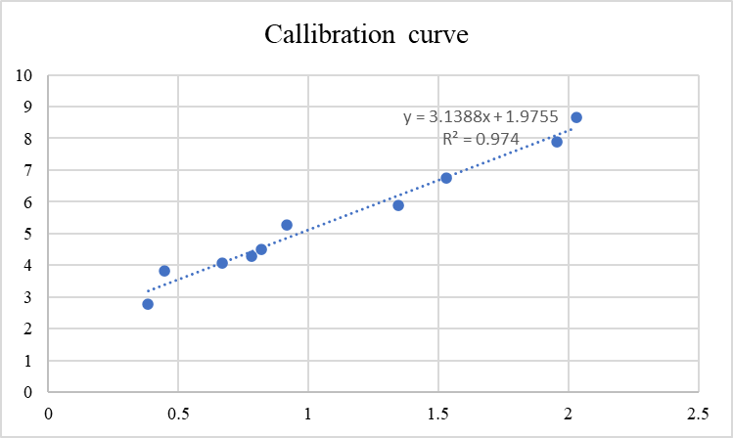
Supplement 2. Two-way ANOVA analysis and Tukey’s post hoc test for growth rate
A1. Overall ANOVA for Growth Rate
 | DF | Sum of Squares | Mean Square | F Value | P Value
Ratio | 3 | 0.0534 | 0.0178 | 11.3318 | 2.09E-04
Concentration | 2 | 0.0067 | 0.0033 | 2.1309 | 0.1477
Interaction | 6 | 0.0179 | 0.003 | 1.8928 | 0.1374
Model | 11 | 0.0994 | 0.009 | 5.7511 | 5.77E-04
Error | 18 | 0.0283 | 0.0016 | -- | --
Corrected Total | 29 | 0.1277 | -- | -- | --
B1. Tukey test for ratio
 | MeanDiff | SEM | q Value | Prob | Sig
Ratio B Ratio A | 0.1063 | 0.0187 | 8.043 | 0.000116 | 1
Ratio C Ratio A | 0.0439 | 0.0187 | 3.3253 | 0.1233 | 0
Ratio C Ratio B | -0.0623 | 0.0187 | 4.7177 | 0.0176 | 1
BBM Ratio A | 0.0567 | 0.0264 | 3.0321 | 0.1771 | 0
BBM Ratio B | -0.0496 | 0.0264 | 2.6552 | 0.272 | 0
BBM Ratio C | 0.0127 | 0.0264 | 0.6807 | 0.9623 | 0
C1. Tukey test for concentration
 | MeanDiff | SEM | q Value | Prob | Sig
Conc. 2 Conc. 1 | -0.0075 | 0.0175 | 0.6074 | 0.9039 | 0
Conc. 3 Conc. 1 | -0.0707 | 0.0175 | 5.7218 | 0.0021 | 1
Conc. 3 Conc. 2 | -0.0632 | 0.0187 | 4.7841 | 0.0088 | 1

Supplement 3. Two-way ANOVA analysis and Tukey’s post hoc test for Biomass yield
A2. Overall ANOVA for Biomass Yiels
 | DF | Sum of Squares | Mean Square | F Value | P Value
Ratio | 3 | 1.27793 | 0.42598 | 2.11187 | 0.1344
Concentration | 2 | 0.60887 | 0.30443 | 1.5093 | 0.24775
Interaction | 6 | 1.81898 | 0.30316 | 1.50299 | 0.23316
Model | 11 | 61.73903 | 5.61264 | 27.8258 | 4.855E-9
Error | 18 | 3.63071 | 0.20171 | -- | --
Corrected Total | 29 | 65.36974 | -- | -- | --
B2. Tukey test for ratio
 | MeanDiff | SEM | q Value | Prob | Sig
Ratio B Ratio A | 0.21536 | 0.21172 | 1.43856 | 0.74168 | 0
Ratio C Ratio A | -0.21437 | 0.21172 | 1.43192 | 0.74432 | 0
Ratio C Ratio B | -0.42973 | 0.21172 | 2.87047 | 0.21409 | 0
BBM Ratio A | -0.52859 | 0.29941 | 2.49672 | 0.32118 | 0
BBM Ratio B | -0.74396 | 0.29941 | 3.51393 | 0.09657 | 0
BBM Ratio C | -0.31423 | 0.29941 | 1.4842 | 0.72334 | 0
C2. Tukey test for concentration
 | MeanDiff | SEM | q Value | Prob | Sig
Conc. 2 Conc. 1 | 0.76514 | 0.19804 | 5.46386 | 0.00311 | 1
Conc. 3 Conc. 1 | 3.25421 | 0.19804 | 23.23821 | 0 | 1
Conc. 3 Conc. 2 | 2.48906 | 0.21172 | 16.62638 | 0 | 1

Supplement 4. Analysis of microalgae cultivation cost
Parameters | BBM | A |  |  | B |  |  | C
Parameters | BBM | 1 | 2 | 3 | 1 | 2 | 3 | 1 | 2 | 3
Biomass
Biomass productivity (g DW.L-1.day-1) | 0.42 | 0.47 | 0.42 | 0.31 | 0.44 | 0.49 | 0.36 | 0.48 | 0.42 | 0.33
Biomass density at peak (g DW. L-1) | 6.71 | 5.65 | 7.07 | 9.00 | 5.78 | 6.83 | 9.75 | 5.77 | 6.34 | 8.96
Mass of biomass in 10 PBR (1 liter WV) | 67.11 | 56.54 | 70.68 | 89.95 | 57.85 | 68.33 | 97.45 | 57.73 | 63.36 | 89.65
Number of PBR required to produce 1 kg DW of Biomass | 14.90 | 17.69 | 14.15 | 11.12 | 17.29 | 14.63 | 10.26 | 17.32 | 15.78 | 11.16
Cultivation Cost
Cost of Medium
1 litre of water (IDR) | 10 | 10 | 10 | 10 | 10 | 10 | 10 | 10 | 10 | 10
Nutrient/fertilizer cost for 1 litre of medium | 495 | 127.5 | 191.25 | 255 | 159.375 | 239.0625 | 318.75 | 159.375 | 239.0625 | 318.75
Total medium cost (IDR) | 75255 | 24318 | 28474 | 29460 | 29279 | 36447 | 33735 | 29337 | 39307 | 36672
Total medium cost (EUR) | 4.39 | 1.42 | 1.66 | 1.72 | 1.71 | 2.13 | 1.97 | 1.71 | 2.29 | 2.14
Energy
Time to reach the peak density (day) | 16 | 12 | 17 | 29 | 13 | 14 | 27 | 12 | 15 | 27
5 watts of light (kwh/day) | 0.12 | 0.12 | 0.12 | 0.12 | 0.12 | 0.12 | 0.12 | 0.12 | 0.12 | 0.12
Total energy for light (kwh) | 28.61 | 25.47 | 28.86 | 38.69 | 26.97 | 24.58 | 33.25 | 24.94 | 28.41 | 36.14
3 watt of aeration pump (kwh/day) | 0.07 | 0.07 | 0.07 | 0.07 | 0.07 | 0.07 | 0.07 | 0.07 | 0.07 | 0.07
Total energy for pump | 17.17 | 15.28 | 17.32 | 23.21 | 16.18 | 14.75 | 19.95 | 14.97 | 17.04 | 21.69
Total required energy (kwh) | 45.78 | 40.75 | 46.18 | 61.90 | 43.15 | 39.34 | 53.20 | 39.91 | 45.45 | 57.83
Cost for energy (IDR) | 66136 | 58870 | 66717 | 89425 | 62334 | 56828 | 76852 | 57653 | 65665 | 83544
Cost for energy (EUR) | 3.86 | 3.43 | 3.89 | 5.21 | 3.63 | 3.31 | 4.48 | 3.36 | 3.83 | 4.87
Total cost (IDR) | 235645 | 86725 | 99435 | 123332 | 95934 | 98763 | 115718 | 91320 | 110890 | 125793
Total cost (USD) | 8.24 | 4.85 | 5.55 | 6.93 | 5.34 | 5.44 | 6.45 | 5.07 | 6.12 | 7.01

