Supporting Information

Effect of material composition on the performance for ZnO@C/Bi as Zn anode
Ziyuan Wang ^{a,b}, Chun Guo ^{a,b}, Zheng Li ^{a,b}, Zhifan Hua ^{a,b}, Yifan Li ^{a,b}, Zhongliang Tian ^{a,b} and Ke Peng ^{a*}
ª School of Metallurgy and Environment, Central South University, Changsha 410083, PR China
^{b}Engineering Research Centre of Advanced Battery Materials, Ministry of Education, Changsha, China
*Email: pengke_msg@csu.edu.cn
ORCID: 0009-0002-2407-690X
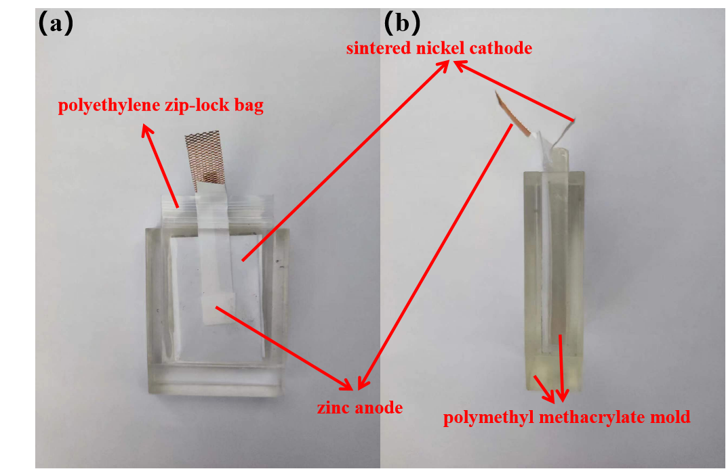

Figure S1. The device picture of the Zn-Ni battery. (a) main view, and (b) side view.

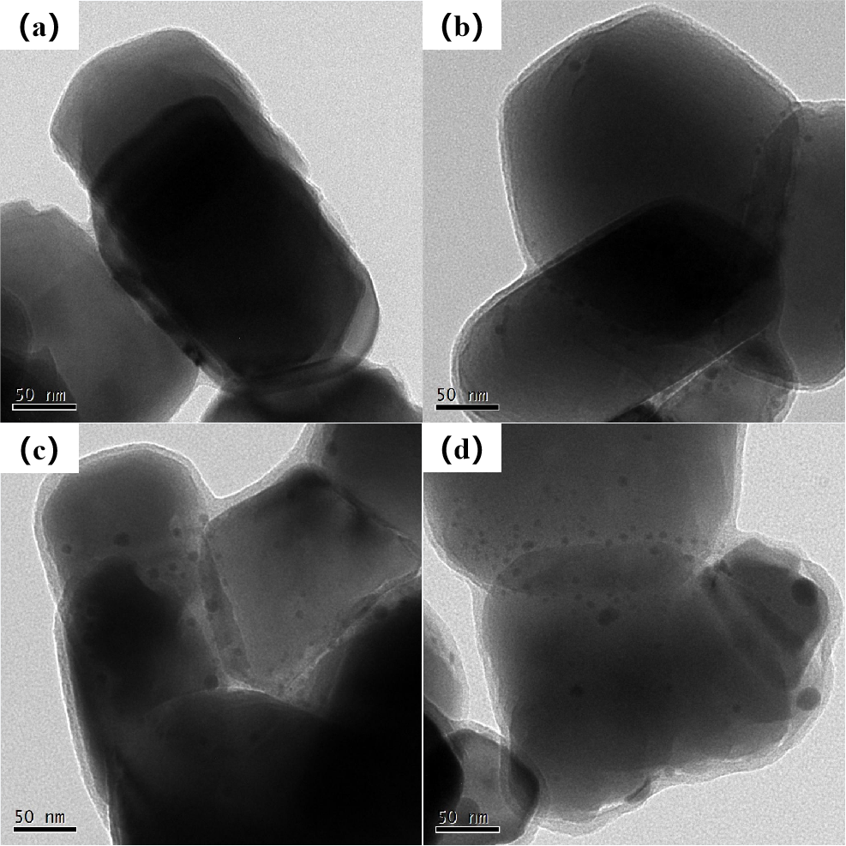
Figure S2. TEM images of ZnO@C/Bi composites with different carbon layer thicknesses at 50nm scale. (a) C-1, (b) C-2, (c) C-3, and (d) C-4.
Table S1. Tafel parameters for ZnO@C/Bi composites with different Bi contents.

Sample | Corrosion potential/V | Corrosion current density/mA cm⁻²
4.14% | -1.436 | 20.55
5.66% | -1.422 | 15.13
8.01% | -1.427 | 17.22

Table S2. CV curves parameters for ZnO@C/Bi composites with different Bi contents.
Sample | Oxidation peak position/V | Oxidation peak height/A | Reduction peak position/V | Reduction peak height/A | Redox peak difference/V
0.10 g | -1.308 | 0.1417 | -1.565 | -0.1776 | 0.257
0.15 g | -1.285 | 0.1655 | -1.548 | -0.1131 | 0.263
0.20 g | -1.251 | 0.2112 | -1.526 | -0.0913 | 0.275

Table S3. Pore volume, specific surface area and pore size of ZnO@C/Bi composites with different carbon layer thicknesses.
Sample | Carbon layer thickness /nm | Vª _{tot}/ cm³ g⁻¹ | V^{b} _{micro}/ cm³ g⁻¹ | V _{micro}/ _{Vtot} | Average pore size/nm | Specific surface area /m² g⁻¹
C-1 | 2.28 | 0.0169 | 0.006 | 36.41% | 3.1086 | 22.97
C-2 | 5.48 | 0.0285 | 0.0178 | 62.56% | 2.1759 | 54.63
C-3 | 14.26 | 0.0497 | 0.0307 | 61.89% | 2.1326 | 96.48
C-4 | 20.38 | 0.0505 | 0.0344 | 68.10% | 2.0175 | 103.97

Table S4. Tafel parameters for ZnO@C/Bi composites with different carbon layer thicknesses.
Sample | Corrosion potential/V | Corrosion current density/mA cm⁻²
C-1 | -1.449 | 15.20
C-2 | -1.426 | 15.13
C-3 | -1.421 | 14.75
C-4 | -1.412 | 19.05

Table S5. CV curves parameters for ZnO@C/Bi composites with different carbon layer thicknesses.
Sample | Oxidation peak position/V | Oxidation peak height/A | Reduction peak position/V | Reduction peak height/A | Redox peak difference/V
C-1 | -1.278 | 0.09693 | -1.555 | -0.09589 | 0.277
C-2 | -1.262 | 0.1081 | -1.561 | -0.08851 | 0.299
C-3 | -1.260 | 0.119 | -1.535 | -0.07973 | 0.275
C-4 | -1.231 | 0.1475 | -1.528 | -0.06729 | 0.297

