Exhibits

Exhibit 1A: Cover Page of PEPFAR Rapid Assessment Tool (in English)

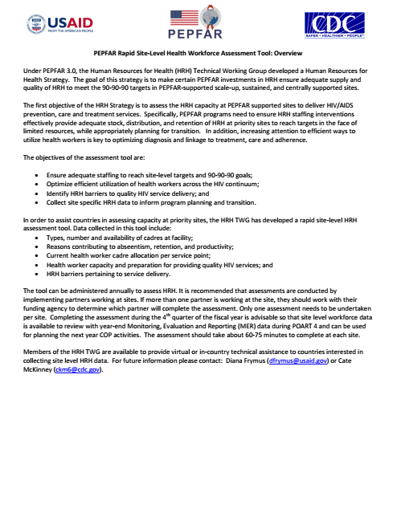

Exhibit 1B: Cover Page of PEPFAR Rapid Assessment Tool (translated to French)

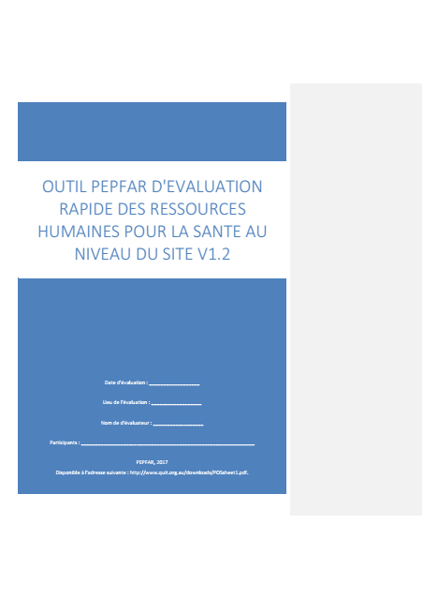

Exhibit 1C: Selected Section of Interview Data Collection Tool (in French in Microsoft Excel)

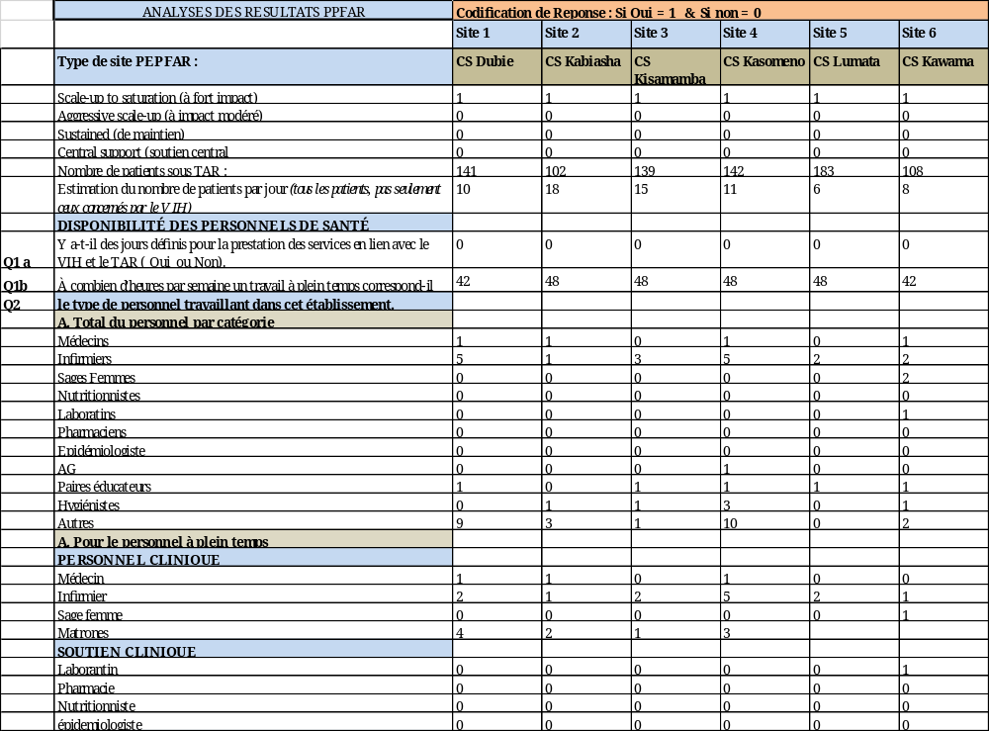

Exhibit 2A: First Set of PEPFAR “95-95-95” Indicators and Progress as of December 2018

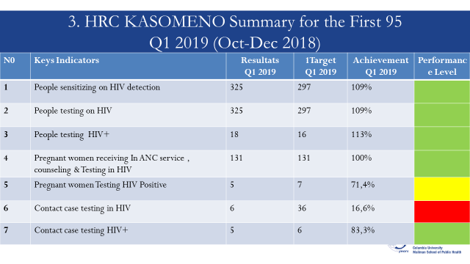

Exhibit 2B: Second Set of PEPFAR “95-95-95” Indicators and Progress as of December 2018

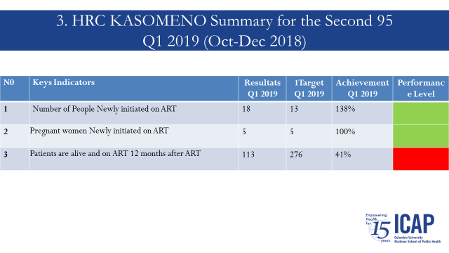

Exhibit 2C: Third Set of PEPFAR “95-95-95” Indicators and Progress as of December 2018

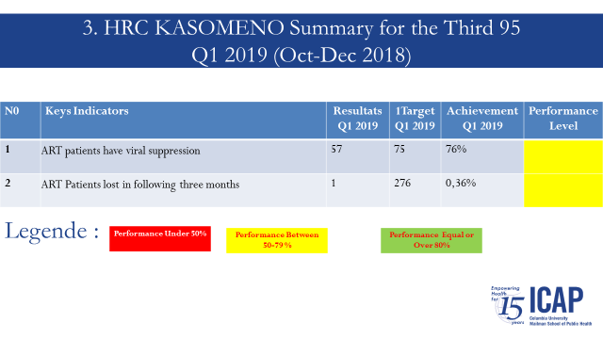

Exhibit 3: Staffing Levels—Total, Full-Time HIV/AIDS, and Part-Time HIV/AIDS--by Category across All 16 High-Priority HFs

*Total staffing bar shows both HIV/AIDS- and non-HIV/AIDS-trained staff.

Exhibit 4: HIV/AIDS Case Load for High-Priority HFs (as of March 2019)

Exhibit 5: Major Challenges to Meeting PEPFAR Targets (Across All High-Priority HFs): March 2019
*Case Load = Registered HIV/AIDS patients at clinic as of end of March 2019

*"Other" includes: Challenges with follow-ups with patients under treatment, lack of drugs for case management, insufficient testing of VCT cases, poor classification of VCT cases, lack of coordination and networking with nearby priority sites that receive large patient volumes.

Exhibit 6A: Suggested Interventions for High-Priority HFs, MoH, and ICAP (Before Prioritization): Staffing, Training, and Workplace Environment Domains, May 2019
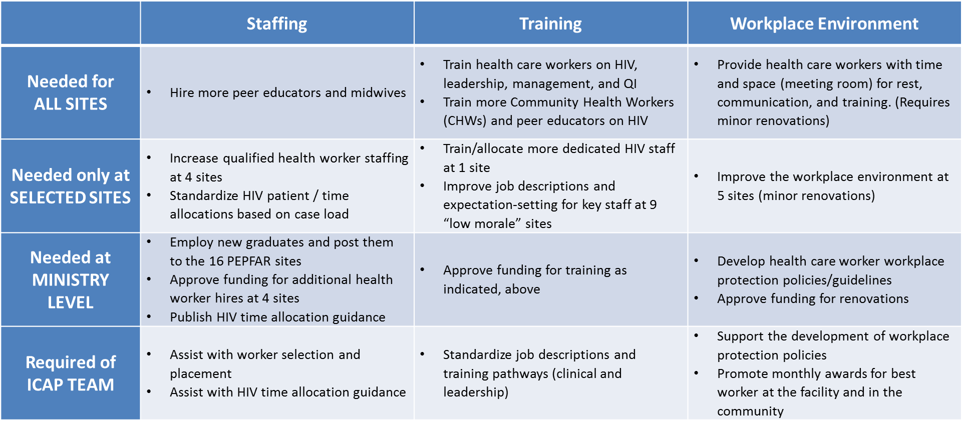

Exhibit 6B: Suggested Interventions for High-Priority HFs, MoH, and ICAP (Before Prioritization): Community Outreach, Medical Supplies and Equipment, and Monitoring and Evaluation Domains, May 2019
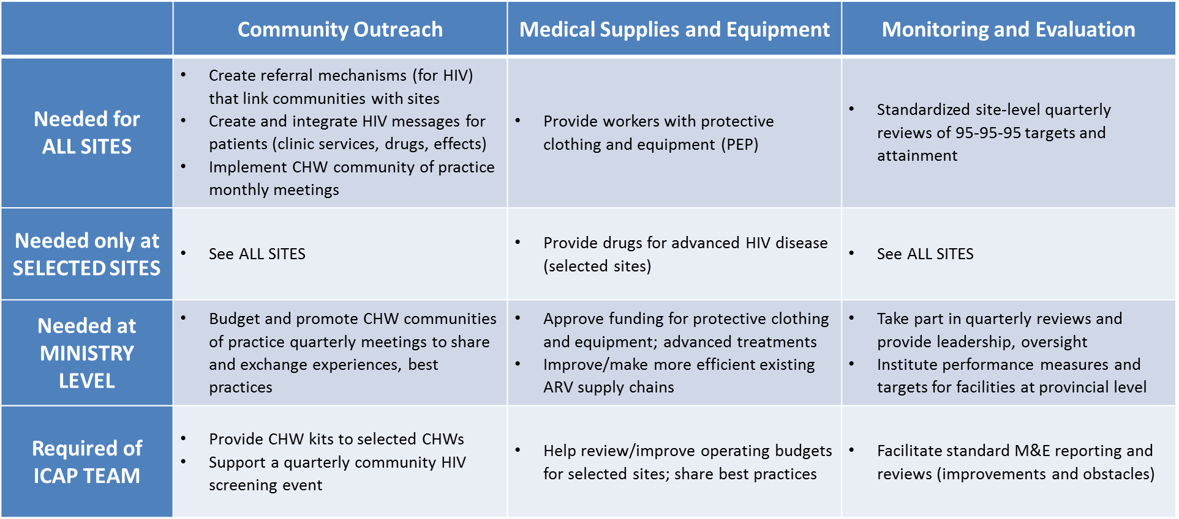

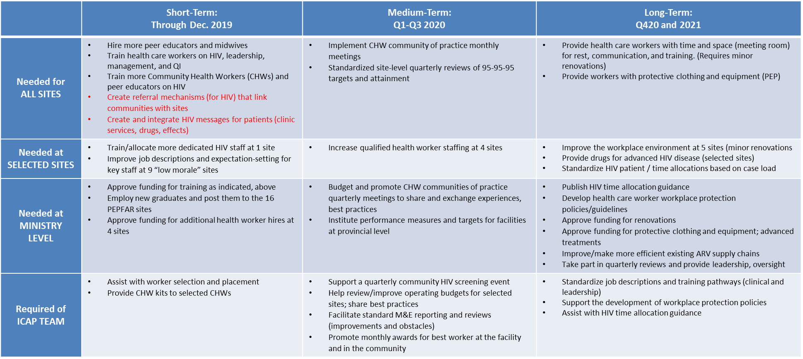
Exhibit 7: Prioritized Interventions for High-Priority HFs, MoH, and ICAP: Short-, Medium-, and Long-Term Time Frames, May 2019

Already Started
Exhibit 8: Short-Term Interventions (All Domains) for High-Priority HFs, MoH, and ICAP, May 2019
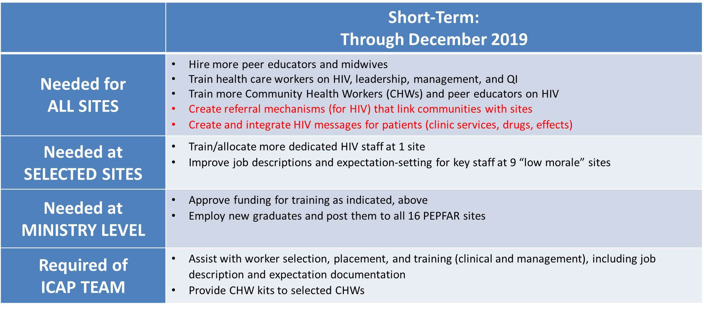

*Budgets already allocated from either Centers for Disease Control and Prevention (CDC) Care & Treatment (C&T) or HRSA RRHS awards.
Already Started*
Exhibit 9A: Site-Level Intervention Tracking Tool (Through November 2019) – MER Indicators and Progress, Only

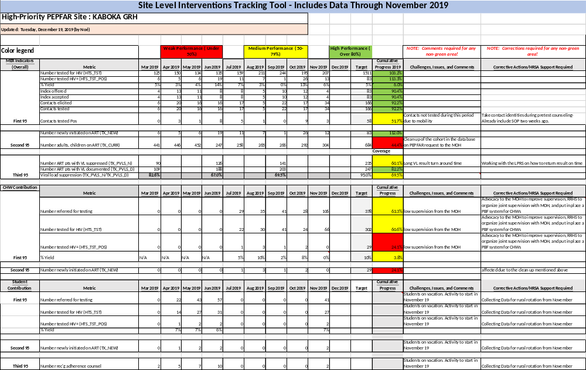

Exhibit 9B: Site-Level Intervention Tracking Tool (Through November 2019) – Short-Term Intervention Status and Progress, Only
