Supplemental information
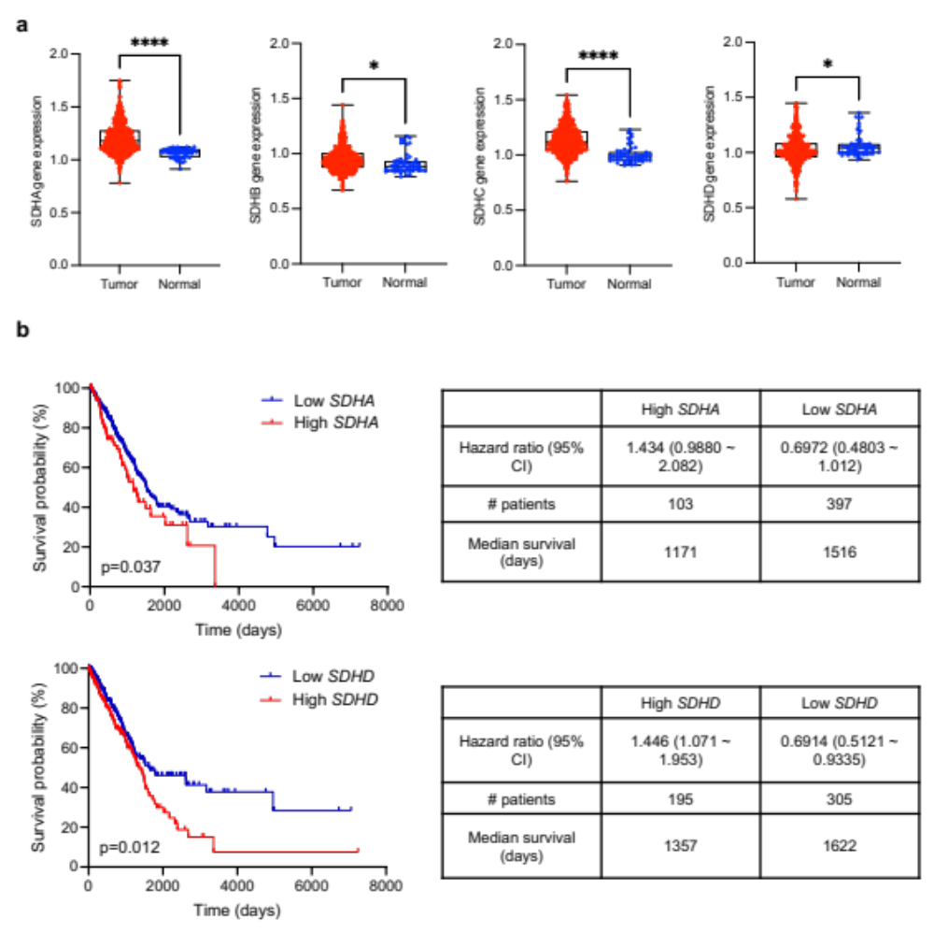
Supplementary Figure 1. SDH abundance is negatively associated with lung adenocarcinoma patients’ survival.
(a) Differential gene expression for SDHA, SDHB, SDHC, and SDHD in lung adenocarcinoma patient-derived tumor and tumor-adjacent normal tissues from The Cancer Genome Atlas (TCGA) database. N = 517 (tumor), N = 59 (normal).
(b) Kaplan-Meier curves and hazard ratios for overall survival in lung adenocarcinoma (LUAD) patients. The optimal expression cut-off point, determined by the lowest log-rank p-value and the greatest difference in survival, was employed to categorize patients into high and low SDHA or SDHD expression groups. N = 500 (TCGA_LUAD). CI, confidence interval.
Data are mean ± s.e.m. and were analyzed with two-tailed unpaired student’s t-test (a) and Log-rank test (b). *, p<0.05; ****, p<0.0001.

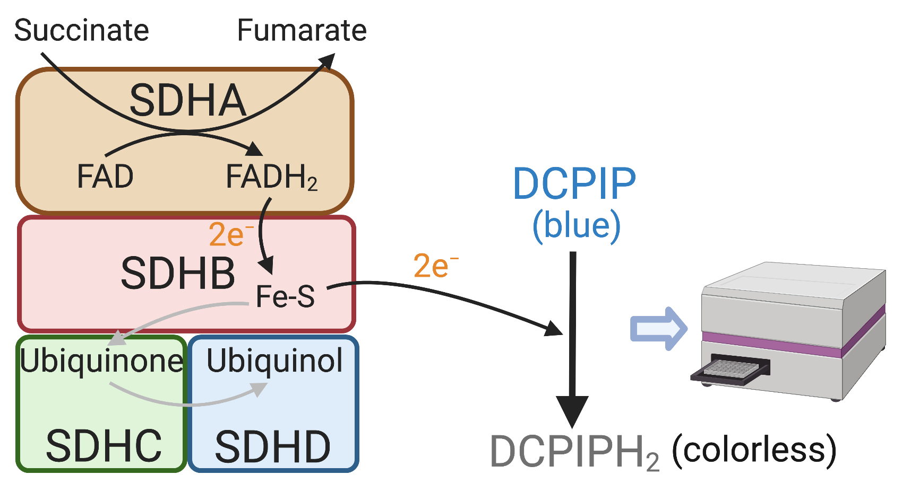
Supplementary Figure 2. Principles of measuring SDH enzyme activity. The electrons generated from SDH-catalyzed reactions are transferred to DCPIP (blue dye), converting DCPIP to the colorless product DCPIPH₂. The reduced optical density is measured by a microplate reader to quantify the SDH enzyme activity. Created with BioRender.com.

Supplementary Figure 3. SDH expression is dysregulated in lung cancer cell lines.
(a) Western blotting for SDHA, SDHB, and SDHD expression across various non-small cell lung cancer and immortalized (AALE) cell lines. Tom20 and β-Actin were used as loading controls. N = 3 replicates.
(b) Immunofluorescent staining for SDHC in NSCLC and AALE cells. Cells were stained with primary anti-SDHC antibody followed by anti-rabbit IgG conjugated with Alexa Fluor 488. The cells were then counterstained with DAPI. Scale bar = 20 μm. N = 6 replicates.

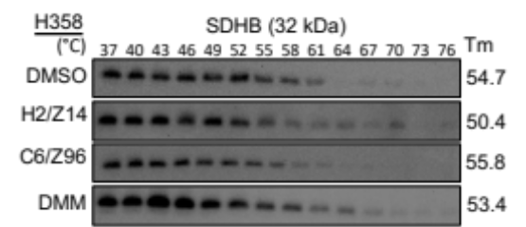

Supplementary Figure 4. Small molecules H2/Z14 and C6/Z96 do not bind SDHB. Thermal shift assay by western blotting for SDHB in H358 cells treated with or without small molecules H2/Z14, C6/Z96, and DMM at 30 μM for 15 minutes. Melting temperature (Tm) was calculated using nonlinear regression analysis. N = 3 replicates.

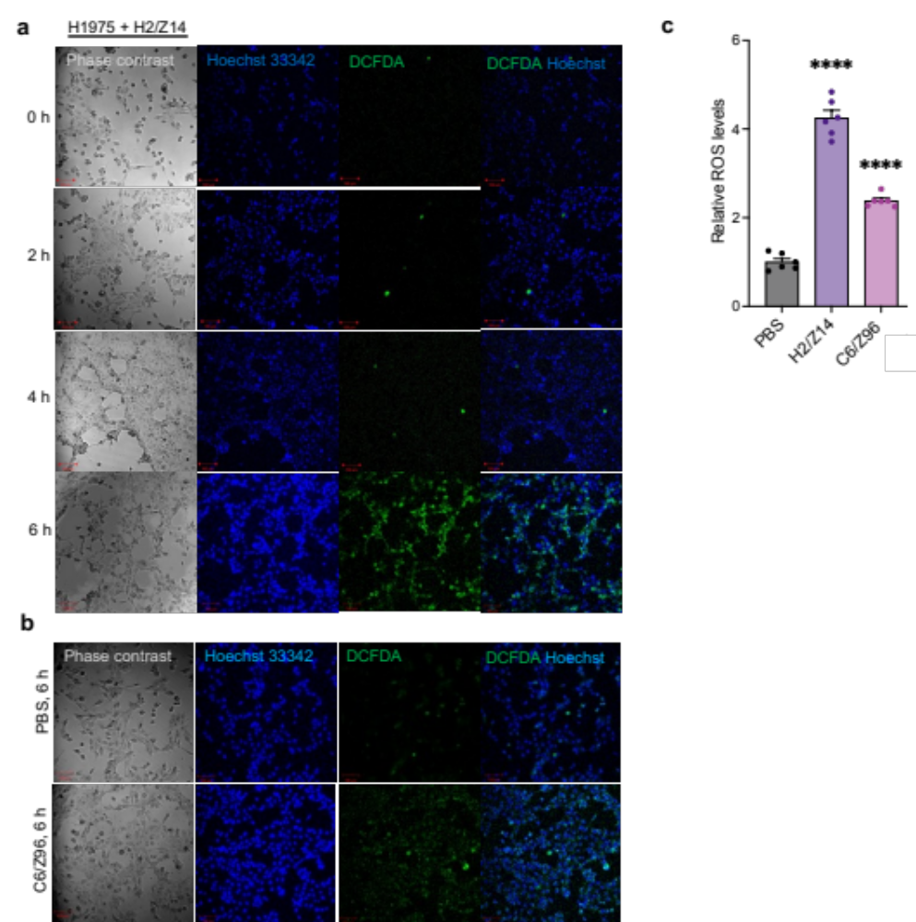Supplementary Figure 5. SDH inhibitors induce cellular ROS generation in H1975 cells.
(a~c) Confocal imaging for ROS by immunofluorescent staining in H1975 cells treated with 30 μM H2/Z14 for 0, 2, 4, and 6 hours (a) and C6/Z96 for 6 hours (b), counterstained with Hoechst 33342. Total cellular ROS levels were quantified using ImageJ software and calibrated to the PBS group (c). Scale bar = 20 µm. N = 3 replicates.
Data are mean ± s.e.m. and were analyzed with one-way ANOVA (c). ****, p<0.0001.
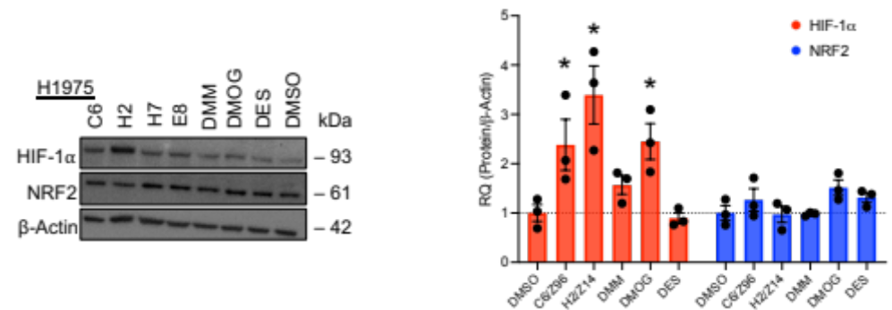
Supplementary Figure 6. Western blotting for HIF-1α and NRF2 and quantification in H1975 cells treated with small molecules (C6/Z96, H2/Z14, H7, E8, DMM, DMOG, DES) at 30 μM and vehicle (DMSO) for four hours. β-actin was used as a loading control. The expression levels of HIF-1α and NRF2 in cells treated with DMSO were calibrated as 1. N = 3 replicates.

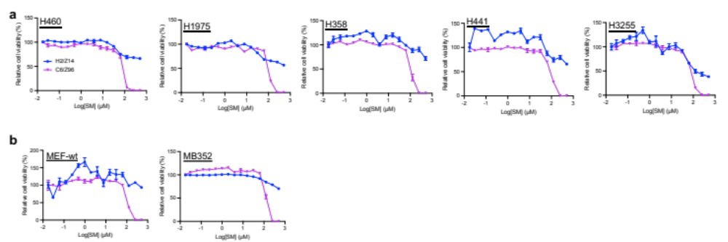Supplementary Figure 7. H2/Z14 and C6/Z96 inhibit short-term lung tumor cell growth in vitro.
(a) Relative cell viability of cell lines (H460, H1975, H358, H441 and H3255) treated with increasing doses of H2/Z14, C6/Z96, or a vehicle (PBS) for three days. N = 3 replicates. increasing doses of H2/Z14, C6/Z96, or a vehicle (PBS) for three days. N = 3 replicates.
(b) Relative cell viability of primary normal fibroblast cells (MEF-wt and MB352) treated with increasing doses of H2/Z14, C6/Z96, or a vehicle (PBS) for three days. N = 3 replicates.
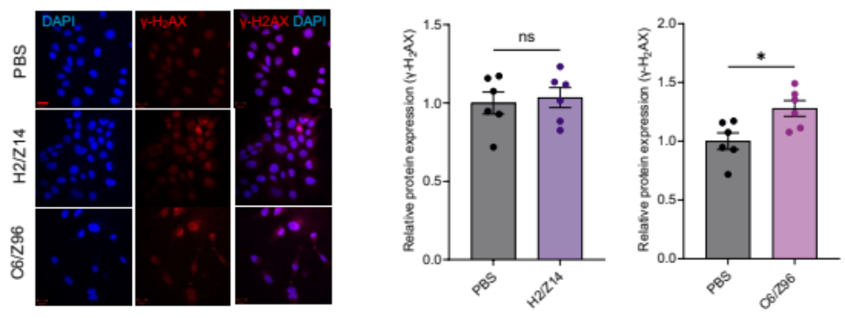
Supplementary Figure 8. Immunofluorescence staining and quantification for γ-H₂AX in H1975 cells treated with 30 µM H2/Z14, C6/Z96, or PBS for four hours. The fluorescence intensity in cells treated with PBS was calibrated as 1. Scale bar, 20 µm. N = 3 replicates. Data are mean ± s.e.m. and were analyzed with Welch’s t-test. *, p<0.05; ns, not significant.

