Supplementary Materials for

Centrality-Based Heuristics in Risk Management: A Network Model for Analyzing Systemic Failure

Correspondence to: Chulwook Park (pcw8531@snu.ac.at)

This file includes: Model mechanisms and parameter calculation

- Illustration of different centralities connectivity 1
- Simulation results referenced by the connectivity 3
- Simulation results referenced by the memorized capital 6
- Failure potential spreads referenced by social learning 9
- Simulation results referenced by the exploration values high effect 14

Appendix 1

In scale-free networks, the distribution of connections among nodes is not uniform. Some nodes have relatively few connections, while others have many connections, a phenomenon known as the scale-free property. This property is evident in the degree distribution of scale-free networks, which exhibits a higher number of outliers than would be expected in a normal distribution. To quantify the importance of nodes in a scale-free network, researchers have developed various centrality measures, one of which is eigenvector centrality that assigns a score to each node in a network based on the number and connectivity of its neighbors. Nodes with many connections to other well-connected nodes will have a higher eigenvector centrality score than those with fewer connections or connections to less well-connected nodes. This is colloquially referred to as the rich-get-richer phenomenon.

Table S1. Numerical result for eigenvector centrality.
$$nodes(n)$$ | 0 | 1 | 2 | 3 | 4 | 5 | 6 | 7 | 8 | 9
$$eigen_cent$$ | 0.32 | 0.08 | 0.27 | 0.27 | 0.20 | 0.44 | 0.43 | 0.36 | 0.29 | 0.32
$$degrees$$ | 5 | 1 | 4 | 4 | 3 | 9 | 8 | 6 | 5 | 5

Note: Numerical results obtained from the simulation (a scale-free graph of $n=10$ nodes with expected degrees of $m$)

Table S1 exemplifies the eigenvector centrality scores for a scale-free network with ten nodes. The eigenvector centrality scores and degrees of the nodes are provided in the table. As can be seen, nodes with higher degrees (i.e., more connections) have higher eigenvector centrality scores. The eigenvector centrality is calculated by solving the eigenvalue problem of the network's adjacency matrix. Specifically, let λ₁,λ₂,…,λ_{N} denote the eigenvalues of the adjacency matrix A = {a_{i,j}} of network G. Then the largest eigenvalue of matrix A, λ_{max}, and its corresponding eigenvector e = [e₁,e₂,…,e_{N}]^{T} satisfy the equation:

$$λ_{max}e_{i}=\sum_{j=1}^{N}{a_{ij}e_{j}}$$
The eigenvector centrality for node $v_{i}$, denoted as $C_{E}(v_{i})$, is then defined as

$$C_{E}(v_{i})=λ_{max}^{-1}\sum_{j=1}^{N}{a_{ij}e_{j}}$$

where $a_{ij}$ defines the tie between nodes $v_{i}$ and $e_{j}$ , $a_{ij}e_{j}$ is the eigenvector value of node $e_{j}$ and λ is a constant. To be specific, the eigenvector centrality score for a node is calculated by solving the eigenvalue problem of the network's adjacency matrix; for a node is between 0 and 1, with a higher score indicating a higher level of centrality.

As depicted in the upper row of Fig. S1, within a scale-free network that utilized the Barabasi-Albert graph ($n$, $m$, $seed=None$) function, nodes of substantial degree exhibit an elevated probability of accruing additional interconnected nodes as "the rich become richer." This metric serves as an invaluable tool for identifying nodes capable of expediently disseminating information to a significant number of other nodes within the network. This is exemplified by the Google PageRank algorithm, which employs eigenvector centrality to ascertain the significance of individual web pages within the World Wide Web. An examination of the lower segment of Fig. S1, reveals that nodes with extensive links have enhanced eigenvector centralities. This relationship is not confined to theoretical representations but is also discernible within real-world network structures. Indeed, nodes with a high degree of connectivity, i.e., the hubs, considerably influence the distribution of information or disease within the network. Thus, the intrinsic properties of scale-free networks and the strategic computation of eigenvector centrality together serve as a robust toolset for identifying these influential hubs. Furthermore, they facilitate a comprehensive understanding of the dynamics governing the dissemination of information within the network.

(a) | (b) | (c)
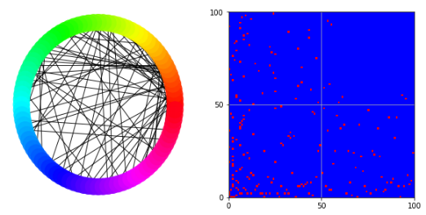 | 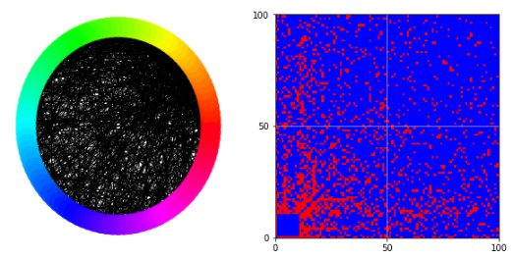 | 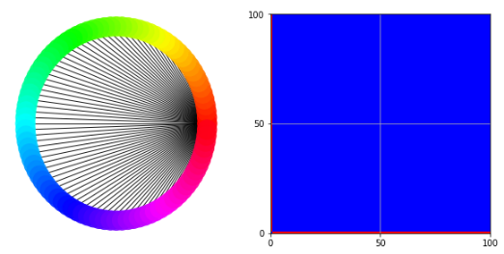
↓ | ↓ | ↓
(d) | (e) | (f)
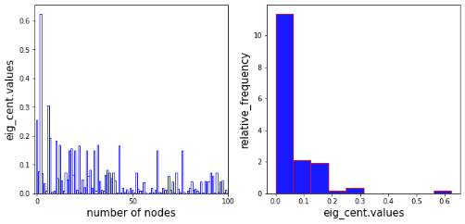 | 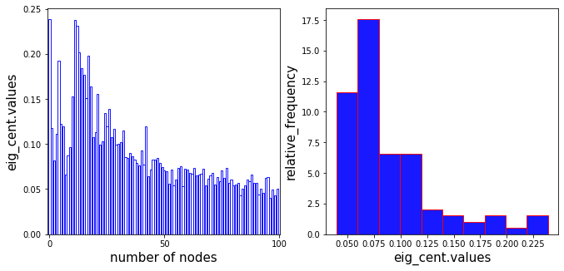 | 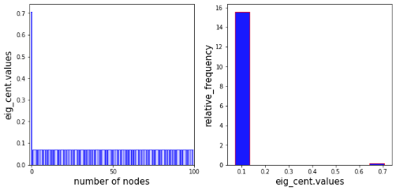

Figure S1. Illustration of several network topologies and corresponding distributions of centralities: The panels labeled (a) to (c) show three networks (left-hand side) and their adjacent matrices (right-hand side) with many nodes (= 100). Panel (d) to (f) represent the corresponding distribution centralities with the same number of nodes in varied degrees (number of connections: left-hand side = 1, middle = 10, right-hand side = 99).

Appendix 2

Our simulation addresses the impact of connectivity by setting fp0 and fp1 to 0, effectively disabling the network connections. We temporarily deactivated the code for strategy exploration and imitation, thus focusing solely on the variables under consideration. The concept that emerged from our meticulous examination of the centrality effect was the intriguing possibility of identifying an optimal degree of connectivity that maximizes a network's capacity for contagion.

Table S2: Numerical result for connectivity. a scale-free graph of $n=100$ nodes with expected degrees of $m$
$$degree(m)$$ | 1 | 2 | $$⋯$$ | 10 | 20 | $$⋯$$ | 40 | 50 | $$⋯$$ | 70 | 80 | $$⋯$$ | 98 | 99
$$fail.prob$$ | 0.292 | 0.589 | $$⋯$$ | 0.990 | 0.999 | $$⋯$$ | 0.999 | 0.999 | $$⋯$$ | 0.999 | 0.998 | $$⋯$$ | 0.566 | 0.376
$$me.capi$$ | 3.023 | 1.671 | $$⋯$$ | 1.008 | 1.000 | $$⋯$$ | 1.000 | 1.000 | $$⋯$$ | 1.000 | 1.001 | $$⋯$$ | 1.650 | 2.296
Note: numerical results obtained from the network = scale free (barabasi_albert_graph), number of nodes = 100, number of connections per node = 1 ~ 99 ($fail.prob$=failure probablity, $me.capi$= memorized capital), time steps = 100,000 (periods 1 ~ 100,000).
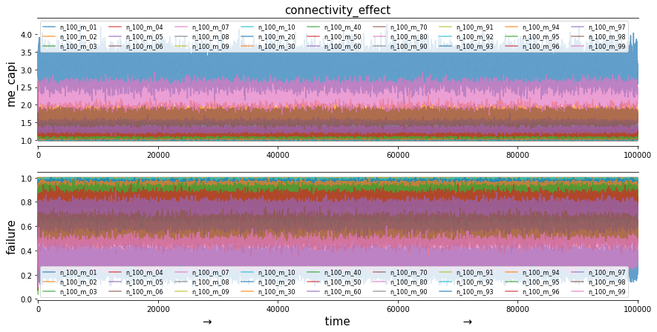
Figure S2. Simulation results referenced by the connectivity. Initialized parameters: Type of network = scale free (barabasi_albert_graph), number of nodes = 100, number of connections per node = 1 ~ 99, p_{max}= 1, c_{p,1/2} = 0.05, initial failure p_{n} =0.1, p_{l} =0.3, initial capital (c) = 1, maintenance (f_{m}) = 0.1, time steps = 100,000 (periods 1 ~ 100,000), realization = 1.
In our model, we are capable of conducting simulations with fp0 and fp1 set to 0, and without the influence of strategy evolution. We carried out these experiments to chart the average contagion failure probability against the degree of connectivity, thereby enabling us to determine if we could discern a significant trend. Particularly, we looked for patterns such as the hump-shaped curves previously documented in various studies, such as "Contagion in Financial Networks" by Gai & Kapadia (2010). Our anticipation is that if we successfully identify such a failure-maximizing connectivity, it would serve as a valuable baseline parameter in our investigation of evolutionary dynamics.

Table S3. Numerical result for connectivity. a scale-free graph of $n=100$ nodes with expected degrees of $m$
$$degree(m)$$ | 1 | 2 | $$⋯$$ | 10 | 20 | $$⋯$$ | 40 | 50 | $$⋯$$ | 70 | 80 | $$⋯$$ | 98 | 99
$$fail.prob$$ | 0.292 | 0.589 | $$⋯$$ | 0.990 | 0.999 | $$⋯$$ | 0.999 | 0.999 | $$⋯$$ | 0.999 | 0.998 | $$⋯$$ | 0.566 | 0.376
$$me.capi$$ | 3.023 | 1.671 | $$⋯$$ | 1.008 | 1.000 | $$⋯$$ | 1.000 | 1.000 | $$⋯$$ | 1.000 | 1.001 | $$⋯$$ | 1.650 | 2.296
Note: numerical results obtained from the network = scale free (barabasi_albert_graph), number of nodes = 100, number of connections per node = 1 ~ 99 ($fail.prob$=failure probablity, $me.capi$= memorized capital), time steps = 100,000 (periods 1 ~ 100,000).
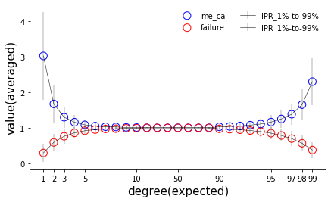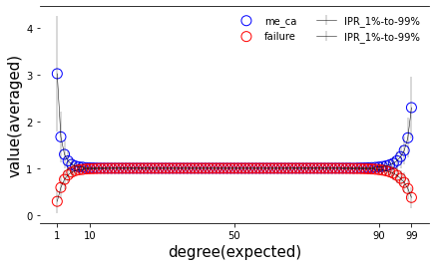
Figure S3.1. Simulation results referenced by the (selected) connectivity. The plot shows averaged value (vertical-axis) by the expected degree (m = 1~99: horizontal-axis) including all the degree values (right side of the plot). Error bars denotes their (values) standard deviation. Initialized parameters: Type of network = scale free (barabasi_albert_graph), number of nodes = 100, number of connections per node = 1 ~ 99, p_{max}= 1, c_{p,1/2} = 0.05, initial failure p_{n} =0.1, p_{l} =0.3, initial capital (c) = 1, maintenance (f_{m}) = 0.1, time steps = 1 ~ 100,000 (periods 1 ~ 100,000), realization = 1 (see the Appendix 3 for more detail).
Our observations reveal the intriguing nature of the peak at 50% connectance, as well as the near symmetry, albeit not complete, between low and high connectance levels. We define connectance as the proportion of actual links to the maximum possible links within the network. Given that we're excluding self-links in this instance, the number of possible links is half the product of the total number of nodes and one less than the total number of nodes, as we're employing undirected links which cut the quantity of potential links in half compared to directed links. In terms of data visualization, we chose to delineate error bars ranging from one quantile to another. Specifically, we used the 1st to the 99th percentile, a range known as the interpercentile range (IPR), for the horizontal axis. For the vertical axis, we transformed each complete time series according to the –log10(1–p) transformation, as outlined below;

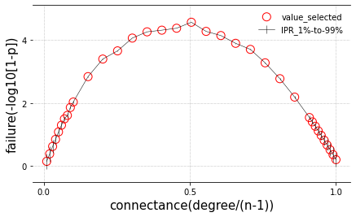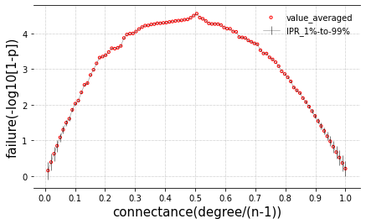
Figure S3.2. Simulation results referenced by the entire connectivity. The plot denotes the log scaled failure probability by the connectance (horizontal-axis) including all the degree values (right side of the plot). Error bars denotes their (values) standard deviation. Initialized parameters: Type of network = scale free (barabasi_albert_graph), number of nodes = 100, number of connections per node = 1 ~ 99, p_{max}= 1, c_{p,1/2} = 0.05, initial failure p_{n} =0.1, p_{l} =0.3, initial capital (c) = 1, maintenance (f_{m}) = 0.1, time steps = 1 ~ 100,000 (periods 1 ~ 100,000), realization = 1.
Our findings suggest that selecting a connectance of 0.5 offers the most substantial opportunity and challenge for the social evolution of protection strategies. This also provides a clear illustration of how connectivity can simultaneously decrease (or increase) the probability of failure while augmenting (or reducing) its potential to spread upon a breakout. The primary objective of this model is to evaluate the success of protection measures with and without the utilization of a centrality-based heuristic.

To execute this comparison, we set fp1 to 0 in one set of runs, signifying the absence of the heuristic, and allow fp1 to evolve in another set of runs, indicating the presence of the heuristic. In both instances, we aim to observe the evolutionary trace (or attractor) to extract diagnostic statistics. Achieving a replicable (fp0, fp1) trace (or attractor) of both fp0 and fp1 strategy dynamics is considered an essential characteristic of the model.

Once we have reliably obtained such an evolutionary trace (or attractor) for both sets of runs—which may, and most likely will, differ in terms of the average of fp0 at the attractor—we can draw comparisons using key statistics such as average failure probability, average capital, average investment in protection, and average gain in protection per investment in protection.

Appendix 3

As we transition into the next segment of our supplementary material, Appendix 3, we will explore the impact of various levels of memory and social learning (pr=imitation, pe=exploration) on our model.
The primary objective of this model is to contrast the success of protection strategies with and without the implementation of a centrality-based heuristic. This comparison is executed by setting $f_{\text{p1}}$ to 0 in one series of runs (representing the absence of the heuristic) and allowing its evolution in a separate series (indicating the presence of the heuristic). To derive diagnostic statistics in both scenarios, we aim to observe the evolutionary trajectory. The replicable attainment of a ($f_{\text{p0}}, f_{\text{p1}}$) trajectory, representative of the dynamics of $f_{\text{p0}}$ and $f_{\text{p1}}$ strategies, is a key characteristic of the model. Upon successful arrival at this evolutionary trajectory for both series of runs (which will likely exhibit variance in terms of the average of $f_{\text{p0}}$ at the attractor), we can then contrast statistical parameters such as the mean failure probability, the average capital, the average investment in protection, and the average gain in protection per investment. To achieve this, we anticipate having to discern a broad pattern that encapsulates memory and evolutionary attributes of imitation ($p_{\text{r}}$), exploration ($p_{\text{e}}$), and its standard deviation ($σ_{\text{e}}$), as outlined in the following sections.

We specifically scrutinize the calculation of memorized capital using the following formula:

$$memorized capital =memory*current capital+\left(1-memory\right)*old capital$$

where $memory<1$ describes the strength of memory and the $capital=1+\left(1-f_{\text{m}}-f_{\text{p}}\right)c$, by using the stochastic moving averaged function

$$X\left(n\right)=ε_{n}+b_{1}ε_{n-1}$$

for example, when we have; $ε=\left\{2,3,…\right\}, b_{1}=7$, the calculation is as follows:

$$X\left(1\right)=ε_{n}+b_{1}ε_{0}=3+7*2=17$$

$$X\left(2\right)=ε_{2}+b_{2}ε_{1}=-1+7*3=20$$

Our analysis reveals that neighboring individuals may also fail if their memorized capital is insufficient to cover the loss from interconnected links. This stochastic, moving average iterative process continues until no individuals are forced into failure.

memory=0.0  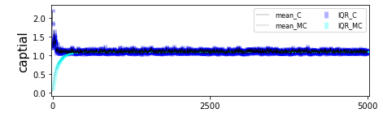  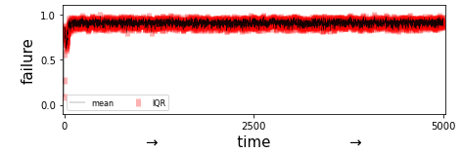 | memory=0.5  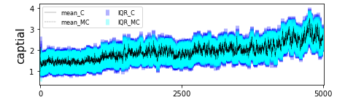  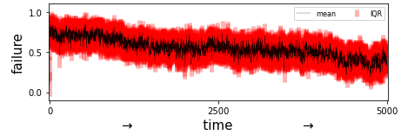 | memory=0.9  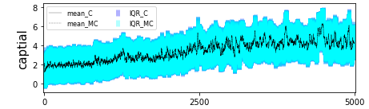  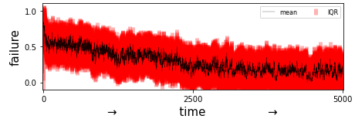
Figure S4. Simulation results referenced by the memorized_capital with imitation effect ($m_{e}$=0.0–0.9) values. Initialized parameters: Node = 100, connection m = 3, pmax = 1, cp = 0.1, initial failure pn=0.1, pl=0.3, initial capital = 1, fm = 0.1, time steps = 5000. Notice that for the memorized capital, we implemented: $memorized capital =memory*current capital+\left(1-memory\right)*old capital$, where $memory<1$ describes the strength of memory and $capital=1+\left(1-f_{\text{m}}-f_{\text{p}}\right)c$, by using the stochastic moving averaged function $X\left(n\right)=ε_{n}+b_{1}ε_{n-1}$ (see the Appendix 3 for more detail).

Now, at least, the failure probability decreases as the memorized capital is increased from 0. We examine the intermediate values of imitation ($p_{\text{r}}$). This is because with any jump and monotonic behavior beyond that parameter value, we would have to reconsider the imitation process and observe its relations as follow:

An encouraging observation is that the failure probability decreases as the memorized capital increases from 0, a result we would naturally anticipate. We delve deeper into examining the intermediate values of imitation (pr) in response to this. This is crucial because if there is any abrupt or monotonic behavior beyond that parameter value, it necessitates a review of the code to identify any potential errors in the coding of the imitation process. Consequently, we examined its relations as outlined below;

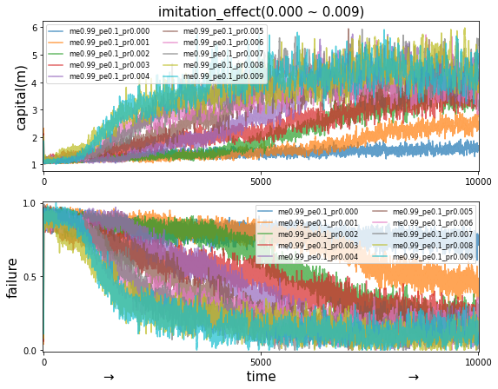 | 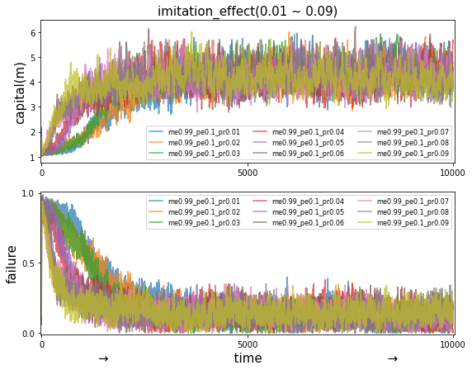 | 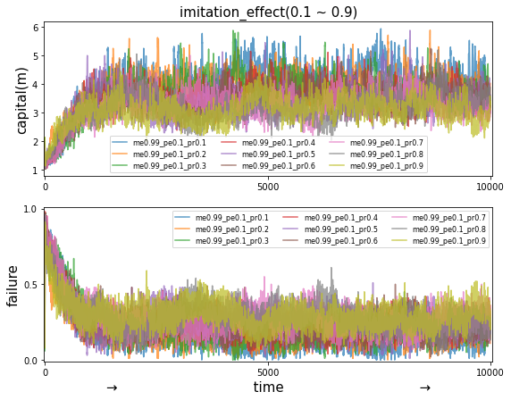
↓ | ↓ | ↓
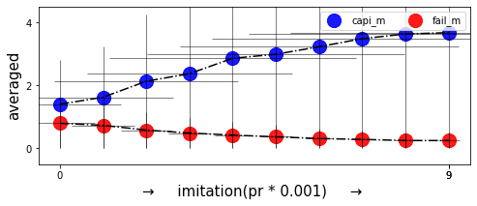 | 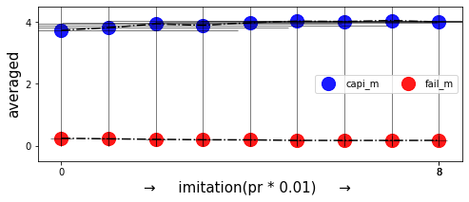 | 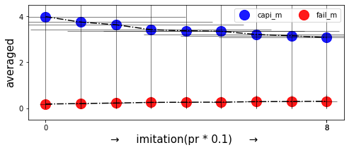

Figure S5.1. Simulation results referenced by the memorized_capital with imitation effect (0.0 ~ 0.9) values. Initialized parameters: Type of network = scale free (barabasi_albert_graph), number of nodes = 100, number of connections per node = 10, p_{max}= 1, c_{p,1/2} = 0.05, initial failure p_{n} =0.1, p_{l} =0.3, initial capital (c) = 1, maintenance (f_{m}) = 0.1, strength of selection, s = 1, σ_{e} = 0.001, time steps = 10,000.
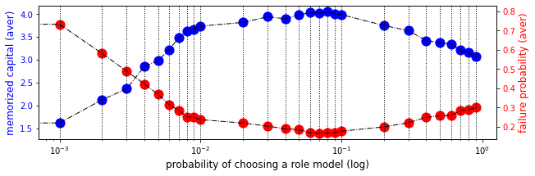
Figure S5.2. Combined simulation results referenced by the memorized_capital with imitation effect (0.0 ~ 0.9) values. Initialized parameters: Type of network = scale free (barabasi_albert_graph), number of nodes = 100, number of connections per node = 10, p_{max}= 1, c_{p,1/2} = 0.05, initial failure p_{n} =0.1, p_{l} =0.3, initial capital (c) = 1, maintenance (f_{m}) = 0.1, strength of selection, s = 1, σ_{e} = 0.001, time steps = 10,000. Note: we combined the observation values from grids with different spacing and showing results for the three grids 0.001, ..., 0.009, and 0.01, ..., 0.09, and 0.1, ..., 0.9 all together in one panel
Through the insights gleaned from our simulations, we have succeeded in parameterizing the influence of different levels of memory and social learning. As we delve into the centrality-based heuristic, we find compelling evidence of enhanced performance. Not only does this approach yield a superior degree of protection, it also facilitates a greater return on protection per investment. This underscores the potency of our model and the potential it holds for advancing our understanding of network dynamics and protection strategies.

The simulation outcomes presented in Fig. S5 confirm the feasibility of parameterizing the influences of varying degrees of social learning on the system under study. Significantly, the dynamics of the system are profoundly affected by social learning, especially imitation ($p_{\text{r}}$), which can be modulated through certain parameter adjustments. By altering these settings, it becomes possible to scrutinize the ramifications of disparate levels of social learning on the system, thereby deepening our comprehension of its functionality. As we unpack how our model is optimized, we now focus on memory and evolutionary traits related to imitation ($p_{\text{r}}$), exploration ($p_{\text{e}}$), and their standard deviation ($σ_{\text{e}}$). Our detailed discussion in the following sections serves to underline the critical role of conducting expansive simulations that span a substantial temporal period and involve averaging across multiple iterative runs. To implement the required parameter values effectively, we employed high-performance computing (HPC), particularly utilizing batch job processing.

Appendix 4

As we continue to unpack our research findings, we now turn our attention to Appendix 3. This section highlights the patterns encompassing memory and evolutionary traits related to imitation (pr), exploration (pe), and their standard deviation (sigma). Our detailed discussion in the following sections serves to underline the critical role of conducting expansive simulations that span a substantial temporal period and involve averaging across multiple iterative runs. To implement the required parameter values effectively, we employed high-performance computing (HPC), particularly utilizing batch job processing.

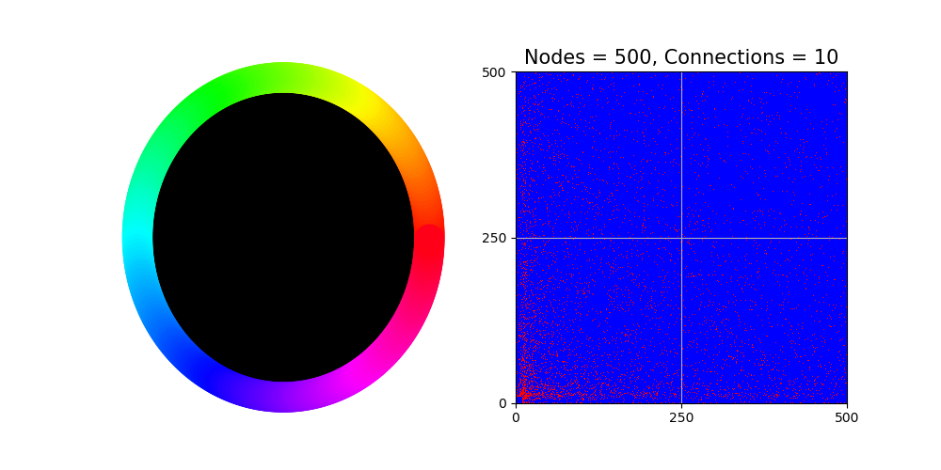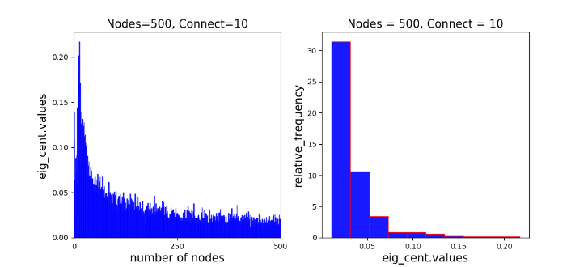
Figure S6.1. Representation of the network property results referenced by the number of nodes = 500. Type of network = scale free (barabasi_albert_graph), number of connections per node = 10.

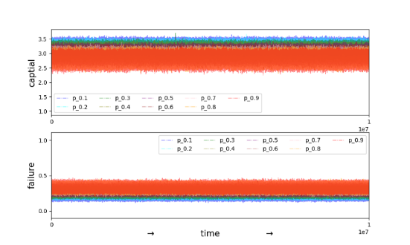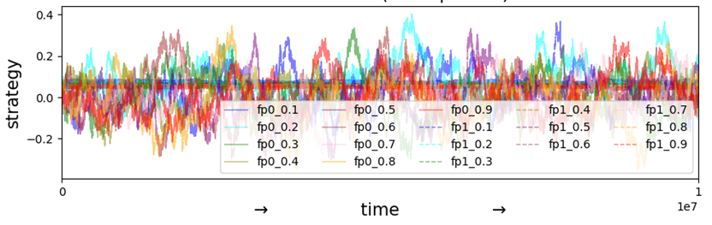

Figure S6.2. Representation of the failure potential spreads anyway referenced by the imitation (pr = 0.1 ~ 0.9) when the exploration (pe = 0.1). Type of network = scale free (barabasi_albert_graph), number of nodes = 500, number of connections per node = 10, p_{max}= 1, c_{p,1/2} = 0.05, initial failure p_{n} =0.1, p_{l} =0.3, initial capital (c) = 1, maintenance (f_{m}) = 0.1, strength of selection, s = 10, σ_{e} = 0.001, realization = 1, time steps =10,000,000.

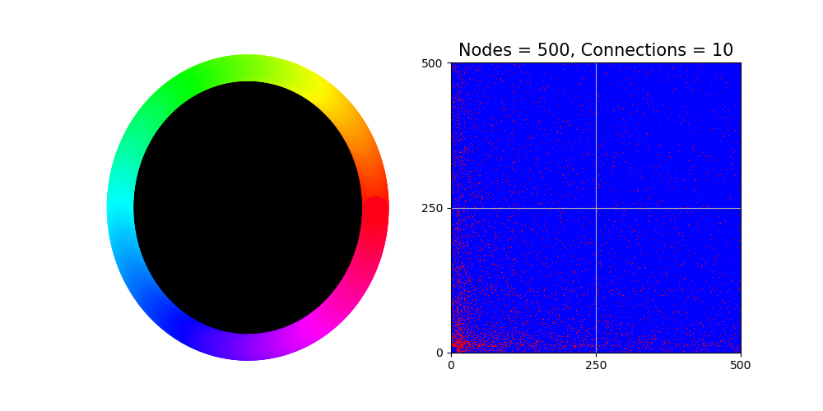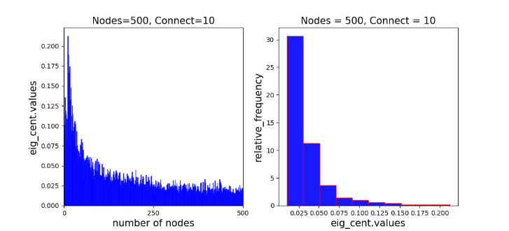
Figure S7.1. Representation of the network property results referenced by the number of nodes = 500. Type of network = scale free (barabasi_albert_graph), number of connections per node = 10.

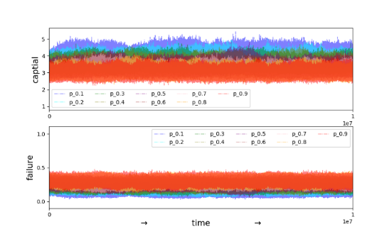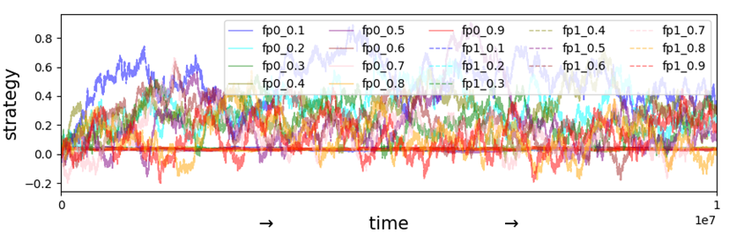

Figure S7.2. Representation of the failure potential spreads only when failure referenced by the imitation (pr = 0.1 ~ 0.9) when the exploration (pe = 0.1). Type of network = scale free (barabasi_albert_graph), number of nodes = 500, number of connections per node = 10, p_{max}= 1, c_{p,1/2} = 0.05, initial failure p_{n} =0.1, p_{l} =0.3, initial capital (c) = 1, maintenance (f_{m}) = 0.1, strength of selection, s = 10, σ_{e} = 0.001, realization = 1, time steps =10,000,000.
In order to ensure clarity in our terminology, we would like to clarify our usage of the term "replication". Typically, "iteration" denotes a sequential set of steps where each step relies on the preceding one. However, "replication" in our context signifies a compilation of results gathered independently of each other, hence they can potentially occur simultaneously. This distinction in terms is essential to comprehending the nature of our simulations and their associated results.
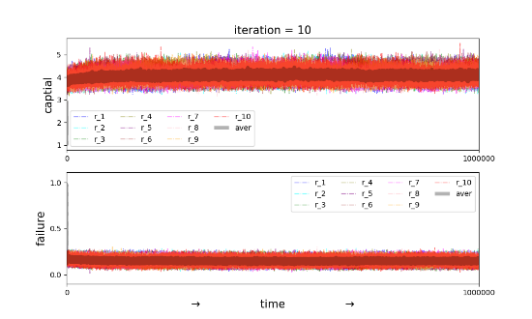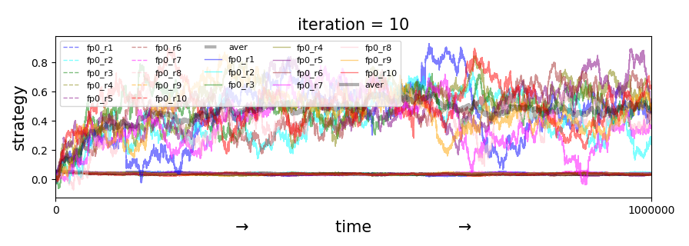
Figure S8.1. Representation of the network property results referenced by the imitation (pr = 0.1) when the exploration (pe = 0.9). Type of network = scale free (barabasi_albert_graph), number of nodes = 500, number of connections per node = 10, p_{max}= 1, c_{p,1/2} = 0.05, initial failure p_{n} =0.1, p_{l} =0.3, initial capital (c) = 1, maintenance (f_{m}) = 0.1, strength of selection, s = 10, σ_{e} = 0.001, realization = 10, time steps =1,000,000.
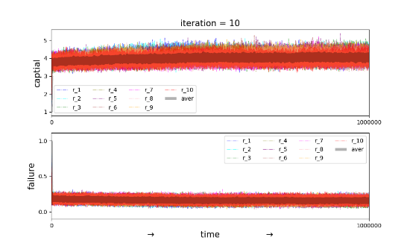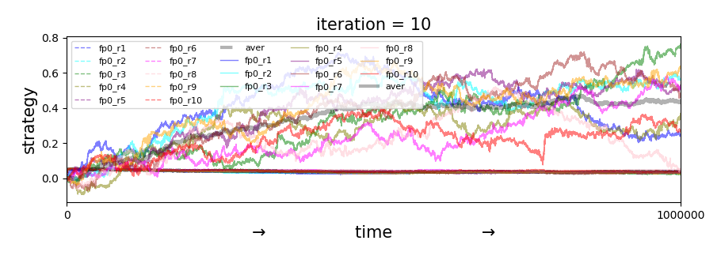
Figure S8.2. Representation of the network property results referenced by the imitation (pr = 0.1) when the exploration (pe = 0.1). Type of network = scale free (barabasi_albert_graph), number of nodes = 500, number of connections per node = 10, p_{max}= 1, c_{p,1/2} = 0.05, initial failure p_{n} =0.1, p_{l} =0.3, initial capital (c) = 1, maintenance (f_{m}) = 0.1, strength of selection, s = 10, σ_{e} = 0.001, realization = 10, time steps =1,000,000.

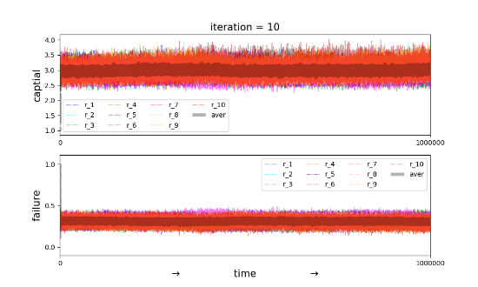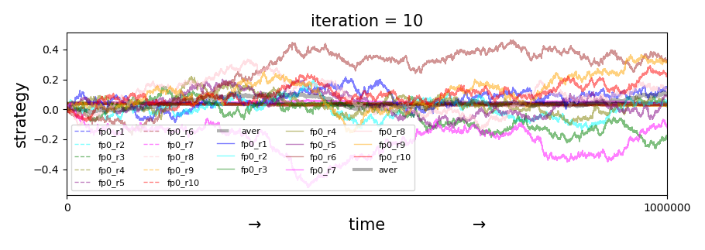
Figure S8.3. Representation of the network property results referenced by the imitation (pr = 0.9) when the exploration (pe = 0.1). Type of network = scale free (barabasi_albert_graph), number of nodes = 500, number of connections per node = 10, p_{max}= 1, c_{p,1/2} = 0.05, initial failure p_{n} =0.1, p_{l} =0.3, initial capital (c) = 1, maintenance (f_{m}) = 0.1, strength of selection, s = 10, σ_{e} = 0.001, realization = 10, time steps =1,000,000.
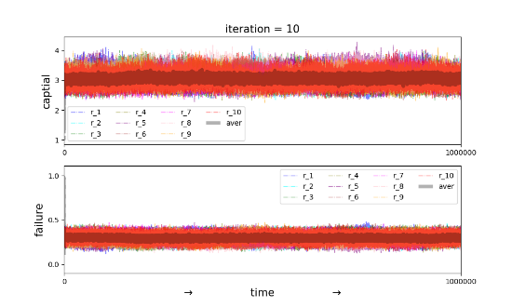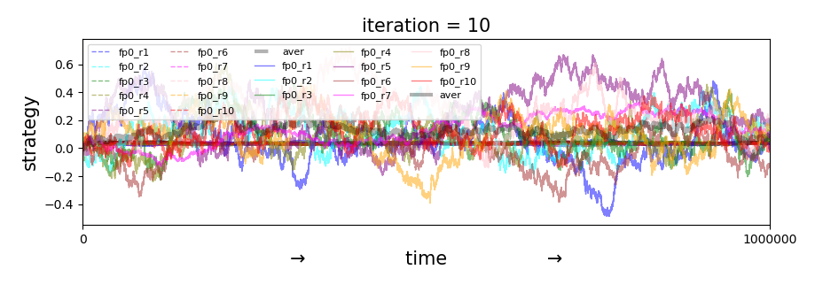
Figure S8.4. Representation of the network property results referenced by the imitation (pr = 0.9) when the exploration (pe = 0.9). Type of network = scale free (barabasi_albert_graph), number of nodes = 500, number of connections per node = 10, p_{max}= 1, c_{p,1/2} = 0.05, initial failure p_{n} =0.1, p_{l} =0.3, initial capital (c) = 1, maintenance (f_{m}) = 0.1, strength of selection, s = 10, σ_{e} = 0.001, realization = 10, time steps =1,000,000.
These plots are remarkable. We assume they also make it very clear now why it is so important that we (1) run the simulations for sufficiently long and (2) average over sufficiently many replicates. We see that pr = 0.1 gives us lower eventual failure probabilities than pr = 0.9. Thus, we should make pr small. We also see that pe does not matter very much for the eventual strategy values but that it does matter much for the speed at which these are reached. Since a higher speed means that our simulations can be shorter, we should make pe large.

We can observe that a value of 0.1 resulted in decreased eventual failure rates compared to a value of 0.9 in the case of the parameter pr, which reflects the extent of social learning or imitation. This shows that a smaller value of pr will reduce the spread of failures more effectively. Additionally, while the parameter pe, which denotes the amount of exploration, has little bearing on the final strategy values, it does influence how quickly these values are attained. To shorten the simulation, it is desirable to pick a more significant value of pe. We performed more simulations with values of pr 0.025, 0.05, 0.2, and 0.4 while maintaining pe at a value of 0.9 to further explore the ideal value for pr. This will help us better understand how the system's failure rate and strategy development are influenced by the parameter pr.

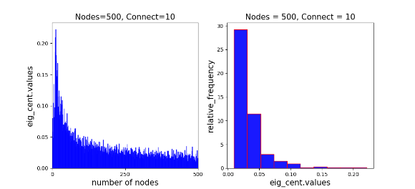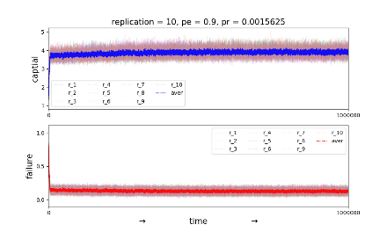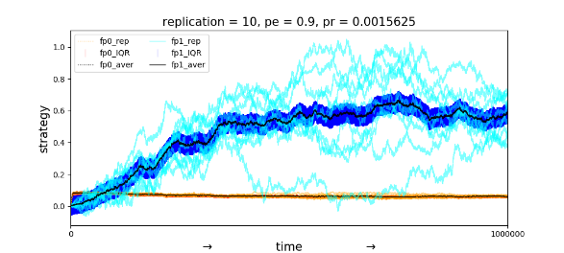
Figure S9.1. Representation of the network property results referenced by the imitation (pr = 0.0015625) when the exploration (pe = 0.9). Type of network = scale free (barabasi_albert_graph), number of nodes = 500, number of connections per node = 10, p_{max}= 1, c_{p,1/2} = 0.05, initial failure p_{n} =0.1, p_{l} =0.3, initial capital (c) = 1, maintenance (f_{m}) = 0.1, strength of selection, s = 10, σ_{e} = 0.001, realization = 10, time steps =1,000,000.
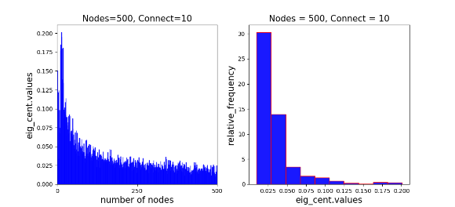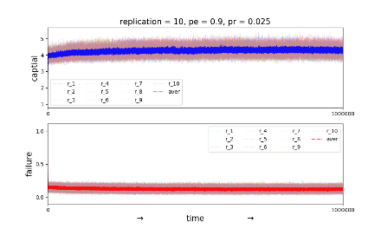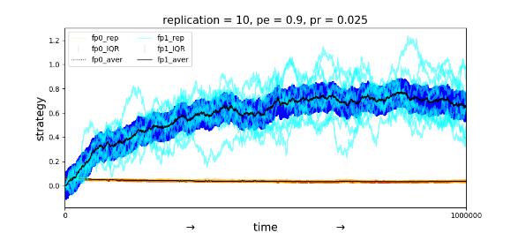
Figure S9.2. Representation of the network property results referenced by the imitation (pr = 0.025) when the exploration (pe = 0.9). Type of network = scale free (barabasi_albert_graph), number of nodes = 500, number of connections per node = 10, p_{max}= 1, c_{p,1/2} = 0.05, initial failure p_{n} =0.1, p_{l} =0.3, initial capital (c) = 1, maintenance (f_{m}) = 0.1, strength of selection, s = 10, σ_{e} = 0.001, realization = 10, time steps =1,000,000.
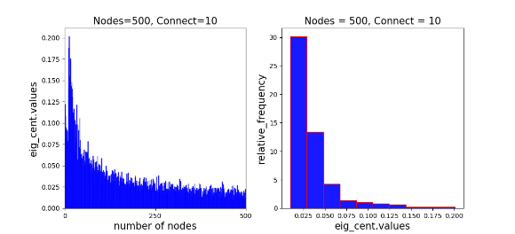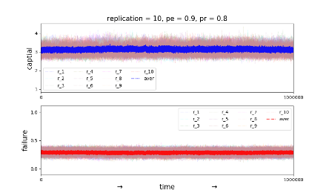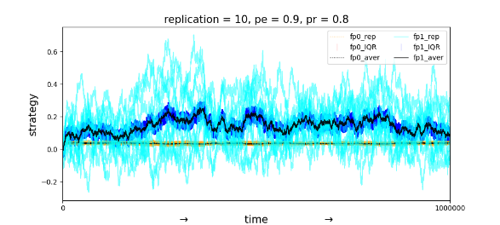
Figure S9.3. Representation of the network property results referenced by the imitation (pr = 0.8) when the exploration (pe = 0.9). Type of network = scale free (barabasi_albert_graph), number of nodes = 500, number of connections per node = 10, p_{max}= 1, c_{p,1/2} = 0.05, initial failure p_{n} =0.1, p_{l} =0.3, initial capital (c) = 1, maintenance (f_{m}) = 0.1, strength of selection, s = 10, σ_{e} = 0.001, realization = 10, time steps =1,000,000.

For the parameter, we anticipate seeing a comparable trend. We want to find an ideal value that strikes a compromise between the speed of convergence and the likelihood of failure by changing the value of pe and examining the effects on the speed at which the steady state strategy values are reached.

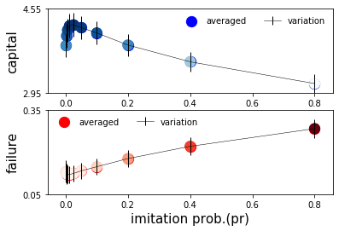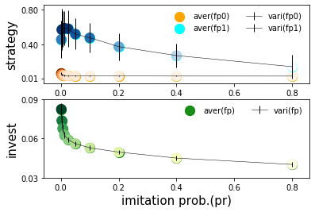
Figure S10.1. Combined representation of the five quantities. The plot of the left side shows the averaged capital (upper) and failure probability (bottom) versus the imitation probability (vertical line = error bar [averaged Standard Deviation value]). The plot of the right side shows the averaged strategy (upper) and investment (bottom) versus the imitation probability (vertical line = error bar [averaged Standard Deviation value]).

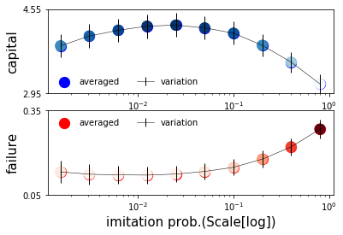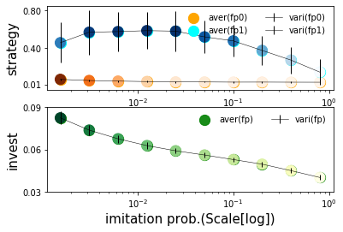
Figure S10.2. Combined representation of the two quantities referenced by the imitation (pr = horizontal axis) with high memory ($m_{e}$ = 0.9). The left-hand plot shows the averaged capital (upper) and failure probability (bottom) versus the imitation probability (vertical line = error bar [averaged Standard Deviation value]). The right-hand side plot shows a combined representation of the two quantities by scaled log = horizontal axis (vertical line = error bar [averaged variation value]). Type of network = scale-free (barabasi_albert_graph), number of nodes = 500, number of connections per node = 10, p_{max}= 1, c_{p,1/2} = 0.05, initial failure p_{n} = 0.1, p_{l} = 0.3, initial capital (c) = 1, maintenance (f_{m}) = 0.1, strength of selection, s = 10, σ_{e} = 0.001, realization = 10, time steps =1,000,000 (see the Appendix 4 for more detail).

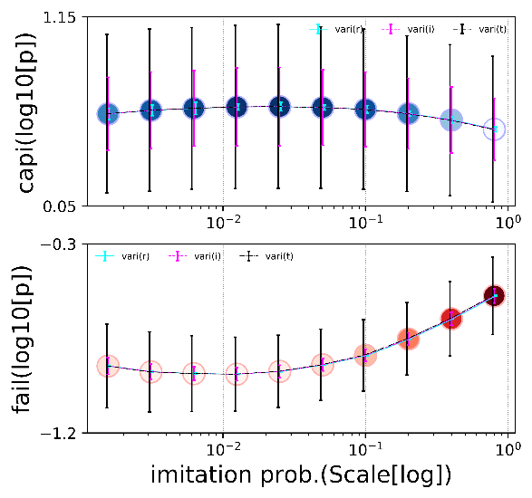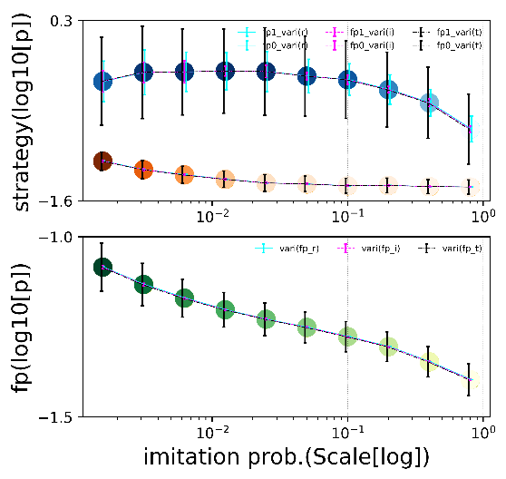

Figure S10.3. Combined representation of the five quantities (scaled log = both axis). The plot of the left side shows the averaged capital (upper) and failure probability (bottom) versus the imitation probability (vertical line = error bar [averaged variation value]). The plot of the right side shows the averaged strategy (upper=fp1, fp0) and investment (bottom=fp) versus the imitation probability (vertical line = error bar [averaged variation value]). Note: error bars of the black line denote square roots of the variances among times of the means averaged over individuals after averaging these variances over realizations, error bars of the magenta line denote square roots of the variances among individuals after averaging these variances over times and realizations, and error bars of the cyan line denote square roots of the variances among realizations of the means averaged over individuals and times.

These simulations yield noteworthy observations, emphasizing the importance of executing simulations for an adequate duration and averaging the results over a significant number of replicates. Our analysis indicates that the imitation ($p_{\text{r}}$) value of 0.1 yields lower eventual failure probabilities than a value of 0.9. Consequently, keeping the imitation ($p_{\text{r}}$) value small would be beneficial. Moreover, while the exploration ($p_{\text{e}}$) value seems to have a minimal impact on the eventual strategy values, it significantly influences the speed of achieving these values. Given that higher speeds allow for shorter simulations, setting the exploration ($p_{\text{e}}$) value high would be advantageous. To further our understanding of the optimal selection of the imitation ($p_{\text{r}}$), we initiate four additional sets of replicates for ($p_{\text{r}}$) values of 0.025, 0.05, 0.2, and 0.4, paired with the exploration ($p_{\text{e}}$) value of 0.9. This observation is intended to supplement our results for $p_{\text{r}}=0.1$ with those for pr values of 0.1/2/2, 0.1/2, 0.12, and 0.12*2. Each simulation is performed using the MP sbatch job, operating under the hypothesis that failure potential only spreads upon the occurrence of failure. We anticipate that plotting the resultant eventual average failure probabilities against $p_{\text{r}}$ will reveal a minimum. The precise location of this minimum can then be further refined by examining a few additional $p_{\text{r}}$ values in its vicinity.

Building upon the previous observation, it is crucial to acknowledge the invaluable insights gleaned from these simulations. These insights contribute significantly to our understanding of failure propagation dynamics, offering strategic measures to effectively mitigate such incidents. However, we must consider that these simulations may not encompass the multitude of complex variables that could potentially shape and direct real-world scenarios. The positive impact of our approach can be attributed to the fundamental mechanism of centrality-based heuristics. This method assesses the degree of connectivity inherent to each entity within the network. Based on this assessment, protection is prioritized for those entities that are most vulnerable to triggering a network-wide cascade of failures. This strategic approach enhances our capacity to preempt and address potential failures within complex networks.
Appendix 5

Transitioning into the discussion encapsulated in Appendix 4, we delve into the visualization of the relationship between an agent's centrality and their respective investment in protection, with respect to other combinations of parameter values. Each data point within the depicted figure represents an individual. The color of the point signifies the individual's centrality, while the vertical position of the point provides an indication of the extent to which the individual has invested in protection. This visualization aids in comprehending the interplay between centrality and investment in protection within complex networks.

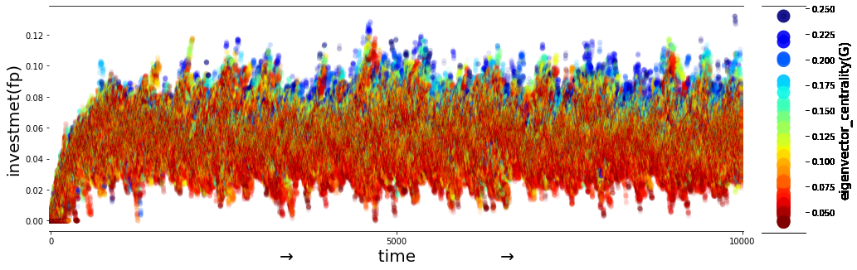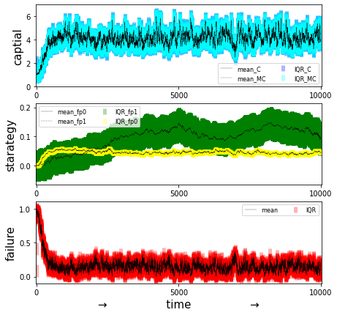
Figure S11.1. Simulation results referenced by the memorized_capital with imitation values, Main parameter: memory ($m_{e}$ = 0.9), exploration (p_{e} =0.9), imitation (p_{r} =0.1). Initialized parameters: Type of network = scale free (barabasi_albert_graph), number of nodes = 100, number of connections per node = 10, p_{max}= 1, c_{p,1/2} = 0.05, initial failure p_{n} =0.1, p_{l} =0.3, initial capital (c) = 1, maintenance (f_{m}) = 0.1, strength of selection, s = 1, σ_{e} = 0.001, time steps = 10,000.

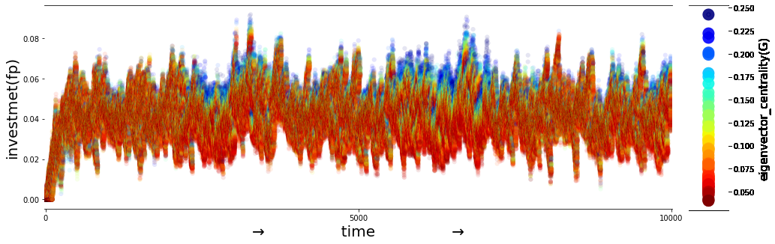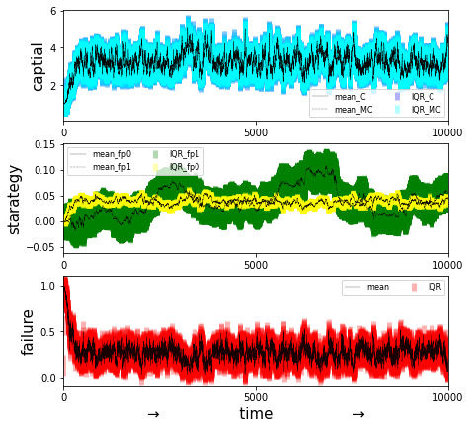
Figure S11.2. Simulation results referenced by the memorized_capital with imitation values; Main parameter: memory ($m_{e}$ = 0.9), exploration (p_{e} =0.9), imitation (p_{r} =0.9). Initialized parameters: Type of network = scale free (barabasi_albert_graph), number of nodes = 100, number of connections per node = 10, p_{max}= 1, c_{p,1/2} = 0.05, initial failure p_{n} =0.1, p_{l} =0.3, initial capital (c) = 1, maintenance (f_{m}) = 0.1, strength of selection, s = 1, σ_{e} = 0.001, time steps = 10,000.

