Supplementary Figures

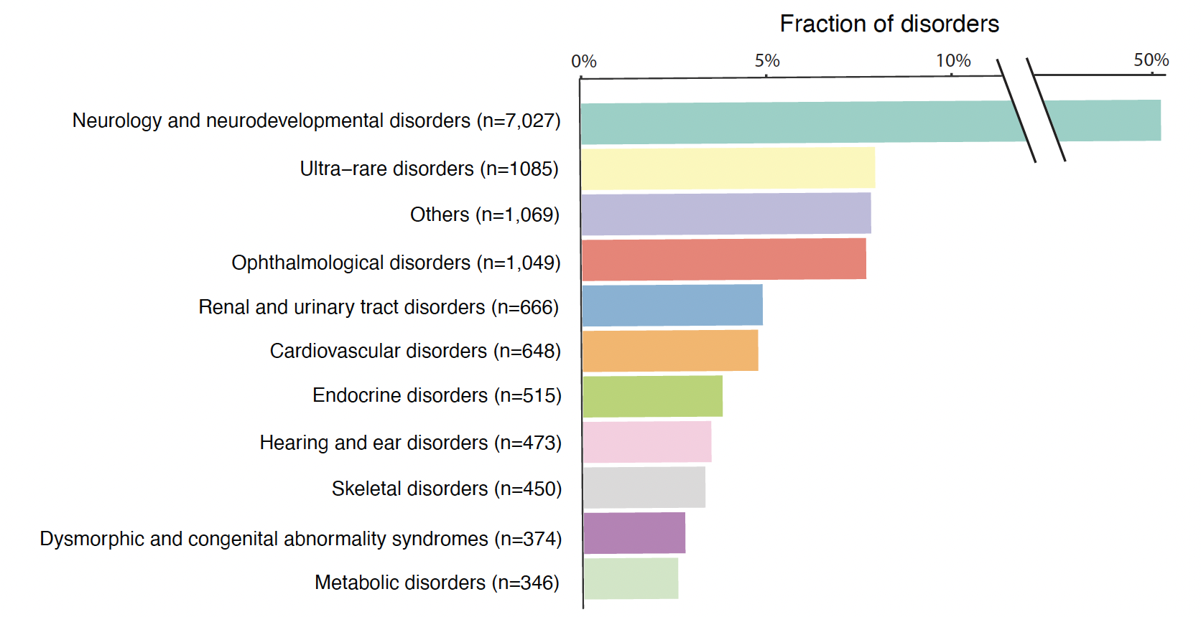

Figure S1. Proportion of samples by rare disorder types

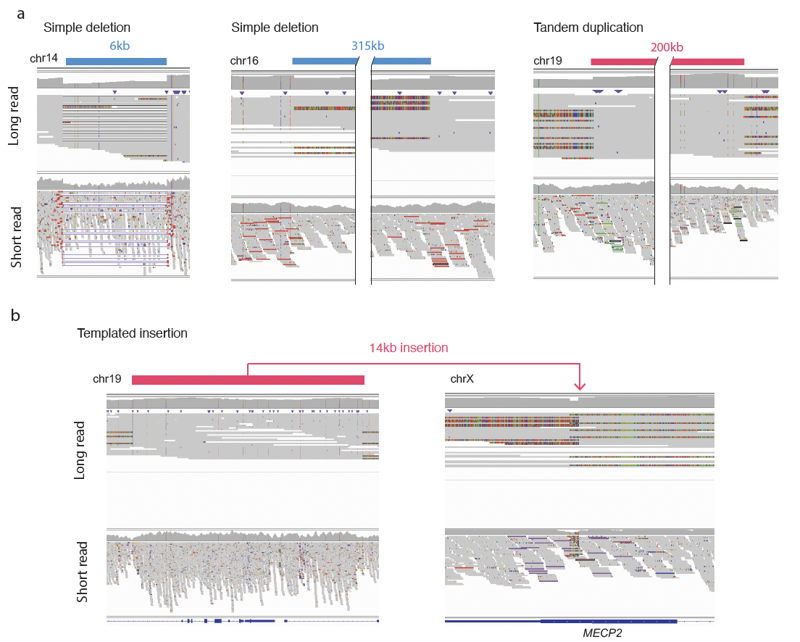
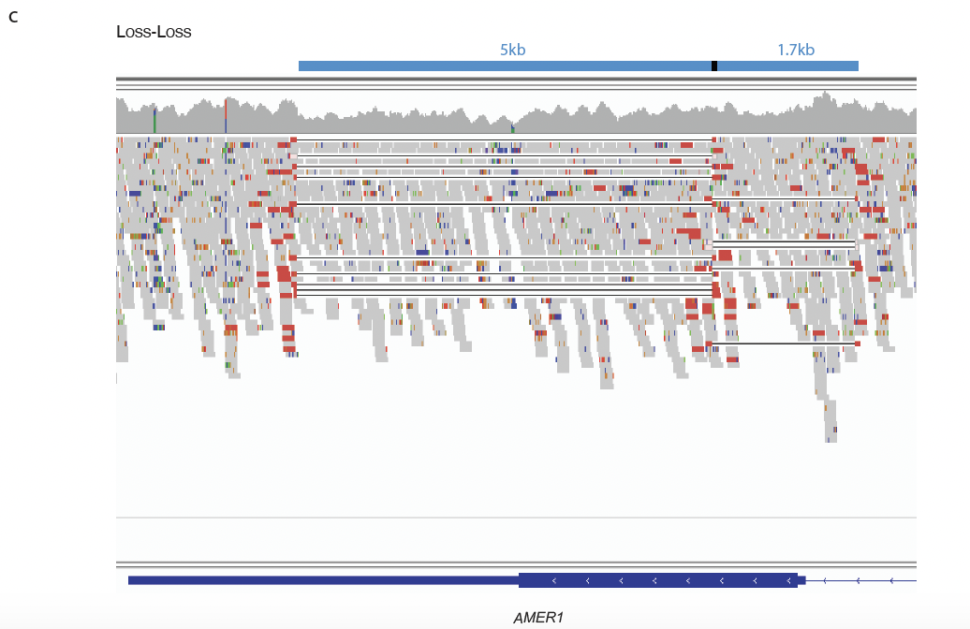
Figure S2. Validation of simple (a-b) and complex dnSVs (c) by long-read.
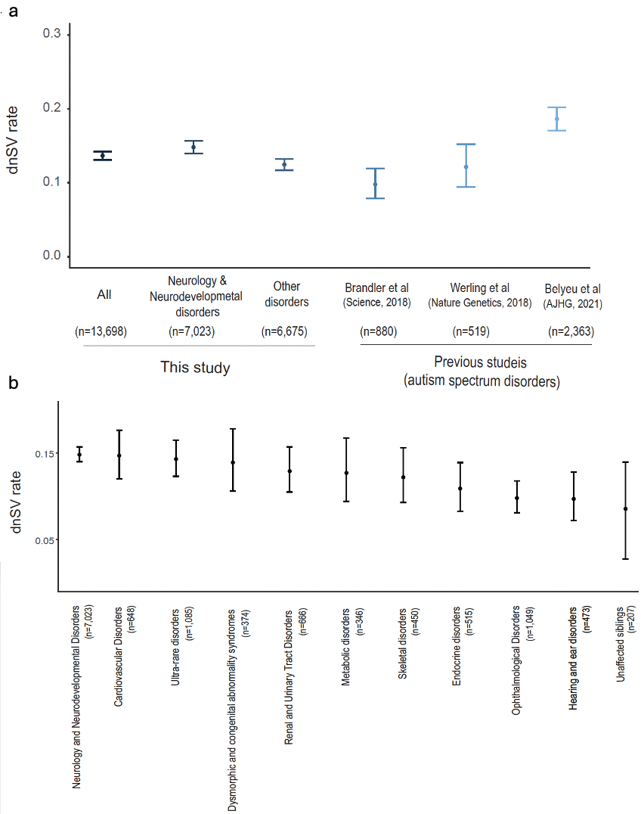
Figure S3. dnSV rate (a) Comparison of the rate of dnSVs between our study and previous three studies. The confidence interval was computed using the Exact binomial test. (b) dnSV rate across rare disorder types. Rare disorder types having ≥ 300 samples except for unaffected siblings are shown.

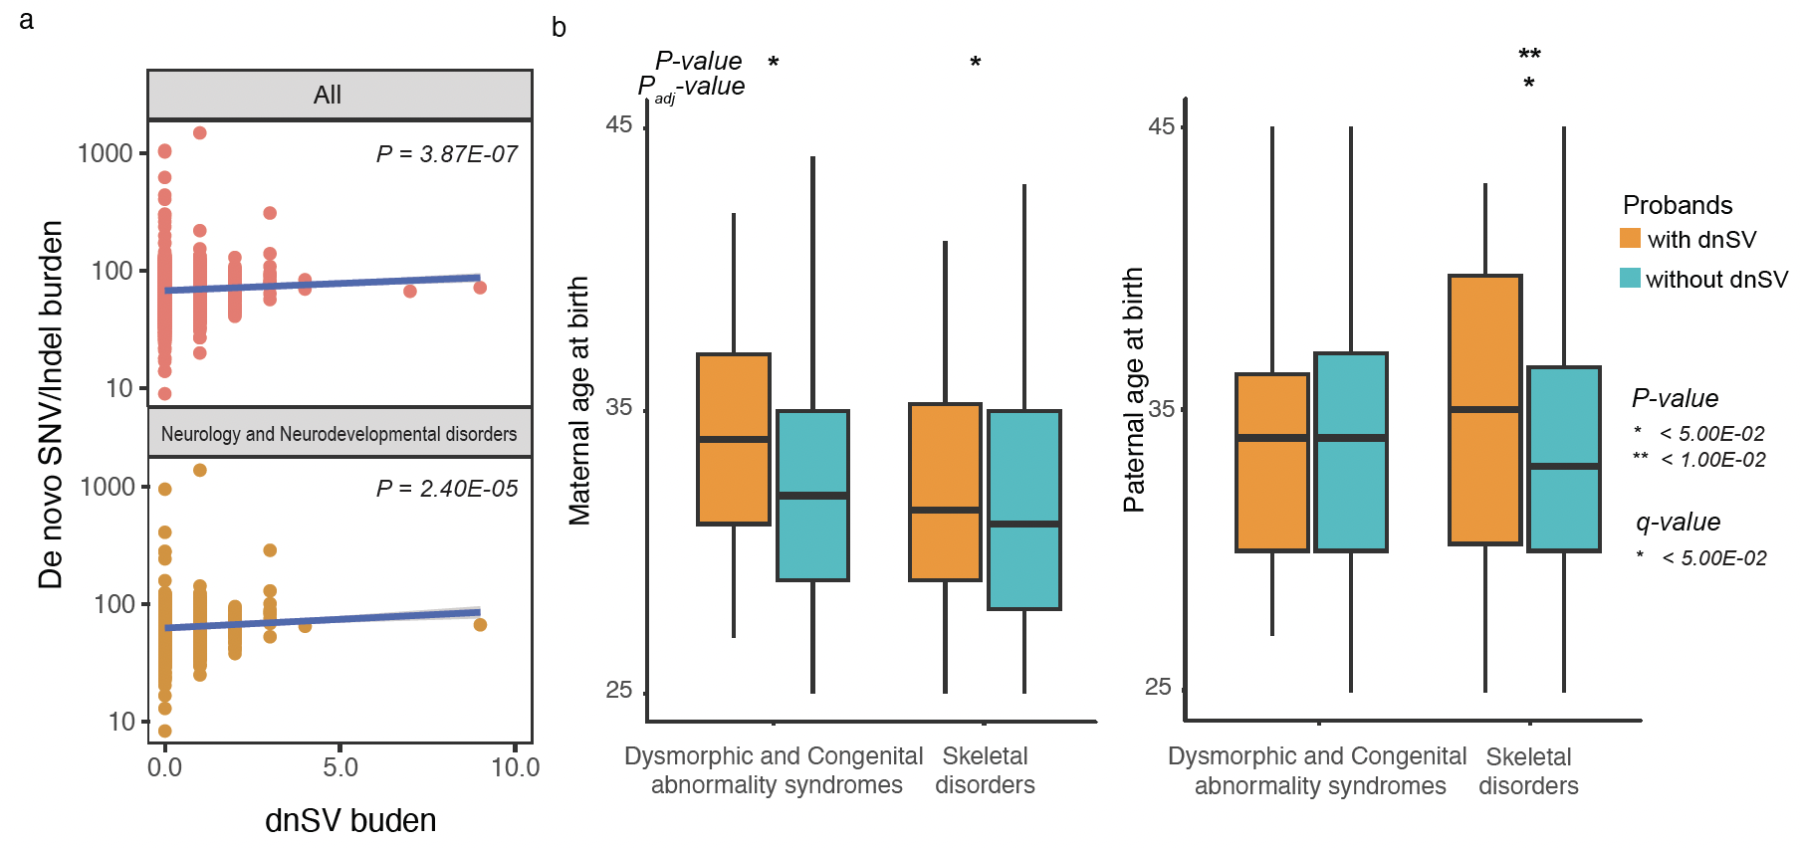
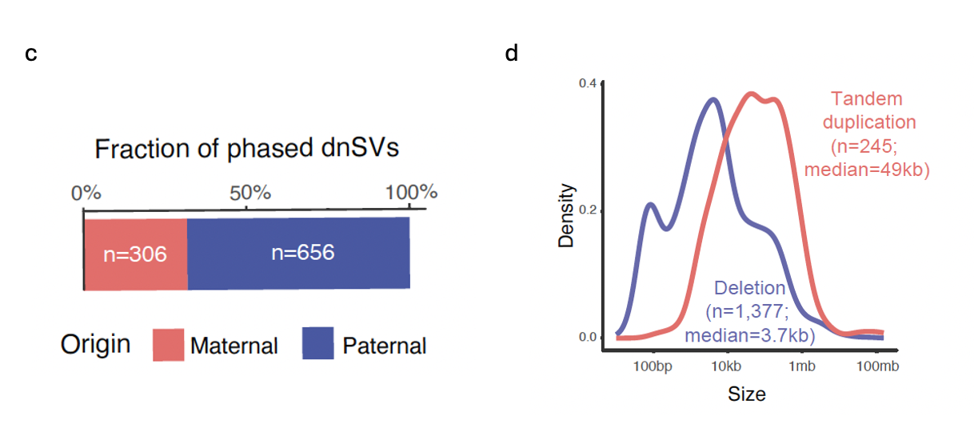
Figure S4. Analysis of dnSV (a) Correlation analysis between dnS and dnS SNV/indel burden using all (up) and NN samples (down). The P values were determined based on Spearman correlation analysis (b) Comparison of maternal and paternal age at birth between probands with dnSVs and those without dnSVs in Dysmorphic and Congenital abnormality syndromes and skeletal disorders. The P values were calculated based on a one-sided t-test and were corrected using the Benjamini-Hochberg method. (c) Fraction of phased dnSVs. (d) Distribution of the size of simple deletion and tandem duplication.

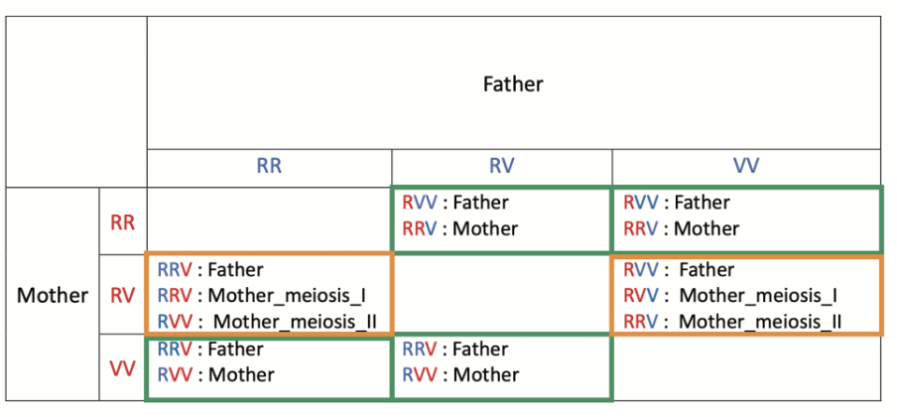

Figure S5. Informative genotypes to infer the timing of triplications from maternal origin. A set of informative genotypes to inter the timing of triplications (i.e., meiosis I or II). The genotypes in the green boxes were first used to infer triplications with maternal origin and then those in the orange boxes were utilized to classify the timing of triplication into meiosis I and II.

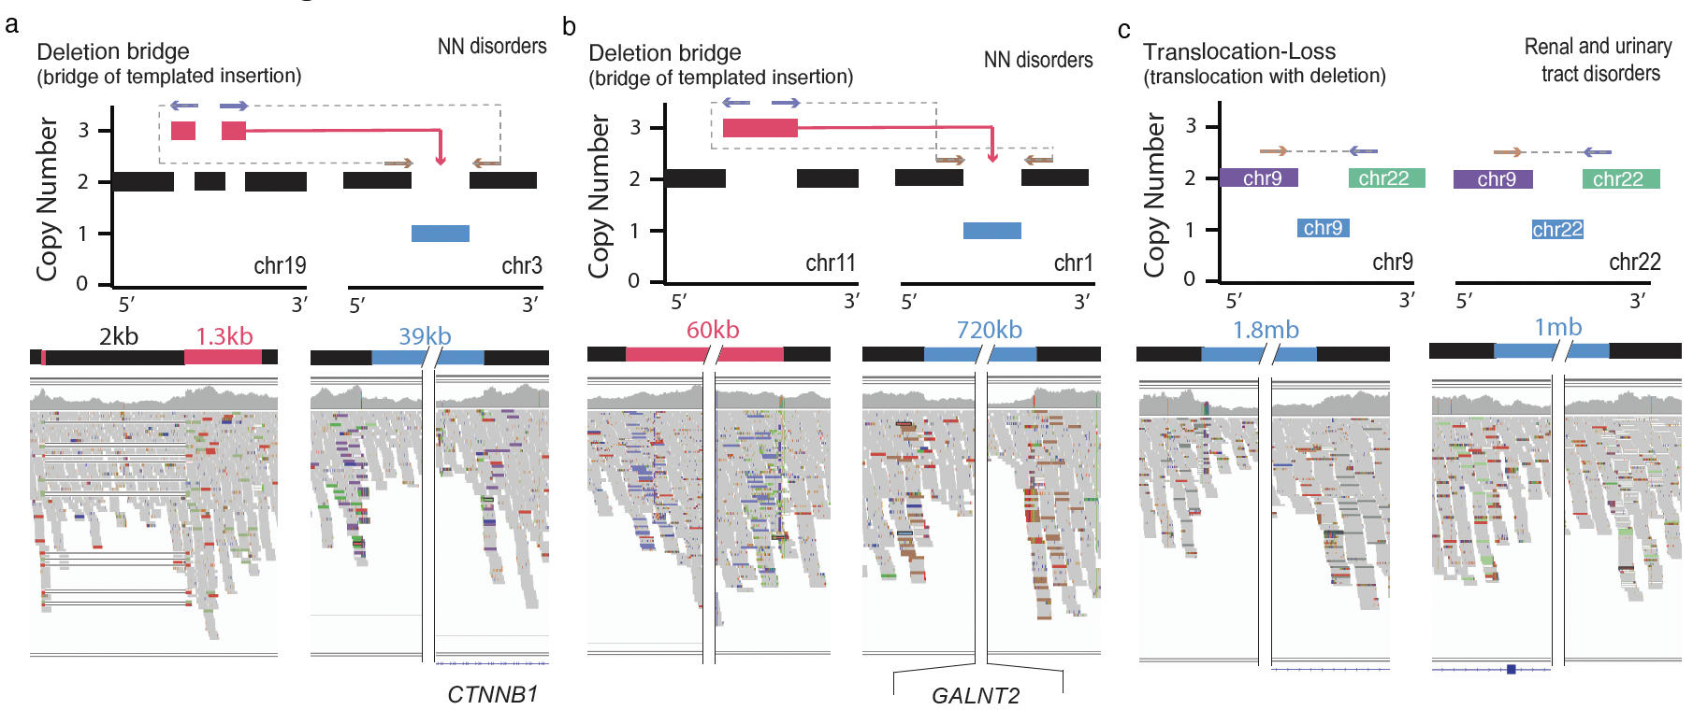
Figure S6. Representative cases with ‘Translocation-Loss’. Two subclasses of ‘Translocation-Loss’: ‘Deletion bridge’ (a) and ‘Translocation with deletion’ (b-c). (a) An additional small deletion (size=2kb) in chr19 was found in the templated sequence. (b-c) Translocations accompanying deletions on either chromosome (b) or on both chromosomes are shown.

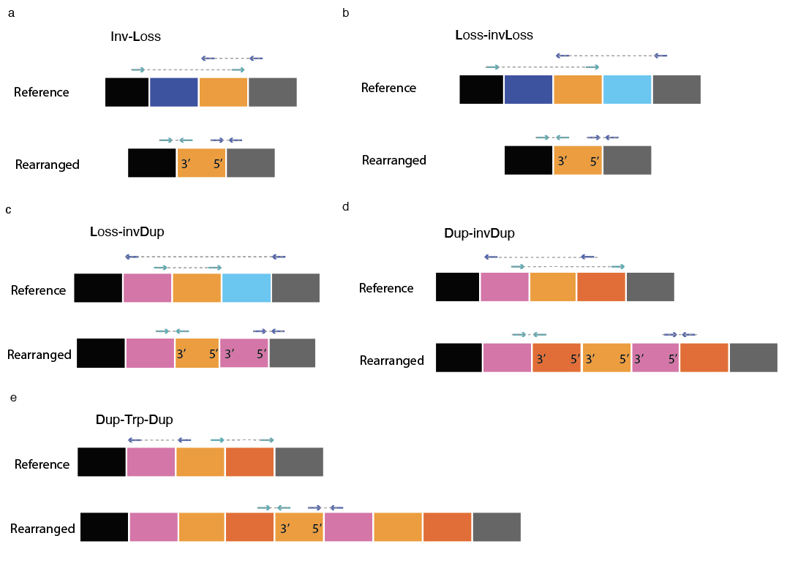

Figure S7. Schematic of complex dnSVs classes involving inversion. (a) ‘INV-Loss’ (b) ‘Loss-invLoss’ (c) ‘Loss-invDup’ (d) ‘Dup-invDup’ (e) ‘Dup-Trp-Dup’. The bottom rearranged segment shows one of the possible genomic configurations resulting from each dnSVs class. Note that all possible schematic configurations for each class are not shown.

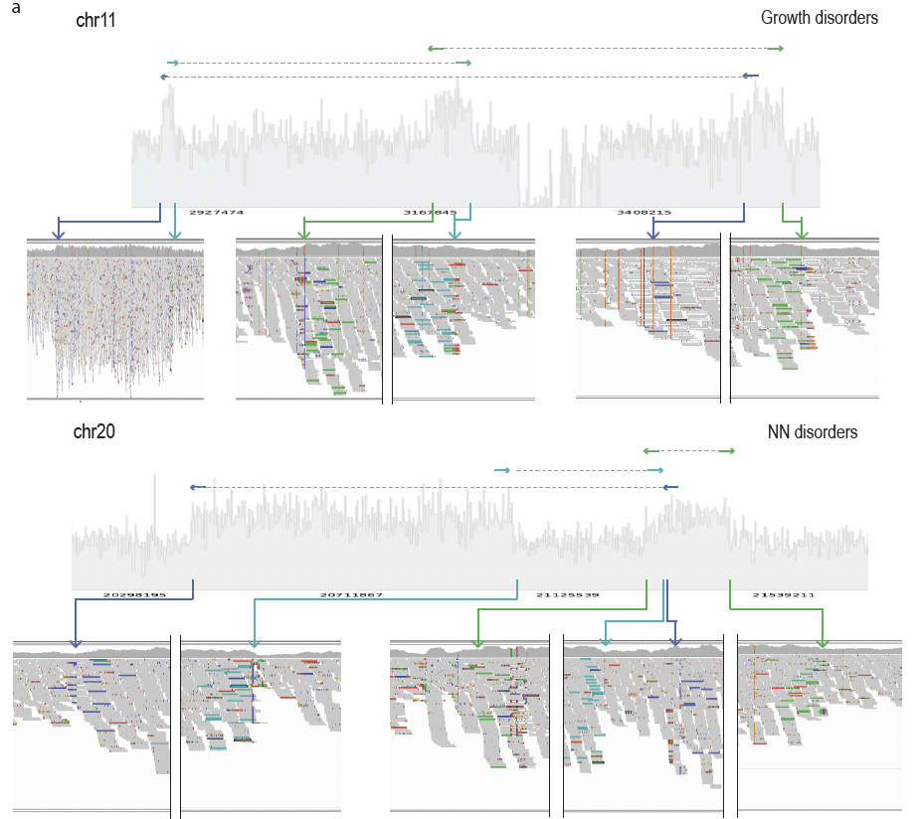
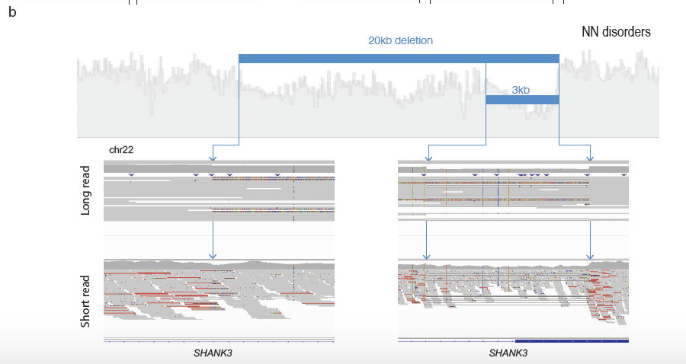

Figure S8. Representative cases with complex SVs. (a) Local-3-jumps (b) Unclassified complex SV type.

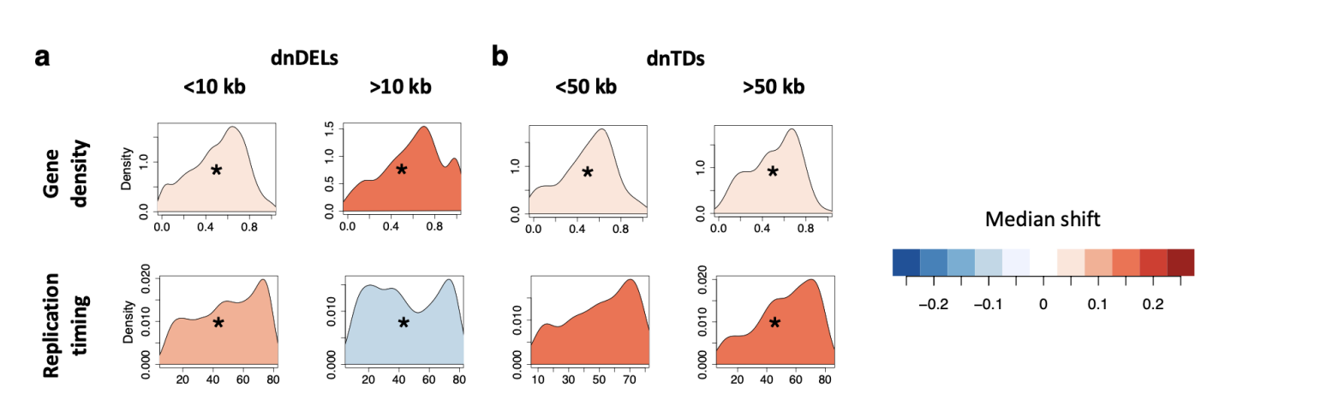

Figure S9. Genomic properties of dnSVs. (a-b) Distribution of dnDELs (a) and de novo tandem duplications (b) in the context of gene density (top) and replication timing (bottom). P values were calculated using Monte Carlo simulation test (*P < 1E-03). Each density plot is coloured by the extent of the median shift below (blue) or above (red) 0.5, assuming that a uniform distribution has a median of 0.5.

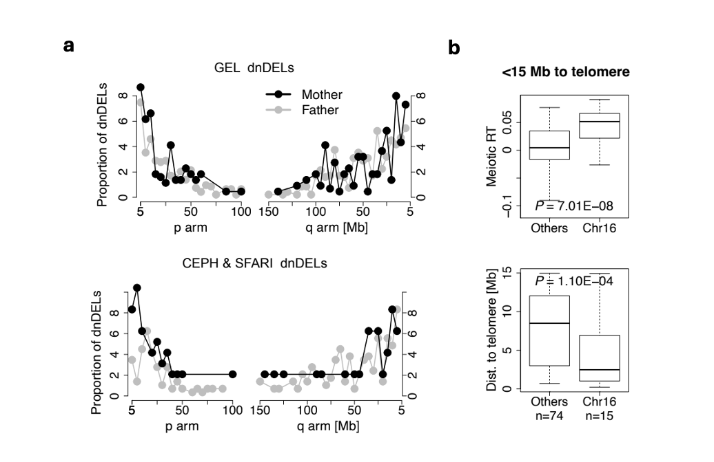
Figure S10. Enrichment of maternal dnDELs at subtelomeric, early replicating regions of chromosome 16. (a) Proportion of dnDELs as a function of the distance to telomere ends (5 mb bins) in GEL (top) and in CEPH & SFARI cohort (bottom). (b) Comparison of replication timing (top) and distance to telomere ends (bottom) of dnDELs between chromosome 16 and the other chromosomes.

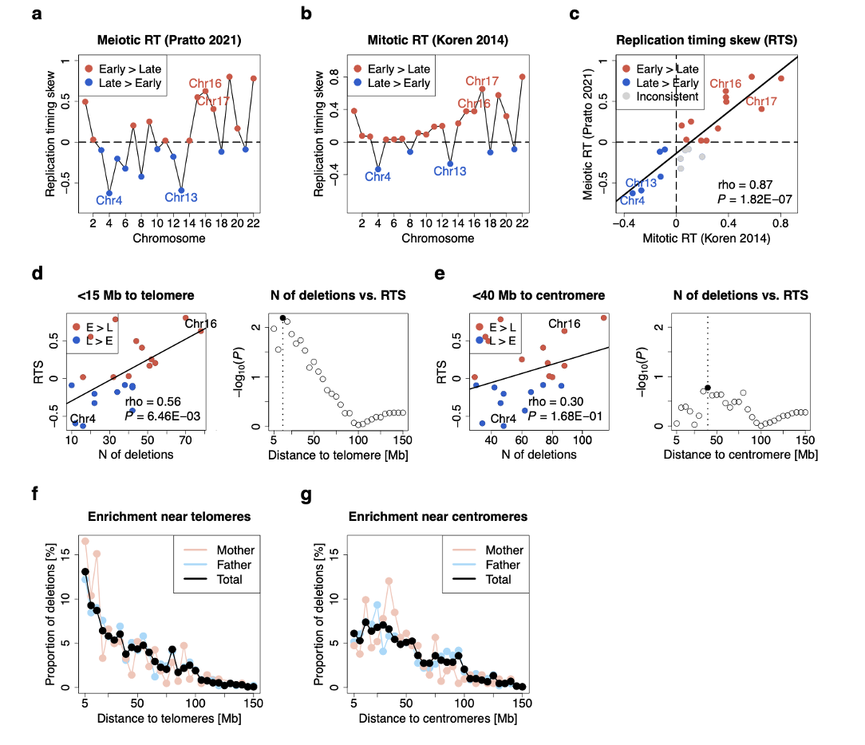

Figure S11. Analysis of dnSVs with telomere. (a) Meiotic replication timing skew (RTS) derived from a male germline (Pratto et al., 2021). (b) Reference mitotic RT derived from lymphoblastoid cell lines. (c) Scatterplot showing replication timing skew (RTS) between germline and somatic cells. (d) Correlation between the number of deletions at the subtelomeric regions and RTS across chromosomes. (e) Correlation between the number of deletions at the centromeric regions and RTS across chromosomes. (f) Proportion of dnDELs as a function of the distance to telomere ends. (g) Proportion of dnDELs as a function of the distance to centromeres.

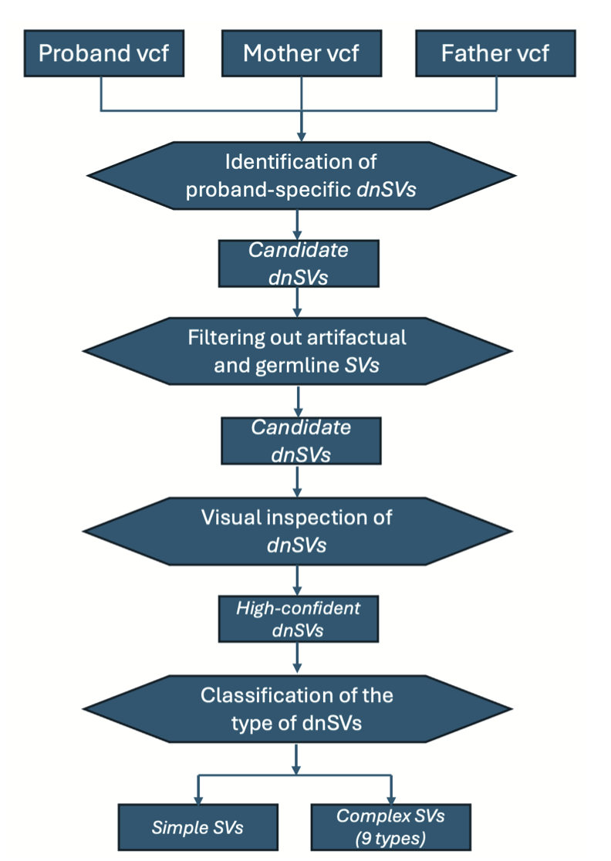

Figure S12. Flowchart for calling dnSVs.

