Title: Identification of MTHFD2 as a Prognostic Factor and Evaluation of its Role in Macrophage Polarization in Kidney Renal Clear Cell Carcinoma by Pan-Cancer Analysis
Journal name: Molecular and Cellular Biochemistry
Author names: Yang Zhou^{1,2,†}, Xinmin Zheng^{1,2,†}, Penghui Ye^{1,2}, Hui Yang^{1,2,*}
Affiliation: ¹ School of Life Sciences, Northwestern Polytechnical University, Xi’an 710072, China
² Engineering Research Center of the Chinese Ministry of Education for Biological Diagnosis, Treatment and Protection Technology and Equipment, Northwestern Polytechnical University, Xi’an 710072, China
Correspondence: Hui Yang, Email: kittyyh@nwpu.edu.cn
Supporting Information
Table S1. The abbreviations and corresponding full names of 33 cancers.
Cancer type | Abbreviation
Adrenocortical carcinoma | ACC
Bladder urothelial carcinoma | BLCA
Breast invasive carcinoma | BRCA
Cervical squamous cell carcinoma and Endocervical adenocarcinoma | CESC
Cholangiocarcinoma | CHOL
Colon adenocarcinoma | COAD
Lymphoid neoplasm diffuse Large B-cell Lymphoma | DLBC
Esophageal carcinoma | ESCA
Glioblastoma multiforme | GBM
Head and neck squamous cell carcinoma | HNSC
Kidney chromophobe | KICH
Kidney renal clear cell carcinoma | KIRC
Kidney renal papillary cell carcinoma | KIRP
Acute myeloid leukemia | LAML
Brain lower grade glioma | LGG
Liver hepatocellular carcinoma | LIHC
Lung adenocarcinoma | LUAD
Lung squamous cell carcinoma | LUSC
Mesothelioma | MESO
Ovarian serous cystadenocarcinoma | OV
Pancreatic adenocarcinoma | PAAD
Pheochromocytoma and paraganglioma | PCPG
Prostate adenocarcinoma | PRAD
Rectum adenocarcinoma | READ
Sarcoma | SARC
Skin cutaneous melanoma | SKCM
Stomach adenocarcinoma | STAD
Testicular germ cell tumors | TGCT
Thyroid carcinoma | THCA
Thymoma | THYM
Uterine corpus endometrial carcinoma | UCEC
Uterine carcinosarcoma | UCS
Uveal melanoma | UVM

Fig. S1. The expression level of MTHFD2 in 31 normal tissues from the GTEx database.
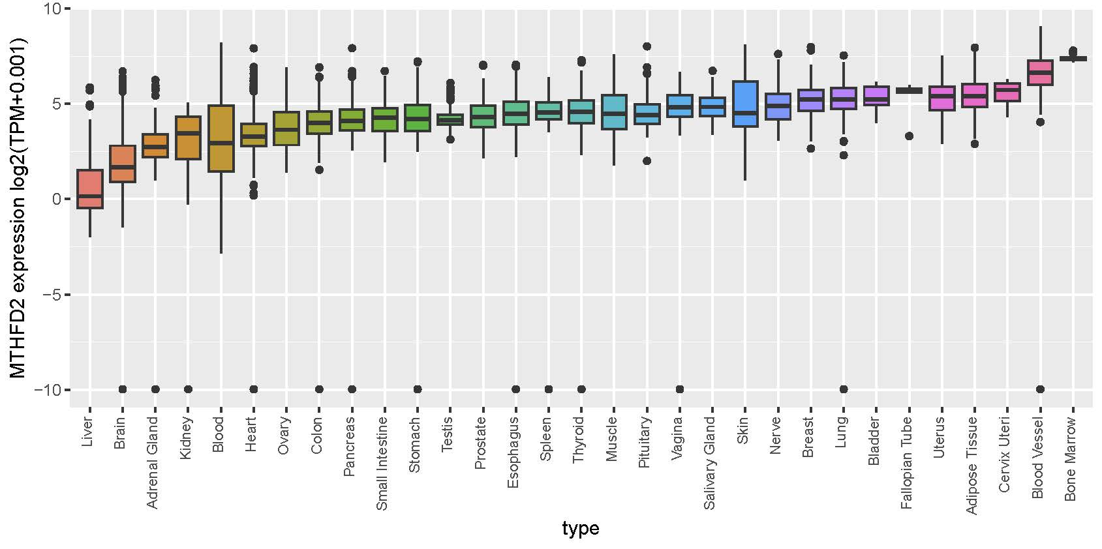

Fig. S2. Relationship between copy number alteration (CNA) and MTHFD2 expression.

Fig. S3. Overall survival curves in the groups with high and low expression of MTHFD2 DNA methylation in CESC (A), KIRC (B), KIRP (C), LGG (D) and PAAD (E) using the Kaplan–Meier method.
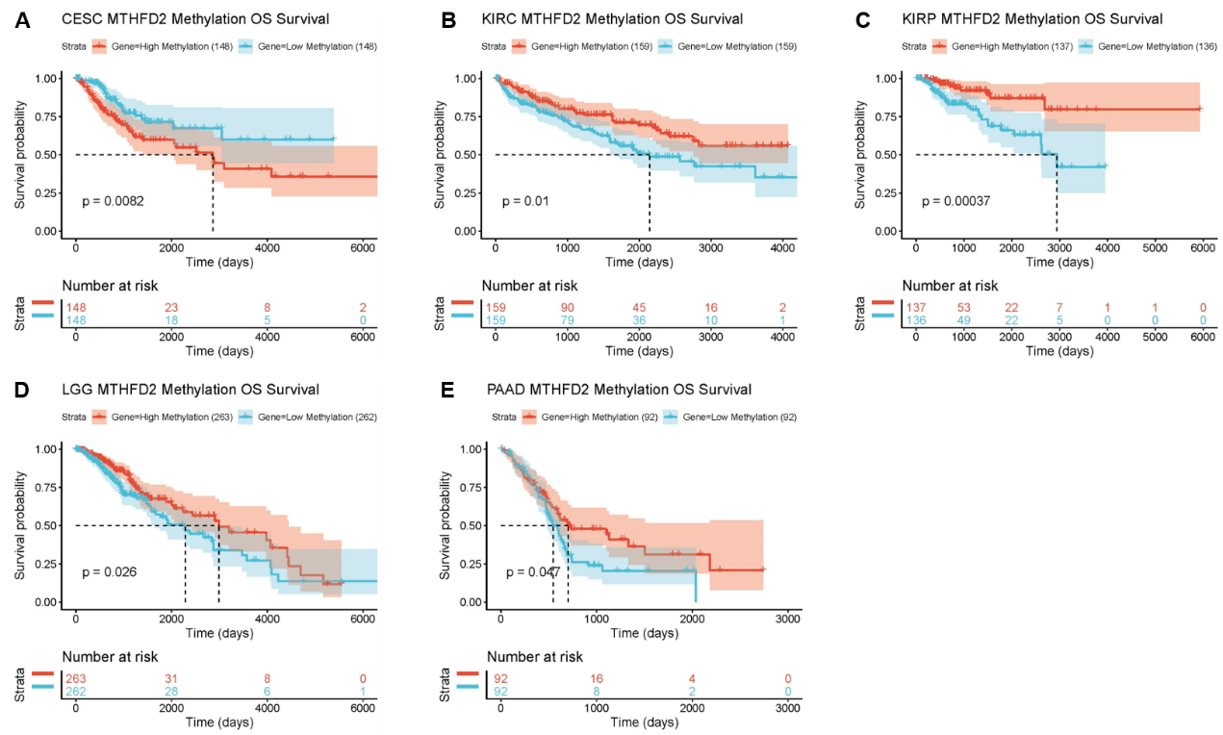 Fig. S4. Correlation of MTHFD2 expression with tumor mutational burden (TMB) and microsatellite instability (MSI). A radar chart depicting the association between MTHFD2 and TMB (A). A radar chart showing the connection between MTHFD2 and MSI (B).
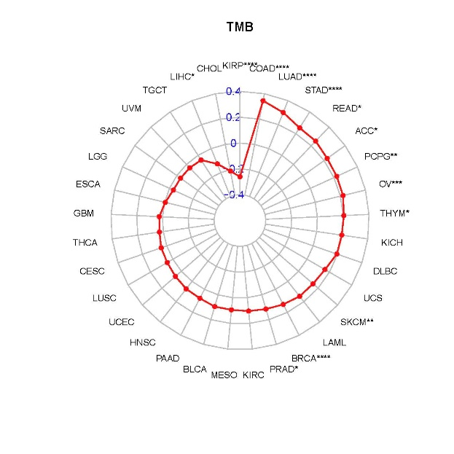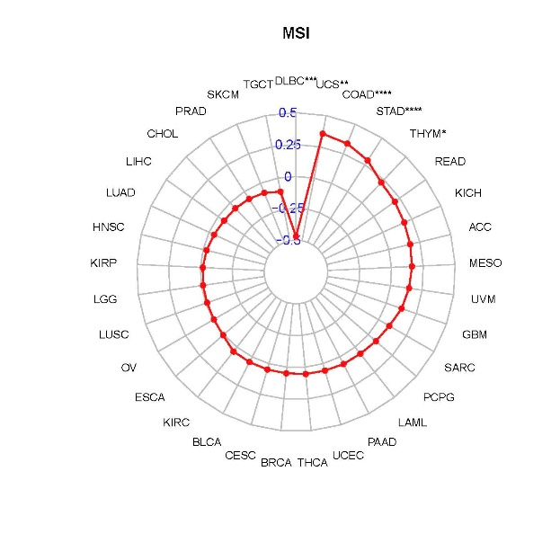

Table S2. Correlation between MTHFD2 expression and clinicopathological characteristics of KIRC patients.
 | variables | MTHFD2 expression |  | total | χ2 | p value
 | variables | low | high | total | χ2 | p value
Age (year) |  |  |  |  | 1.345 | 0.246
 | < 55 | 7 | 19 | 26
 | ＞= 55 | 7 | 38 | 45
Age (year) |  |  |  |  | 2.368 | 0.124
 | <60 | 11 | 32 | 43
 | ＞= 60 | 3 | 25 | 28
Sex |  |  |  |  | 2.895 | 0.089
 | Female | 8 | 17 | 25
 | male | 7 | 40 | 47
Grade |  |  |  |  | 0.397 | 0.529
 | I-II | 9 | 29 | 38
 | III-IV | 6 | 28 | 34
Tumor size |  |  |  |  | 0.000 | 1.000
 | < 5cm | 4 | 17 | 21
 | > =5cm | 11 | 40 | 51
T stage |  |  |  |  | 0.158 | 0.924
 | I | 8 | 29 | 37
 | II | 5 | 18 | 23
 | III | 2 | 10 | 12
N stage |  |  |  |  | 0.400 | 0.527
 | N0 | 15 | 51 | 66
 | N1-N2 | 0 | 5 | 5
TNM stage |  |  |  |  | 1.239 | 0.538
 | I | 8 | 25 | 33
 | II | 5 | 17 | 22
 | III- IV | 2 | 15 | 17

