Title: Brain functional network after intervention with rTMS in OCD individuals is pushed to a more unstable state to decrease obsessive behaviors
Authors: Maryam Ansari Esfeh^{a+}, Alireza Talesh^{b+}, Asiyeh Rezaei Niyasar^{c}, Reza Rostami^{d}, Reza Khosrowabadi^{a*}
+ Both authors have contributed equally to this paper
Affiliations:
ª Institute for Cognitive and Brain Sciences, Shahid Beheshti University, Tehran, Iran
^{b} School of Engineering Science, College of Engineering, University of Tehran, Tehran, Iran
^{c} Cognitive Psychology Department, Institute for Cognitive Sciences Studies, Tehran, Iran
^{d} Department of Psychology, University of Tehran, Tehran, Iran

Running title: rTMS Intervention in OCD Alters Brain Network Dynamics Towards Increased Instability

* Corresponding author: Reza Khosrowabadi
Address: Institute for Cognitive and Brain Science, Shahid Beheshti University GC, Tehran, Iran
Telephone: +98(0)21-29905404
Fax: +98(0)21-29902512
Email: r_khosroabadi@sbu.ac.ir
ORCID: 0000-0002-6282-9389
S.1. Normal group
Fourteen healthy individuals were included for comparison with both pre and post-conditions, as detailed in the supplementary material. This control group exhibited similar gender distribution and age variation to the OCD group (p = 0.68). Given the normality of their data, differences between these two conditions and the normal group were explored using an independent samples t-test.
S.2. Results of the comparison between the Normal group and the pre-condition
In comparing the normal group with the OCD group in the pre-condition, significant differences were observed in all types of triads except |T3|. Specifically, weakly unbalanced triads were significantly more in the OCD pre-condition than the normal group in the Gamma band (p =0.0444, t-value =2.1130, Cohen’s d =0.7987). Conversely, for strong unbalanced triads, the OCD pre-condition had fewer triads than the normal group in Delta (p =0.0015, t-value =-3.5591, Cohen’s d =-1.3452), Theta (p = 0.0121, t-value = -2.6966, Cohen’s d = -1.0192), Alpha ІІ (p =0.0046, t-value =-3.0978, Cohen’s d =-1.1709), Beta ІІ (p =0.0309, t-value =-2.2822, Cohen’s d =-0.8626), and Beta ІІІ (p =0.0076, t-value =-2.8960, Cohen’s d =-1,0946). However, weakly balanced triads stood out as the only triad type with significantly higher statistical results in the OCD pre-condition across all frequency bands. Likewise, the OCD pre-condition demonstrated higher significant differences in total energy (Un) across all frequency bands. This significance extended to network topology, revealing diminished tendencies in both positive (TMH_p) and negative hub formation (TMH_n) in the OCD pre-condition group. This highlights a reduced inclination to make hubs in both positive and negative ways within the OCD pre-condition group compared to normal individuals. Supplementary Table S1 provides comprehensive results for all measures across all frequency bands. However, in the number of positive and negative links, the significant results were limited to Theta and Alpha ІІ frequency bands (for |N| in Theta: p =0.0458, t-value =-2.0978, Cohen’s d =-0.7929, and in Alpha ІІ: p =0.0198, t-value =-2.4832, Cohen’s d =-0.9385, and for |P| in Theta: p =0.0458, t-value =2.0978, Cohen’s d =0.7929, and in Alpha ІІ: p =0.0198, t-value =2.4832, Cohen’s d =0.9385). Notably, in the number of positive and negative links, significance was confined to the Theta and Alpha II frequency bands (for |N| in Theta: p =0.0458, t-value =-2.0978, Cohen’s d =-0.7929, and in Alpha II: p =0.0198, t-value =-2.4832, Cohen’s d =-0.9385, and for |P| in Theta: p =0.0458, t-value =2.0978, Cohen’s d =0.7929, and in Alpha II: p =0.0198, t-value =2.4832, Cohen’s d =0.9385) (illustrated in Supplementary Figure 1).

Supplementary Table S1. Numerical details of measures across all frequency bands in the comparison between normal and OCD pre-condition groups
 |  | Delta | Theta | Alpha І | Alpha ІІ | Beta І | Beta ІІ | Beta ІІІ | Beta IV | Gamma
$$\left|N\right|$$ | p-value | 0.0665 | 0.0458 | 0.2491 | 0.0198 | 0.3439 | 0.1611 | 0.0706 | 0.9204 | 0.4108
$$\left|N\right|$$ | t-value | -1.9158 | -2.0978 | -1.1790 | -2.4832 | -0.9641 | -1.4426 | -1.8854 | 0.1009 | 0.8360
$$\left|N\right|$$ | Cohen’s d | -0.7241 | -0.7929 | -0.4456 | -0.9385 | -0.3644 | -0.5453 | -0.7126 | 0.0381 | 0.3160
$$\left|P\right|$$ | p-value | 0.0665 | 0.0458 | 0.2491 | 0.0198 | 0.3439 | 0.1611 | 0.0706 | 0.9204 | 0.4108
$$\left|P\right|$$ | t-value | 1.9158 | 2.0978 | 1.1790 | 2.4832 | 0.9641 | 1.4426 | 1.8854 | -0.1009 | -0.8360
$$\left|P\right|$$ | Cohen’s d | 0.7241 | 0.7929 | 0.4456 | 0.9385 | 0.3644 | 0.5453 | 0.7126 | -0.0381 | -0.3160
$\left|T_{0}\right|$ | p-value | 0.6077 | 0.5180 | 0.2757 | 0.0741 | 0.8016 | 0.2598 | 0.7506 | 0.3653 | 0.0444
$\left|T_{0}\right|$ | t-value | -0.5196 | -0.6554 | -1.1134 | -1.8609 | -0.2539 | -1.1519 | -0.3212 | 0.9214 | 2.1130
$\left|T_{0}\right|$ | Cohen’s d | -0.1964 | -0.2477 | -0.4208 | -0.7033 | -0.0960 | -0.4354 | -0.1214 | 0.3483 | 0.7987
$$\left|T_{1}\right|$$ | p-value | 0.0015 | 0.0121 | 0.0934 | 0.0046 | 0.0564 | 0.0309 | 0.0076 | 0.0773 | 0.6014
$$\left|T_{1}\right|$$ | t-value | -3.5591 | -2.6966 | -1.7415 | -3.0978 | -1.9974 | -2.2822 | -2.8960 | -1.8393 | -0.5288
$$\left|T_{1}\right|$$ | Cohen’s d | -1.3452 | -1.0192 | -0.6582 | -1.1709 | -0.7549 | -0.8626 | -1,0946 | -0.6952 | -0.1999
$$\left|T_{2}\right|$$ | p-value | 6.1952e-06 | 0.0016 | 0.0085 | 0.0016 | 0.0033 | 4.7757e-04 | 3.8097e-04 | 3.1139e-06 | 0.0013
$$\left|T_{2}\right|$$ | t-value | 5.6441 | 3.5149 | 2.8492 | 3.5324 | 3.2323 | 3.9918 | 4.0784 | 5.9090 | 3.5904
$$\left|T_{2}\right|$$ | Cohen’s d | 2.1333 | 1.3285 | 1.0769 | 1.3351 | 1.2217 | 1.5088 | 1.5415 | 2.2334 | 1.3570
$$\left|T_{3}\right|$$ | p-value | 0.5476 | 0.2335 | 0.8051 | 0.0927 | 0.9387 | 0.6270 | 0.6270 | 0.2208 | 0.1537
$$\left|T_{3}\right|$$ | t-value | 0.6093 | 1.2197 | 0.2493 | 1.7454 | -0.0776 | 0.4227 | 0.4918 | -1.2545 | -1.4693
$$\left|T_{3}\right|$$ | Cohen’s d | 0.2303 | 0.4610 | 0.0942 | 0.6597 | -0.0293 | -0.1598 | 0.1859 | -0.4741 | -0.5553
$$\left|U_{n}\right|$$ | p-value | 6.9627e-04 | 6.4534e-06 | 7.1077e-05 | 0.0043 | 6.7527e-05 | 2.8052e-04 | 6.4791e-04 | 1.3569e-07 | 2.7243e-05
$$\left|U_{n}\right|$$ | t-value | 3.8468 | 5.6285 | 4.7163 | 3.1326 | 4.7357 | 4.1953 | 3.8745 | 7.1507 | 5.0796
$$\left|U_{n}\right|$$ | Cohen’s d | 1.4540 | 2.1274 | 1.7826 | 1.1840 | 1.7899 | 1.5857 | 1.4644 | 2.7027 | 1.9199
TMH_n | p-value | 3.4102e-05 | 1.9632e-04 | 0.0048 | 0.0036 | 0.0207 | 0.0010 | 0.0041 | 1.8264e-06 | 0.0026
TMH_n | t-value | -4.9944 | -4.3311 | -3.0803 | -3.1970 | -2.4643 | -3.7037 | -3.1484 | -6.1161 | -3.3266
TMH_n | Cohen’s d | -1.8877 | -1.6370 | -1.1643 | -1.2084 | -0.9314 | -1.3999 | -1.1900 | -2.3116 | -1.2573
TMH_p | p-value | 7.2777e-04 | 2.0217e-06 | 0.0030 | 0.0390 | 2.9578e-04 | 2.5967e-04 | 3.6523e-05 | 1.3375e-07 | 4.6399e-07
TMH_p | t-value | -3.8297 | -6.0765 | -3.2703 | -2.1738 | -4.1750 | -4.2247 | -4.9684 | -7.1566 | -6.6554
TMH_p | Cohen’s d | -1.4475 | -2.2967 | -1.2361 | -0.8216 | -1.5780 | -1.5968 | -1.8779 | -2.7049 | -2.5155

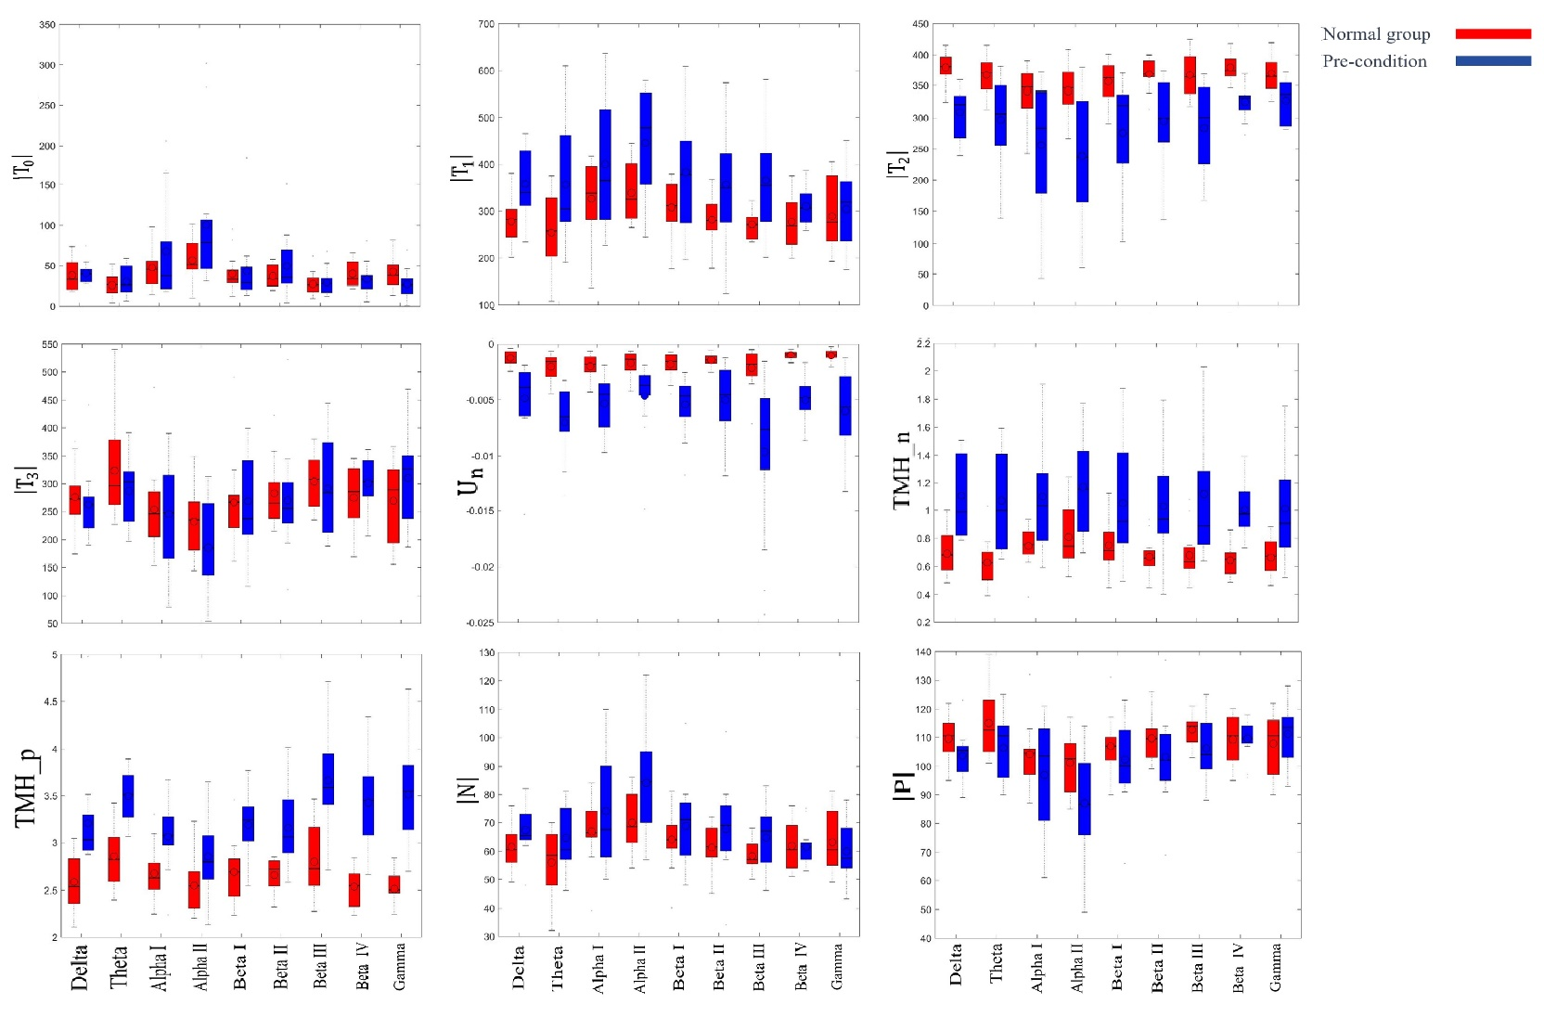
Supplementary Figure S1. Boxplots depict measures examined across nine established EEG frequency bands, contrasting the normal group with the pre-condition of OCD individuals. Circles signify mean values, and lines within the boxes represent median values.

S.2. Results of the comparison between the Normal group and the post-condition
The comparison between the normal group and OCD post-condition, as well as the normal group and OCD pre-condition, exhibited some similarities in results, but differences emerged, especially in the alpha and beta frequency bands. Notably, the$\left|T_{2}\right|$ triad displayed more statistical significance values compared to other triads. However, significance for other triads was limited to Beta IV (p =0.0101, t-value =2.7753, Cohen’s d =1.0490) and Gamma (p =0.0024, t-value =3.3585, Cohen’s d= 1.2694) for $\left|T_{0}\right|$, and Theta (p =0.0118, t-value =-2.7083, Cohen’s d=-1.0236) and Alpha I (p =0.0046, t-value =-3.1022, Cohen’s d =-1.1725) for $\left|T_{1}\right|$. Furthermore, all balance-energy Un values indicated significantly higher total energy in individuals with OCD, even after receiving intervention, compared to normal individuals. In terms of network topology, while the number of positive and negative links showed no significant differences across all frequency bands, significance values were observed in all frequency bands, excluding Alpha II and Beta I for TMH_n, and Alpha II for TMH_p. In this context, Supplementary Table S2 and supplementary Figure S2 provide comprehensive results for all measures across all frequency bands.

Supplementary Table S2. Numerical details of measures across all frequency bands in the comparison between normal and OCD post-condition groups
 |  | Delta | Theta | Alpha І | Alpha ІІ | Beta І | Beta ІІ | Beta ІІІ | Beta IV | Gamma
$$\left|N\right|$$ | p-value | 0.9830 | 0.1418 | 0.0641 | 0.4069 | 0.3589 | 0.6546 | 0.8172 | 0.2628 | 0.3379
$$\left|N\right|$$ | t-value | -0.0215 | -1.5152 | -1.9341 | -0.8430 | 0.9339 | -0.4526 | -0.2335 | 1.1445 | 0.9763
$$\left|N\right|$$ | Cohen’s d | -0.0081 | -0.5727 | -0.7310 | -0.3186 | 0.3530 | -0.1711 | -0.0883 | 0.4326 | 0.3690
$$\left|P\right|$$ | p-value | 0.9830 | 0.1418 | 0.0641 | 0.4069 | 0.3589 | 0.6546 | 0.8172 | 0.2628 | 0.3379
$$\left|P\right|$$ | t-value | 0.0215 | 1.5152 | 1.9341 | 0.8430 | -0.9339 | 0.4526 | 0.2335 | -1.1445 | -0.9763
$$\left|P\right|$$ | Cohen’s d | 0.0081 | 0.5727 | 0.7310 | 0.3186 | -0.3530 | 0.1711 | 0.0883 | -0.4326 | -0.3690
$\left|T_{0}\right|$ | p-value | 0.5511 | 0.4030 | 0.1911 | 0.4908 | 0.3797 | 0.7582 | 0.4481 | 0.0101 | 0.0024
$\left|T_{0}\right|$ | t-value | 0.6040 | -0.8502 | -1.3423 | -0.6990 | 0.8937 | 0.3110 | 0.7703 | 2.7753 | 3.3585
$\left|T_{0}\right|$ | Cohen’s d | 0.2283 | -0.3213 | -0.5074 | -0.2642 | 0.3378 | 0.1176 | 0.2911 | 1.0490 | 1.2694
$$\left|T_{1}\right|$$ | p-value | 0.1225 | 0.0118 | 0.0046 | 0.1173 | 0.7554 | 0.1765 | 0.2237 | 0.5550 | 0.3845
$$\left|T_{1}\right|$$ | t-value | -1.5961 | -2.7083 | -3.1022 | -1.6199 | -0.3148 | -1.3894 | -1.2466 | -0.5981 | -0.8846
$$\left|T_{1}\right|$$ | Cohen’s d | -0.6033 | -1.0236 | -1.1725 | -0.6123 | 0.1190 | -0.5252 | -0.4712 | -0.2261 | -0.3344
$$\left|T_{2}\right|$$ | p-value | 1.2486e-05 | 0.0013 | 3.2681e-04 | 0.0110 | 0.1462 | 0.0211 | 0.0090 | 8.2735e-05 | 0.0048
$$\left|T_{2}\right|$$ | t-value | 5.3762 | 3.6189 | 4.1370 | 2.7379 | 1.4979 | 2.4543 | 2.8236 | 4.6588 | 3.0836
$$\left|T_{2}\right|$$ | Cohen’s d | 2.0320 | 1.3678 | 1.5636 | 1.0348 | 0.5661 | 0.9276 | 1.0672 | 1.7608 | 1.1655
$$\left|T_{3}\right|$$ | p-value | 0.2613 | 0.7738 | 0.3995 | 0.9482 | 0.1857 | 0.8480 | 0.4884 | 0.0616 | 0.0883
$$\left|T_{3}\right|$$ | t-value | -1.1484 | 0.2904 | 0.8566 | 0.0655 | -1.3593 | -0.1936 | -0.7028 | -1.9535 | -1.7710
$$\left|T_{3}\right|$$ | Cohen’s d | -0.4340 | 0.1098 | 0.3238 | 0.0248 | -0.5138 | -0.0732 | -0.2657 | -0.7384 | -0.6694
$$\left|U_{n}\right|$$ | p-value | 2.5790e-04 | 9.6342e-05 | 0.0014 | 0.0034 | 0.0010 | 2.8445e-04 | 3.1648e-04 | 8.7837e-07 | 8.5942e-06
$$\left|U_{n}\right|$$ | t-value | 4.2273 | 4.6011 | 3.5825 | 3.2211 | 3.6998 | 4.1899 | 4.1492 | 6.4027 | 5.5188
$$\left|U_{n}\right|$$ | Cohen’s d | 1.5978 | 1.7391 | 1.3541 | 1.2175 | 1.3984 | 1.5837 | 1.5683 | 2.4200 | 2.0859
TMH_n | p-value | 0.0039 | 0.0028 | 5.1056e-04 | 0.1326 | 0.9641 | 0.0112 | 0.0170 | 0.0019 | 1.6558e-04
TMH_n | t-value | -3.1662 | -3.3018 | -3.9662 | -1.5527 | -0.0454 | -2.7306 | -2.5510 | -3.4545 | -4.3958
TMH_n | Cohen’s d | -1.1967 | -1.2480 | -1.4991 | -0.5869 | -0.0172 | -1.0321 | -0.9642 | -1.3057 | -1.6614
TMH_p | p-value | 3.3344e-05 | 5.1333e-06 | 0.0028 | 0.0563 | 9.8433e-04 | 1.0272e-05 | 1.5323e-04 | 1.9366e-07 | 6.4945e-04
TMH_p | t-value | -5.0029 | -5.7163 | -3.2972 | -1.9975 | -3.7127 | -5.4506 | -4.4252 | -7.0062 | -8.4328
TMH_p | Cohen’s d | -1.8909 | -2.1606 | -1.2462 | -0.7550 | -1.4033 | -2.0601 | -1.6726 | -2.6481 | -3.1873

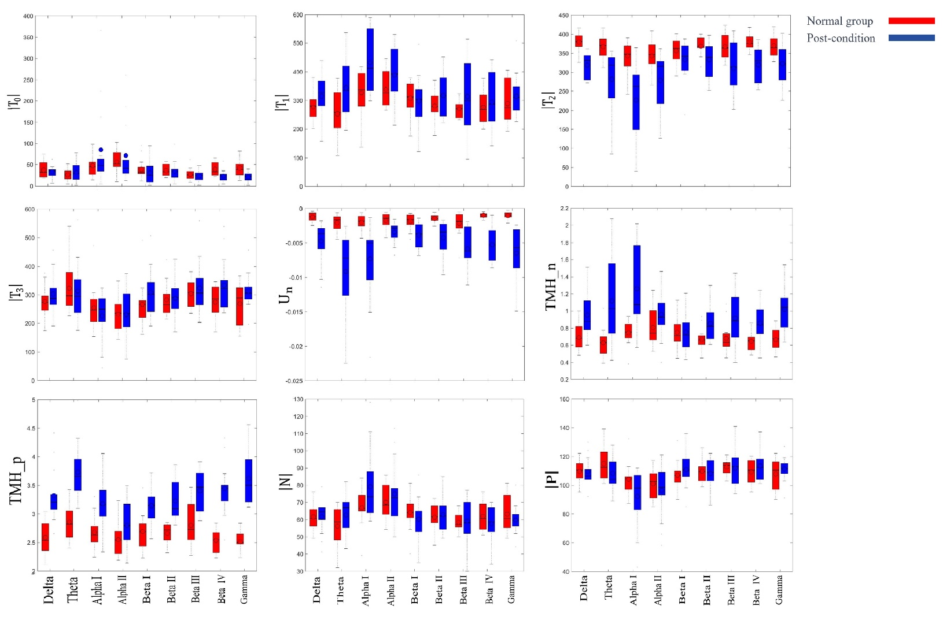
Supplementary Figure S2. Boxplots illustrate the assessment of measures across frequency bands, comparing the normal group with the post-condition of individuals with OCD. Mean values are denoted by circles, while median values are indicated by lines within the boxes.

