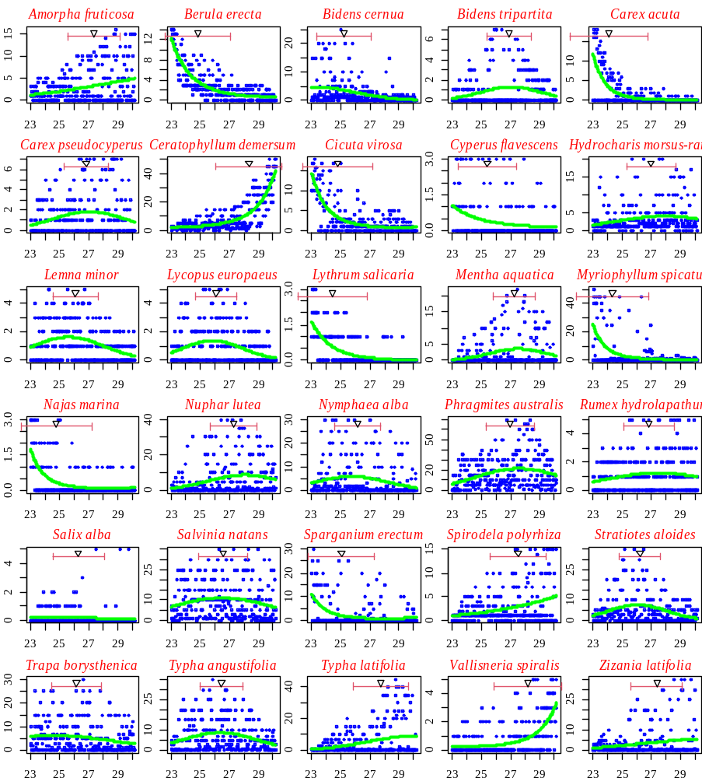

Figure S3. The response of macrophyte species to the gradient of maximum seasonal water temperature and its modeling using regression dependence (green line). The triangle indicates the weighted mean temperature value (optimum), the horizontal "whiskers" indicate the weighted mean standard deviation (tolerance)

