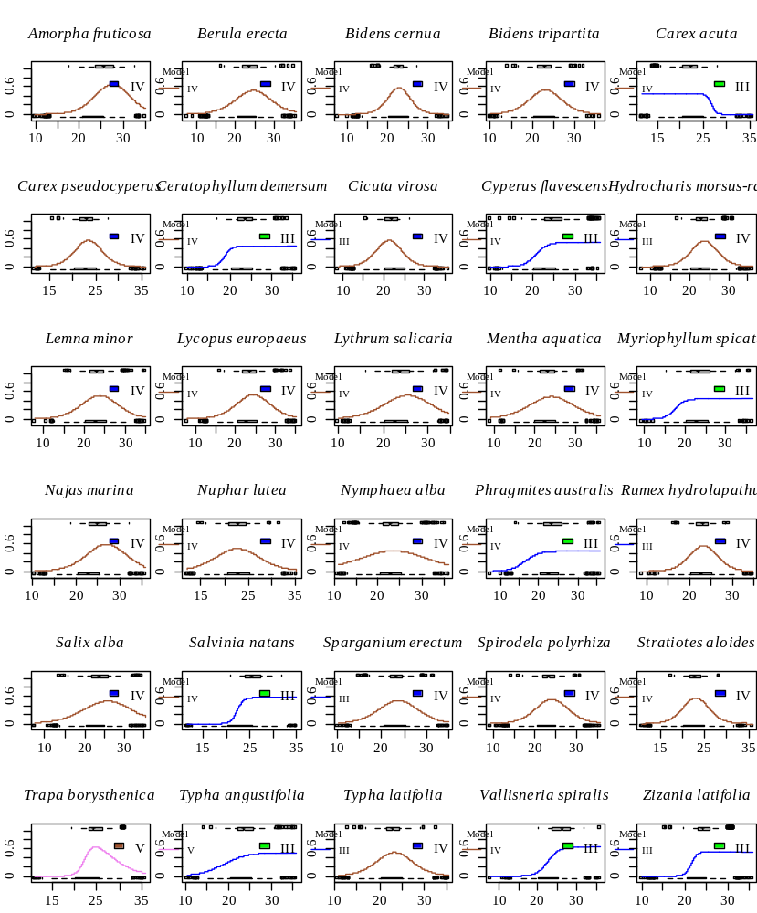

Figure S4. Response of macrophyte species in the gradient of the mean temperature of the warmest month of the year within Europe. The ascending axis is the average temperature of the warmest month of the year within Europe, °C, and the ordinate is the occurrence or absence of plant occurrence. The best model from the HOF list based on the results of the bootstrap procedure is presented as the response model.

