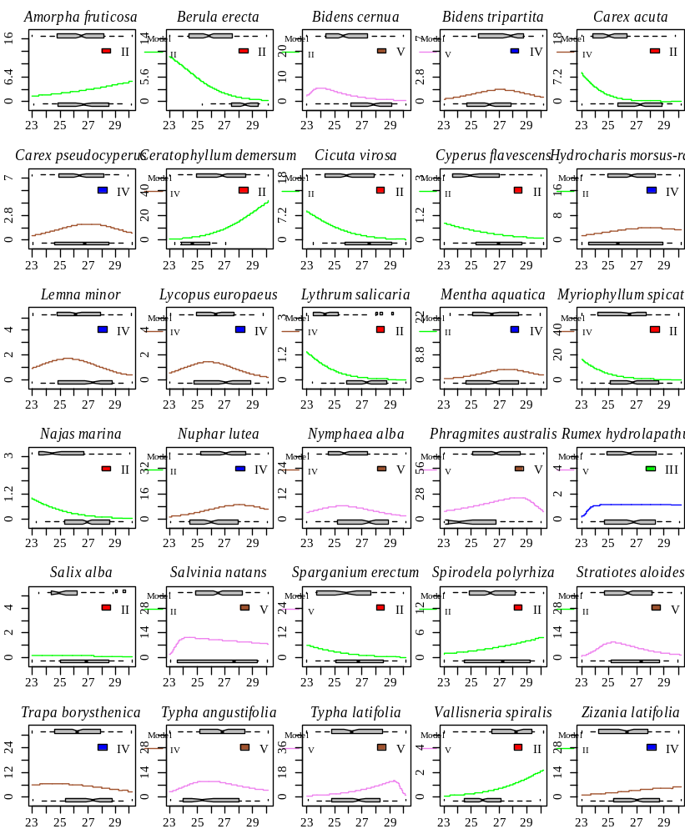
Figure S2. Response of macrophyte species to the water temperature gradient. The y-axis is the water temperature, °C, and the ordinate is the projected plant cover. The best model from the HOF list based on the results of the bootstrap procedure is presented as the response model.

