Supplementary Figure:
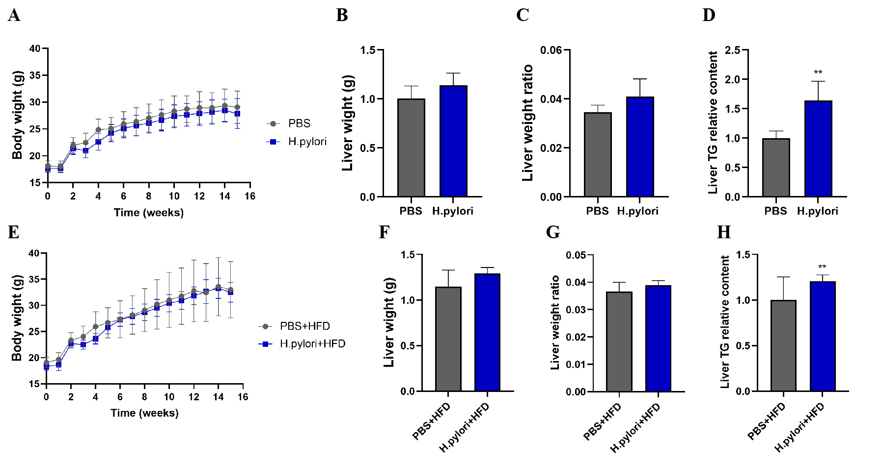
Supplementary Figure 1 Effects of H. pylori infection combined with CD/HFD feeding on body and weight in mice. (A-D) Body weight curves, Liver weight, Liver weight ratio: liver weight/body weight × 100%, Relative TG content in mice liver in CD groups. (E-H) Body weight curves, Liver weight, Liver weight ratio: liver weight/body weight × 100%, Relative TG content in mice liver in HFD groups.

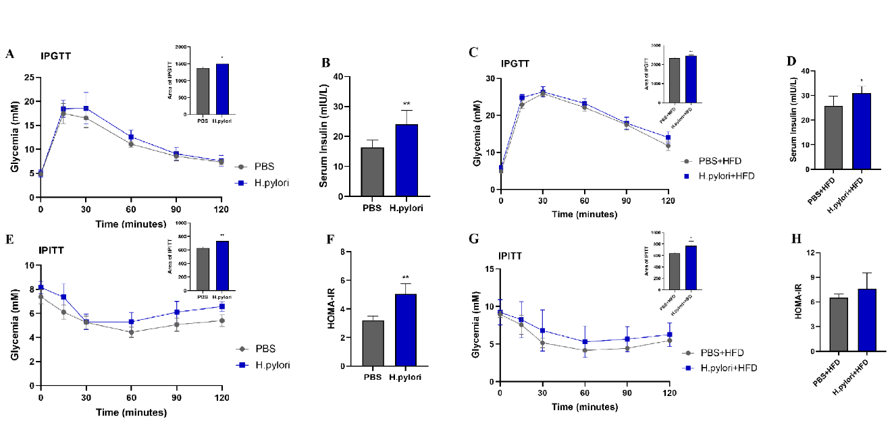
Supplementary Figure 2 Effect of H. pylori infection combined with CD/HFD feeding on mouse glucose homeostasis and insulin sensitivity. In the 15th week of intervention, the mice were subjected to the IPGTT (A: CD groups, C: HFD groups) and IPITT (E: CD groups, G: HFD groups), and the AUC measurements are shown in the right upper corner of the picture. Serum insulin levels (mmol/L) in CD (B) and HFD (D) groups. Insulin resistance was calculated: HOMA-IR = fasting plasma glucose (mmol/L) × fasting insulin (μU/mL)/22.5. HOMA-IR in CD (F) and HFD (H) groups. Data are expressed as mean ± SD, n=6, *P<0.05, **P<0.01, ***P<0.001.

