Supplementary Information - Torres et al. The Acheulian site of Cantera Vieja (Madrid, Spain) and the discussion of the Lower to Middle Paleolithic transition in central Spain.

Sample collection and preparation
Luminescence dating samples were collected by inserting metal tubes on previously cleaned sediment exposures. Owing to the consolidated nature of the sediment exposures. After collection, samples were immediately sealed with black plastic and duct tape to avoid exposure to light. Purified coarse-grained quartz and K-feldspar fractions were extracted from the luminescence samples under safe light (dim red LED) conditions at the University of Adelaide and prepared for burial dose estimation following established procedures (Aitken, 1998). Sediment samples were initially sieved to isolate the fine sand fraction (90-300 µm) and treated with H₂O₂ and HCl to eliminate organics and carbonates, respectively. Heavy liquid separation (LST lithium heteropolytungstate) was used to isolate K-feldspar grains in the 2.53 to 2.58 g/cm³ density range. The quartz fraction was extracted following the same procedure, with the exception that heavy liquid densities of 2.62 g/cm³ and 2.72 g/cm³ were used for isolating quartz grains from lighter feldspars and heavy minerals, respectively. The isolated K-feldspar and quartz fractions were sieved to 90-125 µm and etched with either 10% hydrofluoric acid for 10 minutes for the K-feldspar grains or 48% hydrofluoric acid for 40 minutes for the quartz grains to remove the outer 10 µm rind of each grain (i.e., the alpha-irradiated external layers; Aitken, 1998; Duval et al., 2018). The etched grains were then washed in 30% hydrochloric acid to remove any precipitated fluorides and re-sieved using a 63 µm sieve to eliminate any disaggregated grains.

Dose rate estimation
Dose rate evaluations have been made using a combination of in situ gamma spectrometry measurements and low-level beta counting (Table S1). Elemental concentrations of K, U and Th were determined from the field gamma spectra using the ‘energy windows’ method described in Arnold et al., (2012a) and Duval and Arnold (2013). Radionuclide concentrations and specific activities have been converted to dose rates using the conversion factors given in Guérin et al. (2011), making allowance for beta-dose attenuation (Mejdahl, 1979; Brennan, 2003) and long-term sediment water contents (Aitken, 1985; Readhead, 1987). Additional sediment was collected from the surrounding 1 cm of each luminescence dating sample position for beta dose rate assessments (beta counting), water content evaluations, and high-resolution gamma-ray spectrometry (HRGS) measurements. Low-level beta counting was performed on dry and homogenised sediment using a Risø GM-25-2 beta counter (Botter-Jensen and Mejdhal, 1988). The contribution of cosmic rays to the final dose rates have been calculated as described in Prescott and Hutton (1994), taking into consideration site altitude, geomagnetic latitude, and density, thickness and geometry of sediment overburden. The present-day sediment water contents of the Cantera Vieja luminescence dating samples ranged between ~1 and ~15% of dry sediment weight, but not all are considered to be representative of moisture conditions prevailing throughout the burial period because the sediment exposures had partially dried out prior to sampling. To determine more suitable long-term sediment moisture contents, we examined the range of present-day ‘proportional saturated water content’ values (i.e., present-day water contents / saturated water contents × 100) obtained for the three luminescence dating samples. The highest proportional saturated water content for these samples (~40% of saturated water content; CVJ18-2) was used to establish a more reliable estimate of present-day water content (as a proportion of sediment saturation capacity) in the absence of any prior sediment exposure bias. A 1σ relative uncertainty of 20% (40% at 2σ) has been assigned to the long-term moisture estimates to accommodate any variations in hydrologic conditions during burial. This approach yielded long-term sediment moisture contents ranging between 13.2 ± 1.3% and 15.3 ± 1.5% (Table S1), which are consistent with the long-term average water contents adopted for similar types of fluvial and alluvial deposits from the Iberian Peninsula (e.g., Berger et al., 2008; Arnold et al., 2013; Demuro et al., 2015; Méndez-Quintas et al., 2018; Terradillos-Bernal et al., 2022). Finally, HRGS measurements undertaken on CVJ-1, CVJ-2 and CVJ-3 show that have the ²³⁸U and ²³²Th decay series of these samples are in secular equilibrium (see results in Table S2).

Instrumentation and equivalent dose (D_{e}) measurements
Measurements of post infrared infrared (pIR-IR) and thermally transferred optically stimulated luminescence (TT-OSL) signals were made using two Risø TL/OSL-DA-20 readers equipped with spatially calibrated ⁹⁰Sr/⁹⁰Y β radiation sources delivering mean dose rates of ~0.153 Gy/s and ~0.09 Gy/s. The pIR-IR signals were stimulated using IR light emitting diodes (875 nm, maximum power of 166 mW/cm²) at 90% power. pIR-IR D_{e} values were measured using 90-125 μm K-feldspar grains mounted on stainless steel discs (9.7 mm wide); approximately 360 grains were mounted on each disc. Blue emissions from K-feldspars were detected using an EMI 9235QB photomultiplier fitted with a 4 mm-thick Schott BG39, 3 mm-thick Corning 7-59, and 4 mm-thick Schott GG400 filter pack. The TT-OSL signals of individual quartz grains were stimulated using a 10 mW Nd:YVO4 laser attachment (532 nm, maximum power of ~50 W cm²) at 90% power. Measurements were performed on 90-125 μm quartz grains carefully brushed onto aluminium discs drilled with an array of 300 × 300 μm holes, which resulted in ~18 grains being placed in each hole (Arnold et al., 2012b). This ‘pseudo’ single-grain approach was chosen because of the low proportion of grains yielding TT-OSL signals for these sample: 75-83% of grain-hole positions did not produce any statistically distinguishable TT-OSL signals (Table S6), which effectively means single-grain resolution has been maintained in this study (Demuro et al., 2013). Ultraviolet emissions from quartz were detected using an Electron Tubes PDM 9107B photomultiplier fitted with a 7.5 mm-thick U-340 filter. For single-grain measurements, spatial variations in the beta dose rate across the disc plane were taken into account by undertaking hole-specific calibrations using gamma-irradiated quartz.

TT-OSL and pIR-IR D_{e} values were obtained using the single-aliquot regenerative-dose (SAR) protocols shown in Table S3. Net L_{x} and T_{x} values were calculated by integrating the first 0.15 s of the TT-OSL decay curves and subtracting a background count from the last 0.25 s of the signal. Multi-grain pIR-IR D_{e} values were calculated from the first 10 s of stimulation after subtracting a mean background count from the last 20 s of stimulation. The TT-OSL SAR dose-response curves were fitted using a single-saturating exponential function and the pIR-IR dose-responses were fitted with a saturated exponential plus linear function. Individual D_{e} values were accepted if they passed the following quality assurance criteria: (i) the luminescence signals were statistically distinguishable from background (the net intensity of the natural test dose signal, T_{n}, was >3σ above the late-light background signal); (ii) the recycling ratio (i.e., sensitivity-corrected luminescence responses (L_{x}/T_{x}) for two identical high regenerative doses) was consistent with unity at 2σ; (iii) the recuperation ratio, calculated as the ratio of the sensitivity-corrected 0 Gy dose point (L₀/T_{x}) to the sensitivity-corrected natural (L_{n}/T_{n}), was <5%; (iv) the OSL IR depletion ratio of Duller (2003) was consistent with unity at 2σ (i.e., the ratio of the L_{x}/T_{x} values obtained for two identical regenerative doses measured with and without prior IR stimulation) – this criterion is designed to detect feldspar contamination or inclusions, and therefore has only been applied to the TT-OSL D_{e} values; (v) the net T_{n} signal had a relative error of <30%; (vi) the sensitivity-corrected natural signal intercepted the sensitivity-corrected dose-response curve and it did not intercept the saturated part of the dose-response curve (i.e., the L_{n}/T_{n} value was lower than the I_{max} saturation limit of the dose-response curve at 2σ); (vii) the dose-response curve did not display anomalous properties (e.g., zero or negative responses with increasing dose) and resulted in good Monte Carlo fits.

Dose recovery tests
Single-grain TT-OSL dose recovery tests were performed on sample CVJ18-1 after administering a dose of 814 ± 4 Gy on top of the naturally accumulated dose for a sub-set of grains. A net dose recovery (measured-to-given dose) ratio of 0.94 ± 0.05 (Table S4) was obtained after dividing the measured dose (1545 ± 68 Gy; Table S4) by the sum of the weighted mean (central age model) natural D_{e} of sample CVJ18-1 (836 ± 36 Gy; Table S8) and the given dose (Table S4). The ratio obtained is within 2σ of unity and supports the suitability of the chosen TT-OSL measurement conditions for dating these samples.

pIR-IR dose recovery tests were undertaken on sample CVJ18-1 by bleaching the naturally accumulated signals of ten 160-grain K-feldspar aliquots in direct sunlight for 8 hrs. four of these aliquots were left un-dosed to determine the residual (unbleached) D_{e} remaining after daylight exposure, while the remaining six aliquots were given a laboratory dose of 800 ± 16 Gy. Three aliquots were then measured with the pIR-IR₂₂₅ protocol shown in Table S3 and the other three aliquots were measured with the same protocol, but using a PH1 and PH2 temperature of 320°C and a pIR-IR measurement temperature of 290°C (i.e., pIR-IR₂₉₀ signal) to determine their D_{e} values. Dose recovery (measured to given dose) ratios were calculated after subtracting the residual (unbleached) D_{e} of the un-dosed aliquots from the weighted mean D_{e} obtained from the dosed aliquots (Table S5). Both the pIR-IR₂₂₅ and pIR-IR₂₉₀ dose recovery ratios of sample CVJ18-1 overlap with unity at 2σ (0.99 ± 0.04 and 1.11 ± 0.19, respectively) (Table S5) and supports the suitability of these SAR protocols. However, the pIR-IR₂₂₅ signal produced a dose recovery ratio that was more accurate and less scattered than the pIR-IR₂₉₀ signal, therefore the pIR-IR₂₂₅ SAR protocol was used for D_{e} determination.

pIR-IRSL anomalous fading tests
Anomalous fading assessments were performed on subsets of 3 aliquots for each of the Cantera Vieja samples to investigate the potential for long-term athermal loss of the K-feldspar pIR-IRSL₂₂₅ signal over burial timescales. These evaluations were made following the procedures of Auclair et al. (2003) which involved undertaking repeated SAR L_{x}/T_{x} measurements after delayed storage times of 0.2 – 30 h. Anomalous fading rates (g-value) normalised to 2 days were calculated as described in Huntley and Lamothe (2001), and used to quantify the expected percentage of signal loss per decade of storage time. The results of these anomalous fading tests are presented in Table S9.

References
Aitken, M.J., 1985. Thermoluminescence Dating. Academic Press, London, 359 p.

Aitken, M.J., 1998. An Introduction to Optical Dating: The Dating of Quaternary Sediments by the Use of Photon-stimulated Luminescence. Oxford: Oxford University Press.

Alappat, L., Tsukamoto, S., Singh, P., Srikanth, D., Ramesh, R., and Frechen, M., 2010. Chronology of Cauvery Delta sediments from shallow subsurface cores using elevated-temperature post-IR IRSL dating of feldspar. Geochronometria 37, 37-47.

Arnold, L.J., Bailey, R.M., Tucker, G.E., 2007. Statistical treatment of fluvial dose distributions from southern Colorado arroyo deposits. Quaternary Geochronology 2, 162-167.

Arnold, L.J., Roberts, R.G., 2009. Stochastic modelling of multi-grain equivalent dose (D_{e}) distributions: implications for OSL dating of sediment mixtures. Quaternary Geochronology 4, 204-230.

Arnold, L.J., Duval, M., Falguères, C., Bahain, J.-J., and Demuro, M., 2012a. Portable gamma spectrometry with cerium-doped lanthanum bromide scintillators: suitability assessments for luminescence and electron spin dating applications. Radiation Measurements 47, 6-18.

Arnold, L.J., Demuro, M., Navazo Ruiz, M., 2012b. Empirical insights into multi-grain averaging effects from ‘pseudo’ single-grain OSL measurements. Radiation Measurements 47, 652–658.

Arnold, L.J., Demuro, M., Navazo, M., Benito-Calvo, A., Pérez-González, A., 2013. OSL dating of Middle Palaeolithic Hotel California site, Sierra de Atapuerca, north-central Spain. Boreas 42, 285-305.

Auclair, M., Lamothe, M., Huot, S., 2003. Measurement of anomalous fading for feldspar IRSL using SAR. Radiation Measurements 37, 487-492.

Bailey, R.M., Arnold, L.J., 2006. Statistical modelling of single grain quartz De distributions and an assessment of procedures for estimating burial dose. Quaternary Science Reviews 25, 2475-2502.

Banerjee, D., Murray, A.S., Bøtter-Jensen, L., and Lang, A., 2001. Equivalent dose estimation using a single aliquot of polymineral fine grains. Radiation Measurements 33, 73-94.

Benito-Calvo, A., Ortega, A.I., Pérez-González, A., Campaña, I., Bermúdez de Castro, J.M., Carbonell, E., 2017. Palaeogeographical reconstruction of the Sierra de Atapuerca Pleistocene sites (Burgos, Spain). Quaternary International 433, 379-392.

Berger, G.W., Pérez-González, A., Carbonell, E., Arsuaga, J.L., Bermúdez de Castro, J.M., Ku, T.L., 2008. Luminescence chronology of cave sediments at the Atapuerca palaeoanthropological site, Spain. Journal of Human Evolution 55, 300-311.

Botter-Jensen, L., Mejdhal, V., 1988. Assessment of beta dose-rate using a GM multicounter system. Nuclear Tracks and Radiation Measurements 14, 187-191.

Bowler, J.M., Johnston, H., Olley, J.M., Prescott, J.R., Roberts, R.G., Shawcross, W., Spooner, N.A., 2003. New ages for human occupation and climate change at Lake Mungo, Australia. Nature 421, 837-840.

Brennan, B.J., 2003. Beta doses to spherical grains. Radiation Measurements 37, 299-303.

Carbonell, E., Bermúdez de Castro, J.M., Parés, J.M., Pérez-González, A., Ollé, A., Mosquera, M., Cuenca-Bescós, G., García, N., Granger, D.E., Huguet, R., van der Made, J., Martinón-Torres, M., Rodríguez, X.P., Rosas, A., Sala, R., Stock, G.M., Vallverdu, J., Vergés, J.M., Allué, E., Benito, A., Burjachs, F., Cáceres, I., Canals, A., Díez, J.C., Lozano, M., Mateos A., Navazo, M., Rodríguez, J., Rosell, J., Arsuaga, J.L., 2008. The first hominin of Europe. Nature 452, 465-469.

Cuenca-Bescós, G., Blain, H.-A., Rofes, J., López-García, J.M., Lozano-Fernández, I., Galán, J., Núñez-Lahuerta, C., 2016. Updated Atapuerca biostratigraphy: Small-mammal distribution and its implications for the biochronology of the Quaternary in Spain. Comptes Rendus Palevol 15, 621-634.

Demuro, M., Arnold, L.J., Froese, D.G., Roberts, R.G., 2013. OSL dating of loess deposits bracketing Sheep Creek tephra beds, northwest Canada: Dim and problematic single-grain OSL characteristics and their effect on multi-grain age estimates. Quaternary Geochronology 15, 67–87.

Demuro, M., Arnold, L.J., Parés, J.M., Sala, R., 2015. Extended-range luminescence chronologies suggest potentially complex bone accumulation histories at the Early-to-Middle Pleistocene palaeontological site of Huéscar-1 (Guadix-Baza basin, Spain). Quaternary International 389, 191-212.

Demuro, M., Arnold, L.J., Aranburu, A., Sala, N., Arsuaga, J.L., 2019. New bracketing luminescence ages constrain the Sima de los Huesos hominin fossils (Atapuerca, Spain) to MIS 12. Journal of Human Evolution 131, 76-95.

Duval, M., Arnold, L.J., 2013. Field gamma dose-rate assessment in natural sedimentary contexts using LaBr³(Ce) and NaI(Tl) probes: A comparison between the "threshold" and "windows" techniques. Applied Radiation and Isotopes 74, 36-45.

Duval, M., Guilarte, V., Campaña, I., Arnold, L.J., Miguens, L., Iglesias, J., González-Sierra, S., 2018. Quantifying hydrofluoric acid etching of quartz and feldspar coarse grains based on weight loss estimates: implication for ESR and luminescence dating studies. Ancient TL 36, 1-14.

Feathers, J.K., Casson, M. A., Schmidt, A.H., Chithamboet, M.L., 2012. Application of pulsed OSL to polymineral fine-grained samples. Radiation Measurements 47, 201-209.

Galbraith, R.F., Roberts, R.G., Laslett, G.M., Yoshida, H., Olley, J.M., 1999. Optical dating of single and multiple grains of quartz from Jinmium rock shelter, northern Australia: Part I, experimental design and statistical models. Archaeometry 41, 339-364.

Guérin, G., Mercier, M., Adamiec, G., 2011. Dose-rate conversion factors: update. Ancient TL 29, 5-8.

Huntley, D.J., 2006. An explanation of the power-law decay of luminescence. Journal of Physics: Condensed Matter 18, 1359-1365.

Huntley, D.J., Baril, M.R., 1997. The K content of the K-feldspars being measured in optical dating or in thermoluminescence dating. Ancient TL 15, 11-13.

Huntley, D.J., Clague, J.J., 1996. Optical dating of tsunami-laid sands. Quaternary Research 46, 127-140.

Huntley, D.J., Hancock, R.G.V., 2001. The Rb contents of the K-feldspar grains being measured in optical dating. Ancient TL 19, 43-46.

Huntley, D.J., Lamothe, M., 2001. Ubiquity of anomalous fading in K-feldspars and the measurement and correction for it in optical dating. Canadian Journal of Earth Sciences 38, 1093-1106.

Huntley, D.J., Lian, O.B., 1999. Using optical dating to determine when a sediment was last exposed to sunlight. In D.S. Lemmen and R.E. Vance (eds.), Holocene Climate and Environmental Change in the Palliser Triangle: A Geoscientific Context for Evaluating the Impacts of Climate Change on the Southern Canadian Prairies. Geological Survey of Canada, Ottawa, Bulletin 534, 211-222.

Jacobs, Z., Duller, G., Wintle, A.G., 2006. Interpretation of single grain De distributions and calculation of De. Radiation Measurements 41, 264-77.

Kars, R.H., Wallinga, J., Cohen, K.M., 2008. A new approach towards anomalous fading correction for feldspar IRSL dating-tests on samples in field saturation. Radiation Measurements 43, 786-790. doi:10.1016/j.radmeas.2008.01.021

Lang, A., Wagner, G. A., 1997. Infrared stimulated luminescence dating of Holocene colluvial sediments using the 410 nm emission. Quaternary Science Reviews 16, 393-396.

Lang, A., Hatté, C., Rousseau, D. D., Antoine, P., Fontugne, M., Zöller, L., Hambach, U., 2003. High-resolution chronologies for loess: comparing AMS ¹⁴C and optical dating results. Quaternary Science Reviews 22, 953-959.

Lewis, R.J., Tibby, J., Arnold, L.J., Barr, C., Marshall, J., McGregor, G., et al., 2020. Insights into subtropical Australian aridity from Welsby Lagoon, north Stradbroke Island, over the past 80,000 years. Quaternary Science Reviews 234, 106262.

Mejdahl, V., 1979. Thermoluminescence dating: beta-dose attenuation in quartz grains. Archaeometry 21, 61-72.

Mejdahl, V., 1987. Internal radioactivity in quartz and feldspar grains. Ancient TL 5, 10-17.

Méndez-Quintas, E., Santonja, M., Pérez-González, A., Duval, M., Demuro, M., Arnold, L.J., 2018. First evidence of an extensive Acheulean large cutting tool accumulation in Europe from Porto Maior (Galicia, Spain). Scientific Reports 8, 3082.

Parés J.M., Pérez-González, A., Rosas, A., Benito, A., Bermúdez de Castro, J.M., Carbonell, E., Huguet, R., 2006. Matuyama-age lithic tools from the Sima del Elefante site, Atapuerca (northern Spain). Journal of Human Evolution 50, 163-169.

Pawley, S.M., Bailey, R.M., Rose, J., Moorlock, B.S.P., Hamblin, R.J.O., Booth, S.J., Lee, J.R., 2008. Age limits on Middle Pleistocene glacial sediments from OSL dating, north Norfolk, UK. Quaternary Science Reviews 27, 1363-1377.

Prescott, J.R., Hutton, J.T., 1994. Cosmic ray contribution to dose rates for luminescence and ESR dating: large depths and long-term variations. Radiation Measurements 23, 497-500.

Readhead, M.L., 1987. Thermoluminescence dose rate and dating equations for the case of disequilibrium in the decay series. Nuclear Tracks and Radiation Measurements 13, 197-207.

Rees-Jones, J., 1995. Optical dating of young sediments using fine-grain quartz. Ancient TL 13, 9-14.

Rees-Jones, J., Tite, M.S., 1997. Optical dating results for British archaeological sediments. Archaeometry 39, 177-187.

Terradillos-Bernal, M., Demuro, M., Arnold, L.J., Jordá-Pardo, J.F., Ignacio Clemente-Conte, I, Benito-Calvo, A., Díez Fernández-Lomana, C., 2023. San Quirce (Palencia, Spain): new chronologies for the Lower to Middle Palaeolithic transition of south‐west Europe. Journal of Quaternary Science 38, 21-37.

 |  |  |  |  |  | Environmental dose rate (Gy/ka)
Sample | Unit | Sample depth (cm) | Water content (%) ª | Mineral | Grain  size  (μm) | Gamma ^{b} | Beta ^{c} | Cosmic ^{d} | Internal ^{e} | Total ^{f}
CVJ18-3 | 1 | 230 | 14.7 | quartz | 90-125 | 1.74 ± 0.06 | 2.32 ± 0.15 | 0.15 ± 0.02 | 0.03 ± 0.01 | 4.24 ± 0.22
 |  |  |  | K-feldspar | 90-125 | 1.74 ± 0.06 | 2.32 ± 0.15 | 0.15 ± 0.02 | 0.49 ± 0.03 | 4.70 ± 0.22
CVJ18-1 | 1 | 130 | 13.2 | quartz | 90-125 | 1.49 ± 0.05 | 2.61 ± 0.17 | 0.17 ± 0.02 | 0.03 ± 0.01 | 4.31 ± 0.22
 |  |  |  | K-feldspar | 90-125 | 1.49 ± 0.05 | 2.61 ± 0.17 | 0.17 ± 0.02 | 0.49 ± 0.03 | 4.77 ± 0.22
CVJ18-2 | 2 | 140 | 15.4 | quartz | 90-125 | 1.22 ± 0.04 | 1.99 ± 0.10 | 0.17 ± 0.02 | 0.03 ± 0.01 | 3.41 ± 0.18
 |  |  |  | K-feldspar | 90-125 | 1.22 ± 0.04 | 1.99 ± 0.10 | 0.17 ± 0.02 | 0.49 ± 0.03 | 3.87 ± 0.18

ª Long-term water content is expressed as % of dry mass of mineral fraction and assigned relative uncertainties of ±20%.
^{b} Gamma dose rates were calculated from in situ field gamma spectrometry measurements made at each sample position with a NaI:Tl detector, using the ‘energy windows’ approach (Arnold et al., 2012a; Duval and Arnold, 2013).
^{c} Beta dose rates were calculated on dried and powdered sediment samples using a Risø GM-25-5 low-level beta counter (Bøtter-Jensen and Mejdahl, 1988), after making allowance for beta dose attenuation due to grain-size effects and HF etching (Brennan, 2003).
^{d} Cosmic-ray dose rates were calculated using the approach of Prescott and Hutton (1994) and assigned a relative uncertainty of ±10%.
^{e} An internal dose rate of 0.03 Gy/ka, with an assigned relative uncertainty of ±30%, has been adopted for the quartz fractions of these samples based on intrinsic ²³⁸U and ²³²Th contents published by Mejdahl (1987), Bowler et al. (2003), Jacobs et al. (2006), Pawley et al. (2008) and Lewis et al. (2020), and an a-value of 0.04 ± 0.01 (Rees-Jones, 1995; Rees-Jones and Tite, 1997). Internal dose rate of feldspar grains arising from ⁴⁰K and ⁸⁷Rb concentrations were calculated using assumed values of 12.5 ± 0.5% (Huntley and Baril, 1997) and 400 ± 100 ppm (Huntley and Hancock, 2001), respectively. Internal ²³⁸U and ²³²Th concentrations were assumed to be 0.15 ± 0.03 ppm and 0.35 ± 0.07 ppm, respectively, based on modal values obtained by Mejdahl (1987) and similar values obtained by Huntley and Clague (1996), Huntley and Lian (1999), and Alappat et al. (2010). An a-value of 0.09 ± 0.03 was used to estimate the internal alpha dose rate contributions from these ²³⁸U and ²³²Th concentrations based on published estimates obtained for a wide range of K-feldspar samples (Rees-Jones, 1995; Lang and Wagner, 1997; Banerjee et al., 2001; Lang et al., 2003; Berger et al., 2008; Feathers et al., 2012).
^{f} Mean ± total uncertainty (68% confidence interval), calculated as the quadratic sum of the random and systematic uncertainties.

Table S1. Environmental dose rate summary for the luminescence samples from Cantera Vieja.

Sample | Unit |  | Radionuclide specific activities (Bq/kg) ^{a, b} |  |  |  |  |  |  | Beta dose rate  (Gy/ka) ^{c} |  | Daughter: parent isotopic ratio
Sample | Unit |  | ²³⁸U | ²²⁶Ra | ²¹⁰Pb | ²²⁸Ra | ²²⁸Th | ⁴⁰K |  | Beta dose rate  (Gy/ka) ^{c} |  | ²²⁶Ra:²³⁸U | ²¹⁰Pb:²²⁶Ra | ²²⁸Th:²²⁸Ra
CVJ18-3 | 1 |  | 42.1 ± 3.8 | 44.9 ± 0.8 | 45.0 ± 3.9 | 46.7 ± 1.4 | 49.8 ± 1.2 | 865 ± 20 |  | 2.39 ± 0.10 |  | 1.07 ± 0.10 | 1.00 ± 0.09 | 1.07 ± 0.04
CVJ18-1 | 1 |  | 66.7 ± 2.8 | 69.5 ± 0.9 | 66.7 ± 3.5 | 50.3 ± 1.1 | 51.5 ± 1.1 | 877 ± 19 |  | 2.67 ± 0.10 |  | 1.04 ± 0.05 | 0.96 ± 0.05 | 1.02 ± 0.03
CVJ18-2 | 2 |  | 34.8 ± 3.5 | 34.8 ± 0.7 | 35.7 ± 5.2 | 50.3 ± 1.6 | 48.9 ± 1.2 | 790 ± 20 |  | 2.15 ± 0.09 |  | 1.00 ± 0.10 | 1.03 ± 0.15 | 0.97 ± 0.04

ª Measurements made on dried and powdered sediment sub-samples of ~8 g.
^{b} Mean ± total uncertainty (68% confidence interval), calculated as the quadratic sum of the random and systematic uncertainties.
^{c} Beta dose rates are shown for comparison with the results obtained on the same bulk sediment samples using low-level beta counting (shown in Table 1). The beta dose rate estimates have been calculated for the 90-125 μm quartz fractions used for OSL dating, making allowance for beta dose attenuation due to sediment moisture content (see Table 1), grain-size effects and HF etching. Radionuclide concentrations and specific activities have been converted to dose rates using the conversion factors given in Guérin et al. (2011).

Table S2. High-resolution gamma spectrometry (HRGS) results for the Cantera Vieja luminescence dating samples.

A | Single aliquot pIR-IR₂₂₅ |  |  | B | Single-grain TT-OSL
Step | Treatment | Signal |  | Step | Treatment | Signal
1ª | Give dose |  |  | 1ª | Give dose
2 | Preheat to 250ºC for 60 s |  |  | 2 | Preheat to 260ºC for 10 s
3 | Stimulate with IR LEDs at 50ºC for 200 s |  |  | 3 | Stimulate with green laser at 125ºC for 2 s (90% power)
4 | pIR-IR stimulation at 225ºC for 200 s | pIR-IR₂₂₅  L_{n} or L_{x} |  | 4 | Preheat to 260ºC for 10 s
5 | Give test dose (270 Gy) |  |  | 5 | Stimulate with green laser at 125ºC for 3 s (90% power) | TT-OSL  L_{n} or L_{x}
6 | Preheat to 250ºC for 60 s |  |  | 6 | Stimulate with blue LEDs at 280ºC for 400 s
7 | Stimulate with IR LEDs at 50ºC for 200 s | pIR-IR₂₂₅  T_{n} or T_{x} |  | 7 | Give test dose (270 Gy)
8 | pIR-IR stimulation at 225ºC for 200 s |  |  | 8 | Preheat to 260ºC for 10 s
9 | High temperature IR wash at 280ºC for 100 s |  |  | 9 | Stimulate with green laser at 125ºC for 2 s (90% power)
10 | Return to 1 |  |  | 10 | Preheat to 260ºC for 10 s
 |  |  |  | 11 | Stimulate with green laser at 125ºC for 3 s (90% power) | TT-OSL  T_{n} or T_{x}
 |  |  |  | 12 | Stimulate with blue LEDs at 290ºC for 400 s
 |  |  |  | 13 | Return to 1

ª Step omitted when measuring the natural signal (L_{n}).
^{b} Step added only when measuring the IR depletion ratio described in Duller (2003).

Table S3. SAR protocols used in this study to obtain pIR-IR₂₂₅ (protocol A) and single-grain TT-OSL (protocol B) D_{e} estimates. L_{n} and L_{x} refer to the natural and regenerative-dose signal measurements, respectively. T_{n} and T_{x} refer to the test dose signals measured after the L_{n} and L_{x} signals, respectively.

 | Natural dose assessment (un-dosed grains) |  |  | Dose recovery test results |  |  | Measured / given dose ratio (natural dose +given dose)
Sample | Accepted / measured | CAM D_{e} (Gy) ª | Given dose (Gy) | Accepted / measured | CAM D_{e} (Gy) ª | OD (%) ª
CVJ18-1 | 76 / 900 | 836 ± 36 | 814 ± 4 | 54 / 1300 | 1545 ± 68 | 13 ± 7 | 0.94 ± 0.05
ª Mean ± total uncertainty (68% confidence interval), calculated as the quadratic sum of the random and systematic uncertainties.

Table S4. Single-grain TT-OSL dose recovery test results obtained for 90-125 µm quartz grains of sample CVJ18-1.

Sample | Mineral/  Signal | Grains per disc | Grain size (µm) | Given dose (Gy) | Bleaching | Residual (non-dosed) assessment |  |  | Dose recovery test
 |  |  |  |  |  | accepted/measured | Weighted mean D_{e} (Gy) | Over-dispersion (%) | accepted/  measured | Weighted  mean D_{e}  (Gy) | Over-dispersion (%) | Net measured/  given dose  ratio ª
CVJ18-1 | K-feldspar /  pIR-IR₂₂₅ | ~360 | 90-125 | 800 ± 16 | 8 hours in daylight | 2 / 2 | 18 ± 1 | 8 ± 5 | 3 / 3 | 812 ± 25 | 0 ± 0 | 0.99 ± 0.04
CVJ18-1 | K-feldspar /  pIR-IR₂₉₀ | ~360 | 90-125 | 800 ± 16 | 8 hours in daylight | 2 / 2 | 32 ± 1 | 0 ± 0 | 3 / 3 | 919 ± 154 | 27 ± 13 | 1.11 ± 0.19

ª Mean ± total uncertainty (68% confidence interval), calculated as the quadratic sum of the random and systematic uncertainties.

Table S5. Multi-grain aliquot dose recovery test results for the K-feldspar pIR-IR₂₂₅ and pIR-IR₂₉₀ signals of sample CVJ18-1.

Sample | Grains measured (n) | Rejected grains (%)
Sample | Grains measured (n) | T_{n} signal <3xBG | Poor low recycling ratio | IR depletion ratio | Recuperation >5% | Net T_{n} error >30% | L_{n}/T_{n} not intercepting DRC | Anomalous dose-response curve | Saturated |  | Accepted grains (%)
D_{e} estimation
CVJ18-3 | 1800 | 69.9 | 4.6 | 0 | 0 | 18.6 | 0.1 | 1.8 | 0.3 |  | 4.6
CVJ18-1 | 900 | 51.4 | 7.4 | 0 | 0 | 29.0 | 0.2 | 3.4 | 0 |  | 8.4
Dose recovery tests
CVJ18-1 | 1300 | 70.2 | 7.5 | 0 | 0 | 15.9 | 0.5 | 1.3 | 0.5 |  | 4.2

Table S6. Single-grain TT-OSL classification statistics showing proportion of rejected and accepted grains after applying the SAR quality assurance criteria to the natural D_{e} measurements and dose recovery test measurements. These criteria were applied to each single-grain measurement in the order listed. T_{n} = natural test dose signal response; L_{n}/T_{n} = sensitivity-corrected natural signal response; DRC = dose response curve; BG = background signal.

Sample | Sample  depth  (cm) | Level | Grain  size  (μm) | Total  dose rate  (Gy/ka) | Accepted/Measured | Overdis-persion (%) | Weighted skewness | Critical skewness  (95% C.I.) ª | Critical skewness  (68% C.I.) ª | Age Model  ^{b, c} | L_{max} score ^{d} | D_{e} (Gy) ^{e} | Age (ka) ^{e, f}
CVJ18-3 | 230 | 1 | 90-125 | 4.70 ± 0.22 | 6 / 6 | 4 ± 2 | -0.114 | ±2 | ±1 | CAM | 3.271 | 995 ± 21 | 212 ± 12*
 |  |  |  |  |  |  |  |  |  | MAM-3 | 8.998 | 991 ± 25 | 211 ± 12
 |  |  |  |  |  |  |  |  |  | MAM-4 | 9.084 | 992 ± 25 | 211 ± 12
CVJ18-1 | 130 | 1 | 90-125 | 4.77 ± 0.22 | 6 / 6 | 7 ± 2 | 0.59 | ±2 | ±1 | CAM | 3.129 | 1028 ± 30 | 215 ± 13*
 |  |  |  |  |  |  |  |  |  | MAM-3 | 7.622 | 998 ± 54 | 209 ± 15
 |  |  |  |  |  |  |  |  |  | MAM-4 | 7.626 | 998 ± 54 | 209 ± 15
CVJ18-2 | 140 | 2 | 90-125 | 3.87 ± 0.18 | 12 / 12 | 19 ± 4 | -0.09 | ±1.41 | ±0.70 | CAM | 2.780 | 832 ± 46 | 215 ± 16*
 |  |  |  |  |  |  |  |  |  | MAM-3 | 1.735 | 600 ± 40 | 155 ± 13
 |  |  |  |  |  |  |  |  |  | MAM-4 | 3.537 | 605 ± 30 | 156 ± 11

ª Weighted skewness scores have been calculated on log-transformed D_{e} values using Eq. 7-8 of Arnold and Roberts (2009). Critical skewness scores have been calculated using Eq. 16 of Bailey and Arnold (2006). Critical skewness values are taken to be equivalent to the standard error of skewness score (68% C.I.) for multi-grain D_{e} datasets, following the results of sensitivity analyses performed by Bailey and Arnold (2006) and Arnold et al. (2007).
^{b} CAM = central age model; MAM-3 = 3-parameter minimum age model; MAM-4 = 4-parameter minimum age model (Galbraith et al., 1999).
^{c} MAM D_{e} estimates have been calculated after adding, in quadrature, a relative error of 5% to each individual D_{e} measurement error to approximate the underlying dose overdispersion observed in ‘ideal’ (well-bleached and unmixed) sedimentary samples from this site.
^{d} Maximum log likelihood score of the CAM, MAM-3 or MAM-4 fit. For a given sample, the L_{max} score of the MAM-3 is expected to be substantially higher (i.e. at least 1.92 greater) than that of the CAM when the addition of the extra model parameter improves the fit to the data. Likewise, the L_{max} score of the MAM-4 is expected to be significantly greater than that of the MAM-3 (by at least 1.92 when compared with the 95% C.I. of a X² distribution) when the addition of the extra model parameter improves the fit to the data. If the extra parameter of the MAM-3 (or MAM-4) is not supported by the data, then its L_{max} score will be similar to (i.e. within 1.92 of) the CAM (or MAM-3) L_{max} score, indicating that the simpler age model explains the data equally well (Arnold et al., 2009).
^{e} Mean ± total uncertainty (68% confidence interval), calculated as the quadratic sum of the random and systematic uncertainties. Total uncertainty on the final age estimate includes a systematic component of ±2% associated with laboratory beta-source calibration.
^{f} The preferred age for each sample is indicated with an asterisk. For these samples, the preferred age has been derived using the statistical age model that yielded the optimum L_{max} score, following the criterion outlined in footnote ^{d} and Arnold et al. (2009).

Table S7. D_{e} summary statistics, age model results, and corresponding pIR-IR₂₂₅ ages for the Cantera Vieja samples. The total dose rates shown in this table have been calculated using a combination of in situ gamma-ray spectrometry and low-level beta counting measurements. The preferred age for each sample is indicated with an asterisk.

Sample | Sample  depth  (cm) | Level | Grain  size  (μm) | Total  dose rate  (Gy/ka) | Accepted/Measured | Overdis-persion (%) | Weighted skewness ª | Critical skewness  (95% C.I.) ª | Critical skewness  (68% C.I.) ª | Age Model  ^{b, c} | L_{max} score ^{d} | D_{e} (Gy) ^{e} | Age (ka) ^{e, f}
CVJ18-3 | 230 | 1 | 90-125 | 4.24 ± 0.22 | 83 / 1800 | 41 ± 5 | -0.53 | ±0.53 | ±0.26 | CAM | -62.102 | 746 ± 43 | 176 ± 14
 |  |  |  |  |  |  |  |  |  | MAM-3 | -67.479 | 478 ± 51 | 113 ± 13
 |  |  |  |  |  |  |  |  |  | MAM-4 | -57.78 | 255 ± 44 | 60 ± 11
 |  |  |  |  |  |  |  |  |  | FMM1 | -58.5374 | 268 ± 35 (9%) | 63 ± 11
 |  |  |  |  |  |  |  |  |  | FMM2 | -58.5374 | 837 ± 39 (91%) | 197 ± 14*
CVJ18-1 | 130 | 1 | 90-125 | 4.31 ± 0.22 | 76 / 900 | 23 ± 4 | 0.03 | ±0.56 | ±0.28 | CAM | -34.394 | 836 ± 36 | 194 ± 13*
 |  |  |  |  |  |  |  |  |  | MAM-3 | -34.376 | 745 ± 98 | 173 ± 25
 |  |  |  |  |  |  |  |  |  | MAM-4 | -34.348 | 763 ± 179 | 177 ± 43

ª Weighted skewness scores have been calculated on log-transformed D_{e} values using Eq. 7-8 of Arnold and Roberts (2009). Critical skewness scores have been calculated using Eq. 16 of Bailey and Arnold (2006). Critical skewness values are taken to be equivalent to twice the standard error of skewness score (95% C.I.) for single-grain D_{e} datasets, following the results of sensitivity analyses performed by Bailey and Arnold (2006) and Arnold et al. (2007).
^{b} CAM = central age model; MAM-3 = 3-parameter minimum age model; MAM-4 = 4-parameter minimum age model (Galbraith et al., 1999).
^{c} MAM D_{e} estimates have been calculated after adding, in quadrature, a relative error of 20% to each individual D_{e} measurement error to approximate the underlying dose overdispersion observed in ‘ideal’ (well-bleached and unmixed) sedimentary samples from this site and from global overdispersion datasets (Arnold and Roberts, 2009).
^{d} Maximum log likelihood score of the CAM, MAM-3 or MAM-4 fit. For a given sample, the L_{max} score of the MAM-3 is expected to be substantially higher (i.e. at least 1.92 greater) than that of the CAM when the addition of the extra model parameter improves the fit to the data. Likewise, the L_{max} score of the MAM-4 is expected to be significantly greater than that of the MAM-3 (by at least 1.92 when compared with the 95% C.I. of a X² distribution) when the addition of the extra model parameter improves the fit to the data. If the extra parameter of the MAM-3 (or MAM-4) is not supported by the data, then its L_{max} score will be similar to (i.e. within 1.92 of) the CAM (or MAM-3) L_{max} score, indicating that the simpler age model explains the data equally well (Arnold et al., 2009).
^{e} Mean ± total uncertainty (68% confidence interval), calculated as the quadratic sum of the random and systematic uncertainties. Total uncertainty on the final age estimate includes a systematic component of ±2% associated with laboratory beta-source calibration.
^{f} The preferred age for each sample is indicated with an asterisk. For these samples, the preferred age has been derived using the statistical age model that yielded the optimum L_{max} score, following the criterion outlined in footnote ^{d} and Arnold et al. (2009).

Table S8. D_{e} summary statistics, age model results, and corresponding single-grain TT-OSL ages for the Cantera Vieja samples. The total dose rates shown in this table have been calculated using a combination of in situ gamma-ray spectrometry and low-level beta counting measurements. The preferred age for each sample is indicated with an asterisk.

Sample | Fading rate (g_{2days})  (% / decade) ª
CVJ18-3 (n = 3 aliquots) | 1.46 ± 0.31
CVJ18-1 (n = 3 aliquots) | 1.55 ± 0.32
CVJ18-2 (n = 3 aliquots) | 2.27 ± 0.32
AVERAGE (n = 9 aliquots) | 1.86 ± 0.19

ª Mean ± total uncertainty (68% confidence interval), calculated as the quadratic sum of the random and systematic uncertainties. Total uncertainty includes a systematic component of ± 2% associated with laboratory beta-source calibration.

Table S9. K-feldspar pIR-IRSL₂₂₅ empirical fading rates (g-values) for the Cantera Vieja samples. The g-values were determined from repeated L_{x}/T_{x} measurements made after different storage times (ranging from 0.2 h to 30 h) using Eq. 4 of Huntley and Lamothe (2001), and have been normalised to a measurement delay time of two days (g_{2days}) to enable direct comparisons with published values.

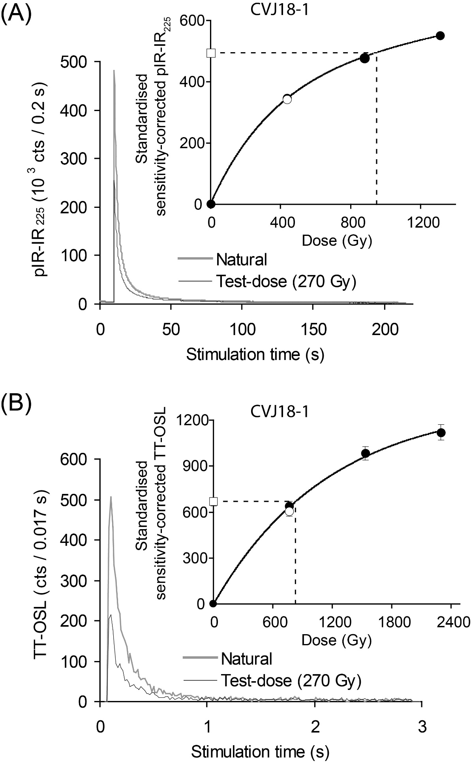

Figure S1. Examples of (A) pIR-IR₂₂₅ decay curves and sensitivity-corrected dose-response curve (inset) for a 160-grain aliquot of sample CVJ18-1 and (B) TT-OSL decay curves and sensitivity-corrected dose-response curve (inset) for a grain of sample CVJ18-1. In both (A) and (B) the dose-point corresponding to the repeated regenerative-dose point (i.e., recycling ratio) is shown as a white circle and the sensitivity-corrected natural signal is shown as a white square.
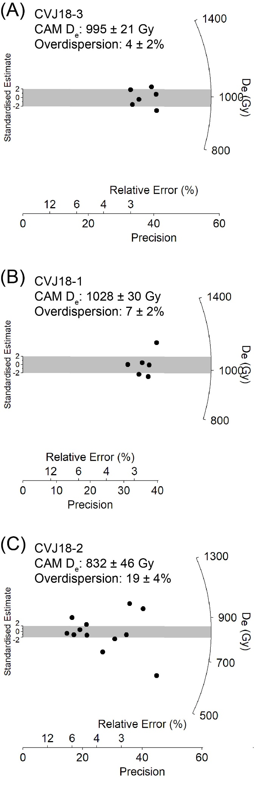
Figure S2. Radial plots obtained for the multi-grain pIR-IR₂₂₅ D_{e} distributions of the Cantera Vieja samples. Grey bars are centred on the CAM D_{e}.

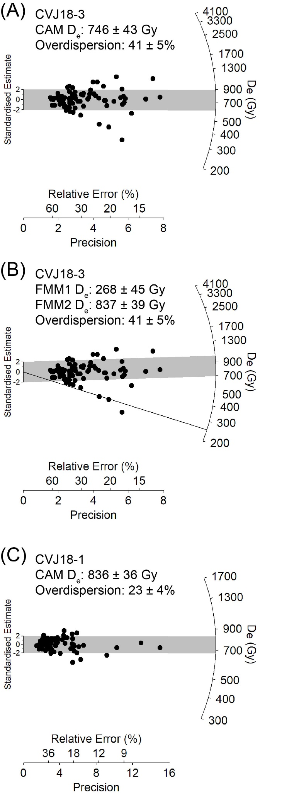
Figure S3. Radial plots obtained for the single-grain TT-OSL D_{e} distributions of the Cantera Vieja. Grey bar in (A) and (C) are centred on the CAM D_{e}. Fine line and grey bar in (B) are centred on the FMM1 and FMM2 D_{e} values, respectively.

Micromorphology methodology
Two blocks of unconsolidated sediment were collected from the southern profile of the site after covering them with plaster (Figures S4 and S5). The first block was denominated CV1 and was 25 cm long, which includes the archaeological levels 2A and 2B. The second block, defined as CV2, was 21 cm long and included archaeological level 1, level R, and part of level 2A. Samples were processed in the soil micromorphological lab of the CENIEH.
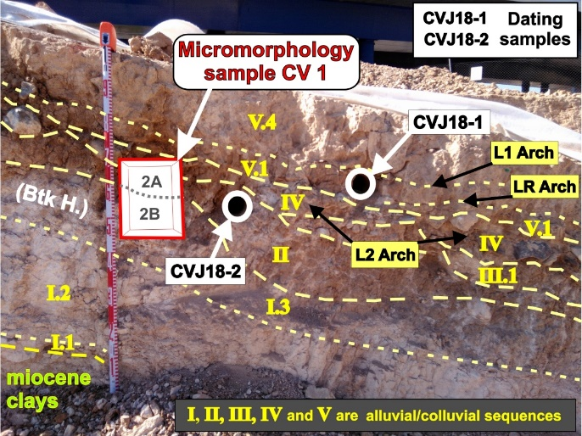
Figure S4. Location of the micromorphological samples MICROCV1 obtained in the southern profile of Ramal 4 in Cantera Vieja site.
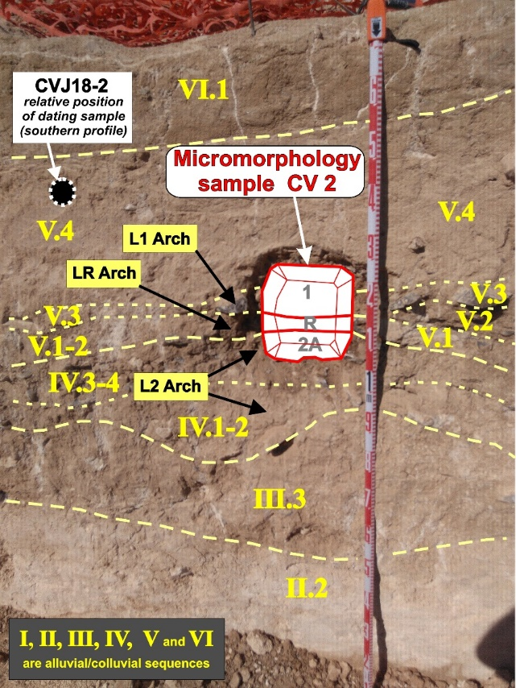
Figure S5. Location of the micromorphological samples MICROCV2 obtained in the southern profile of Ramal 4 in Cantera Vieja site.
After drying the samples, impregnation was carried out under vacuum with 7:3 part mixture of polyester resin (Palatal P4-01), acetone and 7 mL methyl ethyl ketone peroxide (MEKP) per liter of polyester resin and acetone mixture. The impregnation took about 5 weeks and thus absorbed the mixture very slowly. The hardened samples were then sliced into blocks of 135 × 60 x 10 mm. The blocks were mounted on a glass slide (140 x 68 mm) and finally were reduced the standard thickness of 30 μm. A total of 4 thin sections were produced from Cantera Vieja site, 2 from CV1 and 2 from CV2. Thin sections were studied using an Olympus BH2 microscope equipped with an Olympus DP10 digital camera and Nikon Elements imaging software at the University of the Basque Country laboratories.
Results

Table S10 presents a summary of the depositional characteristics from both samples.

Table 1 Main depositional feature description and interpretation
Archaeological Unit | Description | Interpretation
CV2 | Platy to massive microstructure, close porphyric c/f and undifferentiated b- fagric. Skeleton grain have a very poor sorting, very low sphericity, and is compound of: quartz (40%), Fds (30 %), flint (20%), litoclast (5%), bones  (5%). | Mass movement, colluvial
CV1 | Platy microstructure, single spaced porphyric c/f and speckled to granostriated b-fabric. Skeleton grain have mean sorting, low sphericity and is compound of: quartz (35%), Fds (25%), Litoclast (20%), rip-up clast (10%), flint (10%). | Alluvial, flood deposits

2.1. CV1
Sample CV1 shows a bimodal fabric composed of fine and medium sand-sized grains supported by a light yellow-brown silt-clay matrix (Figure S6). Grain selection is relatively good, and the sphericity of the grains is medium. The plot is composed of quartz grains, feldspar (60% plagioclase and 40% potassium feldspar), granite lithoclasts (Figure S6a and b), phosphate aggregates, and flint fragments. The matrix being slightly striated shows that the clays have a preferential orientation.
Most of the sequence shows a homogeneous microstructure, but small subhorizontal levels of grain-supported microfacies have been found intercalating the matrix-supported microfacies (Figure S6e and f).
The predominant porosity is fissure-type, especially the vertical one (Figure S6c), but it also shows some vesicles. Most of the fissures are partially filled by calcite cement (Figure S6d) along the entire level, while only at the top some fissures are filled by illuvial clays, which show a more clayey versus a more silty phase of illuviation (Figure S6g and h). Some fissures, such as the one found in Figure S6 (e and f), are not filled with anything.
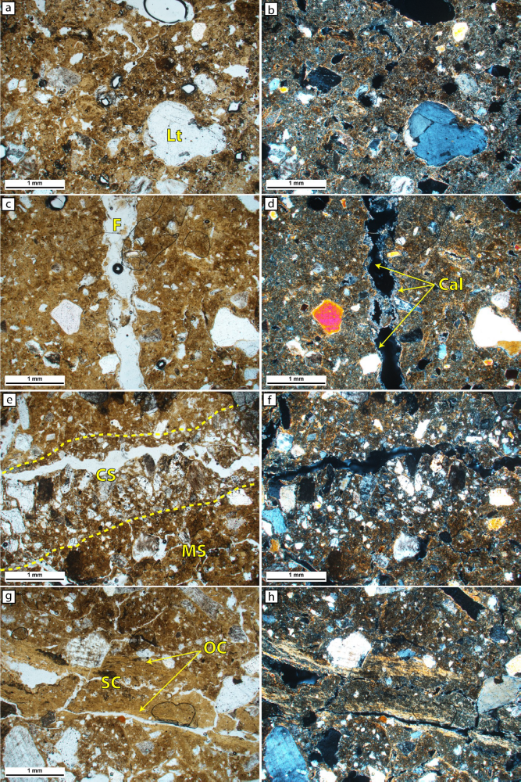
Figure S6. Microphotographs of CV1. a) general microstructure and microfacies of the level; b) same as (a) under cross-polarised light (XPL); c) vertical fissure; d) same as (c) under XPL, whereas calcite cement is visible, coating the fissure partially; e) alternation of clast-supported microfacies with matrix-supported microfacies; f) same as (e) under XPL; g) fissure filled by illuviation clay showing lamination and silty clay illuviated materials; h) same as (g) under XPL. Lt: Litoclast; F: Fissure; Cal: Calcite; CS: Clast-supported; MS: Matrix-supported; OC: Oriented clay; SC: Silty clay
2.2. CV2
It shows a heterogeneous and massive fabric that is supported by very coarse to very fine sand-sized grains and a brown silt-clay matrix (Figure S7). Grain selection is relatively poor, and grains have poor sphericity (Figure S7a and b). The plot is composed of grains of quartz, feldspar (60% potassium feldspar and 40% plagioclase), flint fragments, and bone fragments. The matrix does not show any orientation except slightly in some grooves on the grains.
In the basal part of the level there are subrounded centimeter-long fragments of flint, with calcite impurities inside (Figure S7c) and partially altered on the outside (Figure S7d). They probably belong to the lower reservoir.
The predominant porosity is also fissure, but to a lesser extent than in CV1, in favor of vesicular porosity. Especially in the upper part of the sampled sequence, there is an abundance of sedimentation of illuvial clays in the pores of both fissure and vesicles. The cementation of calcite in the pores is much more continuous along the sequence, but always after the rainfall (Figure S7e and f). Specifically, there are also other more particular types of cements, such as the possible formation of needle-fibre calcite crystals (Figure S7g) or chalcedony cement (Figure S7h).
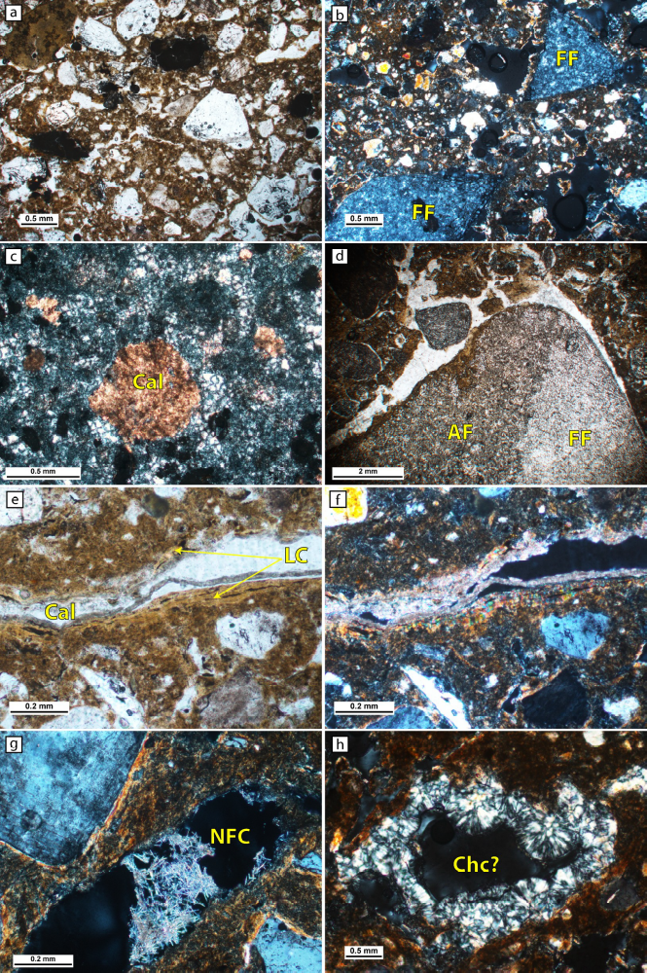
Figure S7. Microphotographs of CV2. a) general microstructure and microfacie of the level; b) general microstructure and microfacie of the level under XPL, whereas fresh flint is visible; c) calcite replacement of the flint, under XPL; d) partially rounded centimetric flint with altered and fress areas; e) fissure partially filled by laminated clay coating and calcite cement; f) same as (e) under XPL; g) acicular cristals with carbonate birrefringence, needle-fibre calcite; h) fibrous quartz colour birrefringence, possible chalcedony cement. FF: Fresh flint; Cal: Calcite; AF: Altered flint; LC: Laminated clay; NFC: Needle-fibre calcite; Chc: Chalcedony

Interpretation

CV1
Given its bimodal nature, relatively good grain selection, and location between the river basins of the Jarama and Manzanares rivers, it is interpreted that this level was formed from alluvial processes. The predominance of the matrix suggests that the area was flooded with low-energy waters, although in some cases, the energy would increase leaving passes of sandier facies (Figure S6e and f). The low roundness of the grains and the high amount of feldspars, such as granite lithoclasts, suggest a relatively short transport of the materials, which may come from the Hercynian igneous rocks located upstream (Diaz de Neira et al., 1993), or rework of other similar older deposits.
The porosity of the filled crack indicates that the cracks are anterior and therefore, probably due to desiccation processes (Stoops et al., 2018). Subsequently, through wet events, these cracks would be filled first by illuvial clays and, later, by micritical cement. The change of fissure infill from clays to calcite minerals is possible due to the burial and alternation of wet and dry processes.
CV2
Due to the heterogeneous nature of the deposit and its poor grain selection, it is interpreted that the level was formed from mass movements (e.g., debris flow), which would resediment older deposits located in the vicinity. The lower plagioclase content in favor of potassium feldspar also suggests the re-sedimentation of surrounding deposits, where weathering has had a more significant impact on plagioclase (Folk, 1974; Nesbitt et al., 1997). As in the CV1 block, the infilled fissures show that there were periods of drought that formed the desiccation cracks and episodes of rain that first percolated the clays through the fissures, and later, more intense cementation processes occurred at the level. The appearance of other cement types, such as needle-fiber calcite and chalcedony, indicates diverse and very local characteristics. Needle-fiber calcite crystals can be produced by microbacterial activity (Bajnoczi and Kovacs-Kis, 2006; Barta, 2011). On the other hand, the formation of chalcedony minerals would be linked to the contribution of silica from the alteration of the flint and evaporation processes that would precipitate chalcedony (Folk and Pittman, 1971).

Archaeological data and supplementary archaeological materials

Sample of experimental 3D biface models used in the morphometric analysis made on the Experimental Laboratory of the UAM (LAEX).

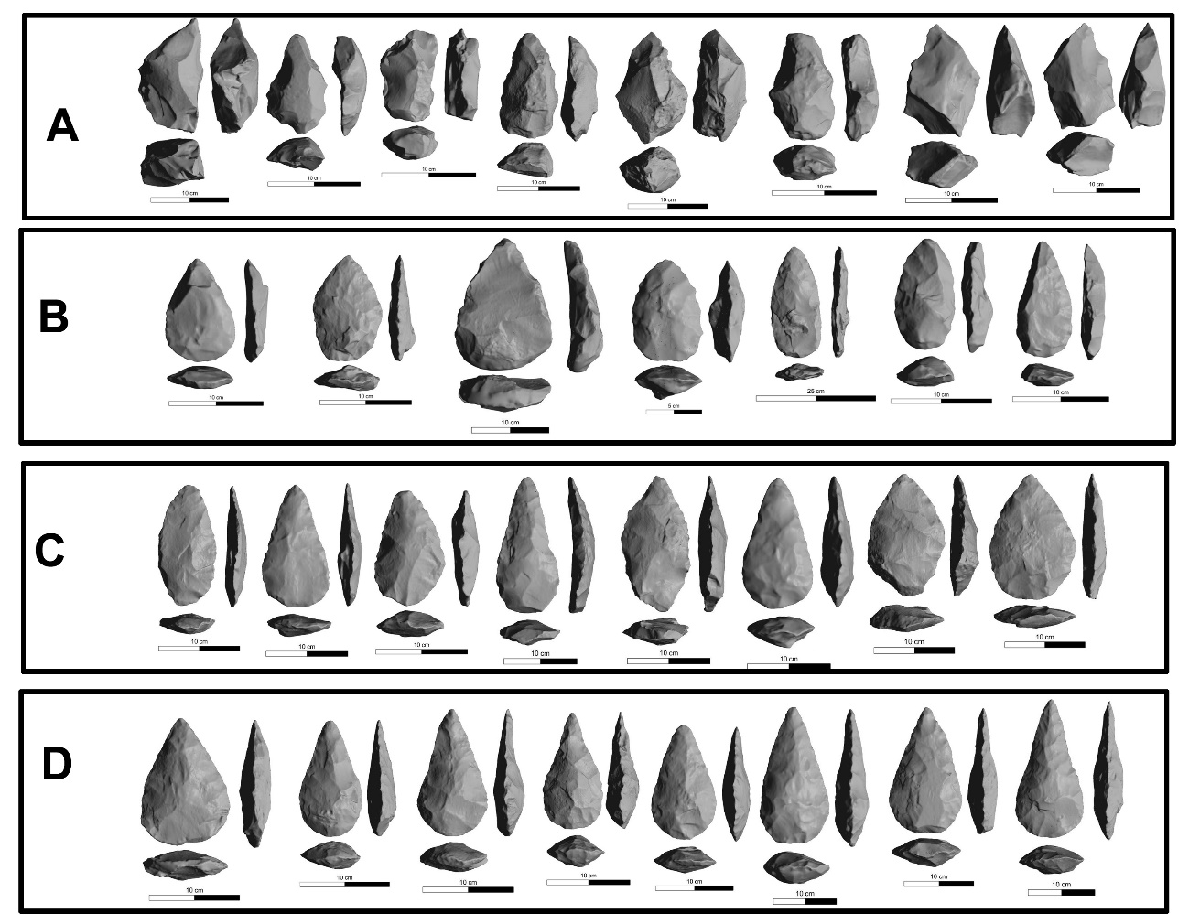
Figure S8. Sample of the experimental bifaces produced at The LAEX-UAM and used in the morphometric analysis classified by skill levels. A. novices, B. apprentices, C. high-skilled apprentices, D. experts

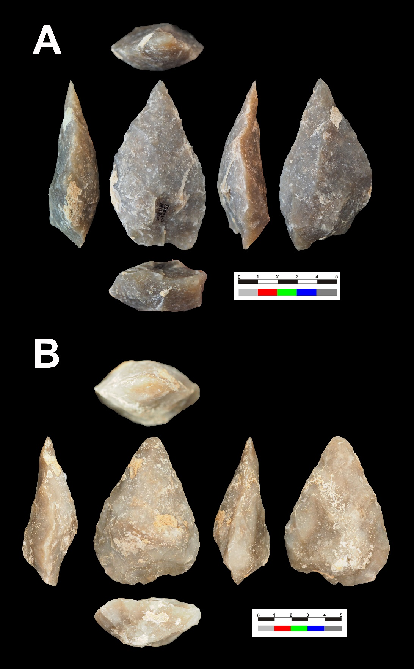
Figure S9. Bifaces or performs from high technological skills. Configuration was successfully obtained. The absence of accidents in functional areas, the homogeneity of scars, and the symmetry of the final morphology, among other features, confirm the skills of the authors. Pieces references A= 6053 B=6055

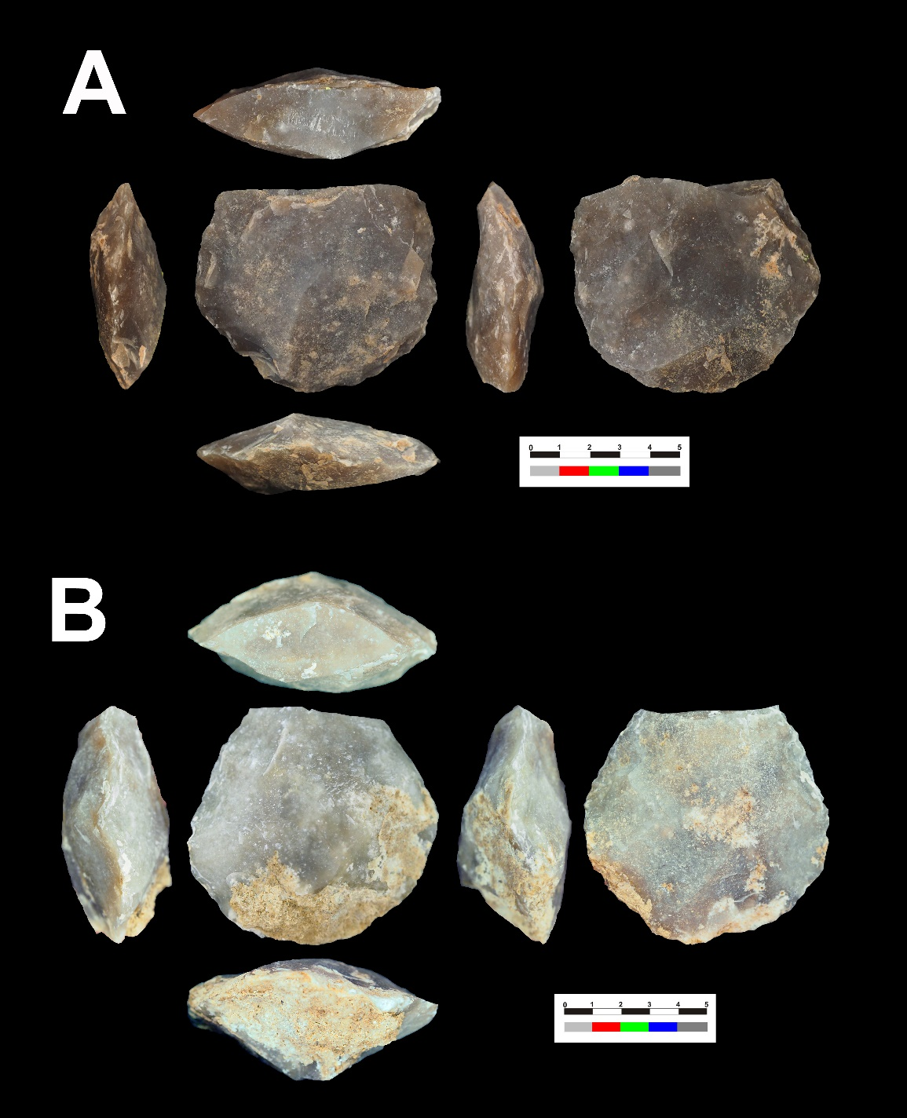
Figure S10. Broken bifaces or performs (mesial fractures) assigned to high technological skills. The rejection of the pieces was produced due to a critical mesial fracture. These accidents correspond to knappers with medium-high skills that knapped with high risk. Pieces references A= 6243 B=6255
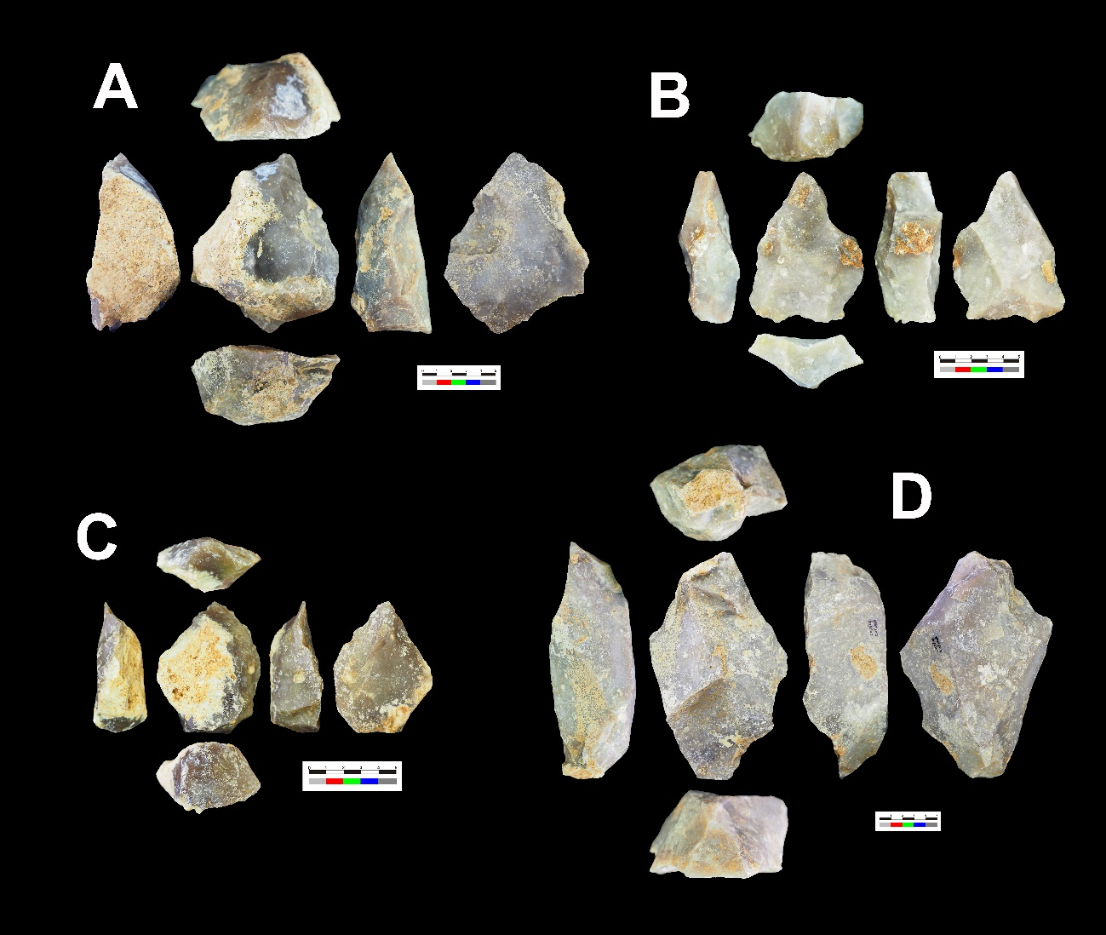
Figure S11. Bifaces or preforms with square borders and limited configuration sequences. These novice products are characterized by asymmetries in negative morphologies, anomalous distribution of scars, accidents, and the absence of perimetrical edges, among other features. Pieces references A=5849 B=2800 C=3413 D= 2965
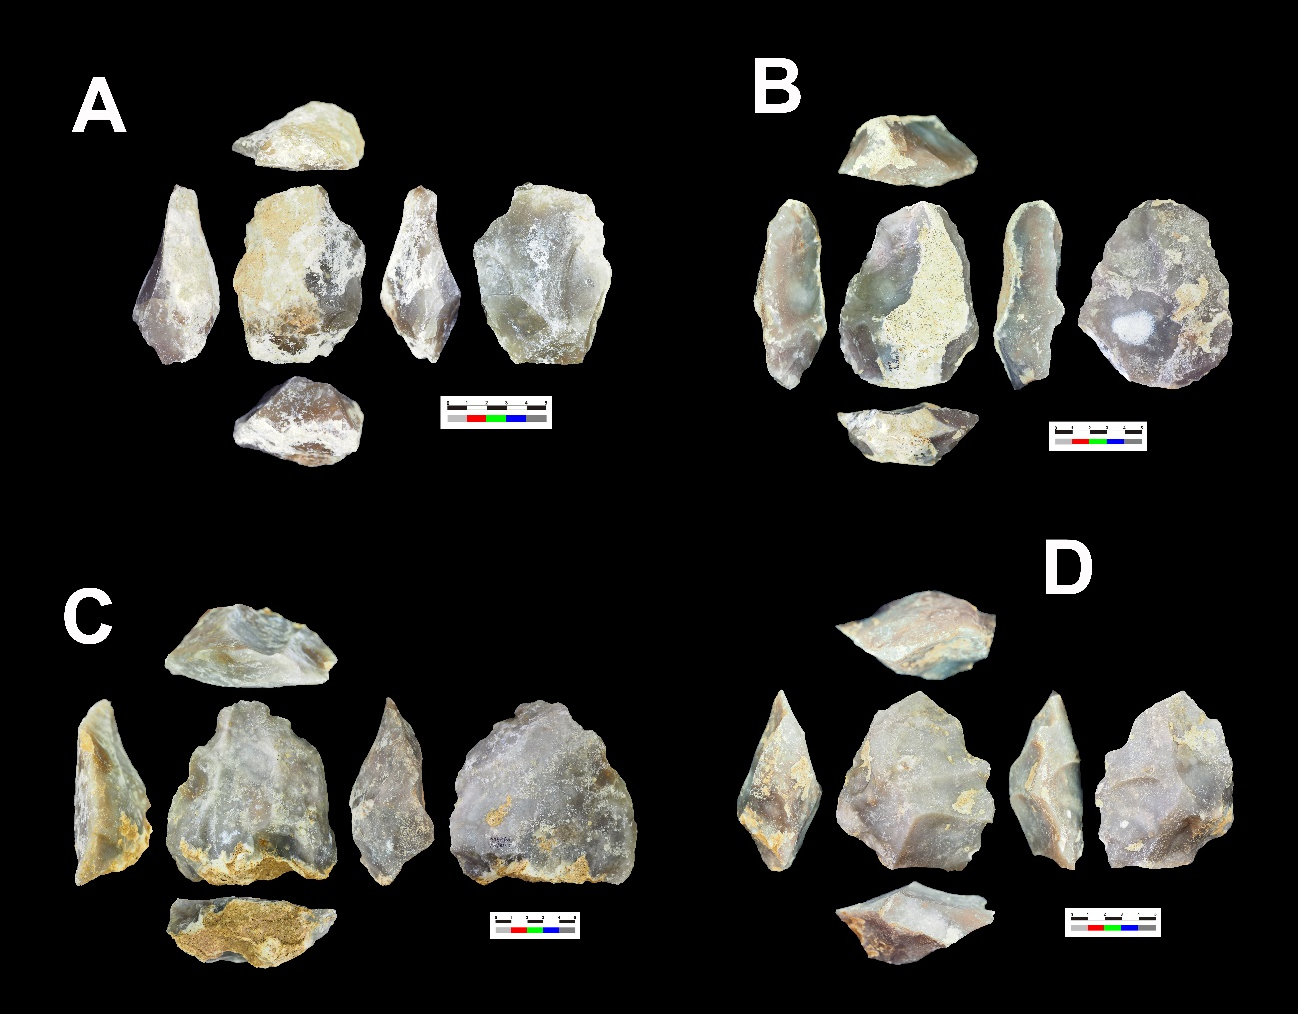
Figure S12. Bifaces or preforms with rounded morphologies and discrete configuration sequences. These novice products are characterized by asymmetries in negative morphologies, anomalous distribution of scars, perdurance of cortical surfaces, general ovoidal morphology, repeated accidents, and the absence of perimetrical edges, among other features. Note that pieces C and D use large flakes as supports. Pieces references A=3027, B=3065, C=3444 D=5417

