Supplementary materials: Standard Curves

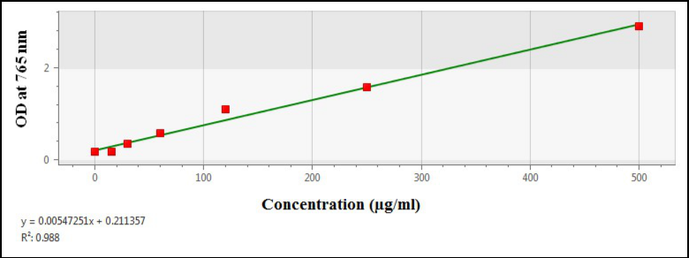

Fig.S1 Standard curve of Gallic acid extrapolated in µg/ml

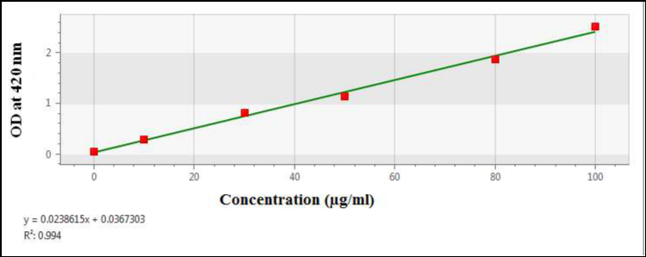

Fig.S2 Standard curve of quercetin was extrapolated in µg/ml

