Supplementary table 1: Comparison of outcomes among survivors and non-survivors (n=100)
Outcome | Non-Survivor (65) | Survivor (35) | Total (100)
 | Median (IQR) | Median (IQR) | Median (IQR) | P value
Duration of mechanical ventilation | 7 (3,15) | 3 (2,6) | 5 (2,12) | 0.019
Length of hospital stay (in days) | 9 (4,20) | 16 (7,23) | 11 (5,21.5) | 0.04
Tracheostomized | 8 (12.3%) | 4 (11.3%) | 12 (12%) | 0.897

Supplementary table 2: Cut-off points for APACHE II and SOFA
Empirical cut point by Liu method | Value | Sensitivity/ Specificity | AUC at cut off
APACHE II | 22.5 | 0.60/0.63 | 0.61
SOFA | 7.5 | 0.57/0.57 | 0.57
CRP (mg/dl) | 83 | 0.71/0.63 | 0.67
LDH (U/l) | 470.5 | 0.49/0.83 | 0.66

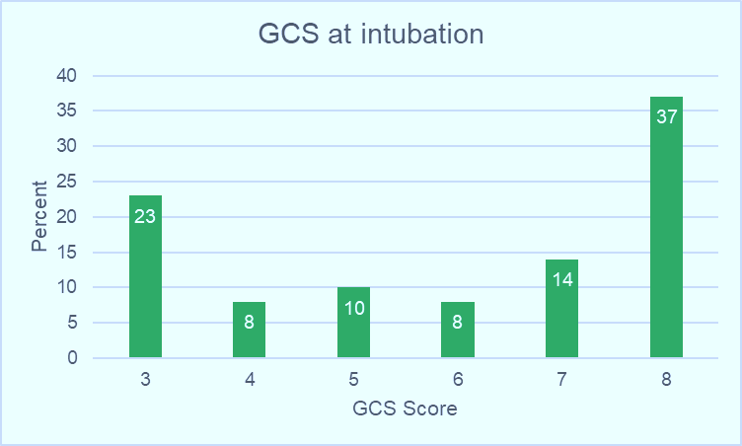
Supplementary figure 1: Bar diagram demonstrating the sensorium (GCS) at the time of intubation (n=100)

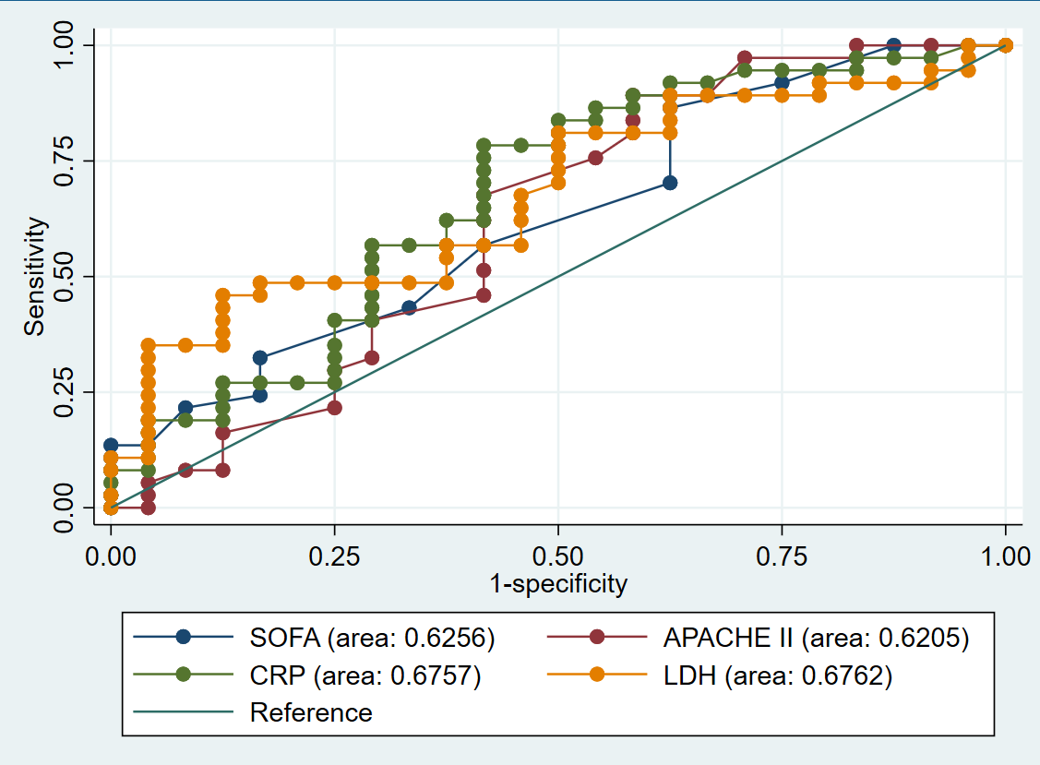
Supplementary figure 2: ROC curve for mortality scores and inflammatory markers
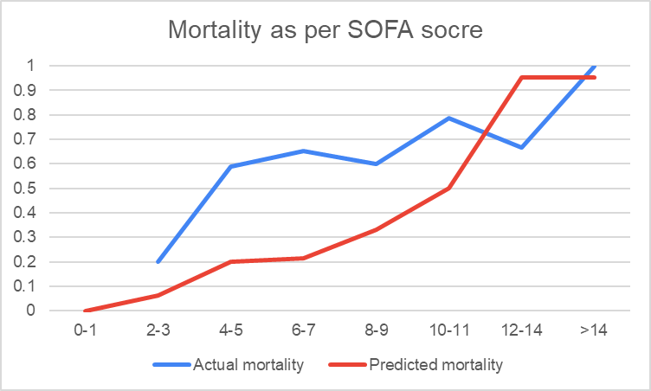
Supplementary figure 3: Predicted versus actual mortality across SOFA scores
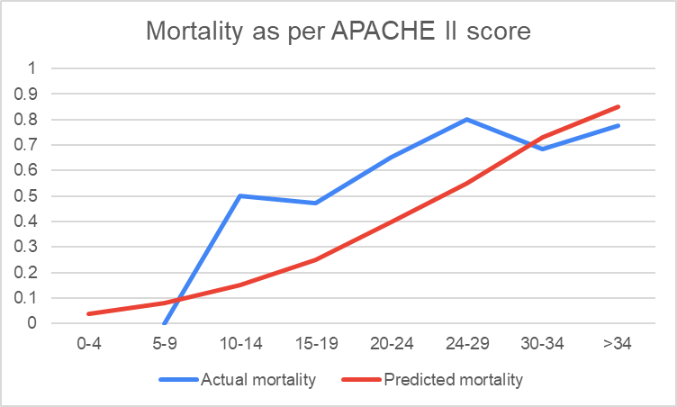
Supplementary figure 4: Predicted versus actual mortality across APACHE II scores
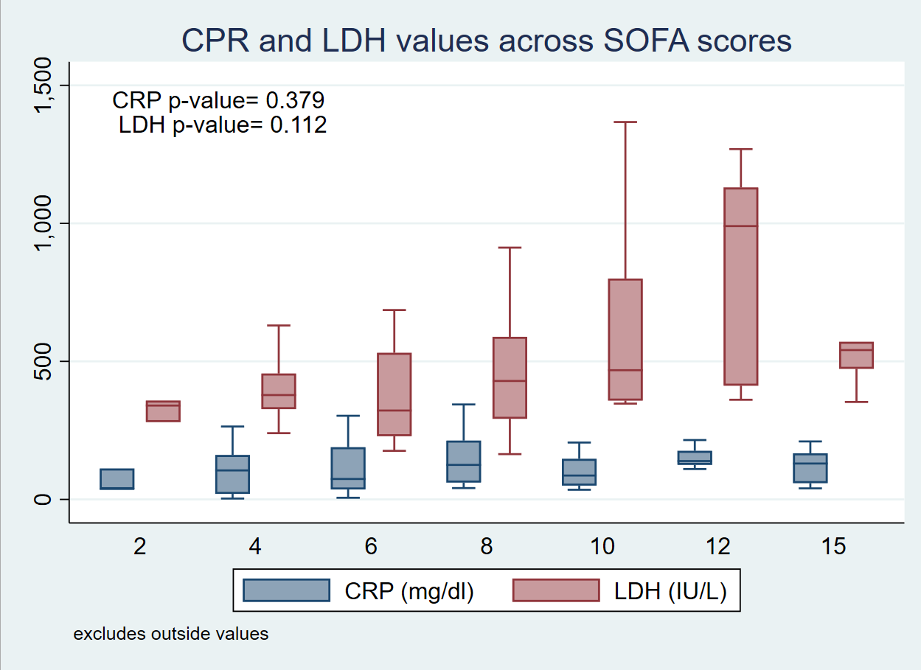
Supplementary figure 5: CRP (mg/dl) and LDH (IU/L) values across SOFA scores
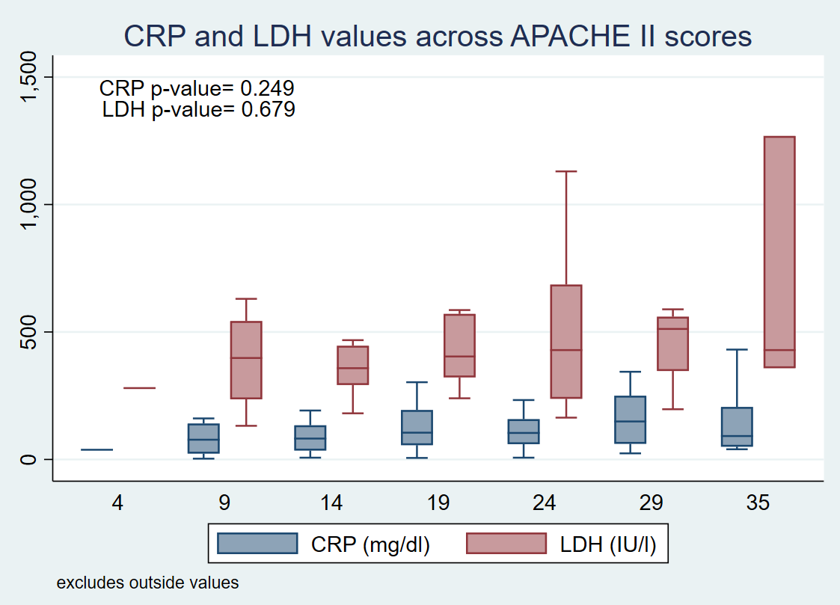
Supplementary figure 6: CRP (mg/l) and LDH (IU/l) across APACHE II scores

