Supplementary Material
Figure S1: Diagram of experimental setup. In generations 1 and 2 no motion detectors were used and the T tube was set at the top of the containers, thereby preventing the female from leaving a male’s cage after she entered it. Starting at generation 3 the T tube was moved to the bottom of the cage and the cones removed, thereby permitting a female to move between cages. Motion detectors were used to monitor the female’s movement. Output from the sound detectors and motion detectors were continually sent to a recording device and stored on an SD card. Song components were recorded at generation 3 and 11 using USB audio recorders.
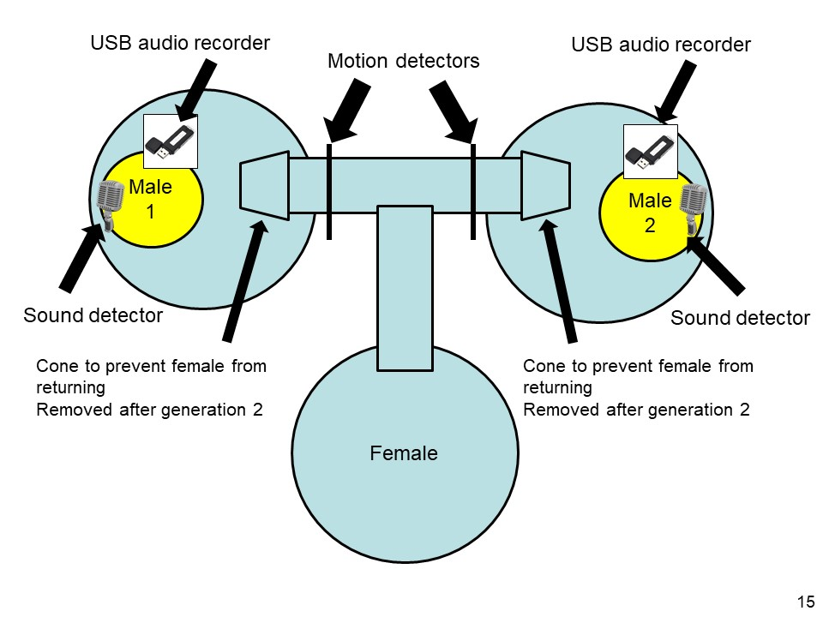

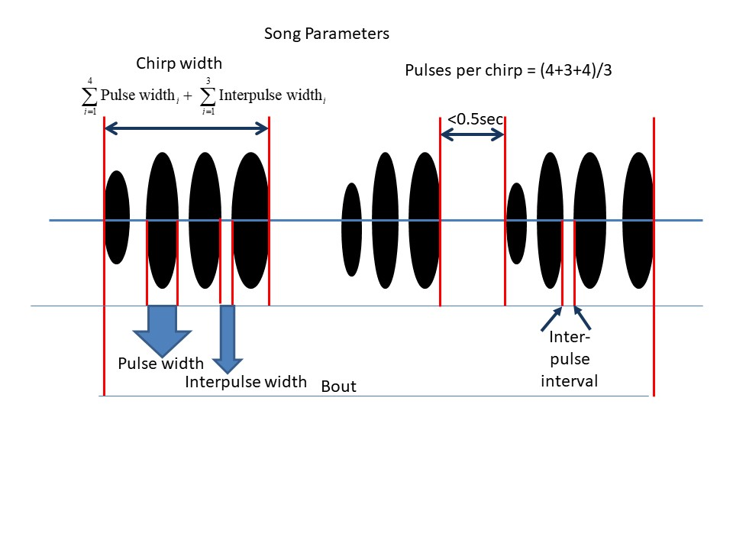
Figure S2: Diagram of song components

Analysis of Stabilizing Preference
In stabilizing preference female preference declines as the difference between her most preferred trait value and the one encountered increases. In this case I used an iterative approach, first assigning a proposed “most preferred” value, say X_{P}, and then calculating the absolute difference between this value and the male’s value. This is done for each male and preference then calculated as for direct preference by regressing Y, as defined above, on X=abs(Focal male trait-X_{P})/(sum of abs(Focal male trait- X_{P})+abs(Other male trait- X_{P})). The value of X_{P} is varied, preference calculated for each value and plotted against the correlation of Y on X (Roff and Fairbairn 2017). If preference is stabilizing the correlation coefficient r will show a humped shaped relationship with X_{P}. Significant stabilizing preference requires that the regression is negative (hence r is negative) and statistically significant at the value of X_{P} at which the -r is maximal. Simulation analysis suggests that a significant level of 5% is weak evidence of stabilizing preference but a P value of 1% or less is strong support (Roff and Fairbairn 2017).
Theory is not a good guide to whether differences in stabilizing preference should be observed between the R and S lines. Therefore, I tested for differences between lines without an a priori prediction on the direction of change that might occur. To test for differences in detected stabilizing preference I used the following randomization test. First, I determined the most preferred male trait value for each line separately. Next I calculated the absolute difference between the two estimates, d_{obs}. I then randomly assigned individuals to the S or R populations and reran the stabilization testing protocol, determining the two preferred male trait values, thence the absolute difference between them, d_{i}. This process was repeated n times giving n values of d_{i}.. The probability of observing a d_{i} greater than or equal to d_{obs} is estimated as {(Number of d_{i} ≥ d_{obs} )+1}/(n+1). The “extra” 1 is required because the observed value is itself a sample and thus must be counted (Roff 2006). If the true probability is close to 0.05 then a sample size of 1,000 or more may be necessary to take into account the standard error of the estimated probability (Roff 2006). Because of the time required to run such a large number of runs, in the present analysis I used a sequential approach, first running 100 randomizations and increasing the number only if the estimated probability was less than 0.20 since the 95% confidence range is , which excludes 0.05.
REFERENCE: Roff DA (2006). Introduction to Computer-Intensive Methods of Data Analysis in Biology. Cambridge University Press: Cambridge.

Figure S3: Distribution of PC scores for male song components. Traits are arranged according to ranking of PC1.
Figure S4. Plots of four traits showing stabilizing preference. Dashed line shows value of the correlation at which P=0.05 for the combined data set.

Figure S5: Correspondence between the genetic and phenotypic correlations in the song components. Dotted line shows 1:1 relationship. Solid line shows regression of genetic correlation on phenotypic correlation (r_{g}=-0.082+0.853r_{p}, P<0.0001)

Figure S6: Comparison of male traits in generations 3 and 11 that showed a significant generation by line interaction.

