Supporting information

KCTD1 downregulation suppresses Hepatocellular Carcinoma by regulating Angiogenesis and influencing the HIF-1α/VEGF Pathway

Xinyu Zhu^{1,2}*, Zhiwei Li^{1,2}*, Limin Li³*, Li Chen¹*, Mi Ouyang^{1,2}, Hao Zhou^{1,2}, Kai Xiao⁴, Ling Lin⁵, Paul K. Chu⁶, Chang Zhou¹, Chengfeng Xun¹, Liu Yang¹, Wenhuan Huang¹, Xiaofeng Ding^{1,2} †

¹ The National & Local Joint Engineering Laboratory of Animal Peptide Drug Development, College of Life Science, Hunan Normal University, Changsha, 410081, China
² Key Laboratory of Model Animals and Stem Cell Biology in Hunan Province, School of Medicine, Hunan Normal University, Changsha, 410013, China
³ College of Engineering and Design, Hunan Normal University, Changsha, 410081, China
⁴ Department of Neurosurgery, Xiangya Hospital of Central South University, Changsha, Hunan, 410008, China
⁵ Department of Hepatobiliary and Pancreatic Surgery, Xiangya Hospital of Central South University, Changsha, Hunan, 410008, China
⁶ Department of Physics, Department of Materials Science and Engineering, and Department of Biomedical Engineering, City University of Hong Kong, Tat Chee Avenue, Kowloon, Hong Kong, China.

* These authors equally contributed to this work.

† Correspondence: Xiaofeng Ding - Email: dingxiaofeng@hunnu.edu.cn; Tel: 86 731 88872916; Fax: 86 731 88872792.
Cover letter
Dear Dr. editors,
Enclosed is an original manuscript entitled “KCTD1 downregulation suppresses Hepatocellular Carcinoma by regulating Angiogenesis and influencing the HIF-1α/VEGF Pathway”. The significance of KCTD1 in carcinogenesis, including hepatocellular cancer (HCC) has not been reported. The manuscript reports the oncogenic role of KCTD1 in HCC cells linking with the angiogenesis and tumor microenvironment, chemotherapy drug sorafenib and exosomes delivering miR-129-5p could downregulate KCTD1 expression and ameliorate the HCC progression, suggesting that KCTD1 may serve as a novel target of sorafenib and pave the way for an efficient therapy against advanced human HCC.
Our manuscript originally investigates the function and molecular mechanism of KCTD1 in HCC, the highlights of our paper are listed as follows,
- Upregulated expression of KCTD1 protein could enhance HCC growth, migration, and invasion in vitro and in vivo.
- KCTD1 overexpression promotes the growth, migration, and tube formation of HUVECs in vitro and in vivo.
- KCTD1 interacts with HIF-1α to activate the VEGF pathway in HCC cells, concurrent with increased M2 macrophage infiltration.
- Sorafenib increases the cytotoxicity of HCC cells by blocking the expression of KCTD1 protein and synergistically inhibits HCC tumor growth.
5. The tumor suppressor miR-129-5p downregulates the KCTD1 expression and abrogates the oncogenic role of KCTD1 by exosome delivery.

Our original data disclose that the importance of KCTD1 among hepatocellular carcinoma, angiogenesis, macrophage accumulation, sorafenib sensitivity and exosome application. Understanding of the molecular mechanisms of KCTD1 in HCC is crucial to future intervention and inhibition of angiogenesis in HCC. Therefore, we believe this will make the highest impact and interest the broadest readership including biology, materials science, chemistry, immunity, medical science.
All the authors declare no conflict of interest.
All authors have approved the manuscript for submission.
The content of the manuscript has not been published, or submitted for publication elsewhere

We sincerely hope the original manuscript will be published in your journal “Journal of Experimental & Clinical Cancer Research”.
Looking forward to your early response as soon as possible.

Sincerely yours
Xiaofeng Ding, Professor
Life Science College, School of Medicine
Hunan Normal University

Methods
Human Tissues
70 HCCs and 10 adjacent normal liver tissues were analyzed (Table S1). The experiments were approved by Hunan Normal University in China and informed consent was gotten from all participants. IHC analysis was carried out on paraffin-embedded samples as described [1]. The protein levels of KCTD1, CD31, and Arg1 were detected. The percentage of stained HCC cells was scored as follows: 0 for no staining, 1 for 1-30%, 2 for 31-60%, and 3 for 61-100%.

Cell lines
The HEK293, 293T cells, HUVEC, SMMC7721, MHCC97H, HepG2, and Hep3B (ATCC, Manassas, USA) were cultured in DMEM medium (Hyclone, Logan, UT, USA) containing 10% fetal calf serum (FCS, Hyclone) and 1% PS antibiotics (Penicillin and Streptomycin) (Gibco). The cells were cultured at 37 °C in a 5% CO₂ humidified incubator.

Plasmid construction
The recombinant plasmid pCMV-Myc-KCTD1 was reported [2]. The KCTD1 cDNA was ligated into the lentiviral vector pEZ-Lv105-Puromycin (GeneCopoeia) [3]. The KCTD1 shRNA and stem-loop sequence of miR-129-5p was ligated into the GV248 vector (Genepharma, Shanghai, China). The 3′ untranslated region (UTR) fragments of the KCTD1 gene was amplified from HEK293 genomic DNA, and ligated into the pmirGLO vector (Promega, Madison, WI, USA) between PmeI and XhoI sites. Mutagenesis of the KCTD1 3′ UTR luciferase construct was directly ligated to the pmirGLO vector to mutate the potential miR-129-5p-binding site. The mimics of miR-16-5p and miR-129-5p were synthesized by GenePharma. All the constructs had been sequenced by the sanger method for verification (Sangon Biotech, Co., Ltd).

Generation of KCTD1 overexpressing/knockdown and miR-129-5p overexpressing lentivirus
Lentiviral particles were generated as previously reported [1]. Briefly, 293T cells were cotransfected with the lentivirus plasmids for KCTD1 overexpression and Lenti-PacTM HIV packaging mix (HPK-LvTR-20). The supernatants were collected, filtered, and concentrated. The Huh7, HepG2, and HUVEC cells were infected with KCTD1-lentivirus [multiplicity of infection (MOI) of 5-20], 5 μg/mL polybrene (Sigma). Cells were observed under the fluorescence microscope on day 4 followed by stable cell selection with 3 μg/ml of puromycin.
The sequence of KCTD1 shRNA and pre-miR-129-5p were ligated to the lentiviral vector GV248 (Genepharma). Recombinant vectors were cotransfected into 293T cells with pHelper1.0 and pHelper2.0 (Genepharma). The viral-containing supernatants were collected 48 h after transfection and purified. The MHCC97H and SMMC7721 cells were infected with lentivirus carrying KCTD1 shRNA or NC shRNA at an MOI of 10 and 5 μg of polybrene/ml, the miR-129-5p-infected MHCC97H cells were then screened with 3 μg/mL of puromycin on Day 4.

Growth assays
In the MTT analysis, 2,000 HCC cells were plated on 48-well plates either untreated or treated with sorafenib (5-10 μM) for 6 h. The cell viability at the indicated timepoints was measured with 3-(4,5-dimethylthiazol-2-yl)-2,5-diphenytetrazolium bromide solution (1 mg/mL MTT, Sigma) for 4 h at 37ºC. 100 μL of dimethylsulfoxide (DMSO) was employed to dissolve the formed formazan crystals and the absorbance of the mixture was determined using EnSpire Multimode Plate Reader (PerkinElmer, USA). Liquid colony formation assays was carried out as reported [1, 3]. 500-1,000 HCC cells were plated in duplicate on 6-well plates and cultured for 7-15 days. The cell colonies were stained for counting. All the experiments were done in triplicate.

Scratch, migration, and invasion assays
In the scratch wound-healing assay, the HCC and HUVEC cells were seeded on 6-well plates. A sterilized yellow pipette tip was employed to create wounding and the cellular debris was washed with PBS. The wounded areas were checked at the indicated timepoints by an inverted microscope (Zeiss). The HCC cell migration and invasion analysis was carried out as stated previously [4]. 2×10⁴ of HCC cells were added to the upper chambers with or without Matrigel. DMEM medium with 15% FCS was put in the lower chambers. After a 24-48 h incubation period, HCC cells were fixed and stained. The mean number of HCC cells per field was calculated. These experiments were done in triplicate.

RNA sequencing analysis
The RNA extracted from infected MHCC97H and Huh7 cells was employed to obtain the cDNA library and Illumina HiSeq 2500 sequencing of these samples was carried out by ANOROAD Gene Technology Co., Ltd (Beijing, China).

Quantitative real-time PCR
The total RNA from the HCC cell lines, mouse tissues, and U937 cells was collected using the TRIzol reagent (Invitrogen, Waltham, USA) and first-strand cDNA was obtained by reverse transcription (Roche Diagnostics, Germany). qRT-PCR was performed using the SYBR Green (TakaRa, Shiga, Japan) on the Applied Biosystems 7900HT system (Weiterstadt, Germany). Reactions were performed in 384-well PCR plates following the standard qualitative PCR conditions. The forward and reverse primers are shown in Additional file 2: Table S2. The Ct values were detected in the exponential phase of the amplification and the relative expression level was calculated by the 2^{−∆∆Ct} method and log₂ values were expressed as relative expression of genes compared to a reference gene.

Luciferase reporter assays
The HEK293 cells were seeded on 12-well plates and transiently cotransfected with the reporter plasmids and miRNA mimics using Lipofectamine 3000 as reported previously [5-7]. At 24-48 h after transfection, both luciferase activities of the cellular lysate were measured using a Dual-Luciferase Assay kit (Promega). The experiments were done in triplicate.

Western blotting
The HCC cells were lysed in the RIPA lysis buffer as reported [8, 9] and Western blots were carried out following the standard protocol. The information about the antibodies is shown in the following: rabbit polyclonal antibodies against KCTD1 (PA5-24877, ThermoFisher), AKT (A11027, Abclonal), phosphorylated AKT^{S473} (AP0140, Abclonal), HIF1α (A7684, Abclonal), ARNT (A0972, Abclonal), CD31 (A11525, Abclonal), VEGFR2 (A5609, Abclonal), p-VEGFR2 (AP0595, Abclonal), AFP (A0200, Abclonal), GPC3 (A12383, Abclonal), mouse monoclonal antibodies against VEGF (A17877, Abclonal) and GAPDH (AC002, Abclonal), secondary HRP-conjugated antibodies against goat anti-rabbit (sc-2004) and anti-mouse (sc-2005) IgG (Santa Cruz Biotechnology).

CO-IP assays
The MHCC97H cells were collected and lysed as reported [10]. The cellular extracts were immune-precipitated using polyclonal antibodies against KCTD1, or ARNT and protein A/G plus-agarose (Santa Cruz Biotech). The mixture was detected with mouse monoclonal antibodies against KCTD1, HIF-1α, or ARNT (Santa Cruz Biotech). Normal rabbit IgG (sc-2027) served as the negative control.

Protein degradation assays
The HCC cells overexpressing or knockdowning KCTD1 were treated with CHX at different time points and different concentrations and then lysed in RIPA buffer. The HCC cells were treated with the defined concentration of CoCl₂ for 24 h to induce hypoxia, harvested and analyzed by Western blotting.

ChIP assays
ChIP was performed using an EZ-ChIP assay kit from Upstate Biotechnology (Lake Placid, NY, USA) following the standard protocol. Briefly, 2×10⁷ cells were used for further analysis. The cellular extracts were immunoprecipitated with rabbit anti-KCTD1 polyclonal antibodies. The DNA fragments of the VEGF regulatory regions span nucleotides −1041 to −750. PCR assays were carried out using specific PCR primers (Table S2).

FACS
The HCC cells were trypsined, centrifuged and resuspended in Annexin V Binding Buffer. Afterwards, cells were labeled with both Annexin V-FITC (1 μg/mL) and propidium iodide (PI, 40 μg/mL) for 20 min in darkness at room temperature. The samples were run by BD FACSCalibur (CA, USA) and analyzed with the FlowJo 10 software.

Differentiation of U937 cells and co-culture with the supernatant from HCC cells
The U937 cells were activated by 100 ng/ml PMA to form macrophage-like cells (M0) for 24 h and M0 was polarized into M1 using LPS (50 ng/mL) and IFN-γ (10 ng/mL) for 24 h and M2 using IL-4 alone (20 ng/mL) for another 24 h. After induction of the TAMs, the morphology of the U937-differentiated M0, M1, and M2 macrophages was examined. The M0 macrophages were cocultured with the supernatant from HCC cells, the levels of the M1 markers and M2 markers were measured by qRT-PCR.

Statistical analysis
The data analysis was performed using SPSS 16.0 software (Chicago, IL, USA) and Prism 6 statistical software (San Diego, CA, USA) and the Pearson′s χ2 test was applied to evaluate the association between gene expression and clinical parameters. The differential expression levels of interest genes between HCC tissues and non-tumor tissues were assessed with Student’s t-test and expression differences between two genes were analyzed using the Fisher′s exact test. The Survival function was estimated by the Kaplan-Meier curve. These data were presented as mean ±3SD and P values less than 0.05 were statistically significant.

References
1. Yang L, Qiu J, Xiao Y, Hu X, Liu Q, Chen L, Huang W, Li X, Li L, Zhang J, Ding X, Xiang S. AP-2β inhibits hepatocellular carcinoma invasion and metastasis through Slug and Snail to suppress epithelial-mesenchymal transition. Theranostics. 2018; 8:3707-21.
2. Ding XF, Luo C, Ren KQ, Zhang J, Zhou JL, Hu X, Liu RS, Wang Y, Gao X, Zhang J. Characterization and expression of a human KCTD1 gene containing the BTB domain, which mediates transcriptional repression and homomeric interactions. DNA Cell Biol. 2008; 27:257-65.
3. Huang W, Zhong Z, Luo C, Xiao Y, Li L, Zhang X, Yang L, Xiao K, Ning Y, Chen L, Liu Q, Hu X, Zhang J, Ding X, Xiang S. The miR-26a/AP-2alpha/Nanog signaling axis mediates stem cell self-renewal and temozolomide resistance in glioma. Theranostics. 2019; 9:5497-516.
4. Huang W, Chen C, Liang Z, Qiu J, Li X, Hu X, Xiang S, Ding X, Zhang J. AP-2alpha inhibits hepatocellular carcinoma cell growth and migration. Int J Oncol. 2016; 48:1125-34.
5. Li X, Chen C, Wang F, Huang W, Liang Z, Xiao Y, Wei K, Wan Z, Hu X, Xiang S, Ding X, Zhang J. KCTD1 suppresses canonical Wnt signaling pathway by enhancing beta-catenin degradation. PLoS One. 2014; 9:e94343.
6. Ding X, Yang Z, Zhou F, Wang F, Li X, Chen C, Hu X, Xiang S, Zhang J. Transcription factor AP-2alpha regulates acute myeloid leukemia cell proliferation by influencing Hoxa gene expression. Int J Biochem Cell Biol. 2013; 45:1647-56.
7. Wu Y, Xiao Y, Ding X, Zhuo Y, Ren P, Zhou C, Zhou J. A miR-200b/200c/429-Binding Site Polymorphism in the 3′ Untranslated Region of the AP-2α Gene Is Associated with Cisplatin Resistance. Plos One. 2011; 6:e29043.
8. Ding X, Fan C, Zhou J, Zhong Y, Liu R, Ren K, Hu X, Luo C, Xiao S, Wang Y, Feng D, Zhang J. GAS41 interacts with transcription factor AP-2beta and stimulates AP-2beta-mediated transactivation. Nucleic Acids Res. 2006; 34:2570-8.
9. Wang F, Huang W, Hu X, Chen C, Li X, Qiu J, Liang Z, Zhang J, Li L, Wang X, Ding X, Xiang S, Zhang J. Transcription factor AP-2beta suppresses cervical cancer cell proliferation by promoting the degradation of its interaction partner beta-catenin. Mol Carcinog. 2017; 56:1909-23.
10. Hu L, Chen L, Yang L, Ye Z, Huang W, Li X, Liu Q, Qiu J, Ding X. KCTD1 mutants in scalp‑ear‑nipple syndrome and AP‑2α P59A in Char syndrome reciprocally abrogate their interactions, but can regulate Wnt/β‑catenin signaling. Molecular Medicine Reports. 2020; 22:3895-903.

Additional file 1: Table S1. Comparisons of KCTD1 expression and the clinical characteristics of HCCs.

Clinical features | Number | Overexpression | Low expression | P value
Total number | 80
Sex |  |  |  | 0.03
Female | 8 | 7 | 1
Male | 62 | 26 | 36
Age, years（mean，46.5） |  |  |  | 0.9493
<46.5 | 28 | 15 | 13
≥46.5 | 42 | 18 | 24
Tumor size, cm |  |  |  | 0.1821
≤5 | 48 | 25 | 23
>5 | 22 | 8 | 14
Cell differentiation |  |  |  | 0.2993
Well/ Moderately | 47 | 24 | 23
Poor | 23 | 9 | 14
Tumor stage |  |  |  | 0.0191
I/II | 50 | 21 | 29
III/IV | 20 | 12 | 8
Adjacent normal tissues | 10

Additional file 2: Table S2. Primer pairs used in this study.

Name | Sequence (5'- to -3') | Purpose
KCTD1-F | ACGCTAAGCGGTGACAAATCC
KCTD1-R | CGAGTCGTGATTCCAGCCTG | RT-PCR
KCTD1 3'UTR mut1/2/3-F | CGGTACCATTTCTTATatgcgcggAACCAAatatgcgcgcTAACTCAAAtgcgcgcgC
KCTD1 3'UTR mut1/2/3-R | TCGAGcgcgcgcaTTTGAGTTAgcgcgcatatTTGGTTccgcgcatATAAGAAATGGTACCgagct | clone
KCTD1 3'UTR WT-F | CGGTACCATTTCTTATgcaaaaagAACCAAatgcaaaaaaTAACTCAAAcaaaaaagC
KCTD1 3'UTR WT-R | TCGAGcttttttgTTTGAGTTAttttttgcatTTGGTTctttttgcATAAGAAATGGTACCgagct | clone
VEGF-F | AGGGCAGAATCATCACGAAGT
VEGF-R | AGGGTCTCGATTGGATGGCA | RT-PCR
HIF-1α-F | ATCCATGTGACCATGAGGAAATG
HIF-1α-R | TCGGCTAGTTAGGGTACACTTC | RT-PCR
KCTD1 3'UTR-F | AGCTTTGTTTAAACATGGACATATTTCTTATGCAAA
KCTD1 3'UTR-R | CCGCTCGAGAATTTCACTTTAATCCAGCCT | PCR
CD11b-F | ACTGGTGAAGCCAATAACGCA
CD11b-R | TCCGTGATGACAACTAGGATCTT | RT-PCR
CD206-F | GGGTTGCTATCACTCTCTATGC
CD206-R | TTTCTTGTCTGTTGCCGTAGTT | RT-PCR
iNOS-F | AGGGACAAGCCTACCCCTC
iNOS-R | CTCATCTCCCGTCAGTTGGT | RT-PCR
IL12a-F | ATGGCCCTGTGCCTTAGTAGT
IL12a-R | AGCTTTGCATTCATGGTCTTGA | RT-PCR
IL1β-F | ATGATGGCTTATTACAGTGGCAA
IL1β-R | GTCGGAGATTCGTAGCTGGA | RT-PCR
TNFα-F | GAGGCCAAGCCCTGGTATG
TNFα-R | CGGGCCGATTGATCTCAGC | RT-PCR
IL10-F | TCAAGGCGCATGTGAACTCC
IL10-R | GATGTCAAACTCACTCATGGCT | RT-PCR
MiR-129-5p-RT | GTCGTATCCAGTGCAGGGTCCGAGGTATTCGCACTGGATACGACGCAAGC | RT
miR-129-5P F | CTTTTTGCGGTCTGGGCTTGC
miR/U6 R | GTGCAGGGTCCGAGGT | PCR
U6-RT | GTCGTATCCAGTGCAGGGTCCGAGGTGCACTGGATACGACAAAATATGG | RT
U6-F | TGCGGGTGCTCGCTTCGGCAGC | PCR
TGFβ-F | CAATTCCTGGCGATACCTCAG
TGFβ-R | GCACAACTCCGGTGACATCAA | RT-PCR
VEGF-chIP F | CAGGAACAAGGGCCTCTGTCT | chIP
VEGF-chIP R | TGTCCCTCTGACAATGTGCCATC | chIP
KCTD1 shRNA F | CcggCGTCCCAGTTCAGCGAATACTCGAGTATTCGCTGAACTGGGACGTTTTTg
KCTD1 shRNA R | aattcaaaaaCGTCCCAGTTCAGCGAATACTCGAGTATTCGCTGAACTGGGACG | clone
miR-129-5p(upper) | GGAUCUUUUUGCGGUCUGGGCUUGCUGUUCCUCUCAACAGUAGUCAGGAAGCCCUUACCCCAAAAAGUAUCU | clone
CCL2-F | CAGCCAGATGCAATCAATGCC
CCL2-R | TGGAATCCTGAACCCACTTCT | RT-PCR
Arg1-F | TGGACAGACTAGGAATTGGCA
Arg1-R | CCAGTCCGTCAACATCAAAACT | RT-PCR

Additional file 3: Figure S1
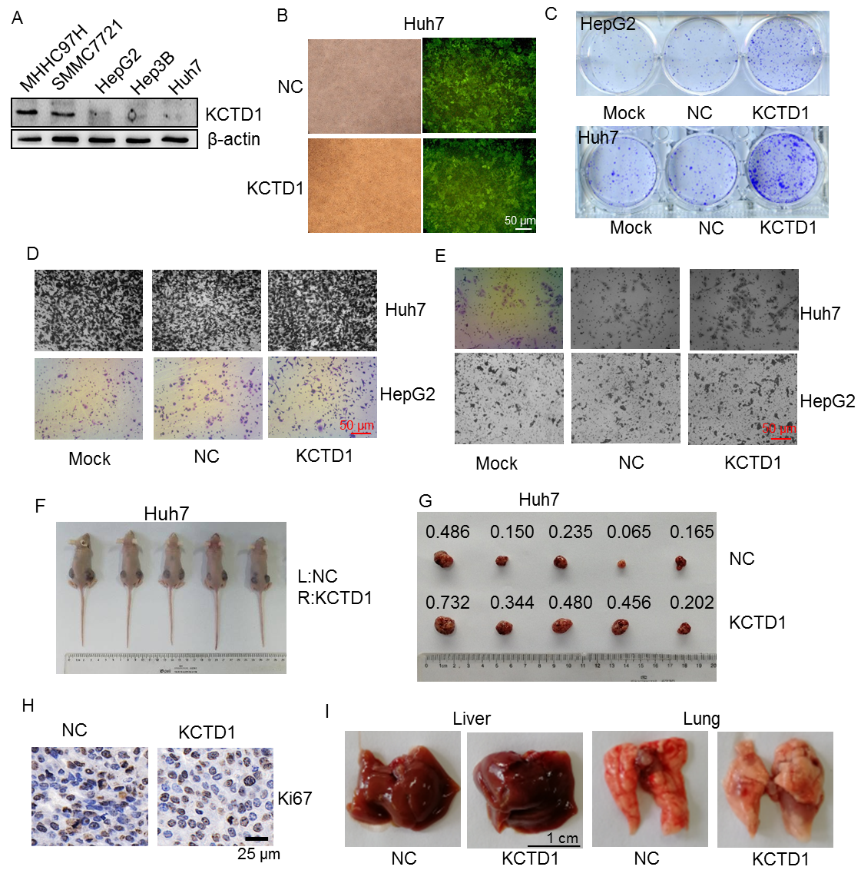
Figure S1. KCTD1 overexpression enhances the in vitro and in vivo growth and invasion of HCC cells. a KCTD1 protein levels in HCC cell lines are analyzed by Western blotting; b Immunofluorescence staining of the KCTD1 expression in the lentiviral-infected HCC cells; c Liquid colony formation assays of the uninfected or LV-infected HCC cells with representative photos taken; d Effects of KCTD1 overexpression on HCC cell migration using transwell migration assays with indicated examples of HCC cells migrating across transwell shown; e Effects of KCTD1 overexpression on HCC cell invasion capacity with indicated examples of HCC cells migrating through transwell Matrigel-coated chambers shown; f KCTD1-Lentivirus-infected Huh7 cells injected subcutaneously into the two points of the back of immunodeficient nude mice (female) and tumors excised four weeks later and photographed (g); h IHC staining of Ki67 expression in Huh7 tumors; i Pictures of metastatic lungs and livers of female nude mice through tail vein injection of Huh7 cells.

Additional file 4: Figure S2
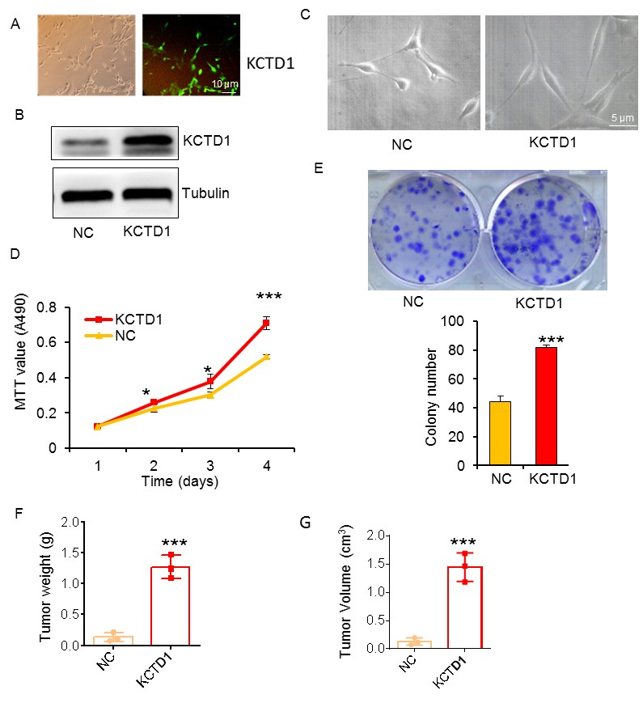
Figure S2. Effects of KCTD1 overexpression on malignant transformation of NIH3T3 cells. a Immunofluorescence staining of KCTD1 expression in lentiviral-infected NIH3T3 cells; b Western blotting of NIH3T3 cells infected with KCTD1-LV using anti-KCTD1 antibodies; c Morphological analysis of NIH3T3 cells infected with KCTD1-LV; d MTT analysis of 1,000 NIH3T3 cells infected with KCTD1-LV seeded on a 96-well plate and cultured in complete DMEM medium and absorbance at OD 490 nm measured on Day 1, 2, 3 and 4; e Liquid colony formation assays of 500 NIH3T3 cells infected with KCTD1-LV plated on 6-well plates and cultured for 11 days. The cell colonies were stained for counting; f About 2×10⁵ KCTD1-LV-infected NIH3T3 cells injected subcutaneously into the back of nude mice (female, n =3 per group) and tumors excised after 4 weeks and then weighed (g). The mean weight/volume of the subcutaneous tumors is obtained in triplicate. The data indicate 3 independent experiments. *, p<0.05, **, p<0.01 and ***, p<0.001.

Additional file 5: Figure S3
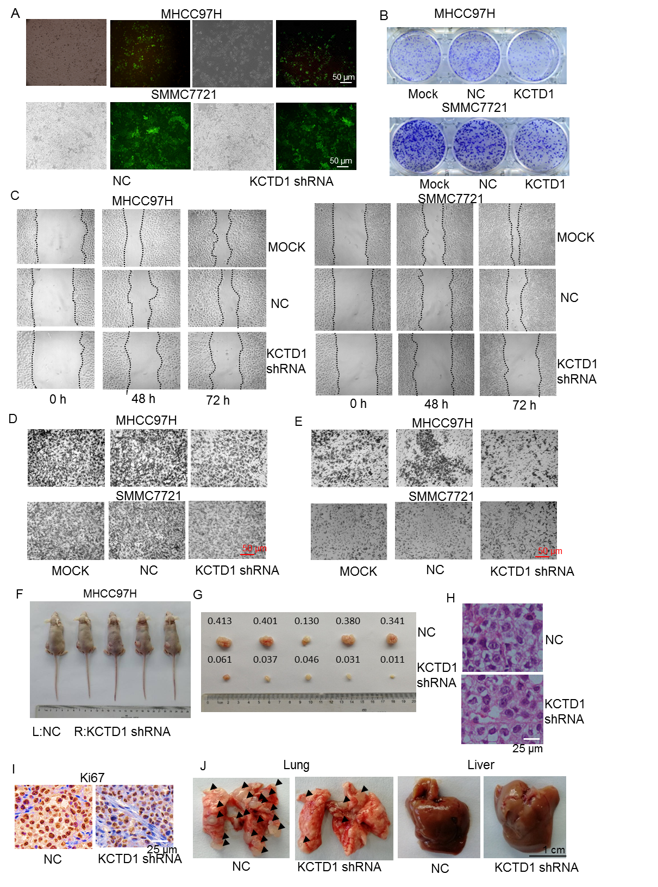
Figure S3. KCTD1 knockdown suppressing the in vitro and in vivo growth, migration and invasion of HCC cells. a Immunofluorescence staining of KCTD1 shRNA in lentiviral-infected HCC cells; b Representative images of liquid colony formation assays of HCC cells infected with KCTD1 shRNA-LV; c Representative images from scratch wound healing assays at different timepoints in HCC cell s infected with KCTD1 shRNA-LV; d Effects of KCTD1 knockdown on HCC cell migration using transwell migration assays with examples of HCC cells migrating across transwells; e Effects of KCTD1 knockdown on HCC cell invasion with indicated examples of HCC cells migrating through transwell Matrigel invasion assays: f About 8×10⁶ infected MHCC97H cells injected subcutaneously into the two points of the back of nude mice (4-week old, female, n = 5 per group) and tumors excised after 2 weeks and analyzed (g); h HE staining carried out on serial 5 μm paraffin sections of subcutaneous tumors from MHCC97H cells; i IHC staining of Ki67 expression in MHCC97H tumors; j Representative photos of metastatic lung nodules from female nude mice by tail vein injection of MHCC97H cells with the arrowheads indicating the metastatic nodules on the surfaces of the lungs, not those of the livers. These data indicate three independent experiments performed.

Additional file 6: Figure S4
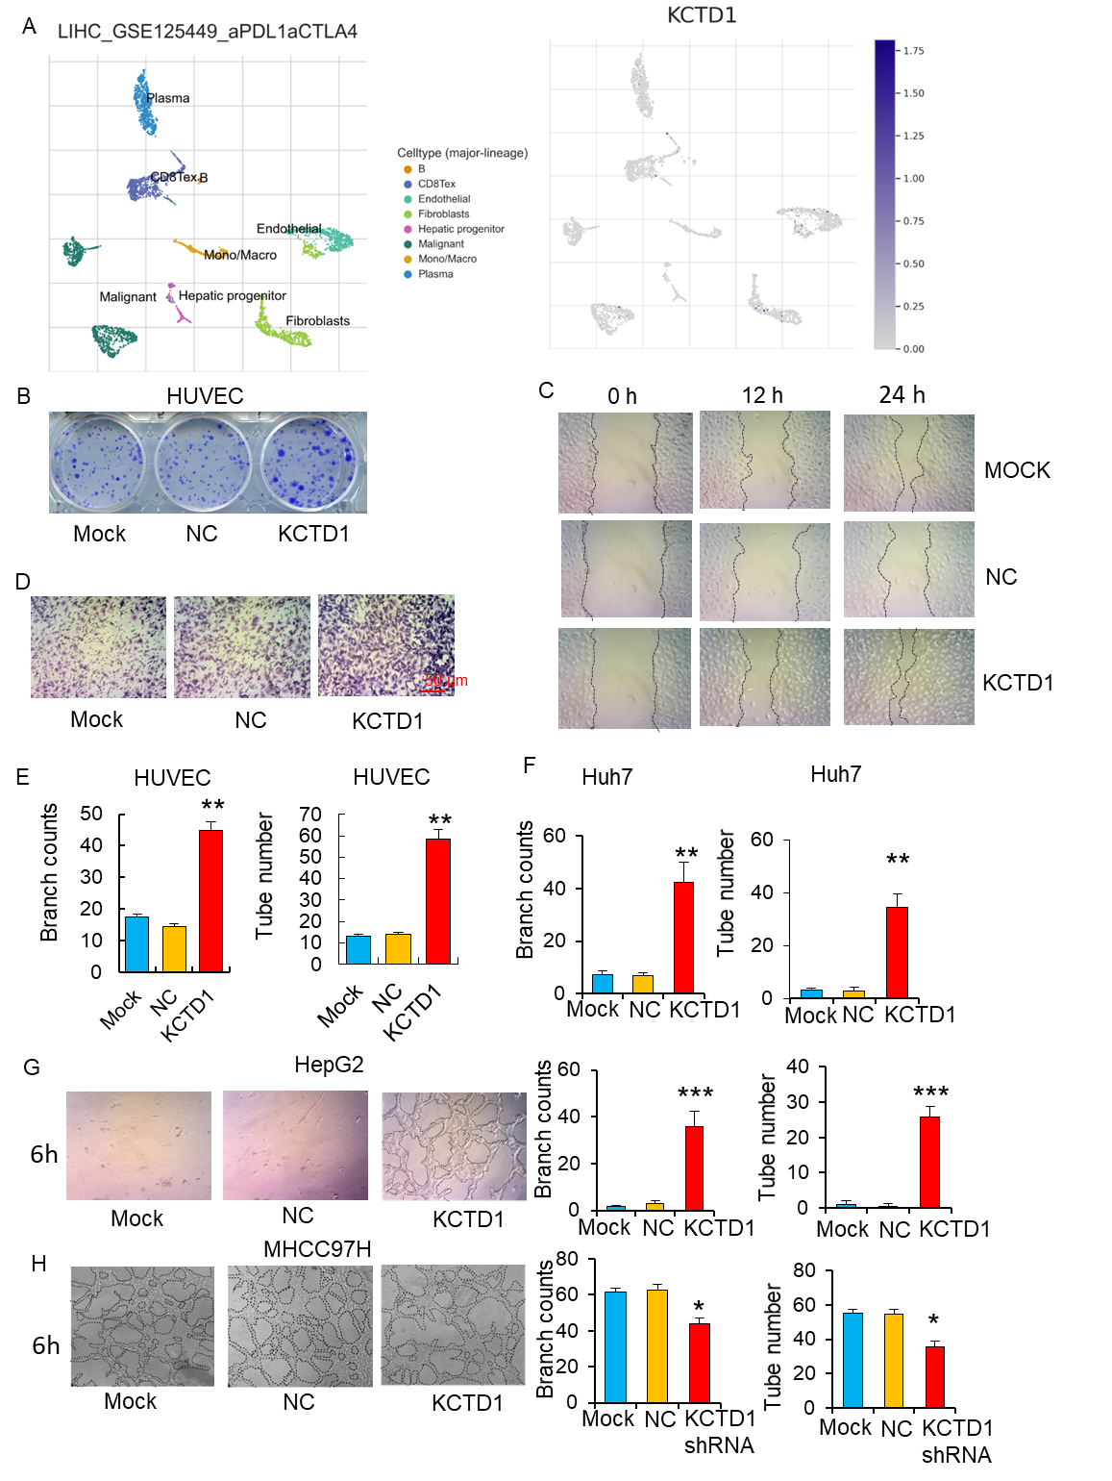
Figure S4. KCTD1 overexpression promoting angiogenesis in vitro. a KCTD1 expression was analyzed in HCC by the single-cell RNA sequencing database TISCH (Tumor Immune Single-cell Hub). b Representative images of liquid colony formation analysis of HUVEC cells infected with KCTD1-LV; c Representative pictures of scratch wound healing assays in HUVEC cells infected with KCTD1-LV; d Effects of KCTD1 overexpression on HUVEC cell migration using transwell migration assays with examples of HUVEC cells migrating across transwell shown; e Normalized number of junctions and tube number formed by KCTD1 overexpressing HUVECs; f Normalized number of junctions and tube number formed by KCTD1 overexpressing Huh7 cells; g Tube formation of HUVECs co-cultured in the supernatant of KCTD1-overexpressing HepG2 cells with the normalized number of junctions and tubes counted; h Tube formation of HUVECs co-cultured in the supernatant of KCTD1-knockdown MHCC97H cells with the normalized number of junctions and tubes counted and tube-forming structures circled by the black dotted line.

Additional file 7: Table S3. Correlation between the KCTD1 expression and CD31 expression in the HCCs by IHC staining.

KCTD1 expression | Cases | CD31 expression |  | P value
KCTD1 expression | Cases | Low，No（%） | High，No（%） | P value
Low（≤30%） | 37 | 20（54%） | 17（46%）
High（＞30%） | 33 | 10（30%） | 23（70%） | 0.0436
Total | 70 | 30（43%） | 40（57%）

The KCTD1 and CD31 expressions are divided into low or high groups according to the IHC score.

Additional file 8: Table S4. Correlation between the KCTD1 expression and Arg1 expression in the HCCs by IHC staining.

KCTD1 expression | Cases | Arg1 expression |  | P value
KCTD1 expression | Cases | Low，No（%） | High，No（%） | P value
Low（≤30%） | 37 | 19（51.4%） | 18（48.6%）
High（＞30%） | 33 | 15（45.5%） | 18（54.5%） | 0.048
Total | 70 | 34（48.6%） | 36（51.4%）

The KCTD1 and Arg1 expressions are divided into low or high groups according to the IHC score.

Additional file 9: Figure S5
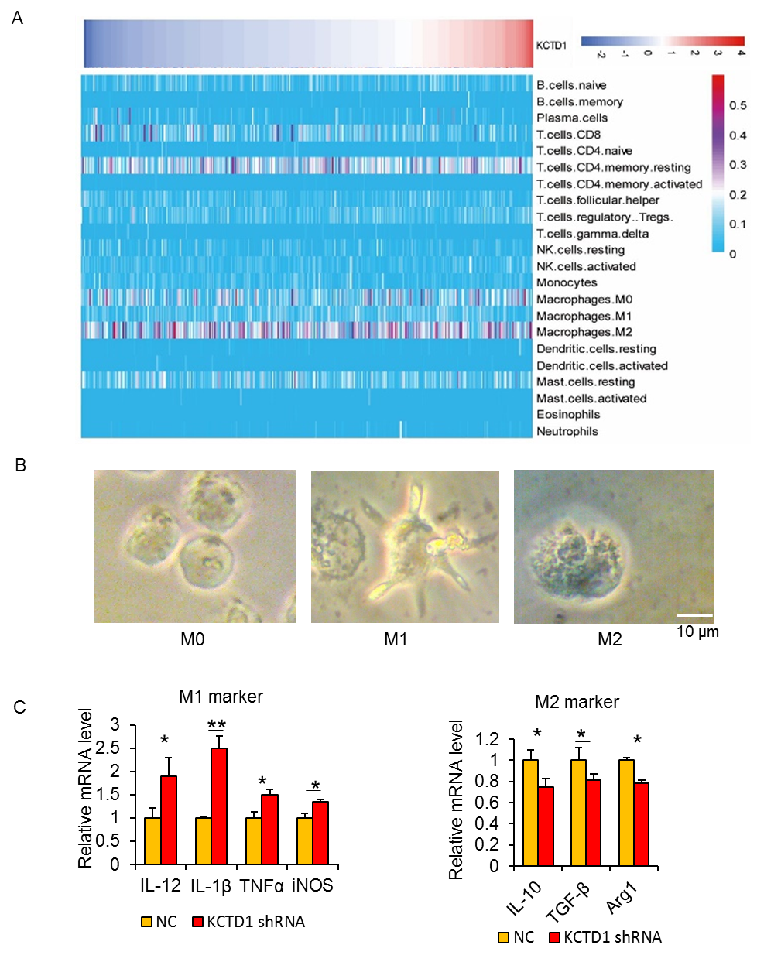
Figure S5. Regulation correlation of KCTD1 and macrophage. a Heat maps correlating KCTD1 mRNA expression with leukocytes infiltration in the TCGA dataset by CIBERSORT analyses; b U937 cells activated by PMA to form macrophage-like cells (M0) for 24 h, M0 cells polarized into M1 macrophages with LPS/IFN-γ for an additional 24 h, and M2 macrophage phenotype by IL-4; c qRT-PCR comparing the expression of macrophage markers in the M0 macrophage cells cocultured with the supernatant from MHCC97H cells.

Additional file 10: Figure S6
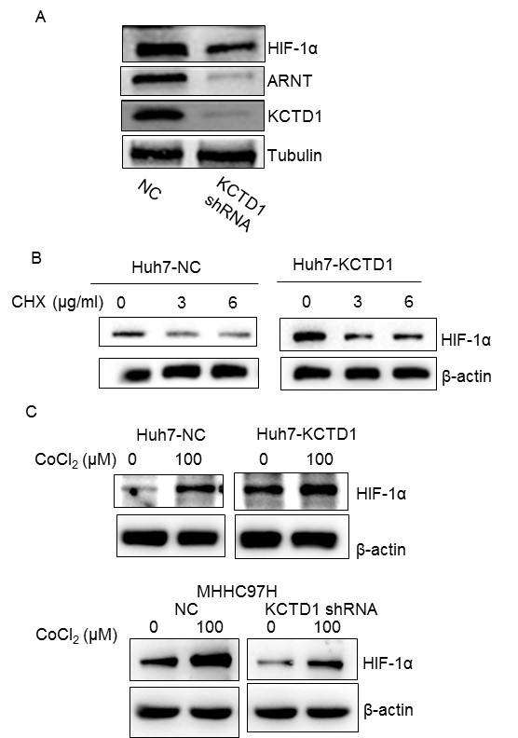

Figure S6. Effects of KCTD1 on degradation of HIF-1α protein. a Western blots detecting the expression of KCTD1 and HIF-1α/ARNT in subcutaneous mouse tissues from MHCC97H cells; b Western blots analyzing the expression of HIF-1α protein in KCTD1-overexpressing Huh7 cells under different concentrations of CHX; c Western blots detecting the influence of KCTD1 overexpression/knockdown on the stability of HIF-1α proteins under hypoxia conditions stimulated by cobalt chloride (CoCl₂).

Additional file 11: Figure S7
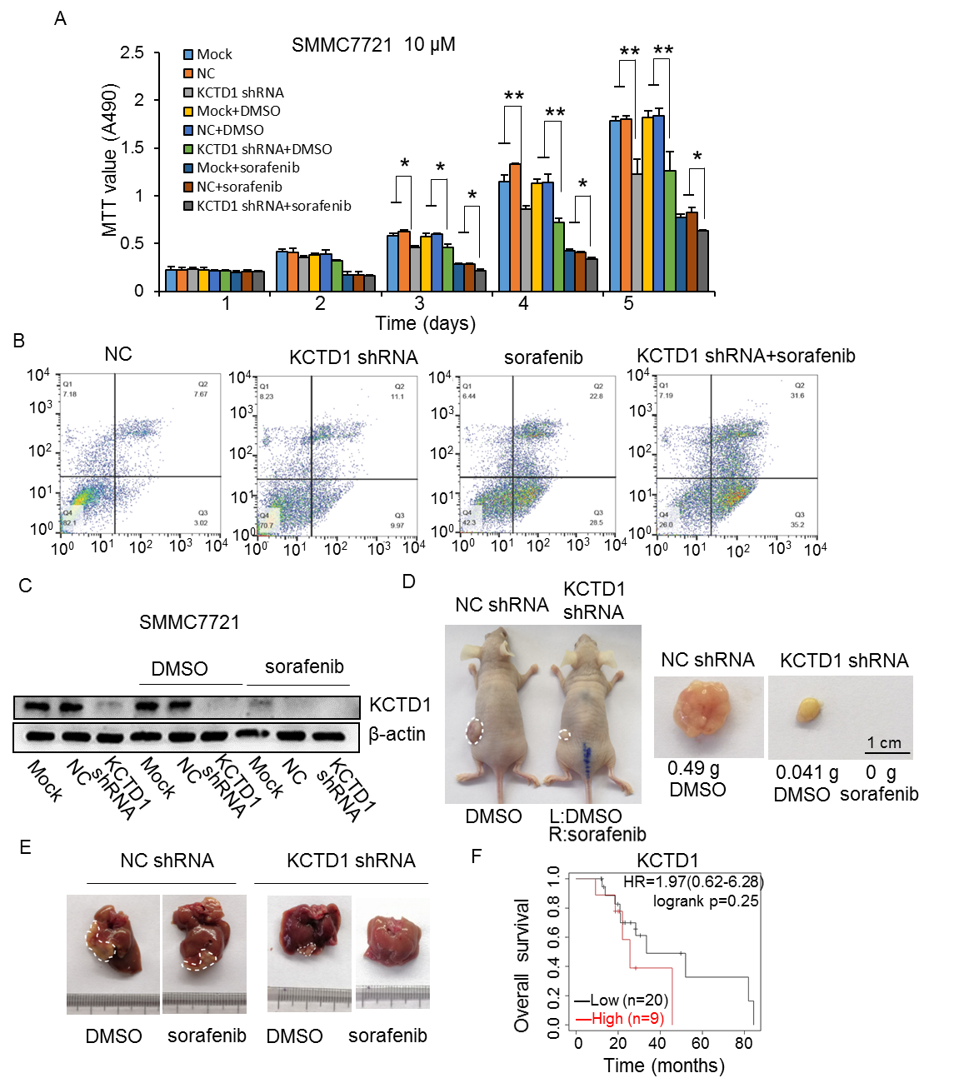
Figure S7. KCTD1 knockdown increasing the cisplatin sensitivity of HCC cell lines. a KCTD1 shRNA-LV infected SMMC7721 cells treated with 10 μM of sorafenib and control agent DMSO for 24 h and cell viability analyzed using the MTT assays (mean ± SD from triplicate experiments); b Cell apoptosis assays of lentivirus-infected and parental MHCC97H cells by flow cytometry. KCTD1 shRNA-LV infected MHCC97H cells are treated with 5 μM of sorafenib for 24 h, MHCC97H cells are treated with Annexin-V-FITC/ PI dual staining, and apoptotic cells is detected by FACS analysis. All mean data are obtained from 3 independent experiments performed; c Western blotting of the effects of sorafenib on the expression of KCTD1 in SMMC7721 cells; d About 8×10⁶ lentivirus-infected and sorafenib treated MHCC97H cells injected subcutaneously into the back of BALb/c nude mice (female, n = 4 per group) and tumors excised after 2 weeks and analyzed; e Intrahepatic tumor model generated by injecting 2×10⁵ MHCC97H cells with the tumor-loaded liver shown; f Correlation of KCTD1 expression and the overall survival of HCC patients treated with sorafenib in the TCGA cohort.

Additional file 12: Figure S8
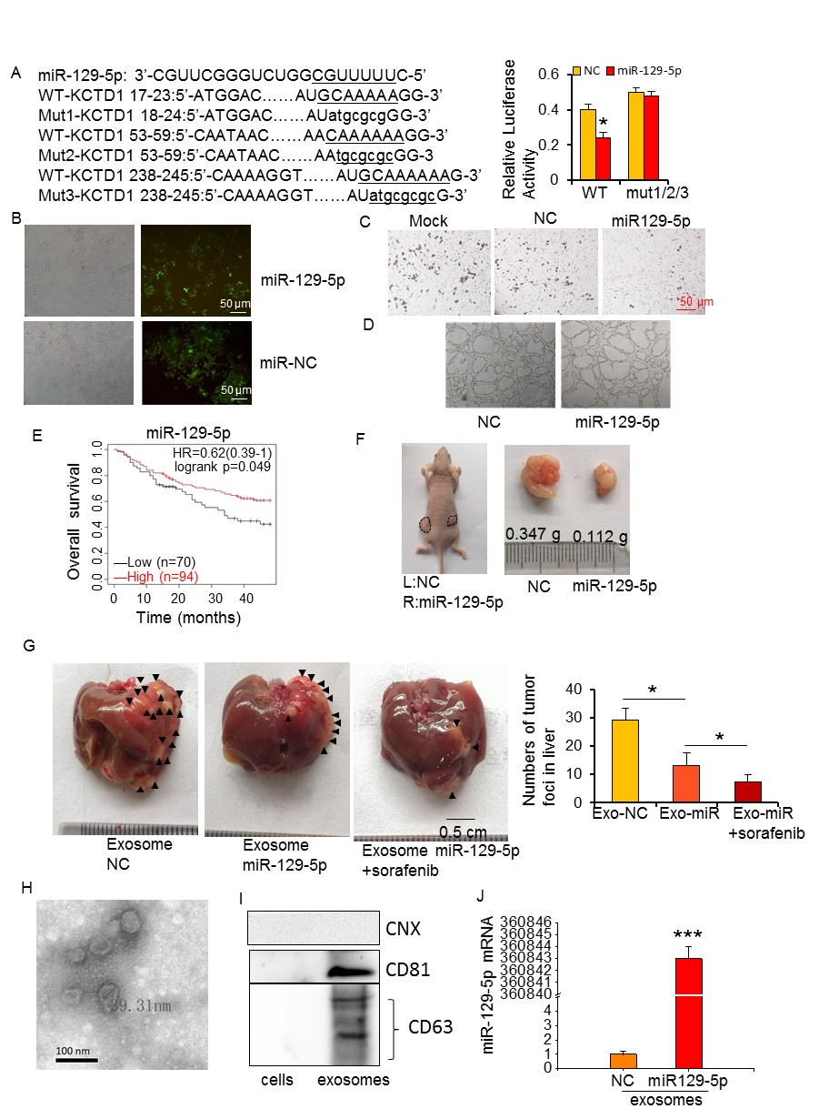
Figure S8. Exosomes from MHCC97H cells overexpressing miR-129-5p target KCTD1 and suppressing HCC progression. a Putative wildtype or mutated luciferase constructs based on the KCTD1 3′ UTR cotransfected with miR-129-5p with dual luciferase activity analyzed; b Immunofluorescence staining of miR-129-5p lentiviral-infected MHCC97H cells; c Influences of miR-129-5p overexpression on MHCC97H cell migration showing the indicated images of migrated cells; d Tube formation performed by 2×10⁴ HUVEC cells cultured with the supernatant of miR-129-5p-infected MHCC97H cells with the tube-forming structures circled by the black dotted line; e Correlation of miR-129-5p expression and the overall survival of HCC patients in the TCGA cohort; f About 8×10⁶ KCTD1 shRNA-LV-infected MHCC97H cells injected subcutaneously into the back of BALb/c nude mice (female) and tumors excised after 15 days and photographed; g Intrahepatic tumor model generated by injecting 2×10⁵ MHCC97H cells and treating with exosome or exosome/sorafenib showing the tumor-loaded liver. The tumor foci in the liver are quantified as mean ± SD; h Exosomes from the supernatant of MHCC97H cells extracted and detected by TEM; i Western blot of the expression of exosome markers; j qRT-PCR analysis of mRNA levels of miR-129-5p from these exosomes.

