Overexpression of dehydroascorbate reductase gene IbDHAR1 improves the tolerance to abiotic stress in sweet potato
Qirui Cheng^{a, ‡}, Xuan Zou^{a, ‡}, Yuan Wang^{b}, Zhe Yangª, Xiangpo Qiuª, Sijie Wangª, Yanxin Yang^{c}, Dongjing Yang^{d}, Ho Soo Kim^{e}, Xiaoyun Jiaª, Lingzhi Li^{b}, Sang-Soo Kwak^{e,*}, Wenbin Wang^{a,*}
ª College of Life Sciences, Shanxi Agricultural University, Taigu 030801, China
^{b} College of Horticulture, Shanxi Agricultural University, Taigu 030801, China
^{c} College of Basic Sciences, Shanxi Agricultural University, Taigu 030801, China
^{d} Key Laboratory of Biology and Genetic Improvement of Sweetpotato, Ministry of Agriculture and Rural Affairs, Xuzhou Institute of Agricultural Sciences in Jiangsu Xuhuai District, Xuzhou, Jiangsu, 221131, China
^{e} Plant Systems Engineering Research Center, Korea Research Institute of Bioscience and Biotechnology (KRIBB), 125 Gwahak-ro, Daejeon 34141, Korea

*sxndwwb@126.com; sskwak@kribb.re.kr

Supplementary Table

Table S1 Primers used for PCR analysis.
Primer name | Primer sequence(5’ to 3’) | Application
IbDHAR1-F | ATGGCGGTGGAGCTCTGTGT | Vector construction
IbDHAR1-R | TCATGCATTAACCTTTGAAG | Vector construction
GFP-F | AGGTTATTGGAAAATTAAGGGCC | Genomic DNA PCR
GFP-R | AACCAGATCCGATTTTGGAGGATG | Genomic DNA PCR
qIbDHAR1-F | TTGATCTGAGTTTGGCACCG | Real-time PCR
qIbDHAR1-R | TTTGGAGGCTTCGTCTTCTG | Real-time PCR
qIbActin-F | GTTATGGTTGGGATGGGACA | Real-time PCR
qIbActin-R | GTGCCTCGGTAAGAAGGACA | Real-time PCR

Supplementary Figures

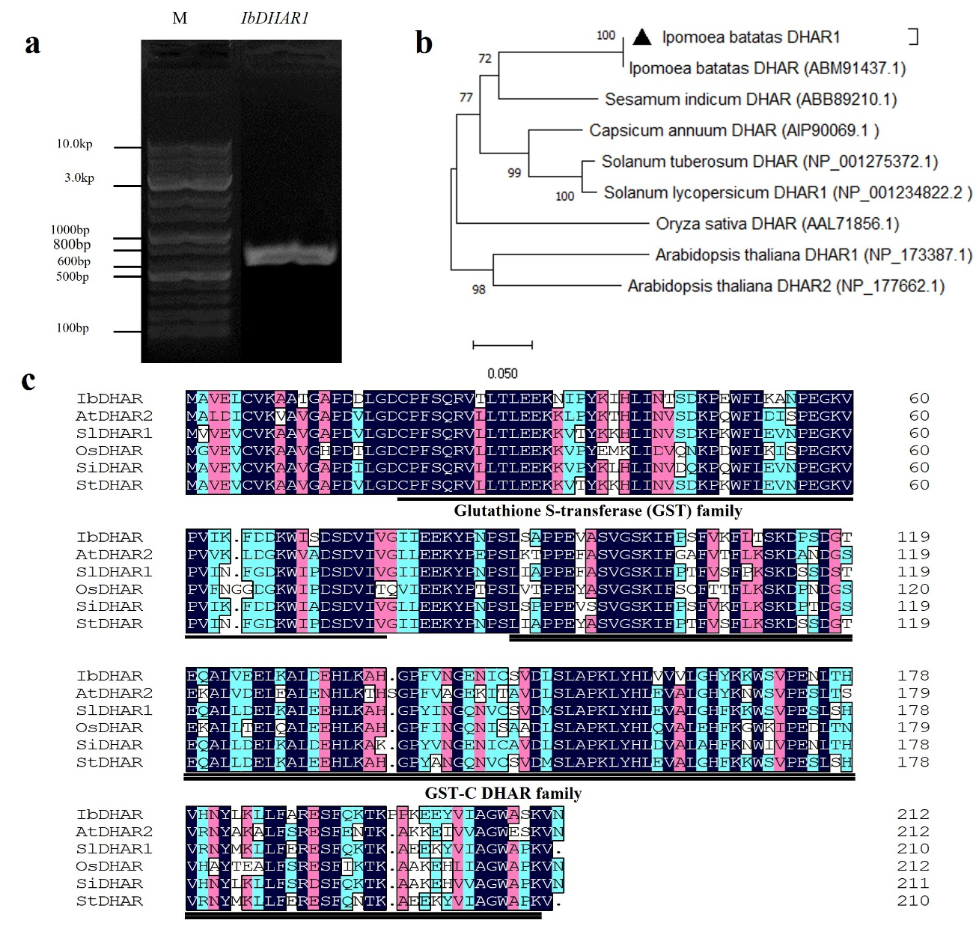
Fig. S1 Cloning and bioinformatics analysis of the IbDHAR1 gene. a Cloning of the sweet potato IbDHAR1 gene. b Sequence analysis of DHAR proteins in plants. The black triangle marks IbDHAR1. c Multiple DHAR-relevant protein sequence alignment. Color coding indicates sequence similarity, decreasing from black to pink to blue.

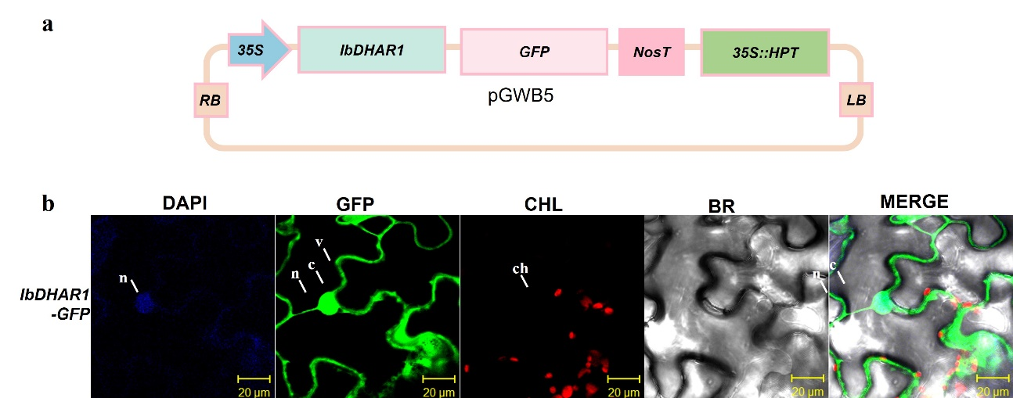

Fig. S2 Plasmid construction and subcellular localization. a Plant expression vector IbDHAR1-pGWB5. b Subcellular localization of the IbDHAR1 protein. Blue, nucleus stained with DAPI; green, GFP fluorescence; red, chlorophyll autofluorescence; merged, combined fluorescence from DAPI GFP and chlorophyll. Scale bars, 20 μm.

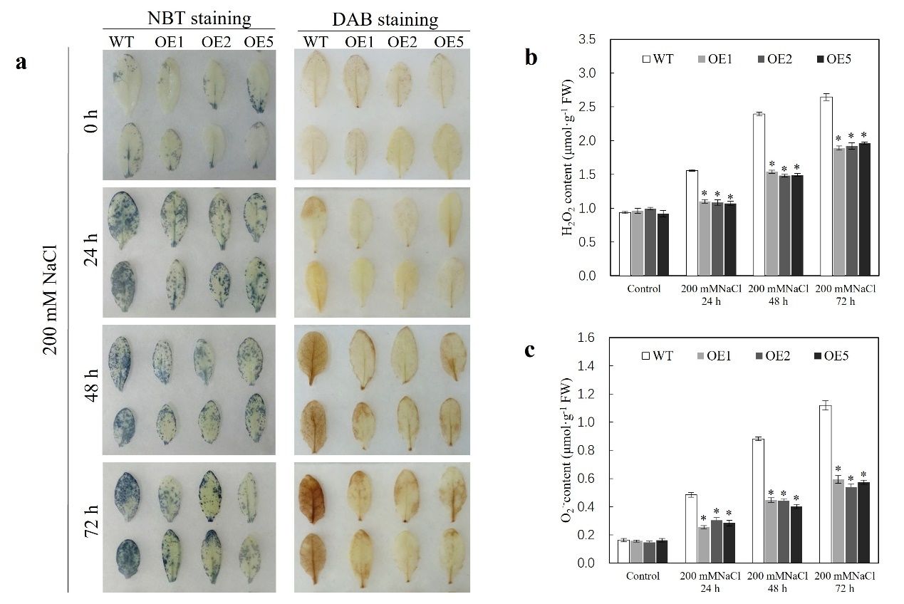
Fig. S3 Analysis of ROS content of IbDHAR1-overexpressing Arabidopsis line under salt stress. a Arabidopsis phenotype after staining. b H₂O₂ content analysis. c O₂⁻ content analysis.

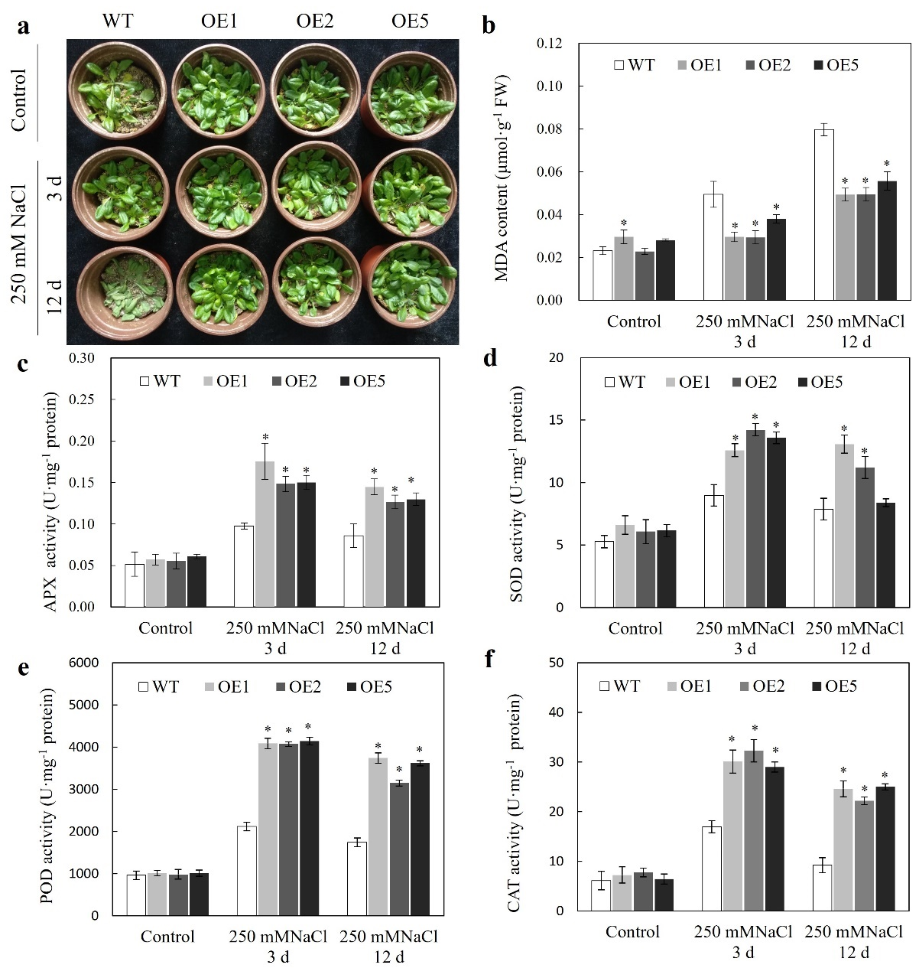
Fig. S4 Overexpression of IbDHAR1 conferred salt tolerance in Arabidopsis. a Tolerance phenotypes of 3-week-old wild-type (WT) and transgenic (OE) Arabidopsis lines (OE1, OE2, and OE5) treated with 250 mM NaCl for 3 and 12 d. Contents of MDA b and activities of APX, SOD, POD, and CAT activities c–f in the WT and OE lines treated with 250 mM NaCl for 3 and 12 d. Results presented as mean ± standard deviation; significant differences (*P < 0.05).

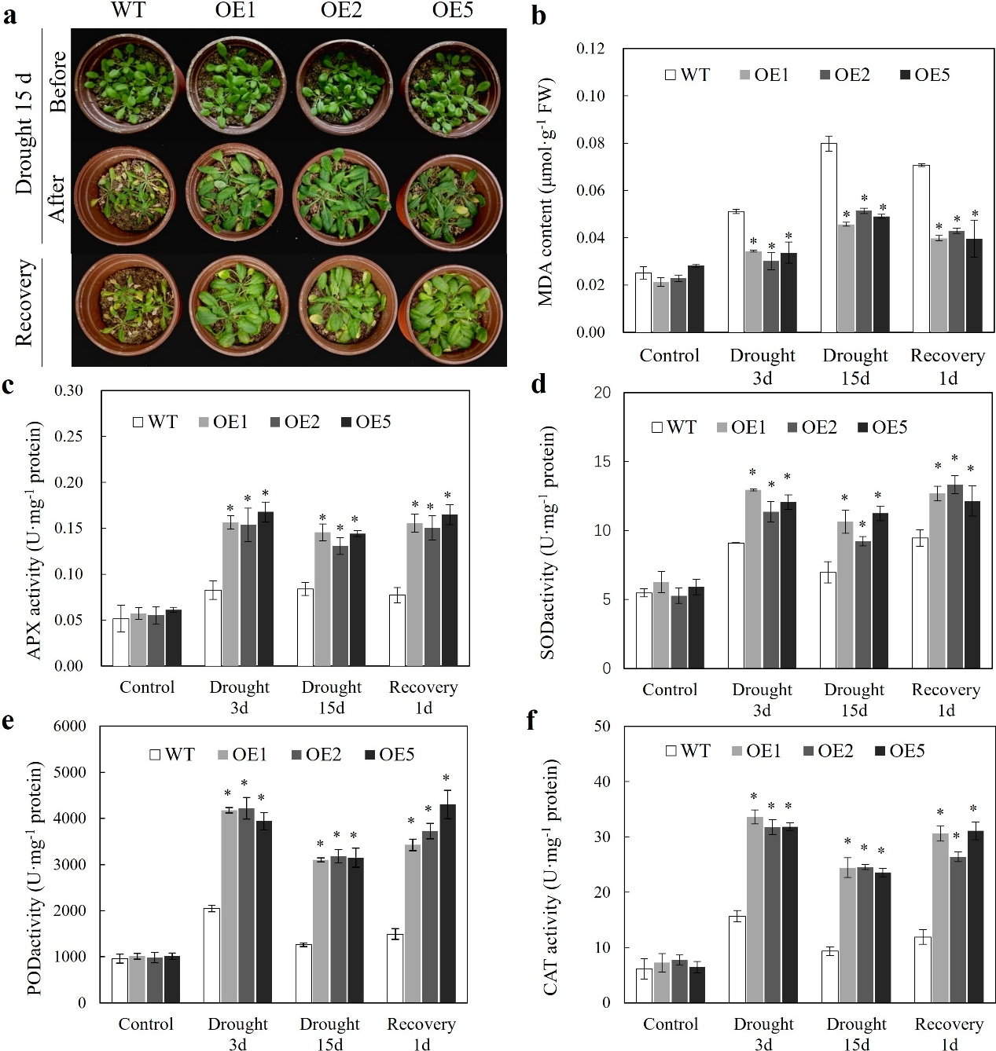
Fig. S5 Overexpression of IbDHAR1 conferred drought tolerance in Arabidopsis. a The phenotype of 3-week-old wild-type (WT) and transgenic (OE) Arabidopsis lines (OE1, OE2, and OE5) grown under drought conditions (for 3 and 15 d, followed by rewatering for 1 d). Contents of MDA b and activities of APX, SOD, POD, and CAT c–f in WT and OE lines grown under drought conditions for 3 and 15 d. Results presented as mean ± standard deviation; significant differences (*P < 0.05).

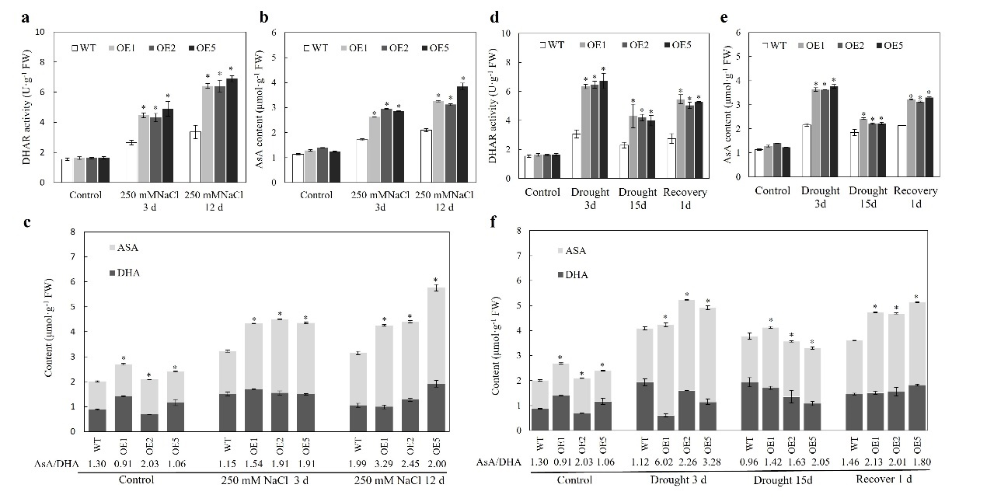
Fig. S6 Overexpression of IbDHAR1 in Arabidopsis affected the ascorbate redox status of plants under salt or drought stress. Analysis of DHAR activity a, d and contents of ASA b, e, DHA and T-AsA c, f in Arabidopsis under salt and drought stress. Data expressed as mean ± standard deviation; significant differences (*P < 0.05).

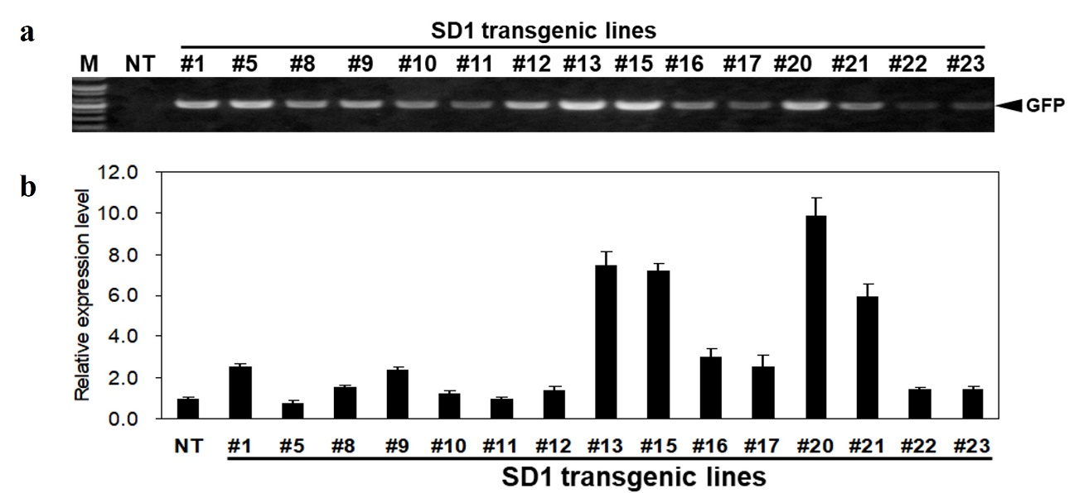 Fig. S7 PCR identification of transgenic sweet potato and expression pattern analysis. M: DNA Marker2000; NT: Negative control; SD1 (1-23): Transgenic sweet potato lines.

