DPA
XYB
F₁
XYB
×
BC₁F₁
XYB
BC₂F₁
XYB
…
BC₇F₁
(XYA)
×
×
×

Figure S1. Construction of the near isogenic line (NIL) for XYA. XYA contains the cytoplasm of DPA in the genetic background of XYB (a maintainer line derived from hybridization of Yuehui520 and Wusansimiao).

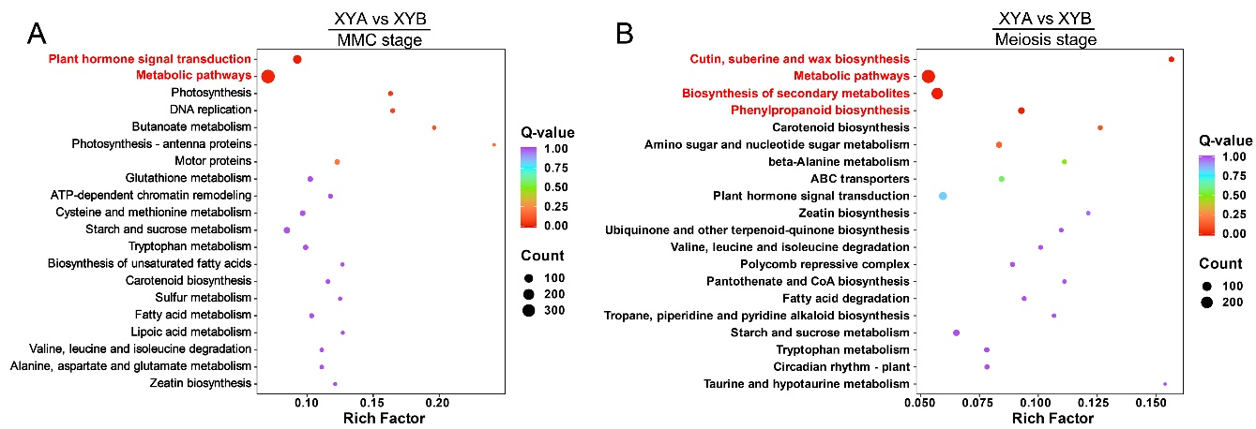
Figure S2. KEGG analysis of DEGs in XYA vs. XYB. KEGG enrichment analysis of DEGs in XYA vs. XYB at MMC stage (A) and meiosis stage (B). Pathways highlighted in red indicate P value < 0.05.

Figure S3. GO analysis of the overlapping DEGs in XYA vs. XYB at both MMC and meiosis stages.

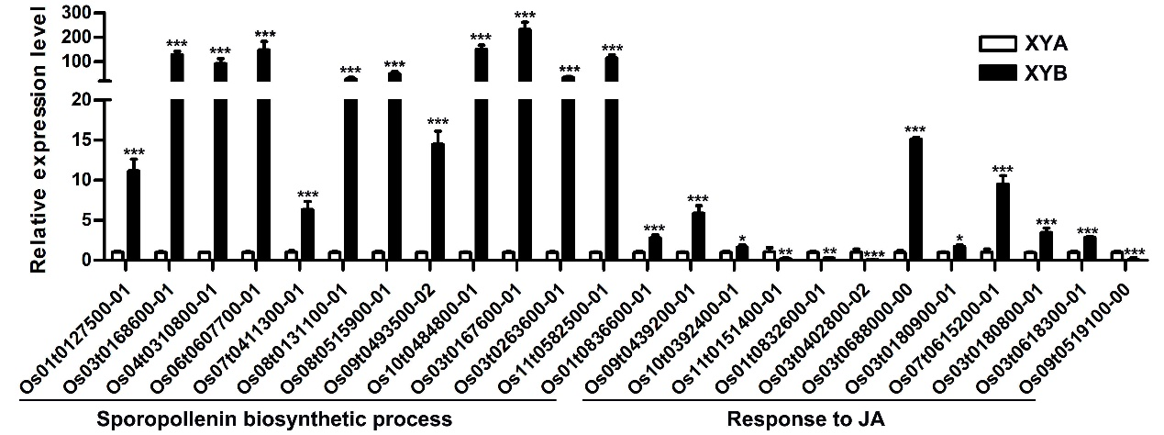
Figure S4. Expression levels of DEGs response to JA and involved in sporopollenin biosynthesis at meiosis stage were verified by qRT-PCR.

Figure S5. Specific DAMs analysis in XYA vs. XYB. (A) KEGG enrichment analysis of 90 specific DAMs in XYA vs. XYB at MMC stage. (B) KEGG enrichment analysis of 52 overlapping DAMs in XYA vs. XYB. Pathways highlighted in red indicate P value < 0.05.

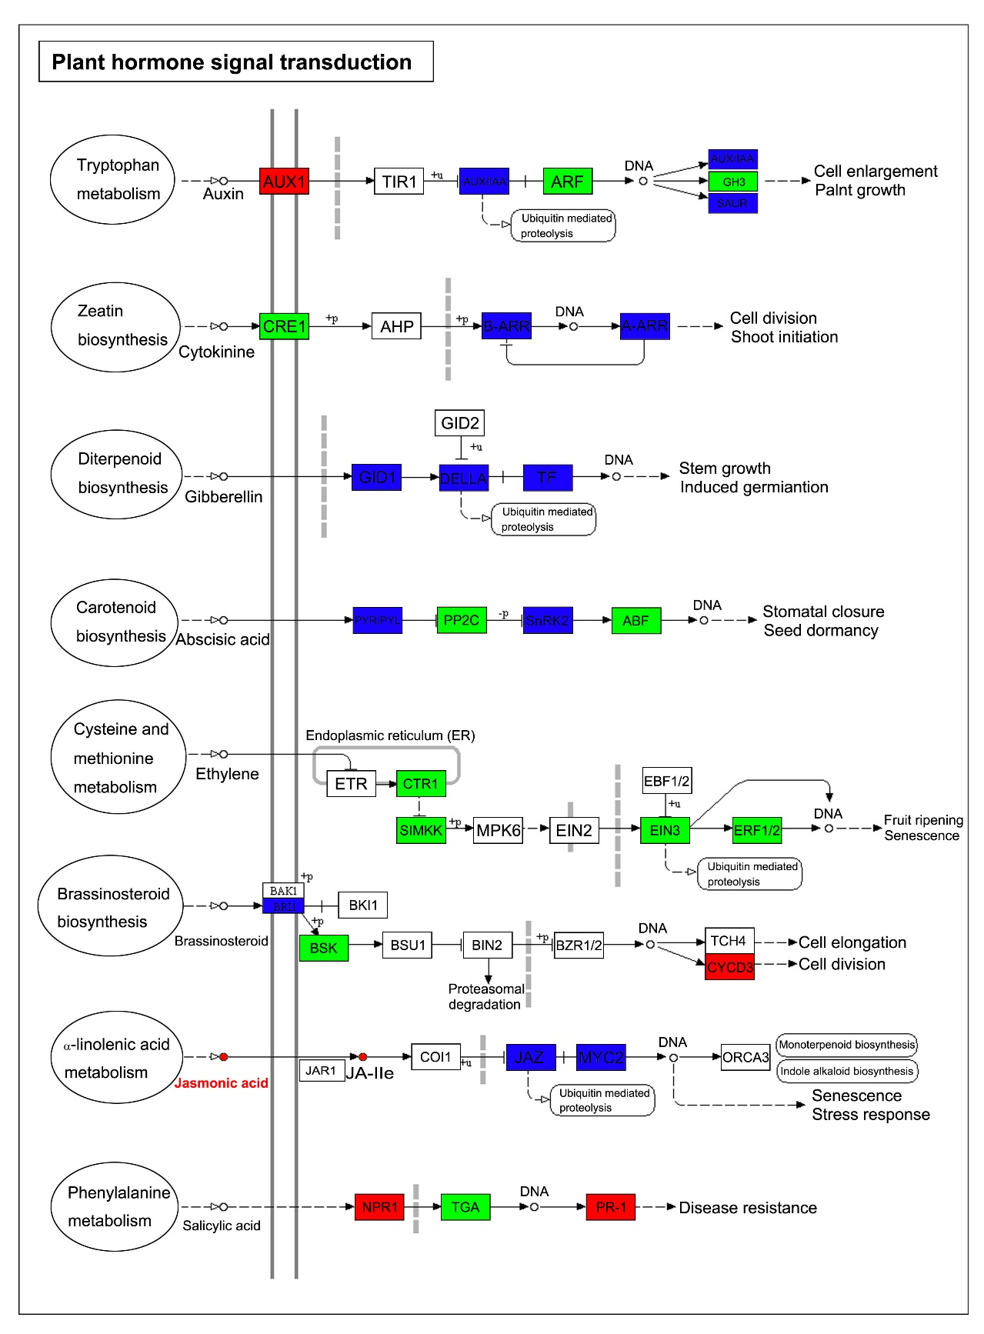
Figure S6. Enrichment of both DEGs and DAMs in the plant hormone signal transduction pathway by KEGG analysis.

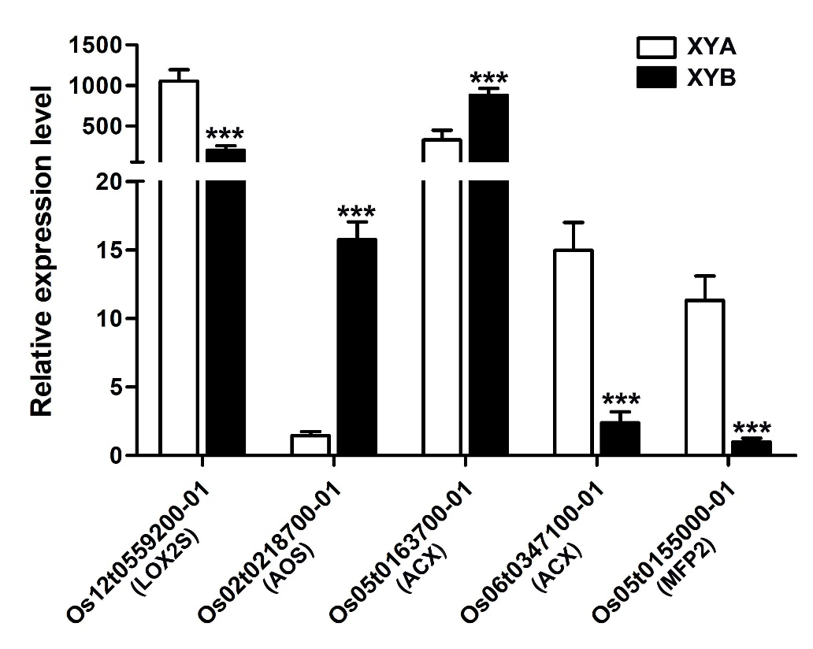
Figure S7. Expression levels of LOX, AOS, ACX and MFP2 genes at meiosis stage were verified by qRT-PCR.

