Appendix
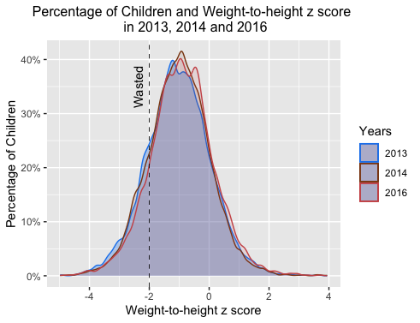

Figure: Trend of children’s weight-to-height z score from 2013-2016.
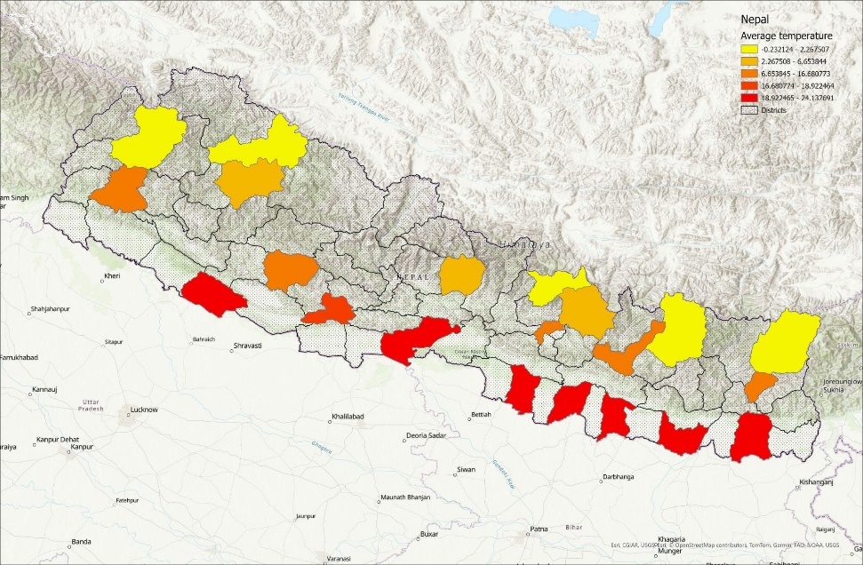
Figure: Visual representation of temperature variation in the districts selected for the dataset. The lighter the color, the lower the temperature.
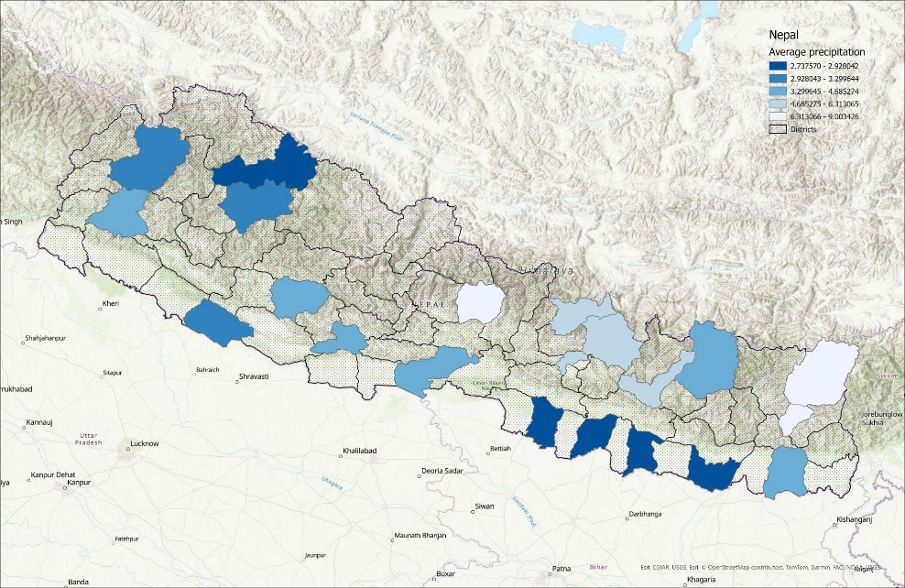
Figure: Visual representation of precipitation variation in the districts selected for the dataset. The lighter the color, the higher the precipitation.
Table: Summary statistics of the dataset across the three regions
Region | N | Mean | SD | Min | Max
Mountain
Weight-to-height | 2505 | -.619 | 1.005 | -4.97 | 3.94
Avg temperature | 2826 | 2.855 | 2.684 | -.232 | 7.007
Avg precipitation | 2826 | 4.371 | 1.427 | 2.738 | 8.015
GDD | 2826 | 617.020 | 347.866 | 0 | 1332.49
Child age | 2826 | 35.518 | 19.631 | 0 | 74
Mother’s education | 2826 | 3.317 | 4.986 | 0 | 17
Hilly
Weight-to-height | 3911 | -.602 | 1.036 | -4.98 | 3.68
Avg temperature | 4323 | 15.972 | 2.831 | 6.107 | 19.498
Avg precipitation | 4323 | 6.716 | 1.595 | 4.131 | 11.291
GDD | 4323 | 1621.734 | 183.833 | 1383.089 | 1971
Child age | 4323 | 33.453 | 19.603 | 0 | 74
Mother’s education | 4323 | 2.335 | 4.100 | 0 | 17
Terai
Weight-to-height | 9750 | -1.229 | 0.997 | -4.94 | 3.72
Avg temperature | 11036 | 23.574 | 0.815 | 21.481 | 24.961
Avg precipitation | 11036 | 4.153 | 0.937 | 2.798 | 6.155
GDD | 11036 | 2464.175 | 86.261 | 2228.227 | 2572.221
HDD | 11036 | 1.681 | 1.998 | 0 | 4.516
Child age | 11036 | 34.483 | 19.986 | 0 | 75
Mother’s education | 11036 | 1.206 | 3.032 | 0 | 17

--------------------------------------------------------------------------------------------------------------------
Weight-to-height z score
----------------------------------------------------------------------------------------------------
(1) (2) (3)
Mountains Hills Terai --------------------------------------------------------------------------------------------------------------------
Panel A
Avg precipitation 0.0189 0.0176 -0.0349
(0.124) (0.0393) (0.0353)
--------------------------------------------------------------------------------------------------------------------
Panel B
Avg precipitation -0.0127 -0.00240 -0.0517
z score (0.0451) (0.0358) (0.0319)
--------------------------------------------------------------------------------------------------------------------
Cluster FE Yes Yes Yes
Year FE Yes Yes Yes
Observations 2505 3911 9750
--------------------------------------------------------------------------------------------------------------------
Standard errors in parentheses
* p<0.10, ** p<0.05, *** p<0.01

Table: Panel A shows the effect of average precipitation during the year on weight-to-height z score using ward and year fixed effects. Panel B shows the effect of deviation from long-term weather average (1979-2016) precipitation on weight-to-height z score. Controls include child age, child sex, number of children, mother’s age and mother’s education.

