Supplementary information

Enzymatically Catalyzed Molecular Aggregation
Wen-Jin Wang^{1,2}, Rongyuan Zhang¹, Liping Zhang¹, Liang Hao¹, Xu-Min Cai³, Qian Wu⁴, Zijie Qiu¹, Ruijuan Han¹, Jing Feng¹, Shaojuan Wang¹*, Parvej Alam¹, Guoqing Zhang², Zheng Zhao¹* and Ben Zhong Tang^{1,4}*

¹ Clinical Translational Research Center of Aggregation-Induced Emission, The Second Affiliated Hospital School of Medicine, School of Science and Engineering Shenzhen Institute of Aggregate Science and Technology, The Chinese University of Hong Kong, Shenzhen (CUHK-Shenzhen), Guangdong 518172, China
² University of Science and Technology of China, Hefei, Anhui 230026, China
³ Jiangsu Co-Innovation Center of Efficient Processing and Utilization of Forest Resources International Innovation Center for Forest Chemicals and Materials College of Chemical Engineering Nanjing Forestry University
⁴ Department of Chemistry, Hong Kong Branch of Chinese National Engineering Research Center for Tissue Restoration and Reconstruction, Institute of Molecular Functional Materials, Division of Life Science and State Key Laboratory of Molecular Neuroscience, The Hong Kong University of Science and Technology, Clear Water Bay, Kowloon, Hong Kong, China
* Corresponding authors. Email: 609199354@qq.com (S. W.), zhaozheng@cuhk.edu.cn (Z. Z), tangbenz@cuhk.edu.cn (B. Z. T)

Table of contents
Experimental Section 2
General 2
Materials 2
General instruments 3
Synthesis and characterization 3
Scheme S1 4
Synthesis of 3 4
Synthesis of TBmA (4a) and TBpA (4b) 5
Synthesis of 5a and 5b 6
Synthesis of TBmA-Glu (6a) andTBpA-Glu (6b) 6
Supporting Scheme, Figures, and Tables 8
Fig. S1 8
Fig. S2 8
Fig. S3 9
Fig. S4 9
Fig. S5 10
Fig. S6 10
Fig. S7 11
Fig. S8 11
Fig. S9 12
Fig. S10 12
Fig. S11 13
Fig. S12 13
Fig. S13 14
Fig. S14 14
Fig. S15 15
Fig. S16 15
Fig. S17 16
Fig. S18 16
Fig. S19 17
Fig. S20 17
Fig. S21 17
Fig. S22. 18
Fig. S23 18
Fig. S24 19
Fig. S25 20
Fig. S26 21
Fig. S27 21
Fig. S28 22
Fig. S29 23
Fig. S30 24
Fig. S31 25
Fig. S32 26
Fig. S33 27
Fig. S34 27
Fig. S35 28
Fig. S36 28
Fig. S37 29
Fig. S38 30
Fig. S39 31
Fig. S40 31
Fig. S41 32
Fig. S42 32
Table S1 33
Table S2. 34
References 35

Experimental Section

General
Materials: 4, 7-dibromo-2,1, 3-benzothiadiazole, N-(4-(4,4,5,5-Tetramethyl-1,3,2-dioxaborolan-2-yl)phenyl-N-phenylbenzenamine were purchased from Energy Chemical, China. Tetratriphenylphosphine palladium, 2-(7-Azabenzotriazol-1-yl)-N,N,N',N'-tetramethyluronium hexafluorophosphate (HATU) were purchased from Adamas-beta (China). N,N-Diisopropylethylamine, 3-aminobenylboric acid, and 4-aminobenylboric acid were obtained from Didepharm (China). Dimethyl sulfoxide (DMSO), 2′,7′-Dichlorodihydrofluorescein diacetate (H₂DCF-DA), Hydroxyphenyl fluorescein (HPF), 9,10-Anthracenediyl-bis(methylene)dimalonic Acid (ABDA), Glutamyltransferase (G9270) and 3-(4,5-dimethyl-2-thiazolyl)-2,5-diphenyl-2-H-tetrazolium bromide (MTT) were purchased from Sigma−Aldrich. Dulbecco's modified eagle medium (DMEM, Giobic®), Roswell Park Memorial Institute medium (RPMI1640 Medium, Giobic®), fetal bovine serum (FBS, Giobic®), trypsin (Giobic®), Phosphate-Buffered Saline (PBS, Giobic®), penicillin-streptomycin solution (Giobic®) were brought from ThermoFisher Scientific. The antibodies for GGT (ab109427), GPX4 (ab125066), and β-actin (ab8226) were obtained from Abcam. All the other reagents were obtained through commercial resources. All the tested compounds were dissolved in DMSO as stock solution and diluted into the expected experiment concentration containing 1% (v/v) DMSO as needed.
General instruments: ESI-MS was carried out on a Thermo Scientific LTQ linear ion trap mass spectrometer. ¹H NMR and ¹³C NMR were recorded by a Bruker AVANCE III 500 MHz spectrometer (Germany). Chemical shifts were referenced relative to the internal solvent signals. Fluorescence measurements were conducted on an FLS1000 system (Edinburgh Instruments) and Horiba PL spectrometer (Fluorolog-3). High-resolution mass spectra (HRMS) were collected on a Bruker maXis ultra-high resolution (UHR)-TOF mass spectrometer in electrospray ionization (ESI)-positive mode. Cell viability was measured using a Molecular Devices FlexStation 3 microplate reader (USA). Cell imaging assays were performed on a Leica TCS SP8 STED 3X confocal laser scanning fluorescence microscopy and Leica DMi8 inversion microscope (Germany). Flow cytometry was conducted on a BD FACS Calibur (USA).

Synthesis and characterization

Scheme S1. The synthetic route for TBmA-Glu and TBpA-Glu.

4-(7-bromobenzo[c][1,2,5]thiadiazol-4-yl)-N,N-diphenylaniline (3): Compound 3 was synthesized according to the reported method¹ with minor modification: 4, 7-dibromo-2,1, 3-benzothiadiazole (1, 587.9 mg, 2.0 mmol), N-(4-(4,4,5,5-Tetramethyl-1,3,2-dioxaborolan-2-yl)phenyl-N-phenylbenzenamine (2, 891.1 mg, 2.4 mmol) were added to 100 mL round-bottomed flask along with potassium carbonate (829.3 mg, 6 mmol) and tetratriphenylphosphine palladium (69.3 mg, 0.06 mmol) in 40 mL of 1, 4-dioxane. The mixture was refluxed under N₂ for 12 h. After the reaction was finished, the catalyst was removed by filtration, and the solvent was removed under reduced pressure. The concentrated liquid was dissolved in methylene chloride (CH₂Cl₂) and washed using a brine solution (NaCl). The organic layer was dried using anhydrous sodium sulfate, concentrated, and finally purified by column chromatography (PE: EA=5:1) to obtain orange-red powder 3 with a yield of 73.2%. The structure of 3 was characterized and confirmed through ¹H NMR and HR-ESI-MS, which are coordinated with the reported data.

4-(7-(3-aminophenyl)benzo[c][1,2,5]thiadiazol-4-yl)-N,N-diphenylaniline (TBmA, 4a): The product 2 (475.0 mg, 1 mmol) and 3-aminobenylboric acid (178.0 mg, 1.3 mmol) were added into a 50 mL round-bottomed flask, respectively. Potassium carbonate (414.7 mg, 3 mmol) and tetratriphenylphosphine palladium (34.7 mg, 0.03 mmol) were dissolved in 20 mL of 1, 4-dioxane. Reflux reaction under argon protection overnight. After the reaction, the catalyst was removed by filtration, and the solvent was removed under reduced pressure. The concentrated liquid was dissolved in methylene chloride (CH₂Cl₂) and washed using a brine solution (NaCl). The organic layer was dried using anhydrous sodium sulfate, concentrated, and finally purified by column chromatography (PE: EA=3:1) to obtain a red powder of TBmA with a yield of 56%.
¹H NMR (500 MHz, CDCl₃) δ (ppm): 7.87 (d, J = 8.2 Hz, 2H), 7.74 (s, 2H), 7.38 – 7.26 (m, 8H), 7.20 (t, J = 9.3 Hz, 7H), 7.07 (t, J = 7.4 Hz, 2H), 6.83 (d, J = 6.8 Hz, 1H).¹³C NMR (125 MHz, CDCl₃) δ (ppm) 154.36, 148.38, 147.80, 138.96, 133.12, 131.24, 130.27, 129.90, 129.70, 128.54, 127.61, 125.25, 123.65, 123.22, 120.45, 116.59. HR-ESI-MS (CH₃OH) m/z: calculated for [M+H]⁺ (C₃₀H₂₃N₄S⁺) 471.1643, found 471.1638.

4-(7-(4-aminophenyl)benzo[c][1,2,5]thiadiazol-4-yl)-N,N-diphenylaniline (TBpA, 4b): TBpA was prepared via the similar synthetic method as TBmA with 4-aminobenylboric acid instead of 3-aminobenylboric acid. TBpA was obtained as a red powder with a yield of 65.4%.
¹H NMR (500 MHz, DMSO-d₆) δ (ppm): 7.94 (d, J = 8.3 Hz, 2H), 7.82 (dd, J = 22.7, 8.2 Hz, 4H), 7.35 (t, J = 7.8 Hz, 4H), 7.10 (d, J = 7.8 Hz, 8H), 6.72 (d, J = 8.2 Hz, 2H), 5.45 (s, 2H). ¹³C NMR (125 MHz, DMSO-d₆) δ (ppm): 153.63, 153.58, 149.32, 147.18, 147.03, 132.45, 130.97, 130.05, 129.97, 129.74, 127.81, 125.92, 124.43, 123.50, 122.62, 113.77. HR-ESI-MS (CH₃OH) m/z: calculated for [M+H]⁺ (C₃₀H₂₃N₄S⁺) 471.1643, found 471.1664.

Tert-butyl N2-(tert-butoxycarbonyl)-N5-(3-(7-(4-(diphenylamino)phenyl)benzo[c][1,2,5]thiadiazol-4-yl)phenyl)-L-glutaminate (5a) and tert-butyl N2-(tert-butoxycarbonyl)-N5-(4-(7-(4-(diphenylamino)phenyl)benzo[c][1,2,5]thiadiazol-4-yl)phenyl)-L-glutaminate (5b): TBmA or TBpA (235.3 mg, 0.5 mmol), Boc-L-glutamate-1-tert-butyl ester (227.5 mg, 0.75 mmol) were added to 50 mL round-bottled flask, respectively. HATU (384.2 mg, 1 mmol) and DIPEA (193.9 mg, 1.5 mmol) were dissolved in 10 mL tetrahydrofuran and reacted overnight at room temperature. After the reaction, it was washed with saturated salt water, extracted using methylene chloride, dried using anhydrous sodium sulfate, and purified by column chromatography (PE: EA=1:1) to obtain target products.
5a: orange powder (yield 92.3%). ¹H NMR (500 MHz, DMSO-d₆) δ (ppm): 10.07 (s, 1H), 8.24 (s, 1H), 7.98 (d, J = 8.3 Hz, 2H), 7.94 (d, J = 7.4 Hz, 1H), 7.88 (d, J = 7.4 Hz, 1H), 7.67 (dd, J = 16.8, 7.9 Hz, 2H), 7.47 (t, J = 7.9 Hz, 1H), 7.37 (t, J = 7.7 Hz, 4H), 7.15 – 7.05 (m, 8H), 3.87 (q, J = 8.0 Hz, 1H), 2.49 – 2.41 (m, 3H), 2.05 – 1.97 (m, 1H), 1.83 (dd, J = 14.5, 8.1 Hz, 1H), 1.41 (s, 18H).¹³C NMR (125 MHz, DMSO-d₆) δ (ppm): 171.62, 170.51, 155.53, 153.39, 153.34, 147.48, 146.87, 139.44, 137.33, 131.85, 131.63, 130.38, 130.17, 129.67, 128.86, 128.38, 127.39, 124.49, 123.84, 123.55, 122.29, 119.68, 118.91, 80.33, 78.06, 53.88, 32.69, 28.18, 27.66, 26.19. HR-ESI-MS (CH₃OH) m/z: calculated for [M+H]⁺ (C₄₄H₄₆N₅O₅S⁺) 756.3241, found 756.3234.
5b: red powder (yield 90.6%). ¹H NMR (500 MHz, DMSO-d₆) δ (ppm): 10.11 (s, 1H), 7.98 (dd, J = 15.1, 8.3 Hz, 4H), 7.91 (s, 2H), 7.77 (d, J = 8.3 Hz, 2H), 7.36 (t, J = 7.8 Hz, 4H), 7.20 (d, J = 7.9 Hz, 1H), 7.12 (d, J = 7.8 Hz, 7H), 3.87 (q, J = 7.8 Hz, 1H), 2.46 (t, J = 7.7 Hz, 3H), 2.06 – 2.02 (m, 1H), 1.83 (dd, J = 14.6, 8.1 Hz, 1H), 1.42 (s, 18H). ¹³C NMR (125 MHz, DMSO-d₆) δ (ppm): 171.62, 170.52, 155.54, 153.40, 147.38, 146.88, 139.36, 131.35, 131.24, 130.50, 130.10, 129.67, 129.40, 127.66, 127.46, 124.46, 123.52, 122.33, 118.89, 80.34, 78.07, 53.88, 32.73, 28.20, 27.94, 27.67, 26.17. HR-ESI-MS (CH₃OH) m/z: calculated for [M+Na]⁺ (C₄₄H₄₆N₅O₅S⁺) 778.3034, found 778.3057.

N5-(3-(7-(4-(diphenylamino)phenyl)benzo[c][1,2,5]thiadiazol-4-yl)phenyl)-L-glutamine (TBmA-Glu, 6a) and N5-(4-(7-(4-(diphenylamino)phenyl)benzo[c][1,2,5]thiadiazol-4-yl)phenyl)-L-glutamine (TBpA-Glu, 6b): The (270 mg, 0.2 mmol) obtained in the previous step was added to a 25 mL round-bottomed flask, and a mixture of 5 mL trifluoroacetic acid/water/triisopropyl silane was added drop by drop under ice bath cooling (V_{TFA}/V_{H2O}/V_{TIS}=95:2.5:2.5). The reaction was heated to room temperature for 10 min and continued for 5 h. After the reaction, the solvent was removed under reduced pressure, and the solid obtained was recrystallized with ethyl acetate to obtain glutamic acid-modified AIE-PS,
TBmA-Glu: red powder (yield 98.4%). ¹H NMR (500 MHz, DMSO-d₆) δ (ppm): 10.55 (s, 1H), 8.26 (s, 1H), 7.93 (dd, J = 20.0, 7.9 Hz, 5H), 7.85 (d, J = 7.5 Hz, 1H), 7.73 (d, J = 8.1 Hz, 1H), 7.64 (d, J = 7.8 Hz, 1H), 7.45 (t, J = 8.0 Hz, 1H), 7.36 (t, J = 7.8 Hz, 4H), 7.14 – 7.07 (m, 8H), 2.59 (d, J = 8.1 Hz, 2H), 2.15 – 2.04 (m, 2H), 2.02 (s, 1H).¹³C NMR (125 MHz, DMSO-d₆) δ (ppm): 153.41, 147.49, 146.88, 139.53, 137.33, 131.85, 131.67, 130.39, 130.19, 129.71, 128.83, 128.40, 127.40, 124.51, 123.59, 122.29, 119.75, 119.02, 59.78, 53.39, 32.81, 14.11. HR-ESI-MS (CH₃OH) m/z: calculated for [M+H]⁺ (C₃₅H₃₀N₅O₃S⁺) 600.2064, found 600.2089.
TBpA-Glu: red powder (yield 98.2%). ¹H NMR (500 MHz, DMSO-d₆) δ (ppm): 10.41 (s, 1H), 7.97 (dd, J = 12.9, 6.7 Hz, 4H), 7.88 (s, 2H), 7.78 (d, J = 6.5 Hz, 2H ), 7.36 (t, J = 6.3 Hz, 4H), 7.11 (dd, J = 6.7, 3.7 Hz, 8H), 3.67 – 3.58 (m, 1H), 2.63 – 2.55 (m, 2H), 2.06 (m, 2H). ¹³C NMR (125 MHz, DMSO) δ 170.33, 153.29, 146.77, 130.01, 129.58, 129.31, 127.58, 127.34, 124.36, 123.45, 122.21, 118.89, 59.64, 20.66, 13.98. HR-ESI-MS (CH₃OH) m/z: calculated for [M+H]⁺ (C₃₅H₃₀N₅O₃S⁺) 600.2064, found 600.2072.

Supporting Scheme, Figures, and Tables
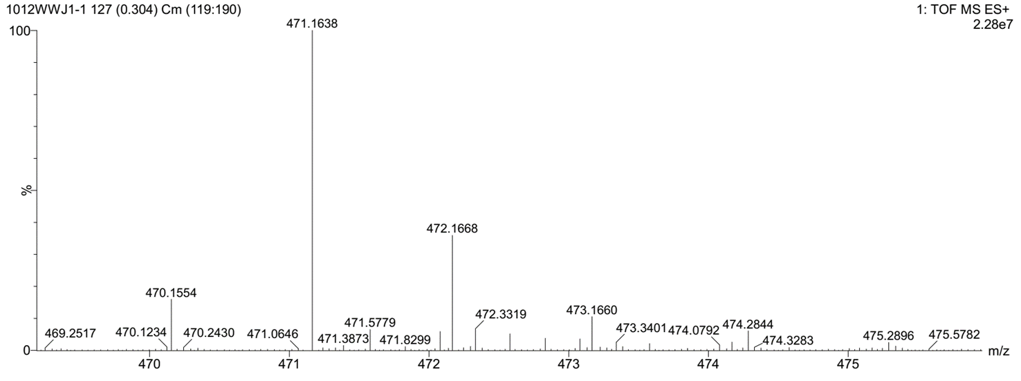
Fig. S1. HRMS of TBmA.

Fig. S2. ¹H NMR spectrum of TBmA.

Fig. S3. ¹³C NMR spectrum of TBmA.

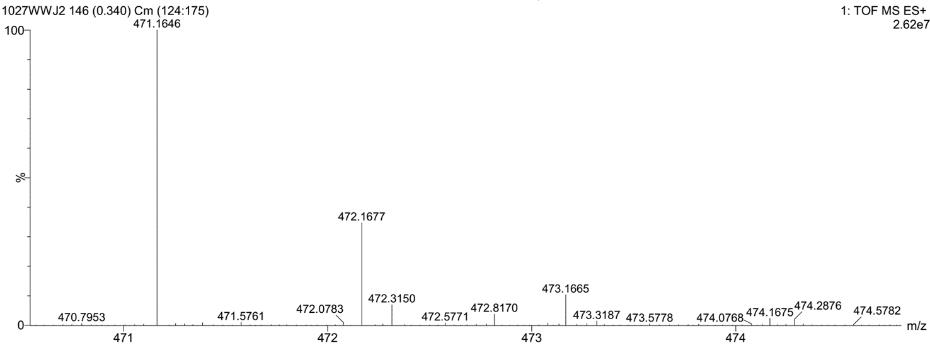
Fig. S4. HRMS spectrum of TBpA.

Fig. S5. ¹H NMRspectrum of TBpA.

Fig. S6. ¹³C NMR spectrum of TBpA.

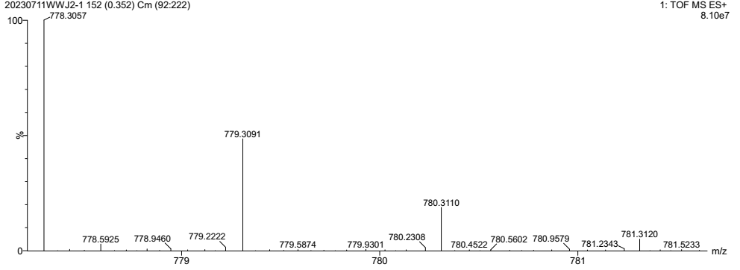
Fig. S7. HRMS spectrum of 5a.

Fig. S8. ¹H NMR spectrum of 5a.

Fig. S9. ¹³C NMR spectrum of 5a.

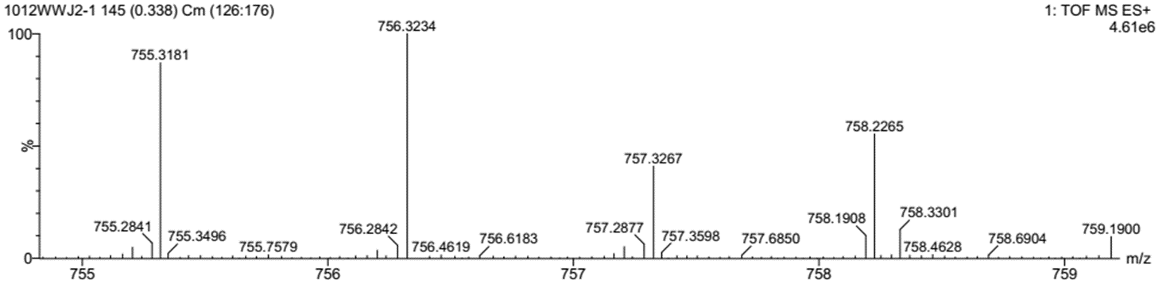
Fig. S10. HRMS spectrum of 5b.

Fig. S11. ¹H NMR spectrum of 5b.

Fig. S12. ¹³C NMR spectrum of 5b.

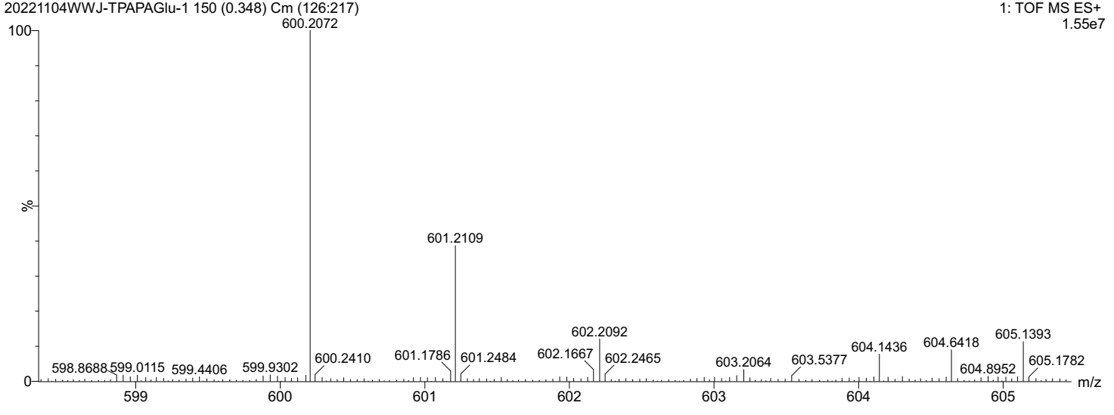
Fig. S13. HRMS spectrum of TBmA-Glu.

Fig. S14. ¹H NMR spectrum of TBmA-Glu.

Fig. S15. ¹³C NMR spectrum of TBmA-Glu.

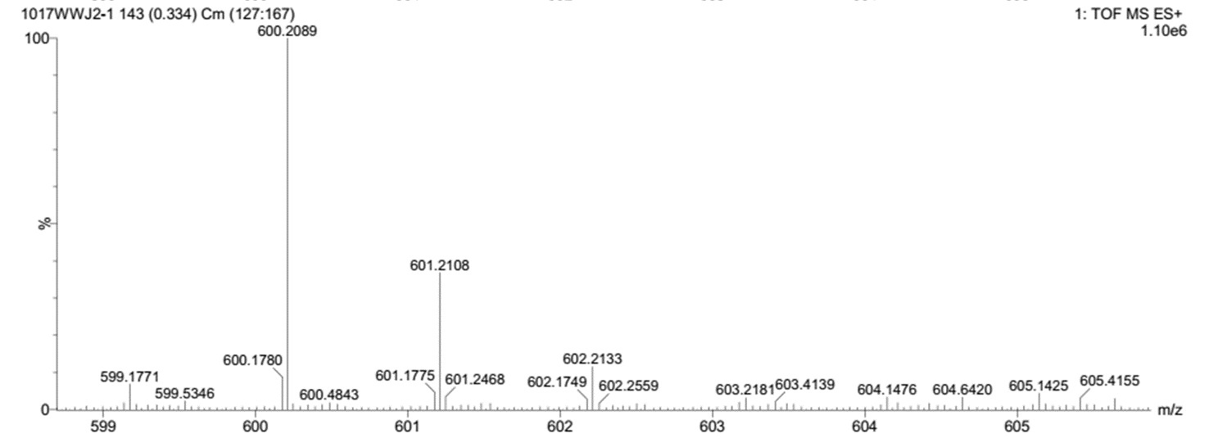
Fig. S16. HRMS spectrum of TBpA-Glu.

Fig. S17. ¹H NMR spectrum of TBpA-Glu.

Fig. S18. ¹³C NMR spectrum of TBpA-Glu.

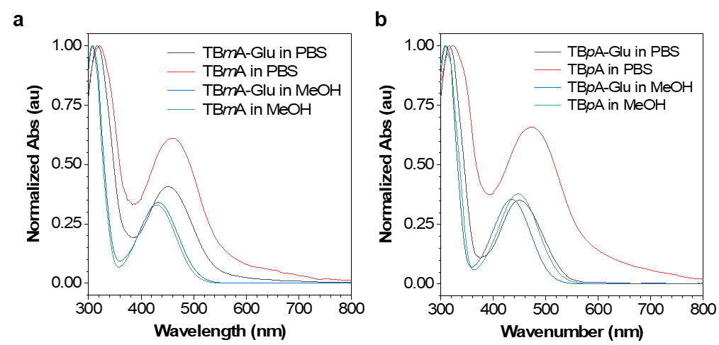
Fig. S19. Normalized absorption spectra of (a) TBmA-Glu/TBmA and (b) TBpA-Glu/TBpA in MeOH and PBS buffer solutions (c = 10 μM).

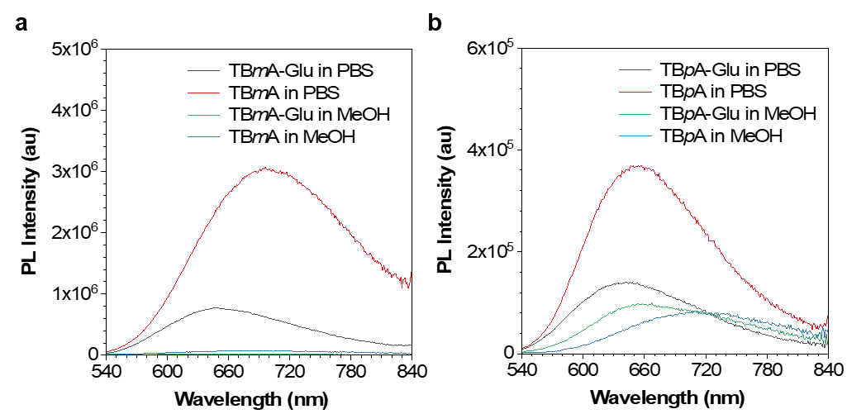
Fig. S20. Emission spectra of (a) TBmA-Glu/TBmA and (b) TBpA-Glu/TBpA in MeOH and PBS buffer solutions (c = 10 μM), λ_{ex} = 455 nm.

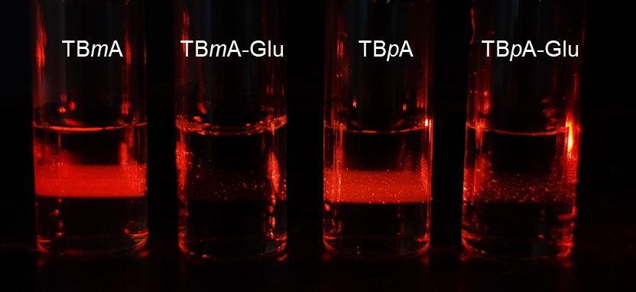
Fig. S21. The Tyndall effect of the TBmA and TBpA-Glu solution was irradiated by a red laser.
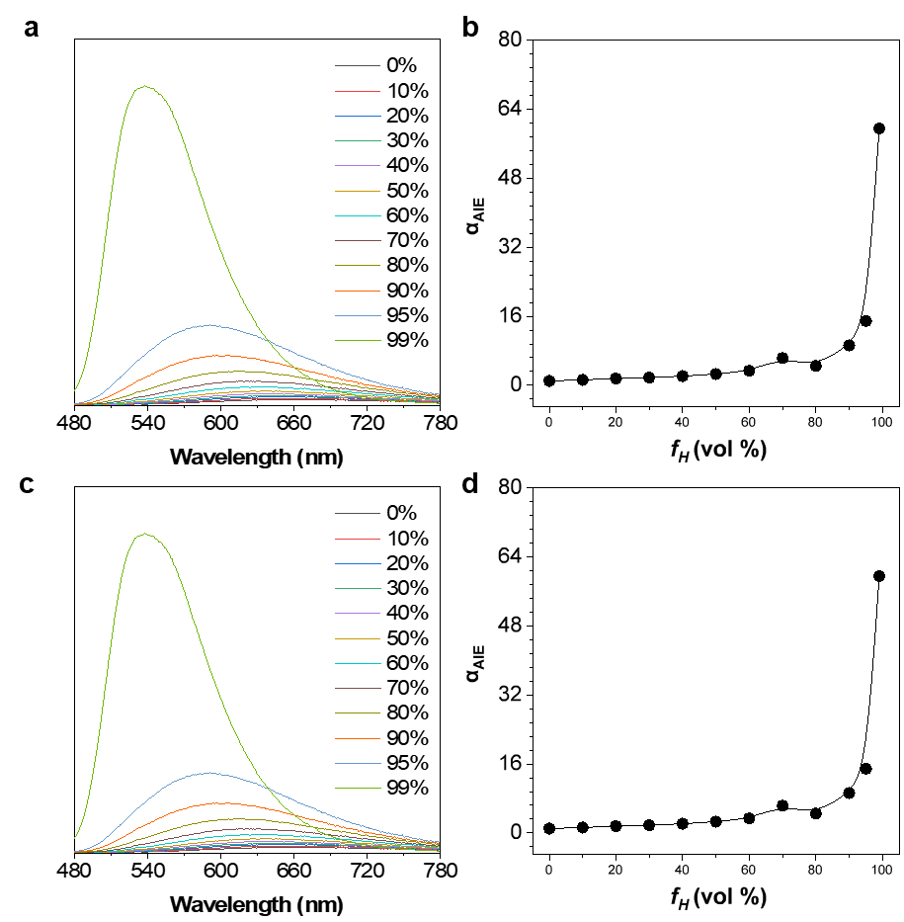
Fig. S22. PL spectra of TBmA-Glu (a, 10 μM) and TBpA-Glu (c, 10 μM) in MeOH/n-Hexane mixtures with different n-hexane fractions. The plot of I/I₀ of TBmA-Glu (b) and TBpA-Glu (d) versus f_{H}, where I₀ = PL intensity in pure MeOH. λ_{ex} = 455 nm

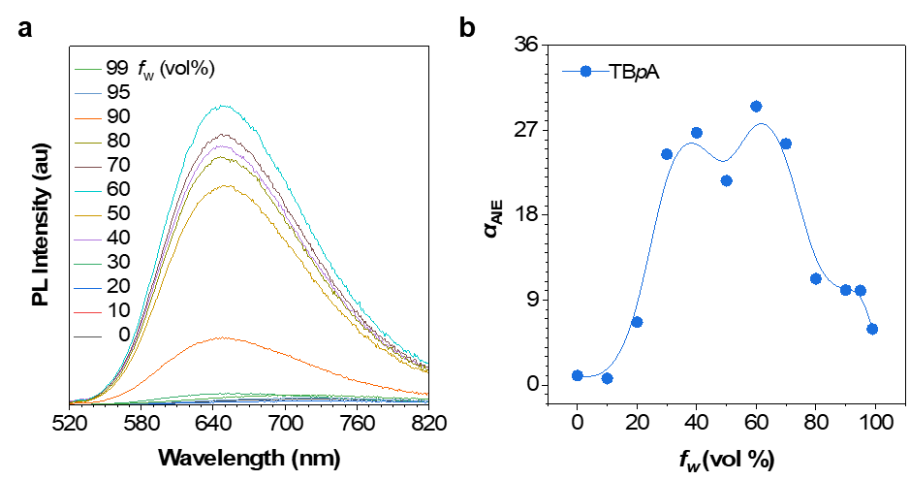
Fig. S23. (a) PL spectra of 10 μM TBpA in DMF/water mixtures with different water fractions (f_{w}). λ_{ex} = 455 nm; (b) Plot of α_{AIE} (I/I₀, where I₀ = PL intensity in pure DMF) of TBpA versus f_{w}.

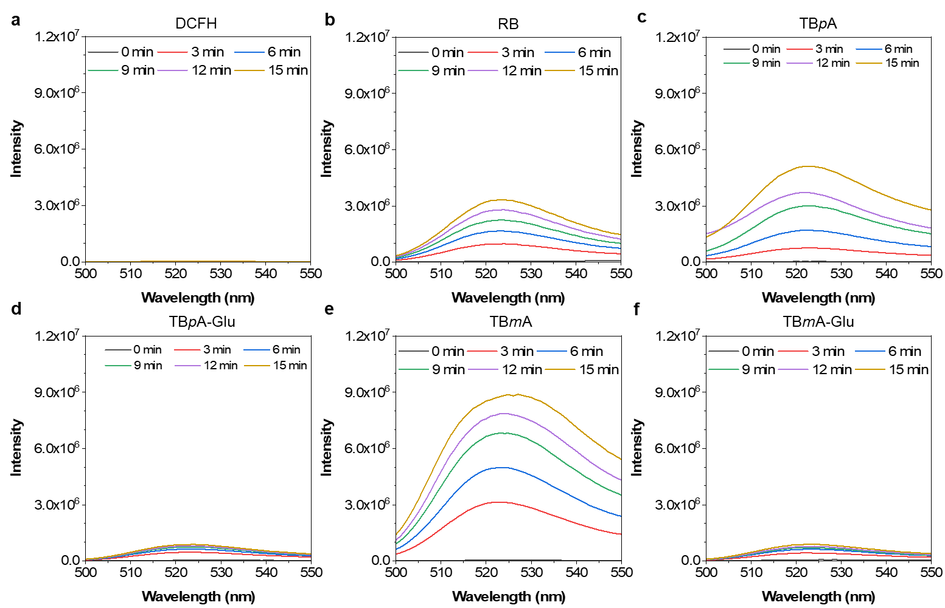
Fig. S24. Fluorescence emission changes of DCFH (10 μM) in the presence of 5 μM photosensitizers in DMSO-PBS (v:v = 1:99) after irradiation (20 MW cm-2) for a different time. (a) DCFH, (b) RB, (c) TBpA, (d) TBpA-Glu, (e) TBmA, (f) TBmA-Glu. DCHF, λ_{ex} = 488 nm.

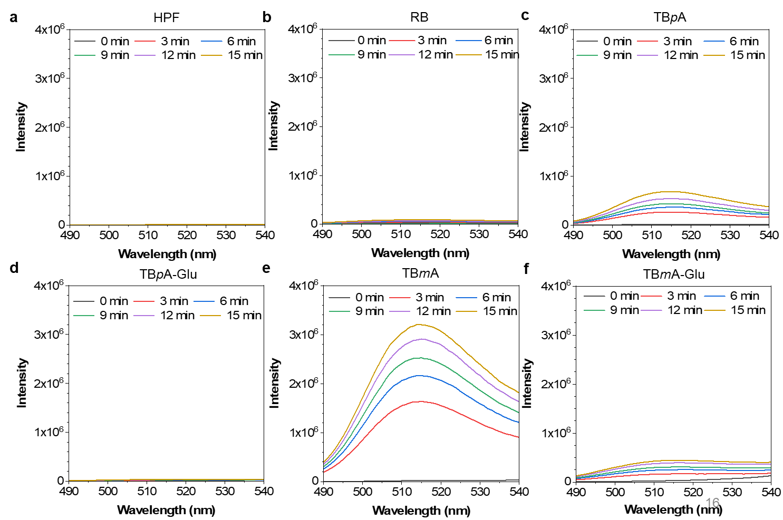
Fig. S25. Fluorescence emission changes of HPF (10 μM) in the presence of 5 μM photosensitizers in DMSO-PBS (v:v = 1/99) after irradiation (20 Mw cm⁻²) for different times. (a) Control, (b) RB, (c) TBpA, (d) TBpA-Glu, (e) TBmA, (f) TBmA-Glu. HPF, λ_{ex} = 488 nm.

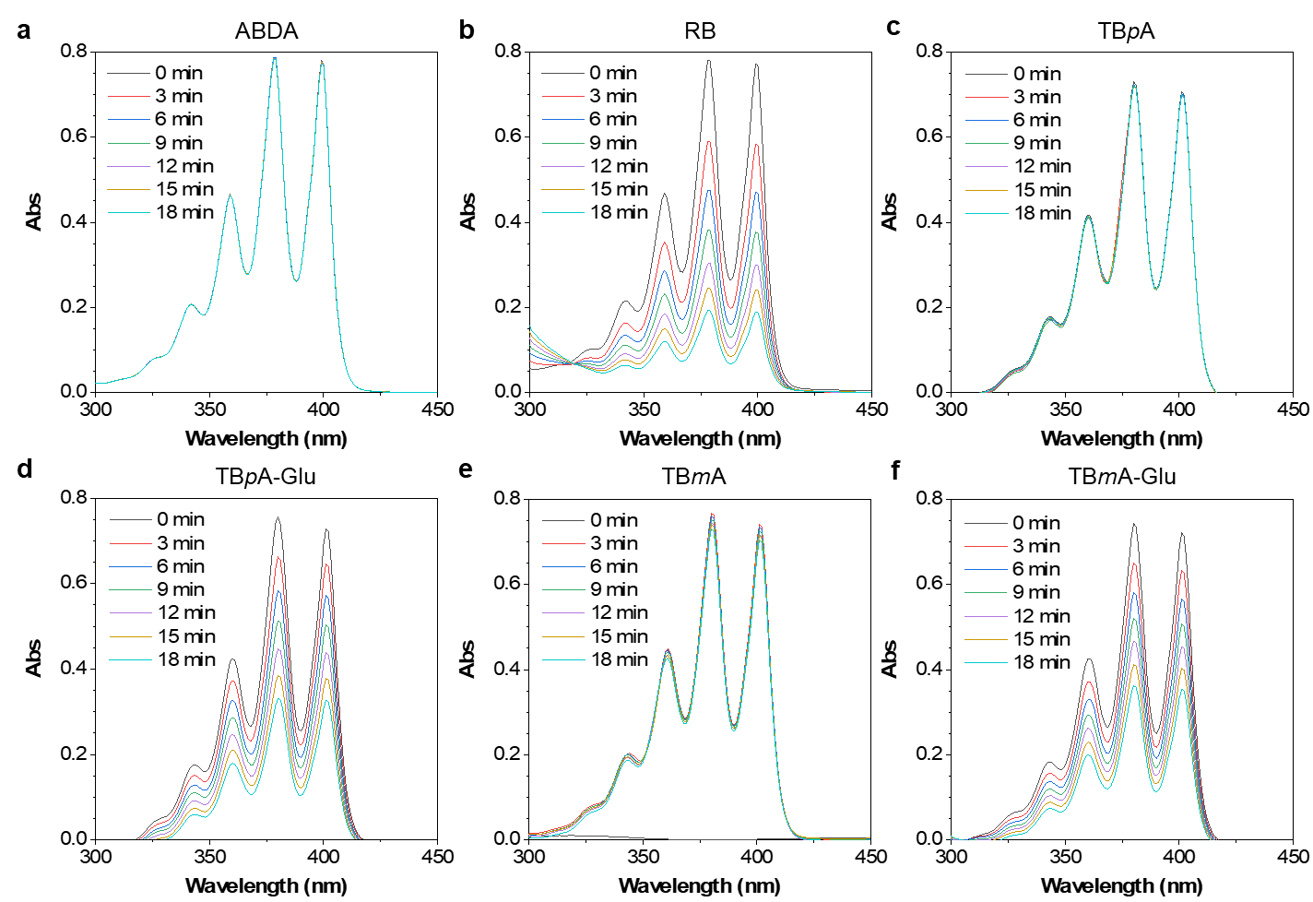
Fig. S26. UV-vis spectra of (a) ABDA in the presence of (b) RB, (c) TBpA, (d) TBpA-Glu, (e) TBmA, (f) TBmA-Glu in DMSO/PBS (v:v = 1:99) mixture under the irradiation with different time. Concentration: 100 μM for ABDA, 5 μM for AIE photosensitizers, white light irradiation (20 mW cm⁻²).

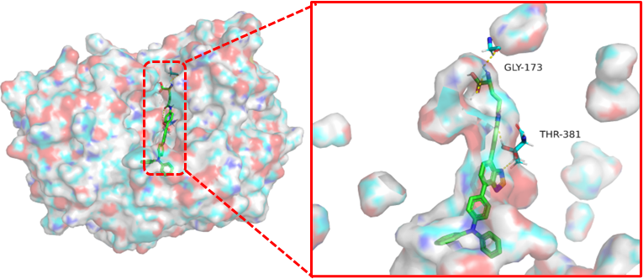
Fig. S27. The molecular docking results of TBpA-Glu with GGT (PDB: 4GG2). The TBpA-Glu are colored green, and the molecular surface of GGT is shown as a colorful surface with transparency. The enlarged images show the hydrogen bonds formed between TBpA-Glu and -Glutamyltransferase (GGT).
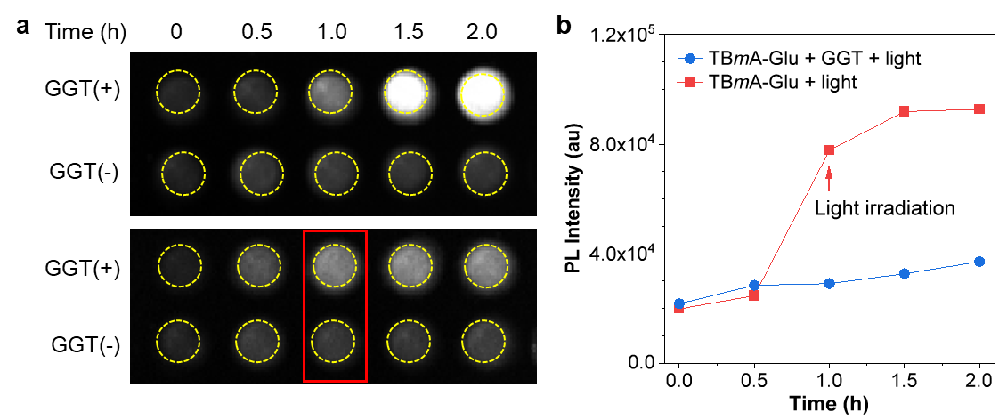
Fig. S28. (a) The fluorescence images of TBmA-Glu in the absence or the presence of GGT. The red arrow indicates the time point for light irradiation (12 J·cm²). (b) Fluorescence intensity changes of TBmA-Glu incubated in the HEPES buffer at 37 ℃ in the presence and absence of GGT with a white light LED array irradiation (12 J·cm⁻²). The red arrows indicate the time points for light irradiation. To a 5 μM solution of TBmA-Glu in 10 mM HEPES buffer, pH 7.4, containing 0.1% DMSO as a cosolvent, 5 units of GGT was added. The reaction mixture was incubated at 37 ℃ for 1 h before the light irradiation.

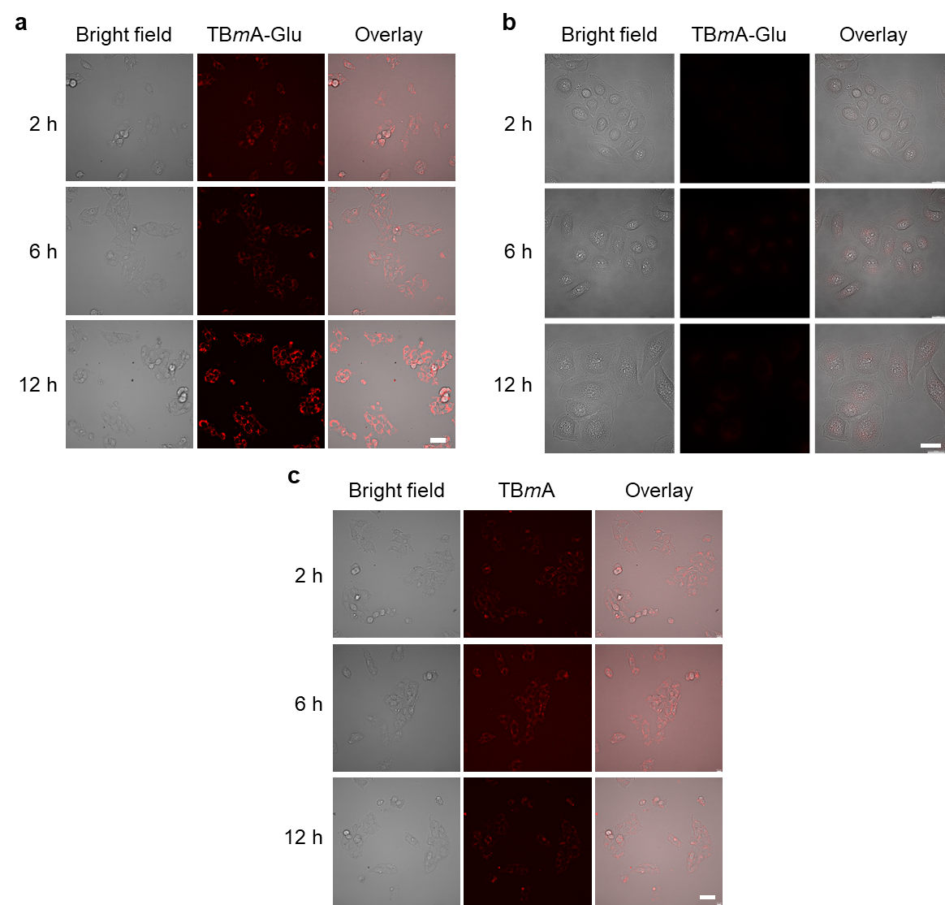
Fig. S29. The time-dependent uptake process of TBmA-Glu (a) / TBmA (b) in HepG2 cells. (c) The time-dependent uptake process of TBmA-Glu in LO2 cells. All the cells were incubated with 5 μM TBmA-Glu / TBmA and imaged at the indicated time. λ_{ex} = 465 nm; λ_{em} = 700 ± 20 nm, Scale bar, 20 μm.

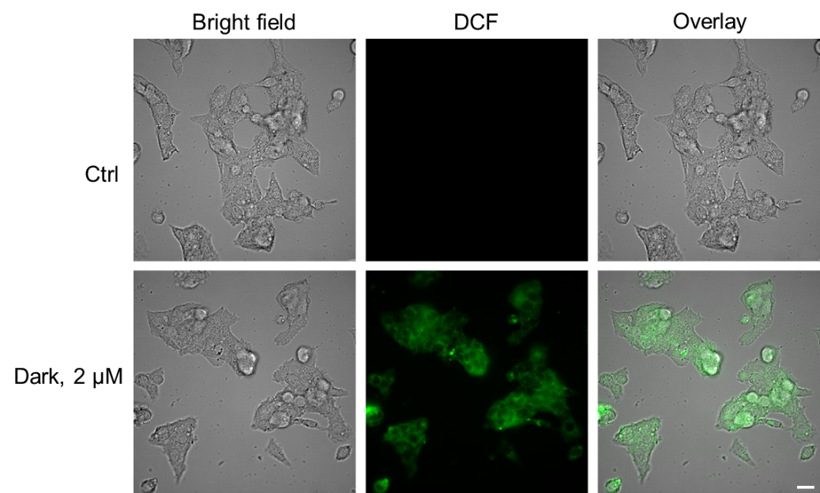
Fig. S30. Intracellular ROS generation in HepG2 cells. HepG2 cells were incubated with TBmA-Glu (2 μM) or 1% DMSO (Ctrl) for 24 h. DCFH-DA (10 μM) was used as the ROS indicator. DCFH-DA, λ_{ex} = 488 nm, λ_{em} = 500 ± 20 nm; TBmA-Glu, λ_{ex} = 465 nm, λ_{em} = 700 ± 20 nm. Scale bar = 20 μm.

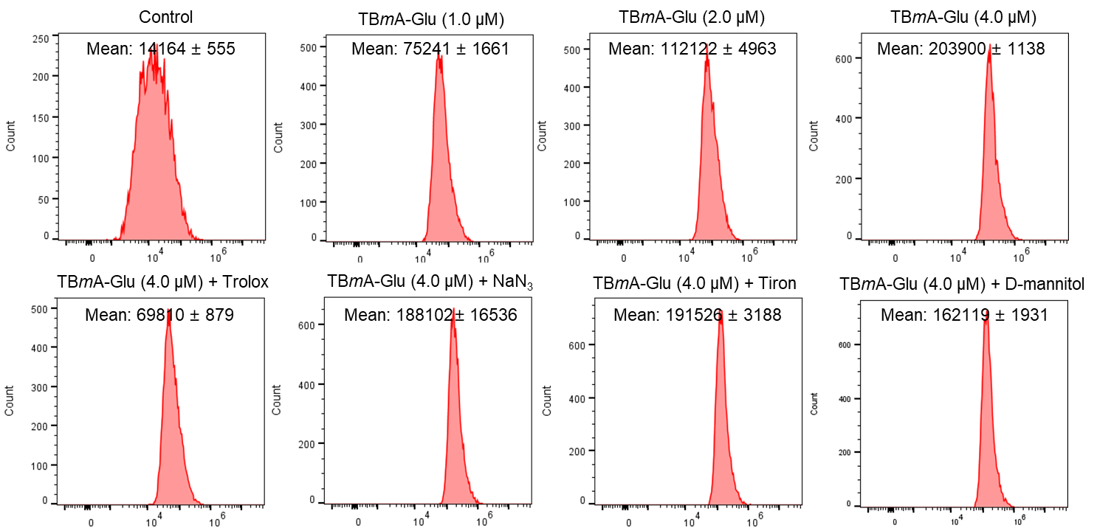
Fig. S31. Intracellular ROS levels measured by DCF staining with flow cytometry (λ_{ex} = 488 nm, λ_{em} = 525 ± 20 nm). HephG2 cells were treated with the TBmA-Glu as the indicated concentrations for 12 h and irradiated with a white laser array (12 J ⋅ cm⁻²) before incubated with DCFH-DA (10 μM, 15 min). For the scavenger assay, cells were pre-incubated with the ROS scavengers for 2 h (Tiron: 10 mM; NaN₃: 5 mM; mannitol: 50 mM; Ebselen: 50 μM), and then the cells were treated with TBmA-Glu (4 μM) for 12 h and irradiated with a white laser array (12 J ⋅ cm⁻²) before incubated with DCFH-DA (10 μM, 15 min).

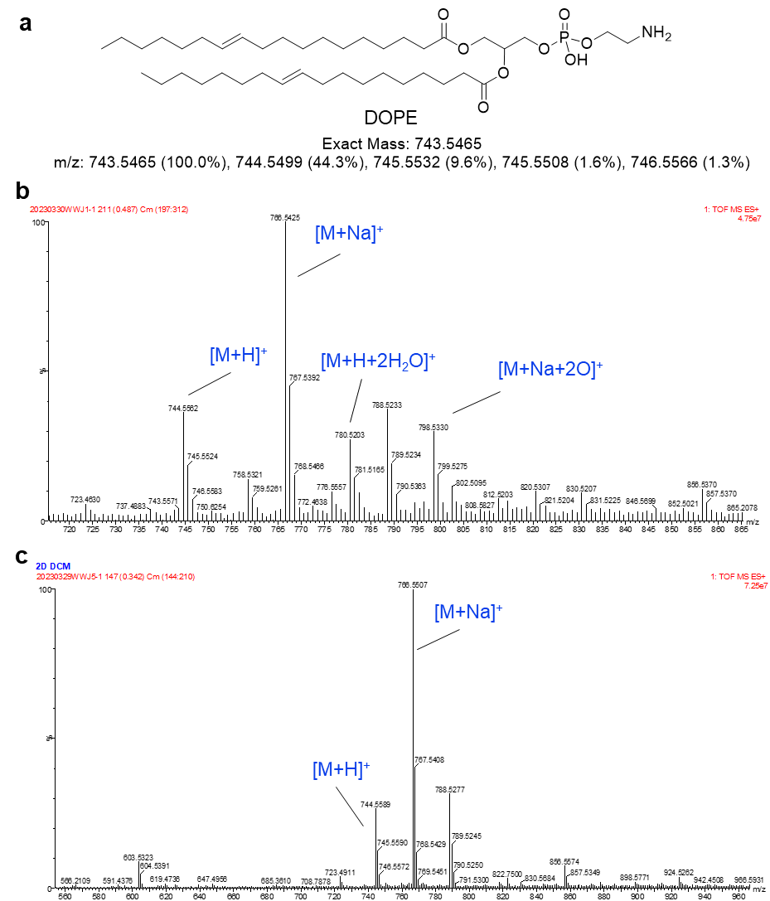
Fig. S32. (a) The structure of 1,2-Dioleoyl-sn-glycero-3-phosphoethanolamine (DOPE). The results of HR-MS of DOPE (10 μM) coincubate with TBmA (10 μM) with (b) /without (c) light irradiation.

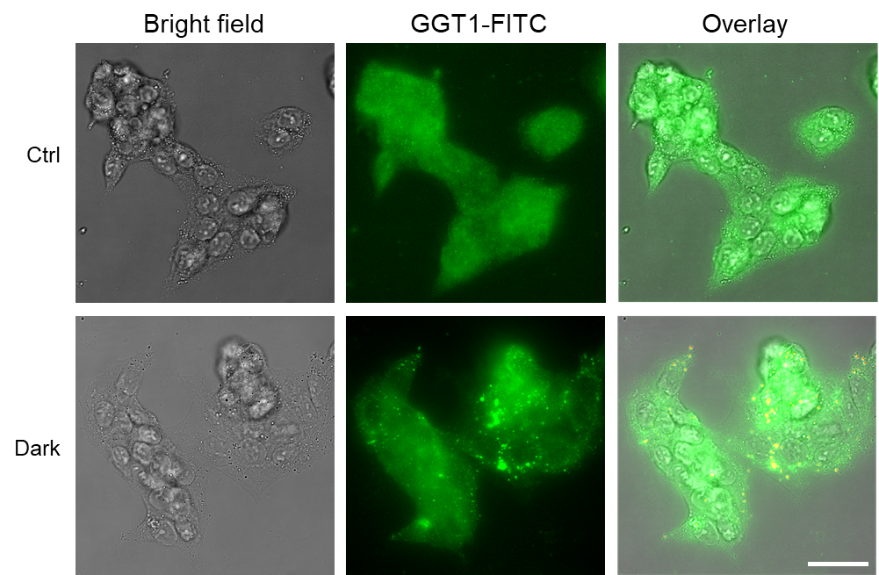
Fig. S33. The intracellular level changes of GGT in HepG2 cells after being treated with TBmA-Glu (2 μM) for 24 h. Scale bar, 20 μm.

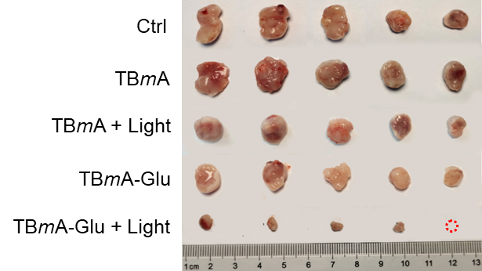
Fig. S34. The photographs of the separated tumors in different treatment groups at the end of the treatment process.

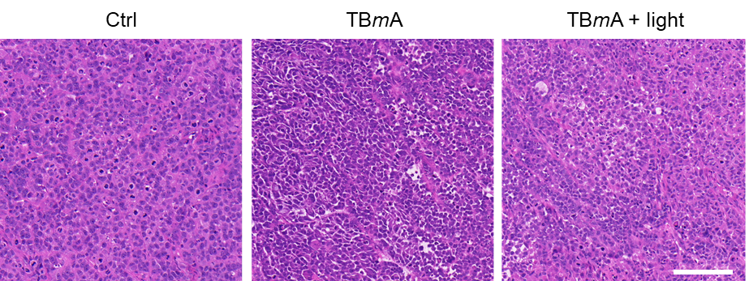
Fig. S35. Hematoxylin-eosin staining in tumor sections from mice with different treatments. The mice were treated with TBmA (5 mg/kg) or physiological saline (Control): scale bar, 100 μm.

Fig. S36. The relative integral optical density (IOD) of GPX4 in immunohistochemistry images of TBmA-Glu/TBmA (5 mg/kg) PDT groups. Data expressed as average ± standard error, n = 3. Statistical significance: P values, ***P < 0.001, calculated with the Student’s T-test.

Fig. S37. The average weight of mice after treatment with TBmA-Glu/TBmA (5 mg/kg) or physiological saline (Control). Data expressed as average ± standard error, n = 5. Statistical significance: P values, ***P < 0.001, calculated with the Student’s T-test.

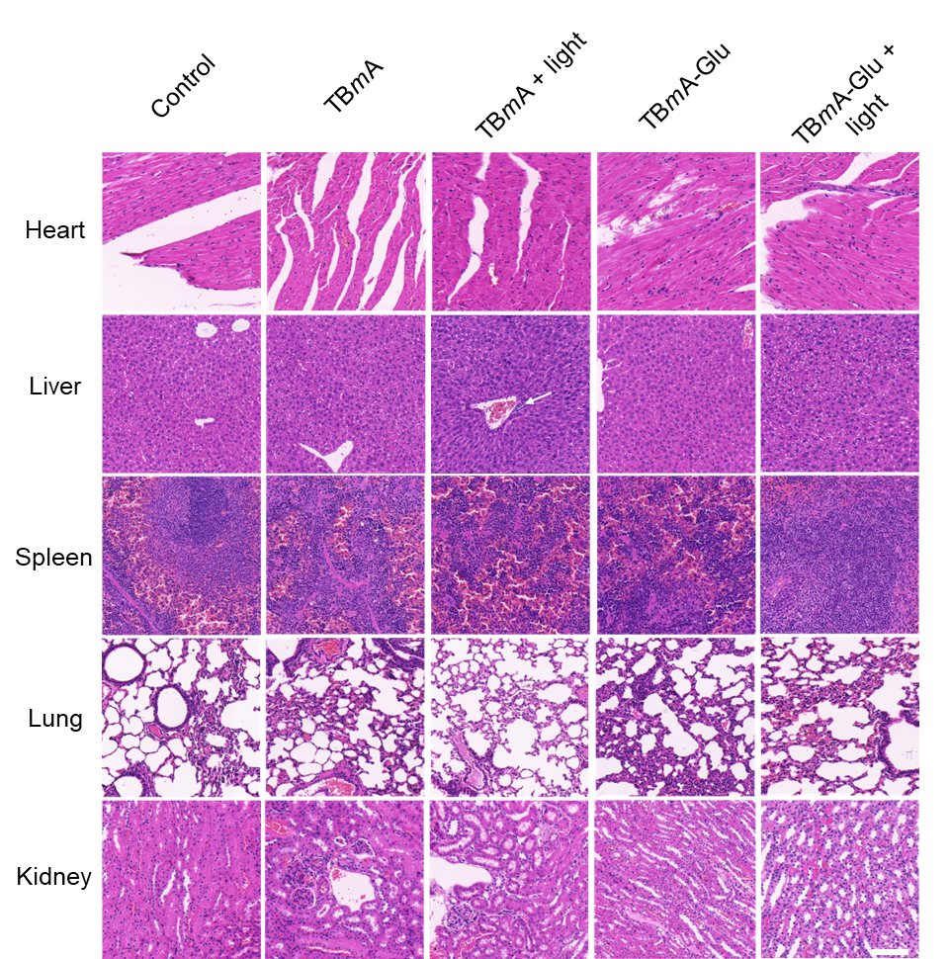
Fig. S38. The representative hematoxylin-eosin staining images of organs from mice after treatment with TBmA-Glu/TBmA (5 mg/kg) or physiological saline (Control). Scale bar, 100 μm

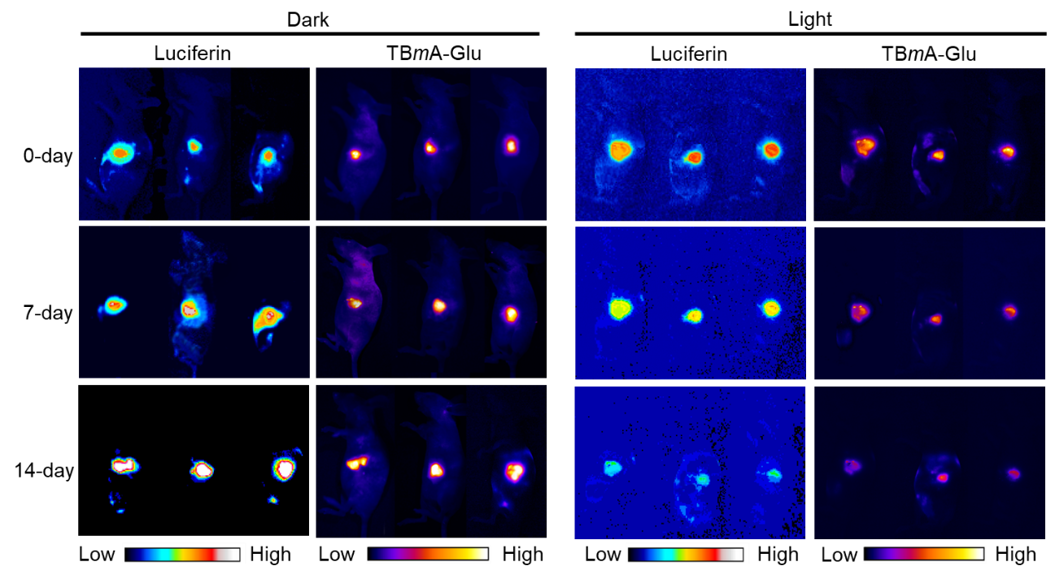
Fig. S39. The fluorescence images of the in-situ hepatoma mice at the start, middle, and end of the treatment process by TBmA-Glu (5 mg/kg). Luminescence, λ_{em} = 550 ± 50 nm (BP), 1000 ms. TBmA-Glu, λ_{ex} = 500 nm, λ_{em} = 700 nm (Long pass filter).

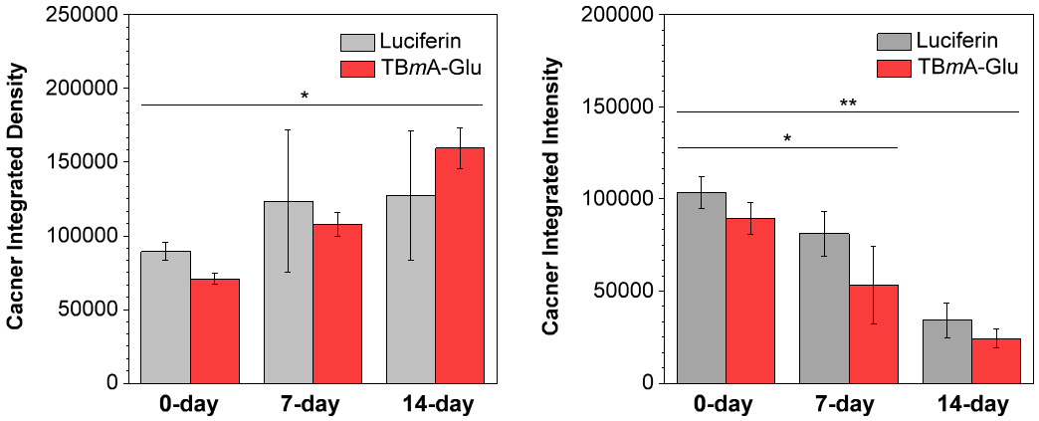
Fig. S40. The relative integral optical density (IOD) of cancer in the mice of in-situ hepatoma models after treated TBmA-Glu (5 mg/kg) with or without light irradiation. Data expressed as average ± standard error, n = 3. Statistical significance: P values, *P < 0.05, **P < 0.01, calculated with the Student’s T-test.

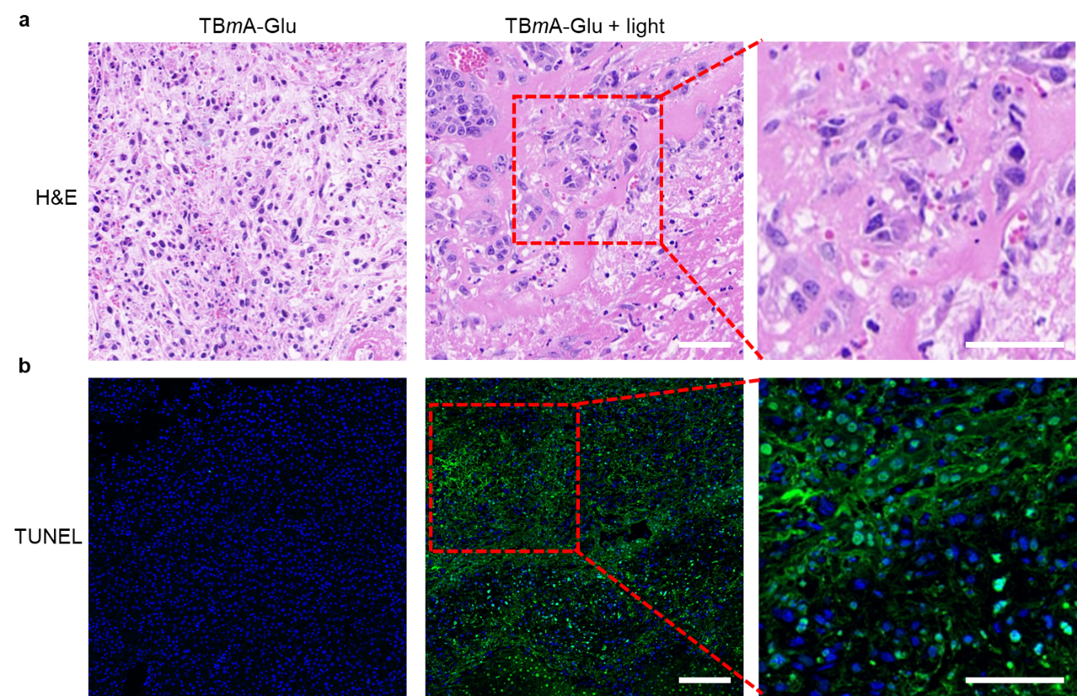
Fig. S41. (a) The representative hematoxylin-eosin staining images of livers of the mice in an in situ hepatoma model after treatment with TBmA-Glu (5 mg/kg). The enlarged area shows fibrosis of tumor tissue after photodynamic therapy by TBmA-Glu. (b) TUNEL assay of livers of the mice in an in situ hepatoma model after treatment with TBmA-Glu (5 mg/kg). Scale bar, 100 μm and 50 μm (for the enlarged images).

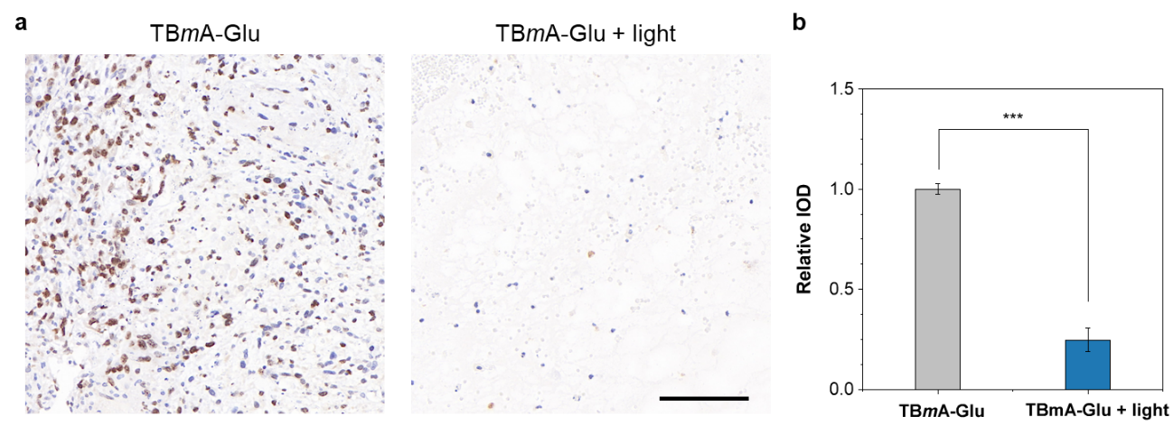
Fig. S42. Ki67 staining of tumor tissue from livers of the mice in an in situ hepatoma model after being treated by TBmA-Glu (5 mg/kg). Scale =100 mm Scale bar, 100 μm.

Table S1. The results of docking with GGT
Compounds | Ki (μM) | Intermolecular energy (Kcal/mol) | Binding energy (Kcal/mol) | Interacting amino acid residues
Glutamate | 14.68 | -8.37 | -6.29 | THR³⁸¹, ASN⁴⁰¹, ASP⁴²³, SER⁴⁵¹, SER⁴⁵² GLY⁴⁷³, GLY⁴⁷⁴
TBmA-Glu | 0.17 | -12.85 | -9.27 | AGR³²⁷, ASP⁴²², PHE⁴²⁴,  ASN⁴³¹
TBpA-Glu | 2.86 | -11.14 | -7.56 | GLY¹⁷³, THR³⁸¹

Table S2. The photocytotoxicity (IC₅₀, μM) of GGT activable AIE photosensitizer in different conditions.
 | Compound | HepG2 (GGT highly expressed) |  |  | HeLa (GGT moderately expressed) |  |  | LO2 (GGT low expressed)
 | Compound | Dark^{[a]} | Light^{[b]} | PI^{[c]} | Dark | Light | PI | Dark | Light | PI
Normoxia (20% O₂) | TBpA | 28.35 ± 5.21 | 20.54 ± 1.14 | 1.38 | 28.47 ± 3.35 | 25.91 ± 3.42 | 1.86 | 24.14± 4.22 | 25.36 ± 1.87 | 1.19
Normoxia (20% O₂) | TBpA-Glu | 23.51 ± 2.31 | 6.70 ± 0.21 | 3.51 | 20.31 ± 2.24 | 15.24 ± 1.10 | 1.98 | 53.45 ± 3.51 | 30.14 ± 1.28 | 1.77
Normoxia (20% O₂) | TBmA | 25.22 ± 2.40 | 12.54 ± 2.24 | 2.01 | 21.46 ± 4.85 | 26.36 ± 2.25 | 1.19 | 25.49 ± 3.47 | 28.58 ± 2.27 | 1.14
Normoxia (20% O₂) | TBmA-Glu | 20.12 ± 3.74 | 2.15 ± 0.23 | 9.36 | 33.22 ± 2.66 | 10.53 ± 3.67 | 3.15 | 47.17 ± 5.81 | 40.45 ± 1.54 | 1.17
Hypoxia  (2% O₂) | TBpA-Glu | 25.44 ± 4.31 | 7.68 ± 1.65 | 3.31 | 37.75 ± 5.17 | 21.28 ± 3.45 | 1.77 | 55.47 ± 2.74 | 41.12 ± 2.14 | 1.13
Hypoxia  (2% O₂) | TBpA | 29.35 ± 5.21 | 24.74 ± 2.11 | 1.19 | 28.47 ± 1.01 | 22.57 ± 2.14 | 1.26 | 27.74 ± 1.55 | 26.28 ± 1.41 | 1.05
Hypoxia  (2% O₂) | TBmA-Glu | 28.85 ± 3.77 | 3.15 ± 0.74 | 9.15 | 38.89 ± 2.19 | 12.57 ± 3.39 | 3.09 | 46.67± 1.33 | 33.11± 1.42 | 1.11
 | TBmA | 26.47 ± 1.15 | 13.47 ± 1.15 | 1.96 | 25.37 ± 1.46 | 15.74 ± 2.10 | 1.61 | 28.39 ± 2.33 | 24.47 ± 1.12 | 1.16
[a] Cells were incubated with the tested compounds for 24 h and detected by MTT assay; [b] Cells were incubated with the compounds in the dark for 24 h. The light treatment groups were irradiated with a white led array (12 J·cm⁻²) after incubation for 12 h, then incubated for another 12 h. [c] Phototoxicity index (PI) is defined as the ratio of ^{dark}IC₅₀ / ^{light}IC₅₀.

References
1. Liu S, Zhang H, Li Y, Liu J, Du L, Chen M, et al. Strategies to enhance the photosensitization: polymerization and the donor-acceptor even-odd effect. Angew. Chem. Int. Ed. 57, 15189-15193 (2018).

