Supplementary Material for “Static magnetic order with strong quantum fluctuations in spin-1/2 honeycomb magnet Na₂Co₂TeO₆”

Inelastic neutron scattering. For the measurements on SEQUOIA time-of-flight spectrometer at the Spallation Neutron Source, Oak Ridge National Laboratory, USA, measurements at 2 K with applied field B = 0 T and 4 T were performed by rotating the sample in steps of 1° with E_{i} = 18 meV and choppers in high-resolution mode, yielding a full-width at half-maximum (FWHM) elastic energy resolution of about 0.41 meV. In order to subtract the background, the INS data were collected at 90 K. The constant-Q scans of the K-point (1/3, 1/3, 0) at 1.5 K with applied field B up to 4 T and B // [-1,1,0] direction were measured on Cold Triple Axis Spectrometer SIKA at the ANSTO, Australia. For the measurements on SIKA, data were collected using a fixed final-energy mode with E_{f} = 5.0 meV.
Muon spin rotation or relaxation. For the measurements on M20D surface muon beam line at TRIUMF, the aligned NCTO crystals were positioned on a thin silver tape, Fig. S2(a) and (b), with their c axes parallel to the muon momentum direction. We aimed at studying the temperature evolution of the magnetically ordered phase and the dynamics of spin fluctuations. For the measurements on GPS instrument, since NCTO is quite thin and flat, we simply used two layers of samples and then wrapped them with Kapton foil, Fig. S2(c) and (d). The muon momentum is always parallel to the c-axis of the crystal. The muon spin should be tuned in the ab-plane (TRAN mode) or along c-axis (LONG mode). Based on the wTF-μSR data, we could determine the temperature evolution of the magnetic volume fraction. For the wTF-μSR measurements, the applied magnetic field was perpendicular to the muon-spin direction.

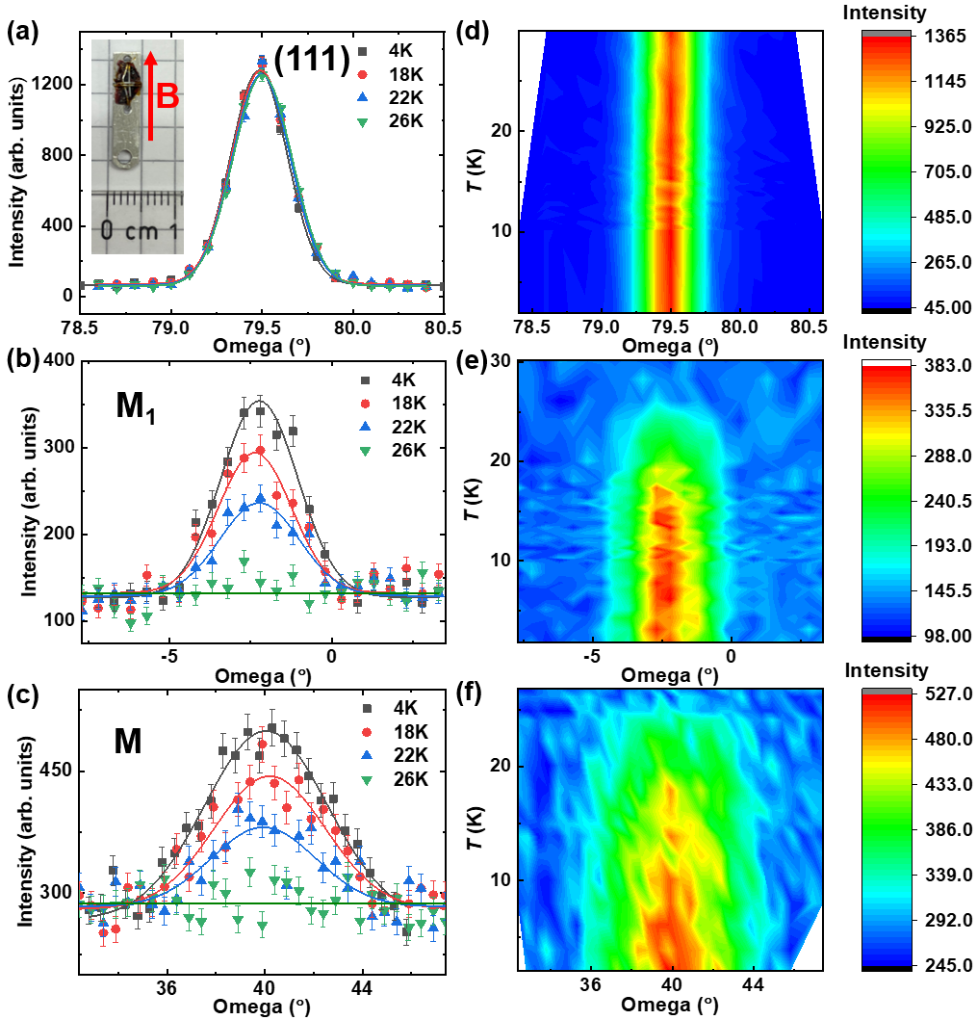
Figure S1. Single-crystal neutron diffraction of NCTO. (a), (b), and (c) Zero-field temperature dependence of nuclear peak (111), magnetic peak M₁ (-0.5, 0.5, 1) and M (0.5, 0, 1) at selected temperatures. The data collected at each temperature was fitted by a Gaussian function (the solid lines) to obtain an integrated intensity plotted in Figure 1. Inset: the sample used for the single crystal neutron diffraction experiment with the magnetic field applying along [-1, 1, 0] direction. (d), (e), and (f) The contour maps of (111), (-0.5 0.5 1), and (0.5, 0,1) peaks. Apparently, there is no any lattice distortion or ferromagnetic contribution with temperature evolution from (d).

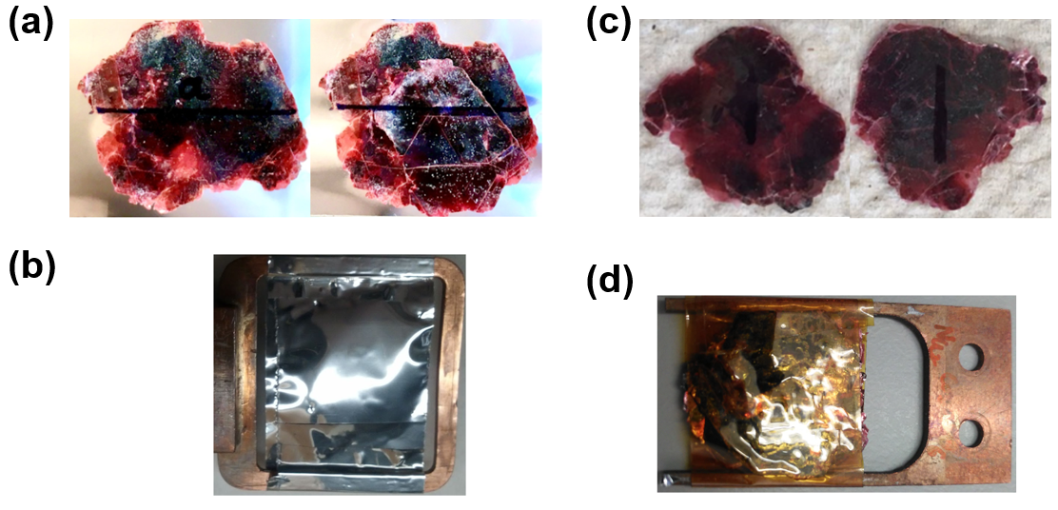
Figure S2. The photos of measured samples for μSR. (a) The sample photos for the μSR M20D spectrometer. The scribed lines on the samples mark the a-axis of the crystal axis. (b) The aligned NCTO crystals are positioned on a thin silver tape for M20D spectrometer. (c) The sample photos for the μSR GPS spectrometer. The scribed lines on the samples mark the a-axis of the crystal axis. (d) The aligned NCTO crystals are wrapped with Kapton foil for GPS spectrometer.

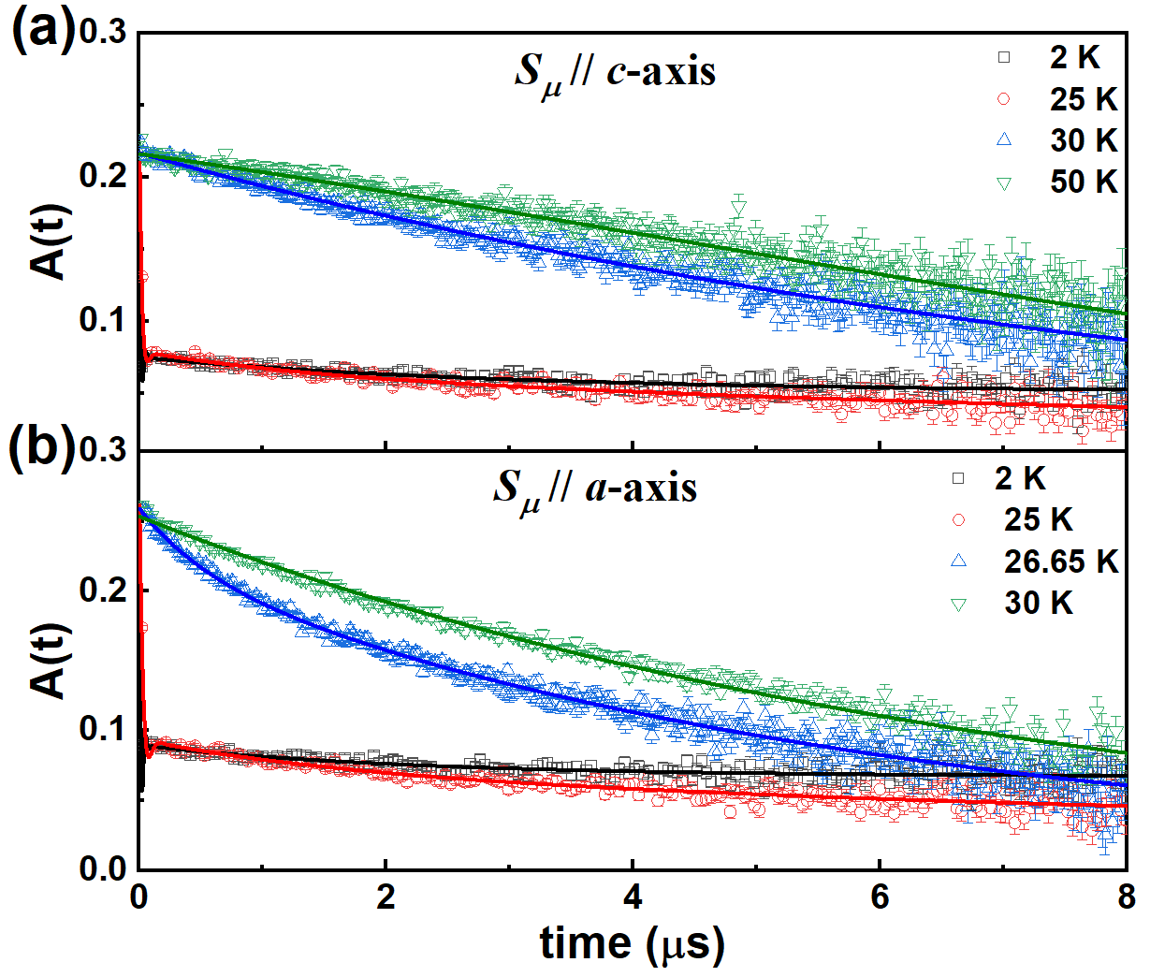
Figure S3. Zero-field μSR data of Na₂Co₂TeO₆ at selected temperatures from high-temperature paramagnetic state to antiferromagnetic ground state. The data can be well described by the Eq. (1.3) of main text.

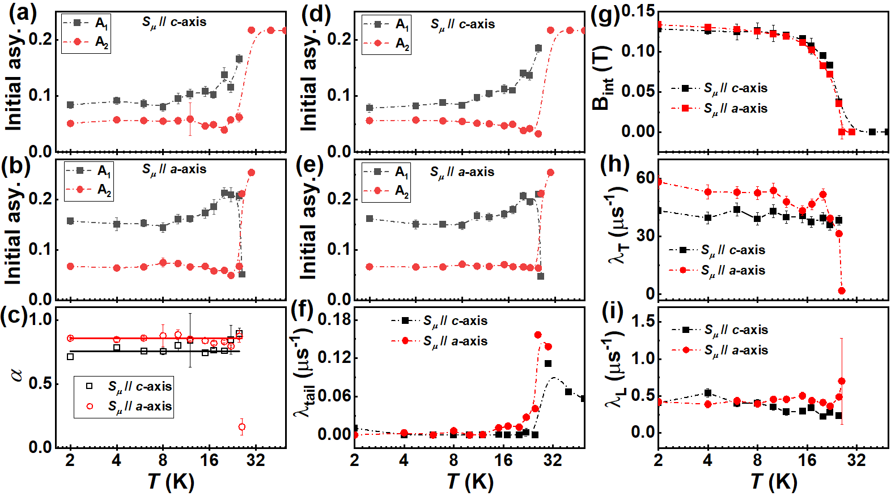
Figure S4. The fitted parameters by the Eq. (1.3) of main text. (a) and (b) The temperature-dependent initial asymmetry A₁ and A₂ are obtained by the unconstrained α values of the Eq. (1.3), which is shown in (c). (d)-(i) Temperature dependence of initial asymmetry, λ_{tail}, B_{int}, λ_{T}, and λ_{L}, respectively, as derived from ZF-μSR analysis with constant values of 0.755 for S_{μ} // c-axis and 0.8567 for S_{μ} // a-axis. The dash-dotted lines are guides to the eyes.

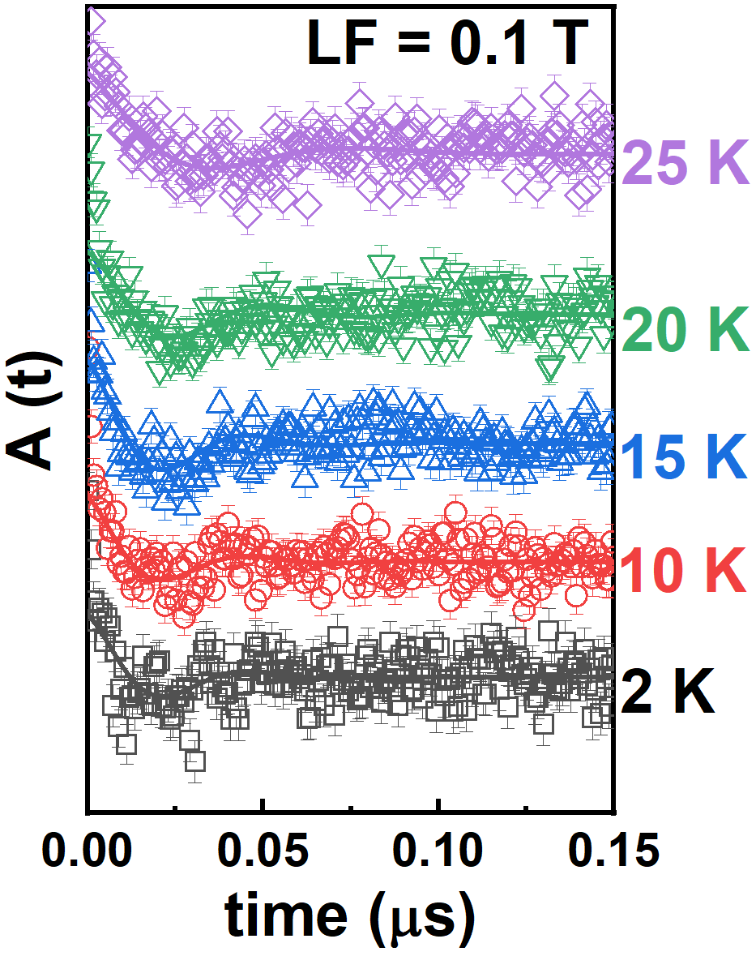
Figure S5. The μSR time spectra with LF = 0.1 T measured at selected temperatures (vertically displaced for clarity) with the muon-spin direction S_{μ} // c-axis. The solid curves represent the results of least-squares fitting using Eq. (1.3) of main text. Such fast depolarization and superimposed oscillations within 50 ns originated from the AFM order can be again confirmed by the the μSR time spectra with LF = 0.1 T.

TABLE SI. Summary of the NCTO single-crystal parameters obtained by means of magnetization and μSR measurements.
 | χ(T) | wTF-μSR | ZF-μSR  S_{μ} // a-axis | ZF-μSR  S_{μ} // c-axis
T_{N} (K) | 26 | 26.2 | 25.8 | 25.8
T_{F} (K) | 15 | 16 | 15 | /
T* (K) | 7 | / | / | 8
B_{int} (T) | / | / | 0.13 | 0.127
γ | / | / | 1.93 | 3.16
δ | / | / | 0.47 | 0.47

