Supplement - tables

Table S1. List of ICD-10 codes used to define potential risk factors when extracting data from the Region Stockholm central healthcare utilization data warehouse (VAL)
Risk factor | ICD-10 code
Hypertension | I10
Heart failure | I50, I110, I43, I42 (excluding I42.1 and I42.2)
Ischemic Heart Disease | I20-I25
Atrial fibrillation | I48
Obesity | E66
Diabetes type II | E11
Kidney failure | N17, N18, N19 and Z491

Table S2. Bias-minimized models for each of the studied potential risk factors for covid-19 hospitalization/death
Risk factor | Adjustment variables
Hypertension | Age, sex, COPD*, diabetes type II, kidney failure, obesity, socioeconomic status (as stratification variable)
Heart failure | Age, sex, COPD*, diabetes type II, hypertension, kidney failure, obesity, socioeconomic status (as stratification variable)
Ischemic Heart Disease | Age, sex, obesity, socioeconomic status (as stratification variable)
Atrial fibrillation | Age, sex, COPD*, diabetes type II, heart failure, hypertension, kidney failure, obesity, socioeconomic status (as stratification variable)
Obesity | Age, sex, socioeconomic status (as stratification variable)
Diabetes type II | Age, sex, obesity, socioeconomic status (as stratification variable)
Kidney failure | Age, sex, COPD*, diabetes type II, heart failure, hypertension, obesity, socioeconomic status (as stratification variable)

*COPD= Chronic Obstructive Pulmonary Disease

Supplement - figures

Figure S1 and S2 Epi-curves of the covid-19 cases and covid-19 related deaths in Stockholm Region during the study period (March 1st, 2020 to July 31st, 2020)

Figure S3. Study population flow chart
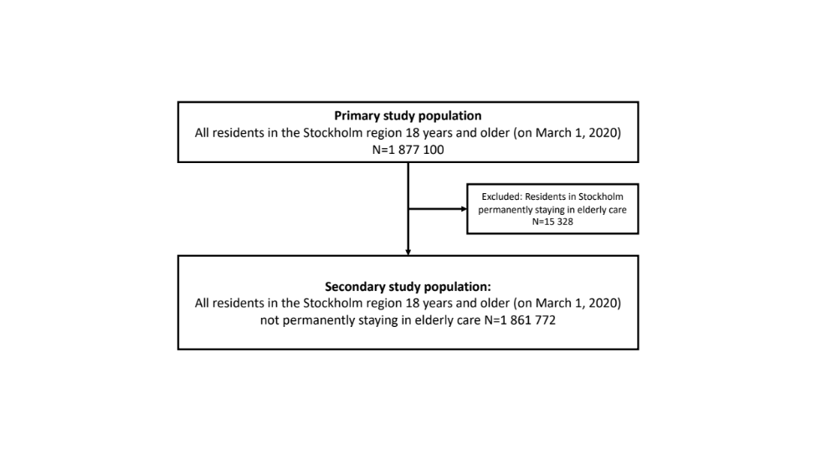

Figure S4. Causal diagram for hypertension as a risk factor for

Covid-19 hospitalization/death, using www.dagitty.net.

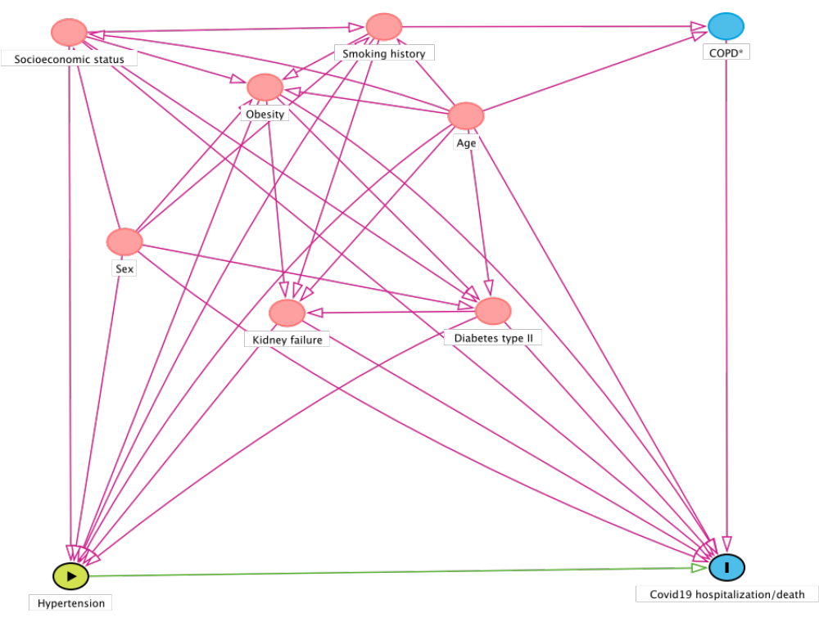
*COPD= Chronic Obstructive Pulmonary Disease

Figure S5. Causal diagram for heart failure as a risk factor for

covid-19 hospitalization/death, using www.dagitty.net.
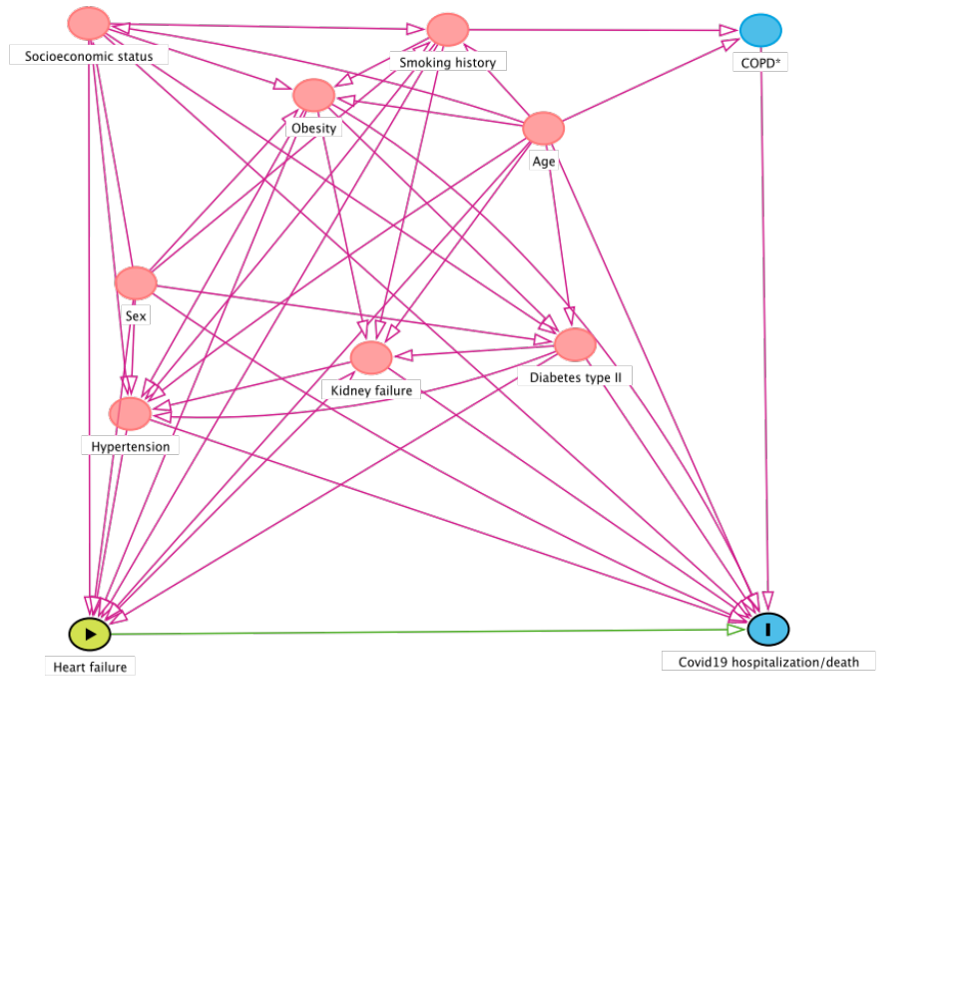
*COPD= Chronic Obstructive Pulmonary Disease

Figure S6. Causal diagram for ischemic heart disease (IHD) as a risk factor for

covid-19 hospitalization/death, using www.dagitty.net.

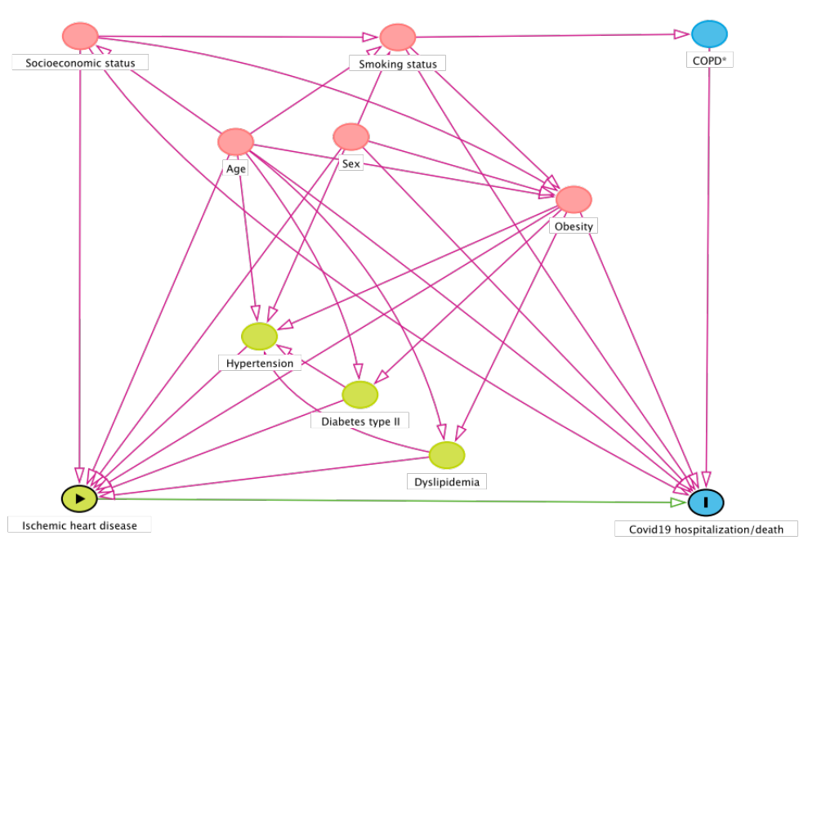
*COPD= Chronic Obstructive Pulmonary Disease

Figure S7. Causal diagram for atrial fibrillation as a risk factor for

covid-19 hospitalization/death, using www.dagitty.net.
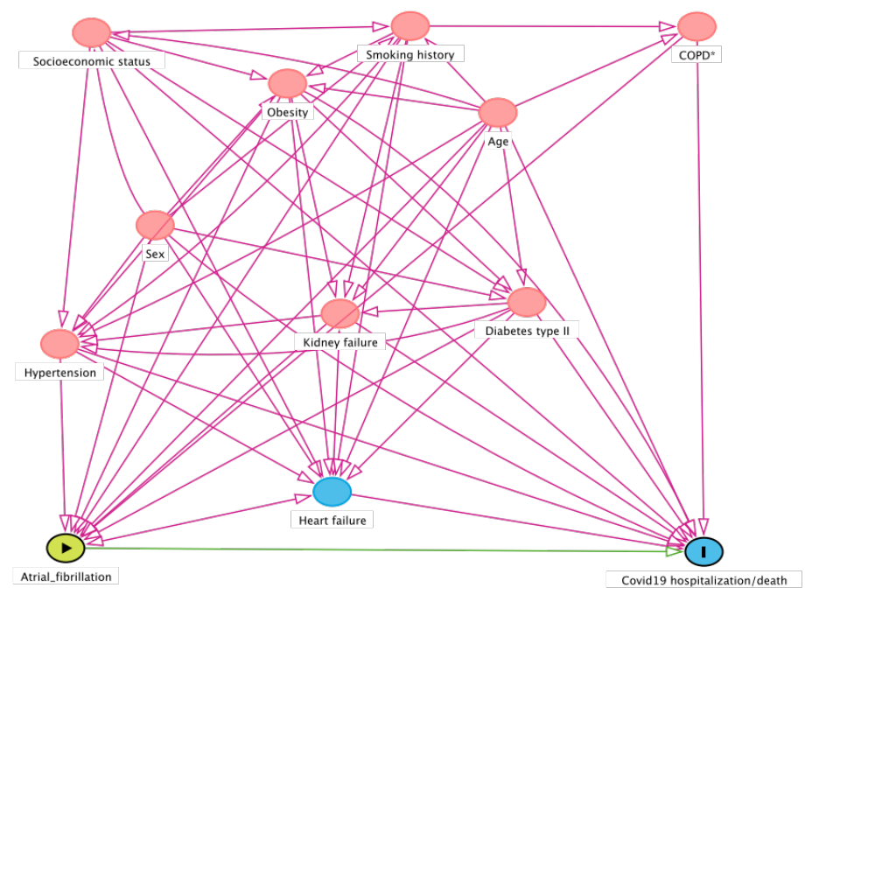

*COPD= Chronic Obstructive Pulmonary Disease

Figure S8. Causal diagram for obesity as a risk factor for

covid-19 hospitalization/death, using www.dagitty.net.
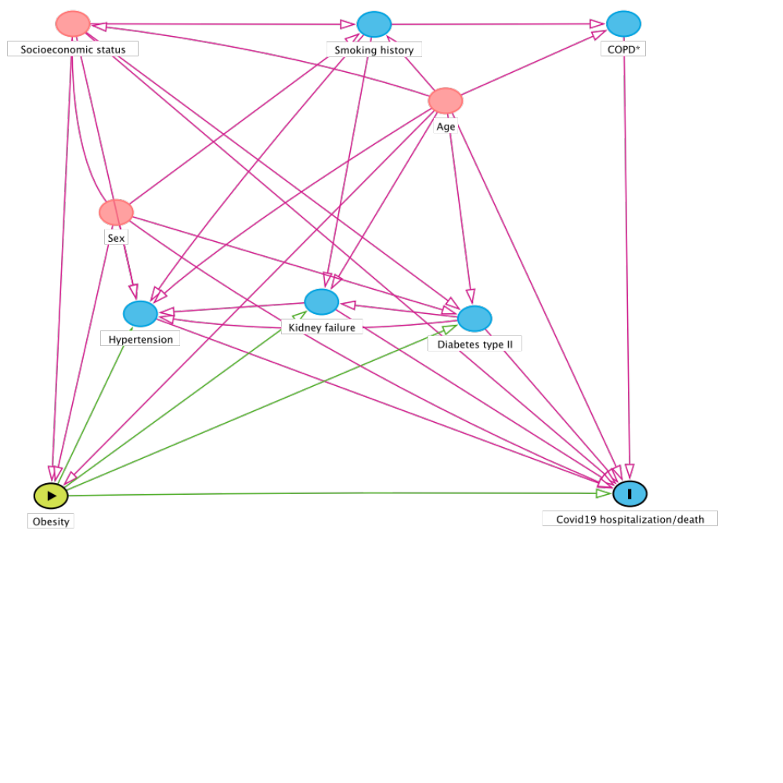

*COPD= Chronic Obstructive Pulmonary Disease

Figure S9. Causal diagram for diabetes type II as a risk factor for

covid-19 hospitalization/death, using www.dagitty.net.
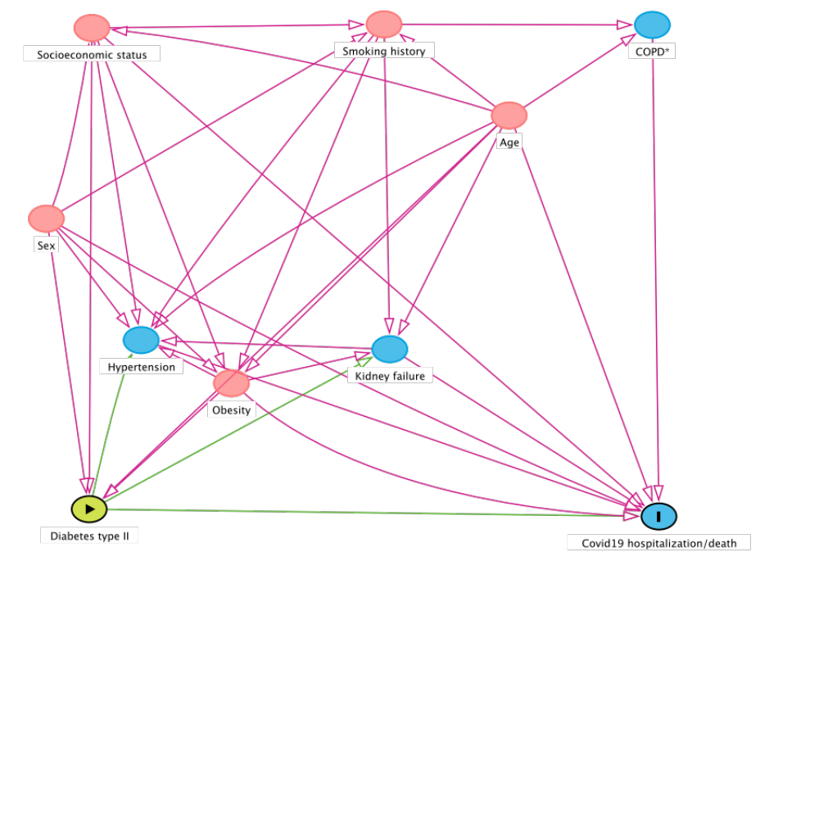

*COPD= Chronic Obstructive Pulmonary Disease

Figure S10. Causal diagram for renal failure as a risk factor for

covid-19 hospitalization/death, using www.dagitty.net.

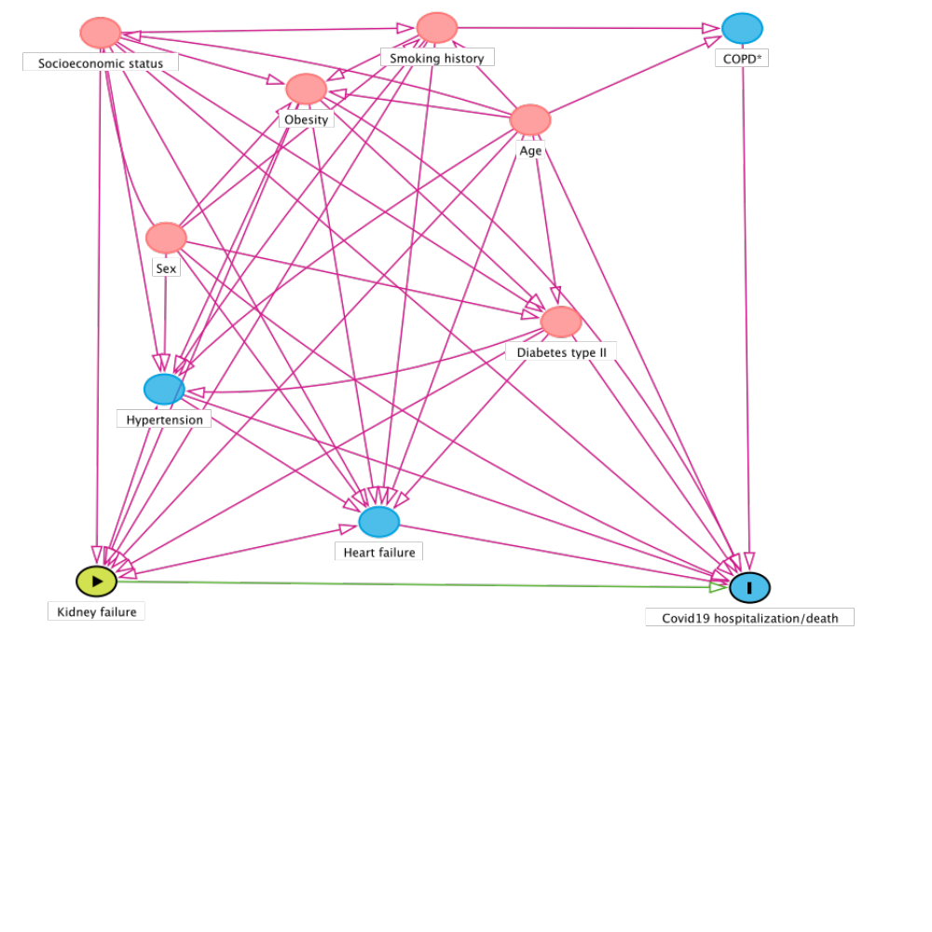
*COPD= Chronic Obstructive Pulmonary Disease

