Table S1 Primers used in this study.
 | Primer | Sequence  (5’- 3’) | Product size  (bp)
Colony PCR | icaA-F | GAAAGTCGATTTACAAGAAAACAG | 120
Colony PCR | icaD-F | GAAATTAATAATCCAGTATACTGT | 120
Colony PCR | bap-F | GAAAAGATGATGATAACATTAAAG | 120
Colony PCR | PCR-R | GGGTATGGACAGATCTCAAAAAAAGCAC | 120
Sanger Sequencing | icaA-F | CCATATGGCTTACAACCTAACTAACG | 1329
Sanger Sequencing | icaA-R | GATATAGCGATAAGTGCTGTTTCTC | 1329
Sanger Sequencing | icaD-F | AGTCGCACTCTTTATTGATAGTCG | 525
Sanger Sequencing | icaD-R | CCAGTGTGCTTACAGGCAATA | 525
Sanger Sequencing | bap-F | CCAATGACACTGCTGTTGAATCTACG | 1188
Sanger Sequencing | bap-R | GCACGAATAAAGTTGACTTCCCAAG | 1188
Sanger Sequencing | mecA-F | CGTTACAGTGTCACTTTCAACAT | 1146
Sanger Sequencing | mecA-R | AACGATTGTGACACGATAGCC | 1146
Housekeeping gene | 16srRNA-F | ACGTGGATAACCTACCTATAAGACTGGGAT | 94
Housekeeping gene | 16srRNA-R | TACCTTACCAACTAGCTAATGCAGCG | 94
PCR | icaA-F | GAGGTAAAGCCAACGCACTC | 131
PCR | icaA-R | CCTGTAACTGCACCAAGTTT | 131
PCR | icaD-F | ACCCAACGCTAAAATCATCG | 211
PCR | icaD-R | GCGAAAATGCCCATAGTTTC | 211
PCR | bap-F | GCAACACCACAAAGAACTATG | 227
PCR | bap-R | CTGTTTCCAGAGTTTGCTCC | 227

Table S2 Oligos used in this study
Name | Sequence  (5’ – 3’) | Description
icaA-F | GAAAGTCGATTTACAAGAAAACAG | icaA spacer for gene deletion
icaA-R | AAACCTGTTTTCTTGTAAATCGAC | icaA spacer for gene deletion
icaD-F | GAAATTAATAATCCAGTATACTGT | icaD spacer for gene deletion
icaD-R | AAACACAGTATACTGGATTATTAA | icaD spacer for gene deletion
bap-F | GAAAAGATGATGATAACATTAAAG | bap spacer for gene deletion
bap-R | AAACCTTTAATGTTATCATCATCT | bap spacer for gene deletion

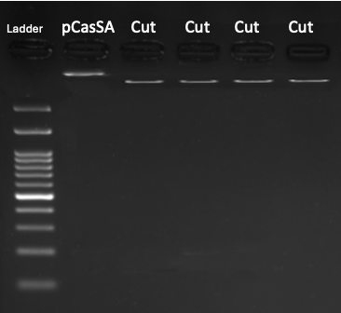

Fig. S2 Restrictional digestion agarose gel electrophoresis image (Cut: pCasSA linearised with BsaI)

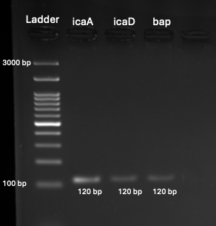

Fig. S3 Colony PCR agarose gel electrophoresis image

