Extended data:
Extended Data Fig. 1.
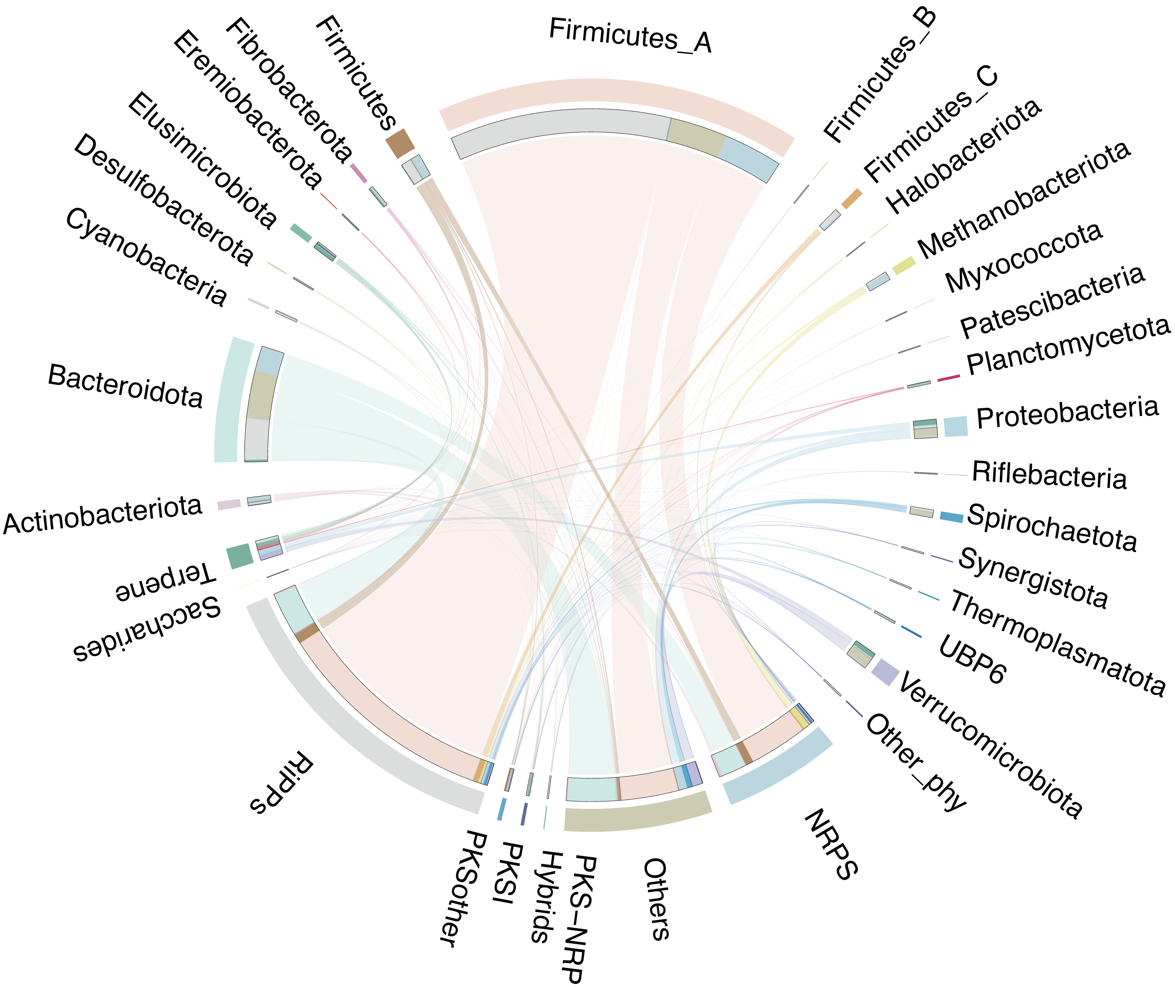
BGC types distribution in major phyla.

Extended Data Fig. 2.
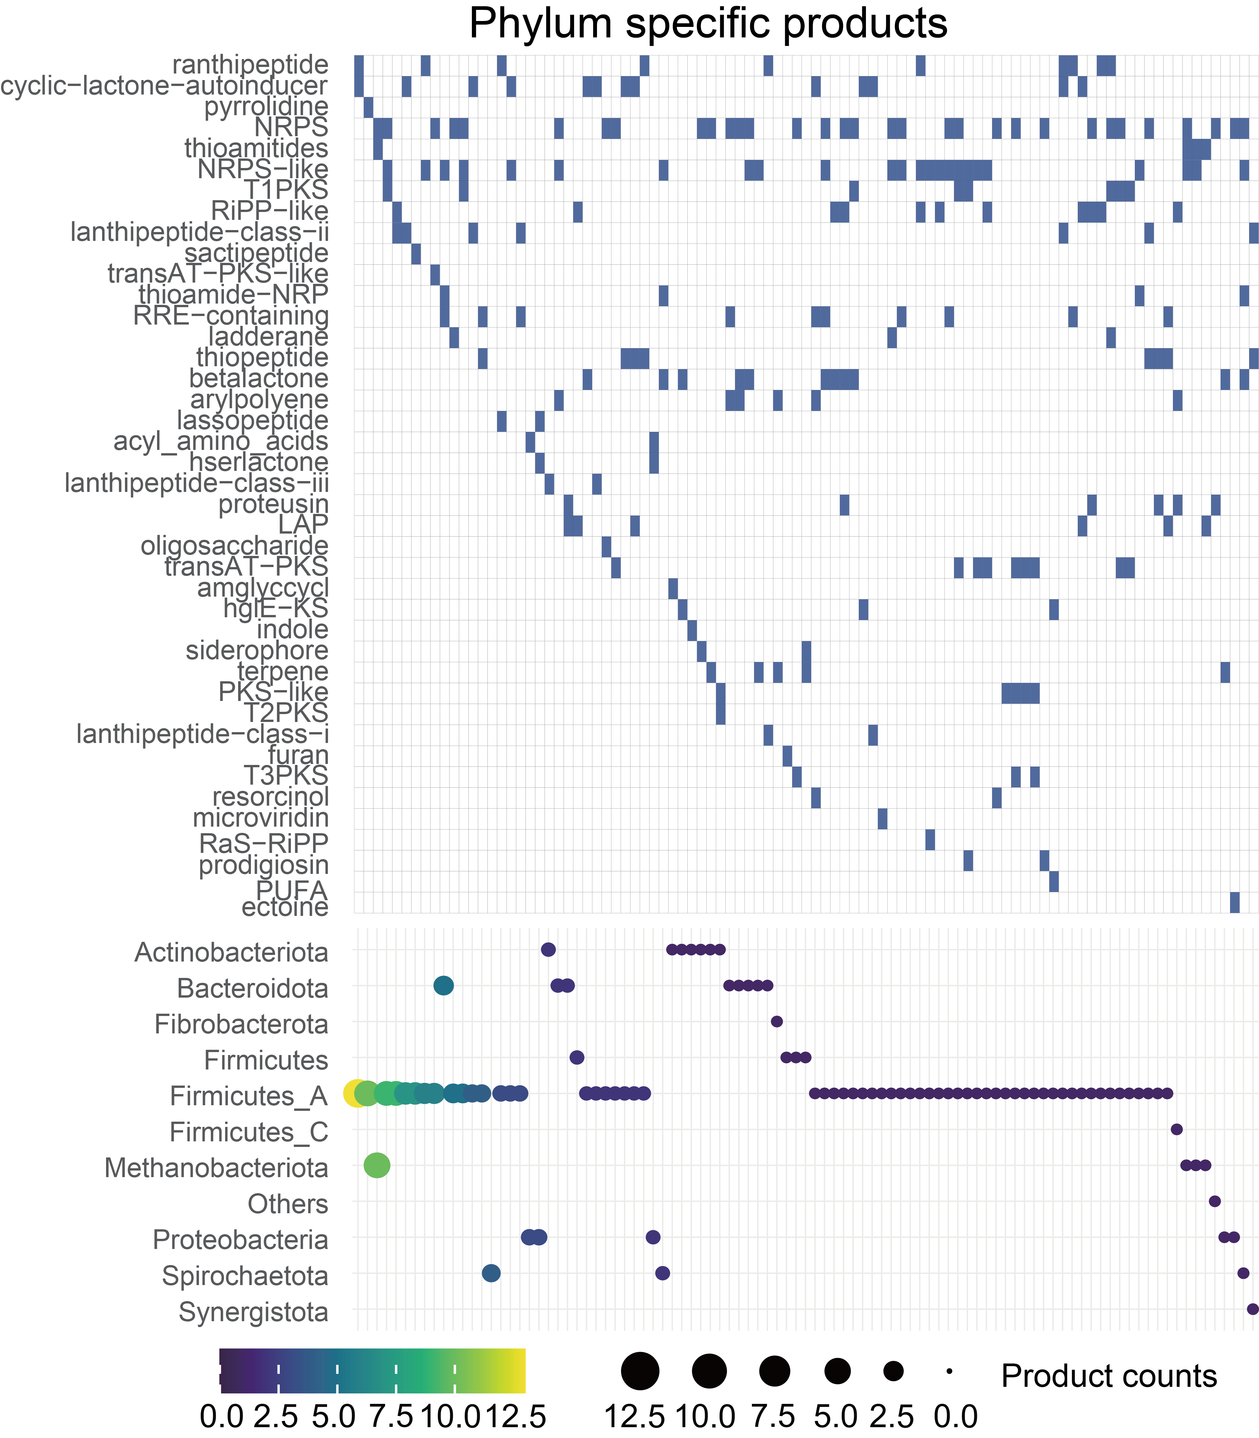
Specific marker BGC products in each phylum.

Extended Data Fig. 3.
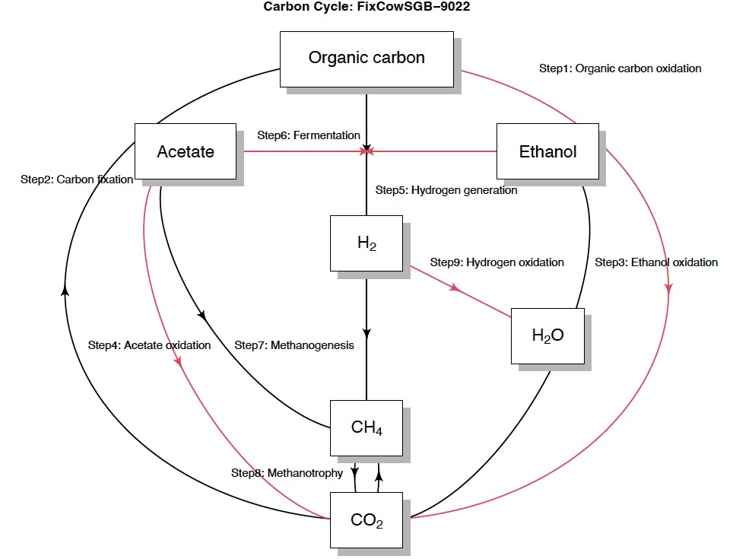
Carbon cycle metabolism in CowSGB_9022.

Extended Data Fig. 4.
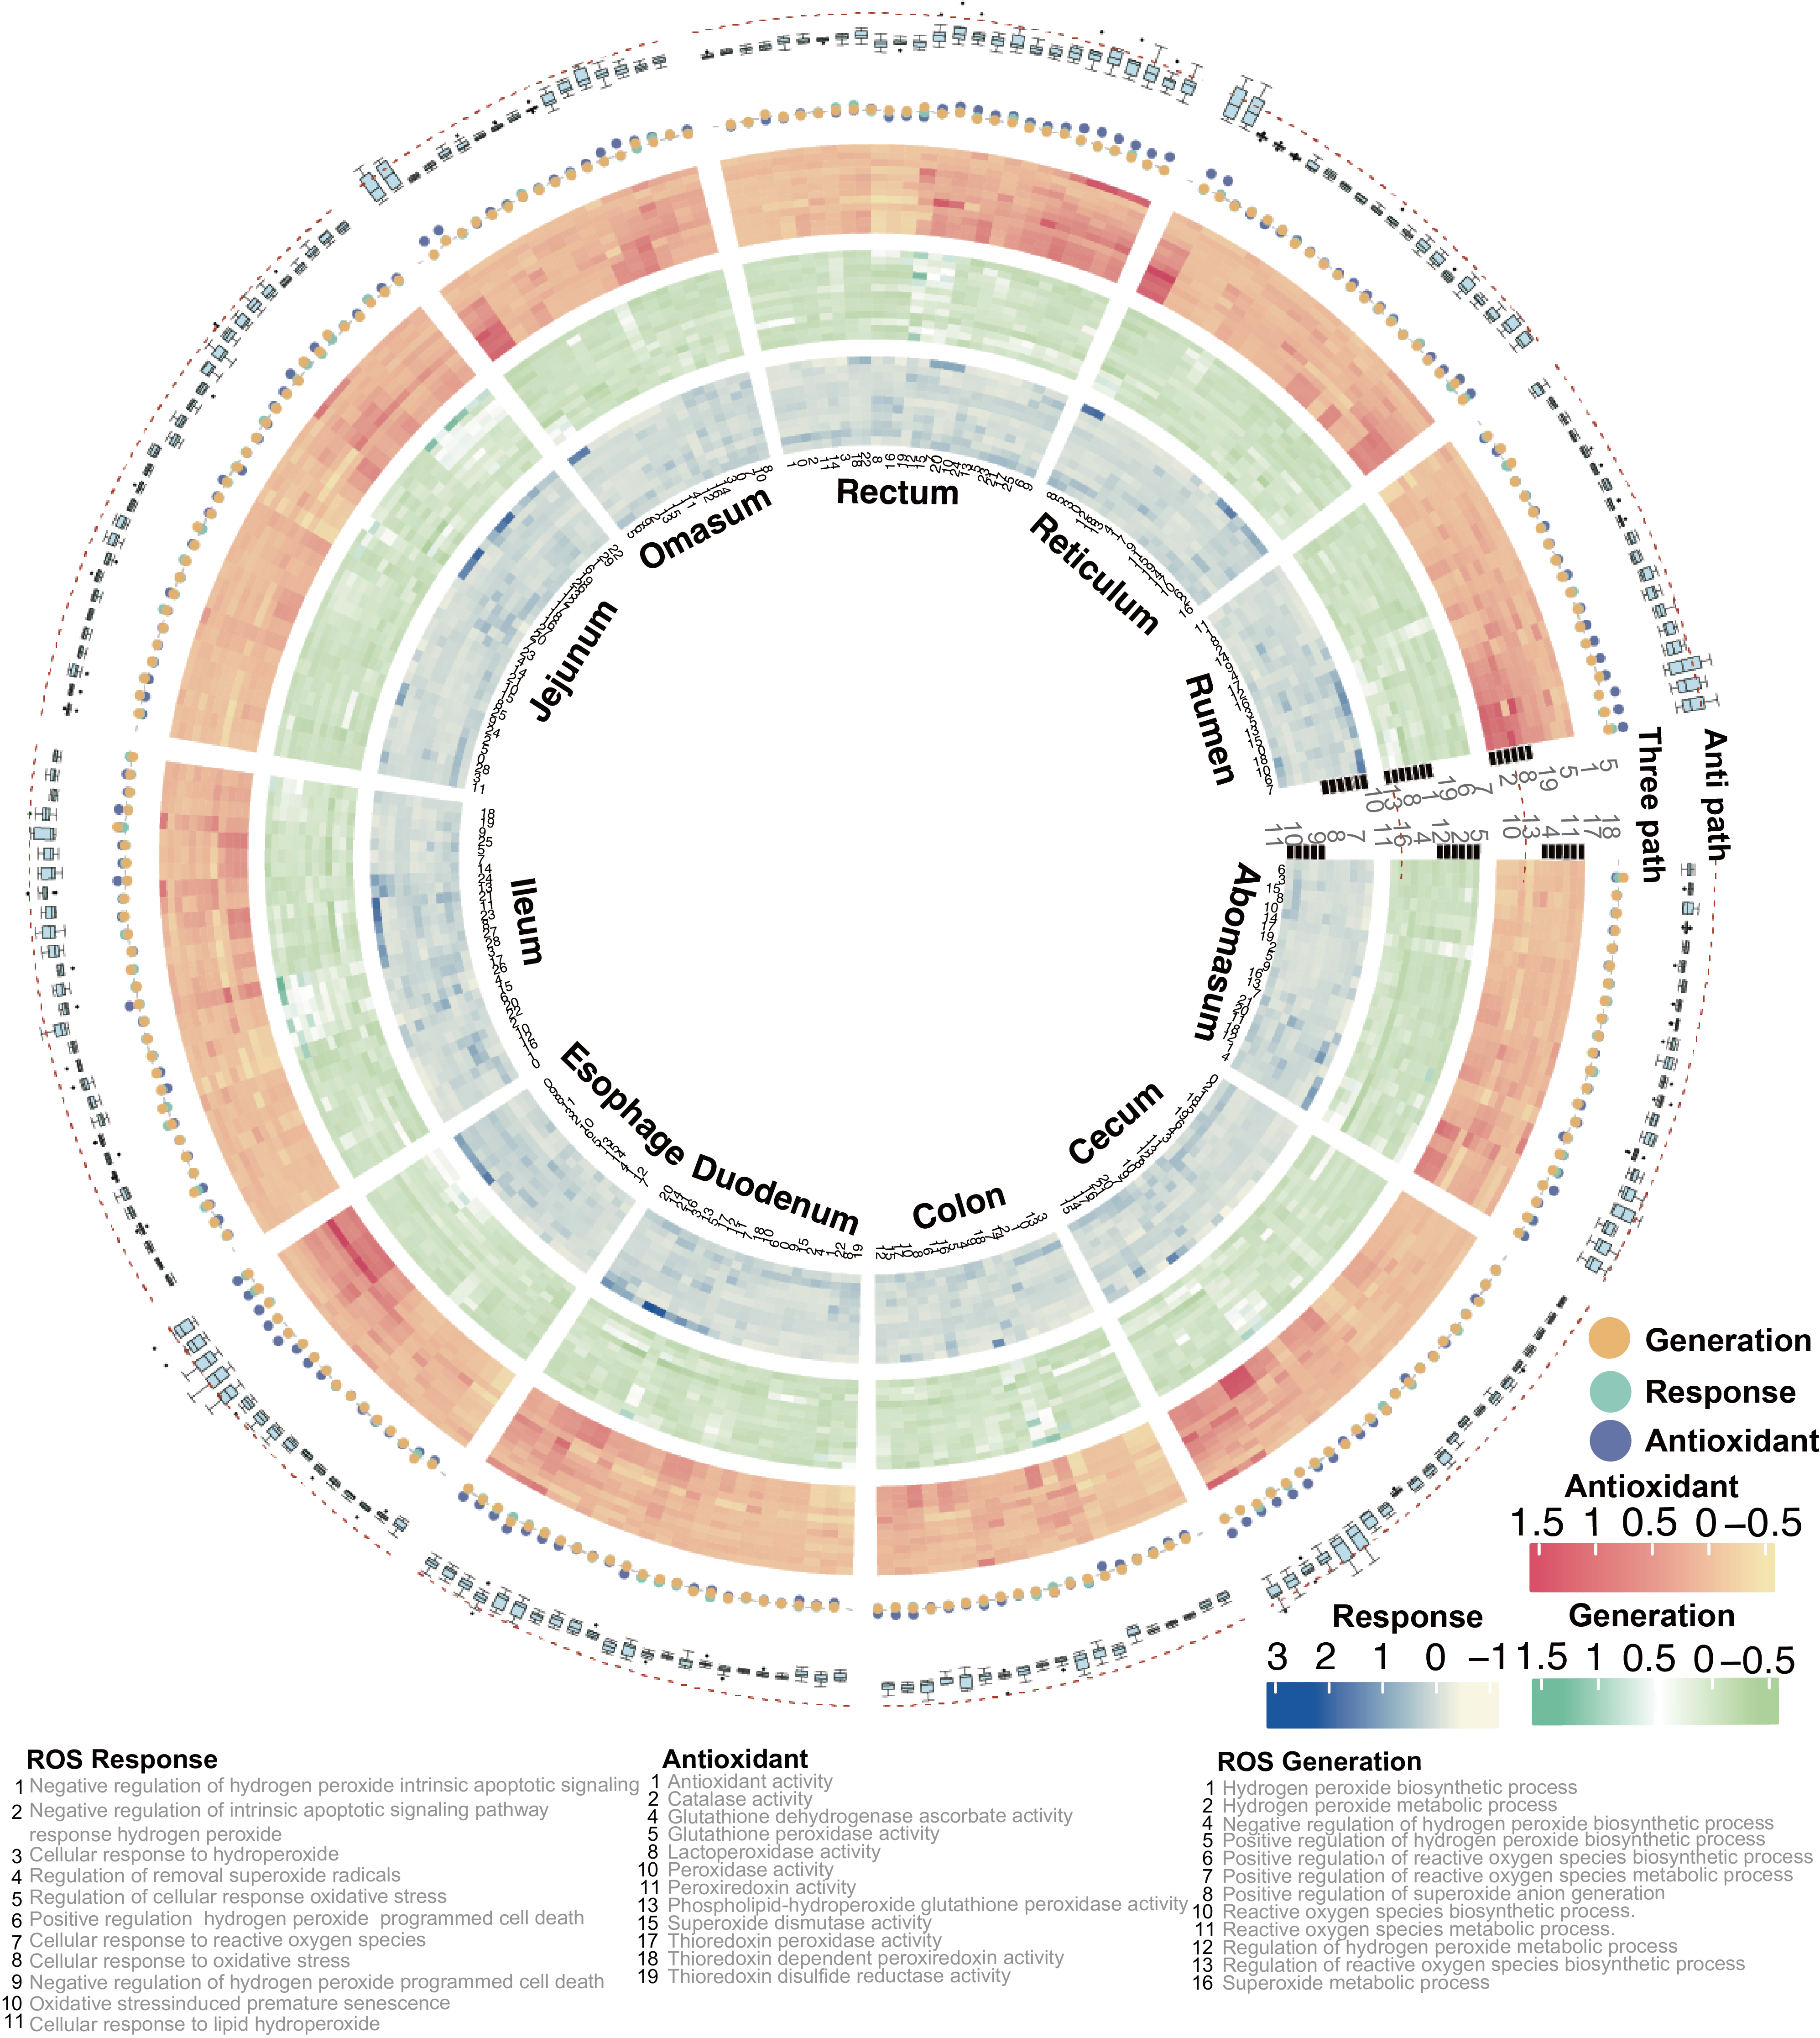
ROS response, antioxidant ROS generation pathways scores in the GIT cell types.

Extended Data Fig. 5.
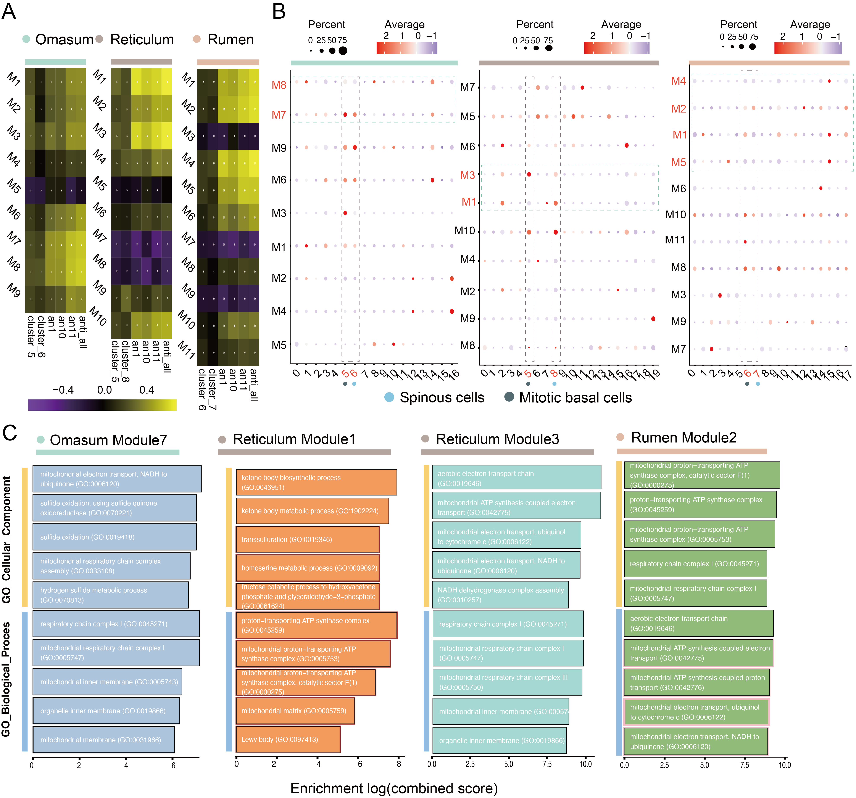
hdWGCNA results in the three forestomach tissues. (A) Correlation results in rumen, reticulum, and omasum. (B) Specific expression of different modules in rumen, reticulum and omasum. (C) Enrichment results of the modules correlated with spinous and mitotic basal cells.

Extended Data Fig. 6.
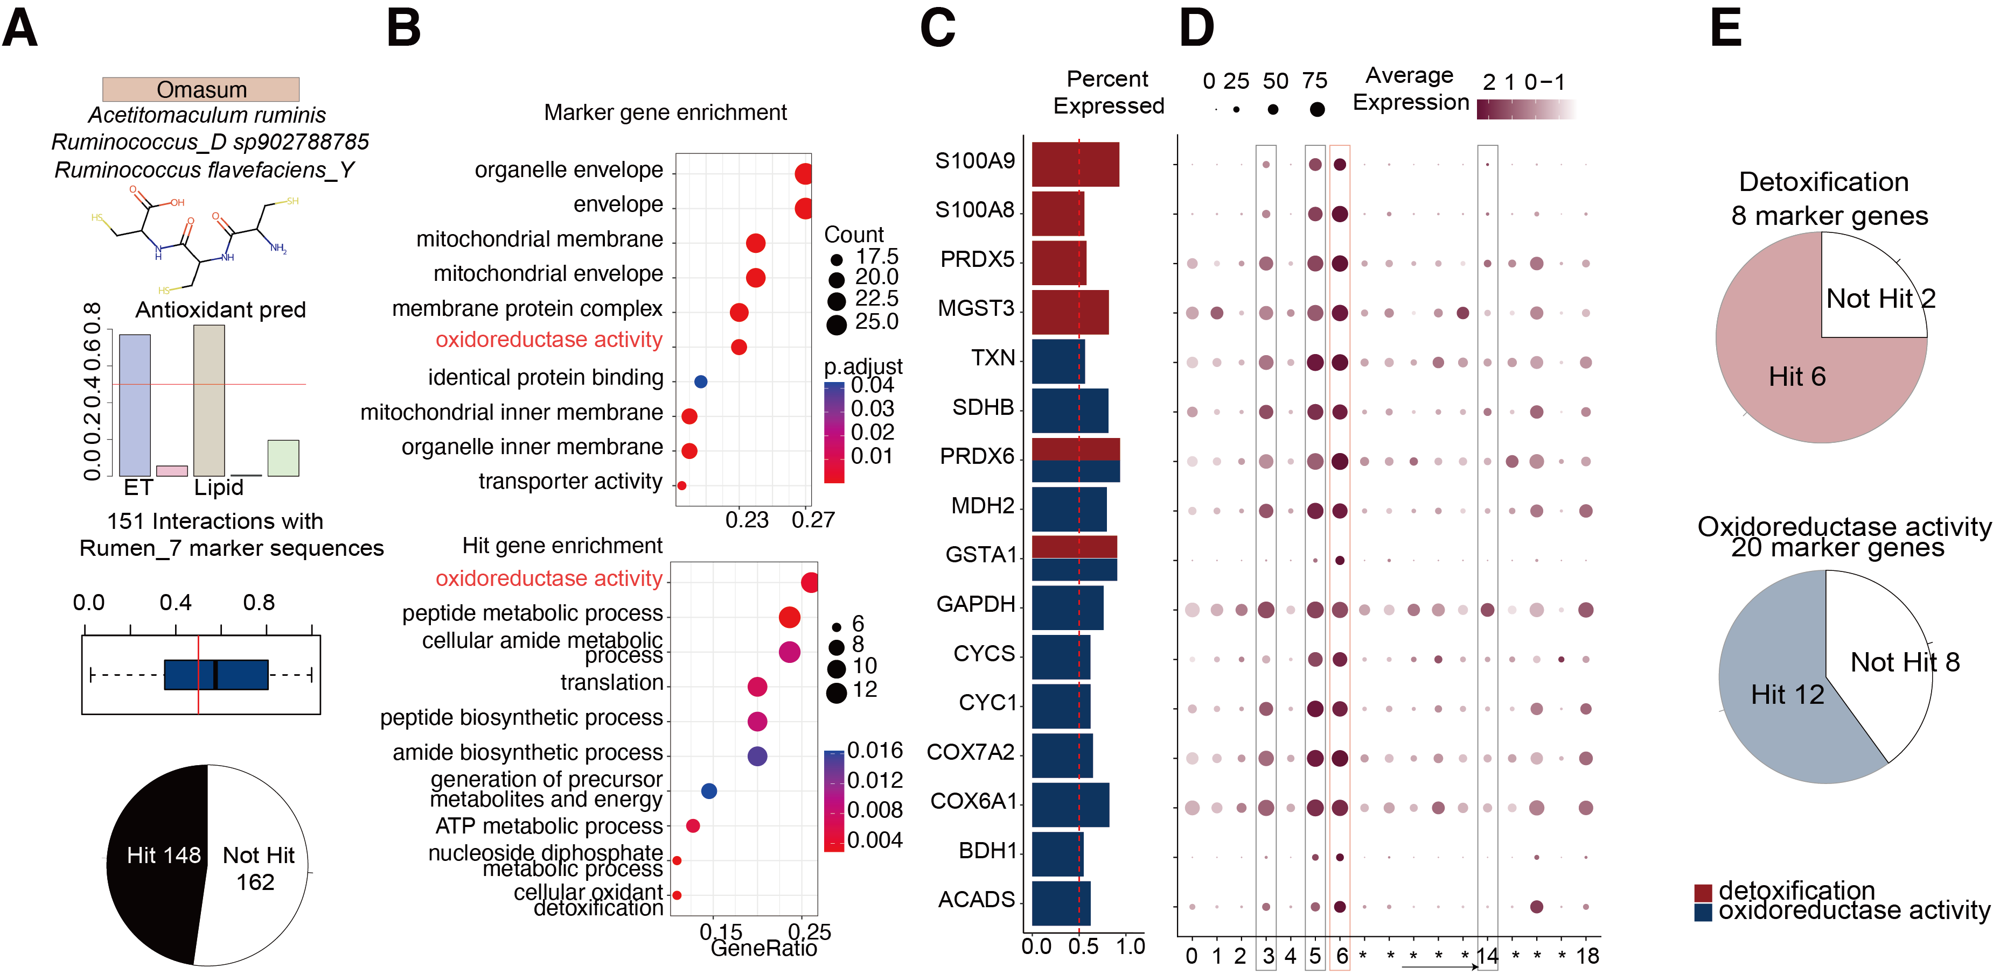
Metabolites-protein interactions in the spinous cells of omasum. (A) Predicted antioxidants properties of potential antioxidants Cys-Cys-Cys and interactive proteins in the omasum spinous cells. (B) Enriched GO pathways in the marker proteins of omsum spinous cells and marker proteins predicted to interact with Cys-Cys-Cys. (C) Interactive scores between Cys-Cys-Cys and omasum marker proteins in two pathways. (D) Omasum single-cell expression of interactive marker genes in two pathways. (E) Interactive genes percentages in the two enriched pathways in omasum marker genes.

