Supplementary Materials
Magnetometer Survey and Drone (UAV) Photography
Following geoarchaeological trenching, we conducted geophysical and drone based (UAV) prospection. The geomagnetic survey grid, extending 135 by 90-meter, used a MAGNETO® MXPDA 3-Channel Type F magnetometer unit by SENSYS. UAV aerial survey was undertaken with a DJI Phantom 4 RTK paired with a D-RTK 2 High Precision GNSS Mobile Station.
OSL Dating
The OSL samples were processed at Coastal Carolina University in a dark room illuminated with amber LED light. The samples were removed from their containers. Then, their outer rims exposed to sunlight during field sampling were cleaned to ~1 cm depth and kept for water content and natural radioactivity measurements. The materials for OSL measurement were subsequently sampled beneath the cleaned surface and processed following established methods (Mauz et al. 2002; Shen and Mauz 2011). The materials were treated in sequence with (1) ~100 ml 30% hydrogen peroxide to remove organic materials; (2) 25 ml 10% hydrochloric acid to remove carbonate materials followed by neutralization; (3) wet sieving to separate silt and very fine sand (vfS) fractions (63-125 μm); (4) repeated settling experiments to isolate the fine silts (4-15 μm) from the silt fraction; and (5) density separation with LST heavy liquid at 2.75 g/cm³ and 2.62 g/cm³, respectively to extract quartz from the vfS fraction. The fine silt and vfS extractions were treated with 20% hydrofluoric (HF) acid for 20 minutes and 48% HF for 40 minutes, respectively, at the University of Salzburg. The OSL measurements were carried out using a Freiburg Instruments Lexsyg Smart TL/OSL reader with a 100 mW/cm² blue (458 nm) LED stimulation unit and an H7360-02 (UV/VIS) detection window centered at 365 nm.
For fine silts, we prepared cups containing ~1 mg sediments by settling through acetone. For vfS, the measurement cups were prepared by fixing a monolayer of sand with silicon oil covering the center 0.5-1 mm diameter area of the cups. We used a standard single aliquot regenerative dose (SAR) protocol with a 280 °C hot blue OSL stimulation for 40 s at the end of each run for De measurements. According to a preheat test with the vfS quartz of COSL151, the protocol is set up with a preheat at 220 °C for 10 s for the natural/given doses and a cut heat at 220 °C following the administering of the test doses. We used OSL signal integrated during the initial 0.2 s and the following 0.3 to 1.1 s as signal and background for De calculation. The OSL dose-response curves were all fitted with a single saturation exponential function and De values for aliquots meeting the following criteria were accepted for age calculation: (1) recycling ratio falling between 0.9-1.1; (2) recuperation ratio <5%; (3) Test dose OSL signal >3σ above background signal. A dose recovery test with COSL152 produced a recovered/given dose ratio of 0.95±0.16 (n=6
The sediments were assumed to be near saturation at the time of deposition, and an initial water content of 20% was used for silty samples TP1 T and TP1 M and 30% for silty clayey sample TP1 B. The water content is expected to decrease exponentially due to compaction after burial. The average water content during the entire burial period is used for age calculations.
Radiocarbon
Seed samples from Area C were prepared at the Weizmann Institute Radiocarbon laboratory. Pretreatment followed the Acid-Base-Acid protocol to prevent contamination during processing by inorganic carbon, humic substances and modern carbon dioxide. AMS radiocarbon measurements were conducted on a NEC 1.5SDH-1 0.5MV Pelletron with a 40-sample MC-SNICS ion source. All radiocarbon dates have been converted to calendar ages (BC) using OxCal 4.4 (Bronk-Ramsey 2009) with the IntCal20: Northern Hemisphere atmospheric calibration dataset (Reimer et al. 2020).
According to field notebooks housed at the Penn Museum in Philadelphia, the barley seeds dated in Level I of Area C represent about 1 gram of material located on a floor of “Room 6.” The sample was collected on the 16th of November, 1970 and processed with the lab identifier 6524-1.1.

Supplementary Figure 1 – Western section of Test Trench 1, including an upper water lain level and a lower anthropogenic level. Bits of mudbrick architecture can be seen in the lower right-hand corner of the section. White dots indicate the locations of samples taken for OSL dating.

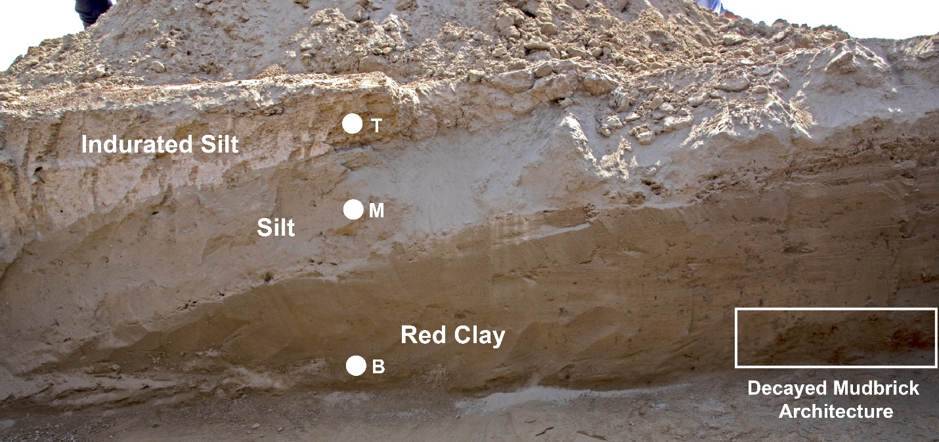

Supplementary Figure 2 – Northern section of Test Trench 2. Note the shallow depth of silt facies.

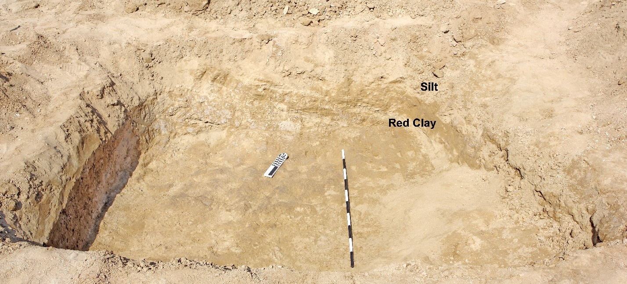

Supplementary Figure 3 – Eastern section of Test Trench 3. Pieces of unbaked mudbricks and ash are revealed in section sloping toward lower elevation, indicative of fluvial deposition under energetic conditions.

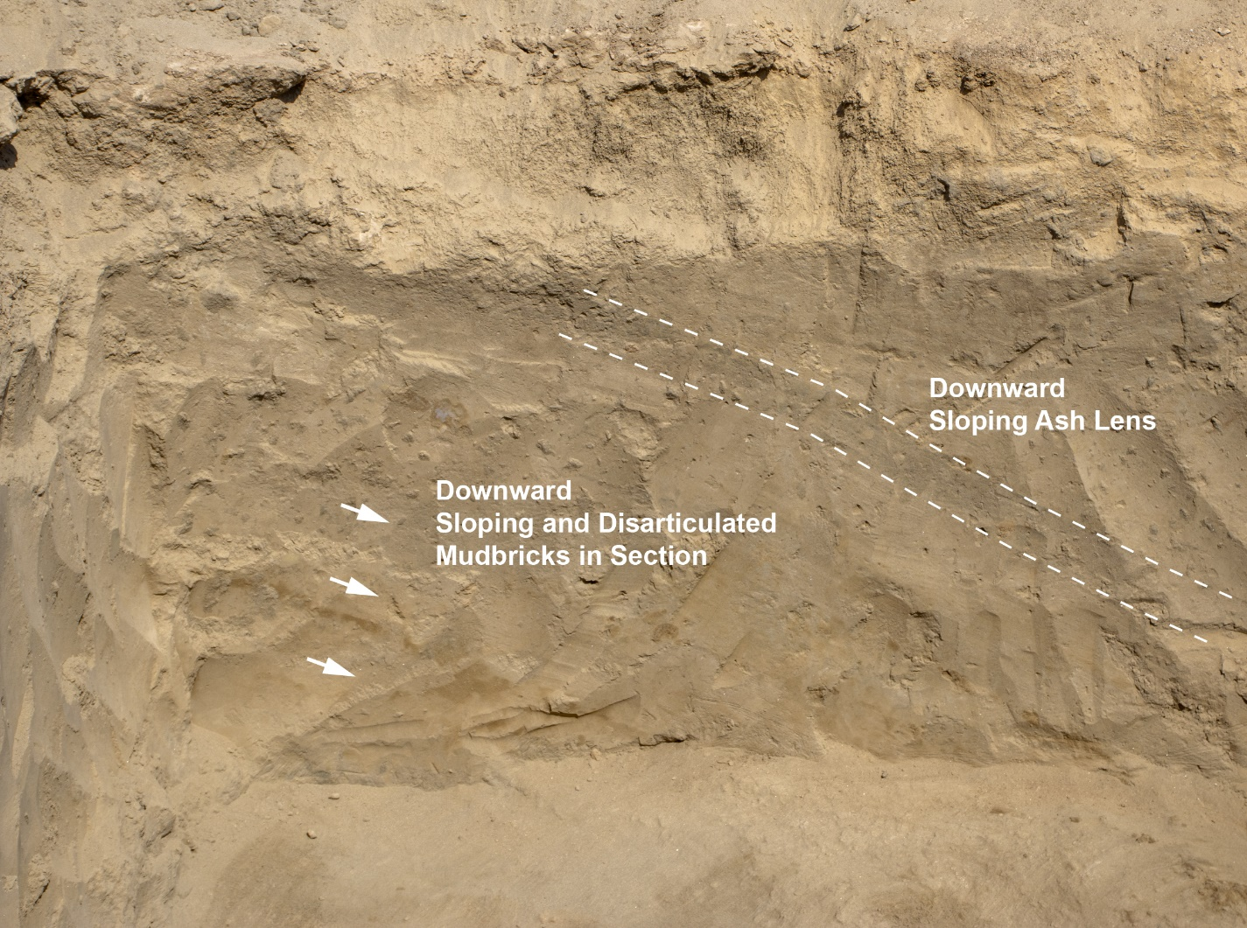

Supplementary Figure 4 – Western section of Test Trench 4. An unbaked mudbrick wall was uncovered just beneath the surface.
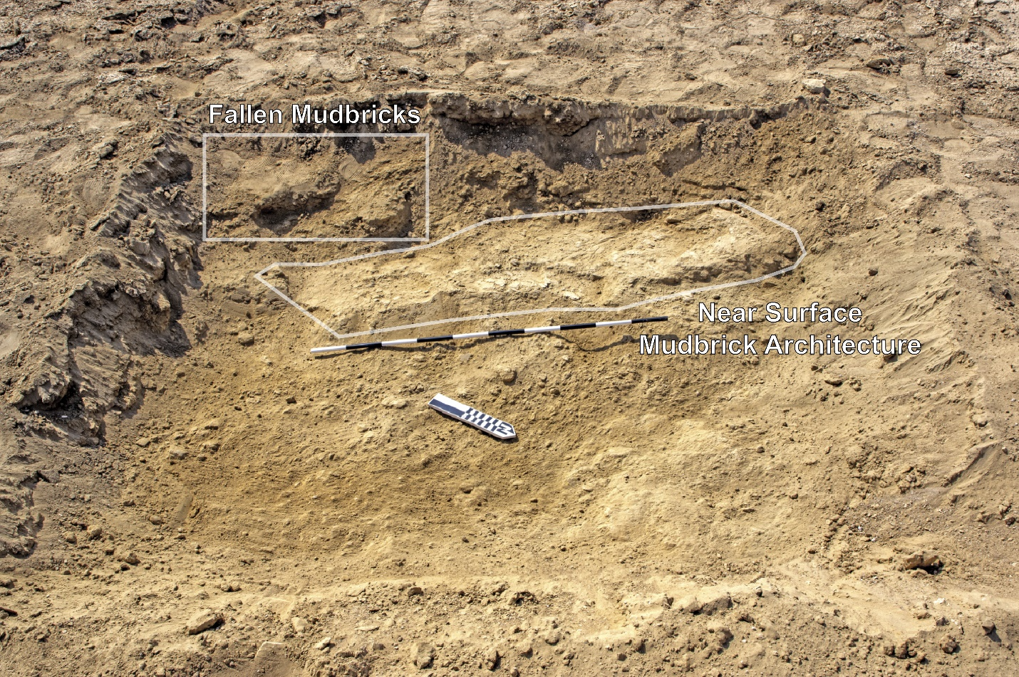

Supplementary Figure 5 – A. Representative cross-section of all test trenches. Note that the horizontal dimension of each test trench has been doubled for clarity. OSL date ranges from Test Trench 1 are indicated at approximate depth. B. Inset shows overlap between radiocarbon of the destruction level in Area C and OSL dating with error ranges.

