Figure 1 – A. Location of primary sites mentioned in the text. B. Reconstruction of historical and political geography and principal waterways of the Lagash city-state and its neighbors in the Early Dynastic period. Modified from Rey (2016).

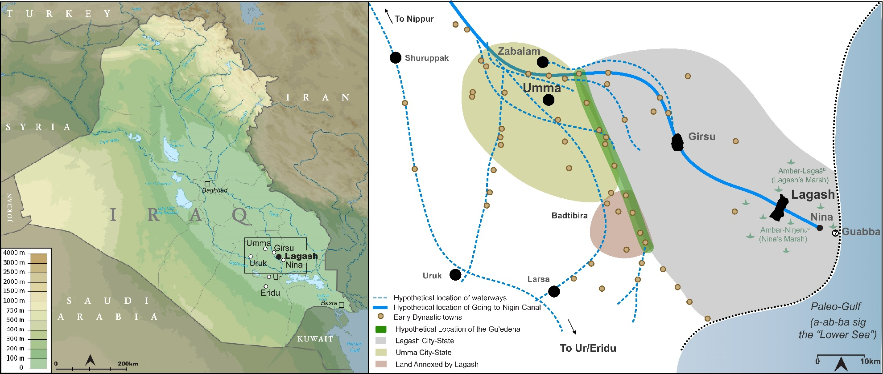

Figure 2. – A. Satellite image of Tell al-Hiba with old excavation and magnetometry areas labeled, along with the locations of previously excavated units and the coverage of Carter’s 1984 walking survey. The group of excavated units just south of Area B unveiled part of a monumental city wall dating from the Early Dynastic period (see Figure 10). B. Inset map shows Hammer (2022) and Hammer et al. (2022)’s reconstructed intracity watercourse, which they characterized and dated based on aerial imagery.
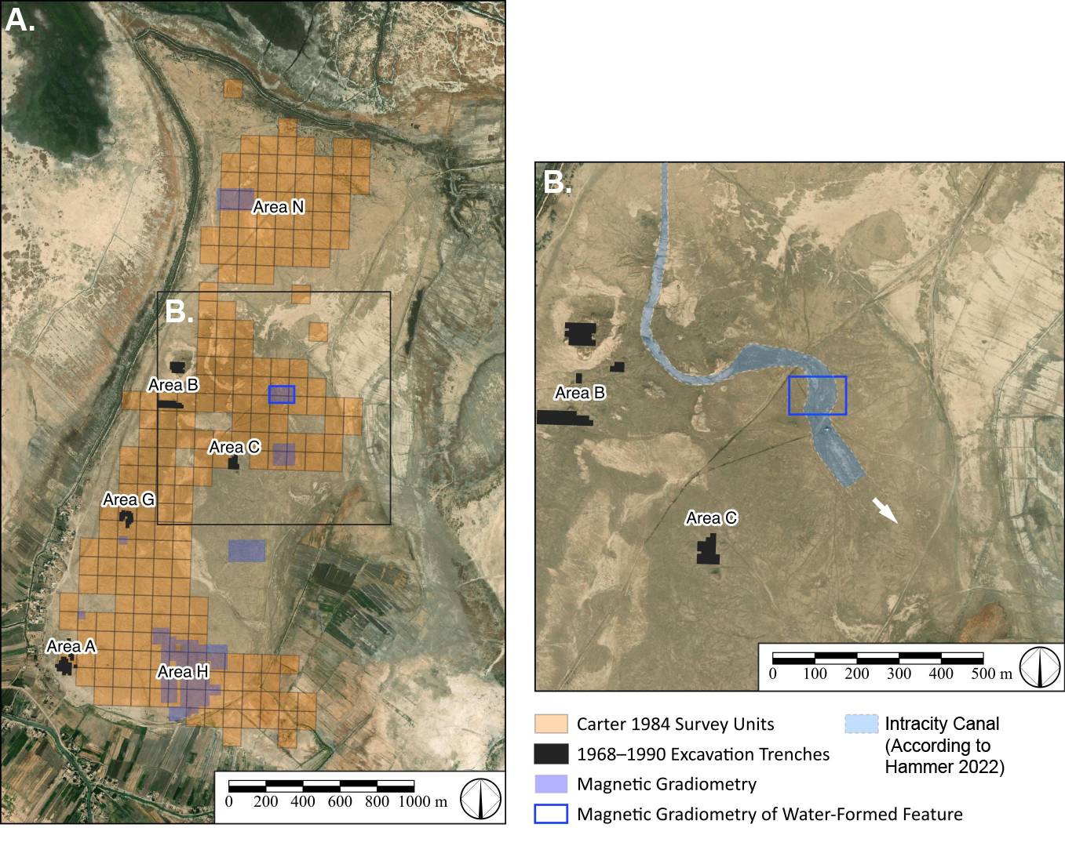

Figure 3. – A. Satellite image (Hexagon) indicating location of the water-formed meander scrolls on the site. B. Zoomed-in image of meander scrolls, and C. Magnetogram (135 by 90 meter) of meander scrolls with the location of test trenches indicated in purple.

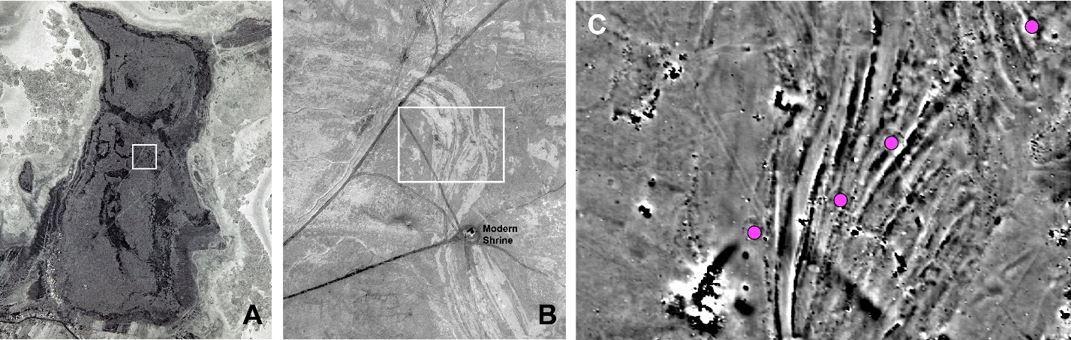

Figure 4 – Picture of the inscribed Enanatum Nail located in Test Trench 2 along with the location of its findspot. The nail, dating to c. 2,450 BC, was found within the matrix of the water lain silt deposit in the southeast corner of the test trench. Note the shallow depth of silt in this trench.
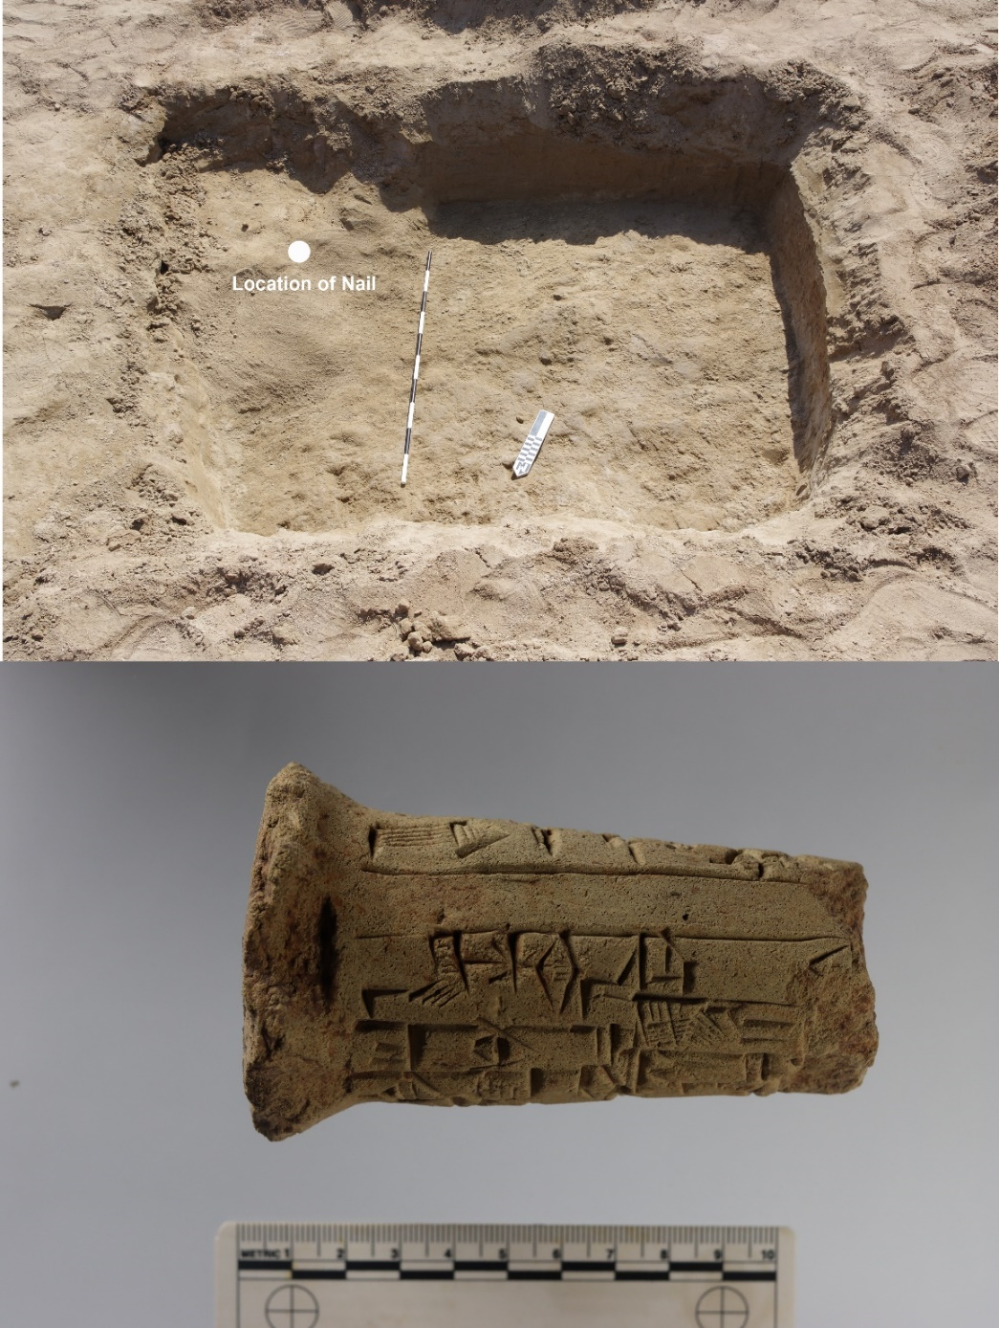

Table 1 –Optically-stimulated luminescence dates from Test Trench 1.
Sample Name | Lab  Code | Sample  depth (m) | Water  Content  (%) ª | In-situ Water Content (%) | Assumed initial water content | ²³⁸U  (ppm) ^{b} | ²³²Th  (ppm) | K  (%) | d_{cosmic}  (Gy ka⁻¹) ^{c} | Φ(μm) ^{d} | d_{Natural}  (Gy ka⁻¹) | n ^{e} | D_{e} (Gy)^{f} | σ (%)^{g} | Age  (ka) ^{h}
TP1 T | COSL151 | .15 | 3 | 20 | 9 | 1.59±0.11 | 4.15±0.41 | 1.00±0.04 | 0.22 | 4-15 | 1.97±0.12 | 8/8 | 8.77±0.17 | 0 | 4.45±0.27
 |  |  |  | 20 | 9 |  |  |  |  | 63-125 | 1.78±0.08 | 31/60 | 7.80±0.53 | 26±6 | 4.39±0.36
TP1 M | COSL152 | .45 | 3 | 20 |  | 1.67±0.12 | 4.51±0.45 | 1.05±0.04 | 0.19 | 63-125 | 1.84±0.06 | 35/80 | 8.10±0.40 | 20±5 | 4.41±0.29
TP1 B | COSL153 | .75 | 16 | 30 | 22 | 1.70±0.12 | 4.55±0.45 | 1.11±0.04 | 0.18 | 4-15 | 1.79±0.09 | 8/8 | 8.77±0.16 | 0 | 4.91±0.26

* Analytical results of OSL data reported with 1σ uncertainty.
a. Water content expressed as the mass fraction of water/wet sample and assumed a 5% uncertainty.
b: Natural radioactivity of the samples was measured using a high-resolution low-background gamma spectrometer.
c. Cosmic dose rate was calculated following Prescott and Hutton (1994).
d. Particle size of quartz extractions used for equivalent dose (De) measurement. Note that TP1 T was measured with fine-silt and sand-sized quartz separately.
f. The number of accepted/measured aliquots. The De values were obtained using the central age model, or weighted means of the accepted measurements.
g. The overdispersion parameter characterizing the spreading of De values beyond expectation, as defined by Galbraith et al. (1999).
h. The ages were reported as before 2022 CE.

Figure 5 – Photograph of Test Trench 3 looking west with late ED conical vessel face down on a surface. Collapsed mudbricks and downward sloping facies, indicative of energetic fluvial deposition, can be seen in section.

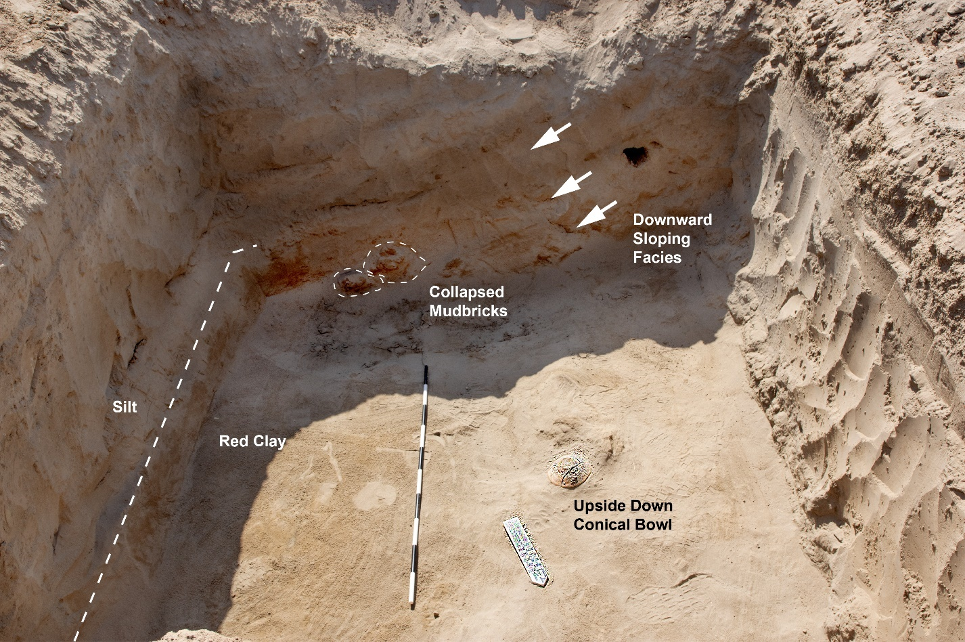

Figure 6 – Magnetogram overlain on drone orthomosaic image (taken March 29th, 2022) with contour lines. Relict channel meander (point bars) cut through a relatively large architectural signature, outlined in purple-dashed lines running northwest-southeast. Surface soil marks captured in the drone image also reveal a corner or bastion that is part of a broader city wall dating to the Early Dynastic period (see Figure 10). The eastern corner of that feature seems to be cut and eroded by the relict meander scrolls.
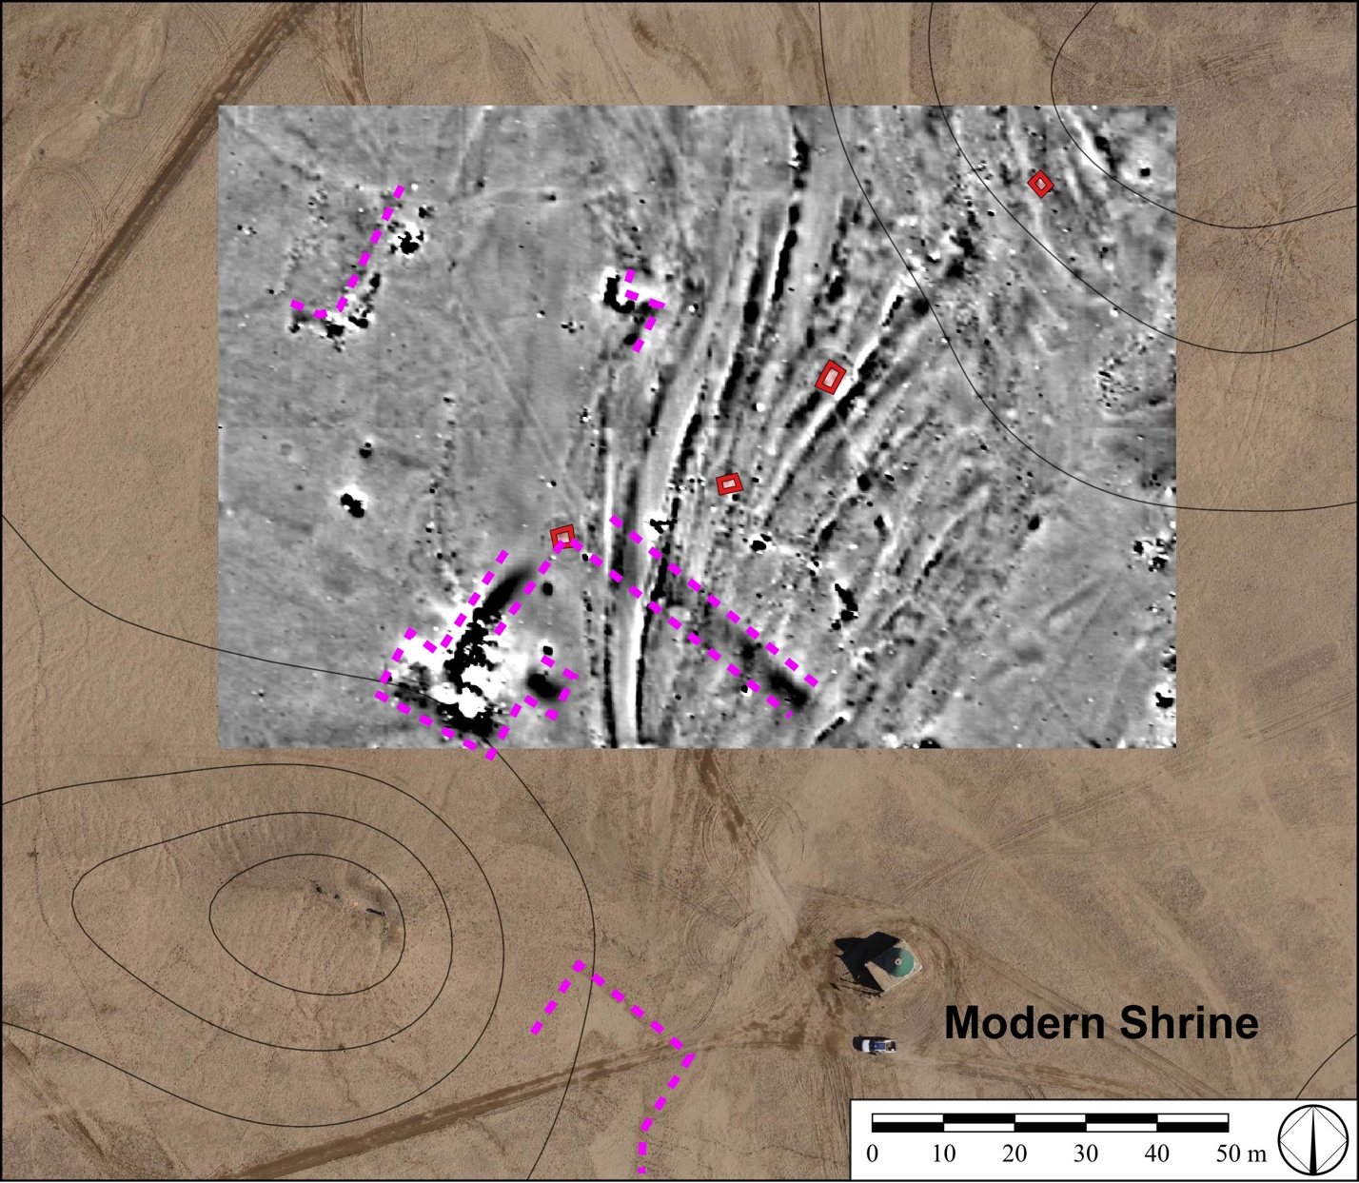

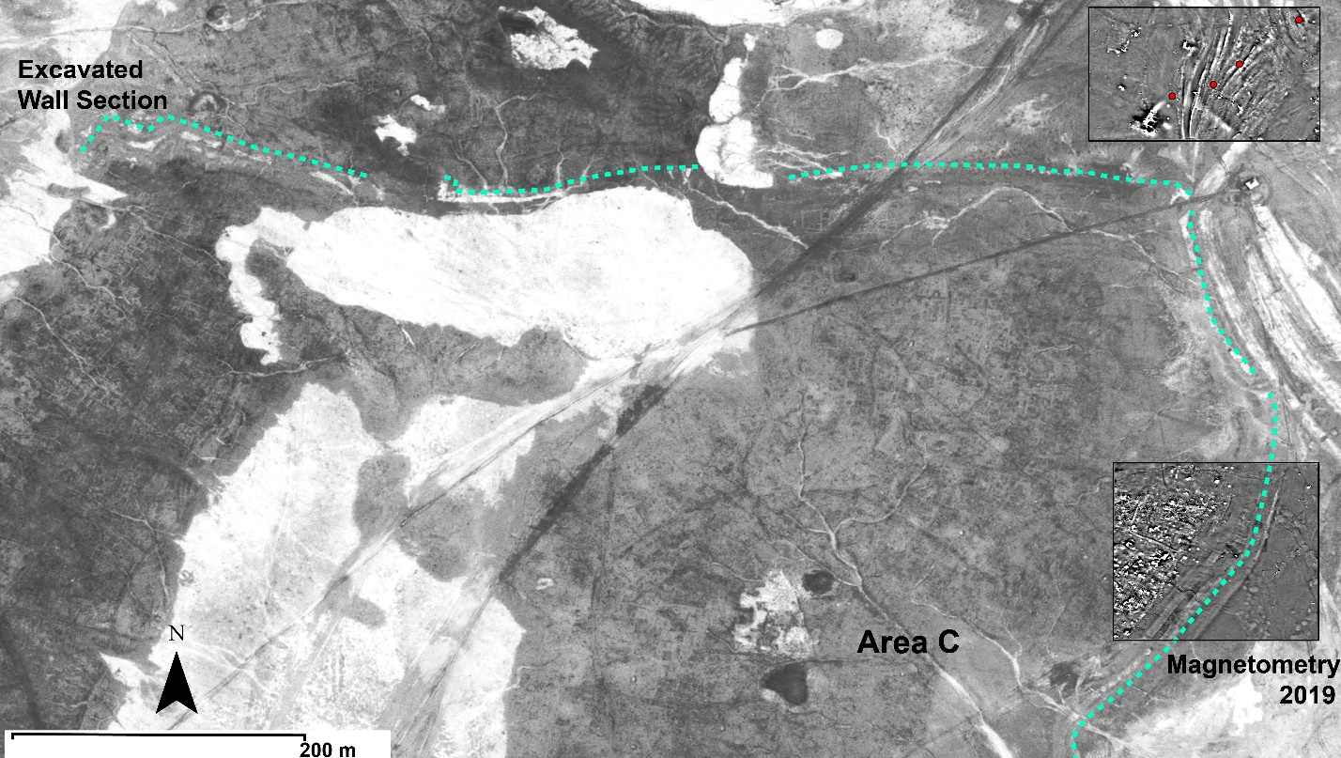
Figure 7 – Satellite image with soil marks indicative of an intracity dividing wall separating Area C from other spaces within the site. The light blue dashed line indicates the outer face of this wall, which encircles parts of Areas C and areas further west. Although never published, Hansen excavated the western section of the wall during his fifth season of excavations in 1978 (see Figure 2 for location of excavation squares). The magnetogram south of the water-formed feature was captured by Emily Hammer in spring 2019, revealing a continuation of that same wall further south past Area C, as well as a paleo-channel, ditch or street running just beyond it. Note that intracity walls often separated neighborhoods or ‘wards’ from each other in Mesopotamia’s ED cities, possibly on account of ethnic or professional divisions (Postgate 1994: 76-82).

Figure 8 – A. Radiocarbon dates of charred barley seeds from burned Levels I and II in the Area C administrative building overlap with the OSL dating of the water lain silt recovered in the test trenches, B (also see Supplementary Figure 5). Architecture in the Area C building was well-preserved because of the high temperature of the fire, turning the bricks and floors a deep red, and C. An oblique view of excavations in the Area C building.
